LAB WORK REPORT
Assignment 2 — Data-Driven Automation in Python Behave
API Automation using Behave Scenario Outline
Name: Biswayan Roy En:12023052002014 Email: bisurock0101@gmail.com / biswayan.roy2023@iem.edu.in IEM,Saltlake(CSE:roll:14)
Module / Tier | Python Behave — Data-Driven Automation
Experiment | Use of Test Data-Driven Automation in Python Behave Framework
Application Under Test | HTTP API endpoints using Python Requests
Automation Tools | Python, Behave, Requests
Execution Environment | Windows PowerShell / VS Code / Python virtual environment

1. Problem Statement
To implement data-driven automation using the Python Behave framework. The same BDD scenario should be executed with multiple sets of test data so that the test logic does not need to be duplicated. In this implementation, different API request data is supplied through a Behave Scenario Outline and Examples table, and the response status code and response content are verified.

2. Objective
The objective is to understand how Behave supports data-driven testing through Scenario Outline and Examples. The experiment also demonstrates sending GET requests, storing the response, performing assertions, and displaying execution evidence.
- Create a Behave feature containing a Scenario Outline.
- Provide multiple test-data rows using an Examples table.
- Execute the same test logic for each data row.
- Send HTTP GET requests using the Requests library.
- Verify HTTP status codes.
- Verify expected content in API responses.
- Display API response information in the terminal for execution evidence.

3. Tools, Software and Concepts
- Python 3.x
- Behave BDD framework
- Requests library
- Visual Studio Code
- PowerShell
- Python virtual environment (.venv)
- Gherkin syntax
- Scenario Outline
- Examples table
- Data-driven testing
- HTTP GET requests
- Assertions

4. Theory
Data-driven automation is a testing technique in which the same test logic is executed repeatedly using different sets of input data. This avoids creating separate test cases when only the input values change.
Behave provides Scenario Outline and Examples specifically for this style of testing. A Scenario Outline contains placeholders such as <url>, <code>, and <text>. The Examples table supplies different values for those placeholders. Behave creates a scenario iteration for every row.
In this experiment, Python Requests sends GET requests to an API endpoint. The response is stored in the Behave context so that subsequent steps can validate the HTTP status code and response text.

5. Project Structure
Assignment2_DataDriven/
│
└── features/
├── api_data.feature
└── steps/
└── api_steps.py

6. Installation and Setup
The project was executed inside a Python virtual environment. Install the required packages using:
python -m pip install behave requests
Verify Behave:
python -m behave --version
The test can then be executed using:
python -m behave -f pretty --no-capture
The --no-capture option is important for this implementation because the step definition prints the API response. It allows the printed response and verification messages to remain visible in the terminal during successful execution.

7. Source Code — api_data.feature
Feature: Data driven API automation
Scenario Outline: Verify GET endpoint
Given I send a GET request to "<url>"
Then the status code should be <code>
And response text should contain "<text>"
Examples:
| url | code | text |
| https://httpbin.org/get | 200 | url |
| https://httpbin.org/get | 200 | args |

8. Source Code — api_steps.py
from behave import given, then
import requests
@given('I send a GET request to "{url}"')
def send_get(context, url):
print("\n")
print("=" * 60)
print("SENDING GET REQUEST")
print("=" * 60)
print("URL:", url)
context.response = requests.get(url, timeout=10)
print("STATUS CODE:", context.response.status_code)
print("RESPONSE:")
print(context.response.text[:1000])
print("=" * 60)
@then("the status code should be {code:d}")
def check_status(context, code):
assert context.response.status_code == code
print("✓ Status code verification passed:", code)
@then('response text should contain "{text}"')
def check_text(context, text):
assert text in context.response.text
print("✓ Response contains:", text)

9. Explanation of the Implementation
The feature file contains one Scenario Outline. The placeholders <url>, <code>, and <text> are replaced with values from the Examples table during execution.
The send_get step uses requests.get() to send the GET request and stores the response in context.response. The following steps use that stored response to verify the expected status code and response content.
The print statements provide visible execution evidence. The --no-capture Behave option ensures that this diagnostic output is shown in the terminal even when the scenarios pass.

10. Data-Driven Test Data
Test Data Set | URL | Expected Data
Iteration 1 | https://httpbin.org/get | Status 200; response contains url
Iteration 2 | https://httpbin.org/get | Status 200; response contains args

11. Execution Procedure
- Open the Assignment2_DataDriven project in Visual Studio Code.
- Activate the Python virtual environment if required.
- Open PowerShell in the project directory.
- Install Behave and Requests.
- Verify the Behave installation.
- Run the Scenario Outline with the pretty formatter and --no-capture.
- Observe the API response for each data row.
- Observe the final feature, scenario, and step pass counts.
python -m behave -f pretty --no-capture

12. Output Screenshots
Output Screenshot 1 — API Responses and Data-Driven Verification
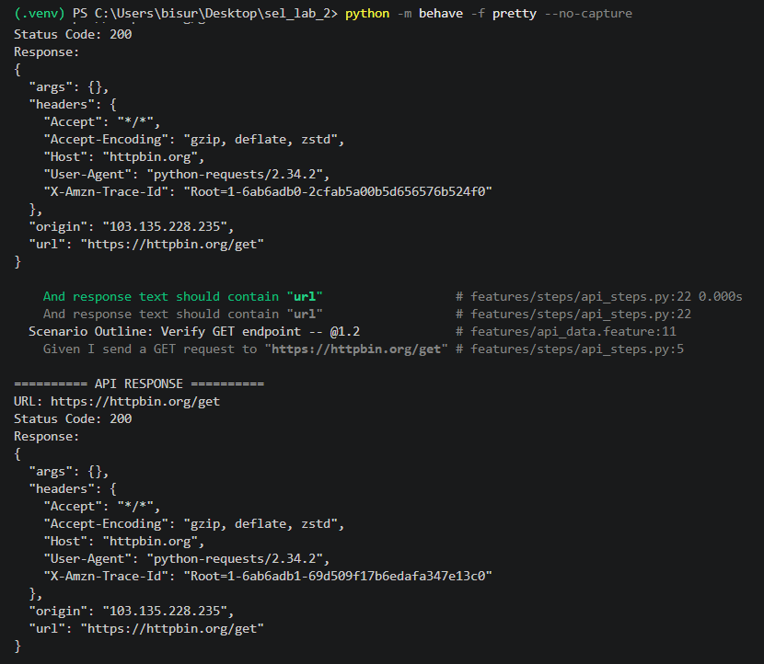

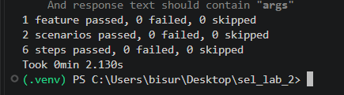
Output Screenshot 2 — Behave Execution Summary

13. Expected / Observed Execution Result
The successful execution should show two scenario iterations because the Examples table contains two data rows. Each iteration sends a GET request, receives HTTP status code 200, verifies the expected response text, and completes successfully.
1 feature passed, 0 failed, 0 skipped
2 scenarios passed, 0 failed, 0 skipped
6 steps passed, 0 failed, 0 skipped
The exact terminal layout and timing can vary. In the completed execution, both scenarios and all six steps passed successfully.

14. Gherkin-to-Python Mapping
Gherkin Step | Python Function | Purpose
Given I send a GET request to "<url>" | send_get() | Sends the API request and stores the response
Then the status code should be <code> | check_status() | Validates the HTTP status code
And response text should contain "<text>" | check_text() | Validates expected response content

15. Result
Data-driven API automation was successfully implemented using Python Behave. The Scenario Outline executed the same test logic for two different data rows. Both scenarios completed successfully, with six steps passing and no failures.

16. Observation
The experiment demonstrated that multiple test-data combinations can be maintained in the Examples table instead of duplicating the scenario. The same Python step definitions were reused for both iterations. The --no-capture option allowed the API response and verification messages to be displayed as execution evidence.

17. Conclusion
The experiment successfully demonstrated data-driven automation using Behave Scenario Outline and Examples. Python Requests was used to send API GET requests, while Behave assertions validated the status code and response content. The approach improves reuse and makes test data easier to extend without changing the core automation logic.

