ASSIGNMENT REPORT
Lab Report: Assignment 1 – The Multi-Locator Challenge
Tier 1: Fundamentals & Basic Interactivity
Name: Biswayan Roy En:12023052002014 Email: bisurock0101@gmail.com / biswayan.roy2023@iem.edu.in IEM,Saltlake(CSE:roll:14)

Field | Details
Tier | Tier 1: Fundamentals & Basic Interactivity
Module | Assignment 1 – Web Element Locators
Framework | Selenium WebDriver with Python
Target URL | https://www.saucedemo.com/

1. Objectives
- Interoperably utilize multiple Selenium locator strategies (By.ID, By.NAME, By.XPATH) to identify distinct web elements on a login interface.
- Automate basic form submission actions (.clear(), .send_keys(), .click()).
- Programmatically validate successful page navigation using Python assertion statements against driver.current_url.

2. Technical Task Execution Summary
Target Element | Applied Locator Strategy | Code Pattern
Username Input | By.ID | driver.find_element(By.ID, "user-name")
Password Input | By.NAME | driver.find_element(By.NAME, "password")
Login Button | By.XPATH | driver.find_element(By.XPATH, "//input[@id='login-button']")
URL Assertion | URL Pattern Matching | assert "/inventory.html" in driver.current_url

3. Source Code & Screenshots
The automation script (assignment_1_locators.py) is divided into a setup block, the multi-locator interaction block, and the final URL validation block. Each screenshot is placed after the code that captures it.

3.1 Setup & Login Page Screenshot
import time
from selenium import webdriver
from selenium.webdriver.common.by import By

# 1. Initialize Driver
driver = webdriver.Chrome()
driver.get("https://www.saucedemo.com/")
driver.maximize_window()
time.sleep(1)

# SCREENSHOT 1: Login Page Overview
driver.save_screenshot("assignment_1_step1_login_page.png")
print("Saved: assignment_1_step1_login_page.png")

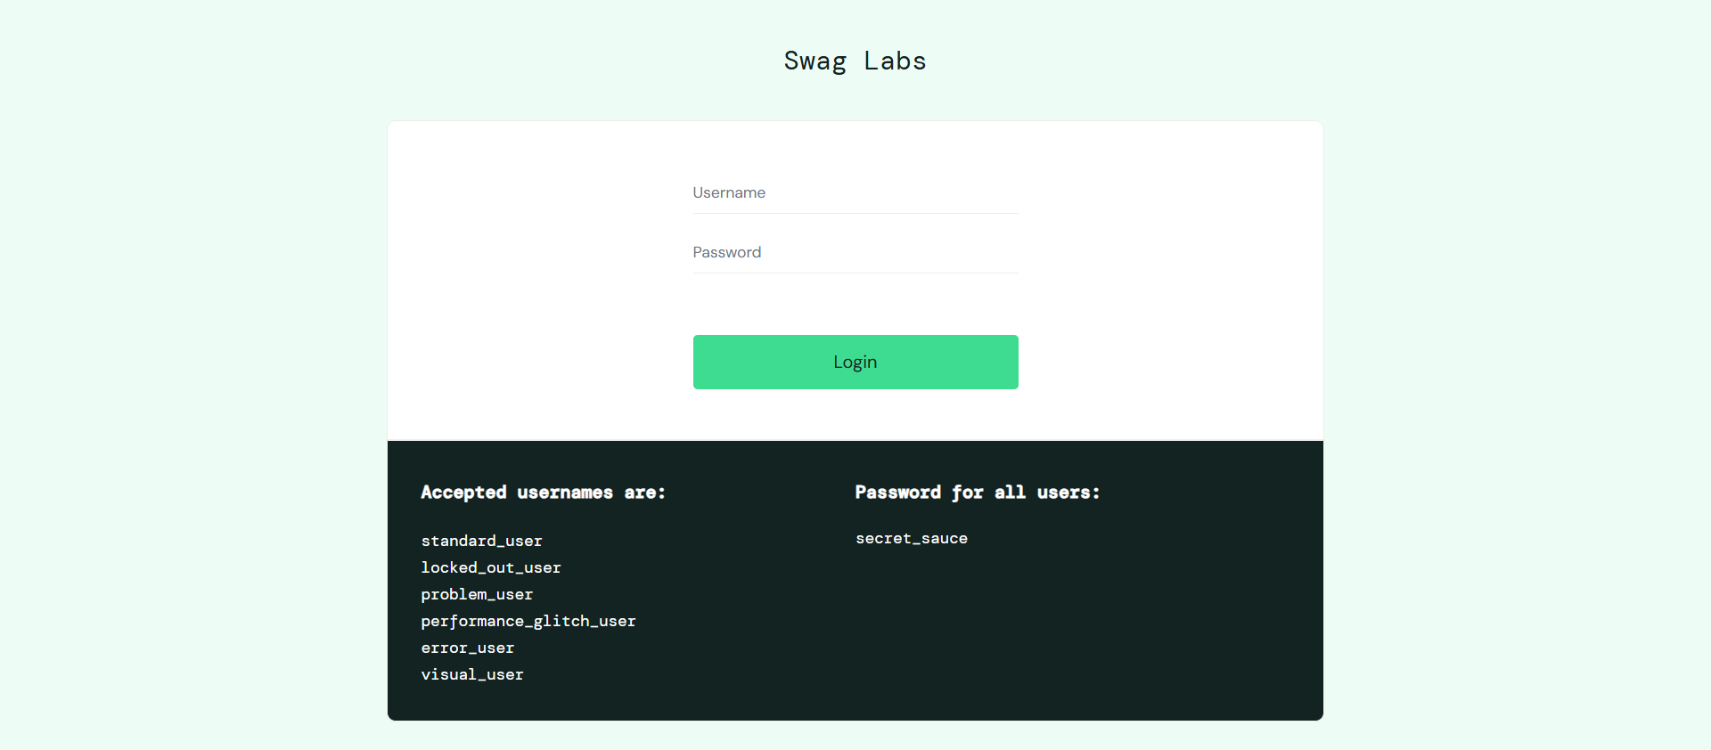
[ Insert Screenshot 1 here ]
assignment_1_step1_login_page.png
Figure 1: Initial login interface state

3.2 Multi-Locator Strategies
# =============================================================
# MULTI-LOCATOR STRATEGIES
# =============================================================

# 1. Interact with Username Field using By.ID
username_field = driver.find_element(By.ID, "user-name")
username_field.clear()
username_field.send_keys("standard_user")
print("Username entered using By.ID")

# 2. Interact with Password Field using By.NAME
password_field = driver.find_element(By.NAME, "password")
password_field.clear()
password_field.send_keys("secret_sauce")
print("Password entered using By.NAME")

# 3. Interact with Login Button using By.XPATH
login_button = driver.find_element(By.XPATH, "//input[@id='login-button']")
login_button.click()
print("Login button clicked using By.XPATH")

time.sleep(2)

3.3 Validation: Assert Resulting URL
# =============================================================
# VALIDATION: ASSERT RESULTING URL
# =============================================================
current_url = driver.current_url
print("Current Page URL:", current_url)

# Assertion to verify login success
assert "/inventory.html" in current_url, f"Assertion Failed: Expected '/inventory.html' in URL, but got '{current_url}'"
print("Validation Passed: URL contains '/inventory.html' successfully!")

# SCREENSHOT 2: Inventory Page After Login
driver.save_screenshot("assignment_1_step2_inventory_page.png")
print("Saved: assignment_1_step2_inventory_page.png")

driver.quit()

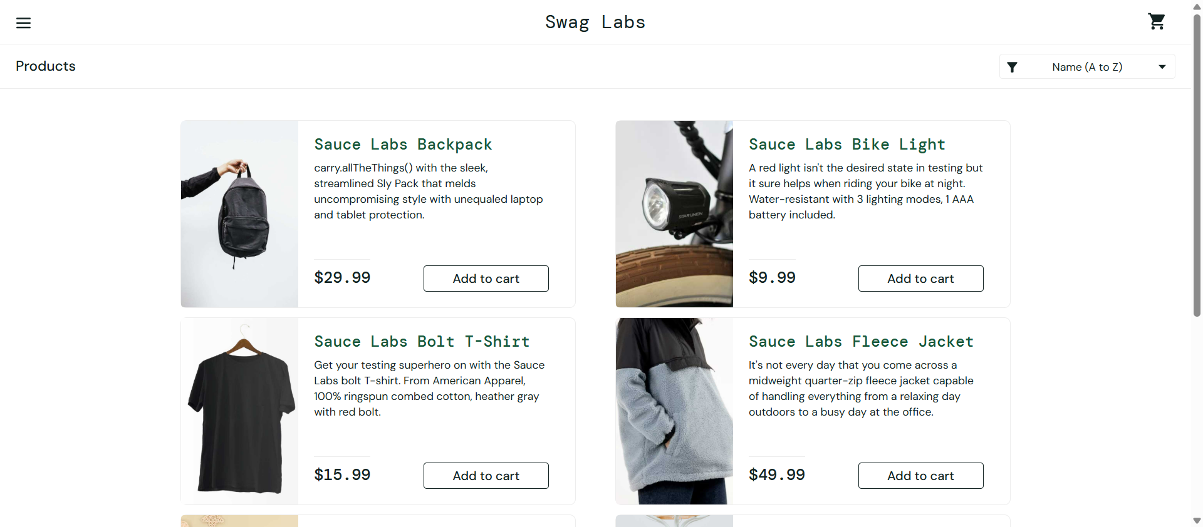
[ Insert Screenshot 2 here ]
assignment_1_step2_inventory_page.png
Figure 2: Inventory screen post-authentication

4. Execution & Verification Steps
- Execution: Execute command python assignment_1_locators.py in the active virtual environment.
Terminal Output Verification:
- Entered credentials into user-name and password fields.
- Triggered submit click via XPath selector.
- Captured current URL: https://www.saucedemo.com/inventory.html.
- Python assertion evaluated True without raising an AssertionError.
Screenshot Proof Output:
- assignment_1_step1_login_page.png: Captures initial login interface state.
- assignment_1_step2_inventory_page.png: Captures inventory screen post-authentication.

5. Conclusion
Assignment 1 from Tier 1 was successfully implemented. The script demonstrates locator identification across By.ID, By.NAME, and By.XPATH, culminating in a validated assertion check confirming navigation to the inventory page.

