ASSIGNMENT REPORT
Lab Report: Assignment 2 – Synchronization & Explicit Waits
Tier 1: Fundamentals & Basic Interactivity
Name: Biswayan Roy En:12023052002014 Email: bisurock0101@gmail.com / biswayan.roy2023@iem.edu.in IEM,Saltlake(CSE:roll:14)

Field | Details
Tier | Tier 1: Fundamentals & Basic Interactivity
Module | Assignment 2 – Synchronization & Explicit Waits
Framework | Selenium WebDriver with Python
Target URL | https://the-internet.herokuapp.com/dynamic_loading/1

1. Objectives
- Master test script synchronization techniques for dynamic web applications and AJAX elements.
- Enforce strict compliance against non-deterministic sleep calls (time.sleep()).
- Utilize WebDriverWait combined with expected_conditions to wait for DOM element visibility before text extraction.

2. Technical Task Execution Summary
Constraint / Task | Applied Solution | Implementation Code
No time.sleep() | Strict WebDriverWait explicit synchronization | wait = WebDriverWait(driver, 10)
Button Interaction | Wait until element is clickable | EC.element_to_be_clickable((By.XPATH, "..."))
Dynamic AJAX Load | Wait for element visibility | EC.visibility_of_element_located((By.XPATH, "..."))
Text Verification | Assert extracted text | assert extracted_text == "Hello World!"

3. Source Code & Screenshots
The automation script (assignment_2_waits.py) is divided into a setup block and the explicit wait implementation block. Each screenshot is placed after the code that captures it.

3.1 Setup & Initial Page Screenshot
from selenium import webdriver
from selenium.webdriver.common.by import By
from selenium.webdriver.support.ui import WebDriverWait
from selenium.webdriver.support import expected_conditions as EC

# 1. Initialize Driver
driver = webdriver.Chrome()
driver.get("https://the-internet.herokuapp.com/dynamic_loading/1")
driver.maximize_window()

# 2. Configure Explicit Wait (Max timeout: 10 seconds)
wait = WebDriverWait(driver, 10)

# SCREENSHOT 1: Initial Page State
driver.save_screenshot("assignment_2_step1_initial_page.png")
print("Saved: assignment_2_step1_initial_page.png")

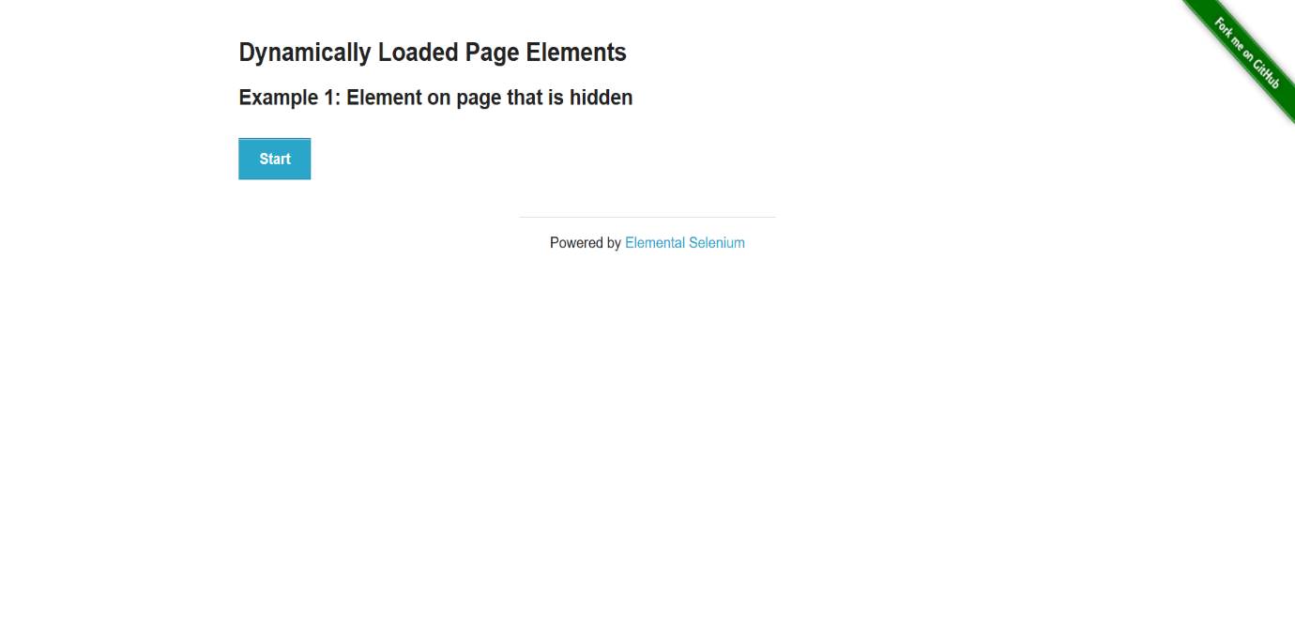
[ Insert Screenshot 1 here ]
assignment_2_step1_initial_page.png
Figure 1: Initial page before triggering dynamic load

3.2 Explicit Wait Implementation (No time.sleep)
# =============================================================
# EXPLICIT WAIT IMPLEMENTATION (NO TIME.SLEEP)
# =============================================================

# Locate and click the Start button
start_button = wait.until(
EC.element_to_be_clickable((By.XPATH, "//div[@id='start']/button"))
)
start_button.click()
print("Start button clicked. Waiting for dynamic text to load...")

# Explicitly wait until the dynamically loaded text element is VISIBLE
# Constraint Verified: Zero usage of time.sleep()
finish_element = wait.until(
EC.visibility_of_element_located((By.XPATH, "//div[@id='finish']/h4"))
)

# Extract and print the loaded text
extracted_text = finish_element.text
print(f"Dynamically Loaded Text Successfully Extracted: '{extracted_text}'")

# Assertion Validation
assert extracted_text == "Hello World!", f"Expected 'Hello World!', but got '{extracted_text}'"
print("Validation Passed: Extracted text matches expected value!")

# SCREENSHOT 2: Revealed Dynamic Text
driver.save_screenshot("assignment_2_step2_dynamic_text_revealed.png")
print("Saved: assignment_2_step2_dynamic_text_revealed.png")

driver.quit()

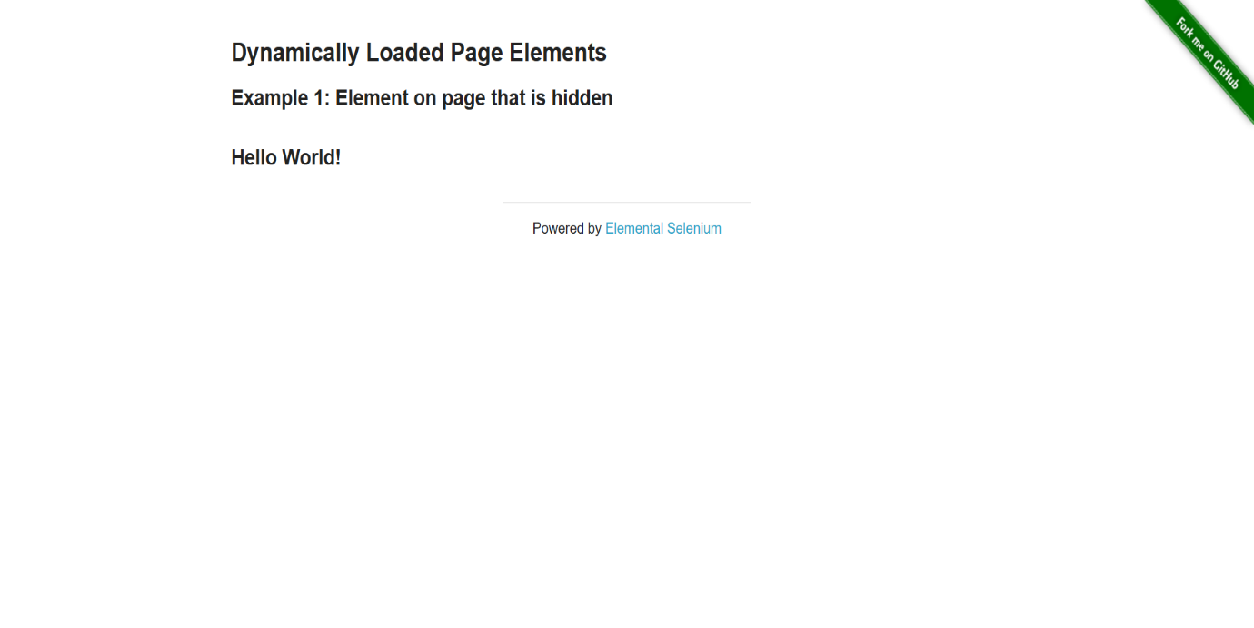
[ Insert Screenshot 2 here ]
assignment_2_step2_dynamic_text_revealed.png
Figure 2: Loaded dynamic text after explicit wait resolution

4. Execution & Verification Steps
- Execution: Run python assignment_2_waits.py inside the active virtual environment.
Terminal Output Verification:
- Clicked "Start" button on dynamic loading page.
- WebDriverWait polled the DOM during AJAX delay and successfully resumed execution upon element rendering.
- Extracted dynamic text: "Hello World!".
- Assertion evaluated True.
Screenshot Proof Output:
- assignment_2_step1_initial_page.png: Captures initial page before triggering dynamic load.
- assignment_2_step2_dynamic_text_revealed.png: Captures loaded dynamic text after explicit wait resolution.

5. Conclusion
Assignment 2 from Tier 1 was successfully completed. Dynamic content delayed by background execution was reliably synchronized using WebDriverWait and expected_conditions, ensuring fast and reliable execution without relying on time.sleep().

