ASSIGNMENT REPORT
Lab Report: Assignment 3 – Dynamic Dropdowns & Checkboxes
Tier 1: Fundamentals & Basic Interactivity
Name: Biswayan Roy En:12023052002014 Email: bisurock0101@gmail.com / biswayan.roy2023@iem.edu.in IEM,Saltlake(CSE:roll:14)

Field | Details
Tier | Tier 1: Fundamentals & Basic Interactivity
Module | Assignment 3 – Dynamic Elements, Checkboxes & Autocomplete Dropdowns
Framework | Selenium WebDriver with Python
Target URL | https://testautomationpractice.blogspot.com/

1. Objectives
- Automate state-based element selection using .click() and .is_selected().
- Programmatically verify checkbox states using boolean assertions.
- Interact with dynamic search-as-you-type input fields, wait for suggestion lists, and loop through dynamic elements to select specific options.

2. Technical Task Execution Summary
Task Requirement | Implementation Approach | Code Pattern
Checkbox Selection | Conditional click based on current state | if not cb.is_selected(): cb.click()
State Verification | State check via .is_selected() | assert sunday_cb.is_selected() == True
Search Autocomplete | Text injection into search-as-you-type box | search_input.send_keys("Selenium")
Suggestion Looping | Iterate dynamic list & click target string | for opt in suggestions: if opt.text == target: opt.click()

3. Source Code & Screenshots
The automation script (assignment_3_dropdowns_checkboxes.py) is divided into a setup block and two tasks. Each part is followed by the screenshot it captures during execution.

3.1 Setup & Initial Page Screenshot
import time
from selenium import webdriver
from selenium.webdriver.common.by import By
from selenium.webdriver.support.ui import WebDriverWait
from selenium.webdriver.support import expected_conditions as EC

# 1. Initialize Driver
driver = webdriver.Chrome()
driver.get("https://testautomationpractice.blogspot.com/")
driver.maximize_window()
wait = WebDriverWait(driver, 10)

# SCREENSHOT 1: Initial Page Overview
driver.save_screenshot("assignment_3_step1_initial_page.png")
print("Saved: assignment_3_step1_initial_page.png")

Screenshot :

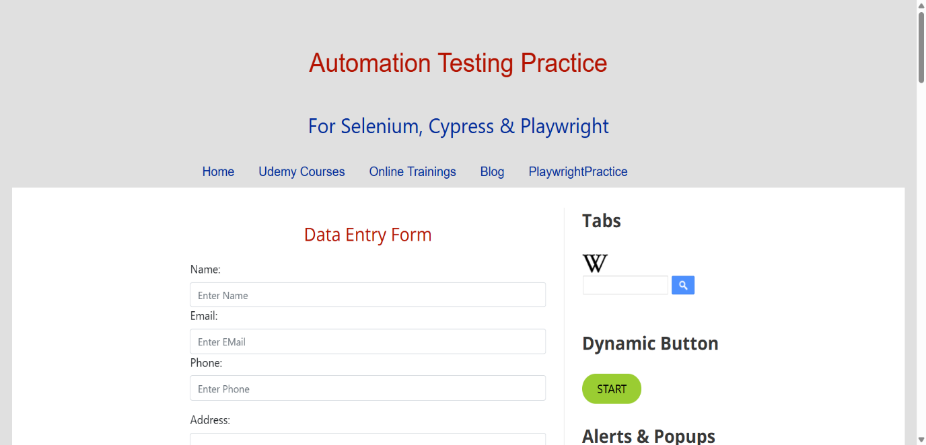
[ Insert Screenshot 1 here ]
assignment_3_step1_initial_page.png
Figure 1: Initial page overview before interaction

3.2 Task 1 – Checkbox Selection & Verification (.is_selected())

# =============================================================
# TASK 1: CHECKBOX SELECTION & VERIFICATION (.is_selected())
# =============================================================
# Scroll to Checkbox section
sunday_cb = driver.find_element(By.ID, "sunday")
monday_cb = driver.find_element(By.ID, "monday")

driver.execute_script("arguments[0].scrollIntoView({behavior: 'smooth', block: 'center'});", sunday_cb)
time.sleep(1)

# Select 'Sunday' if not already selected
if not sunday_cb.is_selected():
sunday_cb.click()

# Verify state using .is_selected()
assert sunday_cb.is_selected() == True, "Verification Failed: Sunday checkbox should be selected!"
assert monday_cb.is_selected() == False, "Verification Failed: Monday checkbox should NOT be selected!"

print("Checkbox Selection & State Verification (.is_selected()) Passed!")

# SCREENSHOT 2: Selected Checkboxes
driver.save_screenshot("assignment_3_step2_checkboxes_selected.png")
print("Saved: assignment_3_step2_checkboxes_selected.png")

Screenshot :
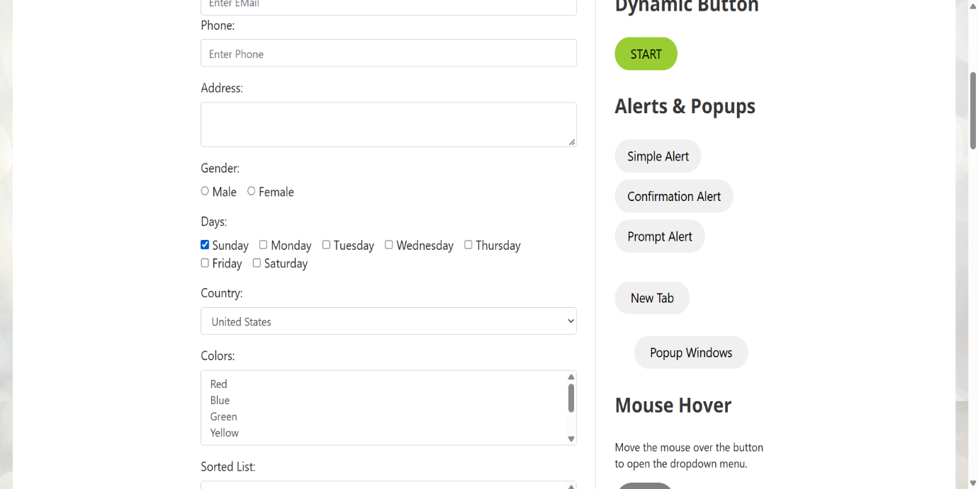
[ Insert Screenshot 2 here ]
assignment_3_step2_checkboxes_selected.png
Figure 2: Verified state of selected checkbox

3.3 Task 2 – Autocomplete / Search-As-You-Type Dropdown
# =============================================================
# TASK 2: AUTOCOMPLETE / SEARCH-AS-YOU-TYPE DROPDOWN
# =============================================================
# Locate Wikipedia search input box (autocomplete pattern)
search_input = driver.find_element(By.ID, "Wikipedia1_wikipedia-search-input")
search_button = driver.find_element(By.CLASS_NAME, "wikipedia-search-button")

driver.execute_script("arguments[0].scrollIntoView({behavior: 'smooth', block: 'center'});", search_input)
time.sleep(1)

# Type into autocomplete search field
search_term = "Selenium"
target_option = "Selenium (software)"

search_input.clear()
search_input.send_keys(search_term)
search_button.click()

# Wait for dynamic suggestions to populate in DOM
wait.until(EC.presence_of_element_located((By.XPATH, "//div[@id='wikipedia-search-result-link']/a")))

# Loop through dynamic suggested results to select matching option
suggestions = driver.find_elements(By.XPATH, "//div[@id='wikipedia-search-result-link']/a")
print(f"Found {len(suggestions)} autocomplete suggestions for '{search_term}':")

matched = False
for option in suggestions:
option_text = option.text
print(f" - Suggestion: {option_text}")

if option_text.strip().lower() == target_option.lower():
print(f"Match found! Clicking option: '{option_text}'")
option.click()
matched = True
break

assert matched == True, f"Failed to find matching option '{target_option}' in dynamic suggestions list!"

time.sleep(2)

# Switch focus to new tab opened by suggestion click if applicable
if len(driver.window_handles) > 1:
driver.switch_to.window(driver.window_handles[1])

# SCREENSHOT 3: Selected Dynamic Dropdown Result
driver.save_screenshot("assignment_3_step3_dropdown_selected.png")
print("Saved: assignment_3_step3_dropdown_selected.png")

driver.quit()

Screenshot :
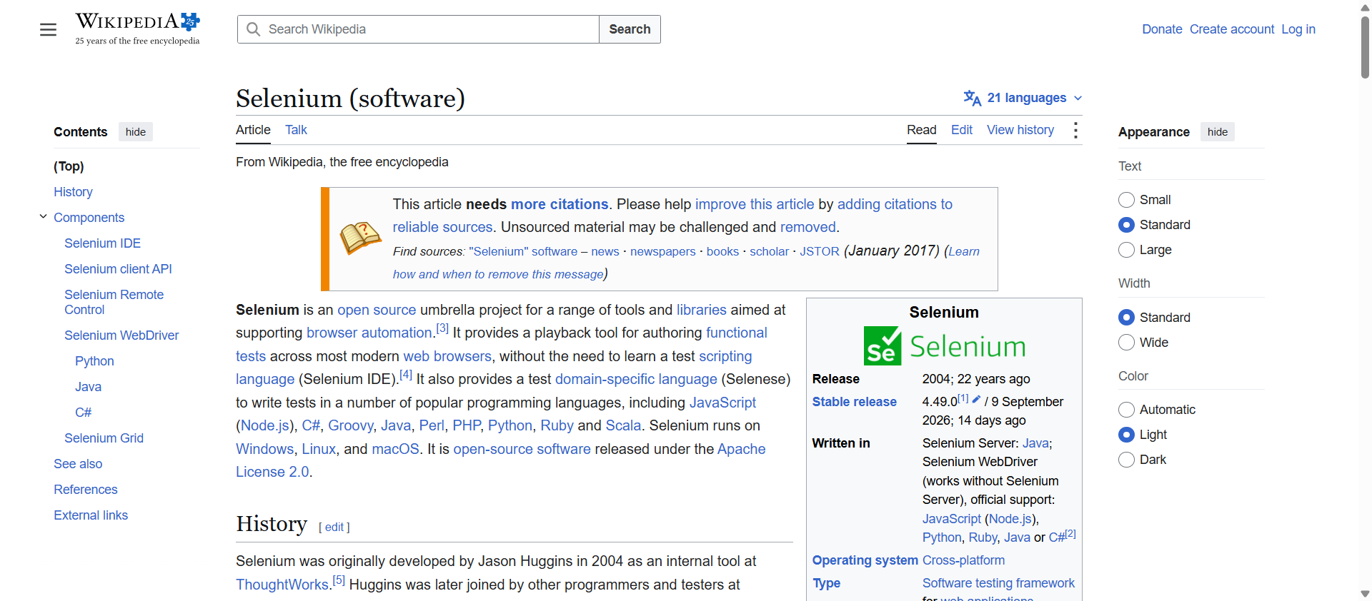
[ Insert Screenshot 3 here ]
assignment_3_step3_dropdown_selected.png
Figure 3: Final state showing selected dynamic suggestion element

4. Execution & Verification Steps
- Execution: Run python assignment_3_dropdowns_checkboxes.py in your terminal inside the virtual environment.
Terminal Output Verification:
- Checked Sunday checkbox and verified state returns True.
- Verified Monday checkbox returns False.
- Injected "Selenium" query into autocomplete input field.
- Dynamically parsed returned list items and located matching option "Selenium (software)".
Screenshot Proof Output:
- assignment_3_step1_initial_page.png: Initial page overview before interaction.
- assignment_3_step2_checkboxes_selected.png: Verified state of selected checkbox.
- assignment_3_step3_dropdown_selected.png: Final state showing selected dynamic suggestion element.

5. Conclusion
Assignment 3 from Tier 1 was successfully implemented. The script demonstrates checkbox state validation using .is_selected() and dynamic list searching through search-as-you-type autocomplete dropdown suggestions.

