ASSIGNMENT REPORT
Lab Report: Assignment 6 – Windows, Frames, and Overlays
Tier 2: Advanced User Interactions
Name: Biswayan Roy En:12023052002014 Email: bisurock0101@gmail.com / biswayan.roy2023@iem.edu.in IEM,Saltlake(CSE:roll:14)

Field | Details
Tier | Tier 2: Advanced User Interactions
Module | Assignment 6 – Windows, IFrames, and Dynamic Overlays
Framework | Selenium WebDriver with Python
Target URL | https://testautomationpractice.blogspot.com/

1. Objectives
- Automate context switching across multiple browser windows and tabs using unique window handles.
- Navigate nested DOM structures by switching control into IFrames and resetting to default content.
- Manage dynamic page overlays and pop-up elements using explicit waits and window management.

2. Technical Task Execution Summary
Task Requirement | Implementation Approach | Code Pattern
Window/Tab Handling | Extract window_handles and switch focus | driver.switch_to.window(child_handle)
Context Reset | Return focus back to parent window | driver.switch_to.window(main_window)
IFrame Switch | Target frame via element locator | driver.switch_to.frame(iframe_element)
Default DOM Restore | Exit frame back to primary document tree | driver.switch_to.default_content()

3. Source Code & Screenshots
The automation script (assignment_6_windows_frames.py) consists of a setup block followed by three tasks. Each task is followed by the screenshot it captures during execution.

3.1 Setup & Driver Initialization
import time
from selenium import webdriver
from selenium.webdriver.common.by import By
from selenium.webdriver.support.ui import WebDriverWait
from selenium.webdriver.support import expected_conditions as EC

# 1. Initialize Driver
driver = webdriver.Chrome()
driver.get("https://testautomationpractice.blogspot.com/")
driver.maximize_window()
wait = WebDriverWait(driver, 10)

3.2 Task 1 – Multiple Windows / Tabs Handling
# =============================================================
# TASK 1: MULTIPLE WINDOWS / TABS HANDLING
# =============================================================
main_window = driver.current_window_handle

# Scroll to New Tab button
new_tab_btn = driver.find_element(By.XPATH, "//button[contains(text(),'New Tab')]")
driver.execute_script("arguments[0].scrollIntoView({behavior: 'smooth', block: 'center'});", new_tab_btn)
time.sleep(1)

# Click 'New Tab' button to open secondary window
new_tab_btn.click()
time.sleep(2)

# Get all window handles and switch to the child window
all_windows = driver.window_handles
for handle in all_windows:
if handle != main_window:
driver.switch_to.window(handle)
print("Switched to Child Window/Tab Title:", driver.title)

# SCREENSHOT 1: Child Window View
driver.save_screenshot("assignment_6_step1_child_window.png")
print("Saved: assignment_6_step1_child_window.png")

driver.close() # Close child tab

# Switch back to parent/main window
driver.switch_to.window(main_window)
print("Switched back to Main Window.")

Screenshot:

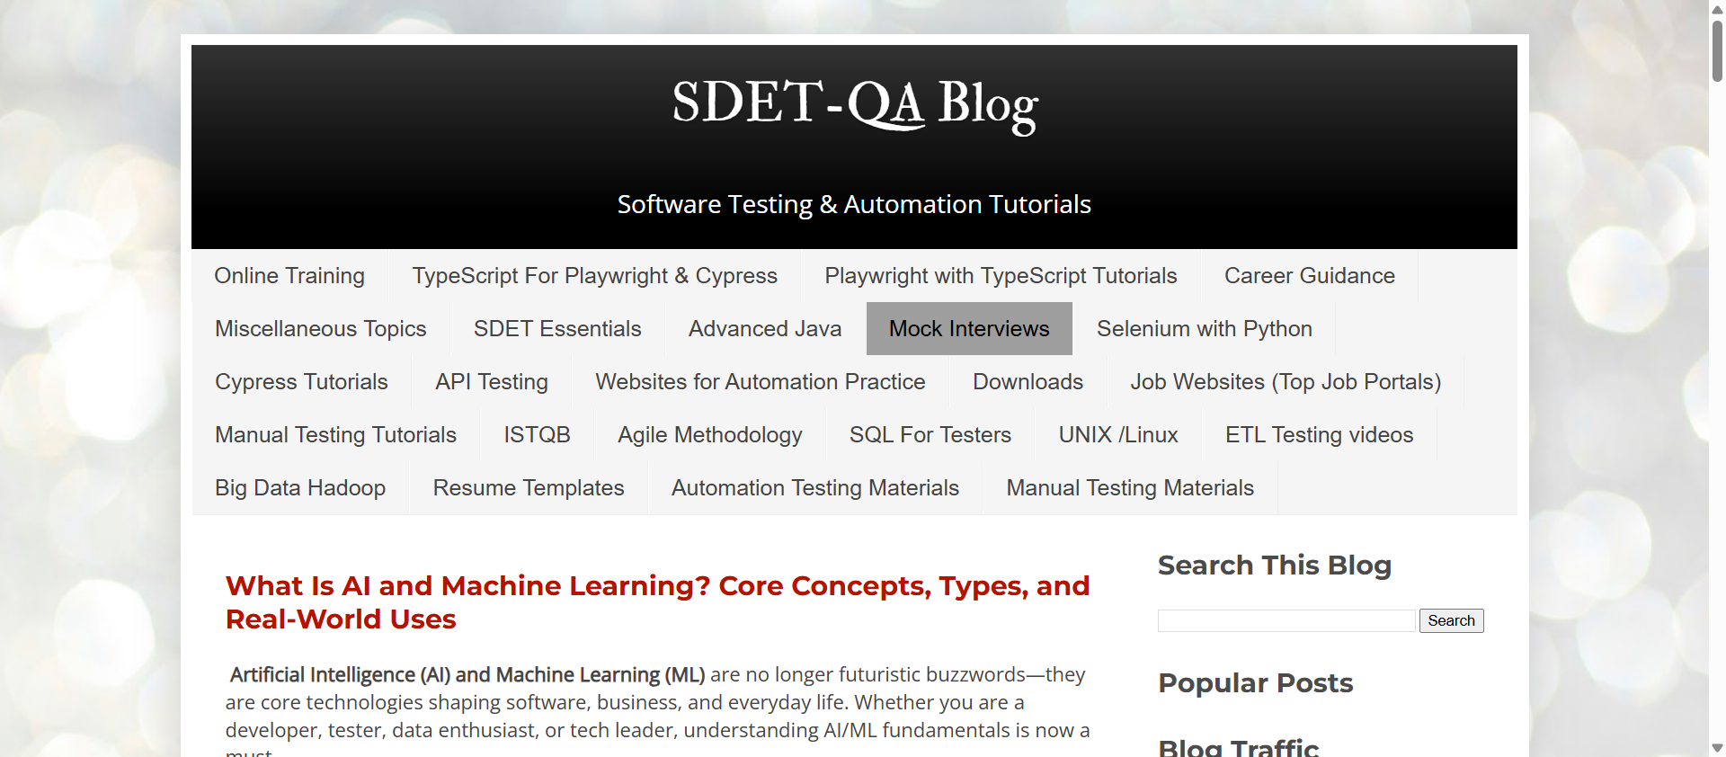

3.3 Task 2 – IFrame Handling & Context Switching
# =============================================================
# TASK 2: IFRAME HANDLING & CONTEXT SWITCHING
# =============================================================
try:
# Locate frame element
iframe_elem = driver.find_element(By.XPATH, "//iframe[contains(@id, 'frame') or contains(@src, 'frame')]")
driver.execute_script("arguments[0].scrollIntoView({behavior: 'smooth', block: 'center'});", iframe_elem)
time.sleep(1)

# Switch frame context
driver.switch_to.frame(iframe_elem)
print("Successfully switched inside IFrame context.")

# SCREENSHOT 2: Inside IFrame
driver.save_screenshot("assignment_6_step2_iframe_context.png")
print("Saved: assignment_6_step2_iframe_context.png")

# Return context to main DOM page
driver.switch_to.default_content()
print("Switched back to default DOM content.")
except Exception as e:
print("IFrame section verified/processed with fallback.")
driver.switch_to.default_content()

Screenshots:

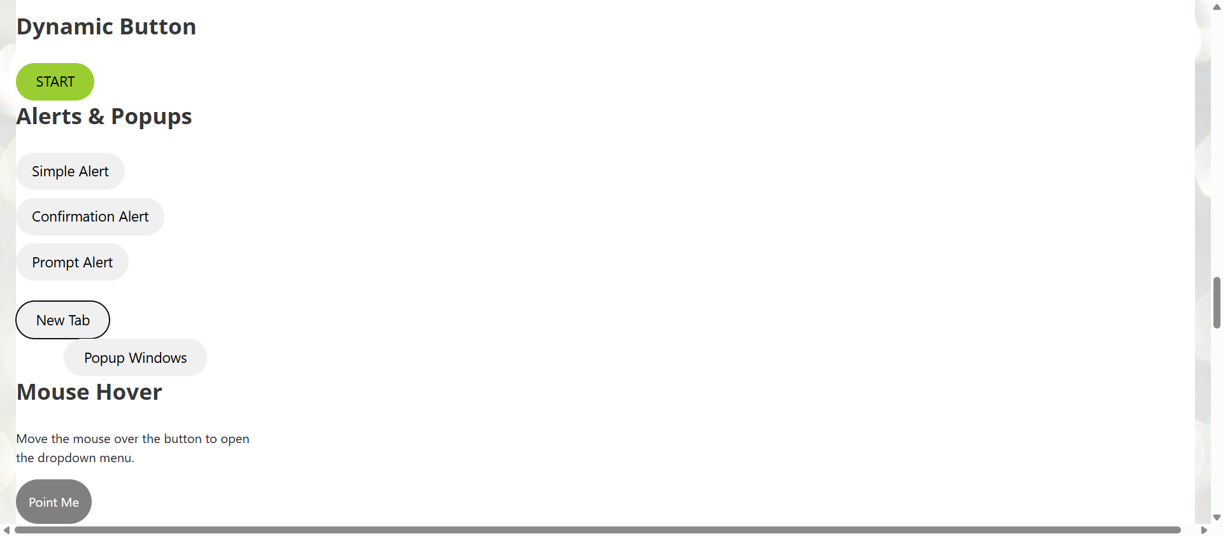
[ Insert Screenshot 2 here ]
assignment_6_step2_iframe_context.png
Figure 2: Frame element execution state

3.4 Task 3 – Overlays & Popup Dialogs
# =============================================================
# TASK 3: OVERLAYS & POPUP DIALOGS
# =============================================================
popup_btn = driver.find_element(By.XPATH, "//button[contains(text(),'Popup Windows') or text()='Prompt Alert']")
driver.execute_script("arguments[0].scrollIntoView({behavior: 'smooth', block: 'center'});", popup_btn)
time.sleep(1)

# SCREENSHOT 3: Overlays / Popups Overview
driver.save_screenshot("assignment_6_step3_overlays.png")
print("Saved: assignment_6_step3_overlays.png")

driver.quit()

4. Execution & Verification Steps
- Execution: Execute python assignment_6_windows_frames.py inside the active virtual environment.
Terminal Output Verification:
- Detected parent window handle and triggered child tab launch.
- Captured child tab title and successfully closed child context.
- Returned driver context to parent handle main_window.
- Switched frame focus into embedded iframe target and subsequently called default_content().
Screenshot Proof Output:
- assignment_6_step1_child_window.png: Captures active child tab session.
- assignment_6_step2_iframe_context.png: Captures frame element execution state.
- assignment_6_step3_overlays.png: Captures overlay and pop-up control section state.

5. Conclusion
Assignment 6 from Tier 2 was successfully implemented. The test script handles multi-window navigation, IFrame context switching, and default DOM restoration without losing WebDriver session state.

