LAB ASSIGNMENT – 3
Selenium Page Object Model (POM) in Python Behave Framework

Name: Biswayan Roy En:12023052002014 Email: bisurock0101@gmail.com / biswayan.roy2023@iem.edu.in IEM,Saltlake(CSE:roll:14)

Assignment | 3 – Selenium Page Object Model in Python Behave
Framework | Selenium WebDriver + Behave BDD
Language | Python
Application Tested | The Internet – Login Page
Execution Status | 1 feature passed, 1 scenario passed, 5 steps passed

1. Problem Statement
Develop a maintainable Selenium automation test using the Page Object Model (POM) design pattern within the Python Behave BDD framework. Page locators and UI actions are encapsulated in a page class, while the feature file describes the behavior and step definitions coordinate the test. Successful login is verified by navigation to the Secure Area page.

2. Objective
- Create a Selenium + Behave BDD automation project using POM.
- Separate page locators and UI actions from test steps.
- Automate valid username/password entry and login.
- Verify successful navigation to the secure page.
- Execute the scenario and record the successful terminal result.
- Keep the browser visible for 15 seconds after the scenario for screenshot evidence.

3. Tools, Software and Concepts
- Python 3.x
- Selenium WebDriver
- Behave BDD
- Google Chrome
- ChromeDriver / Selenium Manager
- VS Code or PyCharm
- Virtual environment (.venv)
- Page Object Model (POM)
- Gherkin feature files and step definitions

4. Theory

4.1 Behavior Driven Development
Behave is a Python BDD framework. Scenarios are written in Gherkin using Feature, Scenario, Given, When and Then, while Python step definitions perform the automation.

4.2 Page Object Model
POM represents a web page as a Python class containing locators and reusable UI methods. This keeps Selenium implementation details separate from test behavior and makes locator maintenance easier.

4.3 Test Flow
The test opens the login page, enters valid credentials, submits the form, verifies that the URL contains /secure, and then keeps the browser open for 15 seconds before cleanup.

5. Project Structure
Assignment3_POM/
└── features/
├── login.feature
├── environment.py
├── pages/
│ └── login_page.py
└── steps/
└── login_steps.py

6. Implementation

6.1 Install Required Packages
python -m pip install selenium behave

6.2 Page Object – login_page.py
from selenium.webdriver.common.by import By
class LoginPage:
USERNAME = (By.ID, "username")
PASSWORD = (By.ID, "password")
LOGIN = (By.CSS_SELECTOR, "button[type='submit']")
def __init__(self, driver):
self.driver = driver
def enter_username(self, username):
self.driver.find_element(*self.USERNAME).send_keys(username)
def enter_password(self, password):
self.driver.find_element(*self.PASSWORD).send_keys(password)
def click_login(self):
self.driver.find_element(*self.LOGIN).click()

6.3 Behave Feature – login.feature
Feature: Login using Page Object Model
Scenario: Submit login credentials
Given the login page is displayed
When I enter username "tomsmith"
And I enter password "SuperSecretPassword!"
And I submit the login form
Then the secure page should be displayed

6.4 Step Definitions – login_steps.py
from behave import given, when, then
from selenium import webdriver
from features.pages.login_page import LoginPage
@given("the login page is displayed")
def open_login(context):
context.driver = webdriver.Chrome()
context.driver.maximize_window()
context.driver.get("https://the-internet.herokuapp.com/login")
context.login = LoginPage(context.driver)
print("\n" + "=" * 60)
print("LOGIN PAGE OPENED")
print("=" * 60)
@when('I enter username "{username}"')
def enter_user(context, username):
context.login.enter_username(username)
print("✓ Username entered:", username)
@when('I enter password "{password}"')
def enter_pass(context, password):
context.login.enter_password(password)
print("✓ Password entered successfully")
@when("I submit the login form")
def submit(context):
context.login.click_login()
print("✓ Login button clicked")
@then("the secure page should be displayed")
def verify(context):
assert "/secure" in context.driver.current_url
print("✓ Login successful!")
print("✓ Current URL:", context.driver.current_url)
print("=" * 60)

6.5 Browser Cleanup – environment.py
import time
def after_scenario(context, scenario):
if hasattr(context, "driver"):
time.sleep(15)
context.driver.quit()
The 15-second delay is used for lab evidence capture. It keeps the browser on the successful Secure Area page before closing. It can be removed for normal automated execution.

7. Execution Procedure
- Open the project folder in the terminal.
- Activate the virtual environment.
- Install Selenium and Behave if required.
- Run the scenario from the project root.
- Use --no-capture so custom execution messages are visible.
- Capture the Secure Area page during the 15-second browser window.
python -m behave -f pretty --no-capture

8. Actual Execution Output
1 feature passed, 0 failed, 0 skipped
1 scenario passed, 0 failed, 0 skipped
5 steps passed, 0 failed, 0 skipped
Took 0min 5.603s
The recorded execution confirms that the complete scenario passed. The test reached https://the-internet.herokuapp.com/secure.

9. Output / Evidence

– Terminal – Successful Behave Execution
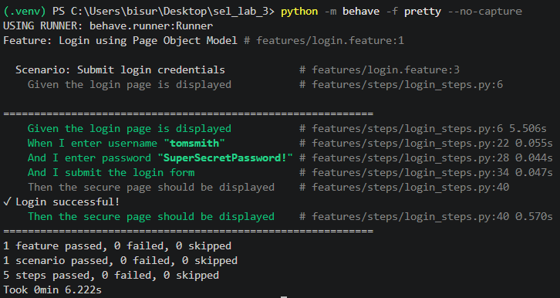 [

– Browser – Secure Area
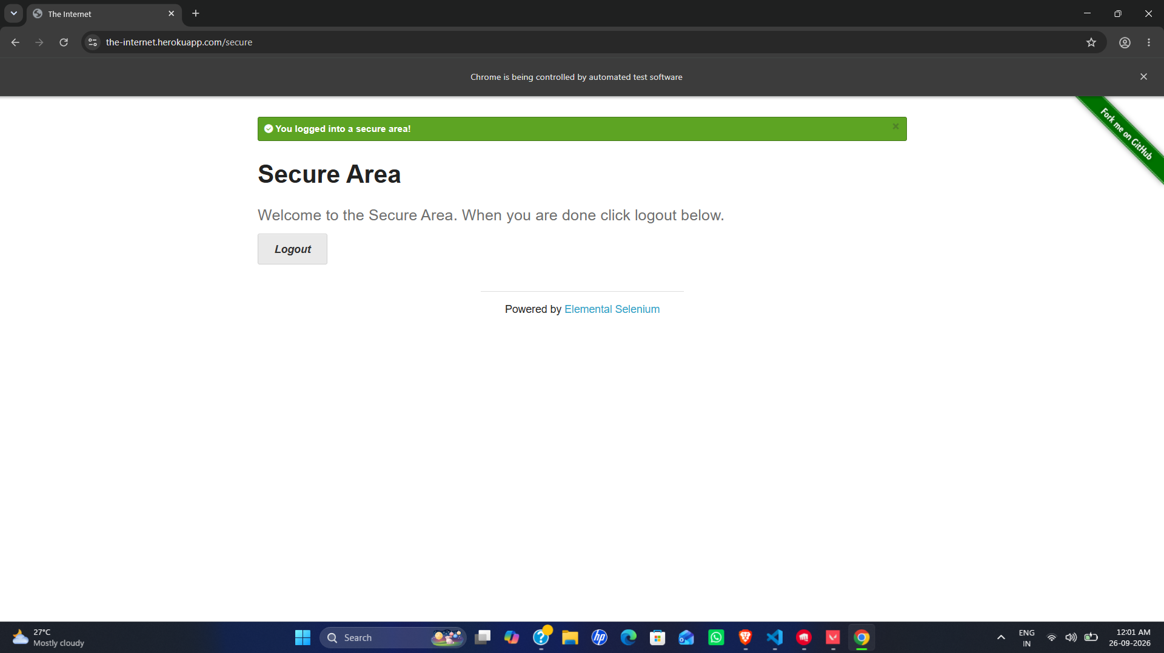

10. Result
The Selenium Page Object Model automation was implemented successfully using Python and Behave. All 5 steps passed with no failures or skipped steps, and successful navigation to the Secure Area was verified.

11. Observation
- The feature file describes behavior rather than Selenium implementation details.
- Locators and UI actions are centralized in LoginPage.
- Step definitions call page-object methods.
- Execution produced 1 passed feature, 1 passed scenario and 5 passed steps.
- The 15-second delay provides time to capture the final browser state.

12. Conclusion
The experiment demonstrates a structured and maintainable Selenium automation approach by combining Behave BDD with the Page Object Model. Separating page objects from feature steps improves organization and makes locator changes easier to manage. The login scenario executed successfully and the Secure Area navigation was verified.

14. Final Execution Summary
Feature | Login using Page Object Model
Scenario | Submit login credentials
Features Passed | 1
Scenarios / Steps Passed | 1 / 5
Failures / Skipped | 0 / 0

