LAB WORK REPORT
Assignment 1 — Selenium Python and Behave BDD
YouTube Web Page Verification
Name: Biswayan Roy En:12023052002014 Email: bisurock0101@gmail.com / biswayan.roy2023@iem.edu.in IEM,Saltlake(CSE:roll:14)
Module / Tier | Selenium Python + Behave BDD
Experiment | Implementation of Selenium Python and Behave BDD
Application Under Test | YouTube — https://www.youtube.com
Tools | Python, Selenium WebDriver, Behave, Google Chrome
Environment | Windows PowerShell / Visual Studio Code

1. Problem Statement
To implement a Behavior Driven Development (BDD) based web automation test using Python, Selenium WebDriver, and Behave. The test launches Google Chrome, opens YouTube, and verifies the page title and visible page content.

2. Objective
To understand and implement a basic BDD automation workflow using Python, Selenium, and Behave by creating a feature file, step definitions, browser automation, assertions, and scenario cleanup.
- Create a Gherkin feature using Given, When, and Then.
- Launch and control Chrome using Selenium WebDriver.
- Navigate to YouTube.
- Verify the page title contains YouTube.
- Verify the webpage contains YouTube text.
- Close the browser automatically after the scenario.

3. Tools, Software and Concepts
- Python 3.x
- Selenium WebDriver
- Behave BDD framework
- Google Chrome
- Visual Studio Code
- PowerShell
- Gherkin syntax
- BDD feature files and step definitions
- Selenium assertions

4. Theory
Behavior Driven Development (BDD) is a testing approach in which expected software behavior is described using readable scenarios. Behave is a Python BDD framework that uses Gherkin syntax. A feature file describes the behavior, while Python step definitions provide the executable implementation.
Selenium WebDriver automates a real browser. In this experiment, Selenium starts Chrome and navigates to YouTube. Assertions are then used to verify the page title and visible page text. Behave connects each Gherkin step to its corresponding Python function.
YouTube is a dynamic production website, so this basic test checks only broad text and title information rather than unstable video-specific elements.

5. Project Structure
Assignment1_Behave/
└── features/
├── browser.feature
├── environment.py
└── steps/
└── browser_steps.py

6. Installation and Setup
Open PowerShell in the Assignment1_Behave folder and install the required packages:
python -m pip install behave selenium
Verify Behave:
python -m behave --version
Using 'python -m behave' is recommended on Windows because it runs Behave through the selected Python interpreter and avoids common PATH issues.

7. Source Code — browser.feature
Feature: Verify YouTube using Selenium
Scenario: Open YouTube and verify page
Given Chrome browser is launched
When I open the YouTube website
Then the page title should contain "YouTube"
And the page should contain "YouTube"

8. Source Code — browser_steps.py
from behave import given, when, then
from selenium import webdriver
from selenium.webdriver.common.by import By
@given("Chrome browser is launched")
def launch_browser(context):
context.driver = webdriver.Chrome()
context.driver.maximize_window()
@when("I open the YouTube website")
def open_site(context):
context.driver.get("https://www.youtube.com")
@then('the page title should contain "YouTube"')
def verify_title(context):
assert "YouTube" in context.driver.title
@then('the page should contain "YouTube"')
def verify_text(context):
text = context.driver.find_element(By.TAG_NAME, "body").text
assert "YouTube" in text

9. Source Code — environment.py
def after_scenario(context, scenario):
if hasattr(context, "driver"):
context.driver.quit()

10. Execution Procedure
- Open the project in Visual Studio Code.
- Open PowerShell in the Assignment1_Behave folder.
- Confirm the features folder and files are present.
- Install Behave and Selenium.
- Run the Behave version check.
- Execute the scenario with the pretty formatter.
- Observe Chrome opening and navigating to YouTube.
- Observe the terminal execution result.
python -m behave -f pretty

11. Output Screenshots
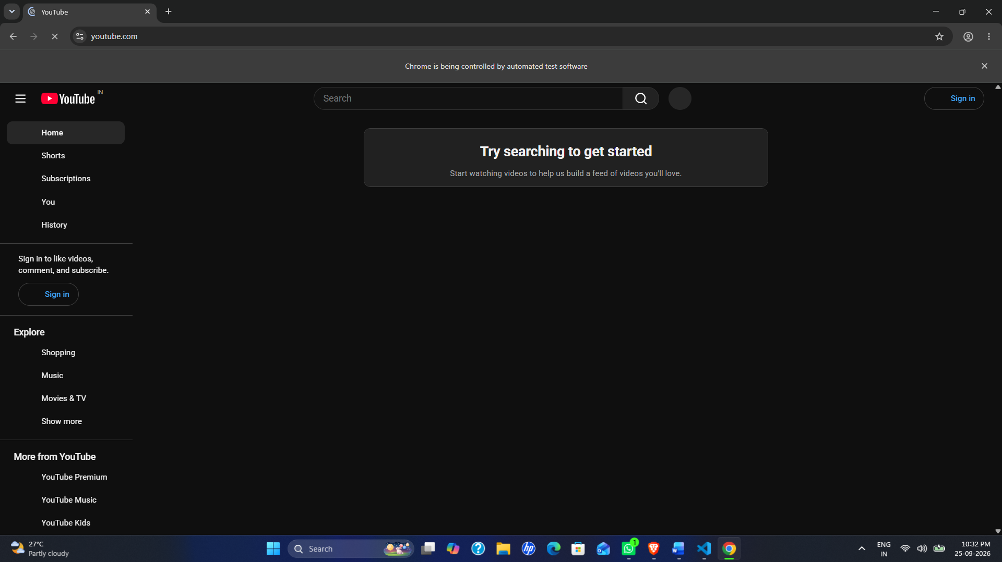
Output Screenshot 1 — YouTube opened successfully in Chrome

Output Screenshot 2 — Behave terminal showing the passed scenario
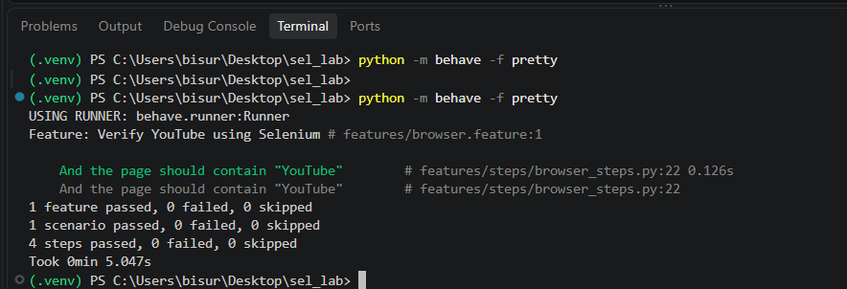

12. Expected Result
Chrome should launch and navigate to YouTube. The title assertion checks that the page title contains 'YouTube', and the body-text assertion checks that the visible page text contains 'YouTube'. The browser is then closed by the after_scenario hook.
Feature: Verify YouTube using Selenium
Scenario: Open YouTube and verify page
Given Chrome browser is launched
When I open the YouTube website
Then the page title should contain "YouTube"
And the page should contain "YouTube"
1 scenario passed
4 steps passed
The exact terminal formatting may vary according to the installed Behave version and execution environment.

13. Gherkin-to-Python Mapping
Gherkin Step | Python Function | Purpose
Given Chrome browser is launched | launch_browser() | Starts and maximizes Chrome
When I open the YouTube website | open_site() | Navigates to YouTube
Then the page title should contain "YouTube" | verify_title() | Checks page title
And the page should contain "YouTube" | verify_text() | Checks visible page text

14. Result
The Selenium Python and Behave BDD automation test was implemented. The test launches Chrome, opens YouTube, verifies the page title and page content, and closes the browser after the scenario.

15. Observation
The experiment demonstrates the separation of test specification from implementation. The Gherkin feature is readable, while the Python step definitions contain the Selenium actions and assertions. Because YouTube is dynamic, only broad title and text checks are used.

16. Conclusion
Selenium WebDriver was integrated with the Behave BDD framework using Python. The experiment provided practical understanding of feature files, Gherkin keywords, step definitions, browser automation, assertions, and scenario cleanup.

