CAPSTONE PROJECT REPORT
Capstone Assignment 2 — Selenium Python Framework Development
(Unittest + PyTest + Page Object Model)
Capstone Project: E-Commerce Web Automation Framework

Name | BISWAYAN ROY
Enrollment Number | 12023052002014
Email | bisurock0101@gmail.com / biswayan.roy2023@iem.edu.in
Phone Number | 9679489411
College Name | Institute of Engineering and Management (IEM,Saltlake)
Project / Repository | ECommerce_Capstone (P:2)

Application Under Test: AutomationExercise (https://automationexercise.com/)
Primary Technology: Python + Selenium WebDriver

1. Assignment and Project Details
Capstone Assignment Number: 2
Assignment Name: Selenium Python Framework Development (Unittest + PyTest + POM)
Scenario: Automate Login and Product Search for an e-commerce application.
Application Under Test: AutomationExercise
Project Name: ECommerce_Capstone

2. Project Overview
The project implements a reusable Selenium automation framework in Python for the AutomationExercise e-commerce website. It automates the Login and Product Search workflows and demonstrates a maintainable test architecture using Page Object Model (POM), PyTest, Python Unittest, configuration management, CSV data-driven testing, screenshots on failure, and HTML reporting.
The framework separates test logic from page interactions and reusable utilities. This makes the tests easier to read, reduces duplication, and allows future scenarios to be added without rewriting the underlying browser setup.

3. Objectives
- Automate the registered-user login workflow.
- Automate product search for multiple product names.
- Implement Page Object Model for reusable locators and actions.
- Create a reusable browser Driver Factory.
- Read application and timeout settings from configuration.
- Implement CSV-based parameterized testing.
- Capture screenshots automatically when PyTest tests fail.
- Generate self-contained HTML execution reports.
- Demonstrate both PyTest and Python Unittest.
- Keep credentials outside source code using a local .env file.

4. Technology Stack
Tool / Technology | Role
Python | Automation programming language
Selenium WebDriver | Browser and web-element automation
PyTest | Test execution, fixtures and parameterization
Unittest | Built-in Python test framework demonstration
Page Object Model | Reusable page interaction layer
pytest-html | HTML execution report
WebDriver Manager | ChromeDriver setup/management
CSV | Product search test data
ConfigParser | Read config.ini settings
python-dotenv | Load local credentials from .env
Git / GitHub | Version control and submission

5. Framework Architecture
The framework is organized into the following layers:
- pages/: Page Object classes for Login, Home and Products pages.
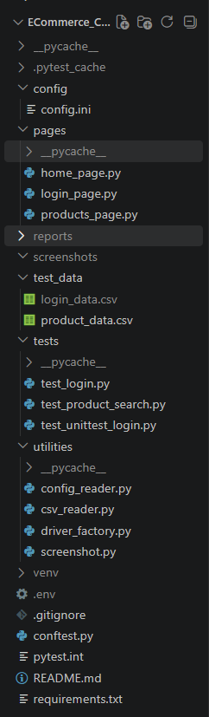
- tests/: PyTest tests and the Unittest login test.
- utilities/: Driver Factory, configuration reader, CSV reader and screenshot utility.
- config/: Application URL, browser and timeout settings.
- test_data/: CSV data used by the product-search test.
- conftest.py: PyTest fixture, failure screenshot hook and report metadata handling.
- reports/: Runtime HTML report output.
- screenshots/: Runtime failure screenshots.
- .env: Local login credentials; excluded from Git.
- README.md and Project Report: Project documentation.

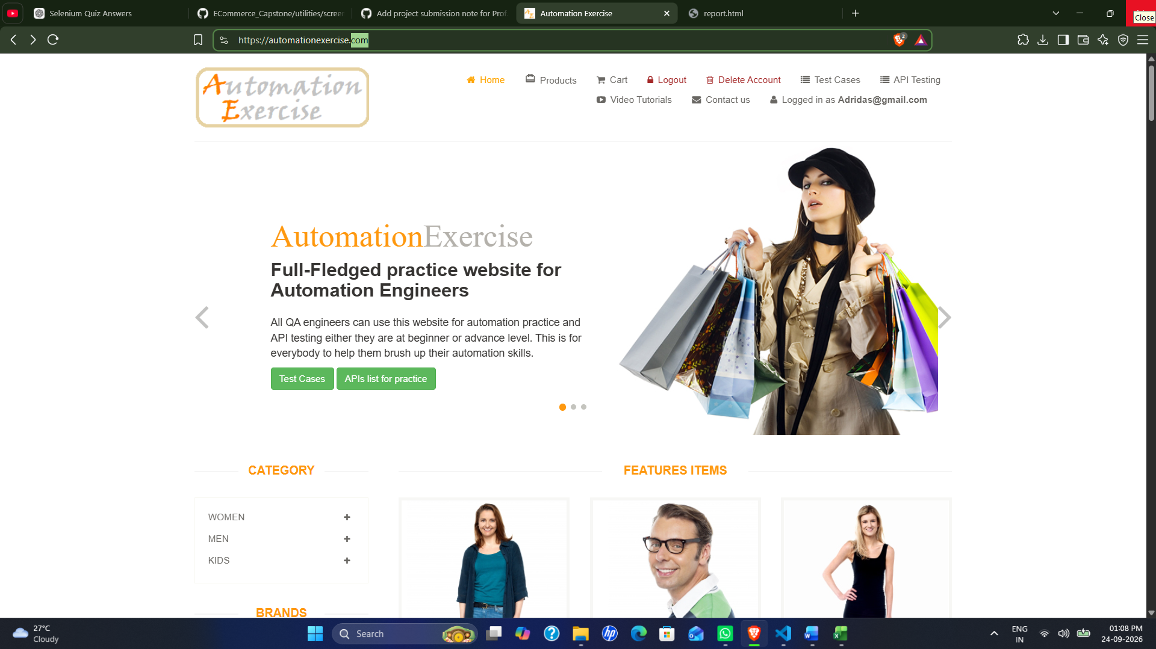

6. Page Object Model (POM)
Page Object Model is the main design pattern used in the project. Each important page is represented by a Python class containing its locators and actions. Test files call these actions instead of repeatedly writing Selenium locator code.
- LoginPage: Signup/Login navigation, email entry, password entry and login action.
- HomePage: Navigation from the home page to Products.
- ProductsPage: Product search and verification of the searched-products heading.

Important Code — Login Page
self.email_field = (
By.CSS_SELECTOR,
"input[data-qa='login-email']"
)
self.password_field = (
By.CSS_SELECTOR,
"input[data-qa='login-password']"
)
The locators are stored as class attributes, so test cases do not need to know the actual CSS selectors. If the application's locator changes, the page object can be updated in one place.
def login(self, email, password):
self.enter_email(email)
self.enter_password(password)
self.click_login()
The login() method combines the smaller page actions into one reusable business-level operation.

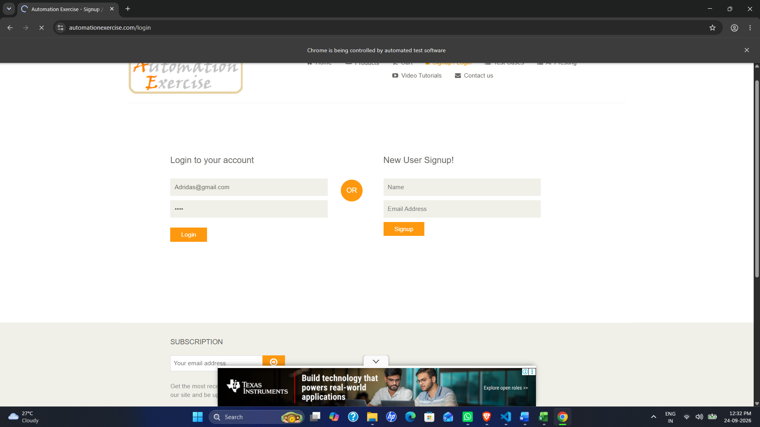

7. Driver Factory and Configuration Management
DriverFactory centralizes browser creation. ConfigReader reads values from config.ini, preventing browser and URL settings from being hard-coded throughout the tests.
class DriverFactory:
@staticmethod
def create_driver(browser="chrome"):
if browser.lower() == "chrome":
options = webdriver.ChromeOptions()
options.add_argument("--disable-notifications")
service = Service(
ChromeDriverManager().install()
)
driver = webdriver.Chrome(
service=service,
options=options
)
driver.maximize_window()
return driver
This design provides a single place to configure WebDriver options. A new browser can later be added as another branch without changing every test.
[environment]
url = https://automationexercise.com/
browser = chrome
[timeouts]
implicit_wait = 5
explicit_wait = 10
The configuration file stores environment-specific values. This keeps test code cleaner and makes basic framework configuration easier to modify.

8. PyTest Fixture and Test Lifecycle
The driver fixture creates the browser, applies the configured wait, opens the application, returns the driver to the test, captures a screenshot after a failed test, and finally closes the browser.
@pytest.fixture
def driver(request):
config = ConfigReader()
driver = DriverFactory.create_driver(
config.get_browser()
)
driver.implicitly_wait(
config.get_implicit_wait()
)
driver.get(config.get_url())
yield driver
if request.node.rep_call.failed:
Screenshot.take_screenshot(
driver,
request.node.name
)
driver.quit()
The yield statement separates setup from teardown. After the test completes, the fixture checks the test result and then closes the browser.

9. CSV Data-Driven Testing
Product names are stored externally in product_data.csv. CSVReader uses csv.DictReader to convert each row into a dictionary. PyTest parameterization then runs the same test against each product value.
product
Blue Top
Men Tshirt
Sleeveless Dress
@pytest.mark.parametrize("data", test_data)
def test_product_search(driver, data):
home_page = HomePage(driver)
products_page = ProductsPage(driver)
home_page.click_products()
products_page.search_product(data["product"])
result_title = (
products_page.get_search_results_title()
)
assert "searched products" in result_title.lower()
This avoids duplicating the same test three times and makes it easy to add more products by adding rows to the CSV.

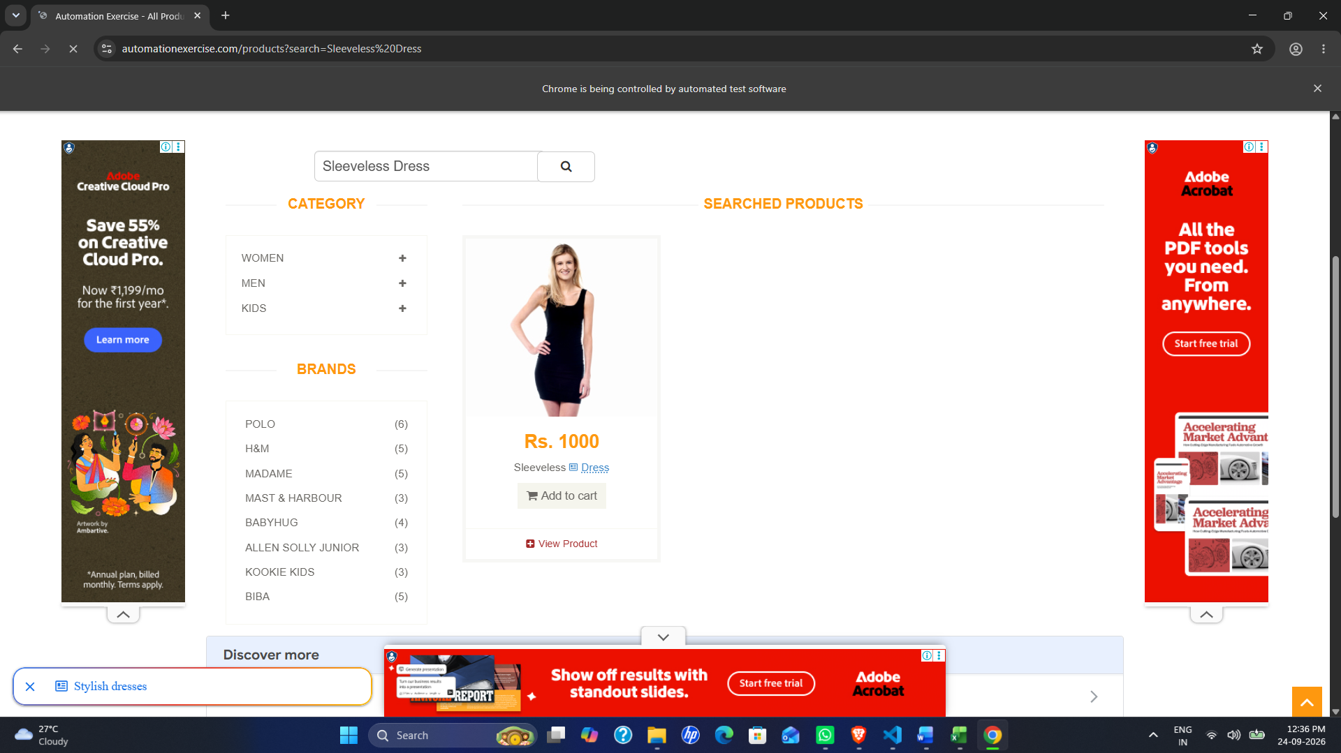

10. Credential Management
Real test credentials are not kept directly in the test files. They are stored locally in .env and loaded through python-dotenv. The file is excluded using .gitignore so credentials are not exposed in the GitHub repository.
LOGIN_EMAIL=your_test_email
LOGIN_PASSWORD=your_test_password
def get_login_email(self):
return os.getenv("LOGIN_EMAIL")
def get_login_password(self):
return os.getenv("LOGIN_PASSWORD")
The login test retrieves these values through ConfigReader and passes them to LoginPage.login().

11. Waits and Robust Web Interaction
The framework uses Selenium explicit waits for important page elements and URL conditions. For the AutomationExercise site, ad overlays can sometimes interfere with normal clicks. The HomePage and ProductsPage therefore use scrolling and JavaScript-assisted clicks where required, followed by URL or element verification.
WebDriverWait(self.driver, 15).until(
EC.url_contains("/products")
)
Waiting for a meaningful page condition is more reliable than assuming that a page is ready after a fixed sleep.

12. Screenshot on Failure
The Screenshot utility creates a screenshots directory if necessary and saves a timestamped PNG using WebDriver.save_screenshot(). The PyTest fixture calls it only when the test result is failed.
driver.save_screenshot(file_path)
print(
f"Screenshot saved: {file_path}"
)

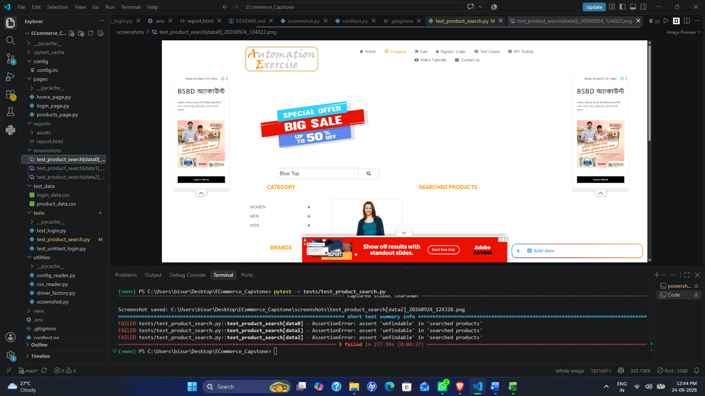

13. HTML Reporting
pytest-html generates an HTML report containing the test session, environment details, duration and test results. The report is regenerated whenever the report command is executed.
pytest -v --html=reports/report.html --self-contained-html
The report is a runtime artifact: running the command again updates or recreates the specified report file with the latest execution results. It is not generated automatically simply by editing the code; it is produced when PyTest is executed with the --html option.

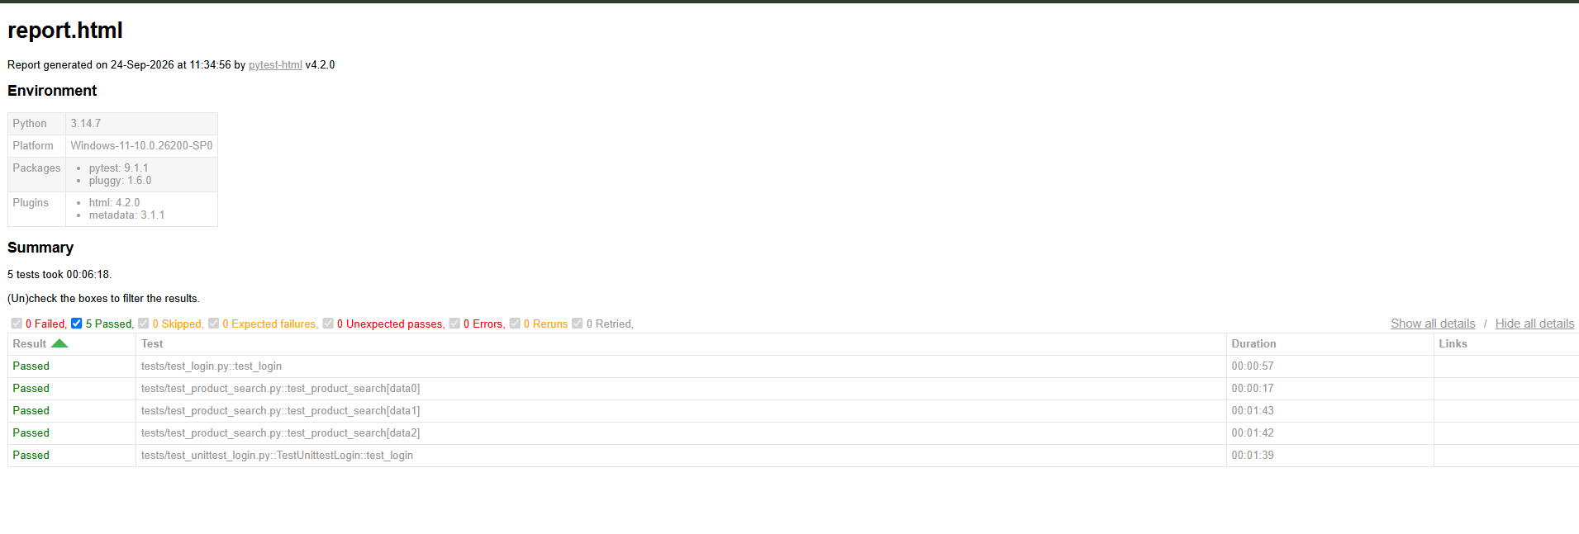

14. Unittest Integration
The project includes a separate Unittest test case to satisfy the requirement for both PyTest and Unittest. It uses unittest.TestCase, setUp(), test_login(), and tearDown(), while reusing the existing LoginPage and ConfigReader classes.
class TestUnittestLogin(unittest.TestCase):
def setUp(self):
# create browser and open application
def test_login(self):
# use LoginPage to perform login
# verify "Logged in as"
def tearDown(self):
self.driver.quit()
Execution command:
python -m unittest tests.test_unittest_login -v
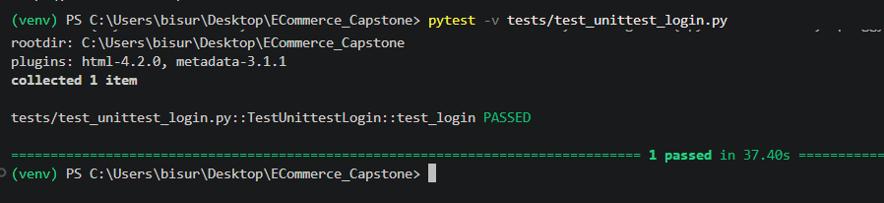

15. Test Scenarios and Verification

15.1 Login
- Open the application.
- Click Signup / Login.
- Load email and password from .env.
- Enter credentials and click Login.
- Verify the successful-login text.

15.2 Product Search
- Open the application.
- Navigate to Products.
- Read a product from CSV.
- Search for the product.
- Verify the searched-products heading.

16. Execution Results
The implemented framework was tested during development. The login workflow was verified successfully through PyTest and Unittest. Product search was executed with multiple CSV records. Screenshot-on-failure functionality and HTML reporting were also verified.
For the submitted report, the final exact pass count, execution duration, and environment values should be taken from the latest clean HTML report generated immediately before submission.

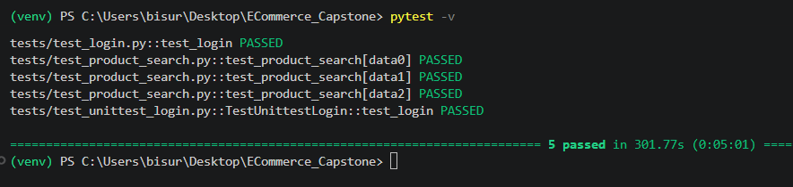

[

17. Installation and Execution
- Create and activate a Python virtual environment.
- Install dependencies using pip install -r requirements.txt.
- Create a local .env containing LOGIN_EMAIL and LOGIN_PASSWORD.
- Keep .env excluded from Git.
- Run pytest -v for the PyTest suite.
- Run python -m unittest tests.test_unittest_login -v for the Unittest test.
- Generate the HTML report with pytest -v --html=reports/report.html --self-contained-html.

18. GitHub Submission Structure
The assignment instructions require the source code, project report, README and related submission material under a folder named capstone. If the repository has already been created, the existing repository can be reorganized so the project contents are placed under capstone; a second repository is not required.
Repository/
└── capstone/
├── config/
├── pages/
├── tests/
├── test_data/
├── utilities/
├── conftest.py
├── pytest.ini
├── requirements.txt
├── README.md
└── Project_Report.docx
The .env file and virtual environment should not be uploaded. Generated reports and screenshots can remain local unless the assignment explicitly requires them in the repository.

19. Security and Good Practices
- Credentials are kept outside the source code.
- .env is ignored by Git.
- Reusable locators and actions are centralized in Page Objects.
- Configuration is separated from test logic.
- Test data is externalized into CSV.
- Failure evidence is captured automatically.
- Dependencies are listed in requirements.txt.
- README and report document installation and execution.

20. Conclusion
The capstone successfully demonstrates a structured Selenium Python automation framework for an e-commerce application. The combination of Page Object Model, Driver Factory, configuration management, data-driven PyTest execution, Unittest integration, screenshots on failure and HTML reporting provides a practical foundation for maintainable web automation. The project is organized for GitHub submission and can be extended with additional pages, test scenarios, browsers and test data.

21. Submission Checklist
- Source code
- README.md
- Project report
- requirements.txt
- Configuration and CSV test data
- PyTest and Unittest tests
- No credentials or .env file in GitHub

