Gene Expression Analysis in Cancer using RNA-Seq

Pranava Upparlapalli

2025-06-06

Table of Contents

## 🔬 Project Overview

This project explores gene expression variation across five cancer types (BRCA, KIRC, LUAD, COAD, PRAD) using RNA-Seq count data. Differential expression was assessed using DESeq2, followed by PCA, clustering, and visualization to identify cancer-specific gene signatures.

### STEP - 1: Loading Libraries

library(tidyverse)  
library(tidyr)  
library(DESeq2)  
library(ggplot2)  
library(VennDiagram)  
library(UpSetR)  
library(RColorBrewer)  
library(pheatmap)  
library(reshape2)  
library(pROC)  
library(caret)  
library(parallel)  
library(mltools)  
library(MASS)  
library(ggfortify)  
library(stats)  
library(data.table)

### STEP - 2: Loading Data + Normalization:

# Set the paths for data and labels  
data_path <- "data/data.csv"  
labels_path <- "data/labels.csv"  
  
data <- read.csv(data_path, header = TRUE)  
labels <- read.csv(labels_path, header = TRUE)  
  
merged_data <- merge(data, labels, by = "X", all.x = TRUE)  
merged_data <- na.omit(merged_data)  
merged_data$Class <- as.factor(merged_data$Class)  
gc()

used (Mb) gc trigger (Mb) max used (Mb)  
 Ncells 6868332 366.9 16011544 855.2 11791454 629.8  
 Vcells 45934884 350.5 75869196 578.9 75868631 578.9

### STEP -3: Data division visualisation:

# Count samples for each cancer type  
class_data <- as.data.frame(table(merged_data$Class))  
colnames(class_data) <- c("Cancer_Type", "Count")  
class_data$Count <- sort(class_data$Count, decreasing = TRUE)  
  
# Create bar plot  
data_division <- ggplot(class_data, aes(x = Cancer_Type, y = Count, fill = Cancer_Type)) +  
 geom_bar(stat = "identity") +  
 theme_gray() +  
 labs(title = "Distribution of Samples Across Cancer Types",  
 x = "Cancer Type",  
 y = "Number of Samples")  
print(data_division)

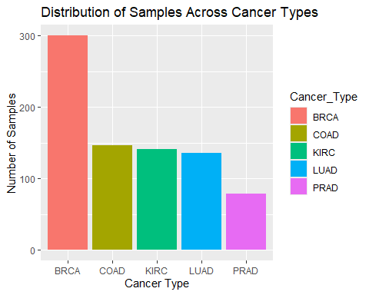

ggsave("plots/sample_distribution.png", plot = data_division, width = 8, height = 5)  
gc()

used (Mb) gc trigger (Mb) max used (Mb)  
 Ncells 7044196 376.3 16011544 855.2 11791454 629.8  
 Vcells 46278554 353.1 75869196 578.9 75868631 578.9

### STEP - 4: DESeq2 Analysis

# 1. Prepare data  
# This intermediate variable holds the numeric data with samples as rows  
gene_data <- merged_data[, !names(merged_data) %in% c("X", "Class")]  
rownames(gene_data) <- merged_data$X  
  
# Transpose to get the final matrix: genes as rows, samples as columns  
gene_expr_matrix <- t(gene_data)  
gene_expr_matrix <- round(gene_expr_matrix) # Ensure integer counts  
  
# Prepare sample information  
sample_info <- data.frame(Class = merged_data$Class)  
rownames(sample_info) <- merged_data$X  
  
# 2. Create DESeq2 object  
# Check for matching sample names  
stopifnot(all(colnames(gene_expr_matrix) == rownames(sample_info)))  
dds <- DESeqDataSetFromMatrix(countData = gene_expr_matrix,  
 colData = sample_info,  
 design = ~ Class)

converting counts to integer mode

# 3. Run analysis  
dds <- DESeq(dds)

estimating size factors

estimating dispersions

gene-wise dispersion estimates

mean-dispersion relationship

-- note: fitType='parametric', but the dispersion trend was not well captured by the  
 function: y = a/x + b, and a local regression fit was automatically substituted.  
 specify fitType='local' or 'mean' to avoid this message next time.

final dispersion estimates

fitting model and testing

res <- results(dds) # Get full results for plotting  
  
# 4. Get significant genes  
res_sig <- subset(res, padj < 0.05 & !is.na(padj)) # Filter for significance  
print(summary(res_sig))

out of 7639 with nonzero total read count  
 adjusted p-value < 0.1  
 LFC > 0 (up) : 3920, 51%  
 LFC < 0 (down) : 3719, 49%  
 outliers [1] : 0, 0%  
 low counts [2] : 0, 0%  
 (mean count < 0)  
 [1] see 'cooksCutoff' argument of ?results  
 [2] see 'independentFiltering' argument of ?results  
   
 NULL

sig_gene_names <- rownames(res_sig)  
  
# Extract normalized counts for visualization  
sig_genes_data <- as.data.frame(counts(dds, normalized = TRUE)[sig_gene_names, ])  
sig_genes_data$Gene <- rownames(sig_genes_data)

# --- MORE ROBUST Cleaning, Clustering, and Reshaping ---  
  
# 1. Create a clean numeric matrix from sig_genes_data  
gene_names <- sig_genes_data$Gene  
numeric_data <- sig_genes_data[, -which(names(sig_genes_data) == "Gene")]  
rownames(numeric_data) <- gene_names  
  
# 2. Find which genes (rows) are valid for analysis  
is_row_valid <- apply(numeric_data, 1, function(row) {  
 all(is.finite(row)) && var(row, na.rm = TRUE) > 0  
})  
  
# 3. Create the final, clean data matrix  
gene_matrix_for_clustering <- numeric_data[is_row_valid, , drop = FALSE] # drop=FALSE is safer  
  
# 4. === ADDED SAFETY CHECK ===  
# Check if we have enough genes to perform clustering  
if (nrow(gene_matrix_for_clustering) >= 2) {  
  
 # Perform clustering on the GENES  
 gene_hclust <- hclust(dist(gene_matrix_for_clustering))  
 ordered_gene_names <- rownames(gene_matrix_for_clustering)[gene_hclust$order]  
  
 # Filter the original data frame to keep only the clean genes  
 sig_genes_data_clean <- sig_genes_data[is_row_valid, ]  
  
 # Reshape the CLEAN data into a long format for plotting  
 sig_genes_data_long <- pivot_longer(  
 sig_genes_data_clean,  
 cols = -Gene,  
 names_to = "Sample",  
 values_to = "Expression"  
 )  
  
 # Set the Gene factor levels based on the clustering order  
 sig_genes_data_long$Gene <- factor(sig_genes_data_long$Gene,  
 levels = ordered_gene_names)  
   
 print(paste("Successfully clustered", length(ordered_gene_names), "genes."))  
  
} else {  
   
 print("Skipping clustering: Fewer than 2 genes remained after filtering.")  
 # Create an empty data frame so the script doesn't fail later  
 sig_genes_data_long <- data.frame()   
   
}

## [1] "Successfully clustered 7639 genes."

gc()

## used (Mb) gc trigger (Mb) max used (Mb)  
## Ncells 7144506 381.6 16011544 855.2 16011544 855.2  
## Vcells 163354885 1246.3 397073465 3029.5 397073446 3029.5

### STEP - 5: DDSEQ2 - Visualisation:

# Create a volcano plot  
volcano_plot <- ggplot(res, aes(x = log2FoldChange, y = -log10(padj))) +  
 geom_point(aes(color = ifelse(padj < 0.05, "Significant", "Not Significant")), alpha = 0.6) +  
 scale_color_manual(values = c("lightcoral", "gray"), guide = FALSE) + # Remove color legend  
 geom_vline(xintercept = c(-1, 1), linetype = "dashed", color = "blue") +  
 geom_hline(yintercept = -log10(0.05), linetype = "dashed", color = "blue") + # Added significance line  
 labs(title = "Volcano Plot of Differentially Expressed Genes",  
 x = "Log2 Fold Change",  
 y = "-log10(Adjusted p-value)") +  
 theme_gray()  
  
print(volcano_plot)

Warning: The `guide` argument in `scale_*()` cannot be `FALSE`. This was deprecated in  
 ggplot2 3.3.4.  
 ℹ Please use "none" instead.  
 This warning is displayed once every 8 hours.  
 Call `lifecycle::last_lifecycle_warnings()` to see where this warning was  
 generated.

Warning: Removed 1461 rows containing missing values or values outside the scale range  
 (`geom_point()`).

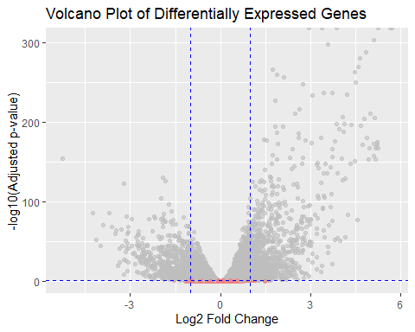

ggsave("plots/volcano_plot.png", plot = volcano_plot, width = 8, height = 6)

Warning: Removed 1461 rows containing missing values or values outside the scale range  
 (`geom_point()`).

# Create an MA plot  
ma_plot <- ggplot(res, aes(x = baseMean, y = log2FoldChange)) +  
 geom_point(aes(color = ifelse(padj < 0.05, "Significant", "Not Significant")), alpha = 0.6) +  
 scale_color_manual(values = c("lightcoral", "darkgray"), guide = FALSE) + # Remove color legend  
 geom_hline(yintercept = 0, linetype = "dashed", color = "blue") +  
 labs(title = "MA Plot of Differentially Expressed Genes",  
 x = "Average Expression (baseMean)",  
 y = "Log2 Fold Change") +  
 theme_gray()  
  
print(ma_plot)

Warning: Removed 284 rows containing missing values or values outside the scale range  
 (`geom_point()`).

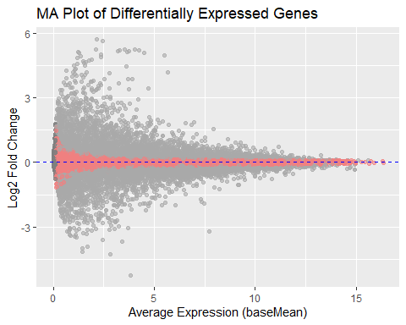

ggsave("plots/ma_plot.png", plot = ma_plot, width = 8, height = 6)

Warning: Removed 284 rows containing missing values or values outside the scale range  
 (`geom_point()`).

### STEP - 6: PCA

# Load libraries if they aren't already  
library(matrixStats)  
library(cluster)

Warning: package 'cluster' was built under R version 4.3.3

library(factoextra)

Warning: package 'factoextra' was built under R version 4.3.3

Welcome! Want to learn more? See two factoextra-related books at https://goo.gl/ve3WBa

# --- PCA Step ---  
# Use variance-stabilized data for best results  
vst_data <- varianceStabilizingTransformation(dds, blind = FALSE)  
vst_assay <- assay(vst_data)  
  
# Filter out genes with zero variance to prevent errors  
vst_assay_filtered <- vst_assay[rowVars(vst_assay) > 0, ]  
  
# Run PCA on the samples  
pca_results <- prcomp(t(vst_assay_filtered), center = TRUE, scale. = TRUE)  
  
# Extract the PC scores for plotting  
pca_scores <- as.data.frame(pca_results$x)  
pca_scores$Class <- colData(dds)$Class  
  
# Print PCA plot (colored by true cancer type)  
pca_plot <- ggplot(pca_scores, aes(x = PC1, y = PC2, color = Class)) +  
 geom_point(size = 1.5) +  
 labs(title = "PCA of Cancer Samples", x = "PC1", y = "PC2") +  
 theme_bw()  
print(pca_plot)

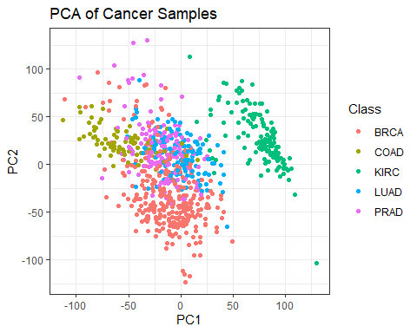 ### Step - 7: K- clustering

# --- K-means Clustering Step ---  
# Perform K-means on the correct PCA scores  
kmeans_result <- kmeans(pca_scores[, c("PC1", "PC2")], centers = 5, nstart = 25)  
pca_scores$K_Cluster <- factor(kmeans_result$cluster)  
  
# Print K-means plot (colored by algorithm-found clusters)  
cluster_plot <- ggplot(pca_scores, aes(x = PC1, y = PC2, color = K_Cluster)) +  
 geom_point(size = 1.5) +  
 labs(title = "K-means Clustering of Cancer Samples", x = "PC1", y = "PC2", color = "Cluster") +  
 theme_bw()  
print(cluster_plot)

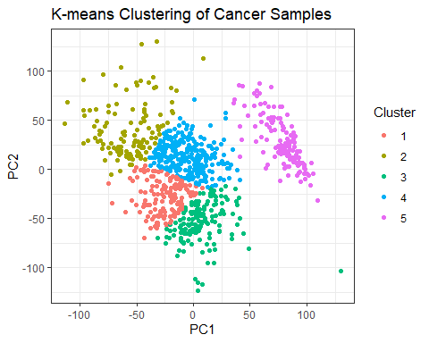

# Assess cluster validity  
silhouette_analysis <- silhouette(kmeans_result$cluster, dist(pca_scores[, c("PC1", "PC2")]))  
print(summary(silhouette_analysis))

## Silhouette of 801 units in 5 clusters from silhouette.default(x = kmeans_result$cluster, dist = dist(pca_scores[, c("PC1", "PC2")])) :  
## Cluster sizes and average silhouette widths:  
## 142 120 149 253 137   
## 0.3192533 0.3221859 0.3396739 0.3692233 0.6006290   
## Individual silhouette widths:  
## Min. 1st Qu. Median Mean 3rd Qu. Max.   
## -0.09723 0.25979 0.40966 0.38740 0.51866 0.72605

# Check the new cluster centroids  
print(kmeans_result$centers)

## PC1 PC2  
## 1 -25.613343 -27.64696  
## 2 -56.601718 41.47128  
## 3 7.334241 -54.63707  
## 4 -5.426191 13.29876  
## 5 78.170256 27.19454

# Create and plot the silhouette using factoextra  
library(factoextra)  
sil_plot <- fviz_silhouette(silhouette_analysis) +  
 theme_minimal() +  
 labs(title = "Silhouette Plot for K-means Clustering")

## cluster size ave.sil.width  
## 1 1 142 0.32  
## 2 2 120 0.32  
## 3 3 149 0.34  
## 4 4 253 0.37  
## 5 5 137 0.60

print(sil_plot)

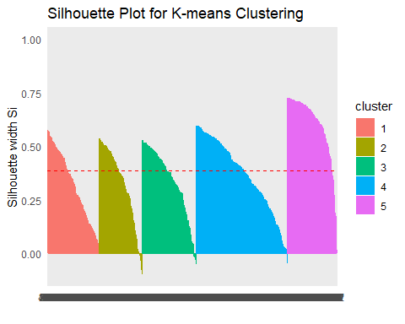

ggsave("plots/silhouette_plot.png", plot = sil_plot, width = 8, height = 6)

### Corrected Gene Expression Heatmap ###  
  
# Ensure these libraries are loaded  
library(pheatmap)  
library(matrixStats)  
  
# 1. Use variance-stabilized data from the previous steps  
vst_data <- varianceStabilizingTransformation(dds, blind = FALSE)  
  
# 2. Find the top 50 most variable genes to visualize  
top_var_genes <- head(order(rowVars(assay(vst_data)), decreasing = TRUE), 50)  
heatmap_matrix <- assay(vst_data)[top_var_genes, ]  
  
# 3. Create an annotation bar for the sample cancer types  
annotation_col <- data.frame(  
 CancerType = colData(dds)$Class  
)  
rownames(annotation_col) <- colnames(heatmap_matrix)  
  
# 4. Generate the heatmap and save it to a file  
# 'scale = "row"' is crucial for visualizing relative gene expression  
pheatmap(heatmap_matrix,  
 scale = "row",  
 annotation_col = annotation_col,  
 show_rownames = FALSE,  
 show_colnames = FALSE,  
 main = "Heatmap of Top 50 Variable Genes",  
 filename = "plots/heatmap_expression.png",  
 width = 8,  
 height = 6)

## ✅ Conclusion

This project demonstrates the ability of RNA-Seq analysis to uncover meaningful differences in gene expression across multiple cancer types. Techniques like DESeq2, PCA, and unsupervised clustering provided statistically and biologically relevant insights into transcriptomic profiles.

## 🔁 Session Info

sessionInfo()

## R version 4.3.2 (2023-10-31 ucrt)  
## Platform: x86_64-w64-mingw32/x64 (64-bit)  
## Running under: Windows 11 x64 (build 22631)  
##   
## Matrix products: default  
##   
##   
## locale:  
## [1] LC_COLLATE=English_India.utf8 LC_CTYPE=English_India.utf8   
## [3] LC_MONETARY=English_India.utf8 LC_NUMERIC=C   
## [5] LC_TIME=English_India.utf8   
##   
## time zone: America/Chicago  
## tzcode source: internal  
##   
## attached base packages:  
## [1] parallel grid stats4 stats graphics grDevices utils   
## [8] datasets methods base   
##   
## other attached packages:  
## [1] factoextra_1.0.7 cluster_2.1.8   
## [3] data.table_1.16.4 ggfortify_0.4.17   
## [5] MASS_7.3-60.0.1 mltools_0.3.5   
## [7] caret_7.0-1 lattice_0.22-6   
## [9] pROC_1.18.5 reshape2_1.4.4   
## [11] pheatmap_1.0.12 RColorBrewer_1.1-3   
## [13] UpSetR_1.4.0 VennDiagram_1.7.3   
## [15] futile.logger_1.4.3 DESeq2_1.42.1   
## [17] SummarizedExperiment_1.32.0 Biobase_2.62.0   
## [19] MatrixGenerics_1.14.0 matrixStats_1.4.1   
## [21] GenomicRanges_1.54.1 GenomeInfoDb_1.38.8   
## [23] IRanges_2.36.0 S4Vectors_0.40.2   
## [25] BiocGenerics_0.48.1 lubridate_1.9.4   
## [27] forcats_1.0.0 stringr_1.5.1   
## [29] dplyr_1.1.4 purrr_1.0.2   
## [31] readr_2.1.5 tidyr_1.3.1   
## [33] tibble_3.2.1 ggplot2_3.5.1   
## [35] tidyverse_2.0.0   
##   
## loaded via a namespace (and not attached):  
## [1] bitops_1.0-9 gridExtra_2.3 formatR_1.14   
## [4] rlang_1.1.4 magrittr_2.0.3 compiler_4.3.2   
## [7] systemfonts_1.1.0 vctrs_0.6.5 pkgconfig_2.0.3   
## [10] crayon_1.5.3 fastmap_1.2.0 backports_1.5.0   
## [13] XVector_0.42.0 labeling_0.4.3 utf8_1.2.4   
## [16] rmarkdown_2.29 prodlim_2024.06.25 tzdb_0.4.0   
## [19] ragg_1.3.3 xfun_0.49 zlibbioc_1.48.2   
## [22] recipes_1.1.0 DelayedArray_0.28.0 BiocParallel_1.36.0   
## [25] broom_1.0.7 R6_2.5.1 stringi_1.8.4   
## [28] car_3.1-3 parallelly_1.40.1 rpart_4.1.23   
## [31] Rcpp_1.0.13-1 iterators_1.0.14 knitr_1.49   
## [34] future.apply_1.11.3 Matrix_1.6-5 splines_4.3.2   
## [37] nnet_7.3-19 timechange_0.3.0 tidyselect_1.2.1   
## [40] rstudioapi_0.17.1 abind_1.4-8 yaml_2.3.10   
## [43] timeDate_4041.110 codetools_0.2-19 listenv_0.9.1   
## [46] plyr_1.8.9 withr_3.0.2 evaluate_1.0.1   
## [49] future_1.34.0 lambda.r_1.2.4 survival_3.7-0   
## [52] ggpubr_0.6.0 pillar_1.9.0 carData_3.0-5   
## [55] foreach_1.5.2 generics_0.1.3 RCurl_1.98-1.16   
## [58] hms_1.1.3 munsell_0.5.1 scales_1.3.0   
## [61] globals_0.16.3 class_7.3-22 glue_1.8.0   
## [64] tools_4.3.2 ggsignif_0.6.4 ModelMetrics_1.2.2.2   
## [67] gower_1.0.1 locfit_1.5-9.10 ipred_0.9-15   
## [70] colorspace_2.1-1 nlme_3.1-166 GenomeInfoDbData_1.2.11  
## [73] Formula_1.2-5 cli_3.6.3 textshaping_0.4.1   
## [76] futile.options_1.0.1 fansi_1.0.6 S4Arrays_1.2.1   
## [79] lava_1.8.0 gtable_0.3.6 rstatix_0.7.2   
## [82] digest_0.6.37 ggrepel_0.9.6 SparseArray_1.2.4   
## [85] farver_2.1.2 htmltools_0.5.8.1 lifecycle_1.0.4   
## [88] hardhat_1.4.0