PostgreSQL is an advanced, enterprise-class, and open-source relational database system.
PostgreSQL supports both SQL (relational) and JSON (non-relational) querying.

\l - List available databases

postgres=# \l
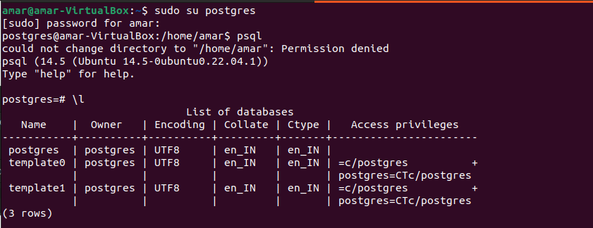
Create a User

postgres=# create user amarnath with password '1234';
CREATE ROLE

Create a database with Owner

postgres=# create database mydb with owner amarnath;
CREATE DATABASE
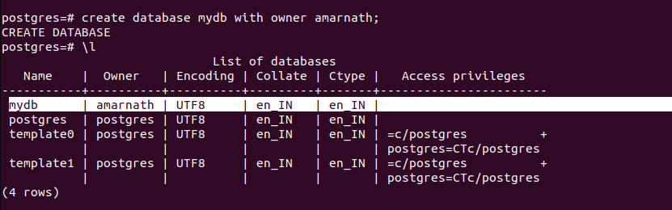

or

Create a database

postgres=# create database test;
CREATE DATABASE
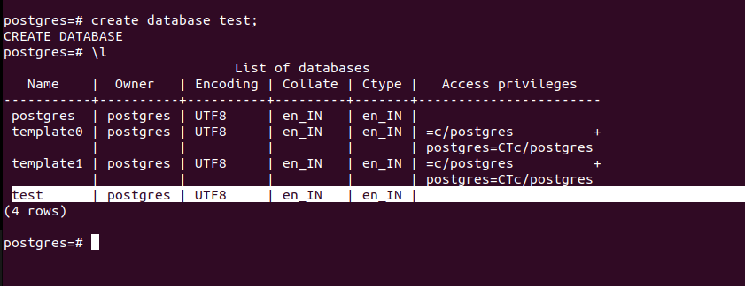

Drop a database

postgres=# drop database test;
DROP DATABASE
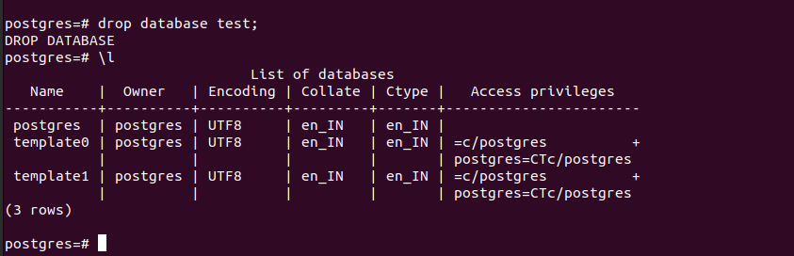

Connect to database

postgres=# \c mydb
You are now connected to database "mydb" as user "postgres”.

Create Table

mydb=# create table Employee(name varchar(20),id int,primary key(id));
CREATE TABLE

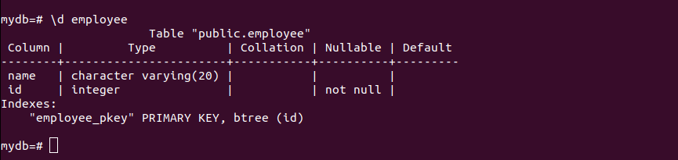
\d table_name:- Describe a table such as a column, type, modifiers of columns, etc.

Insert Query

mydb=# insert into employee(id,name)values(1011,'Abhishek Ray');
INSERT 0 1
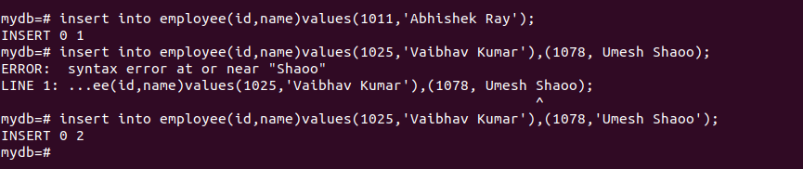

Select Query

mydb=# select * from employee;
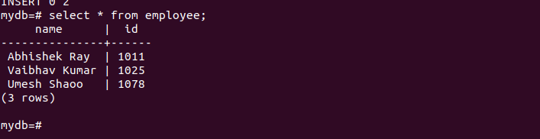

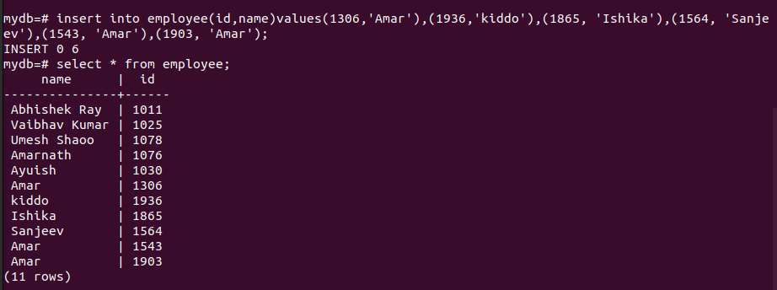

Distinct Query

mydb=# select distinct name from employee;
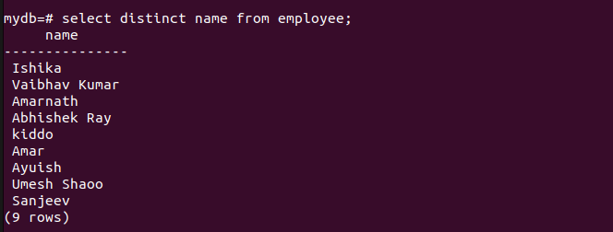

Where Query
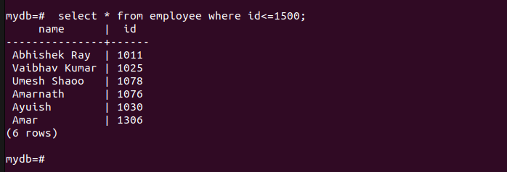
AND Condition
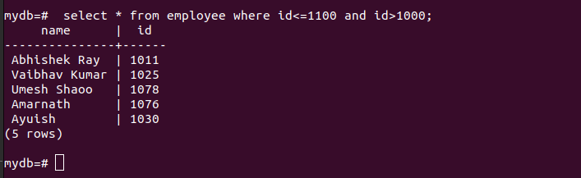

OR Condition
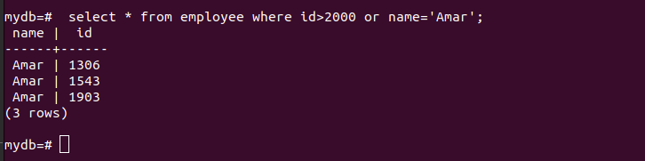

Limit Clause
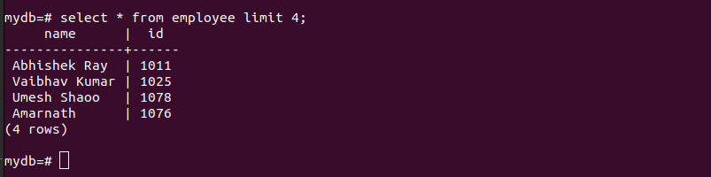

Update
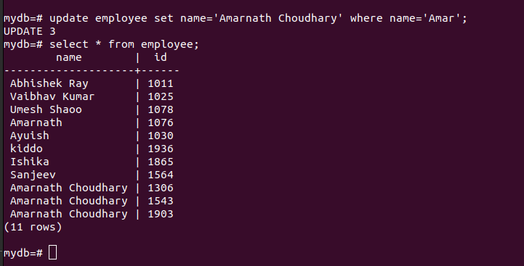
Order By
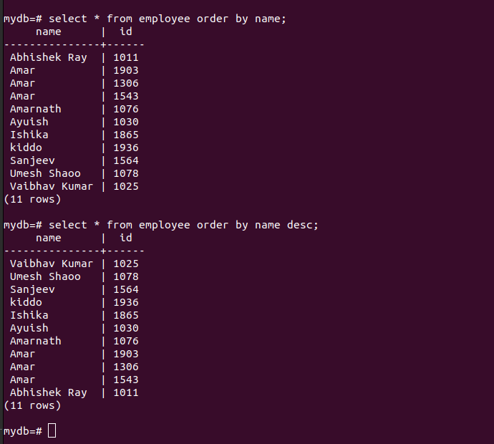
DELETE
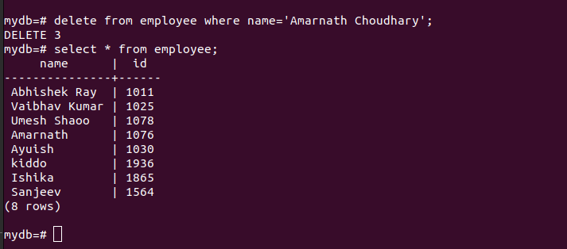

ALTER
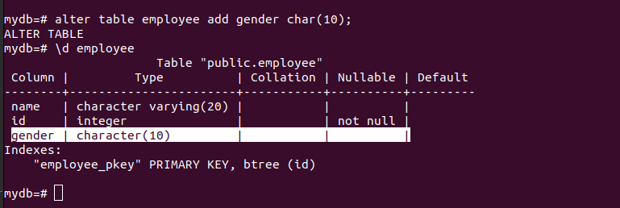

Between Clause
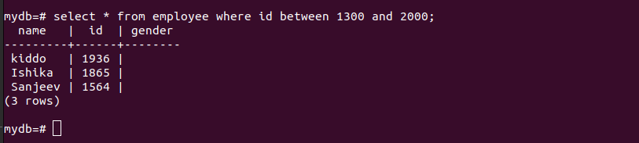

Alias
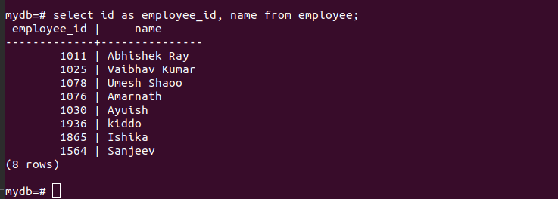

In Condition
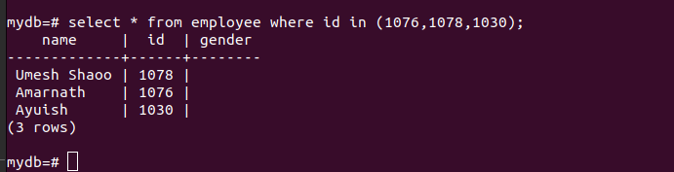

Like Clause
