**Date Submitted: 12/4/2018**

**Assignment Youtube Playlist:** **https://www.youtube.com/playlist?list=PL4oTyvRrubXf1H_VwPL4NZzvR65MmgVTA**

# Task 01: SmartRF Studio ↔ SmartRF Studio

For Task 1 we use SmartRF Studio to send packets between our two devices. CCS is not used for this task, nor is code directly modified. We use the default 50 kbps mode and observe the packets being sent from one device to the other.

**-----------------------------------------------------------------------------------**

# Task 02: Importing and running the rfPacketTx example

**Youtube Link:** **https://youtu.be/-Gg0MAuLf8k**

In this task we import a transmission program into Code Composer Studio. The code is compiled and loaded, which allows our device to begin transmission. As no code was modified, it can be found in the GitHub directory.

**-----------------------------------------------------------------------------------**

# Task 03: Exporting and using RF configuration

**Youtube Link:** **https://youtu.be/jT_RfHTWZu0**

For Task 3 we use SmartRF Studio to modify our settings to 100kBaud with a 50kHz deviation with 196kHz bandwidth. We then export our code and copy it into our CCS project and begin transmitting data.

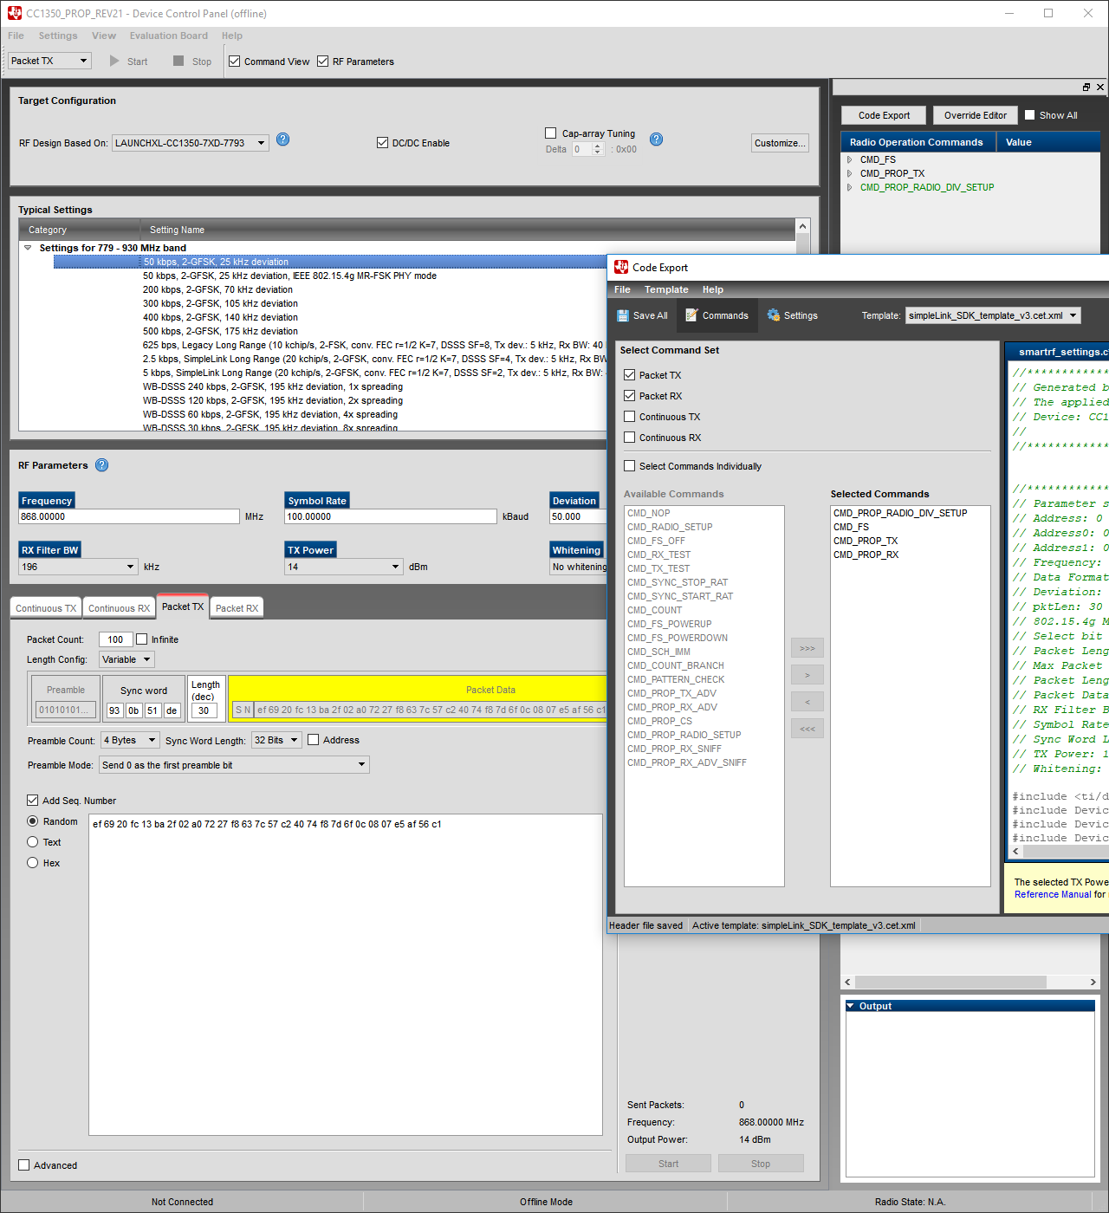

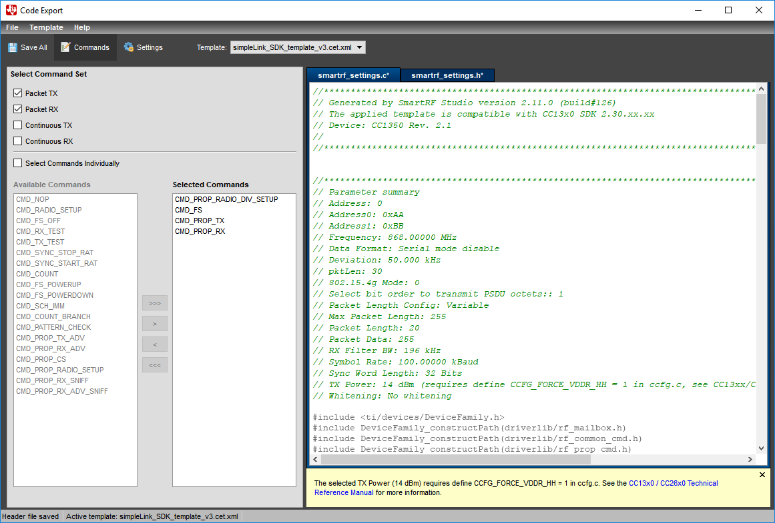

**-----------------------------------------------------------------------------------**

# Task 04: Firmware TX → SmartRF Studio RX

**Youtube Link:** **https://youtu.be/FUFbc9qmyx0**

For Task 4 we use SmartRF to receive packets sent by our modified CCS project. Below shows the output of this transmission.

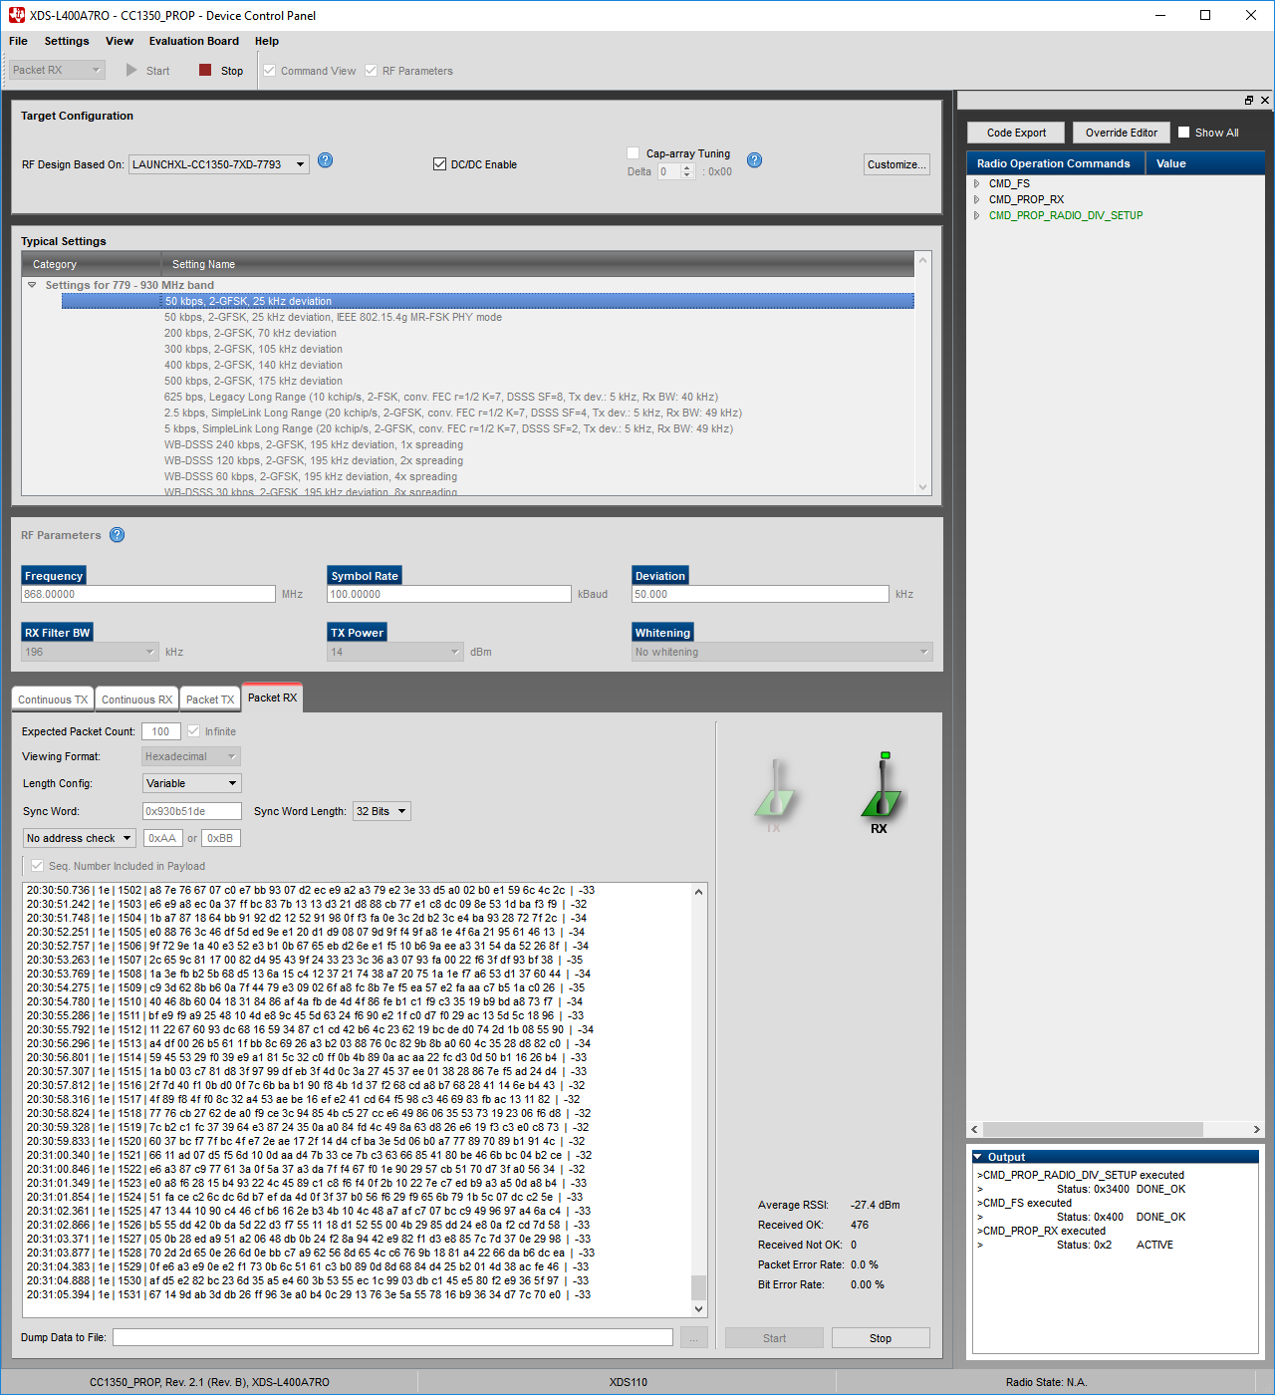

**-----------------------------------------------------------------------------------**

# Task 05: Importing and Modifying rfPacketRx

**Youtube Link:** **https://youtu.be/rjRyqYRPZ48**

For Task 5 we import and modify a receiving program into CCS in a similar fashion to our transmission program. We modify it to share the same bandwidth, frequency, and packet information as in our transmit program.

# Task 06: Firmware TX → Firmware RX

**Youtube Link:** **https://youtu.be/o2kNDlynrcU**

In Task 6 we transmit between our two boards using our imported and modified CCS projects rather than using the SmartRF programs. Here instead of showing data through the SmartRF terminal, we can see the data being received per the blinking green LED on the receiving board in sync with the red LED on the transmitting board.

# Task 07: SmartRF Studio TX → Firmware RX

**Youtube Link:** **https://youtu.be/F-3pdon-xzo**

For Task 7 we now use SmartRF studio’s built-in transmission program to send data to our receiving program modified in CCS. We now see the green receiving LED blinking per the program, but as SmartRF is controlling our transmissions, the red LED does not blink.