**Date Submitted: 11/23/2018**

# Task 01: Provide snapshots of the cfg file XGCONF modifications, stack usage, log variables using ROV, execution graphs using RTOS analyzer, and provide a video of the demo.

For Lab 04 of the TI RTOS tutorials for the TIVA-C, we implemented given code changes to make an LED blink and explored a version of the LED-blinking code using RTOS, implementing the function into our idle task. Below are the snapshots of the modifications made to the configuration file and system information. Note, despite the instructions stating that nothing needed to be adjusted, various parts needed to be added for the logging functions to be enabled on the TIVA-C and to properly display the log messages.

**Youtube Link:** **https://youtu.be/Wq9cnqBaMac**

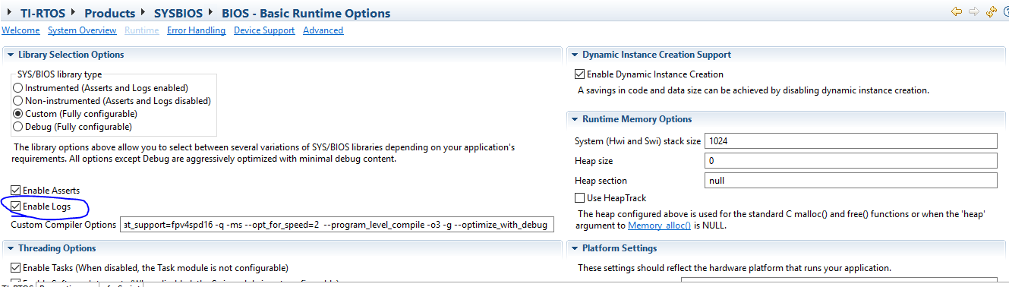

Figure 1 - Enabling logs in BIOS runtime.

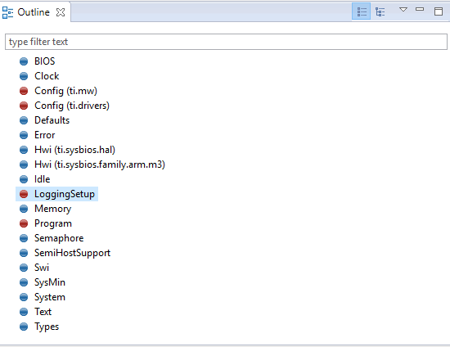

Figure 2 - Adding LoggingSetup to our configuration.

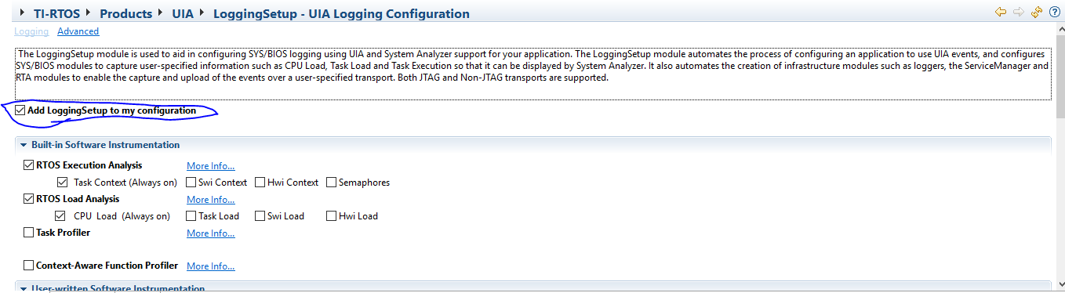

Figure 3 - Adding LoggingSetup to our configuration.

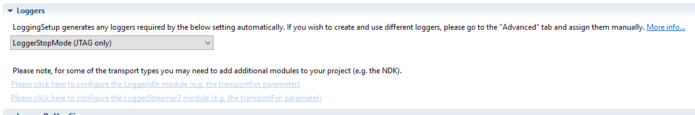

Figure 4 - Adjusting logging mode to be LoggerStopMode, JTAG only for proper log message display.

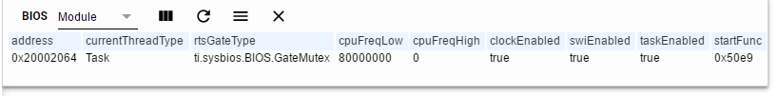

Figure 5 - ROV BIOS information

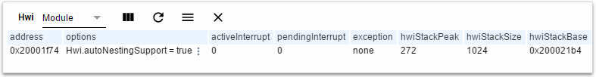

Figure 6 - Hwi stack information

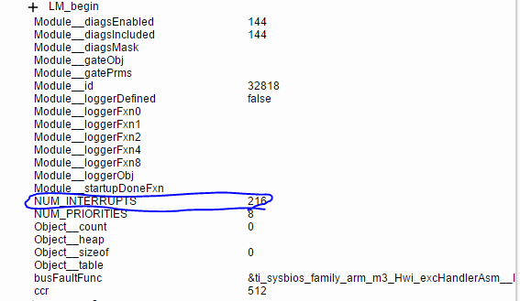

Figure 7 - Number of Hwi

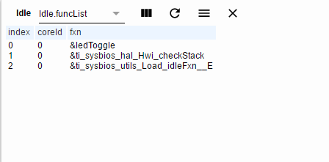

Figure 8 - Number of Hwi in system.

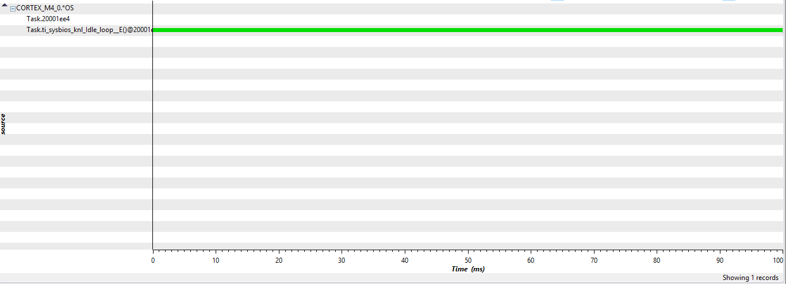

Figure 9 - Execution graph.

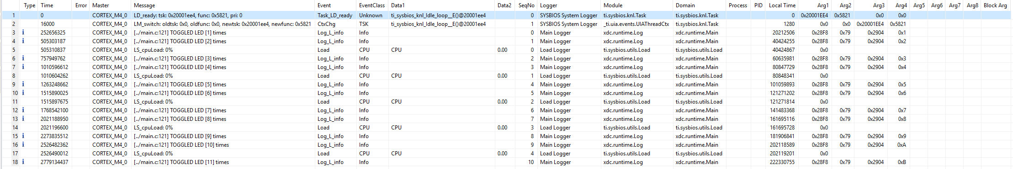

Figure 10 - Log information.