**Date Submitted: 11/23/2018**

# Task 01: Provide snapshots of the cfg file XGCONF modifications, stack usage, log variables using ROV, execution graphs using RTOS analyzer, and provide a video of the demo.

For Lab 05 of the TI RTOS tutorials for the TIVA-C, we implemented given code changes to make an LED blink using hardware interrupts, particularly Timer 2. Below are the modifications made to the configuration file and the status of the system.

**Youtube Link:** **https://youtu.be/DD3WDvQfb_M**

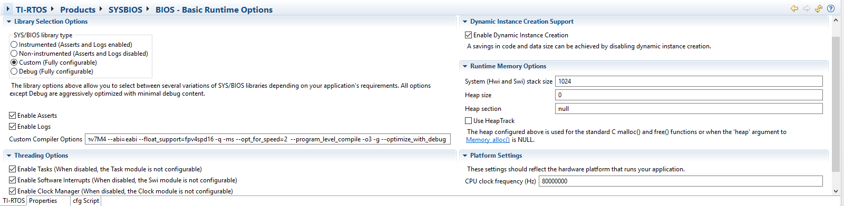

Figure 1 - BIOS logs and tasks enabled.

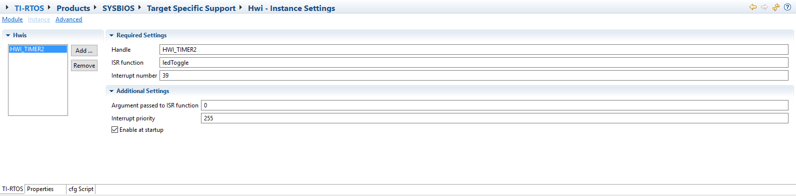

Figure 2 - HWI enabled for Timer 2.

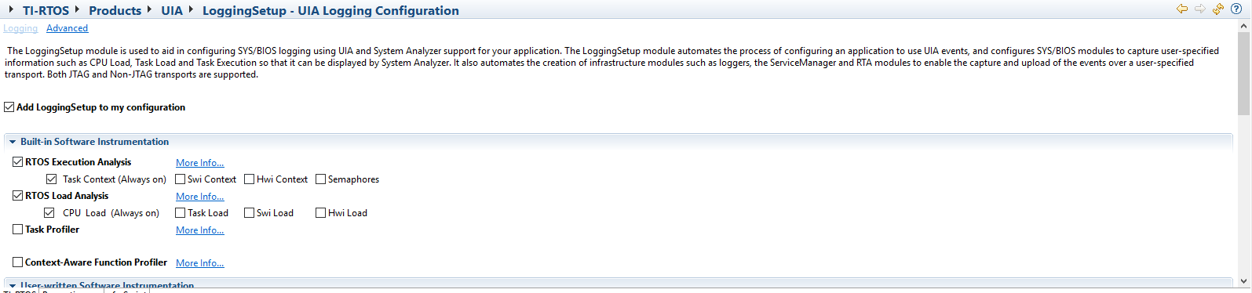

Figure 3 - LoggingSetup added to configuration.

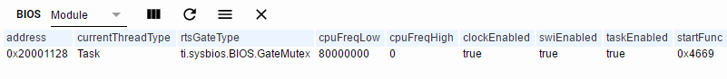

Figure 4 - ROV BIOS information.



Figure 5 -ROV HWI information.

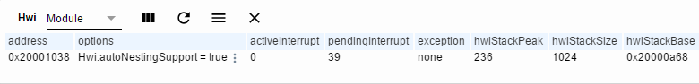

Figure 6 - ROV HWI stack information.

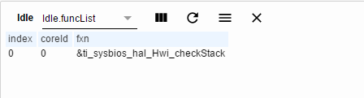

Figure 7 - ROV Idle function information.

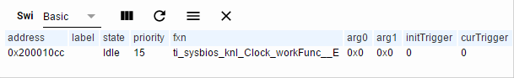

Figure 8 - ROV Idle information.

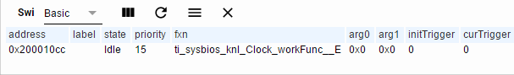

Figure 9 - ROV SWI information.



Figure 10 - ROV Task information.



Figure 11 - ROV Timer information.

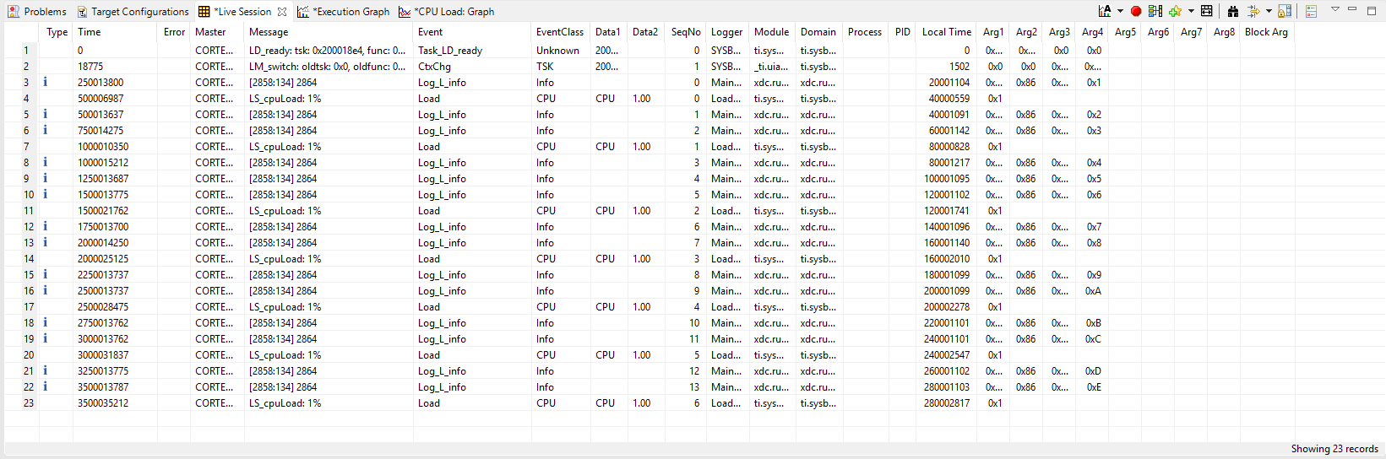

Figure 12 - Execution Analysis (deliberately not set up per Lab 05 instructions).