**Date Submitted: 11/23/2018**

# Task 01: Provide snapshots of the cfg file XGCONF modifications, stack usage, log variables using ROV, execution graphs using RTOS analyzer, and provide a video of the demo.

For Lab 06 of the TI RTOS tutorials for the TIVA-C, we implemented given code changes to make an LED blink using software interrupts. Lab 6 begins with the resulting files from lab 5. Below are the modifications made to the configuration file and the status of the system.

**Youtube Link:** **https://youtu.be/uxKDLSgC9NQ**

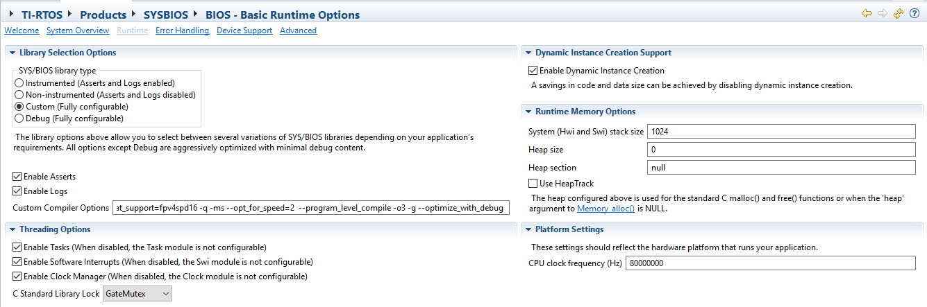

Figure 1 - BIOS Configuration.

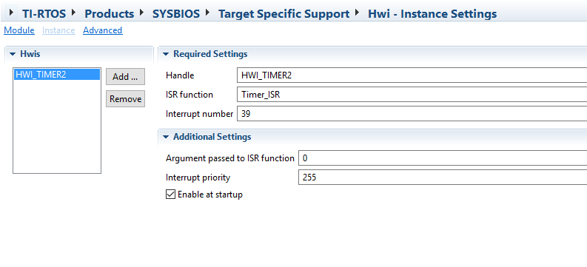

Figure 2 - HWI configuration.

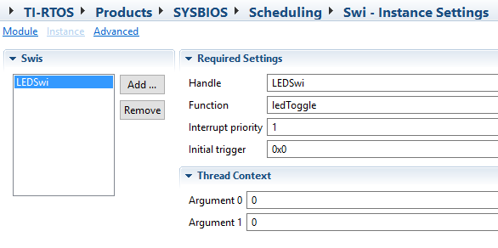

Figure 3 - SWI configuration.

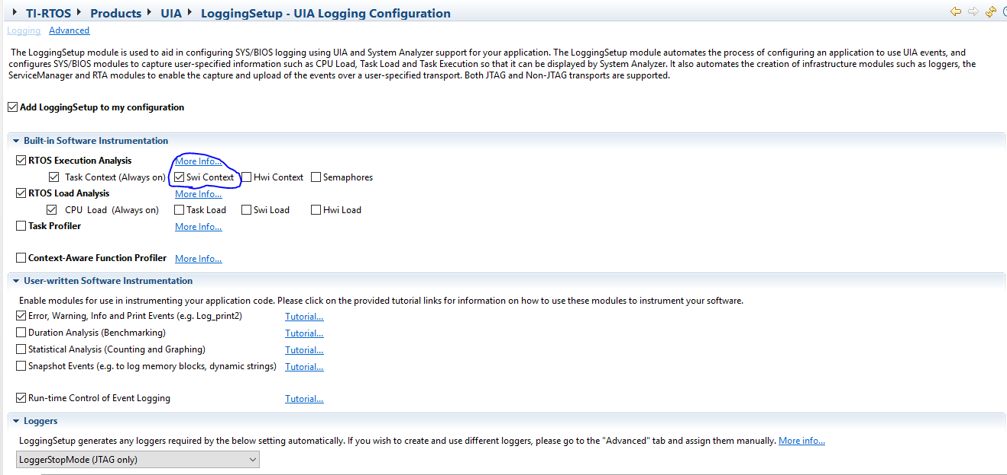

Figure 4 - UIA logging configuration.

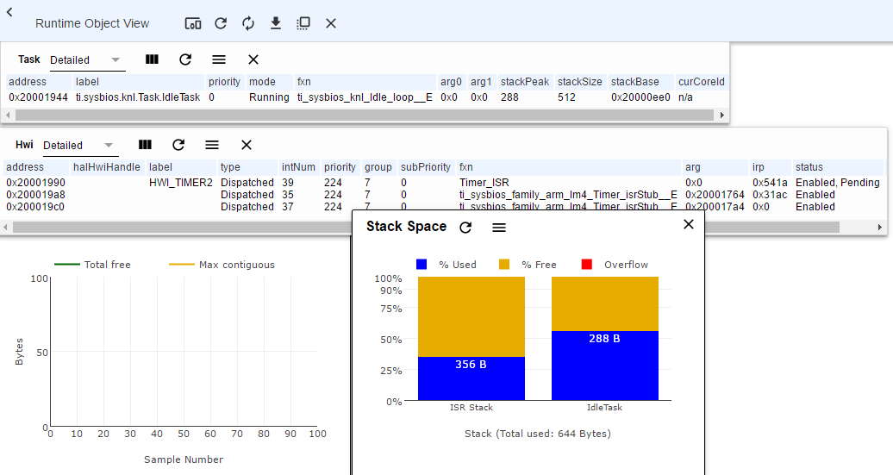

Figure 5 - ROV overview.

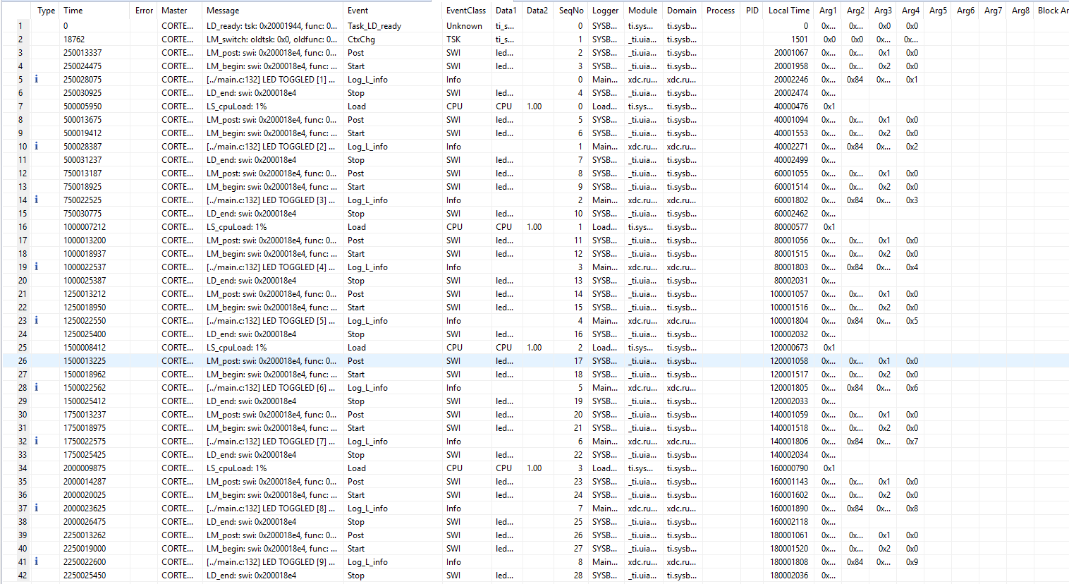

Figure 6 - Logged data

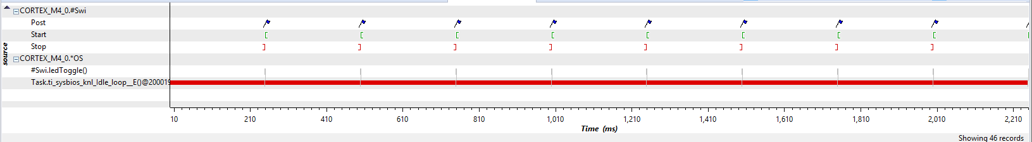

Figure 7 - Execution Graph.

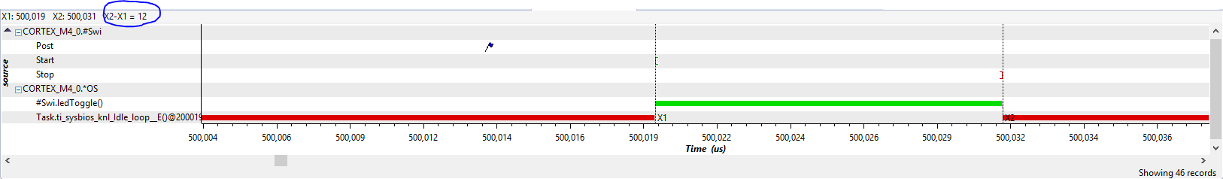

Figure 8 - Zoomed Execution Graph