**Date Submitted: 11/23/2018**

# Task 01: Provide snapshots of the cfg file XGCONF modifications, stack usage, log variables using ROV, execution graphs using RTOS analyzer, and provide a video of the demo.

For Lab 07 of the TI RTOS tutorials for the TIVA-C, we implemented given code changes to make an LED blink using our clock as the primary trigger, rather than a hardware or software interrupt. This lab begins where lab 06 left off, with a few additional lines of c code.

**Youtube Link:** **https://youtu.be/MqHv9xKVT_8**

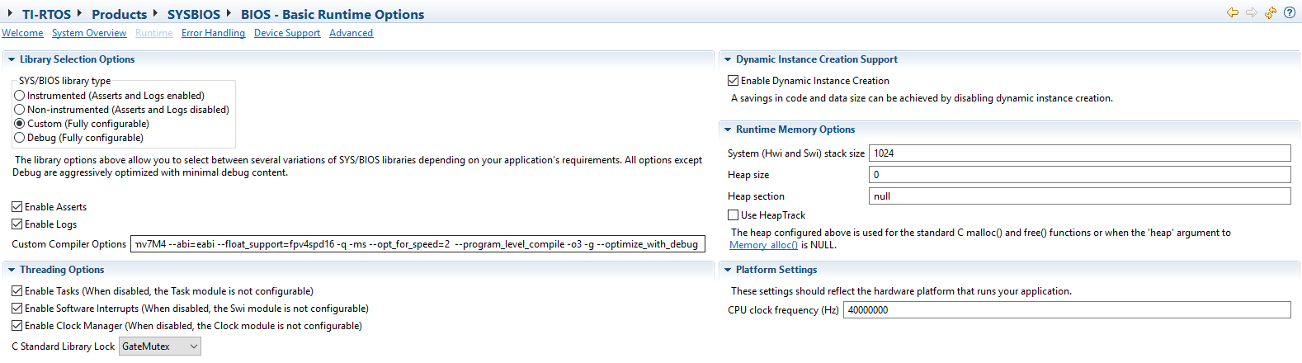

Figure 1 - BIOS configuration.

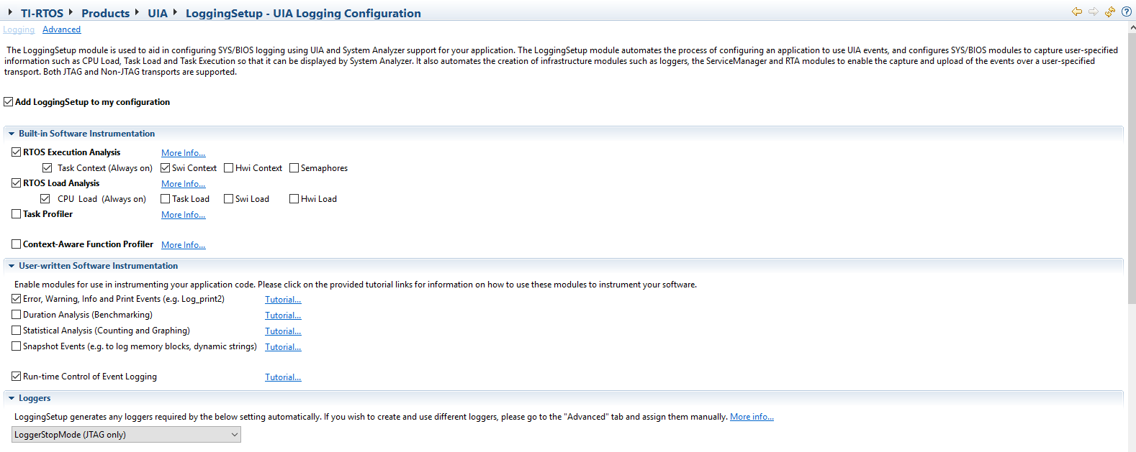

Figure 2 - Logging configuration.

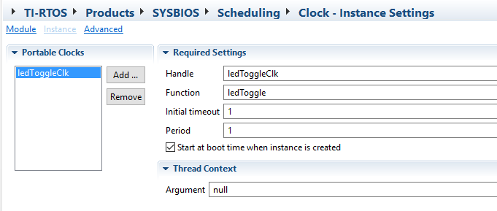

Figure 3 - Clock configuration.

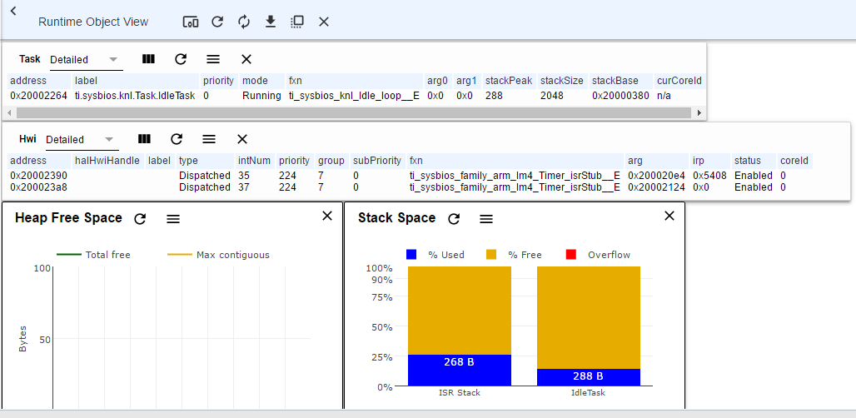

Figure 4 - ROV Overview

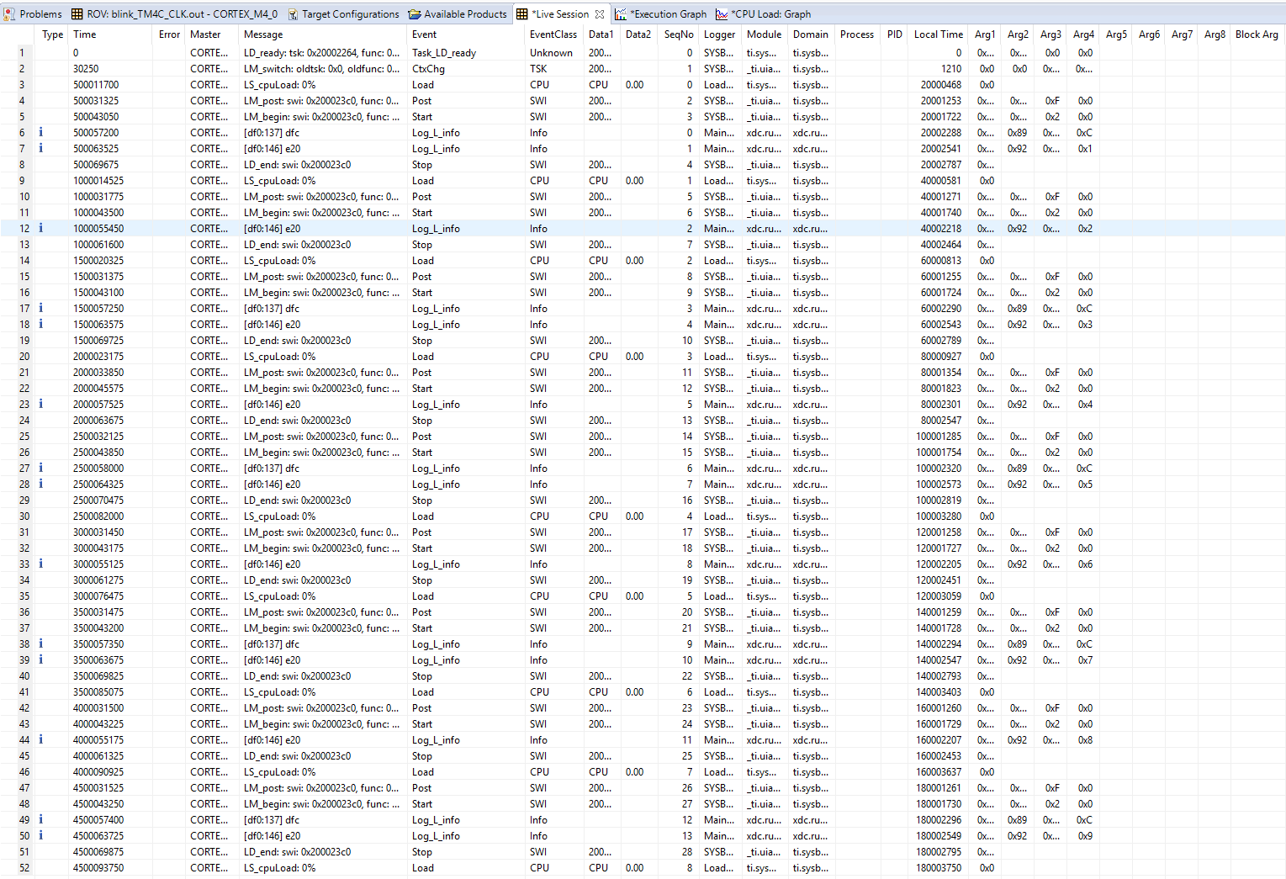

Figure 5 - Log output.

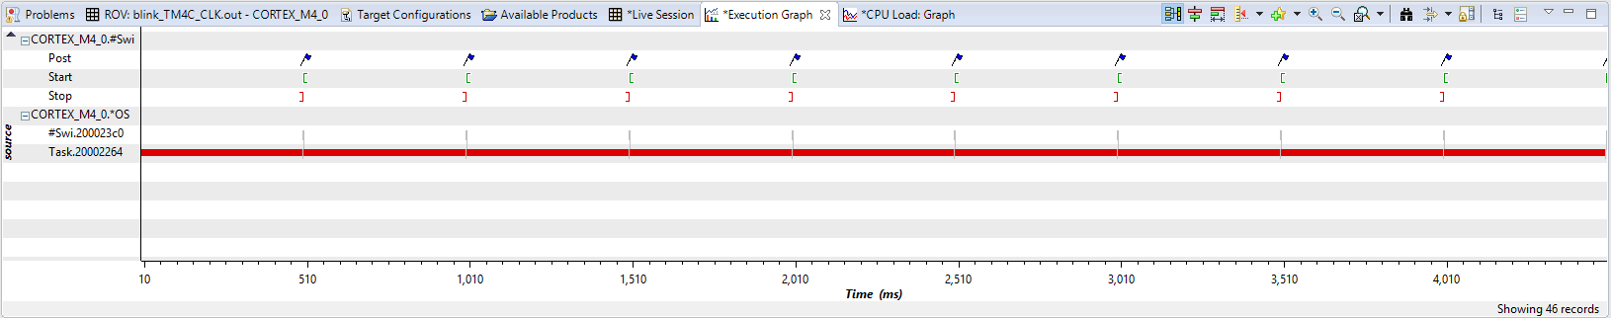

Figure 6 - Execution graph.

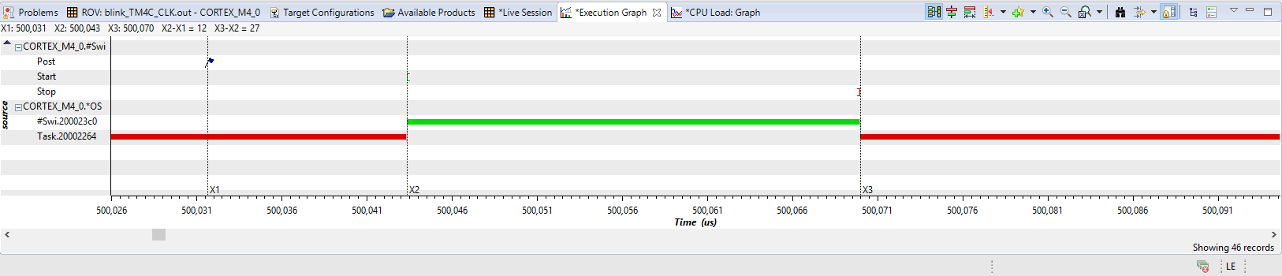

Figure 7 - Zoomed Execution graph.