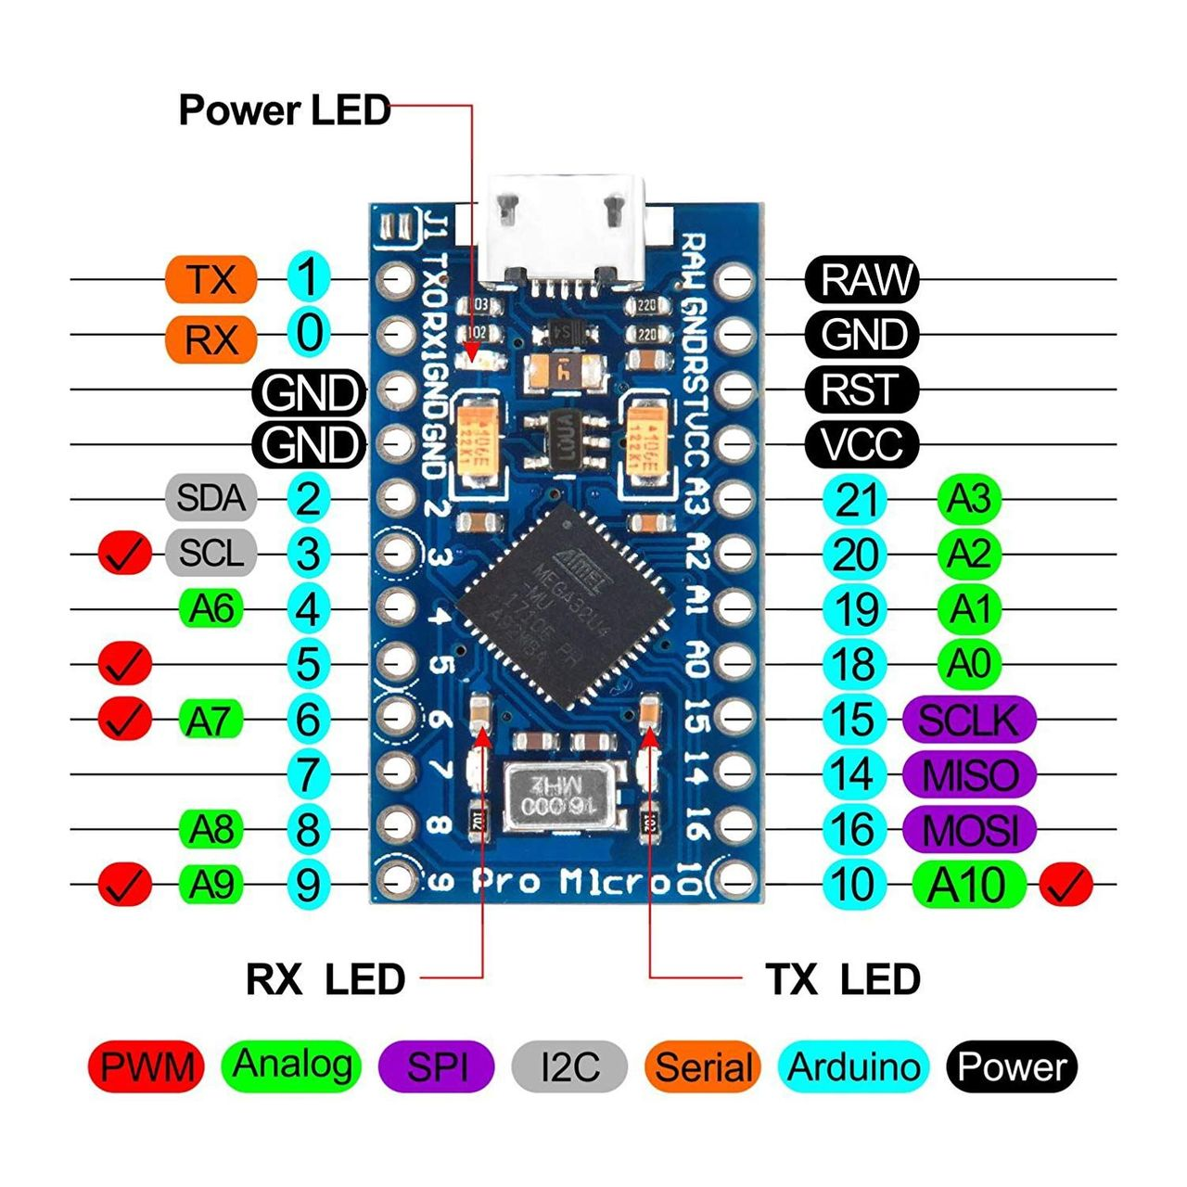

|  |  |  |  |  |
| --- | --- | --- | --- | --- |
|  |  |  |  |  |
|  |  |  |  | GND |
|  |  |  |  |  |
|  |  |  |  | VCC + LED |
|  |  |  | Button |  |
| RES |  |  | Button |  |
| CS | Button |  | Button |  |
| A0 | D/C | LED(tmp) |  | Button |  |
|  | Motortreiber IN4 |  |  | SCK |
|  | Motortreiber IN3 |  |  |  |
|  | Button |  |  | SDA |
|  | Motortreiber ENB |  | Potentiometer |  |

IPS TFT (LCD TFT Display 1.44" SPI ILI9163 128x128) via i2c:

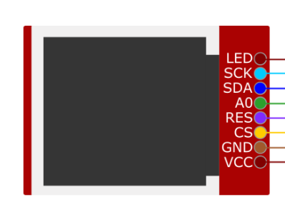

* LED (LED)
* Serial Clock (SCL/SCK)
* Serial Data (SDA)
* (A0 | D/C)
* Reset (RES | RST)
* TFT SPI Chip Select (CS)
* Ground (GND)
* Versorgungsspannung (VCC)  
  “voltage at the common collector”
* ~~[Data/Command (DC)]~~

Buttons (6):

* Weiter
* Zurück
* Home
* Microphone
* Speaker
* Mute
* Change Mic
* Change Speaker

|  |  |  |  |  |
| --- | --- | --- | --- | --- |
| **OS/System** |  | **Python Client** |  | **Arduino** |
| Global Volume   * get/set   Processes   * Name * PID? * Volume * Logo(Path)   Output Devices/Speakers   * switch/set   Input Devices/Mics   * switch/set   Events:   * Mute/Unmute * Volumechange * Keystrokes |  | Mute/Unmute Icons   * Mic * Speaker |  | Events:   * Button presses * Faderchange   Fader:   * Position * Movement   Display: |