Test Rig Documentation

The test rig is a device that records EMG data to an SD card for the purposes of data collection and assessment of a client. It is currently built around an Arduino Nano, and uses a biopill for data collection and SD Card module for recording data.

The following is a current working schematic for the test rig:

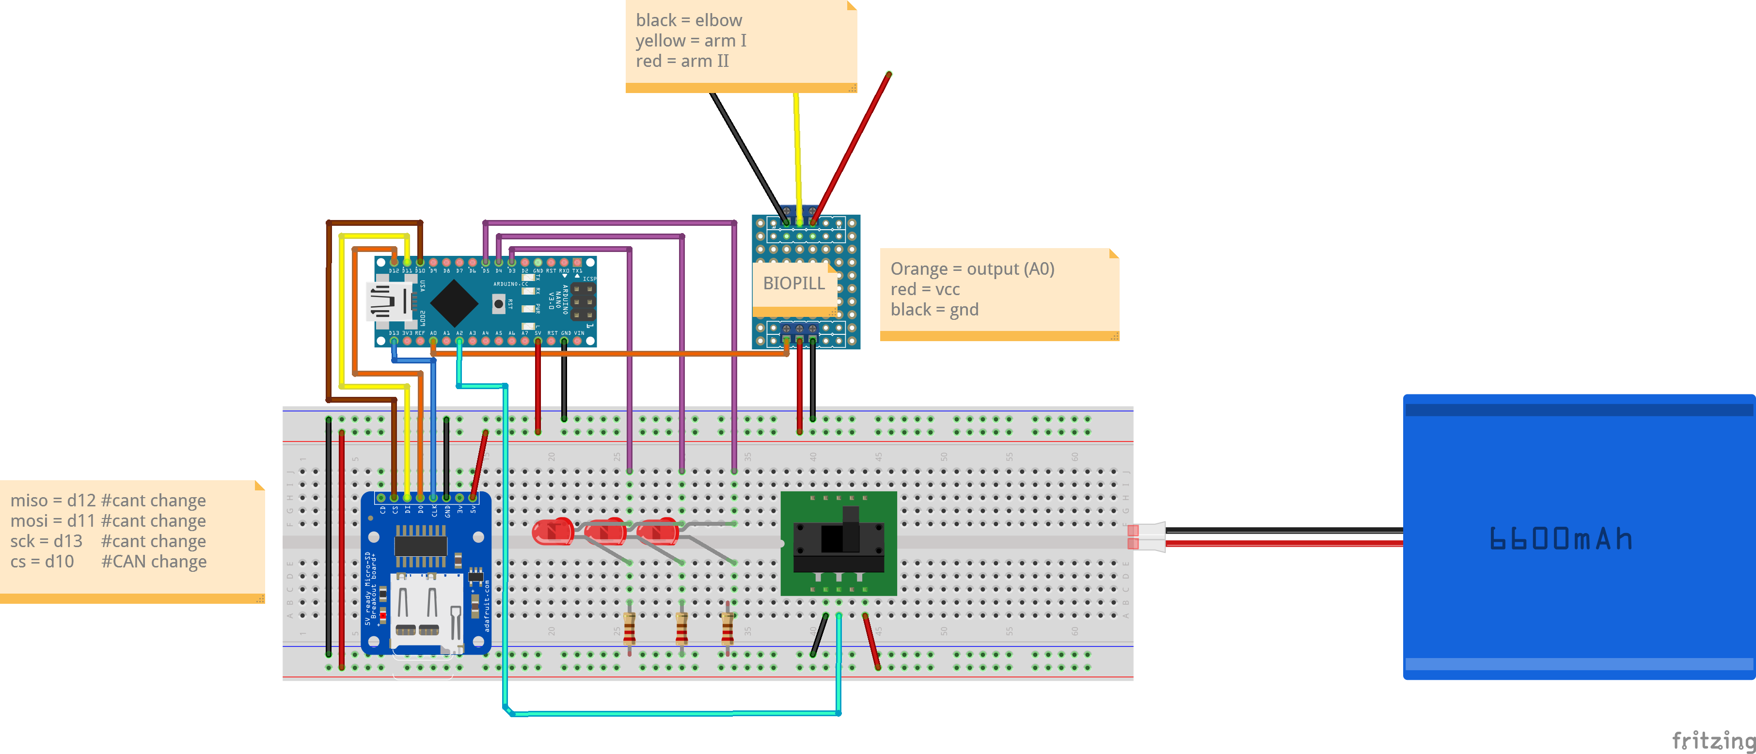

Tentatively, the test rig is powered from a USB power bank, plugged directly into the Nano. The LiPo in the circuit is used for illustration purposes.

This schematic is currently out-of-date. The new Test Rig design has a potentiometer for adjusting the action threshold of the test rig.

The test rig has 3 LEDs – the first being a software power switch (referred to as LEDA in the code, and connected to pin 5), which is used to determine if the Nano is executing code properly. The second LEDC, connected to Pin 4, is to display whether or not the test rig is recording to the SD card – yes if it is on, no if it is off. LEDB, connected to Pin 3, is used to determine if the Test Rig is reading muscle movement – useful for setting a preferred action threshold for the prosthetic wearer.

The SD card data format consists of a single file (data.txt), which gets appended to with every test. Every test begins with a small header of "Begin test X of session. Sample delay is Y”, to separate blocks of data and display information about each test. The number of times the Test rig has been powered on and off, and the number of test sessions, can be calculated by reading the entire file, as the SD card is the only state of the Test rig that survives a power-cycle. The test rig records the rolling boxcar average of the sensor value, the raw sensor value, the clench state, and the clench threshold value, separated by commas and terminated with a newline.

The test rig will not operate without an SD card present. LEDA will not light if this is the case.

The Nano produces a serial communication of its datastring at 9600 baud on the USB port as a serial connection.

grapher.py – produces a line graph (using matplotlib) of data, in the format of floats separated by newlines.