Year 2000 Compliance of Research Concepts Satellite Antenna Control Products
July 13, 1999
Research Concepts, Inc.
5420 Martindale
Shawnee, KS 66218
ph: (913) 422-0210 fax: (913) 422-0211
email: support@researchconcepts.com web: www.researchconcepts.com

Summary
All Research Concepts products should be able to handle the year 2000 transition properly. Some models of the RC8097 Satellite Locator/Antenna Controller product are equipped with Trimble GPS receivers. Several different Trimble models were used. Most of these Trimble receivers will not report the date correctly after the GPS Week Number Rollover (WNRO) event which occurs at midnight between August 21/22, 1999. The vehicle latitude/longitude position reported by the receivers will be accurate.
The RC8097 uses date information in the calculation of magnetic variation. After the WNRO event RC8097 controllers equipped with these Trimble receivers will only calculate an antenna pointing solution (antenna azimuth and elevation pointing angles) if the user manually enters the vehicle latitude and longitude. This is readily accomplished via the controller’s front panel. The RC8097’s Controller mode (where all antenna movement occurs) will not be affected by the GPS date error.
Research Concepts, Inc. will provide software upgrade kits to any user of an RC8097 product that is affected by the Trimble GPS WNRO bug. The upgrade kit will allow the RC8097 to work properly with a Trimble GPS receiver that is affected by the problem. The upgrade kits can be installed by users in the field. There is no charge for the upgrade.
Section 4.2 of this document describes the GPS date error and its effect on the RC8097. Section 4.3 describes the software upgrade and the steps which must be taken to obtain the kit. Appendix B is a table which lists RC8097 serial numbers, manufacture dates, software versions, navigation receiver model numbers, and whether or not the navigation receiver supplied with those units will experience the WNRO event error.

1.0 Research Concepts Satellite Antenna Controller Products
Research Concepts, Inc. (RCI) manufactures a number of satellite antenna control products. Here is a brief description of each product and any Year 2000 related issues that pertain to that product.
Product | Description | Year 2000 Transition Issues
RC1000 | Single axis antenna controller. | The RC1000 does not use time and date information in any way.
RC1500A | Single axis antenna controller (does not track inclined orbit satellites). | The RC1500A does not use time and date information in any way.
RC1500B | Single axis inclined orbit satellite tracking antenna controller. | The RC1500B employs a built-in real time clock to implement inclined orbit satellite tracking algorithms.
RC2000A | Dual axis antenna controller (does not track inclined orbit satellites). | The RC2000A does not use time and date information in any way.
RC2000B and RC2000C | Dual axis inclined orbit satellite tracking antenna controller. | The RC2000B and ‘C controllers employ a built-in real time clock to implement inclined orbit satellite tracking algorithms.
RC2500A | Dual axis antenna controller (does not track inclined orbit satellites). | The RC2500A does not use time and date information in any way.
RC2500B | Dual axis inclined orbit satellite antenna controller. | The RC2500B controller employs a built-in real time clock to implement inclined orbit satellite tracking algorithms.
RC8097 | Satellite locator and antenna controller for mobile uplink antennas. | Various models of this product employ a navigation receiver to provide vehicle latitude/longitude and time/date information. Vehicle lat/lon data is used to calculate the antenna pointing solution. Time/date information is used in the calculation of magnetic variation – the difference between true north and magnetic north. Note that products that employ a GPS receiver must also contend with the ‘Week Number Rollover’ anomaly.
RC3000 | Satellite locator and antenna controller for mobile uplink antennas. Some models will track inclined orbit satellites. | The Year 2000 considerations described for the RC8097 and RC2000C apply to this product.
AutoPilot Software | PC based software that provides manual and scheduled control of Research Concepts antenna controllers and several types of satellite receivers. | The AutoPilot family of software is written by Broadcast Automation Systems of Mississauga, Ontario. Year 2000 Compliance for these products are determined by the PC hardware and operating system.
Smart Booster | High current drive for 36 volt DC antenna actuators. | This product does not use time and date information in any way.

2.0 RCI Definition of ‘Year 2000 Compliant’
In this document, the term Year 2000 Compliant means that the product will function normally during the transition from December 31, 1999 to January 1, 2000. Note that this does not imply that the unit will function properly for all dates after January 1, 2000. Products that maintain current year information in a 2 digit format can only provide valid year information for a range of dates spanning 100 years.

3.0 Inclined Orbit Satellite Tracking Controller Products
The RC1500B, RC2000B/C and RC2500B inclined orbit satellite tracking antenna controller products are Year 2000 Compliant. The inclined orbit satellite tracking function of the RC3000 is also Year 2000 Compliant.
These products all include battery backed, real-time clock modules (OKI p/n MSM6242B) that maintain the date in a 2-digit format. In all temporal calculations in these products sidereal time is used. The sidereal time is calculated from the number of seconds that have elapsed since January 1st 1992 @ 00:00. Any year number read from the real-time clock that is less than 92 is considered to be in the 21st century for time calculations. Years greater than 92 are considered to be in the 20th century. All leap years between 1901 and 2099 are properly accumulated
Below is a code fragment used in RCI tracking products. It illustrates the technique that is used in the time calculations.
/* The following routine calculates the number of seconds which have elapsed
since midnight, January 1, 1992, given the current time and date. */
elapsed$seconds$since$1992: procedure( hms$ptr, mdy$ptr) dword public;
declare
(mdy$ptr, hms$ptr) address,
(mdy based mdy$ptr) MDY$STR,
(hms based hms$ptr) HMS$STR,
(year$buf, day$sum) word,
i byte,
ret$val dword;
/* Initialize year$buf. */
if (mdy.year >= 92) then year$buf = mdy.year + 1900;
else year$buf = mdy.year + 2000;
/* Calculate the number of whole month days which have occurred this
year. */
day$sum = 0;
do i = 1 to (mdy.month-1);
day$sum = day$sum + double(days$per$month(i));
end;
/* If this year is a leap year and the month is greater than feb then
increment the day count by 1. */
if ((((year$buf - 1988) mod 4) = 0) and (mdy.month > 2)) then
day$sum = day$sum + 1;
/* The following code only works if the year is greater than 1992.
This block calculates the number of seconds which have occurred in
whole years up to but not including the current year. Since time (for
this routine) starts in 1992, if the year is 1992 there have been no
whole years which have occurred before now. */
if (year$buf > 1992) then
do;
/* DECREMENT THE YEAR FOR THE CALCULATIONS THAT FOLLOW. */
year$buf = year$buf - 1;
/* Calculate the number of whole leap year seconds which have
occurred. */
ret$val = ((double(year$buf) - 1988)/4) * SECONDS$PER$LEAP$YEAR;
/* Calculate the number of seconds which have occurred in whole
non-leap years. */
ret$val = ret$val + SECONDS$PER$NORMAL$YEAR *
((((double(year$buf) - 1992) / 4) * 3) +
((double(year$buf) - 1992) mod 4));
end;
else ret$val = 0; /* initialize the return value */
ret$val = ret$val +
(double(day$sum + double(mdy.day - 1)) * SECONDS$PER$DAY) +
(double(double(hms.hour)) * 3600) +
(double(double(hms.minute)) * 60) +
double(double(hms.second));
return ret$val;
end elapsed$seconds$since$1992;

4.0 RC8097 Year 2000 and GPS Week Number Rollover Event Issues
The RC8097 is a satellite locator used with mobile satellite transmit vehicles. The satellite locator calculates the antenna azimuth and elevation angles (referred to as the antenna pointing solution) required to align the antenna with a satellite given the satellite’s longitude, vehicle heading, and vehicle latitude/longitude. The RC8097 can optionally accept inputs from a navigation receiver and/or flux gate compass. The flux gate compass supplies the vehicle’s heading and the navigation receiver provides the vehicle’s latitude/longitude and the current time/date. Both GPS and Loran type navigation receivers with NMEA output have been supplied with the RC8097.
GPS receivers can experience another date related anomaly known as ‘GPS Week Number Rollover’ (WNRO) or End of Week (EOW) Rollover. The following excerpt is from a web site operated by the United States Department of Transportation, http://www.dot.gov/affairs/dot8099.htm (June 4, 1999).
The GPS EOW rollover occurs every 1,024 weeks -- about once every 20 years. The GPS system calculates time by counting the number of weeks since Jan. 6, 1980 -- up to a maximum of 1,023 weeks. At midnight between Aug. 21-22, 1999, the GPS week "counter" will roll back to zero weeks. DOD says this will not create problems for the GPS satellites or DOD's GPS ground control center, but it could present a problem for consumers who use older GPS receivers and related applications. That's because after Aug. 21, 1999, receivers could process satellite data incorrectly and display inaccurate information.
The RC8097 product family uses time and date information in the calculation of magnetic variation. Magnetic variation is the difference between true north and magnetic north. The magnetic variation varies with latitude/longitude. For a given latitude and longitude there is a slight change in magnetic variation with time. The RC8097 obtains time and date information from the optional navigation receiver. If a navigation receiver is not present in a system the controller uses a date fixed in the controller’s software. For this case the controller cannot compensate for the change in magnetic variation that occurs with time.
There are two aspects of year 2000 Compliance for the RC8097. First, the navigation receiver must provide the correct latitude, longitude, and date to the RC8097. Second, the RC8097 must be able to use a date whose year is greater than 1999 to compute the date correction in the calculation of magnetic variation.
The output of the navigation receiver is a message conforming to the NMEA 0183 format. The time/date message from the receiver specifies the year as a four digit value. The RC8097 obtains the year from the time message. If the year value read from the navigation receiver is valid the RC8097 will properly apply the date correction in the calculation of magnetic variation. Year 2000 compliance of the product is therefore dependent on the navigation receiver’s ability to produce lat/lon and time/date messages that contain valid data.

4.1 Navigation Receiver Year 2000 and Week Number Rollover Compliance
The RC8097 family can be divided into two distinct branches: RC8097A versions of the product and all other members of the family.
RC8097A versions did not support the satellite antenna controller function. The RC8097A is essentially a calculator that determines the satellite antenna pointing solution. It is always used in conjunction with a standalone antenna controller. All RC8097A’s were supplied with a Micrologic 8500T Loran receiver. The RC8097A was produced in 1987 and 1988. Most of the RC8097A units produced have been converted to other configurations.
The other branch of the RC8097 family includes all other members of the RC8097 family (RC8097B, RC8097C, RC8097D, etc). These products are satellite locators with integrated antenna controllers. On these products the navigation receiver was supplied as an option. Before 1994 the optional navigation receiver was the Micrologic 8500T Loran. Starting in 1994 the product was offered with a Trimble Acutis GPS receiver. In early 1999, the Trimble GPS was discontinued and the RC8097 was offered with the Garmin GPS 35/36 model receiver.
Appendix B of this document is a list of all RC8097x (x = B, C, or D) units produced. Included in the list is the unit’s serial number, date of manufacture, software version, and the following navigation receiver information: manufacturer, model number, serial number, and Week Number Rollover compliance.

4.1.1 Micrologic 8500T Year 2000 Compliance Status
At this time Micrologic has not responded to our requests for Year 2000 Compliance information on their 8500T navigation receiver.

4.1.2 Trimble Actutis Year 2000 Compliance Status
Four different Trimble ‘Acutis’ model receivers with NMEA output were used with the RC8097. The model numbers were: 18636-21, 26203-62, 28515-62, and 37486-62.
Trimble publishes Year 2000 Compliance information on their web site:
http://www.trimble.com/y2kwnro/chart.htm
The http://www.trimble.com/y2kwnro/pdf/acutispre5_04.pdf document on the Trimble web site describes the Y2K and WNRO compliance status of the 26203-62 and 28515-62 model receivers. We believe that this document also covers the model 18636-21 receiver. The document states that after the WNRO event (midnight between August 21/22) these receivers will report an incorrect date. The correct lat/lon position will be reported by the receiver. In an email to Steven Mikinski of Research Concepts Inc., John Lovell, Director of Quality at Trimble, stated that on August 22, 1999, these receivers will report a date of January 6, 1980. As the actual date advances beyond August 22, 1999 the date reported by the receiver will advance from January 6, 1980.
The http://www.trimble.com/y2kwnro/pdf/acutis5_12.pdf document on the Trimble web site describes the Y2K and WNRO compliance status of the 37486-62 model receiver. The document states that the receiver will work correctly through the WNRO and Y2K transitions.

Garmin GPS 35/36 Year 2000 Compliance Status
Garmin gives the Y2K/WNRO status of their products on their web site: http://www.garmin.com/faqs/1.html.
That page states …
GARMIN took Y2K considerations into account from the beginning of its product development. GARMIN GPS products should continue to operate after the year 2000.
A table on that page indicates that ‘…user intervention is not recommended … for EOW …’ for the Garmin GPS 35 navigation receiver.

4.2 Operation with a Non-Compliant Navigation Receiver
If the navigation receiver is not available or provides erroneous information the RC8097 can still be used. All models of the RC8097 allow the user to manually enter the vehicle’s latitude and longitude into the controller via the controller’s front panel user interface. When the user manually enters latitude and longitude data the controller uses a default date in the calculation of magnetic variation. The default date used for a particular version of the RC8097 software is described in section 4.2.2. The next section describes how the RC8097 accumulates and uses lat/lon and time/date information when a navigation receiver is present in the system.

RC8097 Antenna Pointing Solution Calculation When A Navigation Receiver is Present
RC8097 controllers equipped with navigation receivers running software versions prior to 7.0 on power up assume a navigation receiver is present and will by default obtain lat/lon and time/date information from the navigation receiver. The user can override this and manually specify vehicle latitude/longitude via the L/L Source key when the controller is in the Calculator Mode.
For controller’s running software version 7.0 or later a menu item (labeled ‘GPS:’) present on the Test – System – System Constants screen allows the user to specify whether or not a GPS receiver is present in the system. If this menu item is set to ‘Y’ (Yes) the controller will by default attempt to obtain lat/lon and time/date data from the GPS receiver. If the GPS menu item is set to ‘N’ (No) the controller will wait for the user to key in vehicle lat/lon data. Note that even if the GPS menu item is set to ‘Y’ the user can still manually enter vehicle lat/lon data via the ‘L/L Source’ menu.
To obtain an antenna pointing solution, the following information must be available to the controller …
1) Satellite Longitude – This information is specified by the user.
2) Vehicle Heading – Obtained either from a flux gate included as part of the system or via user entry.
3) Vehicle Lat/Lon – Obtained from a built in navigation receiver or via user entry.
4) Date – Source of this data depend on the source of vehicle lat/lon data …
If vehicle lat/lon data is obtained via user entry a default date is used. The default date is dependent on software version. See section 4.2.2.
If the vehicle lat/lon is obtained from a navigation receiver the controller obtains the date from a NMEA data sentence output by the navigation receiver. The controller performs a validity check on the date obtained from the navigation receiver. The validity check is to see if the year is between 1987 and 2050 (inclusively). On August 22, 1999, controllers equipped with Trimble 18636-21, 26203-62, and 28515-62 model GPS receivers will report a date of January 6, 1980.
When these four data items are available the controller will calculate a pointing solution. Note that for controllers equipped with the Trimble 18636-21, 26203-62, and 28515-62 GPS receivers the antenna controller will not be able to obtain date information from the GPS after August 21, 1999. If date information is not available the controller will NOT calculate a pointing solution.
After August 21, 1999, controller’s equipped with these Trimble GPS receivers can only calculate an antenna pointing solution if the user manually specifies the vehicle’s latitude/longitude via either keyboard entry or via selection of a location from the controller’s preset ‘truck locations’ data list.
An upgrade to the controller software is available that will enable the controller to work properly with Trimble GPS receivers that report an incorrect date after August 21, 1999. See section 4.3.
The user can specify vehicle lat/lon by hitting the ‘L/L Source’ key when the controller’s Calculator Mode is active. (Calculator Mode is active on power up.) Note that vehicle latitude values in North America and Europe will always be Northerly. Vehicle longitude values in North America will be Westerly.

4.2.2 RC8097 Manual Lat/Lon Entry Default Dates
When the user manually enters the vehicle latitude and longitude the controller derives a date for the magnetic variation calculation according to the following rule.
The controller looks at the last date used for the magnetic variation calculation.
If the last date used for a magnetic variation calculation was a date on or after CUTOFF_DATE and before 12/31/2020 that date will be used for the calculation.
Otherwise, the controller assigns a date to be used for the calculation. The date assigned will be ASSIGNED_DATE.
The values of CUTOFF_DATE and ASSIGNED_DATE are dependent on the RC8097 software version and are given in the following table.
Software Version | CUTOFF_DATE | ASSIGNED_DATE
3.0 and earlier | Jan. 1, 1987 | Jan. 1, 1987
3.1 through 3.6 | Jan. 1, 1989 | Jan. 1, 1990
3.7 | Jan. 1, 1989 | Jan. 1, 1995
7.x | Jan. 1, 1989 | Jan. 1, 1995
The use of any of the ASSIGNED_DATE values given above will allow the controller to derive a reasonable magnetic variation value. Any error in the calculated value of magnetic variation will result in an error in the controller’s predicted azimuth position. The error in the predicted azimuth position due to errors in the calculated magnetic variation will in general be much less than the error in predicted azimuth due to the controller’s error in determining the vehicle’s heading with the flux gate compass.

4.3 Software Upgrade for Controllers Equipped with Trimble Model 18636-21, 26203-62, and 28515-62 GPS Receivers
Any user of an RC8097 antenna controller equipped with any one of the Trimble receivers listed above may obtain a software upgrade at no charge. With the upgrade installed the controller will calculate the actual date given the (incorrect) date obtained from the GPS receiver and calculate pointing solutions. The upgrade package consists of an EPROM, an operator’s manual, an IC (integrated circuit) puller, and a set of upgrade instructions. To install the upgrade an EPROM has to be changed on the controller’s digital board. The upgrade can be performed in the field by users of the controller. The upgrade should not be installed until after the GPS week number rollover event has occurred (midnight, between August 21 and 22, 1999).
Users of the RC8097 controller wishing to receive the upgrade should contact RCI at …
- Email: support@researchconcepts.com,
- Fax: (913) 422-0211
- Mail: Research Concepts, Inc, 5420 Shawnee, KS, USA 66218
- Phone: (913) 422-0210
With your request for an upgrade please specify the following information …
- Controller serial number (found on a sticker on the back of the unit).
- Controller software version number (displayed as the controller powers up).
- Shipping address.
- Contact name, phone number, fax number, and email address (if available).
Appendix B of the Research Concepts, Inc. Y2K Compliance Status Document is a table that lists all RC8097x (x = B, C, or D) units produced. For controllers equipped with GPS receivers the receiver model number is provided. A field in the table indicates whether or not the receiver will report the correct date after the WNRO event (midnight between August 21 and August 22, 1999).

4.4 Upgrading RC8097 Controllers that Contain Loran or Trimble Navigation Receivers
RC8097 controllers equipped with Loran or Trimble GPS receivers can be retrofitted with the Garmin GPS receiver. The Garmin receiver seems to obtain lock much faster than the Trimble unit does. To perform the upgrade the controller must be returned to RCI for modifications and the cabling between the controller and the receiver has to be replaced. Please contact RCI for details.

RC3000 Y2K and GPS Week Number Rollover Event Issues
The RC3000 is an antenna controller designed for mobile and flyaway uplink applications. The RC3000 combines the satellite locator and antenna controller capabilities of the RC8097 with the inclined orbit satellite tracking capabilities of the RC2000C antenna controller. Many versions of the RC3000 are available. Some include an optional flux gate compass, optional GPS receiver, inclined orbit satellite tracking algorithms, and support for serial communications with a PC.
The RC3000 includes the real time clock IC (integrated circuit) found in the RC2000. The real time clock is the source of date information used in the RC3000’s magnetic variation calculation. The algorithms to calculate the sidereal time are identical to those employed in the RC2000. The RC3000 is optionally equipped with the Garmin GPS 35/36 navigation receiver. The Y2K and WNRO status of the Garmin receiver is described in the RC8097 section of this document.

6.0 AutoPilot PC Computer Software
Research Concepts, Inc. resells the Broadcast Automation Systems’ AutoPilot product. Broadcast Automation Systems has provided two documents outlining the year 2000 compliance status of their products. The documents are included as an appendix to this document. Based on these documents the AutoPilot software is Year 2000 Compliant if the PC platform and operating system under which it is running are Year 2000 Compliant.
For more information contact Broadcast Automation Systems at ph: 905 822 7935, fax: 905 822 9617, or via email: wjcoutts@netcom.ca.

7.0 Ancillary Systems
Research Concepts, Inc. has reviewed its accounting system and has verified its compliance with the Y2K criteria. We anticipate no interruption in Sales, Purchasing, Manufacturing, or Billing.
We are in the process of requesting Y2K compliance information from all of our vendors and suppliers. As of the date of this memo approximately 40% of our vendors have responded with Y2K compliance affidavits.
Signature: Date: July 13, 1999
Steven M. Mikinski Title: President

Appendix A – Broadcast Automation Systems Y2K Compliance Statements

A.1 Windows AutoPilot
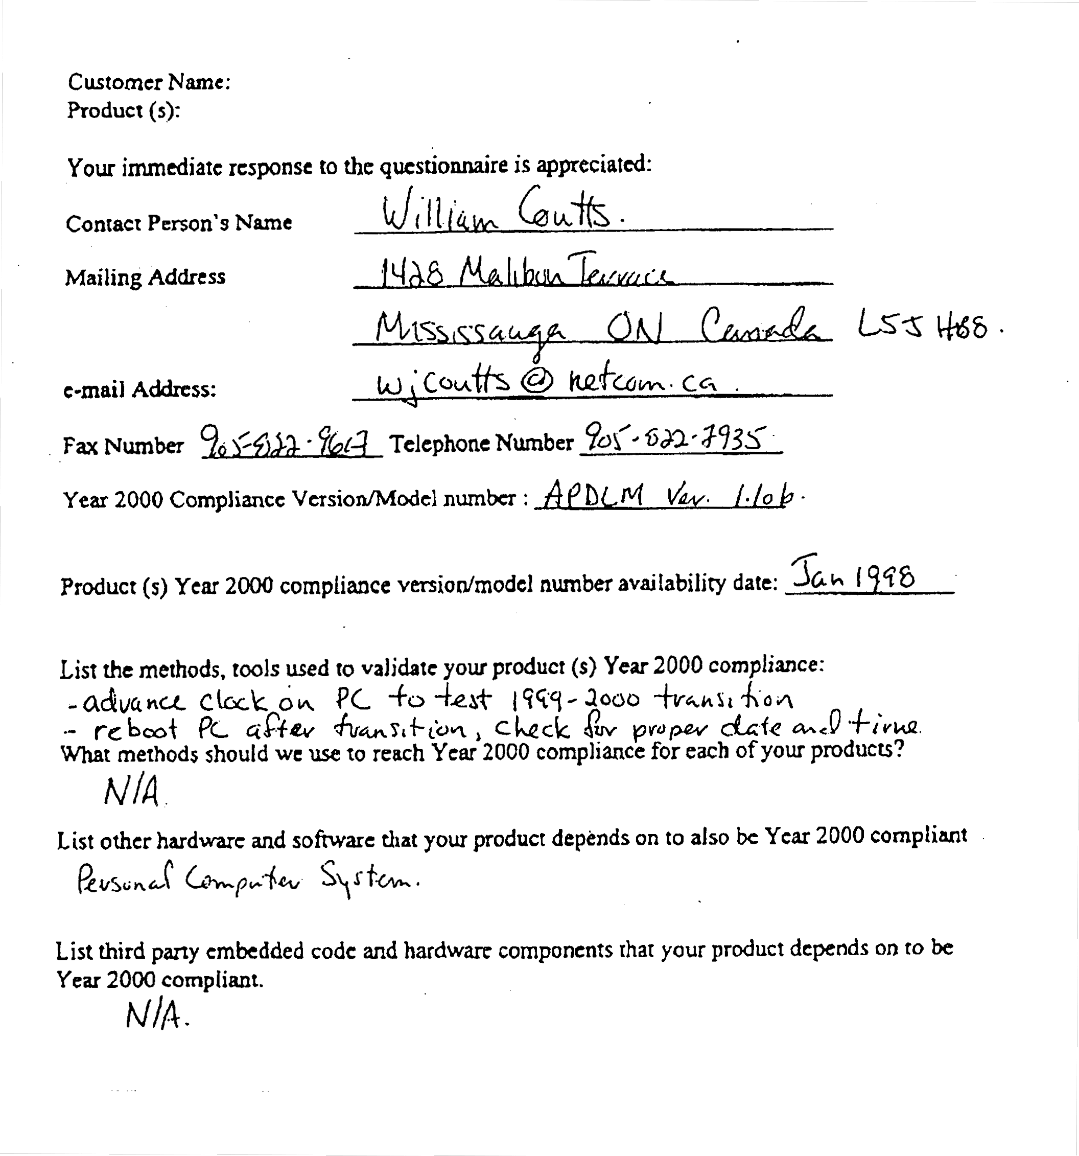

A.2 DOS AutoPilot Y2K Compliance Statement

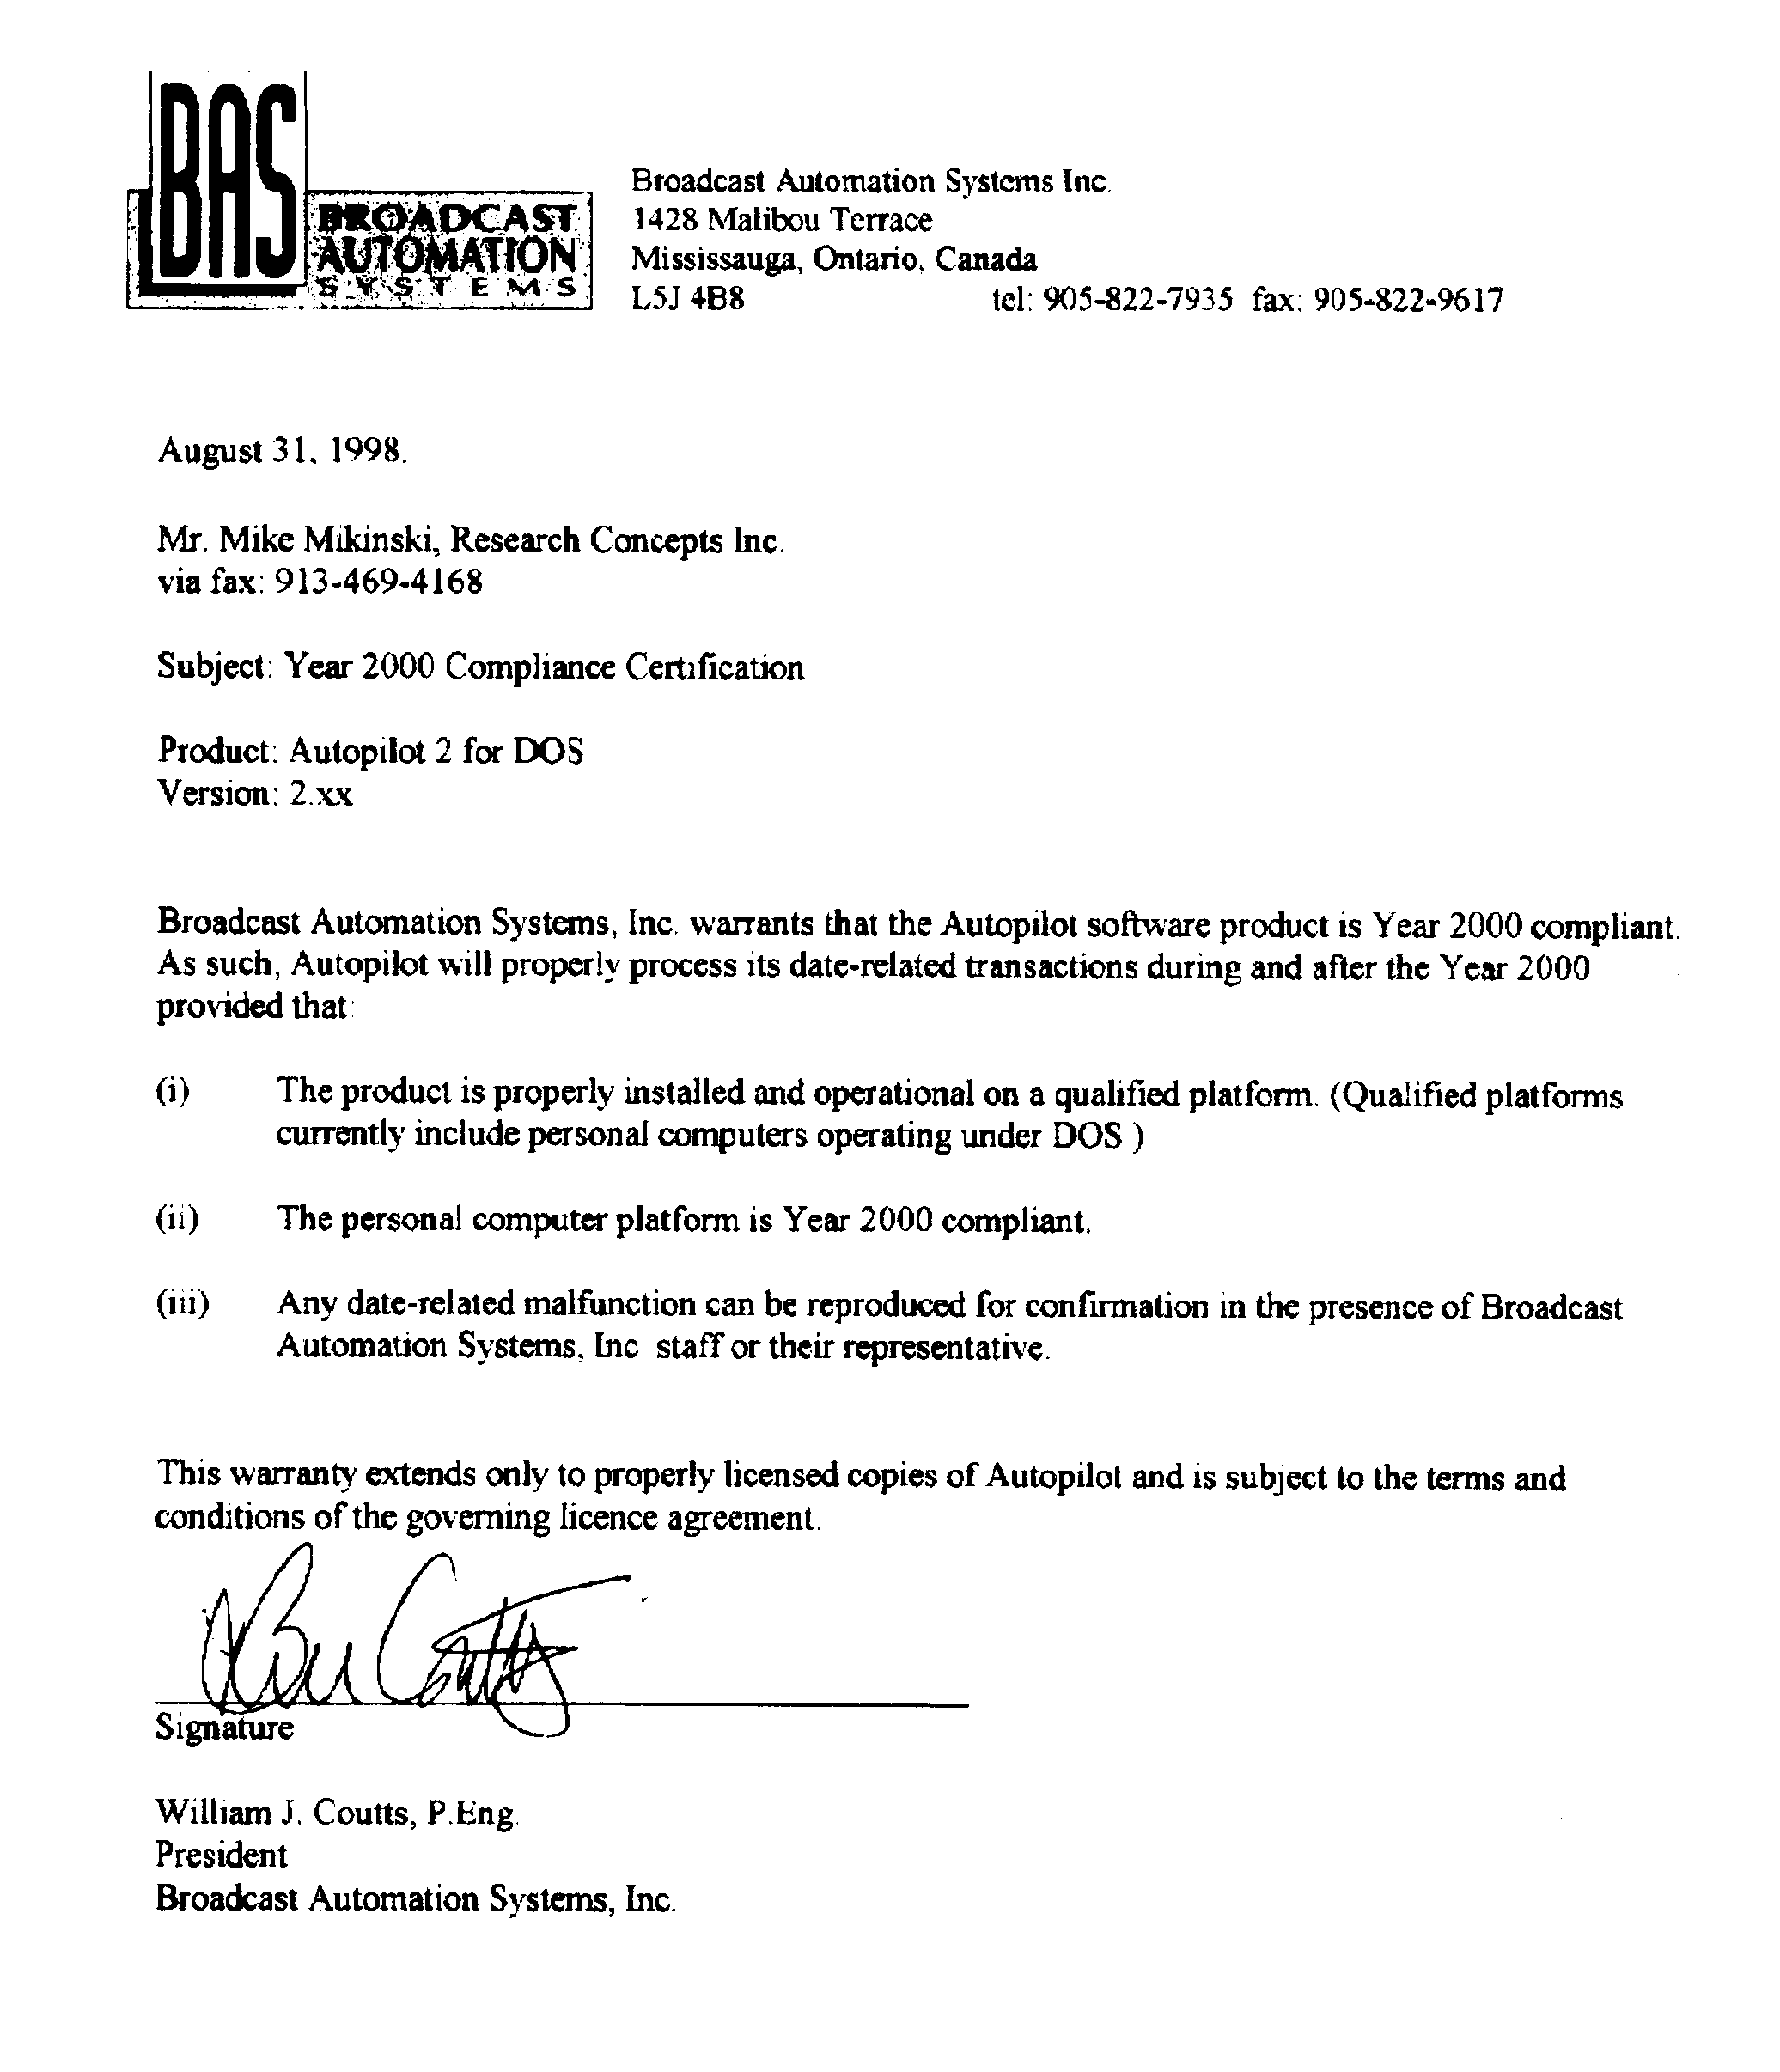

Appendix B – RC8097 Serial Number Table
The following table lists the RC8097 serial number, software version, and navigation receiver serial number, and navigation receiver part number. The ‘L’ suffix implies that the navigation receiver was a Micrologic 8500T loran receiver. TRIMBLE implies that the navigation receiver was a Trimble Acutis GPS receiver, and GARMIN indicates that the Garmin GPS 36 receiver was used on that unit.
Note that most of the Trimble GPS units will not report the date correctly after the GPS Week Number Rollover (WNRO) event which occurs at midnight August 21 and August 22, 1999.

RC8097 serial # | RC8097 Mfg. Date | RC8097 Software version | Loran/GPS Rcvr S/N | Nav Rcvr Part Number | GPS Date will be Incorrect After WNRO Event
001 |  | 3.0 | 14680194 L
002 | 8.11.88 | 3.0 | 27180211 L
003 | 8.11.88 | 3.0 | 22180197 L
004 | 8.30.88 | 3.0 | 23580200 L
005 | 8.30.88 | 7.20 | 0260047438 TRIMBLE |  | YES
006 | 8.30.88 | 3.0 | 23580201 L
007 | 10.20.88 | 3.0 | 27180213 L
008 | 10.20.88 10.23.95 rebuilt | 3.0 | 27180212 L
009 | 10.20.88 2.27.96 rebuilt | 3.0 | 23580203 L
010 | 11.28.88 upgraded 5.6.96 | 3.0 | 27180214 L
011 | 2.10.89 | 3.1 | 23580206 L
012 | 2.10.89 upgraded 9.6.96 | 7.00 | 0260029706 TRIMBLE | 28515-62 | YES
013 | 2.10.89 | 3.1 | 26890403 L
014 | 2.10.89 | 3.1 | 23580209 L
015 | 2.10.89 | 3.1 | 23580208 L
016 | 4.28.89 upgraded 3.21.97 | 7.02 | 0260039330 TRIMBLE | 28515-62 | YES
017 | 4.24.89 | 3.2 | 04590234 L
018 | 4.24.89 | 3.2 | 04590231 L
019 | 4.24.89 | 3.2 | 04590230 L
020 | 4.24.89 | 3.2 | 04590232 L
021 | 4.24.89 | 3.2 | 04590233 L
022 | 7.20.89 | 3.2 | 19590299 L
023 | 7.20.89 | 3.2 | 19590296 L
024 | 7.20.89 | 3.2 | 19590298 L
025 | 7.20.89 | 3.2 | 19590297 L
026 | 7.20.89 | 3.2 | 19590300 L
027 | 9.12.89 | 3.3 | 26890404 L
028 | 9.12.89 | 3.3 | 26890405 L
029 | 9.12.89 | 3.3 | 21390340 L
030 | 9.12.89 | 3.3 | 26890402 L
031 | 9.12.89 | 3.3 | 23580207 L
032 | 7.28.91 | 3.4 | NO GPS
033 | 2.14.94 | 3.5 | 0080074866 TRIMBLE |  | YES
034 | 8.1.94 | 3.5 | NO GPS
035 | 8.1.94 | 3.5 | NO GPS
036 | 1.31.95 | 3.7 | 0080169530 TRIMBLE | 18636-21 | YES
037 | 1.31.95 | 3.7 | 0080169537 TRIMBLE | 18636-21 | YES
038 | 1.30.95 | 3.7 | 0080169536 TRIMBLE | 18636-21 | YES
039 | 1.30.95 | 3.7 | 0080169531 TRIMBLE | 18636-21 | YES
040 | 2.13.95 | 3.7 | 0080169525 TRIMBLE | 18636-21 | YES
041 | 2.13.95 | 3.7 | 0080169526 TRIMBLE | 18636-21 | YES
042 | 2.24.95 | 5.5 | NO GPS
043 | 3.17.95 | 5.6 | NO GPS
044 | 3.17.95 | 3.7 | 0080185409 TRIMBLE | 26203-62 | YES
045 | 3.17.95 | 3.7 | 0080185399 TRIMBLE | 26203-62 | YES
046 | 3.17.95 | 3.7 | 0080185372 TRIMBLE | 26203-62 | YES
047 | 4.26.95 | 5.5 | NO GPS
048 | 4.28.95 | 3.7 | 0080185376 TRIMBLE | 26203-62 | YES
049 | 5.12.95 upgraded 10.04.95 | 5.5 upgraded to 7.03 | NO GPS
050 | 6.28.95 | 5.5 | NO GPS
051 | 7.18.95 | 5.6 | NO GPS
052 | 7.27.95 | 3.7 | NO GPS
053 | 8.28.95 | 3.7 | 0080201934 TRIMBLE | 26203-62 | YES
054 | 1.11.96 | 7.02 | NO GPS
055 | 2.5.96 | 7.02 | NO GPS
056 | 2.8.96 | 7.03 | NO GPS
057 | 3.4.96 | 7.03 | GPS Shp’d on 3.26.96 0260028308 TRIMBLE | 28515-62 | YES
058 | 3.7.96 upgraded 3.12.98 | 7.22 | 0260047430 TRIMBLE | 26203-62 | YES
059 | 3.7.96 | 7.02 | 0260027985 TRIMBLE | 26203-62 | YES
060 | 3.25.96 | 7.02 | 0260028222 TRIMBLE | 26203-62 | YES
061 | 3.25.96 | 7.02 | 0260028211 TRIMBLE | 26203-62 | YES
062 | 3.25.96 | 7.02 | 0260028263 TRIMBLE | 26203-62 | YES
063 | 5.10.96 | 7.02 | 0260028284 TRIMBLE | 26203-62 | YES
064 | 6.17.96 | 7.03 | 0260039348 TRIMBLE | 28515-62 | YES
065 | 6.17.96 | 7.04 | NO GPS
066 | 10.10.96 | 7.02 | 0260028308 TRIMBLE | 28515-62 | YES
067 | 10.11.96 | 7.02 | 0260029693 TRIMBLE | 28515-62 | YES
068 | 10.17.96 | 7.02 | 0260028299 TRIMBLE | 28515-62 | YES
069 | 10.25.96 | 7.02 | 0260029191 TRIMBLE | 28515-62 | YES
070 | 10.25.96 | 7.02 | 0260029888 TRIMBLE | 28515-62 | YES
071 | 11.14.96 | 7.02 | 0260029834 TRIMBLE | 28515-62 | YES
072 | 12.3.96 | 7.03 | NO GPS
073 | 12.9.96 | 7.02 | 0260028970 TRIMBLE | 28515-62 | YES
074 | 12.11.96 | 7.02 | 0260028953 TRIMBLE | 28515-62 | YES
075 | 12.13.96 | 7.02 | 0260029863 TRIMBLE | 28515-62 | YES
076 | 12.17.96 | 7.02 | 0260029845 TRIMBLE | 28515-62 | YES
077 | 12.24.96 | 7.02 | 0260029830 TRIMBLE | 28515-62 | YES
078 | 12.31.96 | 7.03 | NO GPS
079 | 12.31.96 | 7.03 | NO GPS
080 | 1.14.97 | 7.02 | 0260037834 TRIMBLE | 28515-62 | YES
081 | 1.14.97 | 7.02 | 0260037087 TRIMBLE | 28515-62 | YES
082 | 1.21.97 | 7.02 | 0260037835 TRIMBLE | 28515-62 | YES
083 | 1.21.97 | 7.02 | 0260037836 TRIMBLE | 28515-62 | YES
084 | 2.25.97 | 7.02 | 0260039343 TRIMBLE | 28515-62 | YES
085 | 3.3.97 | 7.02 | NO GPS
086 | 3.5.97 | 7.02 | NO GPS
087 | 4.4.97 | 7.00 | 0260039313 TRIMBLE | 28515-62 | YES
088 | 4.15.97 | 7.03 | 0260039355 TRIMBLE | 28515-62 | YES
089 | 4.28.97 | 7.03 | NO GPS
090 | 5.6.97 | 7.03 | NO GPS
091 | 5.16.97 | 7.02 | 0260039316 TRIMBLE | 28515-62 | YES
092 | 5.30.97 | 7.02 | 0260039305 TRIMBLE | 28515-62 | YES
093 | 6.26.97 | 7.02 | 0260039299 TRIMBLE | 28515-62 | YES
094 | 6.30.97 | 7.03 | NO GPS
095 | 7.7.97 | 7.02 | 0260039300 TRIMBLE | 28515-62 | YES
096 | 7.10.97 | 7.02 | 0260039306 TRIMBLE | 28515-62 | YES
097 | 7.11.97 | 7.02 | 0260029926 TRIMBLE | 28515-62 | YES
098 | 7.16.97 | 7.03 | NO GPS
099 | 8.1.97 | 7.02 | 0260029832 TRIMBLE | 28515-62 | YES
100 | 8.1.97 | 7.02 | 0260029846 TRIMBLE | 28515-62 | YES
101 | 8.18.97 | 7.02 | 0260029843 TRIMBLE | 28515-62 | YES
102 | 8.21.97 | 7.23 | NO GPS
103 | 8.21.97 | 7.22 | 0260029964 TRIMBLE | 28515-62 | YES
104 | 8.25.97 | 7.23 | NO GPS
105 | 9.5.97 | 7.22 | 0260029859 TRIMBLE | 28515-62 | YES
106 | 9.5.97 | 7.22 | 0260029970 TRIMBLE | 28515-62 | YES
107 | 11.3.97 | 7.22 | 0260029938 TRIMBLE | 28515-62 | YES
108 | 11.4.97 | 7.22 | 0260027901 TRIMBLE | 28515-62 | YES
109 | 11.5.97 | 7.22 | 0260042558 TRIMBLE | 28515-62 | YES
110 | 11.14.97 | 7.22 | 0260042357 TRIMBLE | 28515-62 | YES
111 | 11.17.97 | 7.22 | 0260039195 TRIMBLE | 28515-62 | YES
112 | 11.20.97 | 7.22 | 0260039184 TRIMBLE | 28515-62 | YES
113 | 11.30.98 | 7.22 | 0260039186 TRIMBLE | 28515-62 | YES
114 | 12.11.98 | 7.22 | 0260039197 TRIMBLE | 28515-62 | YES
115 | 12.22.98 | 7.22 | 0260029869 TRIMBLE | 28515-62 | YES
116 | 2.9.98 | 7.26 | 0260046437 TRIMBLE | 28515-62 | YES
117 | 2.11.98 | 7.22 | 0260046433 TRIMBLE | 28515-62 | YES
118 | 2.11.98 | 7.22 | 0260046432 TRIMBLE | 28515-62 | YES
119 | 2.11.98 | 7.22 | 0260046430 TRIMBLE | 28515-62 | YES
120 | 2.11.98 | 7.22 | 0260046438 TRIMBLE | 28515-62 | YES
121 | 2.11.98 | 7.22 | 0260039239 TRIMBLE | 28515-62 | YES
122 | 2.11.98 | 7.22 | 0260046434 TRIMBLE | 28515-62 | YES
123 | 2.16.98 |  | RCI WRITEOFF
124 | 3.3.98 | 7.22 | 0260047413 TRIMBLE | 28515-62 | YES
125 | 3.5.98 | 7.22 | 0260047401 TRIMBLE | 28515-62 | YES
126 | 3.24.98 | 7.33 | 0260047425 TRIMBLE | 28515-62 | YES
127 | 3.30.98 | 7.36 | 0260047403 TRIMBLE | 28515-62 | YES
128 | 4.1.98 | 7.22 | 0260047394 TRIMBLE | 28515-62 | YES
129 | 4.10.98 | 7.22 | 0260047408 TRIMBLE | 28515-62 | YES
130 | 4.14.98 | 7.22 | 0260047391 TRIMBLE | 28515-62 | YES
131 | 4.20.98 | 7.22 | 0260047412 TRIMBLE | 28515-62 | YES
132 | 4.20.98 | 7.22 | 0260047400 TRIMBLE | 28515-62 | YES
133 | 4.26.98 | 7.22 | 0260047397 TRIMBLE | 28515-62 | YES
134 | 4.26.98 | 7.22 | 0260047441 TRIMBLE | 28515-62 | YES
135 | 5.8.98 | 7.36 | 0260047437 TRIMBLE | 28515-62 | YES
136 | 5.11.98 | 7.36 | 0260047434 TRIMBLE | 28515-62 | YES
137 | 5.20.98 | 7.33 | NO GPS
138 | 5.27.98 | 7.00 | NO GPS
139 | 6.3.98 | 7.22 | 0260047429 TRIMBLE | 28515-62 | YES
140 | 6.10.98 | 7.22 | 0260047432 TRIMBLE | 28515-62 | YES
141 | 6.16.98 | 7.22 | NO GPS
142 | 6.24.98 | 7.34 | NO GPS
143 | 7.16.98 | 7.57 | NO GPS
144 | 7.30.98 | 7.57 | 0260047431 TRIMBLE | 28515-62 | YES
145 | 8.12.98 | 7.57 | 0260047440 TRIMBLE | 28515-62 | YES
146 | 8.18.98 | 7.52 | 0260047447 TRIMBLE | 28515-62 | YES
147 | 8.26.98 | 7.52 | 0260047352 TRIMBLE | 28515-62 | YES
148 | 9.11.98 | 7.51 | NO GPS
149 | 9.15.98 | 7.52 | 0260047353 TRIMBLE | 28515-62 | YES
150 | 9.21.98 | 7.52 | 0260047355 TRIMBLE | 28515-62 | YES
151 | 10.5.98 | 7.52 | 0260046315 TRIMBLE | 28515-62 | YES
152 | 10.6.98 | 7.52 | NO GPS
153 | 10.8.98 | 7.52 | 0260046291 TRIMBLE | 28515-62 | YES
154 | 10.13.98 | 7.52 | 0260046321 TRIMBLE | 28515-62 | YES
155 | 10.16.98 | 7.51 | 0260046330 TRIMBLE | 28515-62 | YES
156 | 10.20.98 | 7.52 | 0260046292 TRIMBLE | 28515-62 | YES
157 | 10.26.98 | 7.52 | 0260046296 TRIMBLE | 28515-62 | YES
158 | 10.30.98 | 7.52 | 0260046302 TRIMBLE | 28515-62 | YES
159 | 11.6.98 | 7.52 | 0260046319 TRIMBLE | 28515-62 | YES
160 | 11.18.98 | 7.51 | 0260046325 TRIMBLE | 28515-62 | YES
161 | 12.4.98 | 7.52 | 0260046299 TRIMBLE | 28515-62 | YES
162 | 12.10.98 | 7.52 | 0260046304 TRIMBLE | 28515-62 | YES
163 | 12.15.98 | 7.52 | 0260046308 TRIMBLE | 28515-62 | YES
164 | 12.24.98 | 7.52 | 0260046317 TRIMBLE | 28515-62 | YES
165 | 12.29.98 | 7.52 | 0260046320 TRIMBLE | 28515-62 | YES
166 | 12.30.98 | 7.52 | 0260046324 TRIMBLE | 28515-62 | YES
167 | 1.5.99 | 7.52 | 0260047404 TRIMBLE | 28515-62 | YES
168 | 1.7.99 | 7.57 | NO GPS
169 | 1.28.99 | 7.6a | 63410393 GARMIN
170 | 1.25.99 | 7.53 | GARMIN
171 | 2.2.99 | 7.52 | 11535868 TRIMBLE | 37486-62
172 | 2.4.99 | 7.6A | 63410386 GARMIN
173 | 2.8.99 | 7.6A | 63410396 GARMIN
174 | 2.10.99 | 7.6A | 63410401 GARMIN
175 | 2.11.99 | 7.52 | 11535918 TRIMBLE | 37486-62
176 | 2.12.99 | 7.53 | 11535894 TRIMBLE | 37486-62
177 | 2.17.99 | 7.6B | 63410387 GARMIN
178 | 2.18.99 | 7.62 | 63410395 GARMIN
179 | 2.24.99 | 7.62 | NO GPS
180 | 3.1.99 | 7.62 | 63409046 GARMIN
181 | 3.5.99 | 7.62 | 63411159 GARMIN
182 | 3.10.99 | 7.62 | 63411168 GARMIN
183 | 3.11.99 | 7.62 | 63411163 GARMIN
184 | 3.12.99 | 7.62 | 63411165 GARMIN
185 | 3.15.99 | 7.67 | 63411164 GARMIN
186 | 3.18.99 | 7.62 | 63412018 GARMIN
187 | 3.25.99 | 7.6A | 63412019 GARMIN
188 | 3.28.99 | 7.6A | 63410394 GARMIN
189 | 3.30.99 | 7.6A | 63412022 GARMIN
190 | 4.5.99 | 7.62 | 63412017 GARMIN
191 | 4.26.99 | 7.62 | NO GPS
192 | 5.4.99 | 7.61 | NO GPS
193 | 5.4.99 | 7.62 | 63412009 GARMIN
194 | 5.24.99 | 7.6A | NO GPS
195 | 5.27.99 | 7.63 | NO GPS
196 | 6.2.99 | 7.62 | 63412143 GARMIN
197 | 6.11.99 | 7.62 | 63411161 GARMIN

Appendix C – Document Revision History
12/10/98 – Added information about the RC8097 antenna controller.
3/23/99 – Modified the section on the RC8097 to cover the switch to the Garmin GPS receiver.
7/13/99 – Make the following modifications to the document …
- describe the WNRO problem with the Trimble GPS receiver,
- update the information about the Garmin receiver,
- add the section on the RC3000 antenna controller, and
- describe the software upgrade program

