SECURITY ASSESSMENT REPORT
Implementing Basic Cloud Security Controls in Microsoft Azure
Design, Hardening, Identity & Storage Controls Security Assessment
Prepared for: XYZ Solutions Startup Company
Prepared by: Cloud Security Analyst
Date: July 5, 2026
Resource Group: interns-rg | Environment: Microsoft Azure

1. Executive Summary
This report presents the findings of a security assessment conducted on the Microsoft Azure environment deployed for XYZ Solutions within the resource group interns-rg. The assessment covers a Linux virtual machine, an Azure Storage account, and supporting identity, monitoring, and threat-detection services.
The objective of the engagement was to establish baseline preventive security controls consistent with the Shared Responsibility Model and the Principle of Least Privilege, and to validate those controls through hands-on configuration, testing, and evidence collection. Controls implemented include SSH port hardening, role-based access control (RBAC) with segregation of duties, private blob storage with Shared Access Signature (SAS) delegation, centralized monitoring through Azure Monitor, threat detection through Microsoft Sentinel, Just-In-Time (JIT) VM access, and an external vulnerability scan using Nmap.
Overall, the environment moved from a default, broadly-exposed configuration to a hardened baseline in which administrative ports are closed by default, storage is private by default, and security-relevant events are centrally logged and monitored. Residual risks and recommended next steps are detailed in Sections 2 and 4.

2. Risks Identified
Before hardening, the environment exhibited a number of common cloud misconfiguration risks. These were identified during the baseline assessment and the Nmap vulnerability scan, and are summarized below.

2.1 Open Services and Public Exposure
- Standard SSH (port 22) was reachable from the public internet on the Linux VM, making it a target for automated scanning and dictionary/brute-force attacks.
- A temporary HTTP service on port 80 was exposed with no restriction, meaning any inbound connection could reach the web service until Just-In-Time access was configured.
- The Nmap scan identified multiple open TCP ports on the target host, including services such as Microsoft Windows RPC, NetBIOS, and a VMware Authentication Service banner, indicating a broader attack surface than required for the VM's function.

2.2 Weak Configurations
- Default NSG rules permitted inbound traffic on well-known management ports without IP restriction, increasing exposure to credential-stuffing and brute-force attempts.
- Operating system fingerprinting during the Nmap scan returned no exact OS match, which on its own is not a vulnerability, but reflects that service banners and responses had not been reviewed for information leakage.
- Prior to hardening, there was no time-bound restriction on administrative ports; once opened, ports such as SSH remained accessible indefinitely rather than only when needed.

2.3 Access Control Issues
- Without RBAC segregation, a single administrative identity could potentially manage both compute and storage resources, increasing the blast radius if that identity were compromised.
- Storage accounts without delegated, scoped access controls force clients to either use long-lived master keys (high risk if leaked) or be granted broad directory-level permissions.

2.4 Public Exposure Risks (Storage)
- Blob containers configured for public anonymous read access can be indexed by automated web crawlers and scanning tools, exposing files, credentials, or business data to anyone with the URL.
- Without expiring, delegated access tokens, any shared link to storage data remains valid indefinitely, so a leaked link becomes a permanent exposure.

3. Security Controls Implemented
The following controls were implemented and validated with hands-on testing to mitigate the risks identified in Section 2.
Control | Description | Risk Mitigated
RBAC (Role-Based Access Control) | Two dedicated identities (infrauser, storageuser) were created in Microsoft Entra ID and assigned scoped roles (VM/Network Contributor, Storage Account Contributor) at the resource group level. | Excessive privilege; single identity compromise leading to full tenant takeover.
NSG Rules (Network Security Group) | Custom inbound rules were defined to explicitly allow only required ports and block all other unsolicited inbound traffic to the VM. | Unrestricted inbound access; automated scanning and exploitation of unused ports.
Custom SSH Port (2244) | Default SSH port 22 was disabled; a custom rule was created to allow administrative access only on port 2244. | Mass automated brute-force attacks that specifically target the default SSH port.
Private Blob Storage | The 'folder1' container was configured with public access set to Private, so anonymous requests return 403/404 responses. | Anonymous internet access to business files and data leakage via indexed public URLs.
SAS Token Access | Read-only, time-bound Shared Access Signature tokens were generated to grant delegated access to specific blobs without exposing storage account keys. | Permanent exposure via long-lived shared links or leaked master keys.
IP Restrictions | Just-In-Time access rules and SAS parameters restrict connections to specific approved source IP addresses. | Access from unauthorized or unknown network locations.
Azure Monitor | VM Insights and a Log Analytics Workspace were configured to collect CPU, memory, disk, and network metrics, visualized on a Grafana-based dashboard. | Lack of visibility into resource health and abnormal performance patterns.
Microsoft Sentinel | A SIEM/SOAR solution was connected to the Log Analytics Workspace with a scheduled analytics rule that detects repeated failed SSH logins and raises incidents in Microsoft Defender. | Undetected brute-force login attempts and delayed incident response.
JIT (Just-In-Time) Access | Microsoft Defender for Cloud was used to keep port 80 closed by default, opening it only for an approved source IP and a limited time window upon request. | Standing exposure of management/application ports outside of active use windows.

3.1 Verification Summary
- SSH connections on port 22 were confirmed refused after hardening; connections on port 2244 succeeded.
- Cross-account testing confirmed infrauser was denied access to storage resources and storageuser was denied access to VM resources.
- Anonymous access to the blob container returned an access-denied/not-found error, while the generated SAS URL successfully rendered the file.
- A simulated CPU load using stress-ng was reflected in near real time on the Azure Monitor dashboard, confirming monitoring pipeline integrity.
- Repeated failed SSH logins were generated and successfully triggered a Microsoft Sentinel analytics rule, producing an incident in Microsoft Defender with an administrator email notification.
- JIT access to port 80 was requested, approved, and automatically revoked after the approved window, confirmed by browser accessibility testing before and after the approval window.
- An Nmap scan from an external Kali Linux host was used to independently verify the exposed attack surface of the hardened host, including port scanning, service/version detection, OS fingerprinting, and an aggressive scan with banner enumeration.

4. Architecture Diagram
The diagram below illustrates the resource group boundary, virtual machine and NSG placement, RBAC identities, storage account and private container with SAS delegation, monitoring and Sentinel data flow, and JIT access control managed through Microsoft Defender for Cloud.
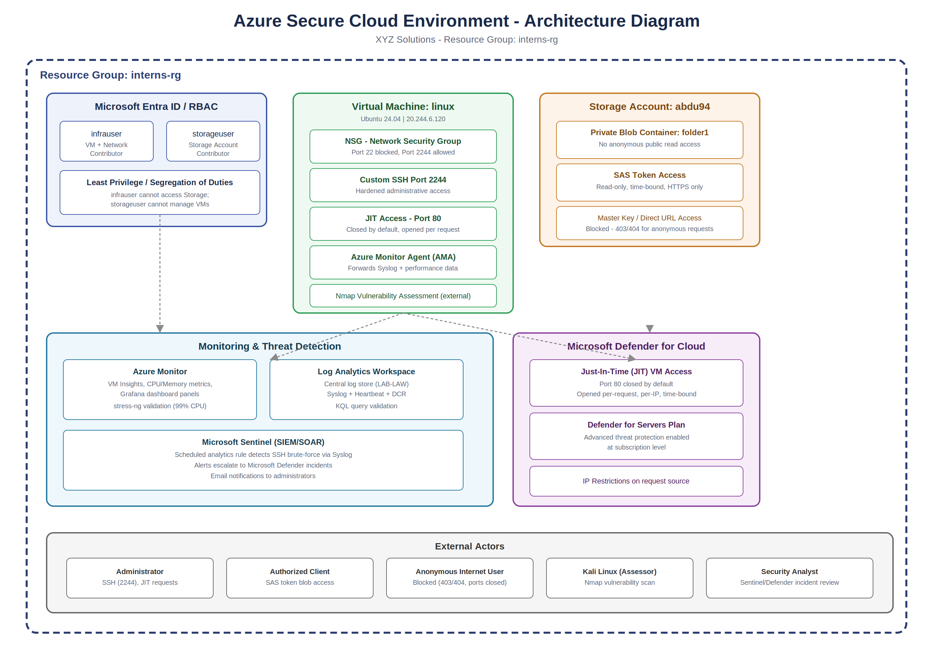
Figure A: Security architecture of the interns-rg environment, showing identity, compute, storage, monitoring, and JIT access control boundaries.

5. Recommendations
The following actions are recommended to further mature the security posture of the XYZ Solutions environment beyond this baseline implementation.

5.1 Identity and Access
- Enforce Multi-Factor Authentication (MFA) via Microsoft Entra ID Conditional Access for infrauser, storageuser, and all administrative accounts.
- Periodically review RBAC role assignments to confirm least-privilege scope remains appropriate as the environment grows.

5.2 Network and Compute
- Extend Just-In-Time access to cover the custom SSH port (2244) in addition to port 80, so administrative access is opened only on request.
- Reduce the attack surface identified by the Nmap scan by disabling or restricting unused services (e.g., RPC/NetBIOS) that are not required for the VM's workload.
- Consider Azure Bastion or a VPN gateway for administrative access instead of exposing any SSH port directly to the internet.

5.3 Storage
- Remove public network access paths entirely from the storage account and implement a Private Endpoint inside a dedicated Virtual Network (VNet).
- Adopt shorter SAS token lifetimes and stored access policies so tokens can be revoked centrally without rotating the storage account keys.

5.4 Monitoring and Detection
- Expand Microsoft Sentinel analytics rules beyond SSH brute-force detection to cover anomalous storage access, privilege escalation, and resource deletion events.
- Use the following KQL query as a starting template for brute-force detection tuning:
Syslog | where ProcessName == "sshd" and SyslogMessage has "Failed password" | summarize FailedAttempts = count() by SourceIP = extract("from ([0-9.]+)", 1, SyslogMessage), Computer, TimeGenerated | where FailedAttempts > 5
- Configure automated SOAR playbooks in Sentinel to automatically block a source IP or disable an account when brute-force incidents are confirmed.

5.5 Governance
- Document and schedule periodic vulnerability scans (e.g., recurring Nmap or Defender vulnerability assessments) rather than a single point-in-time scan.
- Maintain an updated architecture diagram and control inventory as new resources are added to the resource group.

6. Final Deliverables
The following deliverables accompany this report as evidence of successful implementation and testing of each control:
- Architecture Diagram (Section 4)
- VM Configuration Screenshots (provisioning, essentials, port hardening verification)
- RBAC Configuration Screenshots (Entra ID users, role assignments, access-denied validation)
- Storage Security Screenshots (private container, SAS token generation and validation)
- Azure Monitor Dashboard Screenshots (VM Insights, Grafana panels, stress-ng validation)
- Microsoft Sentinel Screenshots (analytics rule, incidents, Defender integration)
- JIT Access Screenshots (policy configuration, request/approval, before/after access validation)
- Nmap Scan Results (port scan, service detection, OS detection, exported report)
- This Security Assessment Report
— End of Report —

