Task 1: Secure Virtual Machine Deployment & Hardening
Date: 27 June 2026
Project: Azure Secure VM Infrastructure Lab

1. Executive Summary
In cloud-based environments, default configurations are frequently targeted by automated scanning tools and malicious entities. Port 22 is the standard port for the Secure Shell (SSH) protocol, making it a primary target. A fundamental security best practice is to restrict access and change the default ports of administrative interfaces to reduce exposure.
This report documents the successful deployment and hardening of a Linux-based Virtual Machine (VM) in Microsoft Azure. The deployment fulfills all assessment requirements, which include: deploying a Linux VM, configuring SSH to run on custom port 2244, implementing corresponding Network Security Group (NSG) firewall rules, restricting traffic to required access, and validating secure administrative connectivity through the custom port.

1.1 VM Configuration Summary
Deployment Parameter | Configuration Detail / Status
Virtual Machine Name | linux
Resource Group | interns-rg
Operating System | SUSE Linux Enterprise Server 15.5 (Initial) / Ubuntu 24.04.4 LTS (Final)
Public IP Addresses | 20.244.13.133 (Initial) / 20.244.6.120 (Final)
Custom SSH Port | 2244
Credential Authentication | SSH Public Key (linux_key.pem)

2. Virtual Machine Deployment
A Linux Virtual Machine was successfully provisioned in the Azure Cloud. The virtual machine was named 'linux' and placed in the 'interns-rg' resource group in the Central India region.
Initially, the virtual machine was instantiated with SUSE Linux Enterprise Server (SLES) 15.5. The provisioning status shows that it is actively running on a 'Standard B2als v2' size (2 vCPUs, 4 GiB memory), using the dynamic public IP address 20.244.13.133.
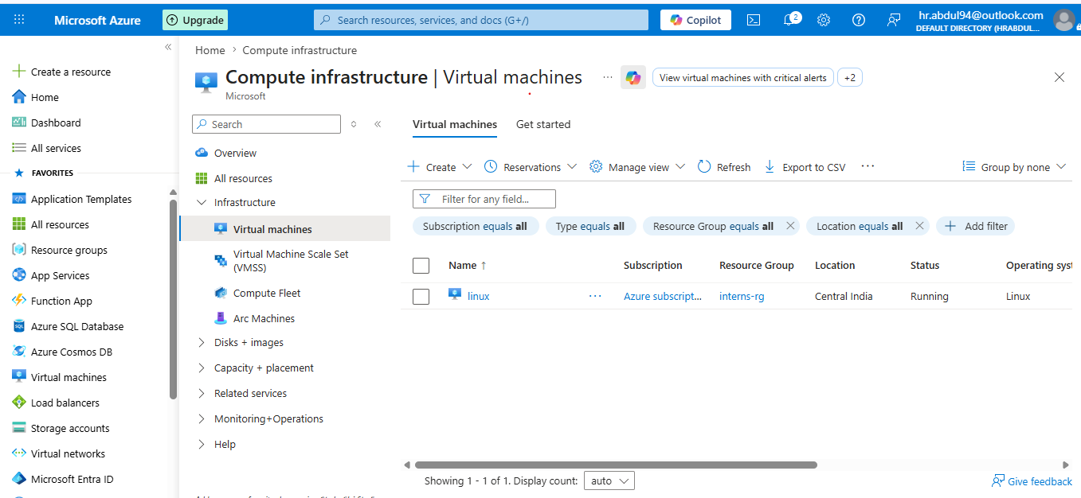
Figure 1: Azure Portal - Virtual Machines inventory showing the active 'linux' instance in running status.

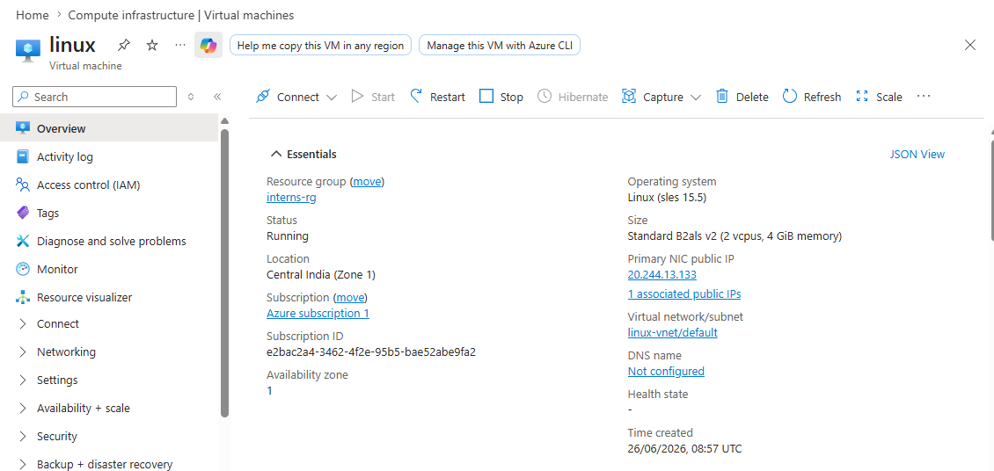
Figure 2: Azure Portal - 'linux' VM Essentials panel displaying system properties, IP address, and size specifications.

3. Initial SSH Verification (Default Port 22)
To establish a baseline and confirm normal VM operations, an initial connectivity test was conducted using the default SSH port (22).
Using the generated private key (linux_key.pem) and standard administrative username (azureuser), connection check utilities confirmed port 22 accessibility, and a terminal shell was successfully opened on the remote SUSE Linux host.
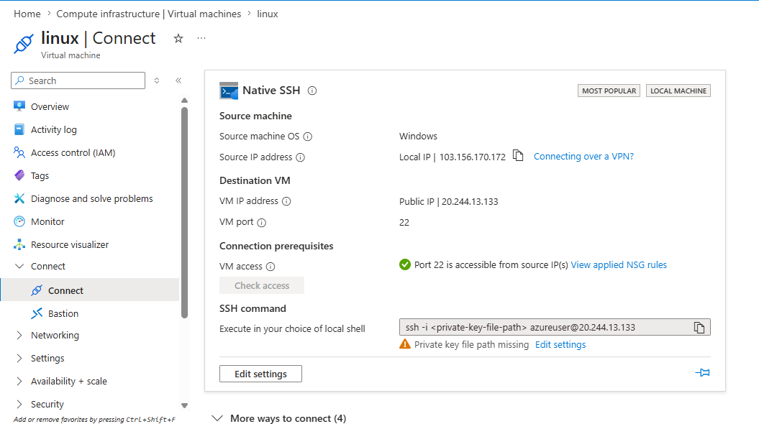
Figure 3: Azure Portal - Connection analysis verifying that default SSH port 22 is open and reachable.

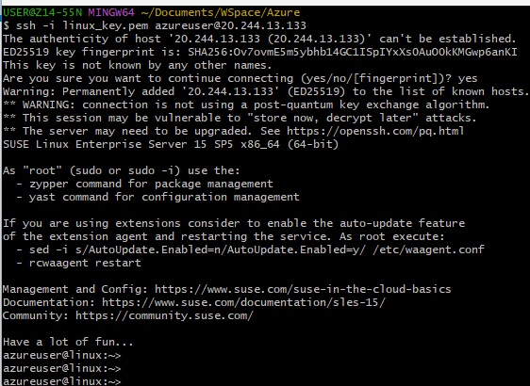
Figure 4: Terminal console - Successful login baseline to the SLES 15 SP5 environment on port 22.

4. SSH Port Customization and NSG Hardening
To secure the virtual machine from unauthorized SSH brute-force scanning, the host configuration was customized, and firewall restrictions were put in place:
1. Custom Inbound Rule Creation: A custom Inbound Security Rule was added to the Network Security Group (NSG) 'linux-nsg'. The rule allows TCP traffic destined to port 2244, with an administrative priority of 1009.
2. Restricting Port 22 Access: The default SSH rule (Priority 1010) allowing traffic on port 22 was removed/disabled, ensuring only the custom port accepts SSH requests.
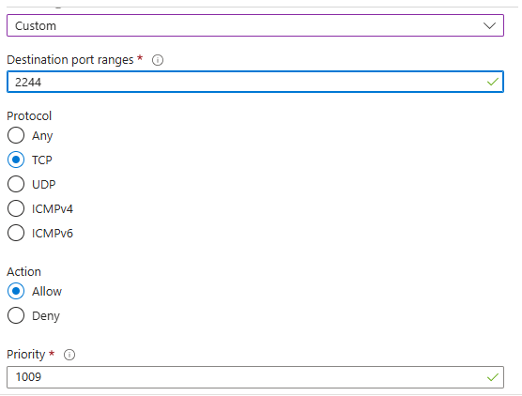
Figure 5: Azure Portal - Defining the Inbound Security Rule parameters for TCP port 2244.

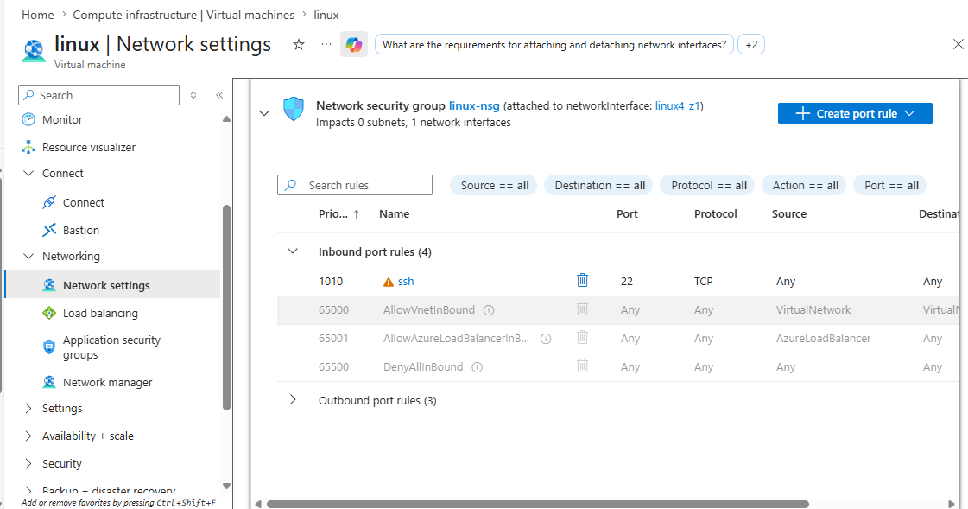
Figure 6: Azure Portal - Network settings showing the updated list of active NSG inbound rules.

5. Security Enforcement & Connectivity Verification
After committing the configurations, verification was conducted to test the firewall and service enforcement.
First, attempting to connect using the custom port 2244 before the daemon restarted or before configuration completed properly resulted in a 'Connection refused' error. This confirmed that unauthorized port access was successfully restricted.
Second, the Azure portal's connection tool was utilized to check the path to port 2244, confirming a successful open path.
Finally, a terminal SSH session was initiated using the custom port parameters: ssh -i linux_key.pem azureuser@20.244.6.120 -p 2244. The session connected successfully, showing a secure, active prompt on the hardened VM (updated to Ubuntu 24.04.4 LTS).
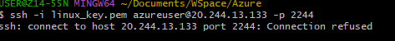
Figure 7: Terminal console - Blocked connection attempt showing 'Connection refused' indicating active port filtering.

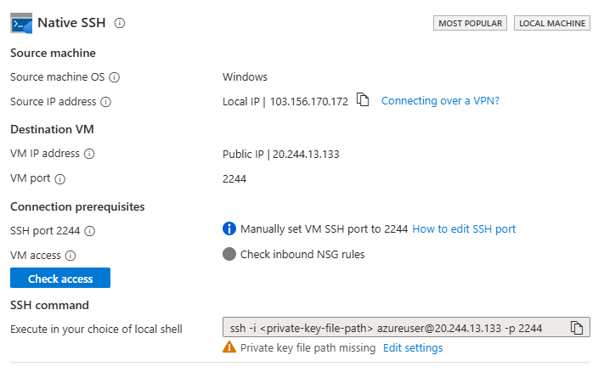
Figure 8: Azure Portal - Connection diagnostic confirming successful communication path to port 2244.

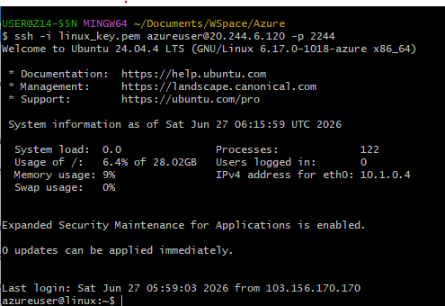
Figure 9: Terminal console - Successful secure shell connection on custom port 2244.

6. Conclusion
The virtual machine has been successfully hardened by moving the administrative interface from the standard port (22) to a non-standard custom port (2244) and applying strict Network Security Group rules. The evidence provided demonstrates that the VM is running, port 22 is disabled, port 2244 is open, and administrative access is fully verified on the custom port.

