

Operating System

Ad Hoc Internet Sharing with Microsoft Windows XP

Microsoft Corporation
Published: October 2003
Updated: August 2004

Abstract
The Internet Connection Sharing (ICS) feature of Microsoft® Windows® XP allows you to share a single Internet connection with multiple computers. Built-in support for IEEE 802.11 wireless LANs (WLANs) allows you to create an ad hoc wireless network. These two features can be used together to share a wired Internet connection with the members of an ad hoc wireless network. This article describes how to quickly and easily use Windows XP to share a wired Internet connection with other WLAN computers.

The information contained in this document represents the current view of Microsoft Corporation on the issues discussed as of the date of publication. Because Microsoft must respond to changing market conditions, it should not be interpreted to be a commitment on the part of Microsoft, and Microsoft cannot guarantee the accuracy of any information presented after the date of publication.
This document is for informational purposes only. MICROSOFT MAKES NO WARRANTIES, EXPRESS OR IMPLIED, AS TO THE INFORMATION IN THIS DOCUMENT.
Complying with all applicable copyright laws is the responsibility of the user. Without limiting the rights under copyright, no part of this document may be reproduced, stored in or introduced into a retrieval system, or transmitted in any form or by any means (electronic, mechanical, photocopying, recording, or otherwise), or for any purpose, without the express written permission of Microsoft Corporation.
Microsoft may have patents, patent applications, trademarks, copyrights, or other intellectual property rights covering subject matter in this document. Except as expressly provided in any written license agreement from Microsoft, the furnishing of this document does not give you any license to these patents, trademarks, copyrights, or other intellectual property.
© 2003 Microsoft Corporation. All rights reserved.
Microsoft, Windows, and Windows Server are either registered trademarks or trademarks of Microsoft Corporation in the United States and/or other countries.
The names of actual companies and products mentioned herein may be the trademarks of their respective owners.

Contents
Overview 1
Configuring Ad Hoc Internet Sharing 2
1. Connecting the ICS Host Computer to the Internet 2
2. Enabling Internet Sharing on the Internet Connection of the ICS Host Computer 4
3. Creating an Ad Hoc Wireless Network on the ICS Host Computer 4
4. Connecting to the New Ad Hoc Wireless Network from the Other Laptop Computers 6
Restoring the Configuration of the ICS Host Computer 9
Summary 10
Related Links 11

Overview
With the Internet Connection Sharing (ICS) feature of Windows XP, you can share access to the Internet with other computers of a small network. For example, when you have one computer that connects to the Internet by using an Ethernet cable and ICS is enabled on the Ethernet connection of this computer, known as the ICS host computer, the other computers on the small network can connect to the Internet through the ICS host computer.
With IEEE 802.11 support for wireless LANs (WLANs), you can create an ad hoc wireless network, also known as a computer-to-computer wireless network. An ad hoc wireless network does not require the use of a wireless access point, which is a separate device that is typically used by private organizations and public locations to provide centralized wireless access to a larger network. You can use ad hoc wireless networks to connect multiple WLAN computers together in homes, small businesses, or for temporary connectivity between two or more computers so that they can either communicate with each other or with a shared resource, such as the Internet. It is this last case that we will explore in this article. We will describe the steps required to configure a computer running Windows XP to connect to the Internet using an Ethernet connection and then share that Internet connection with other WLAN-based computers using an ad hoc wireless network.

Configuring Ad Hoc Internet Sharing
This configuration assumes the following configuration:
- A laptop computer running Windows XP that is equipped with both Ethernet and 802.11 WLAN network adapters. This computer is referred to as the ICS host computer.
- An Ethernet-based connection to the Internet.
- Laptops or other computers running Windows XP that are equipped with 802.11 WLAN network adapters.
The following figure shows the resulting configuration.
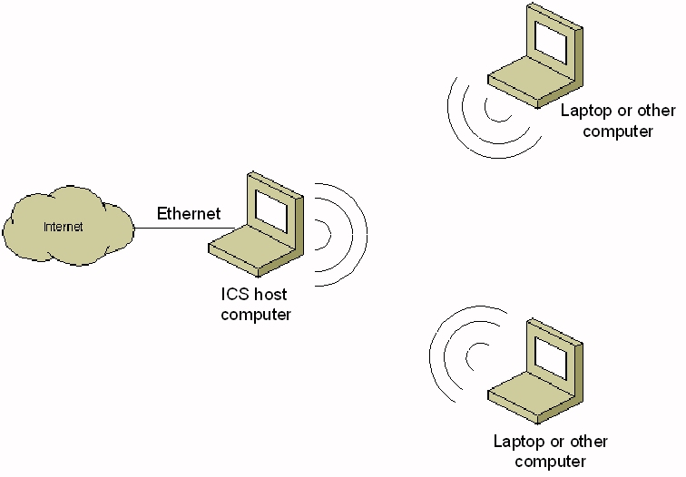
The steps to configuring ad hoc Internet sharing are the following:
- Connect the ICS host computer to the Internet.
- Enable Internet sharing on the Internet connection of the ICS host computer.
- Create an ad hoc wireless network on the ICS host computer.
- Connect to the new ad hoc wireless network from the other laptop computers.
The following sections describe these steps in detail.
Note The following steps assume that the wireless network adapters installed in all of the wireless client computers can connect using a common 802.11 technology, such as 802.11b, 802.11g, or 802.11a.

1. Connecting the ICS Host Computer to the Internet
Connect an Ethernet cable that leads to the Internet to the Ethernet adapter on the ICS host computer. In many cases, the Internet connection will provide automatic IP addressing. To utilize this facility of the Internet connection, the Ethernet connection in the Network Connections folder in Windows XP must be configured for automatic addressing. To configure a computer running Windows XP for automatic addressing, do the following:
- From the Windows XP desktop, click Start, click Control Panel, click Network and Internet Connections, and then click Network Connections.
- Right-click the network connection that corresponds to the Ethernet network adapter attached to the Internet, and then click Properties.
- On the General tab, double-click Internet Protocol (TCP/IP) in the This connection uses the following items list.
- On the General tab, click Obtain an IP address automatically and Obtain DNS server address automatically. An example is shown in the following figure.
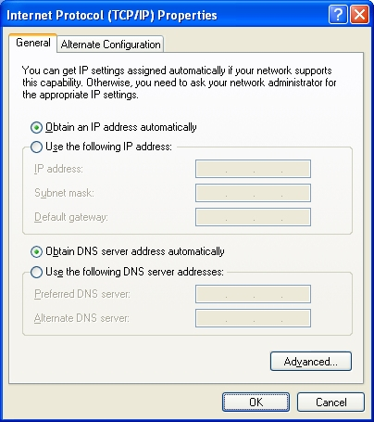
- Click OK to save the changes to your connection's configuration.
If the Internet connection does not provide automatic IP addressing, you must manually configure an IP address configuration. To obtain an IP address configuration, see the network administrator of the network to which you are connecting. To manually configure a computer running Windows XP for an IP address configuration, do the following:
- From the Windows XP desktop, click Start, click Control Panel, click Network and Internet Connections, and then click Network Connections.
- Right-click the network connection that corresponds to the Ethernet network adapter attached to the Internet, and then click Properties.
- On the General tab, double-click Internet Protocol (TCP/IP) in the This connection uses the following items list.
- On the General tab, click Use the following IP address and type the IP address, subnet mask, and default gateway as instructed. Click Use the following DNS server addresses and type the IP address of a preferred and alternate Domain Name System (DNS) server as instructed.
- Click OK to save the changes to your connection's configuration.
Next, you must enable the Windows Firewall feature of Windows XP with Service Pack 2 (SP2), the Internet Connection Firewall (ICF) feature of Windows XP with Service Pack 1 (SP1) or Windows XP with no service packs installed, or a third-party firewall to help protect the ICS host computer from malicious Internet users.
To enable Windows Firewall on the ICS host computer, do the following:
- From the Windows XP desktop, click Start, click Control Panel, click Network and Internet Connections, and then click Windows Firewall.
- Click On, and then click OK.
To enable ICF on the Internet connection of the ICS host computer, do the following:
- From the Windows XP desktop, click Start, click Control Panel, click Network and Internet Connections, and then click Network Connections.
- Right-click the Ethernet network connection that corresponds to the Ethernet network adapter attached to the Internet, and then click Properties.
- On the Advanced tab, select the Protect my computer by limiting or preventing access to this computer from the Internet check box.
- Click OK to save changes to your connection.
After the ICS host computer is connected to the Internet, verify that you have Internet connectivity by using a Web browser such as Internet Explorer to view a few Web sites. To ensure that you are not viewing locally stored copies of Web page contents, refresh each Web page that you view.
When you are confident that you are accessing the Internet from the ICS host computer, proceed to the next step.

2. Enabling Internet Sharing on the Internet Connection of the ICS Host Computer
To enable Internet sharing on the Internet connection of the ICS host computer, do the following:
- From the Windows XP desktop, click Start, click Control Panel, click Network and Internet Connections, and then click Network Connections.
- Right-click the Ethernet network connection that is used to access the Internet, and then click Properties.
- On the Advanced tab, select the Allow other network users to connect through this computer's Internet connection check box and clear the Allow other network users to control or disable this shared Internet connection check box.
- Click OK to save changes to your connection.
- You might be prompted with a Local Network message box that explains how your computer's configuration is being changed. Click Yes to enable Internet sharing.

3. Creating an Ad Hoc Wireless Network on the ICS Host Computer
To create an ad hoc wireless network to share Internet access with the other WLAN computers on a computer running Windows XP with SP2 or Windows XP with SP1 and the WPA Wireless Security Update in Windows XP, do the following:
- From the Windows XP desktop, click Start, click Control Panel, click Network and Internet Connections, and then click Network Connections.
- Right-click the wireless network connection, and then click Properties.
- Click the Wireless Networks tab.
- In the wireless network adapter properties dialog box, click Add under Preferred networks.
- On the Association tab, type the name of your ad hoc wireless network in Network name (SSID). For example, you could name your wireless network AdHocInternet.
- Select the This is a computer-to-computer (ad hoc) network check box and clear the The key is provided for me automatically check box.
- In Network Authentication, select Open.
- In Data encryption, select WEP.
- In Network key, type the WEP key. The WEP key should be a random sequence of hexadecimal digits or numbers, letters, and punctuation.
- In Confirm network key, retype the WEP key.
- Click OK to save changes to the wireless network.
- Click OK to save changes to the wireless network adapter.
To create an ad hoc wireless network to share Internet access with the other WLAN computers on a computer running Windows XP with SP1, do the following:
- From the Windows XP desktop, click Start, click Control Panel, click Network and Internet Connections, and then click Network Connections.
- Right-click the wireless network connection, and then click Properties.
- Click the Wireless Networks tab.
- In the wireless network adapter properties dialog box, click Add under Preferred networks.
- On the Association tab of the Wireless Network Properties dialog box, type the name of your ad hoc wireless network in Network name (SSID). For example, you could name your wireless network AdHocInternet.
- Select the Data encryption (WEP enabled) and This is a computer-to-computer (ad hoc) network check boxes and clear the The key is provided for me automatically check box.
- In Network key, type the WEP key. The WEP key should be a random sequence of hexadecimal digits or numbers, letters, and punctuation.
- Retype the WEP key in Confirm network key.
- Click OK to save changes to the wireless network.
- Click OK to save changes to the wireless network adapter.
To create an ad hoc wireless network to share Internet access with the other WLAN computers on a computer running Windows XP with no service packs installed, do the following:
- From the Windows XP desktop, click Start, click Control Panel, click Network and Internet Connections, and then click Network Connections.
- Right-click the wireless network connection, and then click Properties.
- Click the Wireless Networks tab.
- In the wireless network adapter properties dialog box, click Add under Preferred networks.
- In the Wireless Network Properties dialog box, type the name of your ad hoc wireless network in Network name (SSID). For example, you could name your wireless network AdHocInternet.
- Select the Data encryption (WEP enabled) and This is a computer-to-computer (ad hoc) network check boxes and clear the The key is provided for me automatically check box.
- In Key format, select a key format.
- In Key length, select a key size.
- In Network key, type the WEP key. The WEP key should be a random sequence of hexadecimal digits or numbers, letters, and punctuation.
- Click OK to save changes to the wireless network.
- Click OK to save changes to the wireless network adapter.
These instructions configure an encryption key for wireless communications on the ad hoc wireless network. You must tell the other users who want to access the Internet the WEP key. You can create an ad hoc wireless network without requiring encryption and an encryption key, but it is not recommended.

4. Connecting to the New Ad Hoc Wireless Network from the Other Laptop Computers
To connect each other laptop computer to the newly created ad hoc mode wireless network, do the following:
- Once the new ad hoc wireless network is created, Windows XP on other laptop computers should detect it and prompt you with a One or more wireless networks are available or Wireless networks detected message in the notification area of your taskbar.
- Click the notification message.
If you are not notified, right-click the wireless network adapter in Network Connections and click View Available Wireless Networks.
You should see the Wireless Network Connection dialog box (for Windows XP with SP2), a dialog box with the name of the wireless connection (for Windows XP with SP1), or the Connect to Wireless Network dialog box (for Windows XP with no service packs installed). An example of the Wireless Network Connection dialog box for Windows XP with SP2 is shown in the following figure.
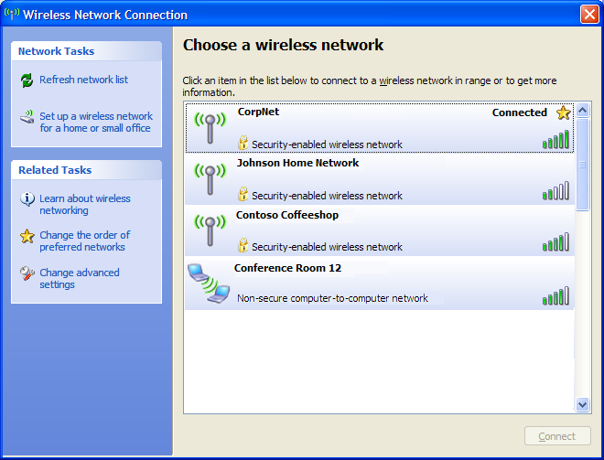
- For Windows XP with SP2, click the name of the new ad hoc wireless network in the list, and then click Connect. When prompted by the Wireless Network Connection dialog box, the WEP key in Network key and Confirm network key, and then click Connect.
For Windows XP with SP1, click the name of the new ad hoc wireless network in Available networks, type the WEP key in Network key and Confirm network key, and then click Connect.
For Windows XP with no service packs installed, click the name of the new ad hoc wireless network in Available networks, type the WEP key in Network key, and then click Connect.
Now that the laptop computer is connected to the ad hoc wireless network, you must configure it for either Windows Firewall or ICF and automatic addressing by doing the following:
- From the Windows XP desktop, click Start, click Control Panel, click Network and Internet Connections, and then click Network Connections.
- Right-click the network connection that corresponds to the wireless network adapter, and then click Properties.
- For computers running Windows XP with SP2, click the Advanced tab, and then click Settings. From the Windows Firewall dialog box, click On, and then click OK.
For computers running Windows XP with SP1 or Windows XP with no service packs installed, click the Advanced tab, and then select the Protect my computer and network by limiting or preventing access to this computer from the Internet check box.
- Click the General tab, double-click Internet Protocol (TCP/IP) in the This connection uses the following items list.
- On the General tab, click Obtain an IP address automatically and Obtain DNS server address automatically.
- Click OK to save the changes to the configuration of Internet Protocol (TCP/IP).
- Click OK to save the changes to your connection's configuration.
The laptop computer should receive an IP address configuration from the ICS host computer and have Internet connectivity. Test Internet connectivity by using a Web browser to view Web pages.

Restoring the Configuration of the ICS Host Computer
After the ad hoc Internet sharing is no longer needed, you can restore the configuration of the ICS host computer running Windows XP by doing the following:
- From the Windows XP desktop, click Start, click Control Panel, click Network and Internet Connections, and then click Network Connections.
- Right-click the Ethernet network connection that is used to access the Internet, and then click Properties.
- On the Advanced tab, clear the Allow other network users to connect through this computer's Internet connection check box. If you are shutting down the computer to later connect it to a secure private network, such as an organization intranet and for which a firewall is not required, do one of the following:
- For computers running Windows XP with SP2, click Settings. From the Windows Firewall dialog box, click Off, and then click OK.
- For computers running Windows XP with SP1 or Windows XP with no service packs installed, clear the Protect my computer by limiting or preventing access to this computer from the Internet check box.
- Click OK to save changes to your connection.
The IP address configuration of the wireless network connection is restored back to its original settings.

Summary
To share an Ethernet-based Internet connection with other ad hoc wireless computers, configure an ICS host computer to connect to the Internet using an Ethernet network adapter, configure the Ethernet network connection for Internet sharing, create an ad hoc wireless network, and then configure each other wireless computer to use the ad hoc wireless network and for automatic addressing. To restore the configuration of the ICS host computer, disable Internet sharing on the Ethernet network connection.

Related Links
See the following resources for further information:
- Home and Small Office Networking with Windows XP at http://www.microsoft.com/homenet
- Configure Internet Connection Sharing in Windows XP at http://support.microsoft.com/default.aspx?scid=kb;en-us;Q306126&sd=tech
- Troubleshooting Internet Connection Sharing in Windows XP at http://support.microsoft.com/default.aspx?scid=kb;en-us;308006

For the latest information about Windows XP, see the Windows XP Web site at http://www.microsoft.com/windowsxp.

