

Step-by-Step Secure Wireless for Home / Small Office and Small Organizations
Microsoft Corporation
Published: October 2005
Author: Brit Weston
Editor: Allyson Adley

Abstract
This white paper presents two deployment methods for secure wireless access: one for small office/home office (SOHO) networks and one for small organizations. For SOHO networks, this guide describes how to configure secure wireless access for computers running Microsoft Windows® XP with Service Pack 2 (SP2) and other wireless devices. For small domain-based organizations, this guide provides step-by-step instructions for configuring secure IEEE 802.1X authenticated wireless access. This configuration requires one or more wireless access points (APs), wireless client computers running Windows XP with SP2, and a computer running Windows Server 2003 with SP1.

Information in this document, including URL and other Internet Web site references, is subject to change without notice. Unless otherwise noted, the example companies, organizations, products, domain names, e-mail addresses, logos, people, places, and events depicted herein are fictitious, and no association with any real company, organization, product, domain name, e-mail address, logo, person, place, or event is intended or should be inferred. Complying with all applicable copyright laws is the responsibility of the user. Without limiting the rights under copyright, no part of this document may be reproduced, stored in or introduced into a retrieval system, or transmitted in any form or by any means (electronic, mechanical, photocopying, recording, or otherwise), or for any purpose, without the express written permission of Microsoft Corporation.

Microsoft may have patents, patent applications, trademarks, copyrights, or other intellectual property rights covering subject matter in this document. Except as expressly provided in any written license agreement from Microsoft, the furnishing of this document does not give you any license to these patents, trademarks, copyrights, or other intellectual property.

© 2005 Microsoft Corporation. All rights reserved.

Microsoft, Active Directory, MS-DOS, Windows, Windows NT, and Windows Server are either registered trademarks or trademarks of Microsoft Corporation in the United States and/or other countries.

All other trademarks are property of their respective owners.

Contents
Step-by-Step Guide for Secure Wireless Deployment for Small Office/Home Office or Small Organization Networks 7
Wireless Connections Overview 8
Deploying wireless access in a small office or home office 10
Preparation 10
Running the Wireless Network Setup Wizard 12
Configuring your wireless AP and other Windows Connect Now-capable wireless devices 18
Configuring Wireless Computers 19
Completing the Wireless Network Setup Wizard 21
SOHO wireless resources 23
Deploying Wireless Access in Small Organizations 23
Components of a wireless infrastructure in a small organization 24
Domain controller 24
Server certificates 26
IAS 26
Wireless APs (RADIUS clients) 27
Wireless client computers 27
Preparation and recommendations 28
Active Directory configuration requirements 28
DHCP configuration requirements 28
Wireless APs 28
IAS RADIUS clients (wireless APs) 32
Client computers with IEEE 802.11 wireless adapters 33
Configuring the wireless network in your small organization 33
Configuring a computer running Windows Server 2003 as a domain controller 33
Deploying and configuring wireless APs 69
Obtaining and installing a server certificate 70
Installing and Configuring IAS 73
Installing IAS 73
Configuring Group Policy settings for wireless network (IEEE 802.11) policies 103
See Also 115

Step-by-Step Guide for Secure Wireless Deployment for Small Office/Home Office or Small Organization Networks

This white paper presents two deployment methods for secure wireless access: one for small office/home office (SOHO) networks and one for small organizations whose domain-based networks are built using Microsoft® Windows Server™ 2003 technologies.
If you are planning a new network with wireless access or if you are considering a change to a different type of network with wireless access, this paper provides information that can assist you in determining which type of deployment suits your needs. In this paper, "IEEE 802.11 wireless" is referred to as "wireless."
Note
Although the instructions in this paper are written to help you create strong wireless security for your network, the concept of a "secure" network is relative and should be weighed with the confidentiality requirements of your home, small office, or small organization in mind.
Portable wireless devices are often used in multiple locations and they connect to multiple wireless fidelity (Wi-Fi) networks. In addition to securing your wireless network, you should also secure the data on portable devices when those devices are used on other, potentially less secure, networks. For information about how to protect your computers and data, see Securing Remote Clients and Portable Computers on the Microsoft Web site (http://go.microsoft.com/fwlink/?LinkId=55254).
If highly sensitive information, such as customer banking data, is regularly sent or stored on your network, you should consider hiring a specialist to configure your wireless network or reconsider the deployment of wireless devices on your network.
This paper is divided into three sections:
• Wireless Connections Overview
This section identifies the differences between SOHO networks and small organization networks. You can use this information to help you determine the more appropriate wireless solution for your needs.
• Deploying Wireless Access in the Small Office/Home Office
This section provides preparation information and step-by-step instructions for deploying wireless access on a SOHO network that uses computers running Windows XP with Service Pack 2 (SP2).
• Deploying Wireless Access in Small Organizations
This section provides a brief component overview, preparation information, recommendations, and step-by-step instructions for deploying secure IEEE 802.1X authenticated wireless access in small organizations that use Windows Server 2003, Standard Edition.
Note
This deployment is not intended for networks that use Microsoft Windows Small Business Server 2003. For information about deploying wireless access in small organizations that use Windows 2003 Small Business Server, see Providing Secure Wireless Services on the Microsoft Web site (http://go.microsoft.com/fwlink/?LinkId=49453).

Wireless Connections Overview
For the purposes of this paper, SOHO networks are workgroup-based networks. Small organization networks are domain networks that use Active Directory® and other Windows Server 2003 technologies.
The following table compares the deployment requirements of SOHO and small organization networks.

SOHO | Small Organization
Does not require any computers running Windows Server 2003. | Requires at least one computer running Windows Server 2003.
Fully supported in Windows XP Home Edition and Windows XP Professional Edition. | Does not support Windows XP Home Edition.
Relatively easy for a novice user to deploy. | More difficult to deploy. Not intended for the novice or small office user.
Requires a wireless access point (AP) or wireless router. | Requires one or more wireless APs that support 802.1X.
Provides wireless network access security through:  • Wi-Fi Protected Access (WPA) preshared key (PSK) authentication with Temporal Key Integrity Protocol (TKIP) encryption, referred to hereafter as WPA-PSK/TKIP. This is the preferred method.  or  • Open system authentication with Wired Equivalent Privacy (WEP), referred to hereafter as open system/WEP. | Provides strong wireless network access security through the use of Active Directory accounts, 802.1X, a RADIUS infrastructure, digital certificates on the RADIUS servers, Protected EAP Microsoft Challenge Handshake Authentication Protocol version 2 (PEAP-MS-CHAP v2), WPA.
Does not require the purchase of a server certificate. | Requires the purchase of a server certificate for PEAP-MS-CHAP v2 authentication.
Does not provide centralized management of user accounts or user authentication.  Anyone who is familiar with either the WPA PSK or the WEP key can join the workgroup and access network resources. | Provides centralized management of user accounts and user authentication using Active Directory user accounts database and Internet Authentication Service (IAS).  Users must have accounts in Active Directory and must provide password-based credentials to log on to the network. In addition, mutual authentication occurs with PEAP-MS-CHAP v2 when client computers authenticate the server running IAS with the IAS server certificate.
Provides limited methods to control or manage workgroup members. | Provides methods to manage domain member accounts. Controls can be fine-tuned.

Deploying wireless access in a small office or home office
To deploy wireless access on a SOHO network, each wireless device must be configured with the same wireless settings. The Windows Connect Now technology in Windows XP with SP2 can be used to configure wireless computers and devices. Windows Connect Now technology is built into many newer wireless devices, such as printers and wireless APs.
The wireless deployment for small offices or home offices is presented in three parts:
• Preparation
Lists the tasks that you need to complete before deploying your wireless network.
• Running the Wireless Network Setup Wizard
Windows Connect Now technology is incorporated into the Wireless Network Setup Wizard. Wireless devices that support Windows Connect Now are configured using the Wireless Network Setup Wizard and a Universal Serial Bus (USB) flash drive (UFD).
• SOHO Wireless Resources
Provides links to information about SOHO wireless networking.

Preparation
To set up your wireless network, you will first need to perform these tasks:
1. If you do not already have one, obtain a USB flash drive with a minimum capacity of 2 megabytes (MB).
2. If you have not already done so, purchase a wireless AP and use the manufacturer's documentation to physically connect it to your network.
Note
Do not configure any wireless settings on the wireless AP at this time.
The following figure shows the components of an Internet Gateway Device (IGD)-based network.
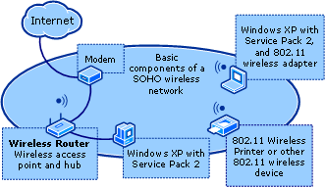

In an IGD-based network, the wireless AP (router) also serves as the IGD. Wireless IGD devices provide network services such as automatic addressing, network address translation (NAT), and bridging. These services enable your computers to communicate with each other and with devices and to share an Internet connection. Wireless IGD devices typically have a built-in hub that you can use to connect a few wired computers.
For an IGD network, use a Windows Connect Now-capable IEEE 802.11 wireless AP that is also a wireless router. For information about wireless devices that support Windows Connect Now technology, see the "Related Products" section in Windows Connect Now Technology on the Microsoft Web site (http://go.microsoft.com/fwlink/?LinkId=52352).
3. Determine which of your wireless devices support Windows Connect Now. See the product documentation for your wireless devices for details.
4. Select the most suitable encryption and authentication for your wireless network.
There are two choices for authentication and encryption: WPA-PSK/TKIP (recommended) and open system/WEP (discouraged). Both methods are supported by Windows XP with SP2.
a. Read the documentation provided with your wireless AP to determine which authentication and encryption options it supports.
b. Determine the level of authentication and encryption your other wireless devices (such as printers) support.
If all of your wireless devices support WPA, then select WPA in the procedure that follows. Use open system/WEP only if you have wireless network devices that do not support WPA-PSK/TKIP.
5. Laptop computers frequently have an external switch to turn the wireless adapter on or off. If any of your wireless computers are equipped with an external switch, make sure the switch is turned on.
6. Use Windows Update to upgrade all of your computers running Windows XP to Windows XP with SP2.
7. Ensure that wireless client computers are configured for automatic addressing, and that automatic wireless network configuration is enabled.
To configure computers for automatic addressing
1. To open Network Connections, click Start, click Connect to, and then click Show all connections.
2. Right-click your wireless network connection, and then click Properties.
3. On the General tab, in This connection uses the following items, click Internet Protocol (TCP/IP), and then click Properties.
4. On the Internet Protocol (TCP/IP) Properties dialog box, on the General tab, select Obtain an IP address automatically. Click OK twice, and then close Network Connections.
To enable automatic wireless network configuration
1. Click Start, click Control Panel, and then double-click Network Connections.
2. Right-click Wireless Network Connection, and then click Properties.
3. On the Wireless Networks tab, make sure the Use Windows to configure my wireless network settings check box is selected.

Running the Wireless Network Setup Wizard
Use the following procedures to set up your wireless network.
Note
If possible, you should launch the Wireless Network Setup Wizard on a computer that is already connected to a printer so that you can print the configuration information that is generated in the final steps of the Wireless Network Setup Wizard. Use this information to manually configure wireless devices that do not support Windows Connect Now.
To run the Wireless Network Setup Wizard
1. On one of your computers, click Start, click My Network Places, and in Network Tasks, click Set up a wireless network for a home or small office to launch the Wireless Network Setup Wizard.
The Welcome to Wireless Network Setup Wizard page is displayed, as shown in the following figure.
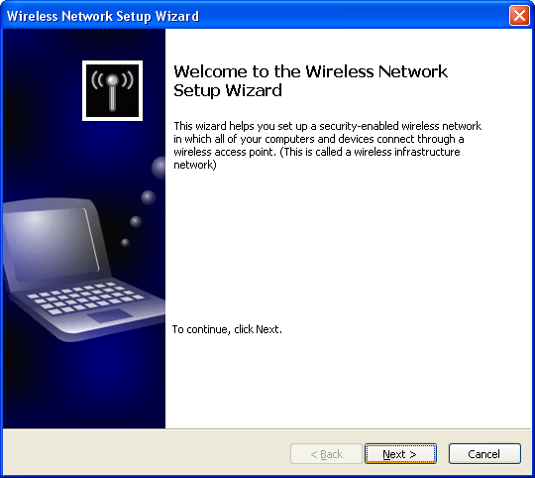

Click Next.
Note
In some cases, you might be redirected to the Network Setup Wizard and asked to provide an Internet connection method, your network name (workgroup name), and to indicate whether the network should be enabled for file and printer sharing. You must complete these tasks before you resume wireless setup.
If this is the first time the Wireless Network Setup Wizard has been launched on the computer, the Create a name for your wireless network page is displayed.
Specify the following:
a. In Network name (SSID), type a name for your wireless network. In the following example, the wireless network is named WiFi Test.
b. Select Automatically assign a network key.
c. Select the wireless encryption for your network.
Note
WPA is much stronger than WEP, but not all wireless devices are compatible with WPA.
If all of your wireless devices support WPA (recommended), select Use WPA encryption instead of WEP.
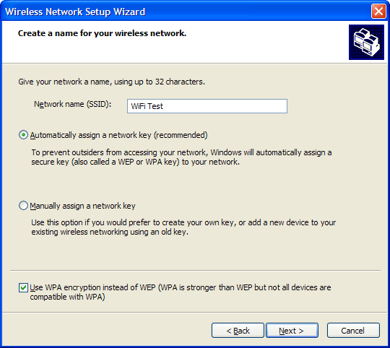

Click Next.
If the Wireless Network Setup Wizard has been launched on the computer before, the What do you want to do? page will be displayed. Select Set up a new wireless network, and then click Next.
2. On the How do you want to set up your network? page, select Use a USB flash drive, as shown in the following figure.
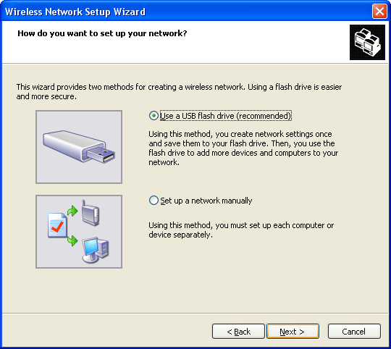

Click Next.
3. On the Save settings to your flash drive page, the wizard prompts you to insert your UFD so that it can create the files you will use to configure your other Windows Connect Now-capable wireless devices.
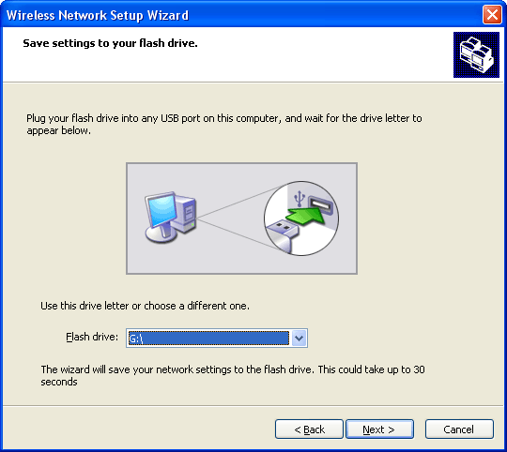

Note
When you plug your UFD into a USB port, the Wireless Network Setup Wizard will automatically detect the UFD and display the drive letter assigned to it in Flash drive. The drive letter that is displayed depends on the hardware configuration of each computer; it will not necessarily be G:\.
Click Next.
4. The Wireless Network Setup Wizard copies the wireless network settings and several other XML files to the UFD, and then displays the Transfer your network settings to your other computers or devices page, as shown in the following figure.
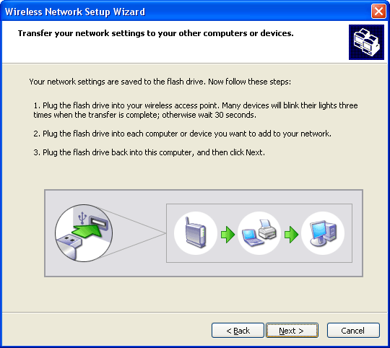

Important
Do not click Next at this time.

Configuring your wireless AP and other Windows Connect Now-capable wireless devices
Next, you will configure your wireless AP and other Windows Connect Now-capable wireless devices. If your wireless AP supports Windows Connect Now, configure it first, and then configure any remaining Windows Connect Now-capable devices, such as wireless printers.
Note
If none of your wireless devices support Windows Connect Now, go to the next procedure, Configuring wireless computers.
To configure your wireless AP and Windows Connect Now-capable wireless devices
1. Plug the UFD into your Windows Connect Now-capable wireless device.
For Windows Connect Now-capable wireless devices that have a monitor or readout display, select from the options provided by the wireless device.
For Windows Connect Now-capable wireless devices that do not have a monitor or readout display, watch the WLAN or USB LED on the indication panel of the wireless device. The LED will flash three times to indicate the configuration is complete for that wireless device.
Important
Some manufacturers use the WLAN or USB LED for other purposes, which may cause it to flash for reasons other than Windows Connect Now configuration. It is recommended that you leave the UFD in each wireless device for 30 seconds to ensure configuration is complete.
2. Remove the UFD from the device.
3. Configure your remaining Windows Connect Now-capable wireless devices using steps 1 and 2 in this procedure.

Configuring Wireless Computers
To configure wireless computers
1. When you plug the UFD into a computer running Windows XP with SP2, the Removable Disk page opens, and the following message is displayed:
This disk or device contains more than one type of content. What do you want Windows to do?
Select Wireless Network Setup Wizard using the program provided on the device.
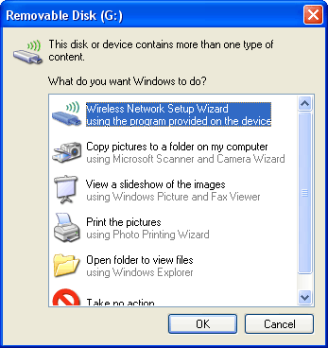

Note
If the Removable Disk page fails to launch automatically, you must launch the Wireless Network Setup Wizard manually:
a. Right-click Start, select Explore, and then navigate to the drive letter for your UFD.
b. Click your UFD drive, and in the right pane, under Name, double-click setupSNK.exe to launch the Wireless Network Setup Wizard.
c. Go to step 3.
2. Click OK to launch the Wireless Network Setup Wizard.
3. When prompted to add the computer to the wireless network, click OK.
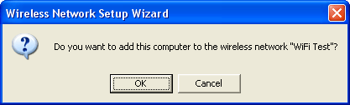

4. When the wizard displays the message, You have successfully added this computer to the wireless network, click OK.
5. Configure your remaining wireless computers using steps 1 - 4 in this procedure.

Completing the Wireless Network Setup Wizard
To complete the Wireless Network Setup Wizard
1. When you have finished configuring all of your Windows Connect Now-capable wireless devices, plug the UFD back into the computer on which the Wireless Network Setup Wizard was initially launched.
2. On the Transfer your network settings to your other computers or devices page, click Next.
3. The Wireless Network Setup Wizard displays the following page, which lists the wireless computers and devices that have been configured by the Wireless Network Setup Wizard and the UFD.
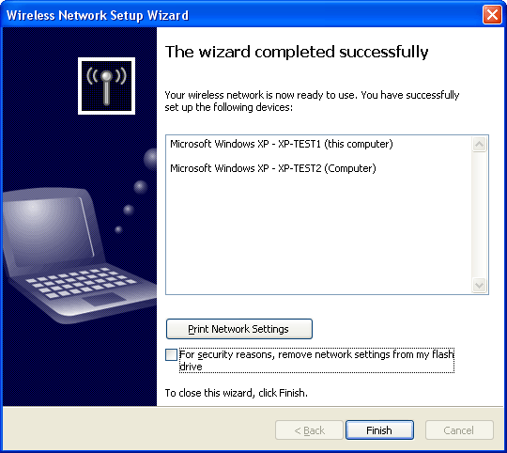

Click Print Network Settings to print the wireless network settings that were configured by the wizard. Use these settings to manually configure the wireless devices on your network that do not support Windows Connect Now.
If you want to use the UFD to configure wireless computers or devices later, clear the For security reasons, remove network settings from my flash drive check box and store the UFD in a secure location.
To remove the wireless network settings from the UFD, select the For security reasons, remove network settings from my flash drive check box.
4. Click Finish.

SOHO wireless resources
For information about wireless adapter and wireless access point support for WPA and WEP, see Certified product listing on the Wi-Fi Alliance Web site (http://go.microsoft.com/fwlink/?LinkId=49773).
For other information about wireless networking, see:
• Wireless Networking on the Microsoft Web site (http://go.microsoft.com/fwlink/?LinkId=49751)
• WPA Wireless Security for Home Networks on the Microsoft Web site (http://go.microsoft.com/fwlink/?LinkId=54434)
• The Cable Guy, November 2004 - Wi-Fi Protected Access Data Encryption and Integrity on the Microsoft Web site (http://go.microsoft.com/fwlink/?LinkId=49763)
• Troubleshooting Microsoft Windows XP-based Wireless Networks in the Small Office or Home Office at the Microsoft Web Site (http://go.microsoft.com/fwlink/?LinkId=55033)

Deploying Wireless Access in Small Organizations
This deployment scenario provides steps for implementing 802.1X authenticated wireless network access in a small organization on a single-subnet network of 250 or fewer network devices.
The deployment relies on one computer running Windows Server 2003 with SP1 to provide the following wireless authentication infrastructure:
• Active Directory domain controller.
• Internet Authentication Service (IAS).
• A server certificate obtained from VeriSign.
• PEAP-MS-CHAP v2 configured as the authentication method in the IAS remote access policy and on client computers running Windows XP with SP2.
• Client computers with IEEE 802.11 wireless adapters.
• One or more wireless APs.
The wireless deployment for small organizations is presented in three parts:
• Components of a wireless infrastructure in a small organization
• Preparation and recommendations
• Configuring your small organization wireless network

Components of a wireless infrastructure in a small organization
The following figure shows the main components of the wireless infrastructure documented in this deployment scenario.
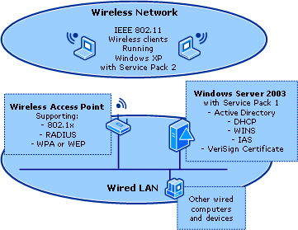

Domain controller
You will use the following components and component features to configure your domain controller:

Active Directory
Active Directory domains contain the user accounts, computer accounts, and properties that are required to authenticate user credentials and to evaluate authorization for wireless and other network connections. Administrators can manage user accounts, network access, shared resources, site topology, and other directory objects from the domain controller.
• Active Directory user accounts, computer accounts, and groups
Active Directory user and computer accounts represent physical entities, such as a computer or person. User and computer accounts that belong to a particular group are referred to as group members. A group is a collection of user and computer accounts that can be managed as a single unit.
• Domain functional level
This deployment relies on features that are available only in two domain functional levels:
• Windows 2000 native
• Windows Server 2003
Domain functional level is determined by the server operating systems of the domain controllers on your network:

Domain controllers | Domain functional level
Windows NT 4.0  Windows 2000  Windows Server 2003 family | Windows 2000 mixed  (default)
Windows 2000  Windows Server 2003 family | Windows 2000 native
Windows NT 4.0  Windows Server 2003 family | Windows Server 2003 interim
Windows Server 2003 | Windows Server 2003

Note
You cannot use these wireless deployment instructions if your network has domain controller computers running Windows NT 4.0.

WINS
Windows Internet Name Service (WINS) is a software service that dynamically maps computer names to IP addresses. Some software applications depend on WINS to access resources.

DHCP
DHCP servers lease IP addresses to network client computers and distribute other configuration parameters to network clients.
• DHCP scopes
DHCP scopes define a single physical subnet on your network and are used by the DHCP server to manage network client IP address assignment and any related configuration parameters.
• DHCP leases
DHCP servers lease IP addresses to network client computers from a finite pool of addresses called an IP address range. Each lease has an expiration period.
• DHCP Server authorization
To lease addresses to network clients, DHCP servers must be authorized in Active Directory. This behavior is designed to prevent unauthorized DHCP servers running Windows operating systems from leasing incorrect IP addresses to network clients or denying DHCP clients that are attempting to renew current address leases.

Server certificates
This deployment scenario relies on:
• PEAP-MS-CHAP v2 to provide secure wireless user authentication with password-based credentials.
• Server certificate installed on the server running IAS, so that the server can authenticate itself to wireless clients. To use PEAP-MS-CHAP v2, this server must have a server certificate that is issued by a certification authority (CA) that is trusted by your wireless clients.
VeriSign, Inc. has partnered with Microsoft to allow customers to easily obtain and install a VeriSign WLAN server certificate for servers running IAS that perform PEAP-MS-CHAP v2 authentication. Client computers running Windows operating systems trust the VeriSign server certificates by default.

IAS
IAS is the Microsoft implementation of a RADIUS server or proxy. IAS manages authentication, authorization, and accounting for virtual private network (VPN), dial-up, 802.1X wireless, and Ethernet switch connection attempts that are compatible with the IETF RADIUS protocol.
In this scenario, IAS is used to authenticate and authorize wireless connection requests. Each wireless AP is configured in IAS as a RADIUS client. By creating an IAS remote access policy, you define who can connect to your network through wireless APs.
• IAS wireless remote access policy
A remote access policy is configured for wireless connections so that employees can access the organization's intranet.
• Wireless APs as IAS RADIUS clients
Wireless APs must be configured as IAS RADIUS clients to communicate with the server running IAS.
• Vendor-specific attributes
Some wireless APs require vendor-specific attributes (VSAs). These attributes provide functionality that is not supported in the standard RADIUS attributes. IAS includes VSAs from a number of vendors in its dictionary; however, not all VSAs for all vendors are included. For required VSAs that are not in the IAS VSA dictionary, you can create a VSA in the profile settings of each remote access policy.
• Logging
Enable logging to store authentication and accounting information for connection analysis and security investigation. IAS can log information to either a local file or to a Structured Query Language (SQL) file in a Microsoft SQL Server™ 2000 database.

Wireless APs (RADIUS clients)
This deployment scenario requires one or more wireless APs compatible with the RADIUS protocol and 802.1X connected to your wired network.

Wireless client computers
Because Windows XP with SP2 has built-in support for IEEE 802.1X authentication using the Extensible Authentication Protocol (EAP), built-in VeriSign trusted root CA certificates, Wireless Auto Configuration, as well as support for WPA and WEP, Windows XP with SP2 requires the least amount of manual configuration. For ease of configuration, and enhanced security, this paper documents configuration to support client computers running Windows XP with SP2.
Note
Wireless Auto Configuration is the feature in Windows XP and Windows Server 2003 that allows Windows to detect available wireless networks and automatically attempt to connect to them in the order in which they are listed in Preferred networks.

Preparation and recommendations
This section provides preparation information and recommendations that will help you deploy your wireless network.

Active Directory configuration requirements
• To install Active Directory, you will need to know the registered name of your domain (for example, microsoft.example.com).

DHCP configuration requirements
• To configure DHCP, you must know the IP address range for your network. If your network does not already have one, you must determine a suitable IP address range for your network.
• To configure a DHCP scope, you must know the IP address of your router (default gateway).
• As part of the DHCP scope configuration, configure a DCHP exclusion range for network devices that require a static IP address. To define your exclusion range, determine how many network devices (routers, wireless APs, printers, and servers) require a static IP address. It is recommended that you configure a scope that is slightly larger than your current needs.

Wireless APs
The wireless APs that you deploy must support the following:
• 802.1X authentication.
• WPA. To deploy WPA, use wireless network adapters and wireless APs that also support WPA.
• RADIUS authentication and RADIUS accounting.
In addition, to provide enhanced security for the network, the wireless APs must support the following filtering options:
• DHCP filtering.
The wireless AP must filter on IP ports to prevent the transmission of DHCP broadcast messages in those cases in which the client is a DHCP server. The wireless AP must block the client from sending IP packets from UDP port 68 to the network.
• DNS filtering.
The wireless AP must filter on IP ports to prevent a client from performing as a DNS server. The wireless AP must block the client from sending IP packets from TCP or UDP port 53 to the network.
For the purposes of consistency and simpler deployment, it is recommended that you deploy wireless APs of the same brand and model.
The following table lists items commonly configured on a wireless AP.
Note
The item names can vary by brand and model and might be different from those listed in the following table. See your wireless AP documentation for configuration-specific details.

Wireless AP Configuration Item | Configuration Information
SSID | The name of the wireless network (for example, WiFi Test).  This is the name that is advertised to wireless clients. In Windows XP, the SSID is the name displayed in View Available wireless networks when the computer detects the wireless AP advertisement.  Recommendation:  In cases in which multiple wireless APs are deployed as part of the same wireless network, configure each wireless AP with the same SSID.
Wireless AP IP address (static) | For each AP, configure a unique static IP address that falls within the exclusion range that you will establish in the Creating a new DHCP Scope procedure.
DNS name | Some wireless APs can be configured with a DNS name. The DNS service on the network can resolve DNS names to an IP address.  On each wireless AP that supports this feature, enter a unique name for DNS resolution.
IEEE authentication | Configure IEEE 802.1X authentication with WPA or WEP enabled, depending on the authentication supported by all of your wireless devices.  Note  WPA2 is not documented in this scenario because it is not supported in the Active Directory Wireless Group Policy in Windows Server 2003 with SP1.
Wireless AP subnet mask | Configure this to match the subnet mask settings on your domain controller computer.
Disable wireless AP DHCP service | If your wireless AP has a built-in DHCP service, disable it.
RADIUS shared secret | Use a unique RADIUS shared secret for each wireless AP. Each shared secret should be a random sequence at least 22 characters long of uppercase and lowercase letters, numbers, and punctuation. To ensure randomness, use a random character generation program to create the shared secrets used to configure the wireless AP and the server running IAS. You will need to know the shared secret for each wireless AP when you configure RADIUS clients in the IAS procedures that follow.  Important  It is recommended that you record the shared secret for each wireless AP and store it in a secure location, such as an office safe.
RADIUS server IP address | Type the IP address of the server running IAS. Because IAS is installed on the domain controller in this scenario, this is the same IP address as the domain controller.
UDP port(s) | By default, IAS uses UDP ports 1812 and 1645 for authentication messages and UDP ports 1813 and 1646 for accounting messages.  Recommendation:  Do not change the default RADIUS UDP ports settings.
VSAs | Some wireless APs require VSAs to provide full wireless AP functionality. VSAs are added in IAS remote access policy.
DHCP filtering | Configure wireless APs to block wireless clients from sending IP packets from UDP port 68 to the network, as documented by the wireless AP manufacturer.
DNS filtering | Configure wireless APs to block wireless clients from sending IP packets from TCP or UDP port 53 to the network, as documented by the wireless AP manufacturer.

IAS RADIUS clients (wireless APs)
This scenario requires that one or more wireless APs are connected to the wired portion of your network. Wireless APs must be configured as IAS RADIUS clients so that they can communicate with the server running IAS. Add all wireless APs as RADIUS clients of the server running IAS. You will need to know the IP address or DNS name of each wireless AP to add them as RADIUS clients in IAS.

VSAs
If you have multiple wireless AP models that require VSA configuration in IAS Remote Access Policy, you must configure a new IAS remote access policy for each model of wireless AP. For each wireless AP model that requires VSA configuration, create a new remote access policy that is identical to the first policy, with the following two exceptions:
• Each policy name must be different.
• The VSA required for each wireless AP model must be configured in its IAS remote access policy profile.
Before adding a new VSA, check to see if the required VSA is in the IAS dictionary. If present, use it. If not, you must add it, as specified by the wireless AP manufacturer.
Note
As a best practice, you should determine whether your wireless APs require the configuration of VSAs. If you have one or more wireless APs that require the configuration of a VSA, make sure that the VSA configuration information is readily available.

Client computers with IEEE 802.11 wireless adapters
• If any of your wireless laptop computers are equipped with a switch to turn the wireless adapter on or off, make sure the switch is turned on.
• Make sure wireless adapters for all of your wireless computers are configured for automatic addressing.
To configure TCP/IP for automatic addressing
1. Click Start, click Connect to, and then click Show all connections to open Network Connections.
2. Right-click your wireless network connection, and then click Properties.
3. On the General tab, in This connection uses the following items, click Internet Protocol (TCP/IP), and then click Properties.
4. On the Internet Protocol (TCP/IP) Properties dialog box, on the General tab, select Obtain an IP address automatically. Click OK twice, and then close Network Connections.

Configuring the wireless network in your small organization
This section provides the steps required to install and configure a secure wireless network as an extension to an existing wired network infrastructure.
The configuration steps in this scenario document how to add wireless services to a newly constructed wired network that has limited or no services configured. If you are adding wireless services to an existing network, you might already have installed some services or components that are described in this paper. In that case, it is recommended that you review the information and then modify your services or components as required.

Configuring a computer running Windows Server 2003 as a domain controller
The following configuration steps assume you have:
• Physically set up the wired portion of your network.
• Already performed a basic installation of Windows Server 2003, with TCP/IP configured on the private interface for static IP addressing.
• Installed SP1 on the computer running Windows Server 2003.
• Installed SP2 on the wireless computers running Windows XP Professional.
In this section you will:
• Configure your computer running Windows Server 2003 SP1 as a domain controller.
a. Install Active Directory.
b. Raise the domain functional level.
c. Configure Active Directory for accounts and groups
d. Install WINS.
e. Install and configure the DHCP Server service.

Installing Active Directory
Use the following procedures to install and configure Active Directory. Run the Active Directory Installation Wizard (dcpromo.exe) to create a new domain. Install the DNS service when prompted.
Note
If Active Directory is already installed on your Windows Server 2003 network computer, go to the next step, Raising the Domain Functional Level.
To install Active Directory
1. Click Start, click Run, in Open type dcpromo.exe, and then click OK to start the Active Directory Installation Wizard.
2. On the Welcome to the Active Directory Installation Wizard page, click Next.
3. On the Operating System Compatibility page, review the information, and then click Next.
4. On the Domain Controller Type page, select Domain Controller for a new domain, as shown in the following figure.
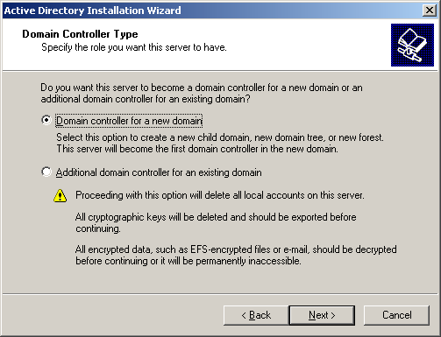

Click Next.
5. On the Create New Domain page, select Domain in a new forest, as shown in the following figure.
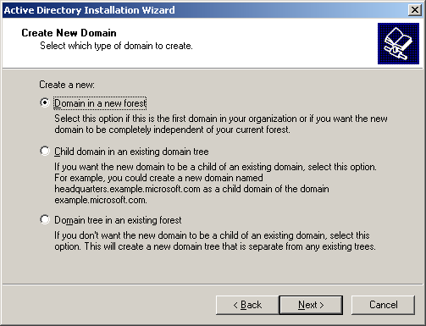

Click Next.
6. On the Install or Configure DNS page:
• If DNS is already running on another computer on your network, click Next.
• If DNS is not running on another computer on your network, select No, just install and configure DNS on this computer, as shown in the following figure.
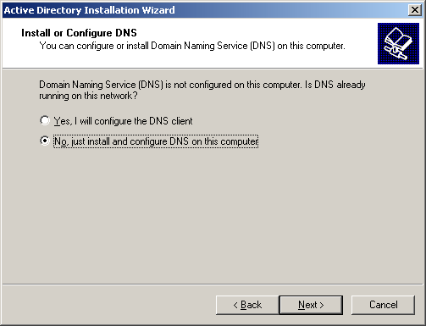

Click Next.
7. On the New Domain Name page, type the full name for your domain, as shown in the following figure.
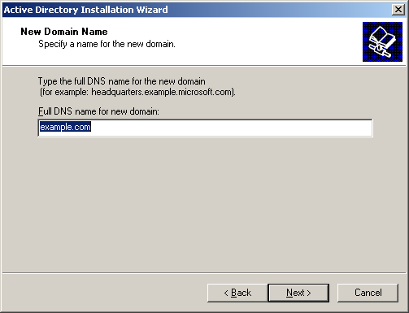

8. On the NetBios Domain Name page, click Next.
9. On the Database and Log Folders page, click Next.
10. On the Shared System Volume page, click Next.
11. On the Permissions page:
• If you run server programs on server operating systems earlier than Windows 2000 Server, select Permissions compatible with pre-Windows 2000 server operating systems.
• If your network servers are running only Windows 2000 Server or Windows Server 2003, select Permissions compatible only with Windows 2000 or Windows Server 2003, as shown in the following figure.
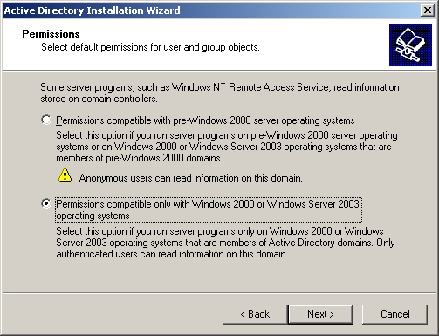

12. On the Directory Service Restore Mode Administrator Password page, under Password, type a strong administrator password. Under Confirm Password, type the password again, and then click Next.
13. On the Summary page, review the information, and then click Next.
14. On the Completing the Active Directory Installation Wizard page, click Finish, and then click Restart Now to restart your computer.

Raising the domain functional level
Important
If domain controllers on your network are running Windows NT 4.0 and earlier, then do not raise the domain functional level to Windows 2000 native. After the domain functional level is set to Windows 2000 native, it cannot be changed back to Windows 2000 mixed.
If domain controllers on your network are running Windows 2000 or Windows NT 4.0 and earlier, then do not raise the domain functional level to Windows Server 2003. After the domain functional level is set to Windows Server 2003, it cannot be changed back to Windows 2000 mixed or Windows 2000 native.
Note
If the domain functional level is already configured for your network, go to Configuring Active Directory for Accounts and Groups.
To raise the domain functional level
1. Click Start, point to All Programs, point to Administrative Tools, and then click Active Directory Domains and Trusts.
2. In the Active Directory Domains and Trusts console, in the details pane, under Name, right-click your domain controller computer, and then click Raise Domain Functional Level.
3. On the Raise Domain Functional Level page, under Select an available domain functional level, select either Windows 2000 native or Windows Server 2003, and then click Raise.
The following figure shows a domain functional level of Windows Server 2003.
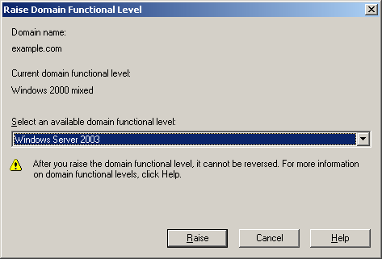

4. When you raise the domain functional level, the Raise Domain Functional Level warning page appears, as shown in the following figure.
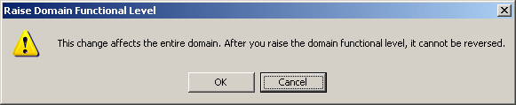

Click OK.
5. On the notification page that informs you the functional level was successfully raised, click OK.
6. Close the Active Directory Domains and Trusts console.

Configuring Active Directory for Accounts and Groups
Use the procedures in this section to perform the following tasks:
• Configure Active Directory for accounts and groups
a. Join computers to the domain.
b. Allow wireless access to computers.
c. Create user accounts in the domain.
d. Create a wireless accounts group named WirelessGroup.
e. Add users and computers to the WirelessGroup.

Joining computers to the domain
Note
If you have already configured computer accounts for all of your network computers, including wireless computers, go to Allowing wireless access to computers.
To join computers to the domain
1. Click Start, click All Programs, click Administrative Tools, and then click Active Directory Users and Computers.
2. In the console tree, expand the domain controller.
The following figure shows a domain controller named example.com.
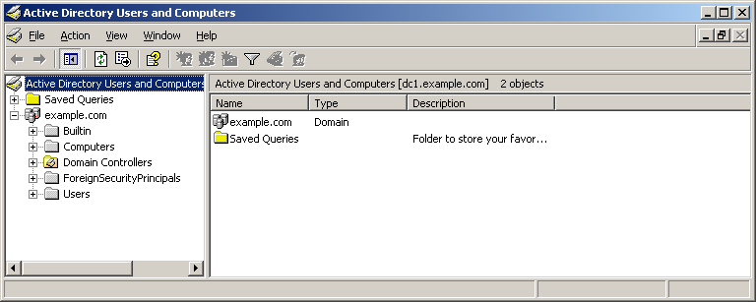

3. Right-click Computers, click New, and then click Computer.
4. In the New Object - Computer dialog box, type the computer name for any domain member computer.
The following figure shows a domain member computer named Client1.
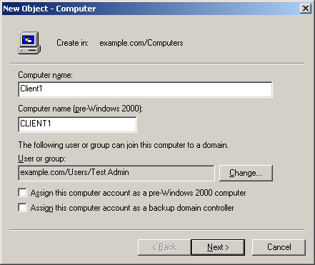

Click Next.
5. In the Managed dialog box, click Next.
6. In the New Object - Computer dialog box, click Finish.
7. Repeat steps 1 - 6 of this procedure to create computer accounts for all the computers on your network.

Allowing wireless access to computers
To allow wireless access to computers
1. In the Active Directory Users and Computers console tree, expand the domain controller.
The following figure shows a domain controller named example.com.

2. Click the Computers folder, and then right-click any computer account.
The following figure shows a computer account named client1.
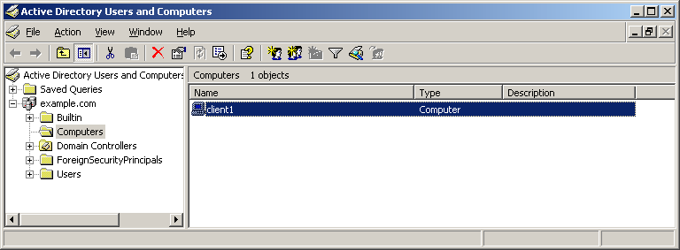

3. Click Properties, and on the Dial-in tab, select Allow access, as shown in the following figure.
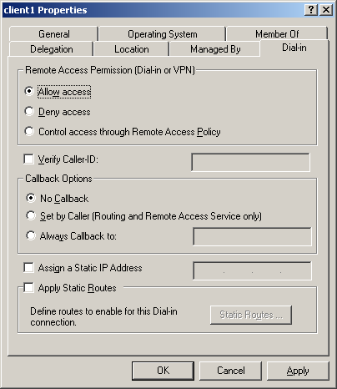

Click OK.
4. Repeat steps 1 - 3 for every computer to which you want to allow wireless access.

Creating user accounts
Note
If you have already configured user accounts in Active Directory for all of your users, go to Creating the group named WirelessGroup.
To create user accounts in the domain
1. In the Active Directory Users and Computers console tree, expand the domain controller.
The following figure shows a domain controller named example.com.

2. In the Active Directory Users and computers console tree, right-click Users, click New, and then click User.
3. In the New Object - User dialog box, specify the following:
For First name, Last name, and Initials, type the user's name. When you type data in First name and Last name, Full name is populated automatically.
In User logon name, type the account name the user will use to log on to the network.
The following figure shows an example.
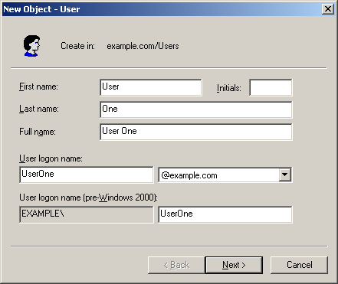

Click Next.
4. In the New Object - User dialog box, type and confirm the password the user will use when logging on to the network, select the option for deploying passwords to the account, click Next, and then click Finish.
5. Repeat steps 1 - 4 to create user accounts for all the users who connect to your network.

Creating the group named WirelessGroup
To create the group named WirelessGroup
1. In the Active Directory Users and Computers console tree, expand the domain controller.
The following figure shows a domain controller named example.com.

2. Right-click Users, click New, and then click Group.
3. On the New Object – Group dialog box, in Group Name, type WirelessGroup, as shown in the following figure.
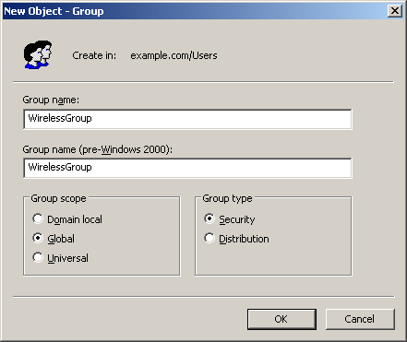

Click OK.

Adding users to the WirelessGroup
To add users to the WirelessGroup
1. In the Active Directory Users and Computers console tree, expand the domain controller.
The following figure shows a domain controller named example.com.

2. Click Users, and in the details pane, double-click WirelessGroup.
3. Click the Members tab, and then click Add.
4. In the Select Users, Contacts, Computers, or Groups dialog box, in Enter the object names to select, type the user account name.
The following figure shows a user account name of UserOne.
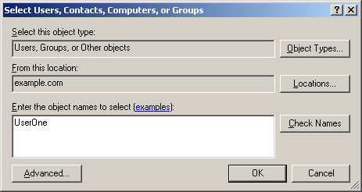

Click OK.
5. If the Multiple Names Found dialog box appears, click OK.
6. The wireless user's account is added to WirelessGroup, as shown in the following figure.
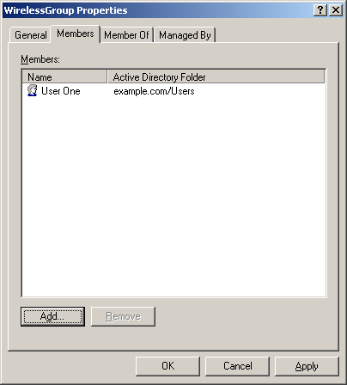

7. Click Add to add other users. When you are finished, click OK to save changes to the wireless group.

Adding client computers to the group named WirelessGroup
To add client computers to the group named WirelessGroup
1. In the Active Directory Users and Computers console tree, expand the domain controller.
The following figure shows a domain controller named example.com.

2. In the details pane, double-click WirelessGroup.
3. Click the Members tab, and then click Add.
4. In the Select Users, Contacts, Computers, or Groups dialog box, in Enter the object names to select, type the computer account name for any computer to which you want to permit wireless connections to your network.
The following figure shows a computer named Client1.
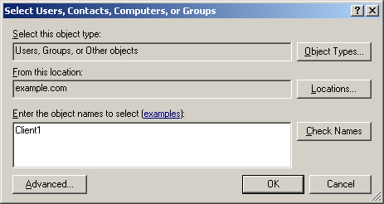

5. Click Object Types, and on the Object Types dialog box, clear the Users check box, and then select the Computers check box, as shown in the following figure.
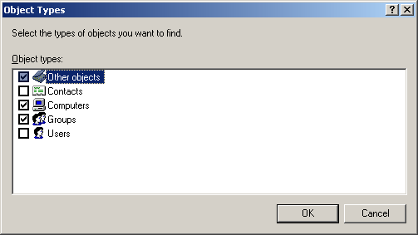

6. Click OK, and then click OK again. The client computer account is added to WirelessGroup.
The following figure shows the client computer account named Client1.
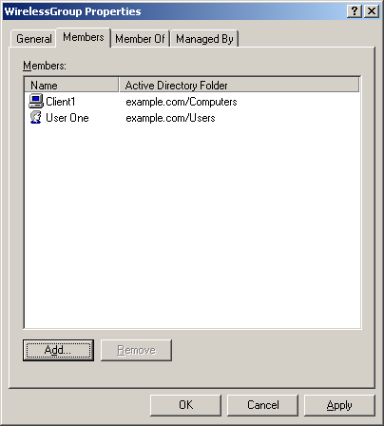

7. Click Add to add other computers, and then click OK to save changes to WirelessGroup.
You can repeat these procedure steps at any time to add computer accounts to WirelessGroup.

Installing WINS
Note
If WINS is already installed on your network, go to Installing and configuring DHCP.
To install Windows Internet Name Service (WINS)
1. On your domain controller, click Start, click Control Panel, click Add or Remove Programs, and then click Add Remove Windows Components to launch the Windows Components Wizard.
2. In Windows Components, select Networking Services, as shown in the following figure.
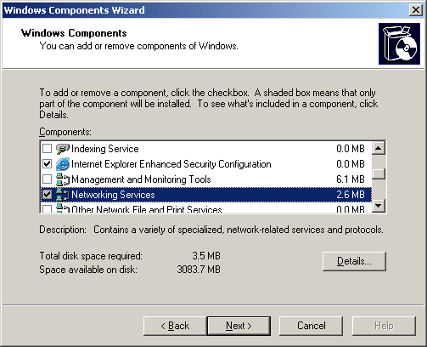

Click Details.
3. Under Subcomponents of Network Services, select Windows Internet Name Service (WINS), as shown in the following figure.
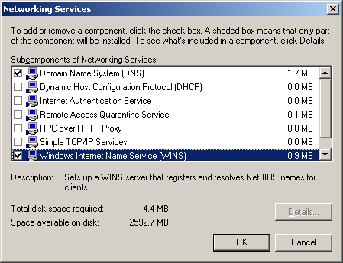

Click OK, and then click Next.
4. If prompted, type the full path to the Windows Server 2003 distribution files (for example, a CD drive containing your Windows Server 2003 CD ROM disk).
5. On the Completing the Windows Components Wizard page, click Finish.
After installation, WINS does not require any additional configuration.

Installing and configuring DHCP
Use the procedures in this section to perform the following tasks:
• Install DHCP.
• Create a new DHCP scope.
• Modify the IP address lease duration.
• Authorize the DHCP server in Active Directory.

Installing DHCP
Note
If DHCP is installed on your network, go to Creating a new DHCP Scope.
To install DHCP
1. On your domain controller, click Start, click Control Panel, click Add or Remove Programs, and then click Add Remove Windows Components to launch the Windows Components Wizard.
2. In Windows Components, select Networking Services, as shown in the following figure.

Click Details.
3. Under Subcomponents of Network Services, select Dynamic Host Configuration Protocol (DHCP), as shown in the following figure.
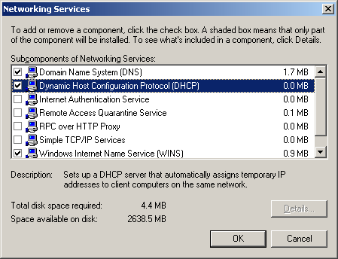

Click OK, and then click Next.
4. If prompted, type the full path to the Windows Server 2003 distribution files (for example, a CD drive containing your Windows Server 2003 CD ROM disk).
5. On the Completing the Windows Components Wizard page, click Finish.
For more information, see To install a DHCP server on the Microsoft Web site (http://go.microsoft.com/fwlink/?LinkId=20034).

Creating a new DHCP scope
Note
The following procedure applies only if you have not configured a DHCP scope for your network. If a DHCP scope is already defined for your network, review the information in this procedure, and then go to Modifying the IP address lease duration.
To create a DHCP scope
1. Click Start, click All Programs, click Administrative tools, and then click DHCP.
2. In the DHCP console tree, click the DHCP server.
The following figure shows a DHCP server named dc1.example.com [172.16.0.1].
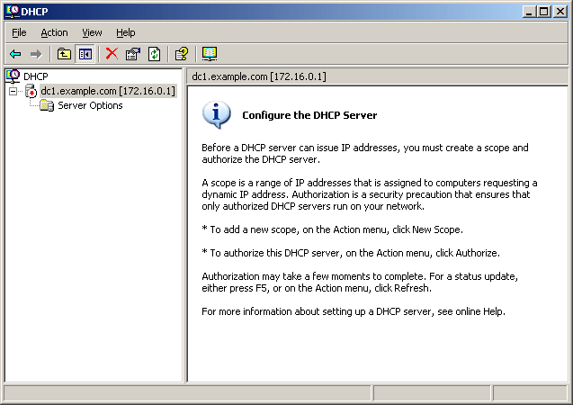

3. On the Action menu, click New Scope to launch the New Scope Wizard.
4. On the Welcome to the New Scope Wizard page, click Next.
5. On the Scope Name page, in Name, type a name for the scope, and in Description, type a brief scope description.
The following figure shows an example.
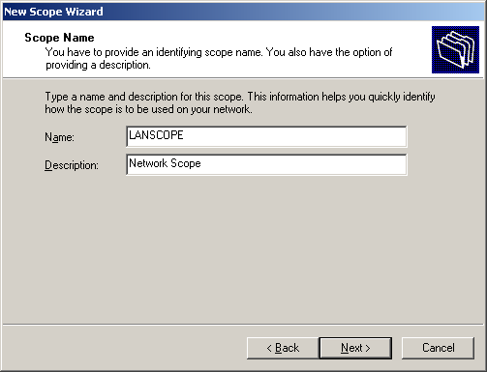

Click Next.
6. On the IP Address Range page, in Start IP address and End IP address, define your IP address range. Specify your subnet mask by length or by subnet mask.
The following figure shows a Start IP address of 172.16.0.1; an End IP address of 172.16.0.254; a Length of 24; and a Subnet mask of 255.255.255.0.
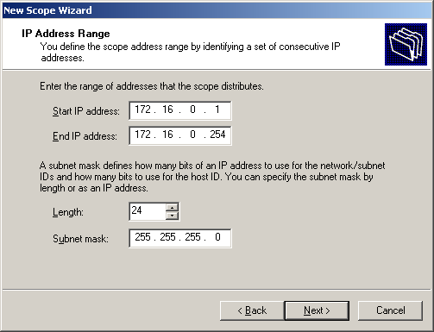

Note
The IP address range in this figure is intended for demonstration purposes only. You must determine the IP address range for your network.
Click Next.
7. On the Add Exclusions page, add an exclusion range for your network devices that will have static address configurations (your wireless APs, domain controller, file servers, and network printers).
For example, if you need to statically assign 10 IP addresses from the address range 172.16.0.1 through 172.16.0.254, you could define your exclusion range as 172.16.0.1 through 172.16.0.10.
The following figure shows a Start IP address of 172.16.0.1 and an End IP address of 172.16.0.10.
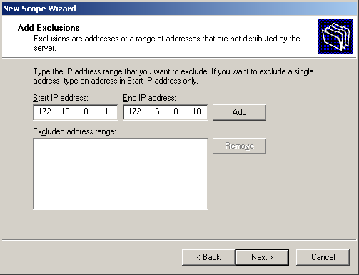

8. Click Add to add the exclusion range, and then click Next.
Note
When deploying wireless technology, the default lease duration of eight days is, in most cases, too long and should be shortened considerably.
9. On the Lease Duration page, modify the lease duration as appropriate.
The following figure shows a lease duration set to 0 days, 3 hours, and 30 minutes.
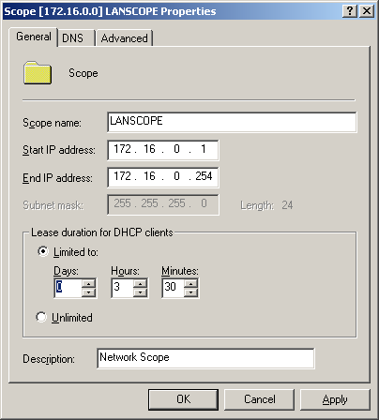

Click Next.
10. On the Configure DHCP Options page, select Yes, I want to configure these options now, and then click Next.
11. On the Router (Default Gateway) page, enter the IP address for your network router.
The following figure shows an IP address of 172.16.0.5.
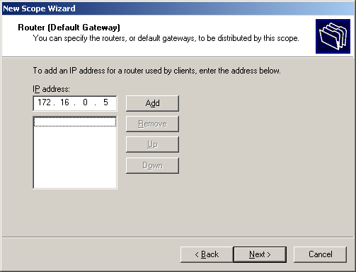

12. Click Add to add the default gateway, and then click Next.
13. On the Domain Name and DNS Servers page, in Parent domain, type the name of your domain. In Server name, type the computer name of your domain controller.
The following figure shows a parent domain of example.com and a server name of DC1.
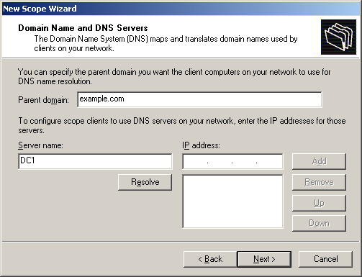

14. Click Resolve to resolve the domain controller IP address. The IP address field is automatically populated with the IP address of the domain controller.
The following figure shows an IP address of 172.16.0.1.
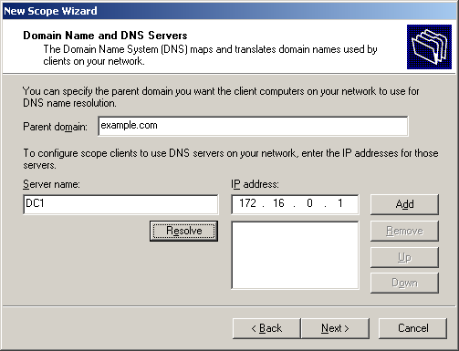

Note
If the DHCP server is not available and the IP address field is not populated automatically, in IP address, type the IP address for your domain controller.
15. Click Add, and then click Next.
16. On the WINS Servers page, in Server name, type the server name for your domain controller, and then click Resolve.
The following figure shows a server name of DC1.
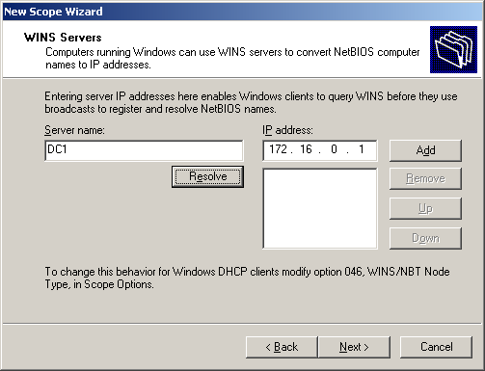

Note
If the WINS server is not available and the IP address field is not populated automatically, in IP address, type the IP address for your WINS server.
17. Click Add, and then click Next.
18. On the Activate Scope page, select Yes, I want to activate this scope now, as shown in the following figure.
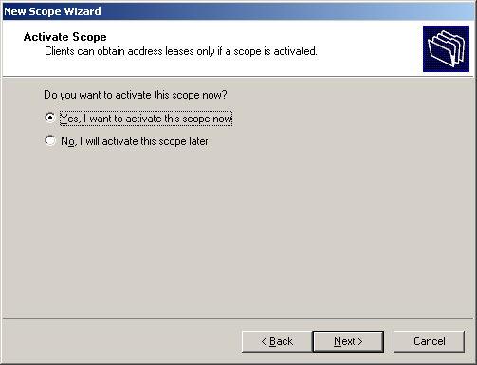

19. Click Next, and then click Finish.
For more information, see To create a new scope on the Microsoft Web site (http://go.microsoft.com/fwlink/?LinkId=20123).

Modifying the IP Address Lease Duration
If you specified the scope lease in step 9 of the preceding procedure, go to Authorizing the DHCP server in Active Directory.
Note
If you experience IP address depletion problems in the future, use this procedure to modify the IP address lease duration.
To modify the IP address lease duration
1. Click Start, click All Programs, click Administrative tools, and then click DHCP.
2. In the DHCP console tree, expand the applicable DHCP server.
The following figure shows a DHCP server named dc1.example.com [172.16.0.1].
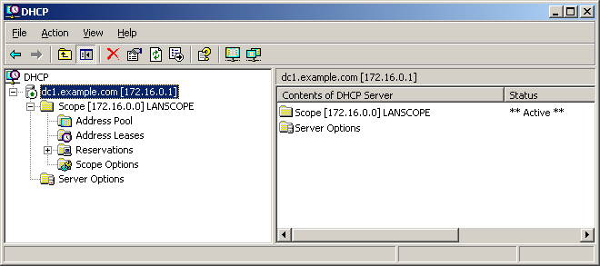

3. Right-click the desired scope, and then click Properties.
4. On the Properties page for the scope, in Lease duration for DHCP clients, select Limited to, and then modify the lease duration as appropriate.
The following figure shows an example lease duration set to 0 days, 3 hours, and 30 minutes.

5. Click OK to save the settings, and then close the DHCP console.

Authorizing the DHCP Server in Active Directory
If your DHCP server is already authorized, go to Deploying and configuring wireless APs.
To authorize a DHCP server in Active Directory
1. On your DHCP server, click Start, click All Programs, click Administrative tools, and then click DHCP.
2. In the DHCP console, click the DHCP server.
The following figure shows a DHCP server named dc1.example.com [172.16.0.1].

3. On the Action menu, click Authorize.
4. If prompted, type the name or IP address of the DHCP server to be authorized, and then click OK.
Note
For more information, see To authorize a DHCP server in Active Directory on the Microsoft Web site (http://go.microsoft.com/fwlink/?LinkId=20125).
The DHCP server is now online and able to provide IP address leases to client computers and other devices.

Deploying and configuring wireless APs
To configure wireless APs
1. Follow the configuration steps included in the product documentation for your wireless AP.
2. Determine whether your wireless AP requires the configuration of VSAs, and if so, keep the VSA configuration information readily available when you configure IAS. VSA configuration is covered in two procedures later in this paper:
• Configure a remote access policy for wireless
• Configure vendor-specific attributes for remote access policy
3. Keep a record of the settings that you configure on your APs, in particular:
• Wireless AP IP address (static)
• DNS name, wireless AP name
• Wireless AP subnet mask
• RADIUS shared secret for each wireless AP
You will need to have this information available when you configure wireless APs as RADIUS clients in the IAS console.

Obtaining and installing a server certificate
This section of the paper will guide you through the following configurations:
• Obtain and install a certificate in the Trusted Root Certification Authority Store.
a. Complete the VeriSign enrollment form.
b. Retrieve your VeriSign wireless local area network (WLAN) server certificate.
c. Install the certificate in the Trusted Root Certification Authority Store.

Completing the VeriSign enrollment form
To complete the VeriSign enrollment form
1. Using an administrator account, log on to your domain controller computer.
2. Use your Internet browser to navigate to the VeriSign Wireless LAN Server Certificates Web page at http://www.verisign.com/products-services/security-services/ssl/wireless-lan-security/index.html.
3. On the Wireless LAN Server Certificates page, click Buy Now to begin the enrollment and payment process.
4. In Select Options, under Validity Period, select either One Year or TwoYear.
Note
After you select the validity period, you can check certificate pricing by clicking Recalculate.
Click Continue.
5. Review the information that you will need to supply to VeriSign to complete the certificate purchase, and then click Continue.
6. Under Technical Contact Information, type your contact information. When you have completed the form, click Continue.
7. On Wireless LAN Server Certificate Information, under Common Name, type the fully-qualified domain name of your domain server.
For example, for a domain server named DC1 in the test.com domain, the fully-qualified domain name is DC1.test.com.
Note
VeriSign server certificates are issued specifically for your server; they will not work on another computer.
8. Type the following information:
• Company
• Division
• City
• State
• Country
Note
All of the fields on this page are required; however, if a particular field does not apply, you can type Not applicable.
9. At this point, you might receive a Potential Scripting Violation warning that informs you that the VeriSign Web site is requesting a new certificate on your behalf. Click Yes to request a certificate.
10. Under Creating a new RSA exchange key, click OK.
11. On the following Web page, under Certificate Information, verify the certificate information. Under Challenge Phrase, type a password phrase, and then confirm the password. Under Reminder Question, enter a short description to remind you of your challenge phrase. Click Continue.
12. Under Organizational Contact Information, type the contact information, and then click Continue.
13. Under Payment Type, select the payment method you will use to purchase the certificate.
• If the billing contact is the same as the technical contact information entered in step 7 of this procedure, select Copy the Technical Contactinformation.
• If the billing contact is the same as the organizational contact information entered in step 12 of this procedure, select Copy the Organizational Contact information.
• If the billing contact differs from either the technical or organizational contact information, select New Contact, and then type the contact information.
14. Click Continue to submit and finish the certificate purchase.

Retrieving the VeriSign server certificate
You will receive an e-mail message from VeriSign that contains a URL to a Web page and a personal identification number that you must use to retrieve your WLAN server certificate.
To retrieve your VeriSign WLAN server certificate
1. Print a copy of the e-mail message that contains the URL and PIN needed to retrieve your certificate.
2. Using an account that has local administrator permissions, log on to the domain controller computer that you used to complete the VeriSign enrollment.
Note
In the next procedure, the VeriSign WLAN server certificate is automatically installed in the Local Computer certificate store. For this reason, you must use a Local Administrator account.
3. Use the Internet browser to access the Web location specified in the e-mail message.
4. When prompted, type and submit the PIN.

Installing the server certificate
To install the server certificate
1. When prompted, click the button to install the certificate.
2. You should see a Potential Scripting Violation warning message that indicates that the Web site is adding certificates to the computer. Click Yes to proceed with the installation.
You now have a WLAN Server Certificate installed in your Certificates (Local Computer)\Personal\Certificates folder.
3.

Verifying the WLAN server certificate installation
To verify that the WLAN server certificate is installed
1. Click Start, click Run, type mmc, and then click OK.
2. On the File menu, click Add/Remove Snap-In, and then click Add.
3. Under Snap-In, double-click Certificates, click Computer Account, and then click Next.
4. Select Local Computer, and then click Finish.
5. Click Close, and then click OK.
6. You will see that Certificates (Local Computer) appears in the list of selected snap-ins for the new console.
7. In the console tree, expand Certificates (Local Computer), expand Personal, and then click Certificates.
8. In the details pane, you will see a certificate with the Issued To name set to the name specified during the enrollment process.
9. To view the details of the certificate, in the details pane, double-click the certificate.

Installing and Configuring IAS
In this section you will:
• Install and configure IAS on the domain controller.
a. Install IAS.
b. Register the server running IAS in the default domain using Active Directory Users and Computers.
c. Configure wireless APs as IAS RADIUS clients.
d. Configure remote access policy for wireless access.
e. Configure remote access logging (database-compatible format).

Installing IAS
If IAS is already installed on your domain controller, go to Registering the server running IAS.
To install and configure IAS
1. On your domain controller, click Start, click Control Panel, click Add or Remove Programs, and then click Add Remove Windows Components to launch the Windows Components Wizard.
2. In Components, select Networking Services, and then click Details.
3. In Subcomponents of Networking Services, select the Internet Authentication Service check box, as shown in the following figure.
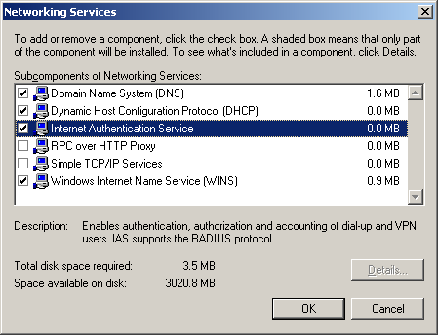

4. Click OK, and then click Next.
5. When the components are configured, click Finish.

Registering the server running IAS
If IAS is already registered, go to Configuring wireless APs as IAS RADIUS clients.
To register the IAS server in the default domain using Active Directory Users and Computers
1. Click Start, point to All Programs, point to Administrative Tools, and then click Internet Authentication Service.
The Internet Authentication Service snap-in is shown in the following figure.
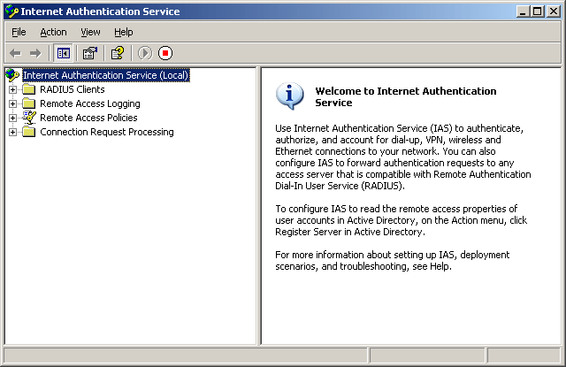

Note
Because IAS was just installed, the Internet Authentication Service snap-in might not be listed alphabetically in the Administrative Tools list.
2. Right-click Internet Authentication Service, and then click Register Service in Active Directory.
3. When the Register Internet Authentication in Active Directory dialog box appears, click OK.
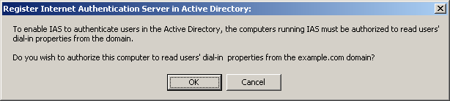

4. In the Server registered dialog box, click OK.

Configuring wireless APs as IAS RADIUS clients
Note
Verify that you typed the correct shared secret for each wireless AP. The shared secret must exactly match the shared secret entered when you configured the wireless AP or authentication will fail.
To configure wireless APs as IAS RADIUS clients
1. In the Internet Authentication Service console tree, right-click RADIUS Clients, and then click New RADIUS Client.
2. On the New RADIUS Client dialog box, in Friendly name, type a descriptive name for your wireless AP. In Client address (IP or DNS):
• If you are using the IP address of the wireless AP, type the IP address you used to configure your wireless AP.
• If you are using the DNS name of the wireless AP, type the name and then click Verify.
The following figure shows a Friendly name of Access Point1 and a Client address (IP or DNS) of 172.16.0.3.
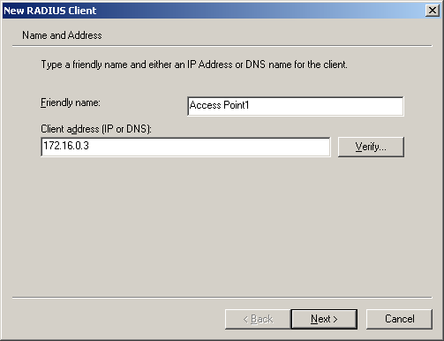

Click Next.
3. On the Additional Information dialog box:
• If you are planning to use wireless AP-specific remote access policies for configuration (for example, a remote access policy that contains vendor-specific attributes) in Client Vendor, select the wireless AP manufacturer from the list.
• If you do not know the manufacturer or if the manufacturer is not in the list, click RADIUS Standard.
In Shared secret, type the shared secret that was used when you configured the wireless AP, and then type it again in Confirm shared secret.
In the following figure, RADIUS Standard is selected to represent an unknown or unlisted wireless AP vendor.
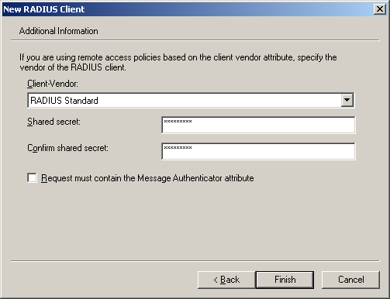

Click Finish.
4. Repeat steps 1 - 4 of this procedure for every wireless AP that you want to add to your network as an IAS RADIUS client.

Configuring an IAS remote access policy for wireless
To configure an IAS remote access policy for wireless
1. In the Internet Authentication Service console, right-click Remote Access Policies, and then click New Remote Access Policy.

2. On the Welcome to the New Remote Access Policy Wizard page, click Next.
3. On the Policy Configuration Method page, select Use the wizard to set up a typical policy for a common scenario. In Policy name, type Wireless access, as shown in the following figure.
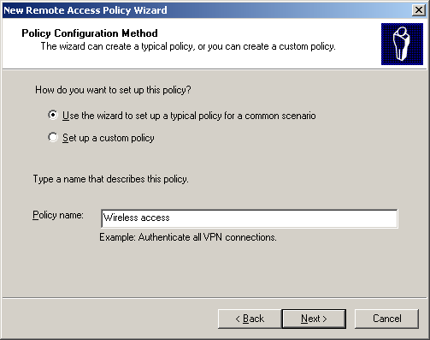

Click Next.
4. On the Access Method page, select Wireless, as shown in the following figure, and then click Next.
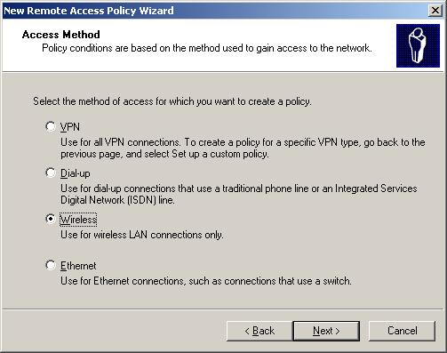

5. On the User or Group Access page, select Group, and then click Add.
6. On the Select Groups dialog box, in Enter the object names to select, type WirelessGroup.
Verify that your domain computer name appears in From this location.
The following figure shows example.com in From this location.
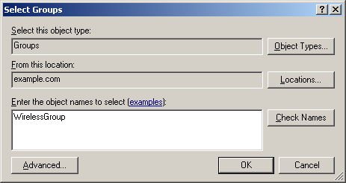

Click OK.
7. On the User or Group Access page, the group is added to the Group name list.
The following figure shows EXAMPLE\WirelessGroup in Group name.
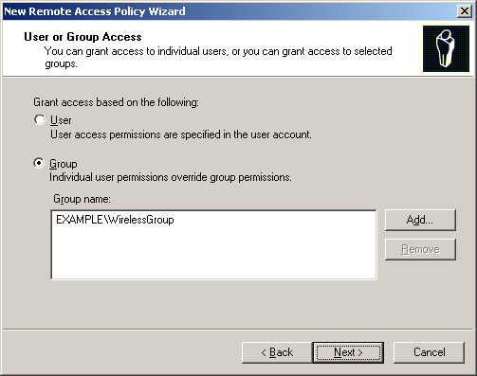

Click Next.
8. On the Authentication Methods page, Protected EAP (PEAP) is selected by default and is configured to use PEAP-MS-CHAP v2.
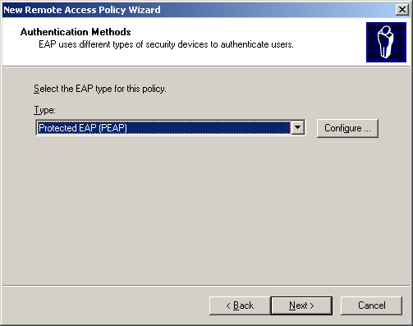

Click Configure.
9. On the Protected EAP Properties dialog box, in Certificate issued, your VeriSign server certificate is selected by default. Select Enable Fast Reconnect, as shown in the following example.
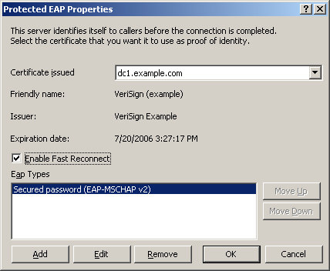

Click OK.
10. On the Authentication Methods page, click Next.
11. The Completing the New Remote Access Policy page provides a summary of the wireless access policy, as shown in the following figure.
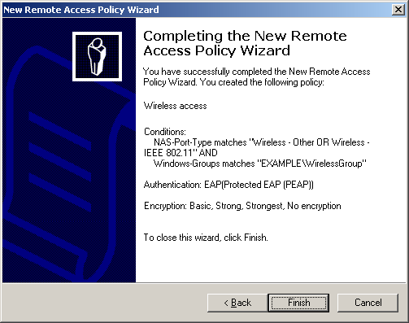

12. Click Finish to close the wizard.
13. In the Internet Authentication Service console tree, click Remote Access Policies, and in the details pane, identify your new wireless access policy and the two default remote access policies:
• Connections to Microsoft Routing and Remote Access server
• Connections to other access servers
The following figure shows an example.
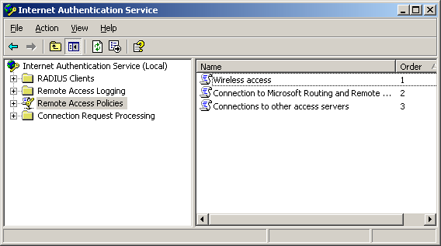

Note
If you are using these steps to create subsequent remote access policies, the two default policies, Connections to Microsoft Routing and Remote Access server and Connections to other access servers, will have already been deleted.
14. Delete the two default remote access policies.
a. Right-click Connections to Microsoft Routing and Remote Access server, and then click Delete.
b. Right-click Connections to other access servers, and then click Delete.
Important
Do not delete the new policy, Wireless Access.
The result is shown in the following figure.
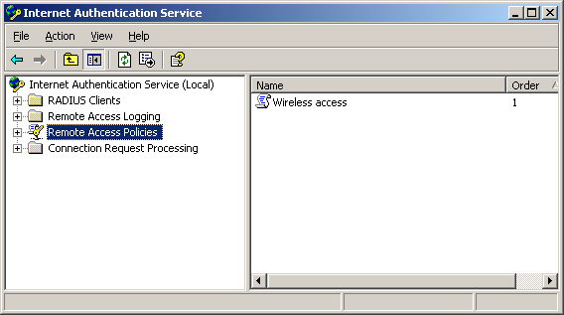

Important
For this scenario, you do not need to configure connection request processing. In the Connection Request Processing container, do not modify either Connection Request Policies or Remote RADIUS Server Groups. Do not delete the default policy named Use Windows authentication for all users; this scenario uses this policy.
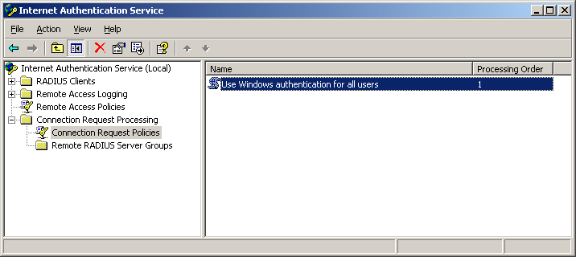

Set attributes for the wireless access policy
Set attributes for the wireless access policy
1. In the Internet Authentication Service console, click Remote Access Policies, and then select your new wireless access policy.
Note
The Wireless access policy name applies only to the first remote access policy configured in this scenario. If you create additional remote access policies to support wireless AP VSAs, the policy names will be different.
The following figure shows a policy named Wireless access.
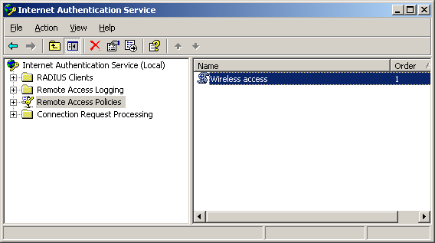

2. Right-click the wireless access policy, and then click Properties.
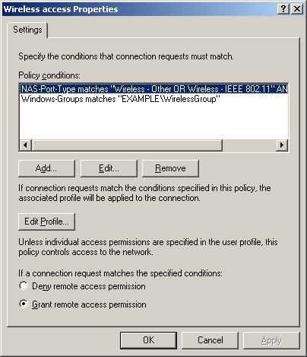

3. On the Settings tab, click Add.
4. On the Select Attribute dialog box, in Attribute types, select the attribute you want to configure.
Note
Do not configure VSAs for your wireless AP at this time. You will configure VSAs in the next procedure, Configuring vendor-specific attributes for an IAS remote access policy.
a. For example, to restrict the hours when wireless users are allowed to connect to the network, select Day And Time Restrictions.
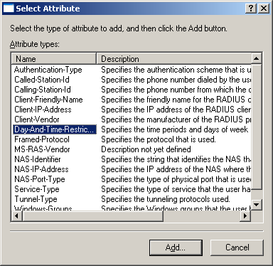

Click Add.
b. On the Time of day constraints dialog box, select the times wireless access is allowed, and then select Permitted.
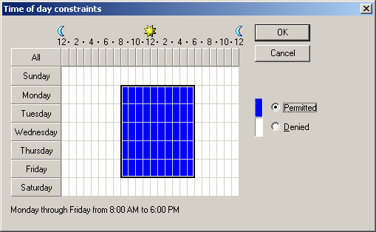

Click OK.
c. To configure other policy attributes, click Add, select the desired attribute from the list, and then configure.
5. When you are finished, click OK.

Configuring VSAs for an IAS remote access policy
If you do not have wireless APs that require VSA configuration, go to Configuring remote access logging.
You can add VSAs for only one wireless AP model to a remote access policy. Use the following table to determine your most appropriate action for this step.

Wireless AP VSAs | Action
Your wireless APs do not require VSA configuration in IAS Remote Access Policy. | Go to the next procedure, Configuring Remote Access Logging.
You have only one model of wireless AP that requires VSA configuration. | Use the steps in Configuring VSAs for remote access policy to configure the VSA in your IAS wireless access policy (Wireless access).
You have multiple wireless AP models that require VSA configuration and you must configure a new IAS remote access policy for each model of wireless AP.  For each wireless AP model that requires VSA configuration: | Configure a new IAS remote access policy that is identical to the policy you created in Configuring an IAS remote access policy for wireless, with the following two exceptions:  • Each policy name must be different.  • The VSA required for each wireless AP model is configured in the IAS remote access policy profile according to the steps described in .  Note  For better organization, when you name the IAS remote access policy in step 3 of the To configure an IAS remote access policy for wireless procedure, in Policy name, type the model name of the wireless AP.

To configure VSAs for an IAS remote access policy
1. In the Internet Authentication Service console, click Remote Access Policies, and then select the policy for the wireless AP that requires VSA configuration.
The following figure shows a policy named Wireless access.

2. Right-click the policy, and then click Properties.
3. Confirm Grant remote access permission is selected, as shown in the following figure.

4. Click Edit Profile, and on the Edit Dial-in Profile dialog box, click the Advanced tab, as shown in the following figure.
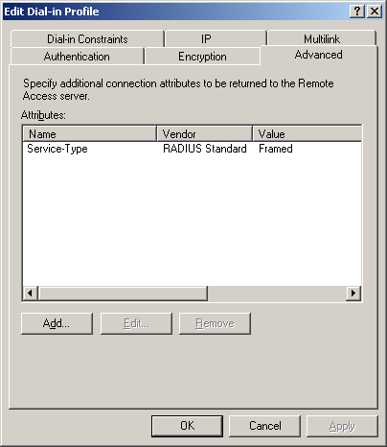

5. Click Add. Review the list to see whether your VSA is already in the list of attributes.
A portion of this list is shown in the following figure.
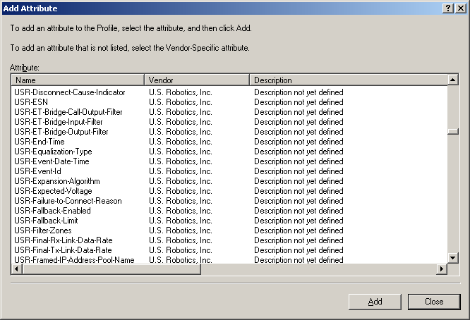

If the VSA is in the list
a. Select the attribute, click Add, and on the Multivalued Attribute Information dialog box, click Add.
b. Configure the attribute as described in your wireless AP documentation.
c. Go to step 6 of this procedure.
If the VSA is not in the list
a. From the list, select Vendor-Specific, as shown in the following figure.
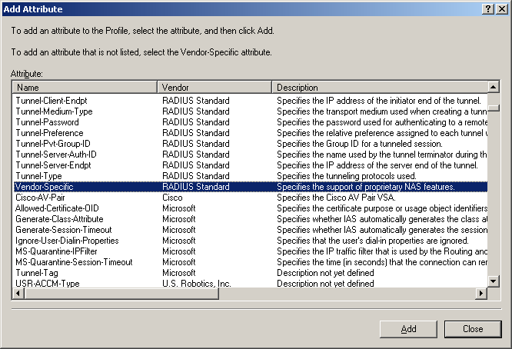

Click Add.
a. On the Multivalued Attribute Information dialog box, click Add.
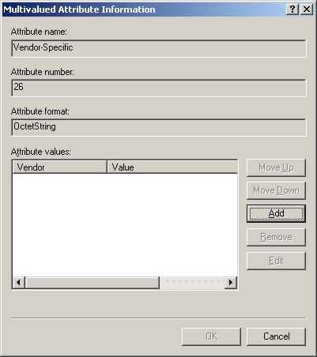

a. On the Vendor-Specific Attribute Information dialog box, specify the following information.
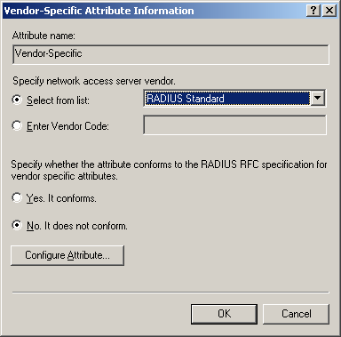

Specify the network access server vendor for your wireless AP
To specify the vendor by selecting the name from the list, select Select from list, and from the drop-down list, select the vendor of the wireless AP for which you are configuring the VSA.
If the vendor does not appear in the list, specify the vendor by typing the vendor code. Select Enter Vendor Code, and then type the vendor code.
For a list of SMI Network Management Private Enterprise Codes, see RFC 1007.

Specify whether the attribute conforms to the RADIUS RFC specification for VSAs
If your attribute conforms to the RADIUS RFC specification, select Yes. It conforms, and then click Configure Attribute.
On the Configure VSA (RFC compliant) dialog box, in Vendor-assigned attribute number, type the number assigned to the attribute. (This should be an integer from 0 to 255.)
In Attribute format, specify the format for the attribute.
In Attribute value, type the value you are assigning to the attribute.
If the attribute does not conform, click No. It does not conform, and then click Configure Attribute.
In Hexadecimal attribute value, type the value for the attribute, as specified in your wireless AP documentation.

6. Click OK or Close to close all open dialog boxes.

Configuring remote access logging
To configure remote access logging
1. In the Internet Authentication Service console, right-click Internet Authentication Service, and then click Properties.
2. On the General tab, verify that Rejected authentication requests and Successful authentication requests are selected, and then click OK.
3. Click Remote Access Logging, as shown in the following figure.
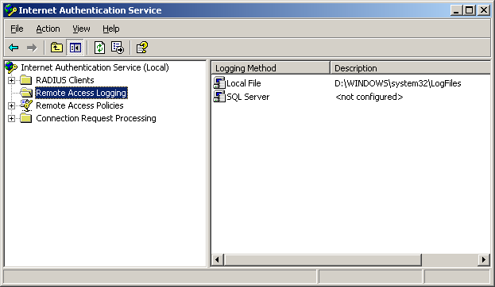

4. In the details pane, double-click Local File.
5. On the Local File Properties dialog box, on the Settings tab, select Accounting requests, Authentication requests, and Periodic status, as shown in the following figure:
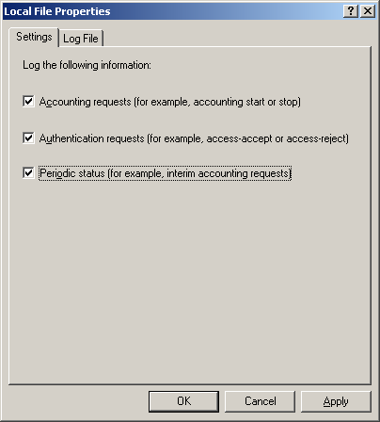

6. On the Log File tab, in Format, select Database-compatible.
7. Under Create a new log file, select the log file frequency setting you prefer, as shown in the following figure.
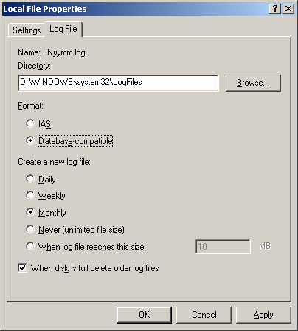

Click OK.

Configuring Group Policy settings for wireless network (IEEE 802.11) policies
To configure Group Policy settings for wireless network (IEEE 802.11) policies
1. On your domain controller, DC1, click Start, point to All Programs, click Administrative Tools, and then click Active Directory Users and Computers.
The following figure shows an example.

Right-click the domain system container that contains your wireless computer accounts, and then click Properties.
2. On the Group Policy tab, click the appropriate Group Policy object.
The following figure shows the default object, Default Domain Policy.
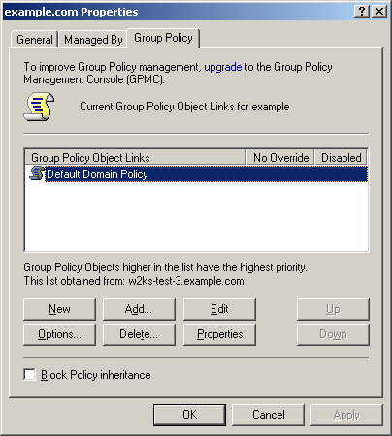

3. Click Edit.
4. In the console tree, expand Computer Configuration, expand Windows Settings, expand Security Settings, and then click Wireless Network (IEEE 802.11) Policies, as shown in the following figure.
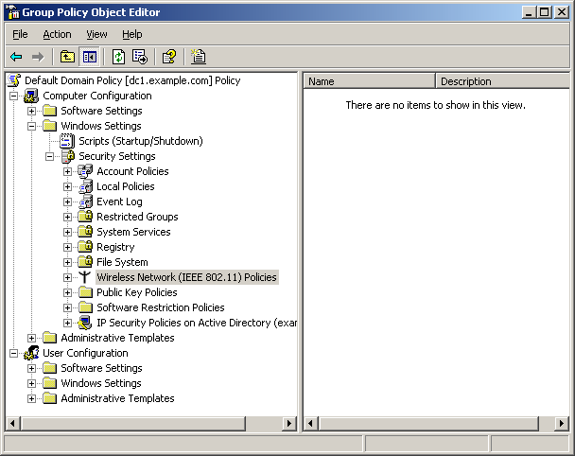

5. Right-click Wireless Network (IEEE 802.11) Policies, and then click Create Wireless Network Policy.
6. On the Welcome to theWireless Network Policy Wizard page, click Next.
7. On the Wireless Network Policy Name page, in Name, type WirelessGroup Policy. In Description, type a brief description of the policy, as shown in the following figure.
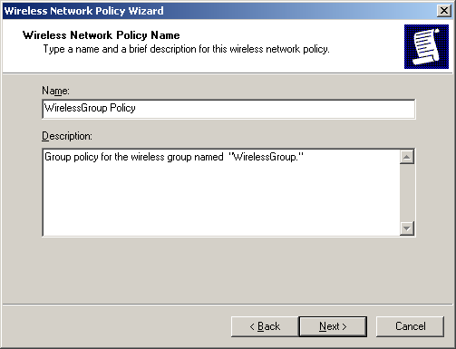

Click Next.
8. On the Completing the Wireless Network Policy Wizard page, confirm Edit properties is selected, as shown in the following figure.
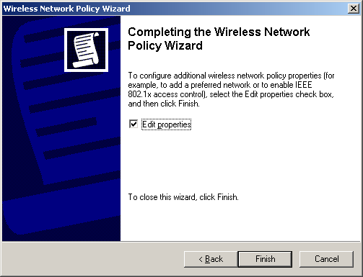

Click Finish.
9. On the WirelessGroup Policy Properties dialog box, on the General tab, select one of the following from the Networks to access drop-down list:
• Any available network (wireless AP preferred) specifies that wireless computers attempt connections to a wireless AP (infrastructure) network before attempting computer-to-computer (ad hoc) connections. Recommended only for wireless policies in which either infrastructure or ad-hoc connections are desirable.
• Wireless AP (infrastructure) networks only specifies that wireless computers only attempt connections to a wireless AP (infrastructure) network. This is the recommended wireless policy for networks in which ad-hoc connections are not desirable.
• Computer-to-computer (ad hoc) networks only specifies that wireless computers only attempt computer-to-computer (ad hoc) wireless connections. This wireless policy is used only in networks in which it is not desirable for wireless devices to make wireless connections to the network infrastructure.
Important
The Computer-to-computer (ad hoc) networks only option conflicts with the purpose of this deployment scenario. Therefore, it is not recommended. If you select this option, connection attempts to your wireless infrastructure will fail.
Make sure that Use Windows to configure wireless network settings for clients is selected, as shown in the following figure.
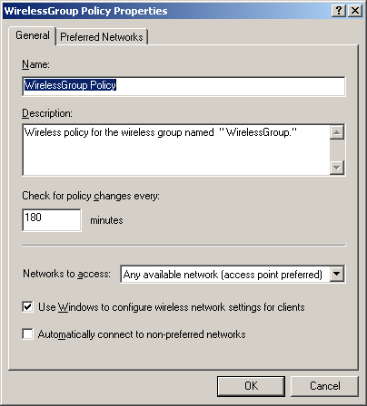

10. On the Preferred Networks tab, click Add to add a preferred network.
11. On New Preferred Networks, on the Network Properties tab:
a. In Network Name (SSID), type the network name for your wireless network.
b. In Description, type a description.
c. To specify that a network key is used for authentication to the wireless network, from the drop-down list in Network authentication, select either WPA (recommended) or Open (discouraged).
By default, open system authentication is used.
Note
Although available in the drop-down list, do not select Shared or WPA-PSK. Neither should be used in this scenario.
d. To specify that a network key is used to encrypt the data that is sent over the network, from the drop-down list in Data encryption, select one of the following:

If in Network Authentication, you selected: | In Data encryption, select one of the following:
WPA (recommended) | TKIP  AES  WEP
Open  or if you did not specify an authentication | • WEP (recommended only if supported by the wireless AP hardware and if WPA is not supported.)  Disabled

Note
By default, WEP is selected in Data encryption.
e. If available, select The key is provided automatically.
The following figure shows an example of New Preferred Setting Properties with these settings:
SSID: WiFiTest
Description: Sample Description for wireless network.
Network Authentication: WPA
Data encryption: TKIP
The key is provided automatically: (selected)
This is a computer-to-computer (ad hoc) network; wireless access points are not used: (not selected)
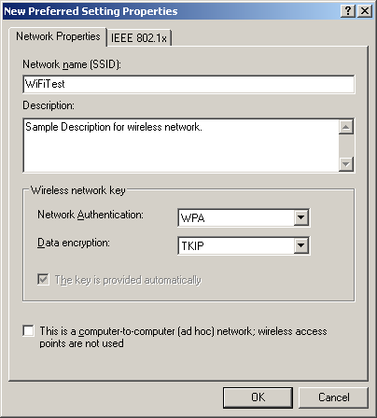

12. Click the IEEE 802.1x tab.
13. Confirm Enable network access control using IEEE 802.1X is selected. (This is the default setting.)
From the EAP type drop-down list, select Protected EAP (PEAP).
These settings are shown in the following figure.
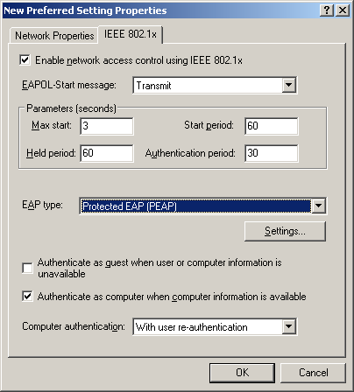

14. Click Settings.
15. On the Protected EAP Properties dialog box, do the following:
a. Verify that Validate server certificate is selected.
b. In Trusted Root Certification Authorities, select the certificate you obtained from VeriSign.
c. From the Select Authentication Method drop-down list, select Secured password (EAP-MS-CHAP v2).
d. Select Enable Fast Reconnect.
These settings are shown in the following figure.
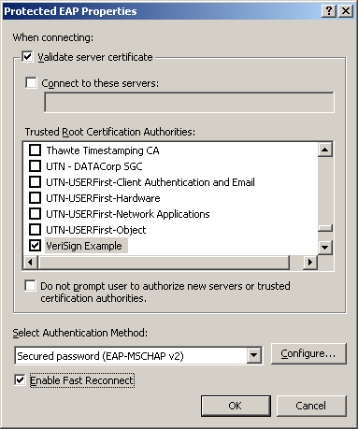

Click Configure.
16. On the EAP MSCHAPv2 Properties dialog box, make sure Automatically use my Windows logon name and password (and domain if any) is selected.
17. Click OK, and then close the Group Policy Object Editor.
The next time your wireless clients running Windows XP with SP2 update computer configuration from Group Policy, their wireless network configuration will be automatically configured.
Log on to the wireless network
1. Log on to a wireless computer using the domain user account.
2. Wait until you are prompted to select the wireless network.
3. In the notification area, right-click the wireless network connection icon, and then click View Available Wireless Networks.
Note
You can right-click the icon for the wireless adapter in either the notification area or in Network Connections.
4. On the Choose a wireless network page, select your network, and then click Connect.
When connected, the Choose a wireless network page will display the status of the connection as Connected.
If you experience difficulty connecting to the wireless LAN, you should first physically connect the computer to the wired LAN and then log on with the domain user account to update Group Policy configuration.
If you continue to experience difficulty connecting, use the following procedure to check the Group Policy-provided wireless configurations.
Troubleshooting wireless connections on client computers
1. Right-click the wireless network connection icon in either the notification area or in Network Connections, and then click View Available Wireless Networks.
2. Under Related Tasks, click Change advanced settings.
3. On the Wireless Network Connection Properties dialog box, click the Wireless Networks tab.
4. In Preferred Networks, select the appropriate wireless network, and then click Properties.
5. On the Association tab, verify that both Network Authentication and Data encryption are set correctly, and confirm that the correct network key is being used.
6. On the Authentication tab, confirm the following settings:
Enable IEEE 802.1x authentication for this network is selected.
EAP type is set to Protected EAP (PEAP).
Authenticate as computer when computer information is available is selected.
7. On the Connection tab, make sure that Connect when this network is in range is selected.
8. After authentication is successful, use Network Connections to check the TCP/IP configuration for the wireless adapter. It should have an address within the range of the DHCP scope.

See Also
Active Directory
User and Group Accounts
DHCP
DNS
IAS
WINS
Wireless Networking
Cable Guy, November 2004 - Wi-Fi Protected Access Data Encryption and Integrity
Windows XP Wireless Deployment Technology and Component Overview
Windows Server 2003 Security Services
Encrypting File System
Public Key Infrastructure
Providing Secure Wireless Services

