
BT-OG01A / BT-OG01B
TWI EEPROM Module for Odroid GO

Features:  - Designed for the Odroid GO expansion Port  - Usage of the 24LCXXA EEPROM Chips  - BT-OG01B Module Selection Pin  - Replaceable EEPROM Chip  - Integrated TWI pull up resistors  - 100 kHz communication frequency  - Status LEDs  Description:  The BT-OG01X is an EEPROM module designed for the expansion port of the Odroid GO to store data. It can be used with the official BT-GoAsm Software, but can also be used in custom programs. The BT-OG01B is embedded in the BT-OG02 EEPROM Array. |  | Pinout:  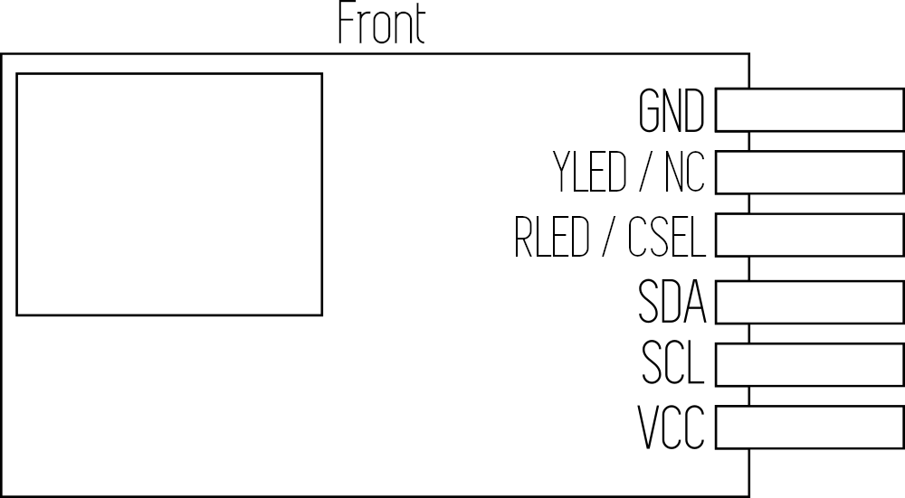  Pin descriptions:  YLED / NC -> For BT-OG01A this pin serves the Yellow LED, on the BT-OG01B this pin is not connected.  RLED / CSEL -> On the BT-OG01A this pin controlls the red LED, on BT-OG01B this pin serves as the chip selection pin, which toggles the TWI address to be 0x51 instead of 0x50. The red LED on the BT-OG01B shows the state of selection.  SDA -> TWI Data  SCL -> TWI Clock  VCC -> 3.3V
Blockdiagram:
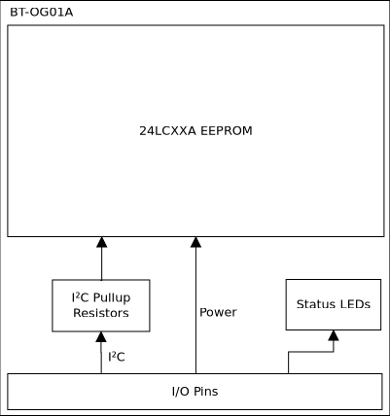 | 