**Automated File Server to OneDrive For Business migration using MSPComplete, UploaderWiz and MigrationWiz**

Contents

1. Description 3

2. Requirements 3

2. Usage 3

3. Inputs and OutPUTS 4

3.1. Upload-UW_FileServerToAzureBlobContainer.ps1 4

3.2. Create-MW_AzureBlobContainerToOD4B.ps1 8

3.3. Start-MW_AzureBlobContainerToOD4BMigrations.ps1 14

# Description

This document will outline the necessary requirements, usage, inputs and outputs when attempting to execute the scripts to automate the File Server Home Directories to OneDrive For Business migration process in MSPComplete and MigrationWiz from Office 365 to Office 365.

The migration process that is completely automated by these scripts is explained in this [File Server Home Directories to OneDrive for Business Migration Guide](https://help.bittitan.com/hc/en-us/articles/115008111407-File-Server-Home-Directories-to-OneDrive-for-Business-Migration-Guide-Using-PowerShell)

# Requirements

* Windows Operating System
* [BitTitan Powershell SDK](https://www.bittitan.com/downloads/bittitanpowershellsetup.msi).msi
* Microsoft Windows PowerShell 4.0+
* Microsoft .NET Framework 3.5
* Microsoft .NET Framework 4.6.2
* The ability to run Powershell as an administrator
* Powershell execution policy set to RemoteSigned or Unrestricted. If already set to Unrestricted do not change to RemoteSigned!
* Ability to create a folder on the root of C:\
* API access granted to BitTitan MSPC account executing the script
* An Azure Subscription and an Azure Storage Account
* 3 MSPComplete endpoints:
* Azure Subscription
* Azure File System
* OneDrive Pro for Business or OneDrive Pro for Business v2

# Usage

1. Unzip the *AutomatedPSTtoOffice365.zip* file into a directory.
2. Make sure the ***BitTitanFunctions.psm1*** is in the same directory as the scripts.
3. Open the BitTitan Command Shell.
4. Change directory to the directory where the zip file was extracted into.
5. Run the following scripts in this order:

**.\Upload-UW_FileServerToAzureBlobContainer.ps1**

**.\Create-MW_AzureBlobContainerToOD4B.ps1**

**.\Start-MW_AzureBlobContainerToOD4BMigrations.ps1**

If you want to delete all the MigrationWiz projects created by *Create-MW_AzureBlobContainerToOD4B.ps1* scripts, you can run this additional script:

**.\Remove-MSPC_FSToOD4BConnectors.ps1**

# Inputs and OutPUTS

## Upload-UW_FileServerToAzureBlobContainer.ps1

The first time the script *Upload-UW_FileServerToAzureBlobContainer.ps1* is executed, it creates the folder *C:\scripts* to place all the CSV files generated during the script execution and a subfolder *C:\scripts\LOGS* for all the log files:

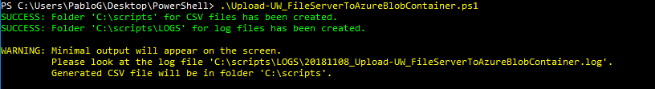

After that, the script automatically downloads the *UploaderWiz.zip* file from the BitTitan server to the same folder where these scripts were unzipped into:





Once the zip file download is completed, the script unzips it into an UploaderWiz folder:



In case there were an *UploaderWiz* folder containing the UploaderWiz.exe file, the script would ask if you want to download it again:



Then the script prompts for the BitTitan credentials:



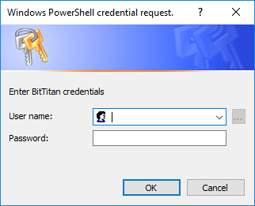

Once authenticated, it retrieves all the Workgroups created by the user and all where the user was invited to. The user will have to select the workgroup that contains the Customer (the default Workgroup does not has name but only ID) and after that, the script displays all the Customers under the selected Workgroup. If there is only one workgroup, it gets selected automatically. The same for the Customer, if there is only one customer, it gets selected automatically:

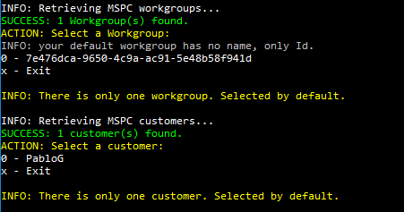

After selecting the Customer, the script display all *AzureSubscription* endpoints:

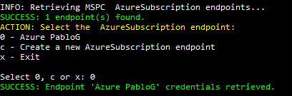

Select your endpoint or create a new one from the shell:

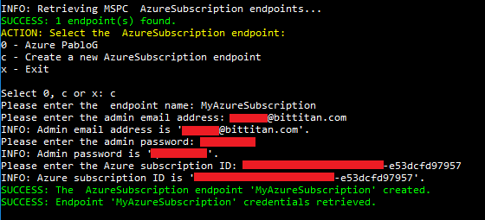

Then the script display all *AzureFileSystem* endpoints:

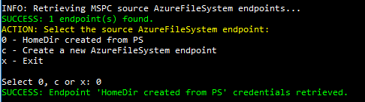

Select your endpoint or create a new one from the shell:

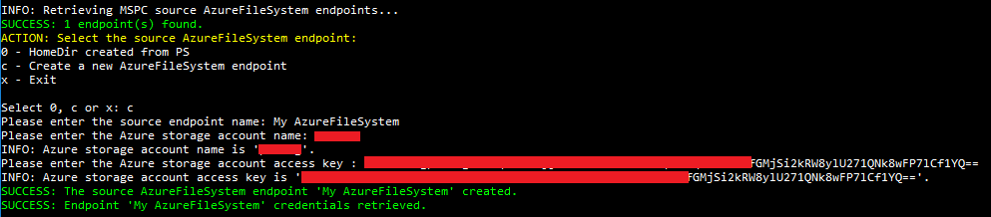

The script retrieves the credentials from the *AzureSubscription* endpoint to connect to Azure. It firstly checks if the AzureRM modue is installed. If not, it downloads, installs and import the module:

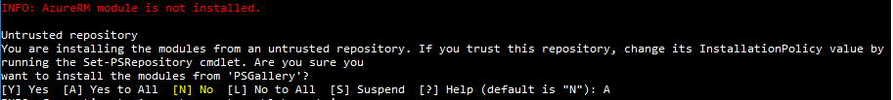

If the AzureRM module is already installed, the script is ready to execute Azure PowerShell:



It connects to the Azure subscription, logs into the Azure storage account and tries to find a blob container called ‘migrationwiz’:



If there is no such blob container, it creates a new one.



After that, it prompts for the File Server root path where all the home directories are located:



For example, the folder path to this root folder: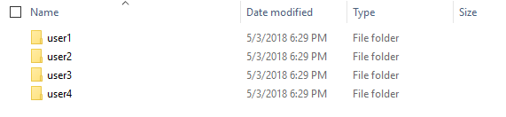

The script changes directory to the UploaderWiz folder and launches UploaderWiz.exe with the required parameters to upload the entire File Server root folder to the Azure blob container “migrationwiz”

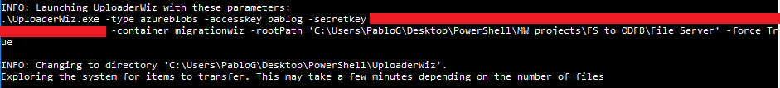

The output changes to the UploaderWiz output:

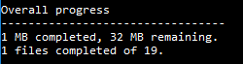

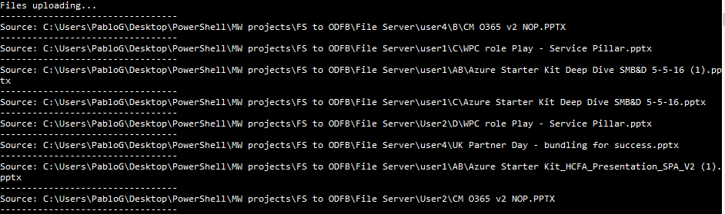

Once the upload finishes, it says how many transfers failed:



You can check in the Azure blob if all the home directories were uploaded successfully:

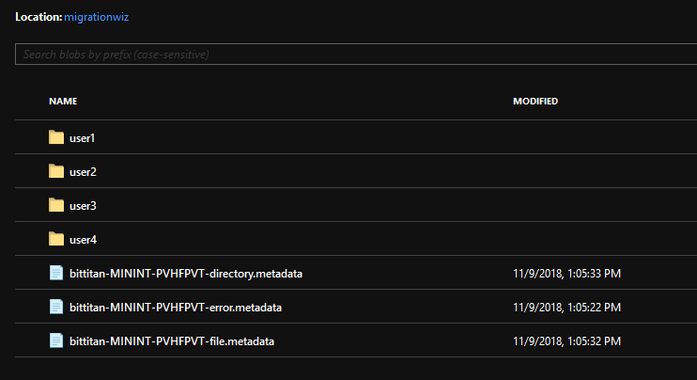

Finally press <Enter> to exit the UploaderWiz.exe.

The scripts goes back to the parent folder and automatically opens the folder containing the UploaderWiz logs:



UploaderWiz-MININT-PVHFPVT.log



## Create-MW_AzureBlobContainerToOD4B.ps1

This script creates a MigrationWiz document project to migrate the File Server home directories from the Azure blob container to the destination OneDrive For Business accounts:



The script starts prompting for the BitTitan credentials:



Once authenticated, it retrieves all the Workgroups created by the user and all where the user was invited to. The user will have to select the workgroup that contains the Customer (the default Workgroup does not has name but only ID) and after that, the script displays all the Customers under the selected Workgroup. If there is only one workgroup, it gets selected automatically. The same for the Customer, if there is only one customer, it gets selected automatically.

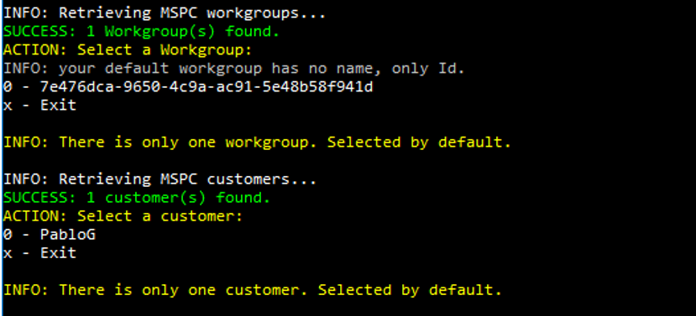

The user then has to select a source *AzureFileSystem* endpoint and to choose between a destination OneDrive For Business endpoint (*OneDrivePro*) or [OneDrive For Business v2 endpoint (*OneDriveProAPI*):](https://help.bittitan.com/hc/en-us/articles/360010811253-When-should-I-use-OneDrive-for-Business-or-SharePoint-Online-v2-Endpoints-)

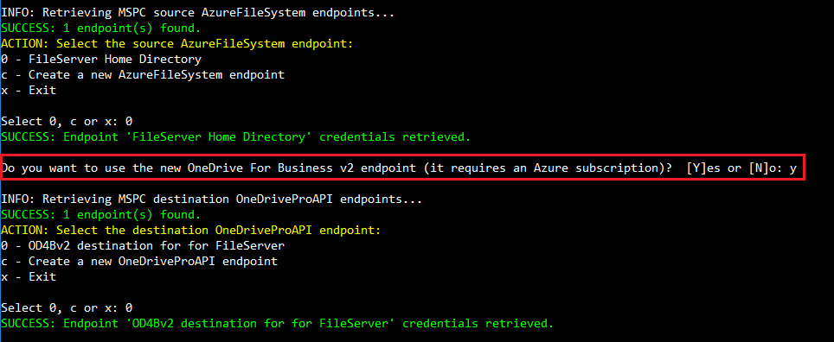

With the Office 365 global admin credentials stored in the *OneDrivePro* or *OneDriveProAPI* endpoint, the scripts connects to the Azure Active Directory to retrieve all users with an OneDrive For Business license and generates a CSV file *OD4BAccounts.csv:*

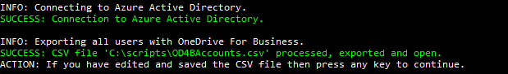

In the CSV file the *SourceFolder* column is populated by default with the prefix of the UPN:

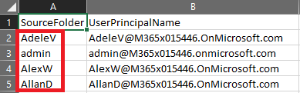

If the home directory name is different, you will have to edit the SourceFolder column:



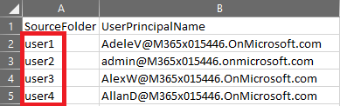

Save the CSV file as MS-DOS *.csv format

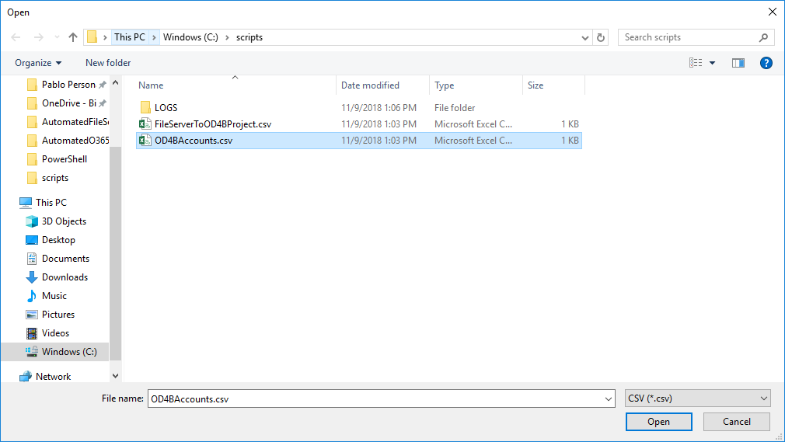



And press any key to continue with the script execution:



The script creates a MigrationWiz document project with the source *AzureFileSystem* endpoint and the destination *OneDriveProAPI* endpoint, adds the project advanced options:

* **InitializationTimeout=28800000** – to increase the timeout to 8 hours.
* **RenameConflictingFiles=1** – to automatically rename the files that have the same name.
* **IncreasePathLengthLimit=1** – to support file path names with up to 400 characters.

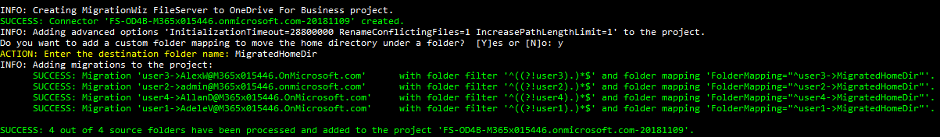

And finally add one migration line items per each OneDrive For Business account found in the Office 365 tenant. Each migration line item will have a folder filter and a folder mapping.

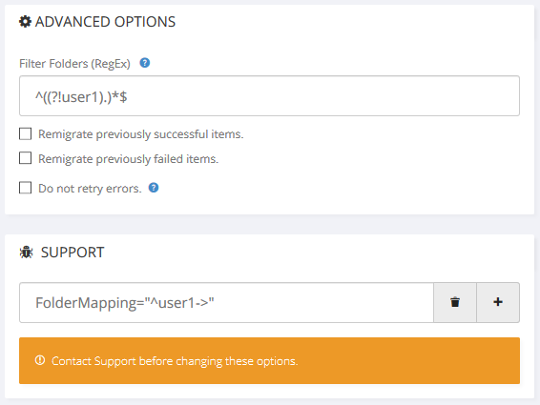

The script asks if a custom folder mapping needs to be added



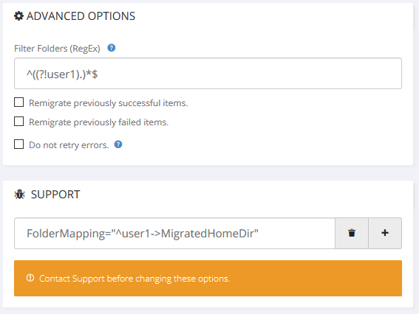

To place the entire home directory under a subfolder in the OneDrive For Business account:

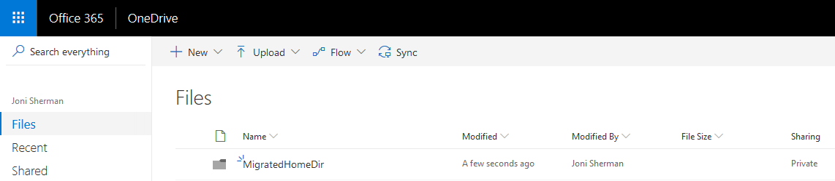

The script then automatically opens in the default web browser the Users view in the MSPComplete platform under the selected Customer for you to apply the User Migration Bundled to the OneDrive For Business accounts:



You have to select the users you want to migrate and apply an User Subscription Bundle:

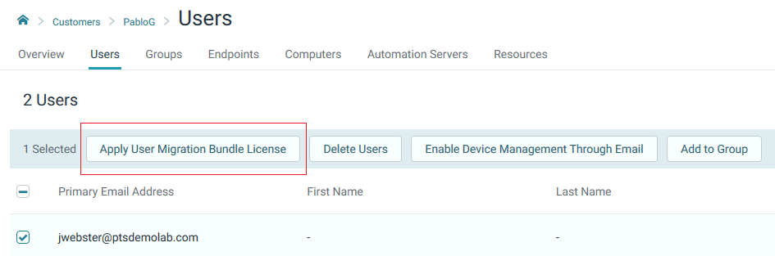

After that go back to the script and press any key to continue.

The script finishes exporting all the migration line items added to the MigrationWiz project to a CSV file *FileServerToOD4BProject.csv*:



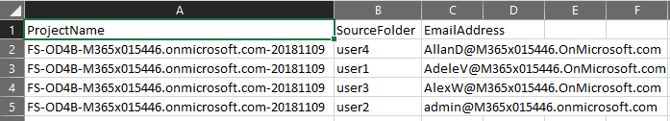

This CSV file will be used by the next script *Start-MW_AzureBlobContainerToOD4BMigrations.ps1* to submit all the migrations automatically:

## Start-MW_AzureBlobContainerToOD4BMigrations.ps1

This script controls the submission of all migrations added to the MigrationWiz project created by the previous script *Create-MW_AzureBlobContainerToOD4B.ps1.* **The script assumes that all migration items have corresponding User Migration Bundle licenses applied before running the script.** If not, purchase and [apply a User Migration Bundle](https://help.bittitan.com/hc/en-us/articles/115014263488-Apply-User-Migration-Bundle-licenses-to-the-Customer-s-Users) per each OneDrive For Business account.

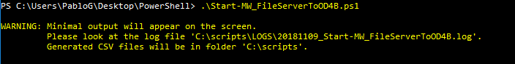

The script starts prompting for the BitTitan credentials:



After that, it prompts for CSV file *AzureBlobContainerToOD4BProject.csv* created by the script *Create-MW_AzureBlobContainerToOD4B.ps1* by opening a File Dialog window:

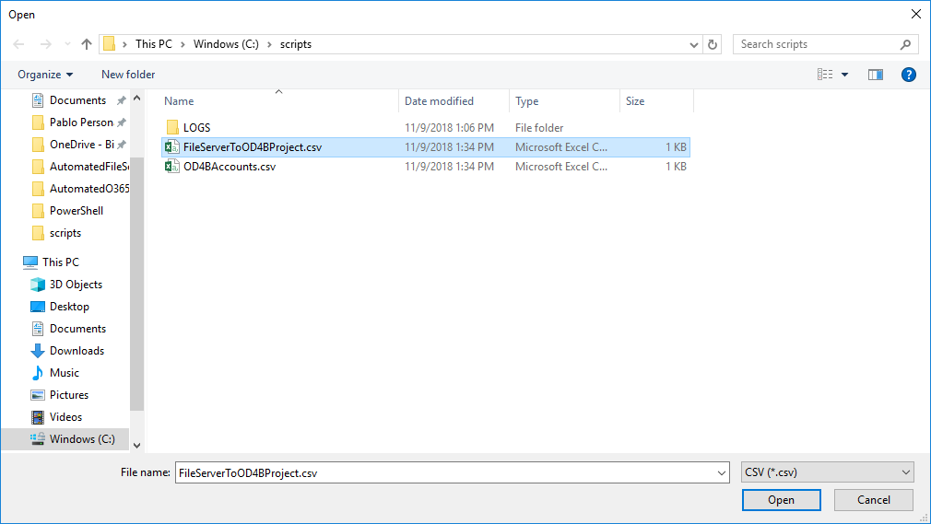

The CSV file contains the name of MigrationWiz project and the home directory to OneDrive For Business migrations to be submitted:

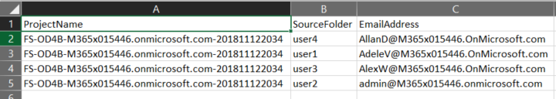

The script reads the MigrationWiz project name from the CSV file and retrieves all the migrations added to the project:

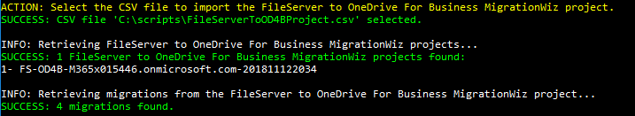

And it asks which migrations must be submitted:

1. All migrations
2. Not started migrations
3. Failed migrations
4. Successful migrations that contain errors
5. Specify the email address of the OneDrive For Business account
6. All migrations that were not successful (failed or stopped)

For example, you could enter ‘0’ the first time all the PST files are being submitted for migration.

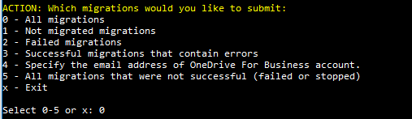

After that, select the type of migration pass you want to submit:

1. Migration (including delta pass if previously migrated)
2. Verify credentials
3. Retry errors
4. Trial migration

You can start with a *Verify credentials*,

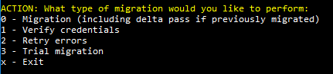

And the script submits all migrations for verify credentials:



In MigrationWiz UI you will see all the migrations submitted:



After displaying how many migrations were successfully submitted



The menu is displayed again, infinitely until you enter ‘x’ for exit.