**Automated Office 365 Group migration from O365 to O365 using MSPComplete and MigrationWiz**

Contents

1. Description 3

2. Requirements 3

2. Usage 3

3. Inputs and OutPUTS 4

3.1. Create-MW_Office365Groups.ps1 4

3.2. Start-MW_Office365GroupMigrations.ps1 8

3.3. Remove-MSPC_Connectors.ps1 12

3.4. Remove-MSPC_Endpoints.ps1 14

# Description

This document will outline the necessary requirements, usage, inputs and outputs when attempting to execute the scripts to automate the Office 365 Group migration process in MSPComplete and MigrationWiz from Office 365 to Office 365.

The migration process that is completely automated by these scripts is explained in [this migration guide for Office 365 Group documents](https://help.bittitan.com/hc/en-us/articles/115008113567-Office-365-Group-to-Office-365-Group-Documents-Migration-Guide) and [this migration guide for Office 365 Group conversations](https://help.bittitan.com/hc/en-us/articles/115008113587-Office-365-Group-to-Office-365-Group-Mailbox-Conversations-Migration-Guide).

# Requirements

* Windows Operating System
* [BitTitan Powershell SDK](https://www.bittitan.com/downloads/bittitanpowershellsetup.msi)
* Microsoft Windows PowerShell 4.0+
* Microsoft .NET Framework 3.5
* Microsoft .NET Framework 4.6.2
* The ability to run Powershell as an administrator
* Office 365 Groups must exist in the destination Office 365 tenant before running these scripts. You can use [this Microsoft script *(ExportImportUnifiedGroups.ps1)*](https://gallery.technet.microsoft.com/office/Export-and-Import-Unified-e73d82ba) to export / import Office 365 Groups and their settings as part of your tenant-to-tenant migration.
* Powershell execution policy set to RemoteSigned or Unrestricted. If already set to Unrestricted do not change to RemoteSigned!
* Ability to create a folder on the root of C:\
* API access granted to BitTitan MSPC account executing the script
* 2 MSPComplete endpoints:
* **Office 365** – with the source Office 365 tenant global admin credentials
* **Office 365** – with the destination Office 365 tenant global admin credentials

Note: If the **AccessType** of the Office 365 group is **private**, the Office 365 global admins account must be a member of the Office 365 Group (being an owner is not necessary).

# Usage

1. Unzip the *AutomatedPSTtoOffice365.zip* file into a directory.
2. Make sure the ***BitTitanFunctions.psm1*** is in the same directory as the scripts.
3. Open the BitTitan Command Shell
4. Change directory to the directory where the zip file was extracted into
5. Run the following scripts in this order:

**.\Create-MW_Office365Groups.ps1**

**.\Start-MW_Office365GroupMigrations.ps1**

1. If you want to delete all changes made by these 2 scripts, you can run these 2 additional scripts in this order:

**.\Remove-MSPC_Connectors.ps1**

**.\Remove-MSPC_Endpoints.ps1**

# Inputs and OutPUTS

## Create-MW_Office365Groups.ps1

The first time the script *Create-MW_Office365Groups.ps1* is executed, it creates the folder *C:\scripts* to place all the CSV files generated during the script execution and a subfolder *C:\scripts\LOGS* for all the log files:

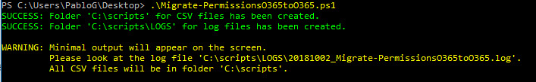

After that, the script prompts for the BitTitan credentials:

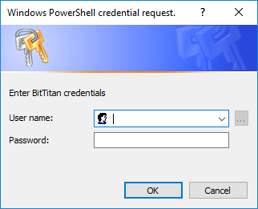

And retrieves all the Workgroups created by the BitTitan user. The user will have to select the workgroup that contains the Customer (the default Workgroup does not has name but only ID) and after that, the script displays all the Customers under the selected Workgroup:

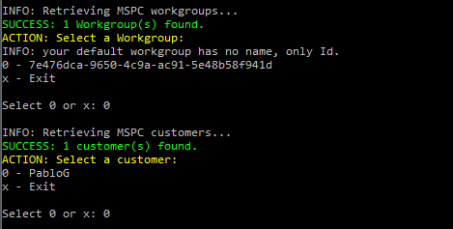

The user has to select a source Office 365 Endpoint (ExchangeOnline2) and destination Office 365 Endpoint for the script to retrieve the source and destination Office 365 global admin credentials that will be used to build the Office 365 Group Endpoints:

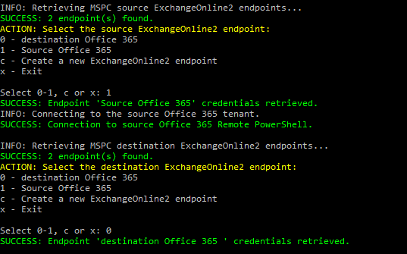

After that, the script asks how the destination email addresses are:

* If the destination email addresses are the same.
* If not, if the destination domain/s is/are different
  + if the destination domain/s is/are different, prompts for the new destination domain/s
* Finally if the destination email prefixes change.



Based on the answers to those questions, the script will automatically build a recipient mapping for the domain or will display a File Dialog window to select a CSV file with for each of the mailbox email address mapping to be added to the project advanced options.

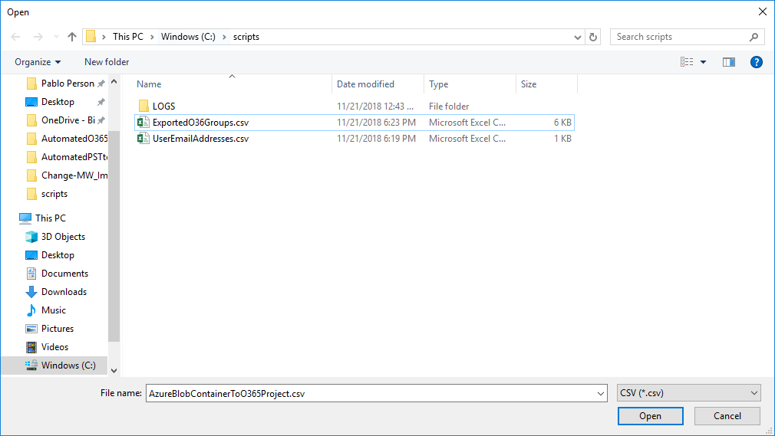

For example, a recipient mapping to map a domain:

***RecipientMapping="@old-domain.com->@new-domain.com"***

A recipient mapping to map each of the mailbox email addresses when there are several domains to be mapped or when user prefixes change at destination:

***RecipientMapping="userOne@old-domain.com->user.1@new-domain.com"***

***RecipientMapping="userTwo@old-domain2.com->user.2@new-domain2.com"***

The CSV file with the mailbox email address mappings must have two columns *SourceEmailAddress* and *DestinationEmailAddress*:

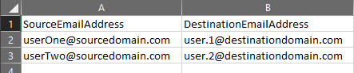

Then with the source Office 365 global admin credentials previously retrieved from the selected source endpoint, the script connects automatically to the source Office 365 tenant and export all Office 365 Groups (DisplayName, URL and primary SMTP address).



A CSV file ***ExportedO36Groups.csv*** is generated with these columns:

srcDisplayName, srcSharePointSiteUrl, srcPrimarySmtpAddress, dstSharePointSiteUrl, dstPrimarySmtpAddress

The 3 first columns (srcDisplayName, srcSharePointSiteUrl, srcPrimarySmtpAddress) referring to the souce (src prefix) are automatically populated with the source Office 365 Groups data exported from the source tenant. The last 2 columns (dstSharePointSiteUrl, dstPrimarySmtpAddress) referring to the destination (dst prefix) must be populated by the user with the correct destination URLs and primary SMTP addresses:

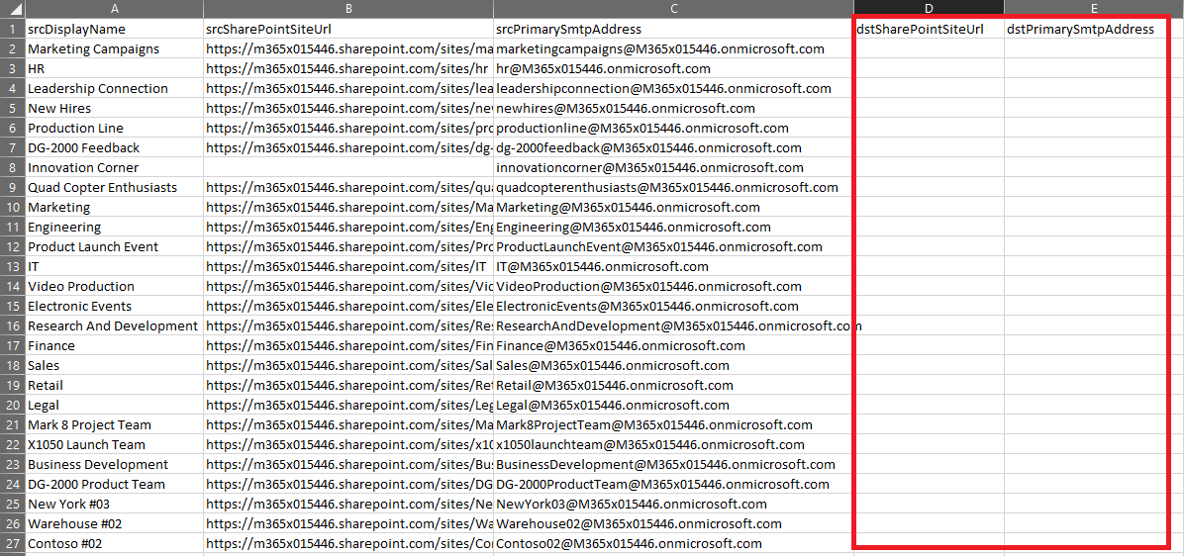

Once the CSV file is populated with the destination Office 365 Groups, press any key to continue with the script execution.

Finally the script builds all the MSPC endpoints and MigrationWiz projects needed for the Office 365 Group migration process. It creates:

* **2 Office 365 Group MSPC endpoints per each Office 365 Group**
* **1 MigrationWiz Document migration project per each Office 365 Group** with the *Document-<primarySMTPAddress>* project name and import the source and destination *Shared Documents* Libraries into each of the projects and adds these advanced options at the project level:
  + **Under support options:**
    - InitializationTimeout=28800000
    - FolderLimit=20000
    - SyncItems=1 which explained [here](https://help.bittitan.com/hc/en-us/articles/115008261208-What-do-I-need-to-know-about-the-Sync-Migration-Pass-)
* **Only 1 MigrationWiz Mailbox migration project for all the Office 365 Groups conversations** as you can see highlighted in yellow below with the *Mailbox-O365 Group Conversations* project name, imports all the primary email addresses under that project and adds all these advanced options at the project level:
  + **Under folder filter:** ^(?!Inbox|Calendar)
  + **Under support option:** The script will apply either a RecipientMapping for the domain or a RecipientMapping per each mailbox email address depending on how the destination email addresses are.



Ann sample output:

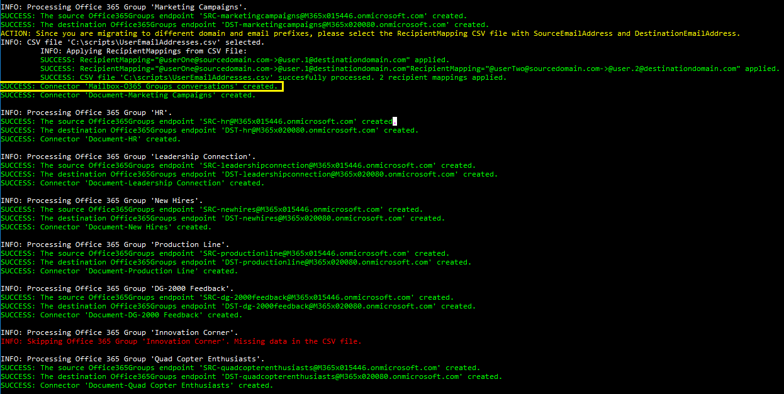

If some of the Office 365 Groups in the CSV file has missing data, the group processing is skipped as showed in red above.

If the endpoint already exists from a previous script execution, they are skipped:



After processing all exported Office 365 groups, the script says how many were successful in creating the MSPC endpoints and MigrationWiz projects:



Finally a CSV file with all MigrationWiz project names will be automatically created and opened.



This CSV file will be used for the next script *Start-MW_Office365GroupMigrations.ps1:*

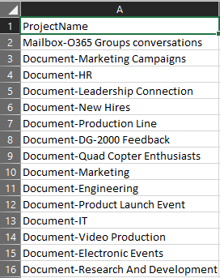

## Start-MW_Office365GroupMigrations.ps1

This script controls the submission of all migrations across all MigrationWiz projects created by the previous script *Create-MW_Office365Groups.ps1.* **The script assumes that all migration items have corresponding User Migration Bundle licenses applied before running the script.** If not, purchase and [apply a User Migration Bundle](https://help.bittitan.com/hc/en-us/articles/115014263488-Apply-User-Migration-Bundle-licenses-to-the-Customer-s-Users) per each Office 365 Group email address.

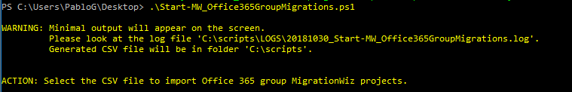

The script starts prompting for the CSV file by opening a *File Dialog* window:

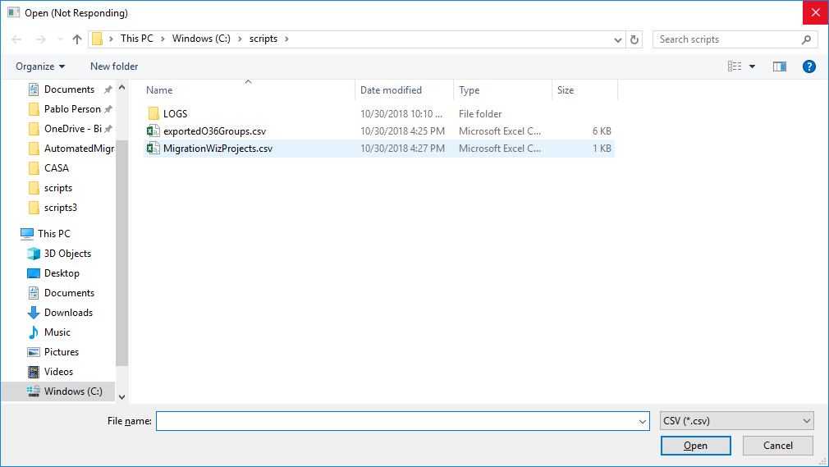

Select the *MigrationWizProjects.csv* CSV file created by the script *Create-MW_Office365Groups.ps1*. The script then goes through all the all MigrationWiz projects found in the CSV file, displays their names and retrieves all migrations from each of them (there is a Document project per each Office 365 Group containing only one migration with the source and destination *Shared Documents* libraries and only one Mailbox migration project for all Office 365 Groups containing all source and destination primary SMTP email addresses):

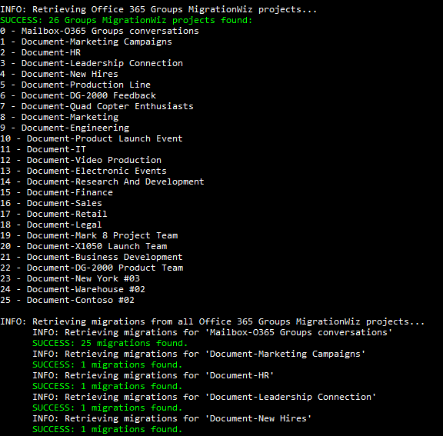

Finally the script displays the total number of migrations found across all MigrationWiz projects:



After that, it asks which migrations must be submitted:

1. All mailboxes
2. Not migrated mailboxes
3. Failed mailboxes
4. Successful mailboxes that contain errors
5. Specify the email address
6. All mailboxes that were not successful

For example you could enter ‘0’ the first time all the Office 365 Groups are being submitted for migration.

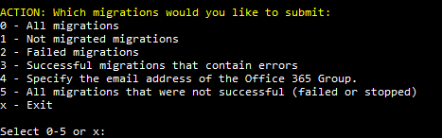

After that, select the type of migration pass you want to submit:

1. Migration (including delta pass if previously migrated)
2. Verify credentials
3. Retry errors
4. Trial migration

You can start with a *Verify credentials*,

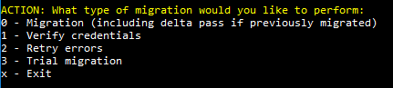

And the script submits all migrations for verify credentials:

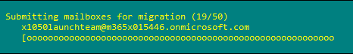

After displaying how many migrations were successfully submitted



The menu is displayed again, infinitely until you enter ‘x’ for exit:

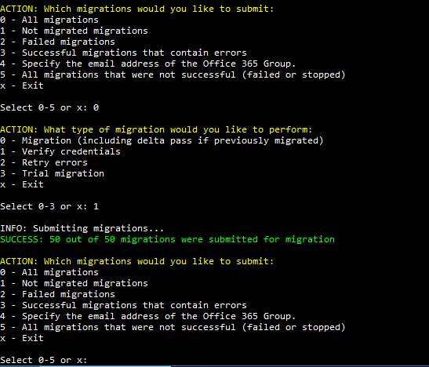

Then you can submit for Migration by entering ‘0’. If you want to submit a delta pass just enter ‘0’ for a new full migration pass. For documents the advanced option **SyncItems=1** will synchronize all changes made at source since the first migration pass.

If the migration is currently running the submission will fail:

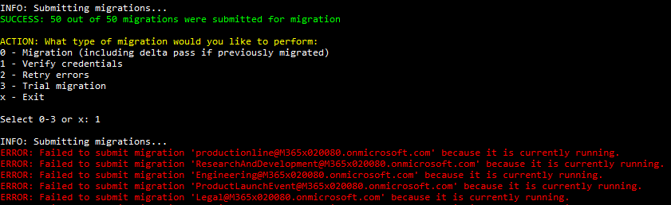

## Remove-MSPC_Connectors.ps1

This script is to remove all MigrationWiz projects created by *Create-MW_Office365Groups.ps1* once you have completed the migration or after performing a test. You have to provide again the Workgroup and the Customer instance before starting the deletion:

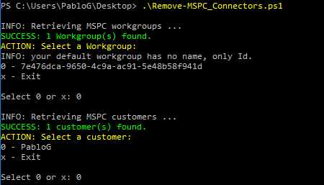

Then the script retrieves all MigrationWiz projects whose names start with “Document-“ or “Mailbox-“ prefixes and delete them all:

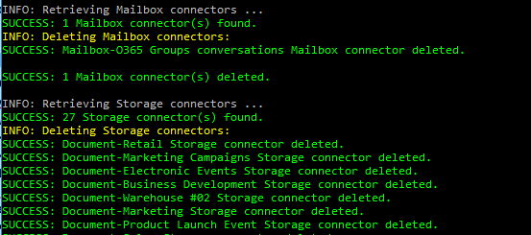

At the end of the execution says how many MigrationWiz projects were successfully deleted:



If the MigrationWiz projects do not exist or their names do not match with the “Document-“ or “Mailbox-“ prefix naming convention, the script does not delete anything:

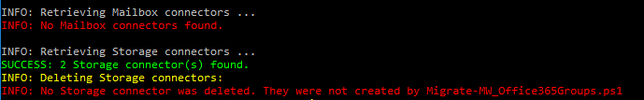

## Remove-MSPC_Endpoints.ps1

This script is to remove all MSPC endpoints created by *Create-MW_Office365Groups.ps1* once you have completed the migration or after performing a test. You have to provide again the Workgroup and the Customer before starting the deletion:

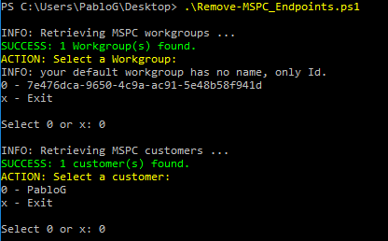

Then the script retrieves all MSPC endpoints whose names start with “SRC-“ or “DST-“ prefixes and delete them all:

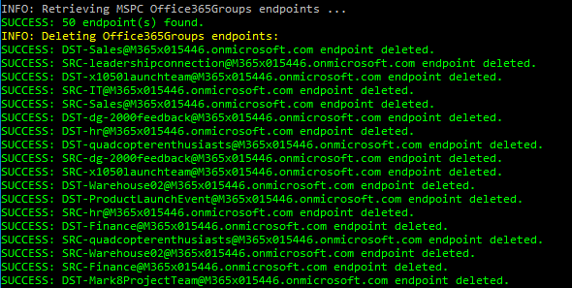

At the end of the execution says how many MSPC endpoints were successfully deleted:



If the MSPC endpoints projects do not exist or their names do not match with the “SRC-“ or “DST-“ prefix naming convention, the script does not delete anything:

