**Online Madden Tournament tracker**

* Must be a web application
  + You can choose the language
  + You can choose the storage mechanism (database, XML, nosql, etc…)
  + Must be accessible for me to grade as your progress
    - Both the source code and the running application
    - Let me know if you need a development environment and I’ll get one set up for you in the IA Lab – most likely a .NET/SQL server environment if you have me do it
    - Consider using github for version control and publishing
    - Make sure you include directions for configuration/installation/use
    - Comments are your friends! ☺
    - You will have TONS of supporting documentation. (Yes, there’s much more to programming than writing code!)
* User creates a profile to log in with
  + Name (first & last)
  + Username (DSU email)
  + Twitter handle (optional)
  + Profile picture (optional)
  + Anything else you’d like to include
* Administrator accounts can do everything (create, edit, delete) in the application.
* There can be several tournaments going at once
  + The app should assign a tournament ID that can be used to reference the tournament in email and twitter updates
  + A user can pick what tournament to sign up for
  + Each tournament should have certain properties
    - Quarter length in minutes (5, 10, or 15)
    - Difficulty level (pro, all-pro, etc..)
    - Etc..
  + Each tournament should have defined dates for sign-up (date/time for open & close of sign-up)
  + Each tournament should have defined dates for each round of play (date/time for round open & round close)
  + All un-played tournament games should have a winner randomly picked between the two teams.
    - Make sure to indicate the game was simulated
    - Make sure to update the bracket accordingly
  + Before starting tournament play:
    - Each user should be assigned a random NFL team
    - Each user should be assigned a random spot on the bracket
    - If not all teams are claimed, the computer should be assigned to the open teams
  + The application should send out email and twitter updates to all players when:
    - Tournament is available to sign up for
    - Tournament is full of teams
    - Current round is open for play
    - Current round is over in 24 hours
    - Tournament is done (results)
* Must handle tournament play
  + Single elimination
  + Create and populate a bracket like the one below where there are 4 “regions” that all progress towards the middle of the bracket.
  + You don’t need to name the regions – the idea here is for the appearance and functionality of the bracket.

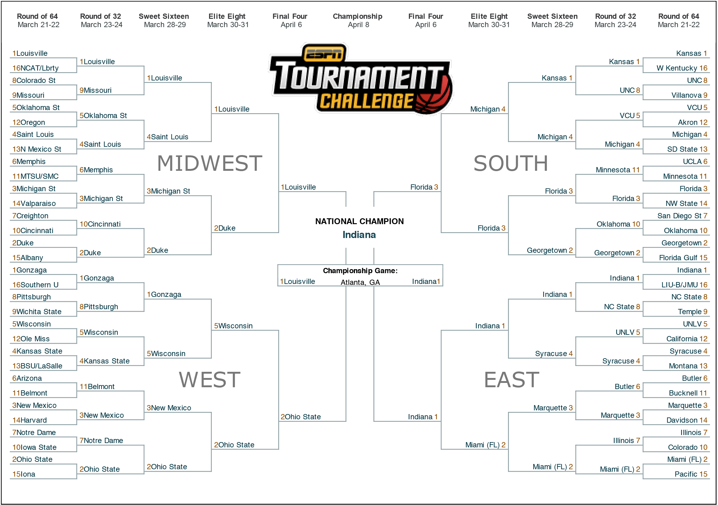

* + After each game, the team on the top of the matchup must enter the score.
    - When playing the computer, the human player needs to enter the score.
    - The high scoring team advances to the next round of the tournament.