# Controller-Cold-Setup

This is the advised Method to setup your Masternodes. The wallet containing the coins does not have to be exposed and can run on your local computer. It does not have to run all the time and you are not vulnerable to someone hacking your VPS because all he can do when he hacked your VPS is stop your MNs but not steal your coins!

# Desktop Wallet Setup

In the first steps the desktop wallet will be setup. This is the wallet you can run on your local PC. When the masternodes are connected this wallet can be closed and the PC does not have to run in order for the masternodes to generate rewards.

We will create an address, private key and transaction for each masternode (MN in the following) and show the necessary steps for configuration.

1. 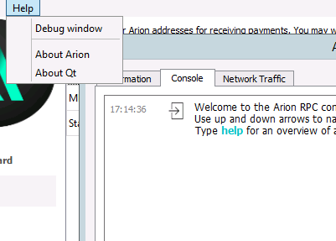Open Console: Tools → Debug window
2. 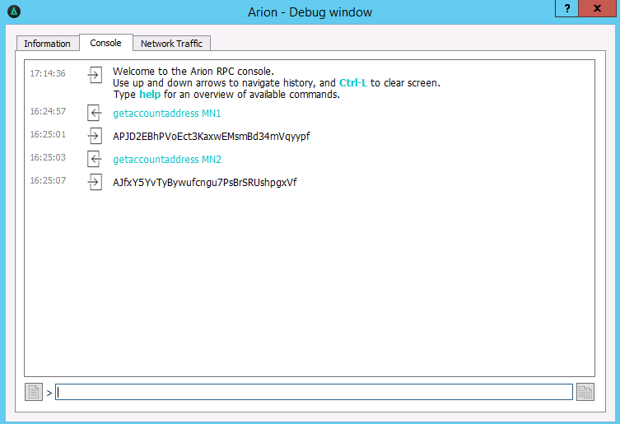Type “getaccountaddress MN1” and press Enter.

Repeat this step for the amount of masternodes you want to setup as shown. Make sure you count up (MN1, MN2 etc.)

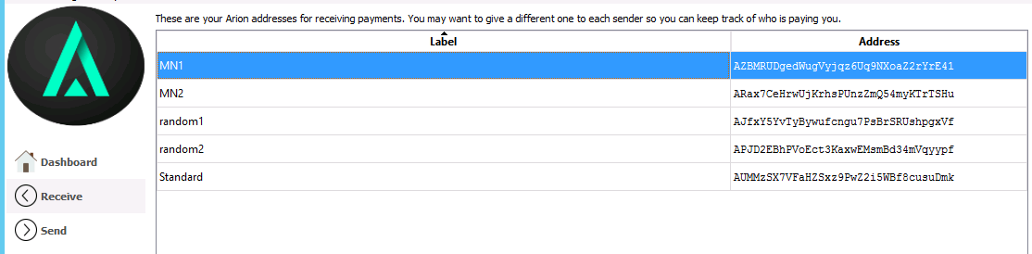

These *are the addresses that will be associated with the MNs. You can view all you created addresses under Receiving Addresses*

1. Send exactly 5000 coins to each MN address

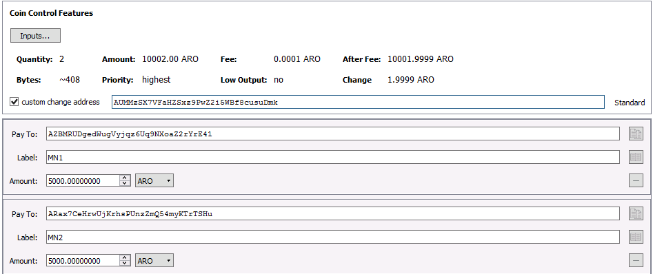

Klick on “add recipient” to add lines so you can send to all nodes in one transaction.

1. Now create (or open) the “masternode.conf” this file is located under %appdata%\Roaming\Arion  
   [**Make sure you activated file extension!**](https://www.techadvisor.co.uk/how-to/software/how-show-or-hide-file-extensions-3341794/)

We will now add a Line for each MN with the following Format:

alias IP:port masternodeprivkey txhash outputindex

* 1. Begin by entering and alias IP:port
     1. Alias: the name of the MN receiving address (we named them MN1, MN2, …)
     2. IP: The static IP of your server (If you don’t have one scroll down to find out where to get one!)
     3. port: A port the MN will connect to. The port is not fixed and multiple nodes can run on one server but need different ports.

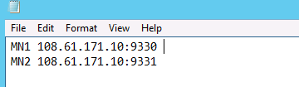You can have more than one node per IP just adjust the ports. If you don’t have a linux VPS by now please scroll down to “Get a Linux VPS first”

* 1. Next we get the “masternodeprivkey “
     1. Open debug console again, type “masternode genkey” and press enter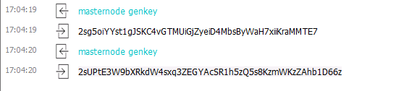
     2. Repeat the line for each MN you want to setup
     3. Copy the output keys to the config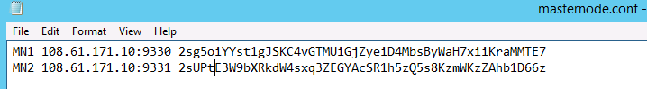

The private keys are used for voting and identify you as the real owner so don’t share them.

* 1. Next we will add txhash and outputindex
     1. 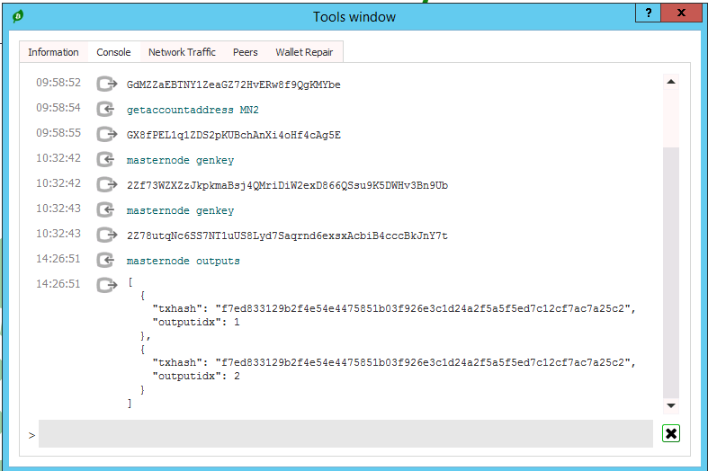Go to the debug console again, type “masternode outputs” and press enter
     2. If you send the coins in one transaction the “txhash” will be the same. If you add a masternode later, another tuple will be added. So every masternode has a unique pair of txhash and outputindex
     3. 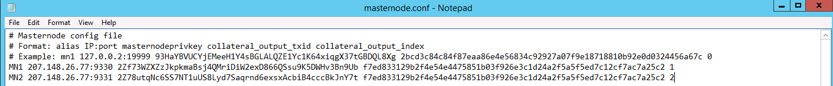Copy the information to the config file (Make sure you don’t forget the index!)

This is what your config should finally look like.

1. Save the file and restart the wallet.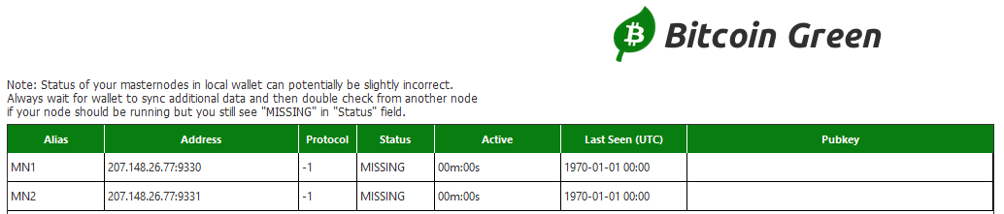

Verify now that your MN are shown in the Masternodes tab.

### Getting a VPS

For the cold wallets you first need a linux VPS. You can get very cheap ones for 5$ here: <https://www.vultr.com/?ref=7285424>. These can run around 3 Arion masternode instances though it might be a good idea to split your MNs across some different Servers. The more isolation you have the less likely you are hit big by a server outage☺.

After registration you get to the Dashboard. You have to do the first payment with something else then Bitcoin. After the first payment you can pay the servers in BTC.

1. Deploy the server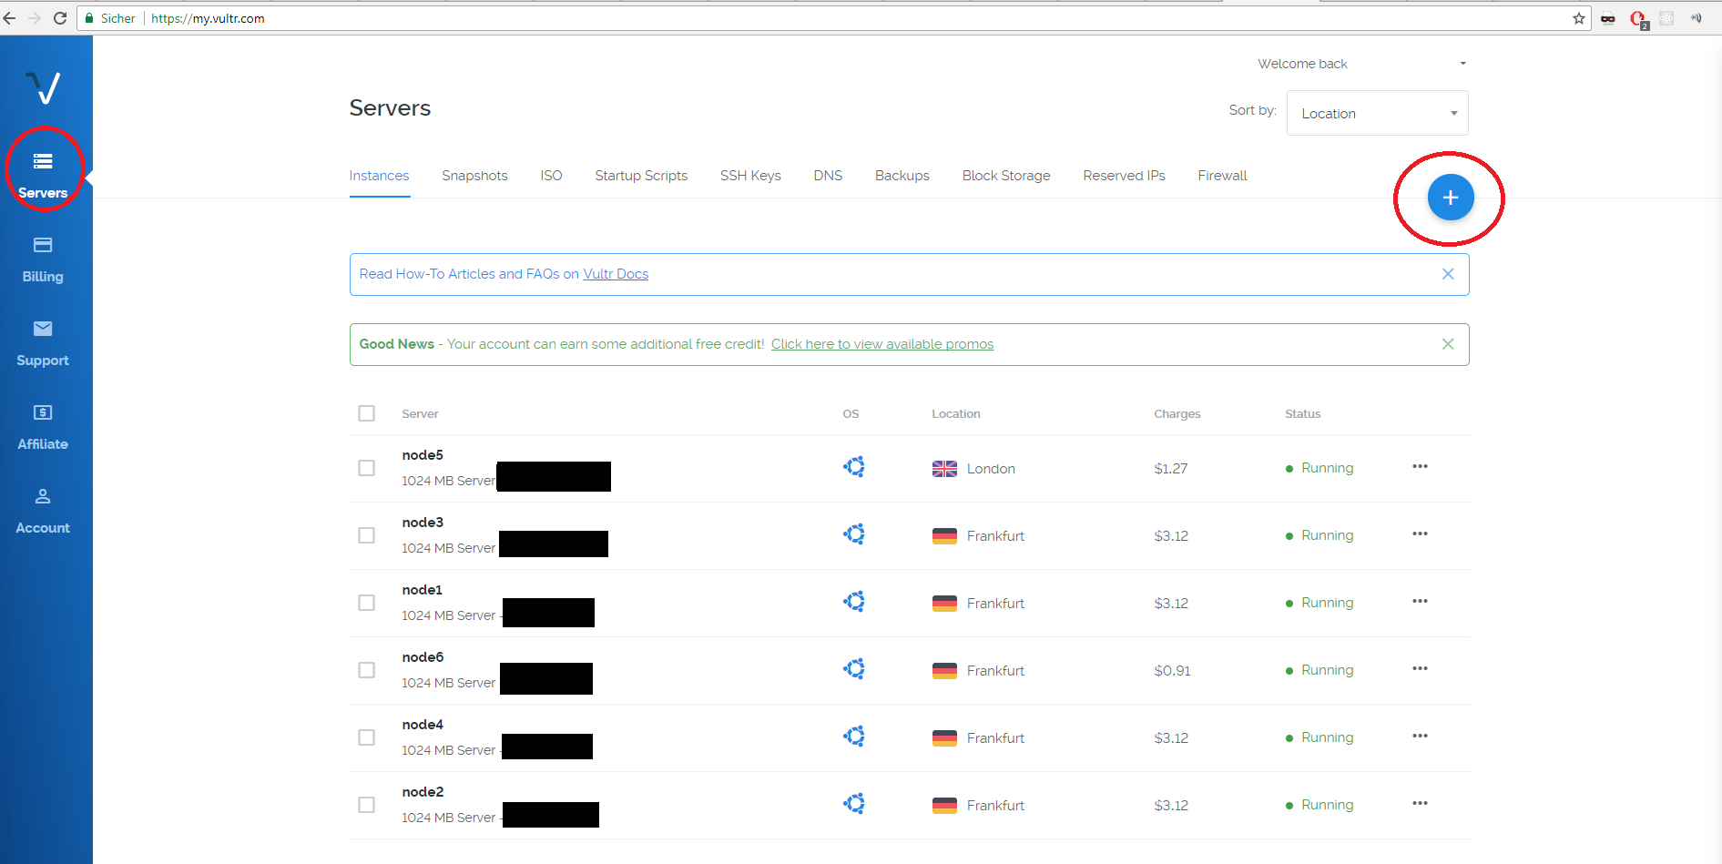Hit the plus top right to add new instances
2. 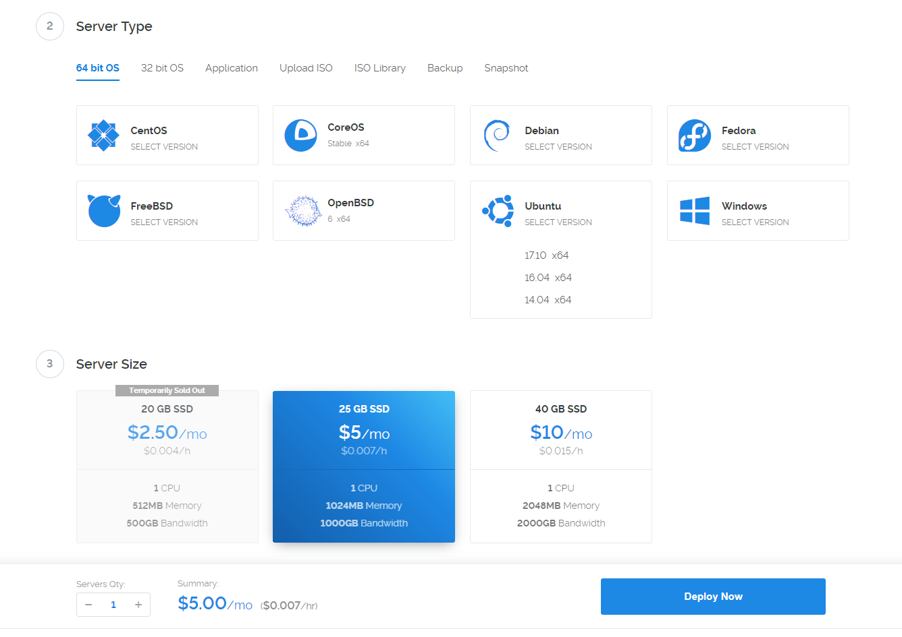Choose a region near you. It does not really matter.
   1. As “Server Type” choose Ubuntu and klick 16.04 (Important don’t take 17.10!)
   2. As Server Size choose the 5$ instance with 1GB Ram. If available you can choose the 2.50$ one if you only want to run only one node on it.
   3. Scroll down and give the node a name.
   4. After that click “Deploy now” in the overview you should see this:



1. Connect to the Server.
   1. You will need some SSH tool connect. I use “Royal-TS” to manage several connections at once. It’s a bit harder getting used too but has real value.
   2. To connect with “putty” a basic tool refer to [this guide](https://mediatemple.net/community/products/dv/204404604/using-ssh-in-putty-)
   3. You can find username (root) and password when you click on the newly created instance. The installation has to finish before!
   4. Note: pasting your clipboard is “right click”

## Automatic server installation and setup.

1. Download and execute script on VPS:

wget https://raw.githubusercontent.com/XeZZoR/scripts/master/Arion/setup.sh

chmod 755 setup.sh

./setup.sh

This process is interactive and takes several minutes.

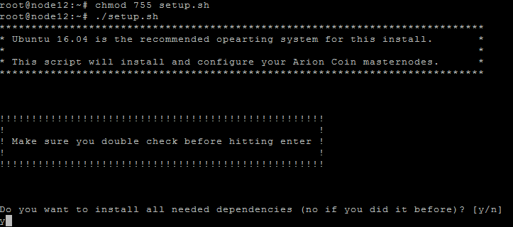

Enter y and press enter when you first setup the server. All dependencies and needed programs will be installed (takes ~10-30 minutes for compilation)

C:\Users\XeZZ\Desktop\Guide\s4.PNG

Enter the the servers IP address (199.247.4.66 in my case)

C:\Users\XeZZ\Desktop\Guide\s5.PNG

Enter the number of masternodes you want to run on the server (2 in my case)

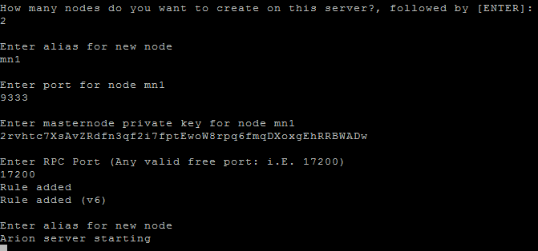

Enter the asked information. The alias is to give each node a unique name and control it. Enter port and masternode key which you configured before in the desktop wallet. Also unique free rpc port is needed. You can take any. The input process repeats for every node you want to configure (2 times in my case)

If you made an error when typing the interactive stuff: ctrl+c and restart the script ☺

1. Controlling the masternode
2. The script from the last step already started all wallets on VPS
3. Type “source .bashrc” in console
4. Each MN has now its own control script under ~/bin (named with alias you typed before)
5. 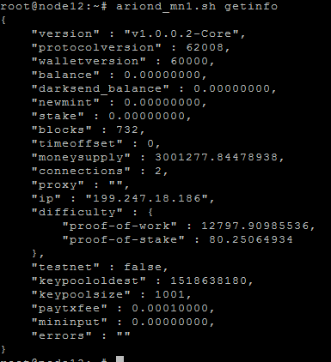To see if everything works type “aroind_mn1.sh getinfo”

Every node has a script “ariond_ALIAS.sh”. Always use these scripts and not the daemon directly.  
You can see the amount of blocks here. Wait till its fully synced till the next step.

1. 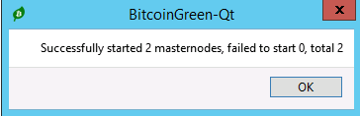If sync is finished go to your desktop wallet and start MNs in the masternode tab (unlock wallet before).
2. 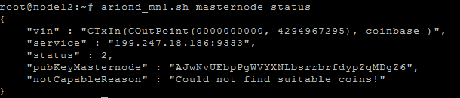See if node is running: “aroind_mn1.sh masternode status”

*This is a bad status. You either have a config error or the node is not started in the desktop wallet.*

If you see this status your node is successfully running and you can close the controller wallet!

# Adding more nodes to existing VPS

To add more Arion MNs to an existing server setup with the setup.sh script before just restart the script and type “n” when asked if you want to install the dependencies at the beginning. After that just follow the steps from before in the interactive script. When asked on “how many nodes do you want to setup” type the number of nodes you want to add now (So if 2 are running and you want to add a third type 1).