# Controller-Cold-Setup

This is the advised Method to setup your Masternodes. The wallet containing the coins does not have to be exposed and can run on your local computer. It does not have to run all the time and you are not vulnerable to someone hacking your VPS because all he can do when he hacked your VPS is stop your MNs but not steal your coins!

# Desktop Wallet Setup

In the first steps the desktop wallet will be setup. This is the wallet you can run on your local PC. When the masternodes are connected this wallet can be closed and the PC does not have to run in order for the masternodes to generate rewards.

We will create an address, private key and transaction for each masternode (MN in the following) and show the necessary steps for configuration.

1. 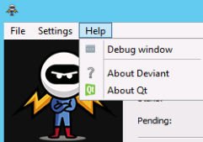Open Console: Tools → Debug window
2. 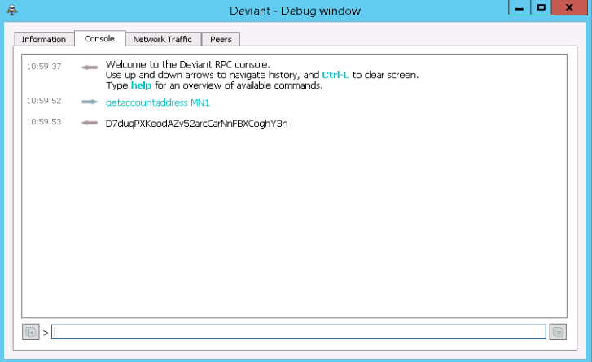Type “getaccountaddress MN1” and press Enter.

*This is the address your masternode will be affiliated to.*

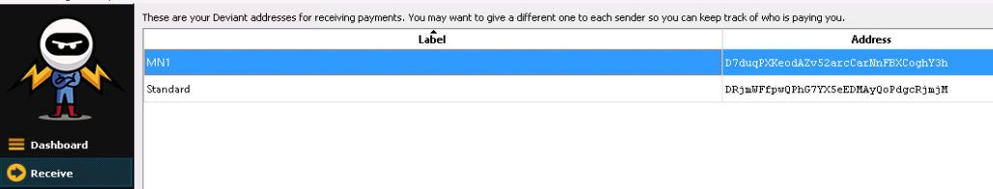

*You can view all you created addresses under Receiving Addresses*

1. Send exactly 5000 coins to the created MN address:

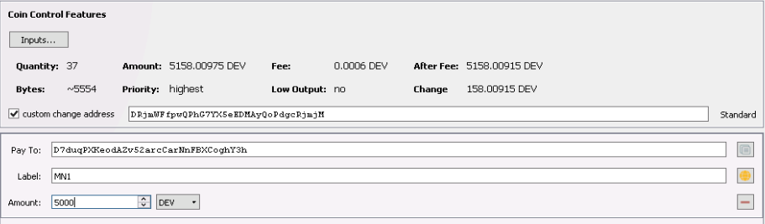

Click on “add recipient” to add lines so you can send to all nodes in one transaction.

1. Now create (or open) the “masternode.conf” this file is located under %appdata%\Roaming\Deviant  
   [**Make sure you activated file extension!**](https://www.techadvisor.co.uk/how-to/software/how-show-or-hide-file-extensions-3341794/)

We will now add a Line for each MN with the following Format:

alias IP:port masternodeprivkey txhash outputindex

* 1. Begin by entering and alias IP:port
     1. Alias: the name of the MN receiving address (we named them MN1, MN2, …)
     2. IP: The static IP of your server (If you don’t have one scroll down to find out where to get one!)
     3. port: A port the MN will connect to. The port is fixed to 7118 and you need a separate IP (VPS) for each running node!

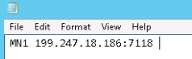You cannot have more than one node per IP make sure the port is 7118. If you don’t have a linux VPS by now please scroll down to “Get a Linux VPS first”

* 1. Next we get the “masternodeprivkey “
     1. Open debug console again, type “masternode genkey” and press enter

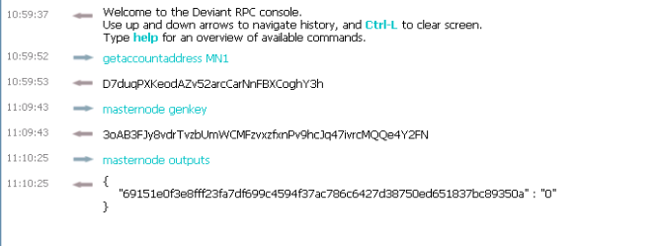

* + 1. 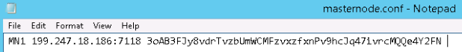Copy the output keys to the config

The private keys are used for voting and identify you as the real owner so don’t share them.

* 1. Next we will add txhash and outputindex
     1. Go to the debug console again, type “masternode outputs” and press enter
     2. If you send the coins in one transaction the “txhash” will be the same. If you add a masternode later, another tuple will be added. So every masternode has a unique pair of txhash and outputindex
     3. Copy the information to the config file (Make sure you don’t forget the index!)

This is what your config should finally look like.

1. 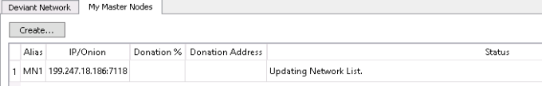Save the file and restart the wallet.

Verify now that your MN are shown in the Masternodes tab. If they don’t appear press the “update”-Button below. It will say “Not in Masternode list” for now.

### Getting a VPS

For the cold wallets you first need a linux VPS. You can get very cheap ones for 5$ here: [https://www.vultr.com/](https://www.vultr.com/?ref=7285424). These can run around 3 different MNs so you can use them for other coins too! The more isolation you have the less likely you are hit big by a server outage so don’t put to many eggs in one basket.

After registration you get to the Dashboard. You have to do the first payment with something else then Bitcoin. After the first payment you can pay the servers in BTC.

1. Deploy the server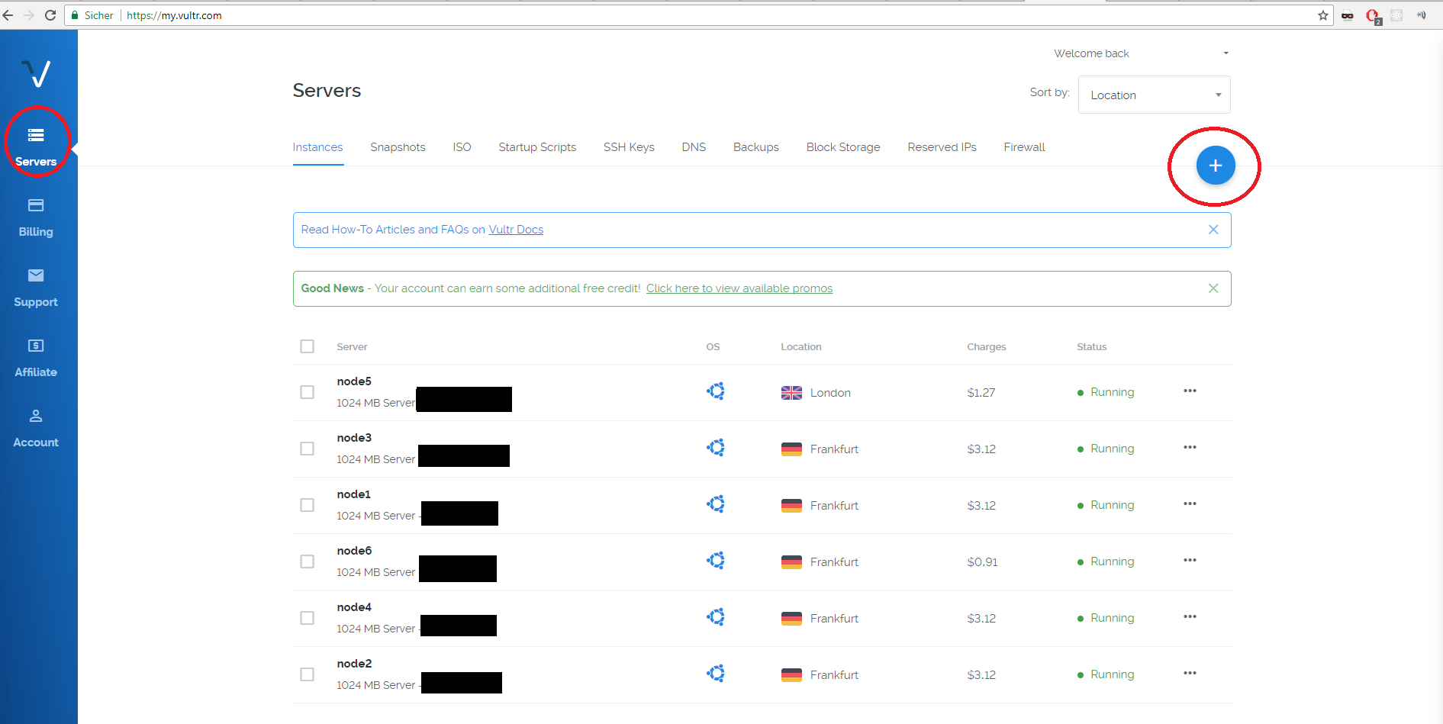Hit the plus top right to add new instances
2. 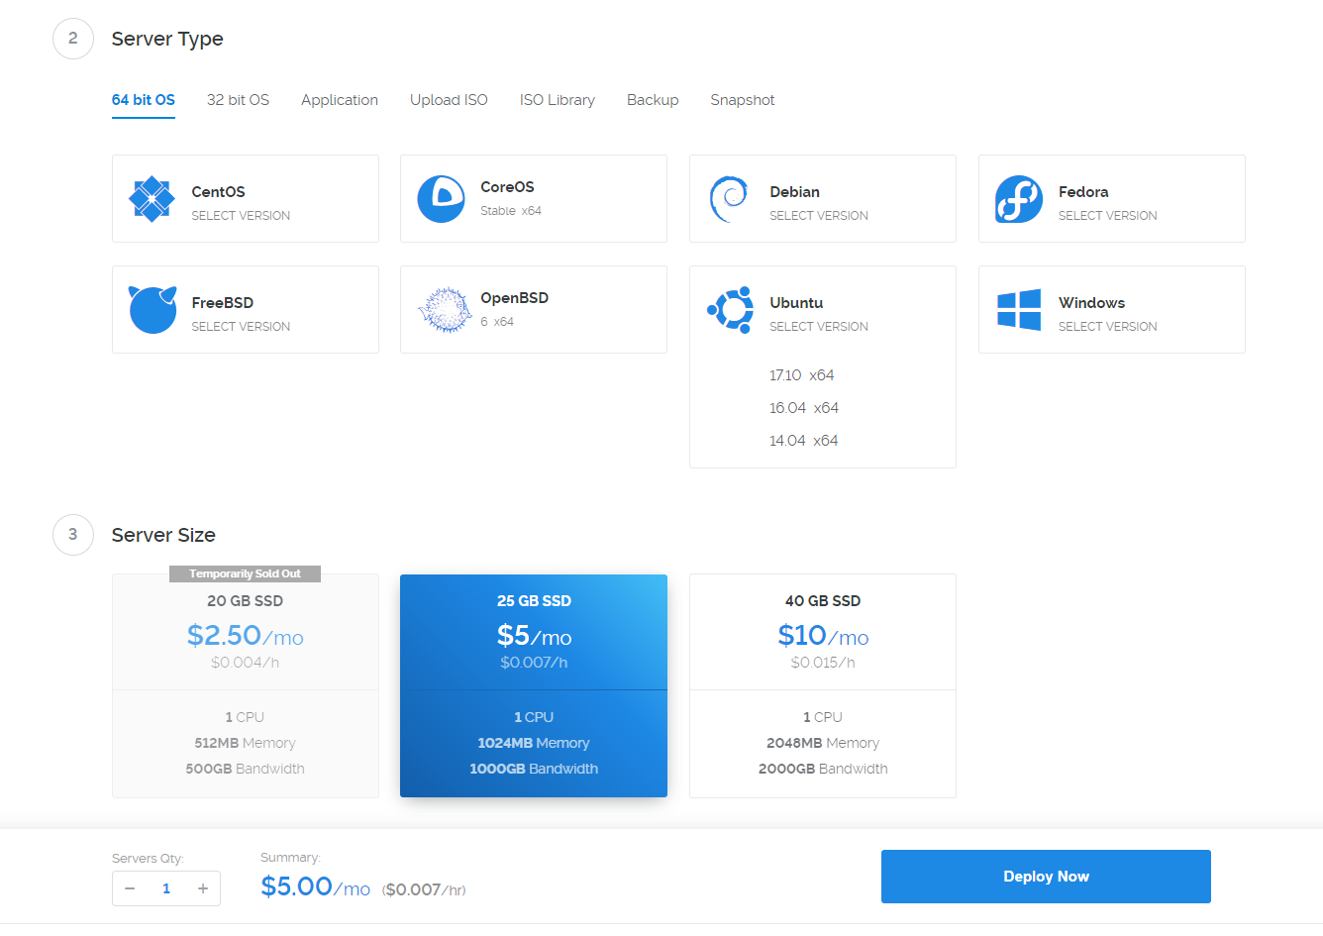Choose a region near you. It does not really matter.
   1. As “Server Type” choose Ubuntu and klick 16.04 (Important don’t take 17.10!)
   2. As Server Size choose the 5$ instance with 1GB Ram. If available you can choose the 2.50$ one if you only want to run only one node on it.
   3. Scroll down and give the node a name.
   4. After that click “Deploy now” in the overview you should see this:



1. Connect to the Server.
   1. You will need some SSH tool connect. I use “Royal-TS” to manage several connections at once. It’s a bit harder getting used too but has real value.
   2. To connect with “putty” a basic tool refer to [this guide](https://mediatemple.net/community/products/dv/204404604/using-ssh-in-putty-)
   3. You can find username (root) and password when you click on the newly created instance. The installation has to finish before!
   4. Note: pasting your clipboard is “right click”

## Automatic server installation and setup.

1. Download and execute script on VPS:

wget https://raw.githubusercontent.com/XeZZoR/scripts/master/Deviant/setup.sh

chmod 755 setup.sh

./setup.sh

This process is interactive and takes several minutes.

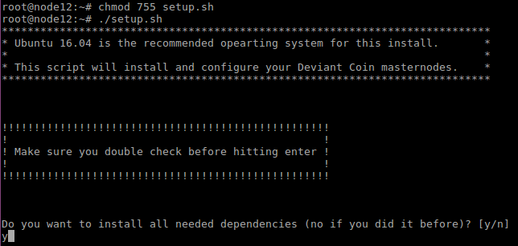

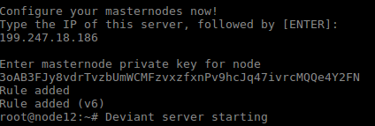Enter y and press enter when you first setup the server. All dependencies and needed programs will be installed (takes ~10-30 minutes for compilation)

Enter the the servers IP address (199.247.18.186 in my case) This is the one you configured before and the IP address of the Linux server.



Enter masternode key which you configured before in the desktop wallet. If it “hangs” after this just press enter once.

If you made an error when typing the interactive stuff: ctrl+c and restart the script!

1. Controlling the masternode
2. The script from the last step already started the daemon on VPS

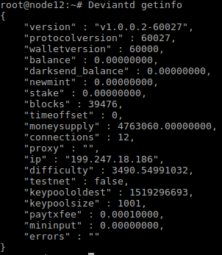To see if everything works type “Deviantd getinfo”  
You can see the amount of blocks here. Wait till it’s fully synced till the next step. (See “blocks” match the explorer or your wallet)

1. If sync is finished go to your desktop wallet and start MNs in the masternode tab (unlock wallet before).

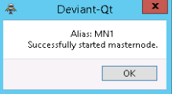



The status should be “Masternode is Running.” now. This is only an indicator that the network acknowledged it. Check below to see if its running on the MN wallets!

1. 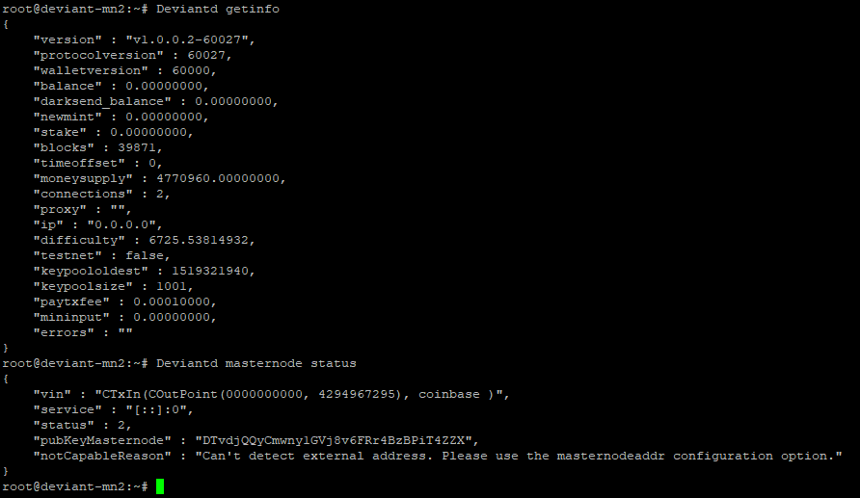See if node is running: “Deviantd masternode status”

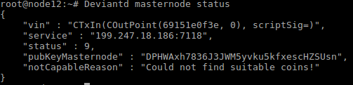This status might occur if the node is not started on the controller wallet or you started it before the transaction has 15 confirmations.

If you see this status your node is successfully running and you can close the controller wallet! The not capable reason can be ignored. Its important you see status = 9

**Any status that is not 9 means the node is NOT running correctly! If status is 9 you can ignore the error message there!**

# Adding more Masternodes

If you want to setup more masternodes just repeat all the steps. Remember that as the port is fixed to 7118 you will need another VPS instance for each node. On the GUI you can just repeat all the steps and add a new line into the masternode.conf. The controller wallet can hold any number of masternodes as its just a remote. The masternodes actually run in the wallets you setup on the linux instances!

# Staking and Masternodes

You can unlock your GUI wallet for staking if you want. This gives some extra rewards but the wallet has to run all the time for that to happen. If you don’t want additional staking rewards you can close the GUI wallet after the MNs are in a running state.