SYSTEM DESIGN DOCUMENT
AI Workforce OS
As-Built: Architecture, Data Design, Detailed Design, API Contracts & UI
Web Services & Service-Oriented Architecture (IT644), Autumn 2026
Version 2.0 · 1 October 2026 · revised to match the implementation
Team and module ownership
Team member | Module owned
Aum Parmar | Project lead and system architecture
Love Shah | Agent orchestration and shared memory
Panthil Shah | AI employee agents and agent runtime
Fahim Saiyad | Knowledge base and RAG pipeline
Ismail Mansuri | MCP integration layer
Yash Doshi | Frontend (web client)
Param Patel | Backend platform: gateway, auth and organisations
Afif Momin | DevOps, testing and documentation

Document control
Field | Value
Document title | AI Workforce OS — System Design Document (As-Built)
Version | 2.0
Date | 1 October 2026
Supersedes | v1.0 (27 August 2026), which described the intended design before implementation
Status | Revised to describe the system as actually built, at repository commit d99740d
Basis | Every figure, table and endpoint below was read from the source code, the Flyway migrations and the running application; nothing is carried over unverified from v1.0.
Repository | github.com/BitecodesHub/AI_Workforce_OS

Contents

1. Introduction

1.1 Purpose
This document describes AI Workforce OS as it is actually built: the system architecture, the database schema, the detailed design, the REST API surface, and the user interface. It replaces version 1.0, which was written before implementation and specified an intended design. Where the build diverged from that design, this document follows the build, and section 9 lists every such change.
AI Workforce OS is an enterprise multi-agent platform. A company configures a team of role-specialised AI agents; the agents answer from the company’s own documents and act on business tools, every action is permission-checked and recorded, and any action that leaves the workspace waits for a person’s approval.

1.2 Scope
The platform is eight Spring Boot services behind one API gateway, a React web client, and three data stores (PostgreSQL, Redis and Qdrant). It exposes 99 REST operations reachable through the gateway, plus 7 internal service-to-service operations. State lives in 7 PostgreSQL schemas holding 54 tables, of which 34 are in active use; the remaining 20 are created by the migrations but not yet read or written, and are marked “reserved” throughout. Model providers and tools run against a deterministic offline sandbox by default, so the whole platform is demonstrable with no API key.
The honest scope markers in this document — “reserved”, “designed, not yet deployed”, and the Partial and Not-implemented rows in section 7 — are deliberate. A design document that claimed features the code does not have would be worth less than one that states plainly what exists.

1.3 How to read this document
- Section 2 (Architecture) describes the moving parts and how they talk to each other.
- Section 3 (Data Design) is the schema: the entity-relationship diagrams and the full table catalogue.
- Section 4 (Detailed Design) covers the orchestrator internals, two sequence diagrams for the signature flows, and deployment.
- Section 5 (API Contracts) lists every endpoint, grouped by service, with its permission and summary.
- Section 6 (User Interface) shows the real screens.
- Section 7 (Requirement traceability) maps each BRD requirement to its implementation, honestly, including gaps.
- Section 9 (Changes from v1.0) records where the build diverged from the original design and why.

1.4 References
- AI Workforce OS — Business Requirements Document, v1.0 (Deliverable 3).
- AI Workforce OS — System Design Document, v1.0, 27 August 2026 (the design this document revises).
- The source repository at commit d99740d, which is the authority for every fact here.

2. System architecture

2.1 Overview
A single React web client talks to one API gateway, which authenticates the request at the edge and routes it to one of eight independently deployable Spring Boot services. Each service owns its own database schema and never reads another service’s tables; where one service needs another’s data it makes a synchronous HTTP call. The agent runtime lives inside the orchestrator service: it runs the model-and-tool loop, routes model calls through an ordered provider chain, and gates every tool call. Redpanda (Kafka) is provisioned in the compose stack but has no producers or consumers, so all inter-service communication is HTTP.
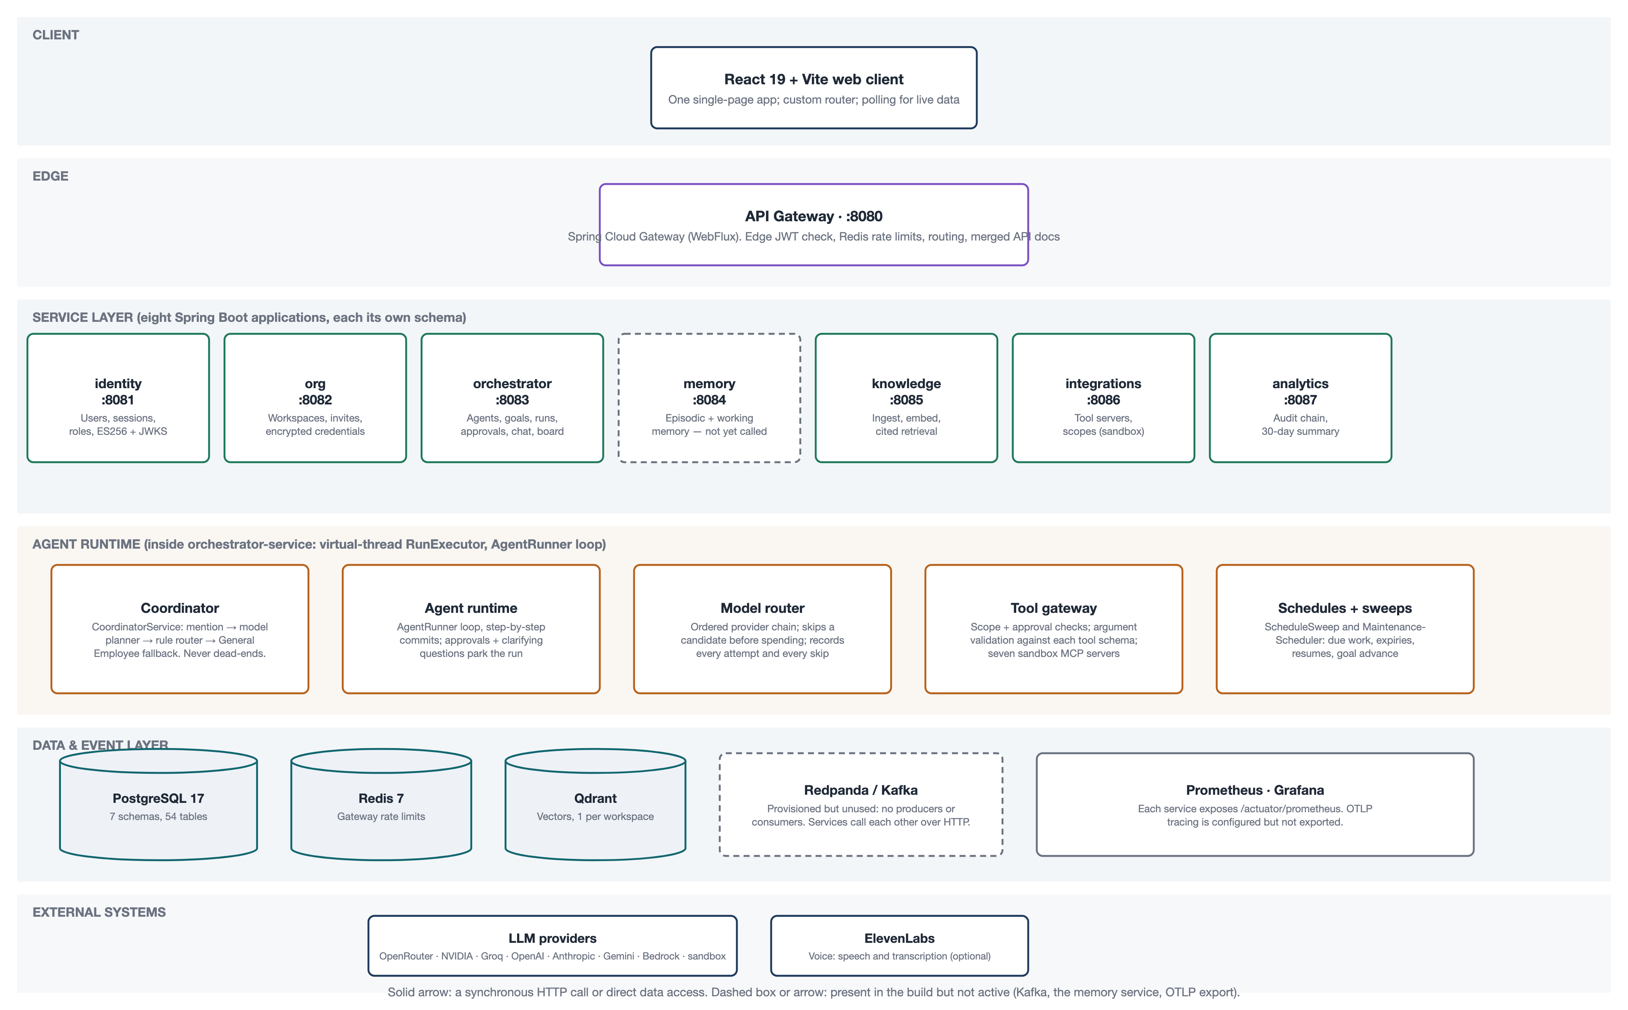
Figure 1. System architecture as built. Dashed elements are present but not active (Kafka, the memory service, OTLP export).

2.2 Service descriptions
Ports are the local defaults; in a container every service listens on 8080. Ownership follows the module assignments on the cover.
Service | Port | Responsibility | Owner
gateway | 8080 | Edge JWT check, Redis rate limits, routing, merged API docs | Param Patel
identity | 8081 | Users, sessions, roles, permissions, ES256 signing and JWKS | Param Patel
org | 8082 | Workspaces, invitations, envelope-encrypted credentials | Param Patel
orchestrator | 8083 | Agents, goals, runs, approvals, clarifying questions, chat, board, schedules, voice | Love Shah · Panthil Shah
memory | 8084 | Episodic and working memory (built; not yet called by any service) | Love Shah
knowledge | 8085 | Ingestion, chunking, embeddings, cited retrieval | Fahim Saiyad
integrations | 8086 | MCP tool servers, scopes, sandbox drivers | Ismail Mansuri
analytics | 8087 | Hash-chained audit log and 30-day activity summary | Yash Doshi
Shared libraries: platform-core (request context, the permission registry, envelope encryption, resilience presets), platform-web (the resource-server security and the permission interceptor), llm-core (provider adapters and the model router), mcp-core (the tool gateway and the sandbox servers), and platform-contracts (reserved; currently empty).
Stack: Java 21 · Spring Boot 3.5.16 · Spring Cloud 2025.0.3 · PostgreSQL 17 · Redis 7 · Qdrant · React 19 + Vite 6 + TypeScript. Tokens are signed with ES256.

2.3 Key architectural decisions
Decision | Rationale, as built
One API gateway fronts every service. | The gateway checks the JWT and applies rate limits once at the edge; each service then re-checks the caller’s permissions itself, so the gateway is a first pass, not the only control.
Services never share a schema; they call each other over HTTP. | Each service owns its data and migrations. No foreign key crosses a schema boundary; cross-service links are by id or value. Kafka was intended for this but is not used.
A run commits step by step. | AgentRunner writes each step in its own REQUIRES_NEW transaction, so a run’s progress and its parked state are visible to other requests immediately, and a cancellation is seen between steps.
Language models are configuration, not code. | Providers and models are database rows; the router tries an ordered chain and disqualifies a candidate before spending a request. A safety refusal stops the chain rather than retrying elsewhere.
Outbound and destructive tool calls always wait for a person. | The tool gateway raises an approval and parks the run; the approved call runs exactly once on resume. This is the governance guarantee shown in Figure 4.
The platform runs with no secrets. | A deterministic sandbox provider and sandbox tool drivers are the default, so the system is fully demonstrable offline; a real key is a database row added later.

3. Data design

3.1 Entity-relationship diagrams
State lives in seven PostgreSQL schemas, one per service, in a shared database for local running (the production plan is one database per service). There are 54 tables; no foreign key crosses a schema boundary. The orchestrator schema is the largest and is shown on its own in Figure 2; the other six schemas are in Figure 3.
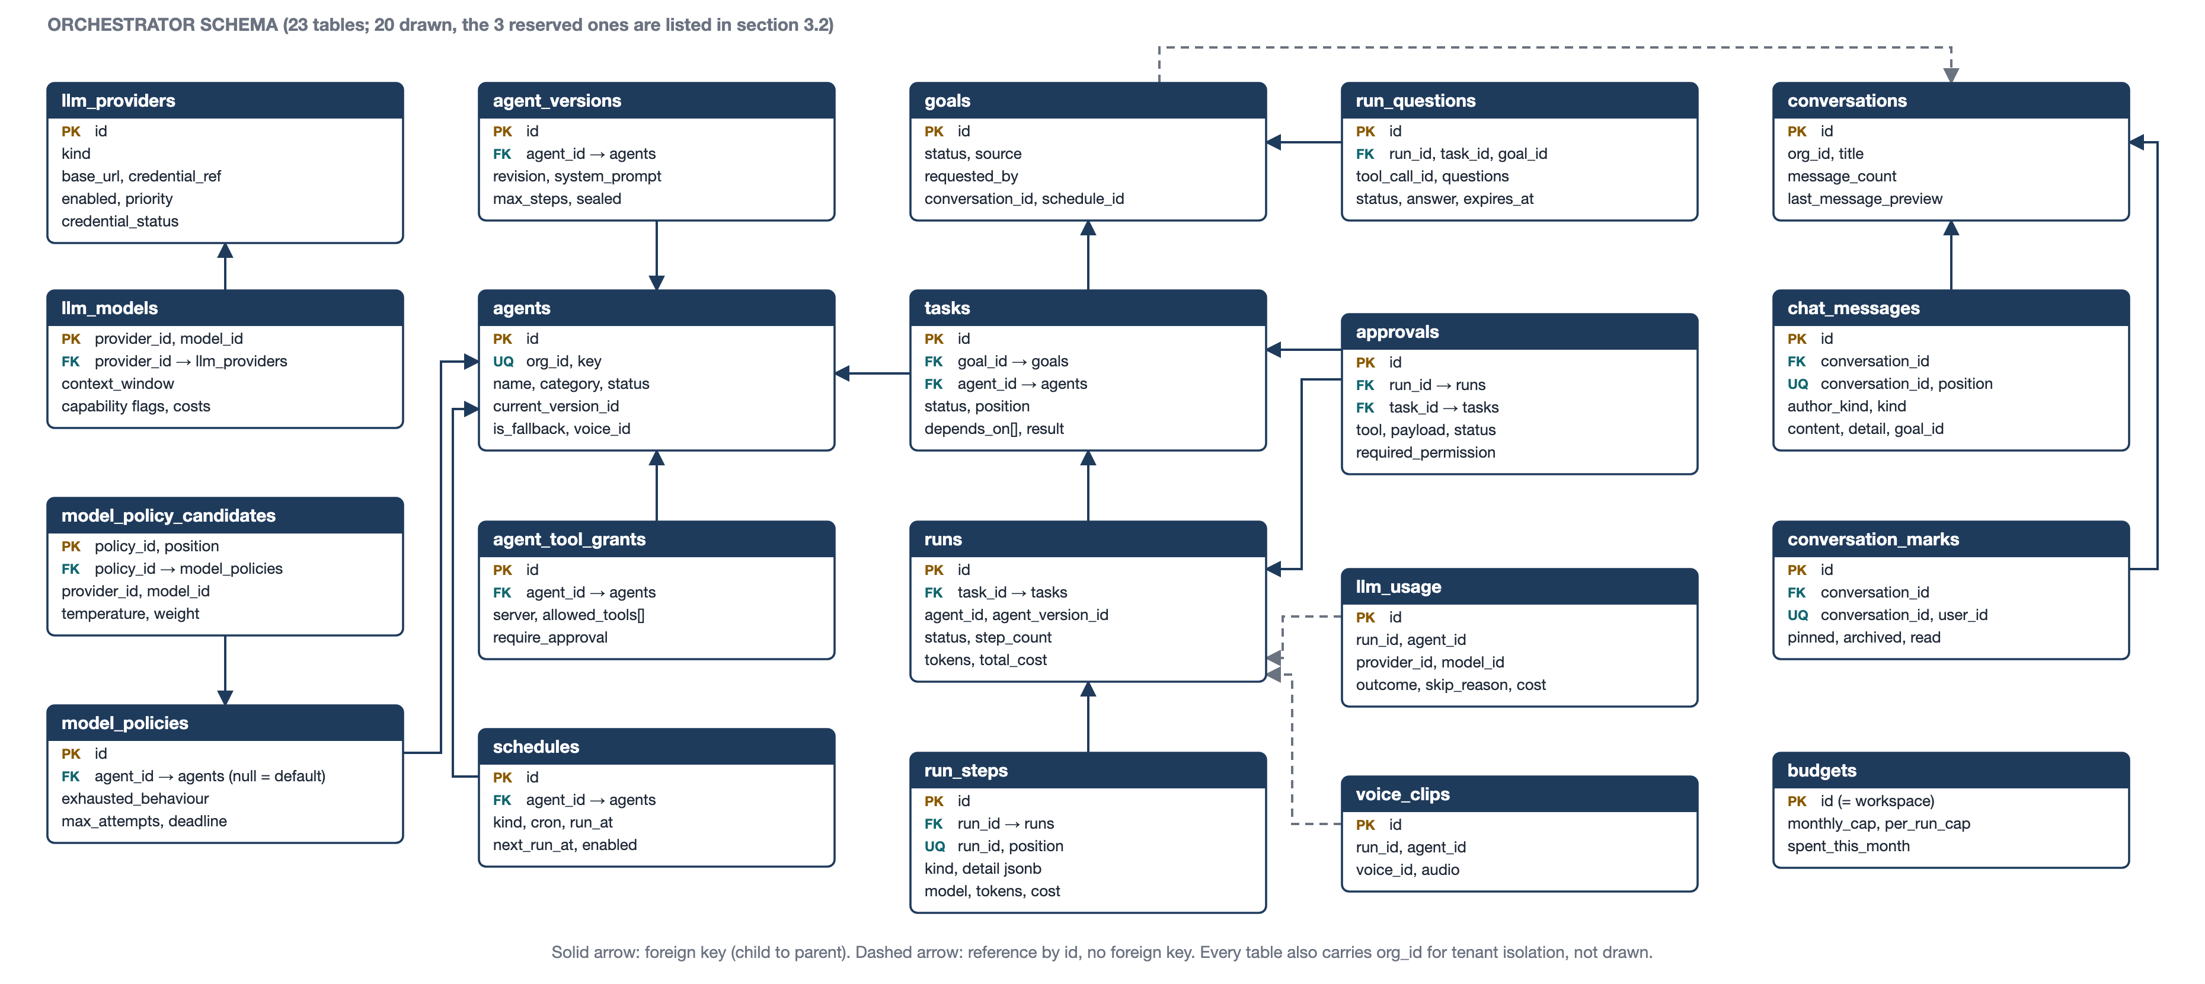
Figure 2. The orchestrator schema (23 tables). Solid arrows are foreign keys; dashed arrows are references by id with no foreign key.
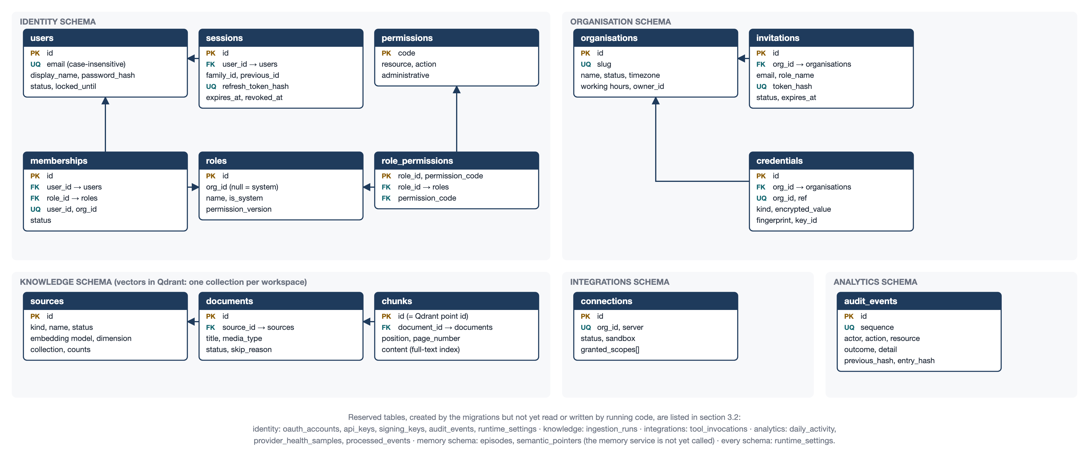
Figure 3. The identity, organisation, knowledge, integrations and analytics schemas, with the reserved memory-schema tables noted.

3.2 Table catalogue
Every table created by the migrations is listed below, grouped by schema. “In use” means code that runs reads or writes it; “reserved” means the migration creates it but nothing reads or writes it yet. Each in-use table also carries an org_id for tenant isolation. [A] denotes the five audit columns (version, created_at, updated_at, created_by, updated_by).

3.2 · identity schema (Identity service)
Migrations: V1 identity core; V2 membership removed status.
Table | Purpose | Key columns and constraints | State
users | People who can sign in | id PK; email (unique, case-insensitive); display_name; password_hash; status (active, invited, suspended, deactivated); failed_login_count; locked_until; locale; timezone; [A] | In use
sessions | Refresh-token sessions, rotated as a family | id PK; user_id FK users; family_id; refresh_token_hash (unique); previous_id FK sessions; expires_at; used_at; revoked_at; org_id; [A] | In use
permissions | The fixed catalogue of permission codes | code PK; resource; action; description; administrative | In use
roles | System roles and workspace roles | id PK; org_id (null for system roles); name (unique per workspace); is_system; permission_version; [A] | In use
role_permissions | Which permission codes a role carries | role_id FK roles + permission_code FK permissions (composite PK); granted_by | In use
memberships | A person's role in a workspace | id PK; user_id FK users; org_id; role_id FK roles; status (active, invited, suspended, removed); invited_by; joined_at; unique (user_id, org_id); [A] | In use
oauth_accounts | Linked Google, GitHub or Microsoft sign-in | id PK; user_id FK users; provider; provider_user_id (unique per provider) | Reserved
api_keys | Workspace API keys | id PK; org_id; role_id FK roles; key_hash (unique); key_prefix; expires_at; revoked_at | Reserved
signing_keys | Persisted token-signing keys | kid PK; algorithm; public_jwk; private_key_encrypted; status (active, retiring, retired) | Reserved
audit_events | Identity-local audit trail | id PK; org_id; actor_id; action; resource_type; outcome; detail jsonb; previous_hash; entry_hash | Reserved
runtime_settings | Per-workspace runtime settings | key; org_id; value (unique per key and workspace) | Reserved

3.2 · organisation schema (Organisation service)
Migrations: V1 organisation.
Table | Purpose | Key columns and constraints | State
organisations | Workspaces | id PK; name; slug (unique); status (active, suspended, closed); timezone; working hours and days; owner_id; [A] | In use
invitations | Pending invitations to a workspace | id PK; org_id FK organisations; email; role_name; token_hash (unique); status (pending, accepted, revoked, expired); expires_at; one open invitation per email | In use
credentials | Envelope-encrypted secrets (model and tool keys) | id PK; org_id FK organisations; ref (unique per workspace); kind (api_key, oauth_token, aws_keypair, webhook_secret); encrypted_value; fingerprint; key_id | In use
runtime_settings | Per-workspace runtime settings | key; org_id; value | Reserved

3.2 · orchestrator schema (Orchestrator service)
Migrations: V1 orchestrator; V2 seed providers; V3 backfill run cost; V4 coordination; V5 chat; V6 schedules; V7 voice; V8 questions and chat.
Table | Purpose | Key columns and constraints | State
agents | AI employees | id PK; org_id; key (unique per workspace); name; category (operations, engineering, growth, support); status (active, paused, retired); current_version_id; voice_id; is_fallback (one per workspace); [A] | In use
agent_versions | Immutable revisions of an agent's configuration | id PK; agent_id FK agents; revision (unique per agent); system_prompt; goals; temperature; max_output_tokens; max_steps; sealed | In use
agent_tool_grants | Which tool servers and tools an agent may use | id PK; agent_id FK agents; server (unique per agent); allowed_tools[]; scopes[]; require_approval; max_calls_per_run; enabled | In use
goals | A request, made of one or more tasks | id PK; org_id; title; description; status (planning, running, waiting, completed, failed, cancelled); source (manual, chat, schedule); requested_by; conversation_id; schedule_id; completed_at | In use
tasks | One agent's step of a goal | id PK; goal_id FK goals; agent_id FK agents; instruction; status (pending, ready, running, waiting_approval, waiting_input, completed, failed, cancelled, skipped); position; depends_on uuid[]; attempt; result; failure_reason | In use
runs | One execution of an agent | id PK; task_id FK tasks; agent_id; agent_version_id; status (running, waiting_approval, waiting_input, completed, failed, cancelled, abandoned); trigger; step_count; lease_expires_at; token totals; total_cost; failure_reason | In use
run_steps | The trace of a run, step by step | id PK; run_id FK runs; position (unique per run); kind (model_call, tool_call, approval, question, handoff, memory_read, memory_write, knowledge_query, note, error); detail jsonb; provider_id; model_id; tokens; cost; duration_ms | In use
approvals | Actions waiting for a person's decision | id PK; run_id FK runs; task_id FK tasks; agent_id; action_class; tool; summary; payload jsonb; status (pending, approved, rejected, expired, cancelled); required_permission; expires_at; decided_by; decision_note; tool_call_id | In use
run_questions | Clarifying questions an agent asked a person | id PK; run_id FK runs; task_id FK tasks; goal_id FK goals; conversation_id; agent_id; tool_call_id (unique per run); questions jsonb; status (pending, answered, expired, cancelled); answer jsonb; answered_by; answered_via (chat, orchestrator, run, approvals); requested_by; expires_at; one pending per run | In use
conversations | Chat threads with the workforce | id PK; org_id; title; message_count; last_message_preview; [A] | In use
chat_messages | Messages in a conversation | id PK; conversation_id FK conversations; position (unique per conversation); author_kind (user, coordinator, agent, system); author_id; agent_id; kind (text, routing, documents, progress, answer, schedule_suggestion, error, question, notice); content; detail jsonb; goal_id | In use
conversation_marks | Per-person pin, archive and read position | id PK; conversation_id FK conversations; user_id; pinned; archived; last_read_position; unique (conversation_id, user_id) | In use
schedules | Recurring and one-off work | id PK; agent_id FK agents; instruction; kind (recurring, once); cron; run_at; timezone; description; enabled; overlap_policy (skip, queue); next_run_at; last_run_at; consecutive_failures; paused_reason; requested_by | In use
voice_clips | Audio an agent produced | id PK; org_id; run_id; agent_id; text; voice_id; content_type; audio bytea | In use
llm_providers | Model providers (eight seeded) | id PK; display_name; kind (OPENAI_COMPATIBLE, ANTHROPIC, GEMINI, BEDROCK, SANDBOX); base_url; credential_ref; enabled; priority; credential_status | In use
llm_models | Models each provider offers (nineteen seeded) | provider_id FK llm_providers + model_id (composite PK); context_window; max_output_tokens; capability flags; per-million costs; enabled; unavailable_until | In use
model_policies | Workspace or agent routing policy | id PK; org_id; agent_id FK agents (null for the workspace default); exhausted_behaviour (FAIL_CLOSED, DEGRADE_TO_SANDBOX); max_attempts_per_candidate; overall_deadline_seconds | In use
model_policy_candidates | The ordered fallback chain of a policy | policy_id FK model_policies + position (composite PK); provider_id; model_id; temperature; max_output_tokens; weight | In use
llm_usage | Every model attempt, including skips | id PK; org_id; agent_id; run_id; provider_id; model_id; outcome; failure; skip_reason; tokens; cost; duration_ms | In use
budgets | Spending caps per workspace | id PK (the workspace id); monthly_cap; per_run_cap; per_agent_daily_cap; spent_this_month; on_exhausted (stop, sandbox) | In use
approval_policies | Per-class approval rules | id PK; org_id; agent_id; action_class (READ, WRITE, OUTBOUND, DESTRUCTIVE); require_approval; approver_role; expiry_minutes | Reserved
processed_events | Idempotency for event consumers | event_id PK; topic; processed_at | Reserved
runtime_settings | Per-workspace runtime settings | key; org_id; value | Reserved

3.2 · knowledge schema (Knowledge service)
Migrations: V1 knowledge.
Table | Purpose | Key columns and constraints | State
sources | A collection of documents | id PK; org_id; kind (upload, google_drive, notion, confluence, github_wiki); name (unique per workspace); status (idle, ingesting, ready, failed, reconnect_required); chunk_size; chunk_overlap; embedding_provider; embedding_model; embedding_dimension; collection; counts | In use
documents | One uploaded document | id PK; source_id FK sources; external_id (unique per source); title; uri; media_type; content_hash; page_count; chunk_count; status (indexed, pending, skipped, failed, tombstoned); skip_reason | In use
chunks | Passages, searchable by keyword (GIN index) and by vector (Qdrant) | id PK (also the Qdrant point id); document_id FK documents; source_id; position (unique per document); content; page_number; heading; char_start; char_end | In use
ingestion_runs | History of ingestion runs | id PK; source_id FK sources; status; document and chunk counters; started_at; finished_at | Reserved
runtime_settings | Per-workspace runtime settings | key; org_id; value | Reserved

3.2 · integrations schema (Integrations service)
Migrations: V1 integrations.
Table | Purpose | Key columns and constraints | State
connections | A workspace's connection to a tool server | id PK; org_id; server (unique per workspace); status (disconnected, connected, sandbox, error, revoked); granted_scopes[]; requested_scopes[]; credential_ref; sandbox | In use
tool_invocations | Record of every tool call | id PK; org_id; agent_id; run_id; server; tool; side_effect; status; arguments_redacted jsonb; approval_id; duration_ms | Reserved
runtime_settings | Per-workspace runtime settings | key; org_id; value | Reserved

3.2 · analytics schema (Analytics service)
Migrations: V1 analytics.
Table | Purpose | Key columns and constraints | State
audit_events | The append-only, hash-chained audit trail | id PK; org_id; sequence (unique); actor_id; actor_kind; action; resource_type; resource_id; outcome (succeeded, failed, denied); detail jsonb; previous_hash; entry_hash | In use
daily_activity | Per-agent daily roll-up | org_id + day + agent_id (composite PK); run, approval and tool counters; tokens; cost | Reserved
provider_health_samples | Model provider health over time | id PK; provider_id; circuit_state; success and failure counts; p95_latency_ms | Reserved
processed_events | Idempotency for event consumers | event_id PK; topic; processed_at | Reserved
runtime_settings | Per-workspace runtime settings | key; org_id; value | Reserved

3.2 · memory schema (Memory service)
Migrations: V1 memory.
Table | Purpose | Key columns and constraints | State
episodes | Episodic memory: observations, decisions, hand-offs, outcomes | id PK; org_id; agent_id; run_id; task_id; kind (observation, decision, handoff, outcome, preference, summary); summary (full-text index); detail jsonb; importance 1 to 10; expires_at | Reserved
semantic_pointers | Facts with a pointer to their source passage | id PK; org_id; agent_id; fact; source_type; source_id; chunk_id; confidence 0 to 1 | Reserved
runtime_settings | Per-workspace runtime settings | key; org_id; value | Reserved
In total: 7 schemas, 54 tables (34 in use, 20 reserved), from 15 migration files. Vector embeddings for retrieval live in Qdrant, one collection per workspace; Redis holds only the gateway’s rate-limit counters.

4. Detailed design

4.1 The orchestrator engine
The orchestrator carries the platform’s hardest logic. Its parts, as built:
- GoalService validates a goal’s task graph (no cycles, at most 50 tasks) and claims tasks in short transactions. A later task receives earlier tasks’ results as a hand-off, and a goal can be retried from the step that did not finish.
- AgentRunner runs the model-and-tool loop. Each step commits in its own REQUIRES_NEW transaction; it re-reads the run’s status before each model call so a cancellation is seen; it parks the run as waiting_approval or waiting_input; and on resume it rebuilds the conversation from stored steps and runs an approved call exactly once.
- RunExecutor starts runs on virtual threads, so chat and scheduled work run in the background rather than on the request thread.
- ApprovalService raises an approval with a 24-hour window, re-checks the approver’s permission when the decision is made, blocks a second decision, and cancels the run on rejection or expiry.
- QuestionService / AskPersonTool let an agent ask the person a clarifying question (1–4 questions, 2–4 options each, at most 3 asks per run); the run parks as waiting_input and resumes with the answer. Scheduled work never asks.
- CoordinatorService (chat) routes a message in three phases — record, decide with no transaction open, then act — through @mentions, a model planner, a keyword rule router, and finally a General Employee fallback, so a request is never left unrouted.
- MaintenanceScheduler sweeps on fixed intervals: reap abandoned runs (60 s), expire overdue approvals and questions (120 s), resume decided-but-parked runs (60 s), and advance goals (15 s).

4.2 Signature flows
The approval loop is the platform’s governance guarantee: an action that leaves the workspace cannot happen until a person approves it, and once approved it happens exactly once.
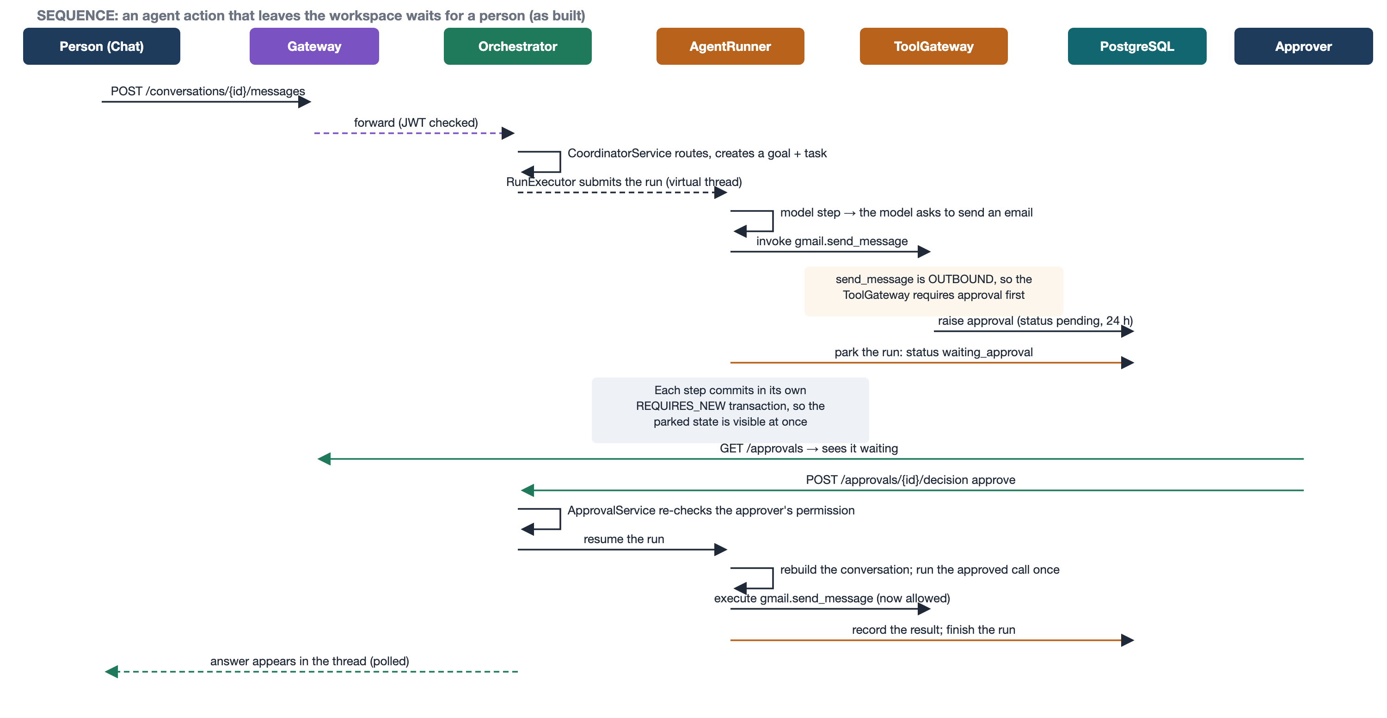
Figure 4. An outbound agent action waits for a person, then runs exactly once on resume. Verified live during this revision.
The retrieval path answers a question from the workspace’s own documents and returns an answer that cites its sources.
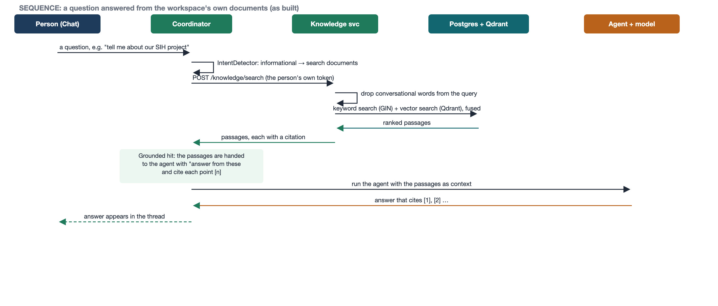
Figure 5. A question answered from uploaded documents, with a citation for every passage.

4.3 Model routing and tools
llm-core holds one provider interface with adapters for OpenRouter, NVIDIA NIM, Groq, OpenAI, Anthropic, Google Gemini and AWS Bedrock, plus a deterministic sandbox. The router looks up the agent’s policy, then the workspace default, then a sandbox-only fallback. Before spending a request it skips any candidate that is disabled, unavailable, lacks a needed capability, has too small a context window, has an open circuit breaker, has no stored credential, or would exceed the budget, and records every skip. On failure it retries the same candidate within an overall deadline, then moves on; a safety refusal stops the chain.
mcp-core’s tool gateway is the single path for tool calls. It shows the model only the tools an agent is granted, checks server, tool, grant, scopes and per-run limit in order, validates arguments against each tool’s JSON schema, and requires approval for outbound and destructive tools. Seven sandbox tool servers are registered — gmail, calendar, slack, github, jira, drive and voice — offering 21 tools in all; the orchestrator additionally exposes the internal person.ask_question tool.

4.4 Deployment
The platform was developed and verified as a local run: PostgreSQL on port 55432, Redis and Qdrant in Docker, the seven services from their jars, the gateway separately, and the web client on Vite. A set of Kubernetes manifests also exists and builds in CI (base plus a staging overlay), but it is designed, not yet deployed: the image tag and two required configuration keys (CORS origins and the internal service secret) are placeholders, and there are no manifests for the data stores, so a service’s own start-up validation would currently refuse to start in production. The manifests are therefore the intended production topology rather than a running deployment.
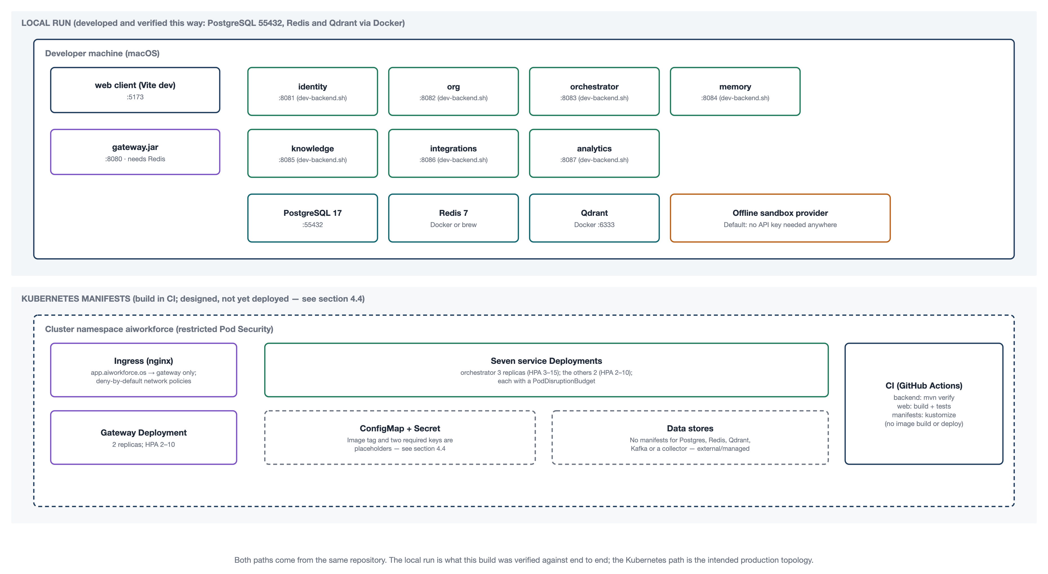
Figure 6. Deployment: the verified local run (top) and the designed Kubernetes topology (bottom).

5. REST API contracts

5.1 Conventions
- All requests and responses are application/json. Paths are served under /api.
- Authentication is a bearer JWT (ES256), except the public endpoints: register, sign-in, refresh, sign-out, the demo-account list, the JWKS document and invitation acceptance.
- The gateway checks the token and rate-limits at the edge; each service then re-checks the caller’s permission with its own @RequiresPermission annotation.
- Errors return a consistent { code, message } body: 400 for validation, 401/403 for authorisation, 404 for a missing resource, 409 for a conflict.
- The surface is 106 operations across 28 controllers: 99 reachable through the gateway and 7 internal service-to-service operations. The tables below list the 99 gateway-reachable operations; the internal ones follow in 5.3.

5.2 Endpoints by service

Identity service (port 8081)
Method | Path | Permission | Summary
GET | /.well-known/jwks.json | public | Public keys used to verify access tokens
GET | /api/auth/demo-accounts | public | Demo accounts available in this environment
POST | /api/auth/refresh | public (refresh cookie) | Exchange a refresh token for a new session
POST | /api/auth/register | public | Create an account
POST | /api/auth/sign-in | public | Sign in and start a session
POST | /api/auth/sign-out | public | End the session
GET | /api/roles | role:read | List the roles available in this workspace
POST | /api/roles | role:create | Create a role for this workspace
GET | /api/roles/permissions | workspace:read | Every permission a role may be given
PUT | /api/roles/{roleId} | role:update | Change the permissions a role carries
DELETE | /api/roles/{roleId} | role:delete | Delete a role that nobody holds
GET | /api/users | member:read | Members of this workspace and the role each holds
GET | /api/users/me | workspace:read | The signed-in account
DELETE | /api/users/{userId} | member:remove | Remove a member from the workspace
PUT | /api/users/{userId}/role | member:update | Change the role a member holds

Organisation service (port 8082)
Method | Path | Permission | Summary
GET | /api/credentials | provider:read | Which credentials are stored, without revealing any of them
PUT | /api/credentials/{ref} | provider:manage | Store or replace a credential
DELETE | /api/credentials/{ref} | provider:manage | Remove a credential
POST | /api/invitations/accept | public | Accept an invitation and become a member
GET | /api/orgs/{orgId}/invitations | member:invite | Invitations pending for this workspace
POST | /api/orgs/{orgId}/invitations | member:invite | Invite someone to this workspace
POST | /api/workspaces | authenticated | Create a workspace and become its owner
GET | /api/workspaces/{workspaceId} | authenticated | One workspace

Orchestrator service: agents, goals, runs, approvals, questions (port 8083)
Method | Path | Permission | Summary
GET | /api/agents | agent:read | List the agents in this workspace
POST | /api/agents | agent:create | Add an agent
GET | /api/agents/{agentId} | agent:read | One agent, with its current configuration and tool grants
PUT | /api/agents/{agentId}/configuration | agent:update | Save a new revision of an agent's configuration
GET | /api/agents/{agentId}/model-policy | agent:read | An agent's own routing policy, if it has set one
PUT | /api/agents/{agentId}/model-policy | agent:set_model_policy | Set an agent's own routing policy
POST | /api/agents/{agentId}/pause | agent:update | Pause an agent so its queued tasks wait rather than run
POST | /api/agents/{agentId}/resume | agent:update | Resume a paused agent
POST | /api/agents/{agentId}/runs | agent:run | Give this agent something to do
GET | /api/agents/{agentId}/versions | agent:read | Every revision of this agent's configuration
PUT | /api/agents/{agentId}/voice | agent:update | Set or clear the ElevenLabs voice an agent speaks with
GET | /api/approvals | approval:read | Actions waiting for a decision
POST | /api/approvals/{approvalId}/decision | approval:decide [c] | Approve or reject an action
GET | /api/goals | task:read | Recent goals in this workspace, with their tasks
POST | /api/goals | task:create | Create a goal and start it
GET | /api/goals/{goalId} | task:read | One goal and its tasks
POST | /api/goals/{goalId}/cancel | task:cancel | Cancel a goal and every task still open under it
POST | /api/goals/{goalId}/retry | task:create [e] | Try a failed or stopped goal again, from the step that did not finish
GET | /api/runs | run:read | Recent runs, optionally filtered by status and agent
GET | /api/runs/{runId} | run:read | One run
POST | /api/runs/{runId}/cancel | run:cancel | Stop a run in progress
GET | /api/runs/{runId}/questions | run:read | The questions this run asked, oldest first
GET | /api/runs/{runId}/steps | run:read | The full trace, including attempts that failed
GET | /api/orchestrator/board | run:read | Every agent, goal, queued task, question, approval and recent run
POST | /api/orchestrator/stop-all | run:cancel [f] | Cancel all active work, withdraw pending decisions, optionally pause schedules
GET | /api/orchestrator/questions | run:read | Questions agents asked in this workspace
GET | /api/orchestrator/questions/{id} | run:read | One question
POST | /api/orchestrator/questions/{id}/answer | task:create or agent:run [e] | Answer a question, and let the run that asked it continue
POST | /api/orchestrator/questions/{id}/extend | task:create or agent:run [e] | Keep a question open longer, up to seven days

Orchestrator service: chat (port 8083)
Method | Path | Permission | Summary
GET | /api/conversations | chat:use | Conversations: pinned, needing you, and the rest, most recent first
POST | /api/conversations | chat:use | Start a conversation
GET | /api/conversations/{id} | chat:use | A conversation, its recent messages, its goals and open questions
PATCH | /api/conversations/{id} | chat:use [d] | Rename a conversation
DELETE | /api/conversations/{id} | chat:use [d] | Delete a conversation, stopping its active work first
PUT | /api/conversations/{id}/archive | chat:use | Archive a conversation out of this person's own list
DELETE | /api/conversations/{id}/archive | chat:use | Bring an archived conversation back
POST | /api/conversations/{id}/goals/{goalId}/retry | chat:use and task:create [e] | Try a goal a chat message started again
POST | /api/conversations/{id}/goals/{goalId}/stop | chat:use [e] | Stop the work a chat message started
GET | /api/conversations/{id}/messages | chat:use | An older page of a conversation's messages
POST | /api/conversations/{id}/messages | chat:use | Send a message; the coordinator's reply is created before this returns
POST | /api/conversations/{id}/messages/{messageId}/answer-from-documents | chat:use and task:create | Ask an agent to answer from a documents card's passages
POST | /api/conversations/{id}/messages/{messageId}/reroute | chat:use [e] | Send a routing message's work to a different agent
PUT | /api/conversations/{id}/pin | chat:use | Pin a conversation to the top of this person's own list
DELETE | /api/conversations/{id}/pin | chat:use | Unpin a conversation
PUT | /api/conversations/{id}/read | chat:use | Mark a conversation read up to a position, for this person only

Orchestrator service: schedules, model routing, providers, voice (port 8083)
Method | Path | Permission | Summary
GET | /api/schedules | task:read | Every schedule in this workspace
POST | /api/schedules | task:create | Create a schedule
POST | /api/schedules/preview | task:read | Read a schedule phrase back, without saving anything
PUT | /api/schedules/{scheduleId} | task:create | Change a schedule's name, agent, instruction or timing
DELETE | /api/schedules/{scheduleId} | task:create | Delete a schedule
POST | /api/schedules/{scheduleId}/pause | task:create | Pause a schedule
POST | /api/schedules/{scheduleId}/resume | task:create | Resume a paused schedule
POST | /api/schedules/{scheduleId}/run-now | task:create | Fire a schedule immediately
GET | /api/schedules/{scheduleId}/runs | task:read | The goals this schedule has fired, newest first
GET | /api/model-policy | provider:read | The workspace's default routing policy
PUT | /api/model-policy | provider:manage | Set the workspace's default routing policy
GET | /api/providers | provider:read | Configured providers and their current health
GET | /api/providers/models | provider:read | Every model available to this workspace
POST | /api/providers/{providerId}/disable | provider:manage | Turn a provider off, so the router stops considering it
POST | /api/providers/{providerId}/enable | provider:manage | Turn a provider on
GET | /api/voice/clips/{clipId} | run:read | The audio for one clip a run produced
POST | /api/voice/speech | chat:use | Read a piece of text aloud, in an agent's voice when one is given
GET | /api/voice/status | chat:use | Whether a workspace ElevenLabs key is stored, and its quota
POST | /api/voice/transcriptions | chat:use | Turn a short recording into text
GET | /api/voice/voices | chat:use | The voices the stored key offers; empty without one

Knowledge service (port 8085)
Method | Path | Permission | Summary
GET | /api/knowledge/health | knowledge:read | Whether the knowledge base can currently answer
POST | /api/knowledge/search | knowledge:query | Search the knowledge base, with a citation for every passage
GET | /api/sources | knowledge:read | Connected knowledge sources
POST | /api/sources | knowledge:source_manage | Create a source to upload documents into
GET | /api/sources/{sourceId} | knowledge:read | One source
GET | /api/sources/{sourceId}/documents | knowledge:read | Documents in a source, including any that could not be indexed
POST | /api/sources/{sourceId}/documents | knowledge:source_manage | Upload a document and index it
POST | /api/sources/{sourceId}/reindex | knowledge:source_manage | Retry vector indexing for every document in a source

Integrations and analytics services (port 8086 / 8087)
Method | Path | Permission | Summary
GET | /api/integrations | integration:read | Connected tool servers, and what each one offers
GET | /api/analytics | analytics:read | Activity over the last 30 days, derived from the audit log
GET | /api/audit | audit:read | This workspace's audit entries, newest first

Notes on the permission column: [c] The caller must also hold the permission that the specific approval requires. [d] The caller must have started the conversation or hold workspace:update; deleting while other people's work runs also needs task:cancel. [e] The caller must have requested the goal, or hold task:cancel. [f] Pausing every schedule as well also needs task:create.

5.3 Internal endpoints
These seven operations are not routed through the gateway. They carry a short-lived service token (or, for token minting, a shared secret) and reject ordinary user tokens.
Service | Method | Path | Auth | Purpose
Identity | POST | /internal/tokens | Shared secret header | Mint a short-lived service-to-service token
Identity | POST | /internal/memberships/bootstrap-owner | Service token | Grant the owner role for a workspace just created
Identity | POST | /internal/memberships/bootstrap-member | Service token | Grant a named role to a person who accepted an invitation
Organisation | GET | /internal/credentials/{ref} | Service token | Resolve a stored credential for a sibling service
Orchestrator | POST | /internal/embeddings | Service token | Embed text through the workspace's configured provider
Integrations | GET | /internal/connections/{server}/credential | Service token | Resolve a tool credential for a sibling service
Analytics | POST | /internal/audit-events | Service token | Append one entry to the append-only audit projection

5.4 Gateway routes
The gateway maps path prefixes to services and applies rate limits. Eleven further prefixes are reserved in the route table for planned endpoints that have no controller yet; they are listed after the table.
Route | Path prefixes | Target | Rate limit
identity-public | /api/auth/**, /.well-known/jwks.json | Identity :8081 | Rate limit by address, 1 per second, burst 10
identity | /api/users/, /api/roles/ | Identity :8081 | Default
organisation | /api/workspaces/, /api/invitations/, /api/credentials/, /api/orgs/ | Organisation :8082 | Default
orchestrator | /api/agents/, /api/goals/, /api/runs/, /api/approvals/, /api/providers/, /api/model-policy/, /api/conversations/, /api/orchestrator/, /api/schedules/, /api/voice/ | Orchestrator :8083 | Default
knowledge | /api/knowledge/, /api/sources/ | Knowledge :8085 | Rate limit by user, 2 per second, burst 10
integrations | /api/integrations/** | Integrations :8086 | Default
analytics | /api/analytics/, /api/audit/ | Analytics :8087 | Default
Reserved route prefixes with no controller yet: /api/permissions/, /api/api-keys/, /api/sessions/, /api/members/, /api/settings/, /api/tasks/, /api/chat/, /api/memory/, /api/tools/, /api/oauth/, /api/reports/**.

6. User interface
These are the real screens, captured from the running web client at 1440px. They replace the mockups in v1.0, which showed a different visual design and a Next.js client that was not built. The client is a single React application; live screens poll their data.
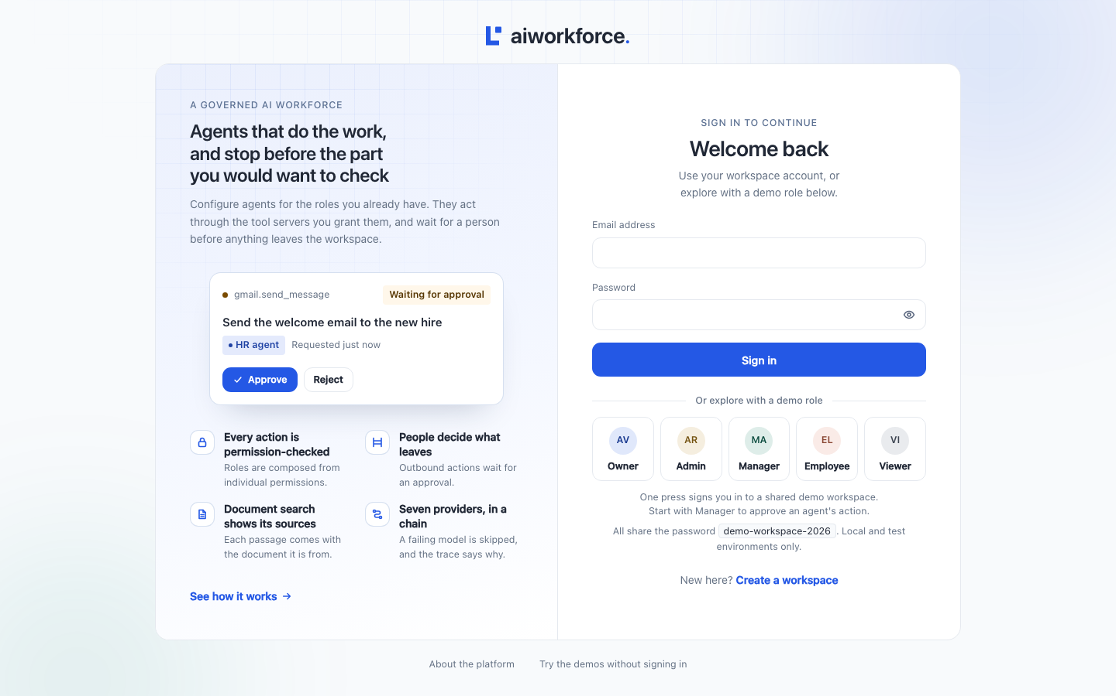
Figure 7. Sign in. A standard form, plus a one-click demo-role picker (owner, admin, manager, employee, viewer) so the platform can be tried with no set-up.
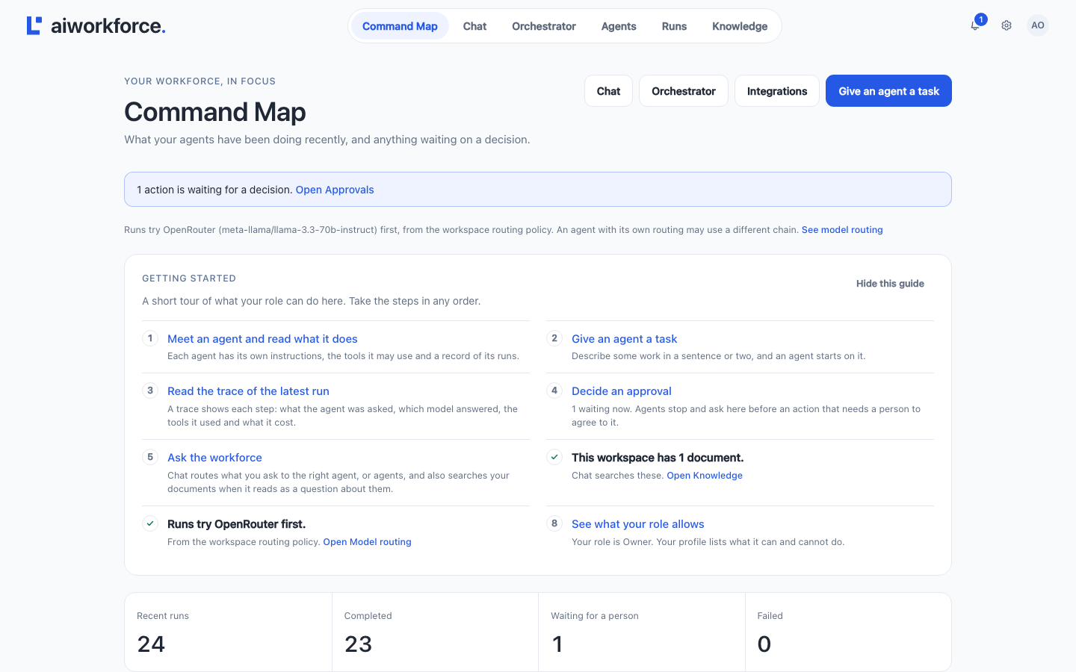
Figure 8. Command Map, the signed-in landing page: what is waiting on you, which model is in use, and recent runs.
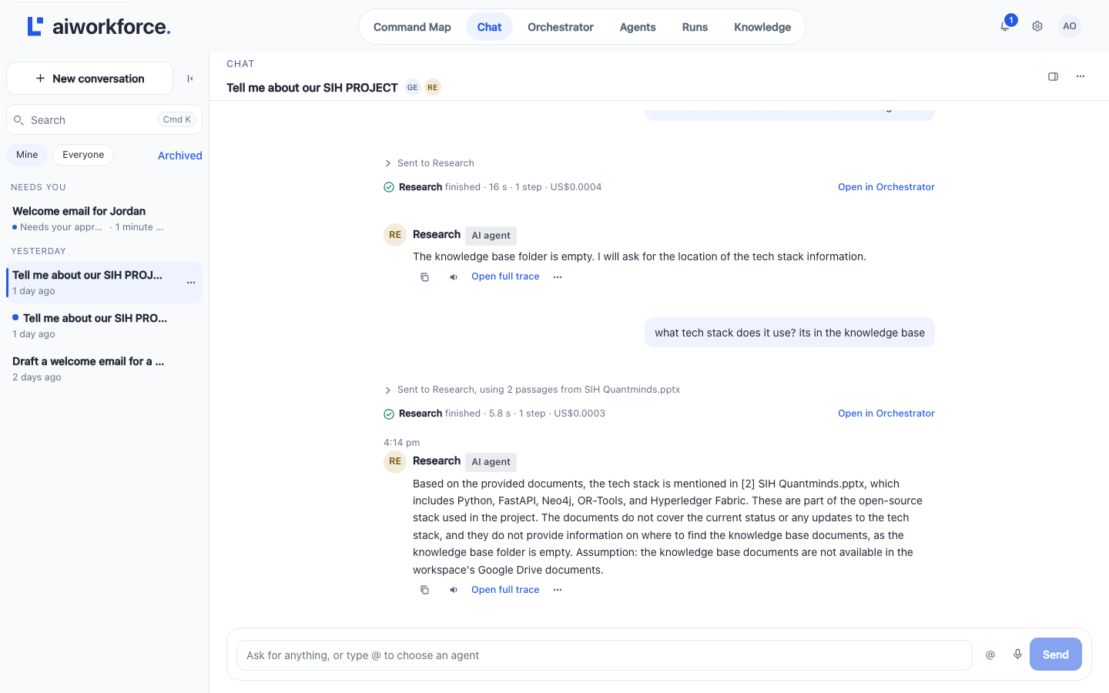
Figure 9. Chat with the workforce. A request is routed to an agent with a one-line receipt; answers from documents cite their source.
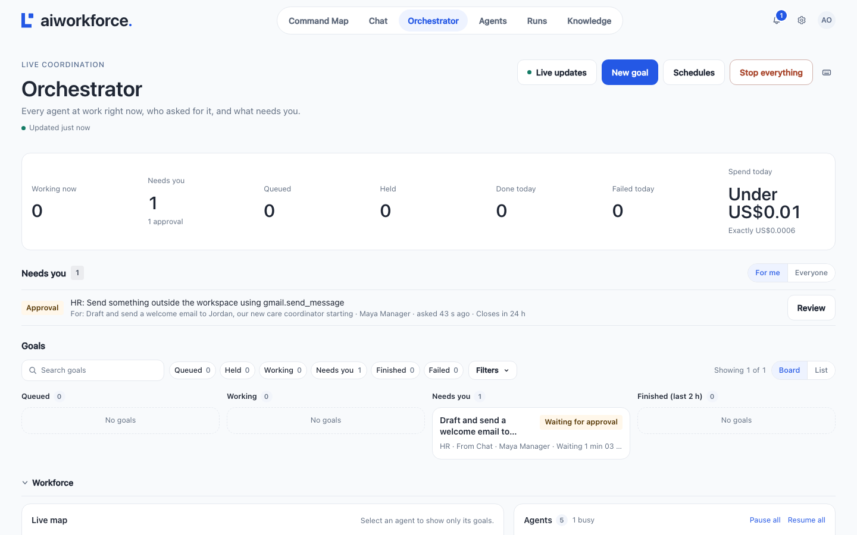
Figure 10. Orchestrator: a live board of all work, a “Needs you” inbox of approvals and questions, and per-agent status.
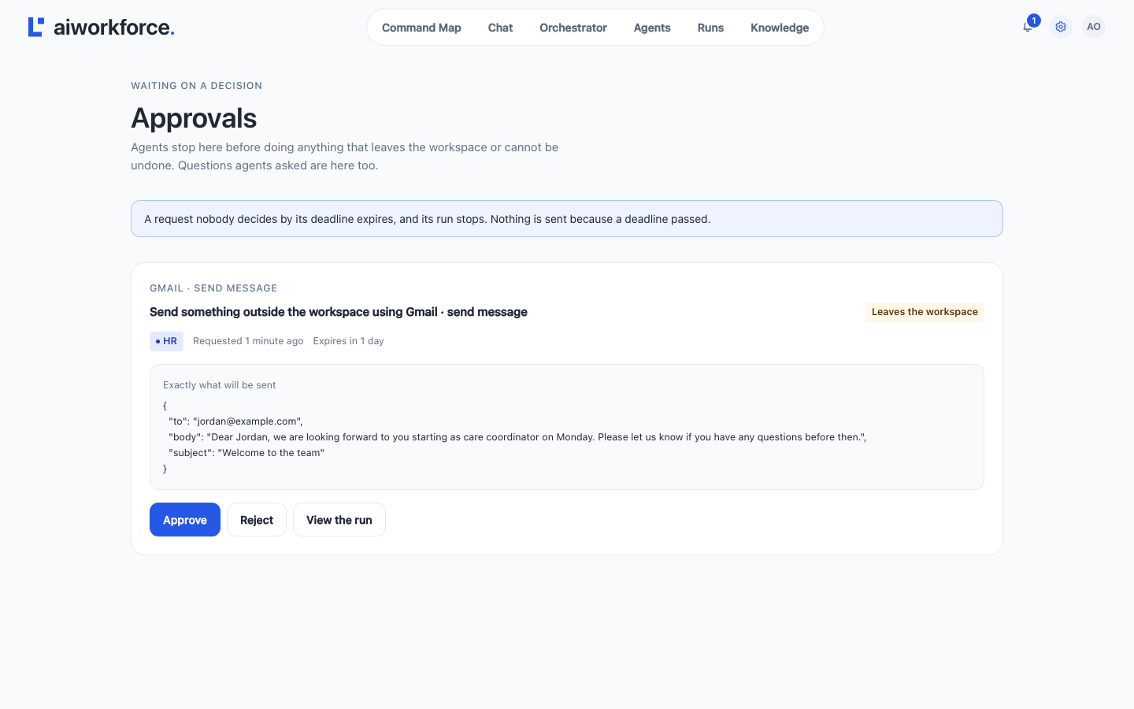
Figure 11. Approvals. An outbound action is held with the exact payload shown, for one-tap approve or reject.
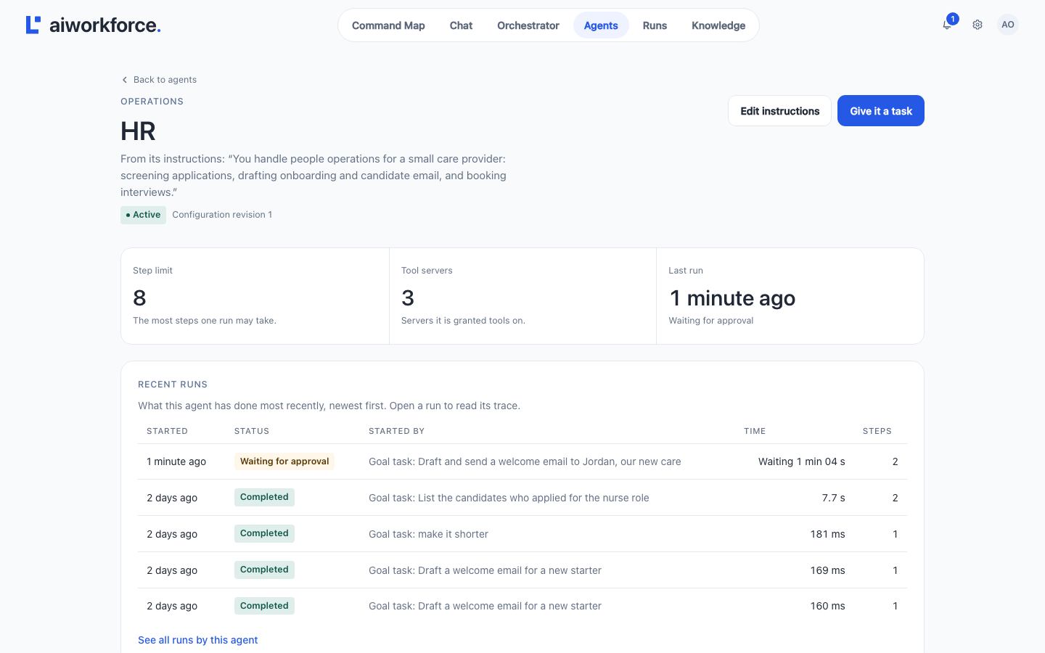
Figure 12. An agent’s configuration: persona and goals, model routing policy, voice, recent runs, and a box to give it a task.
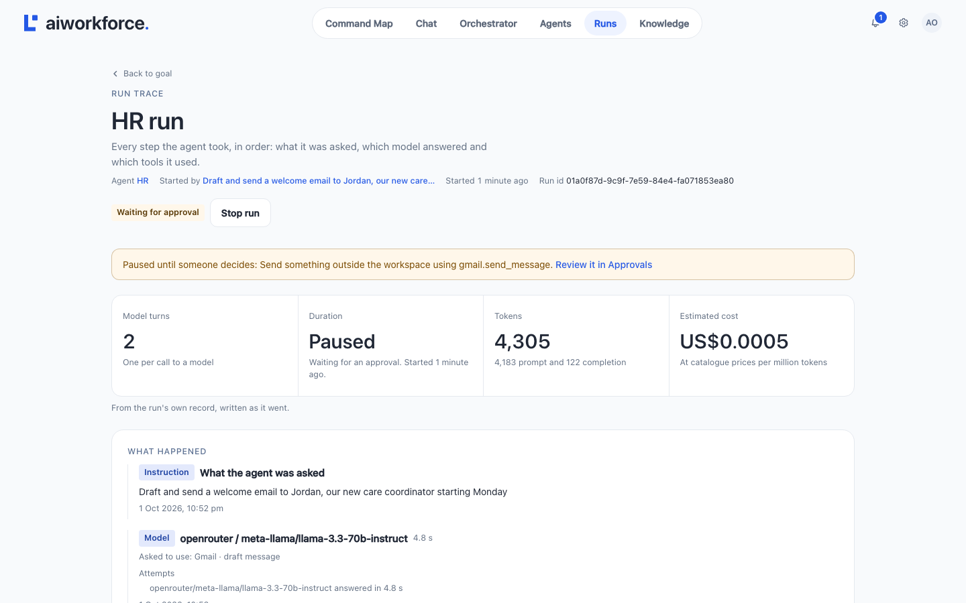
Figure 13. A run’s full trace, step by step, including attempts that failed.
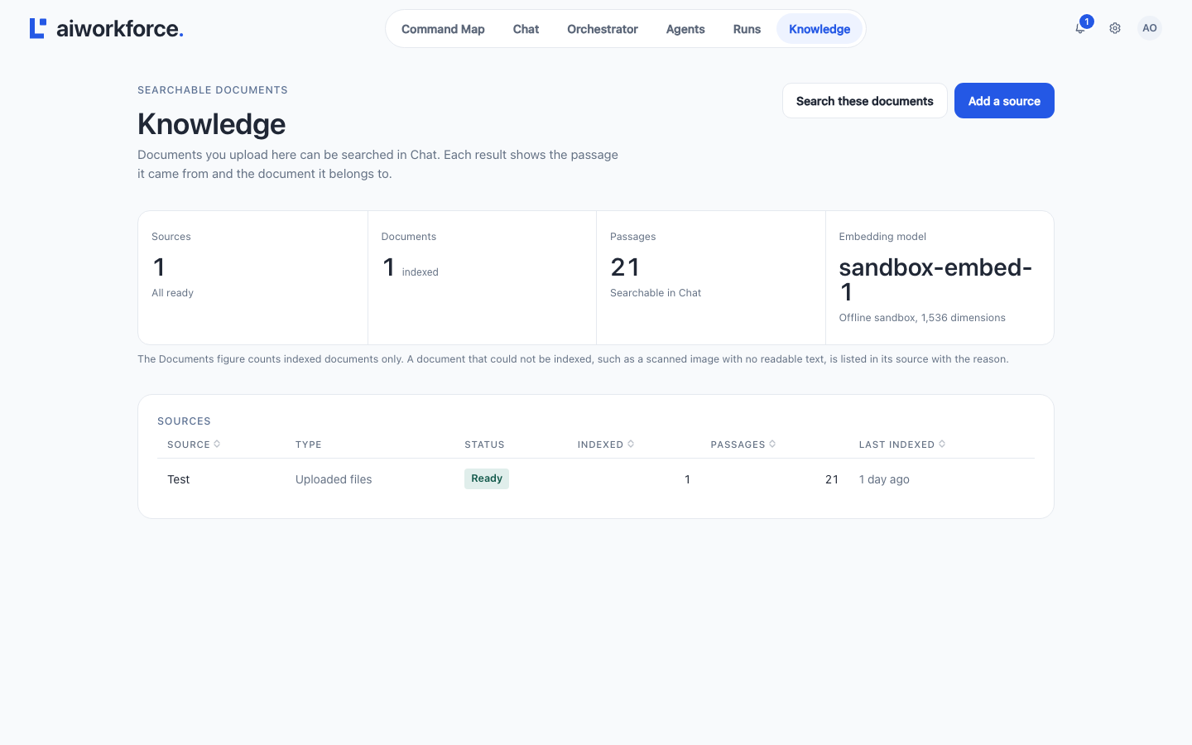
Figure 14. Knowledge: the document sources, their indexing status, and the embedding model in use.
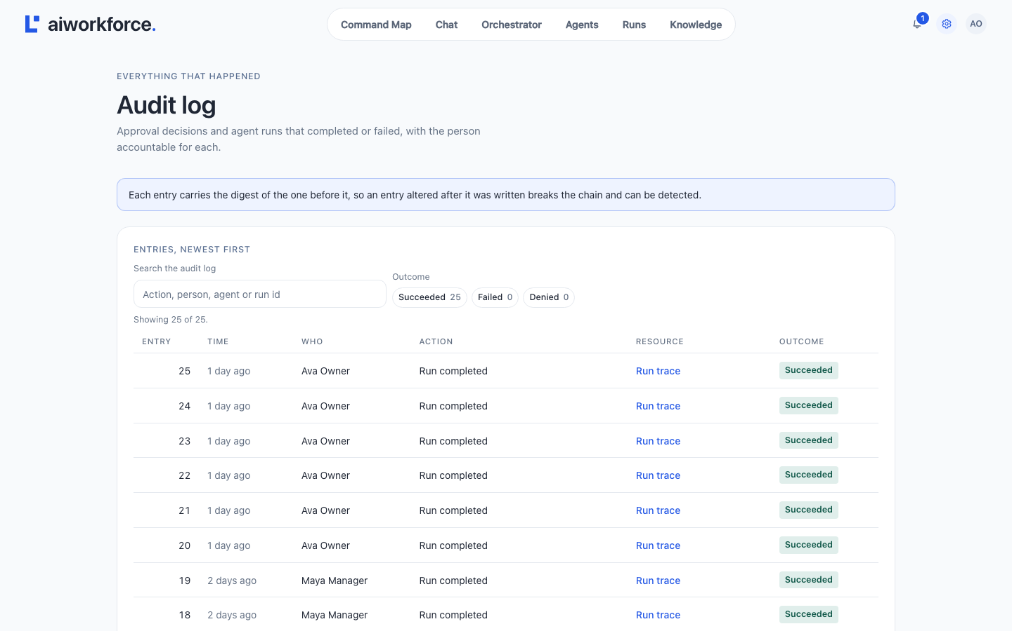
Figure 15. The audit log: every recorded action, newest first.
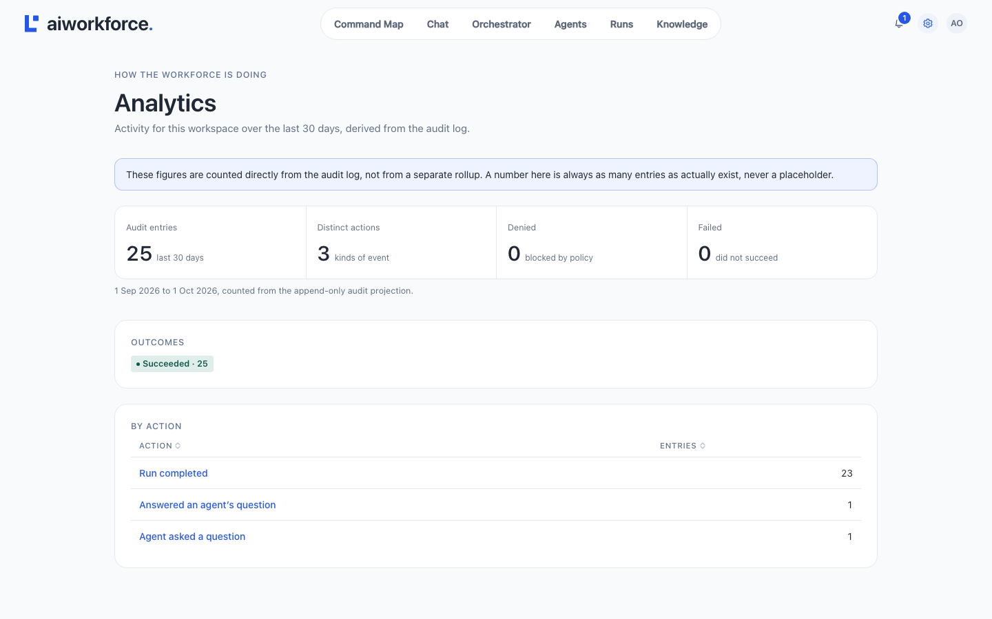
Figure 16. Analytics: a 30-day activity summary derived from the audit log.
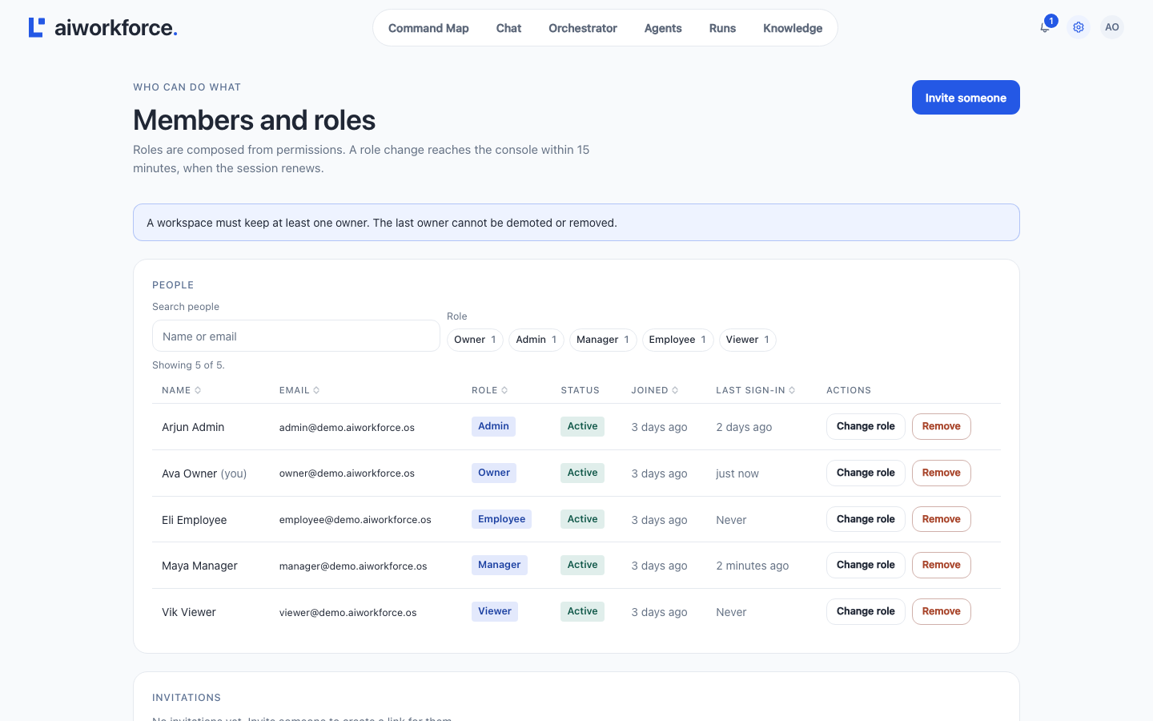
Figure 17. Members and roles: membership, invitations, role changes and custom roles.
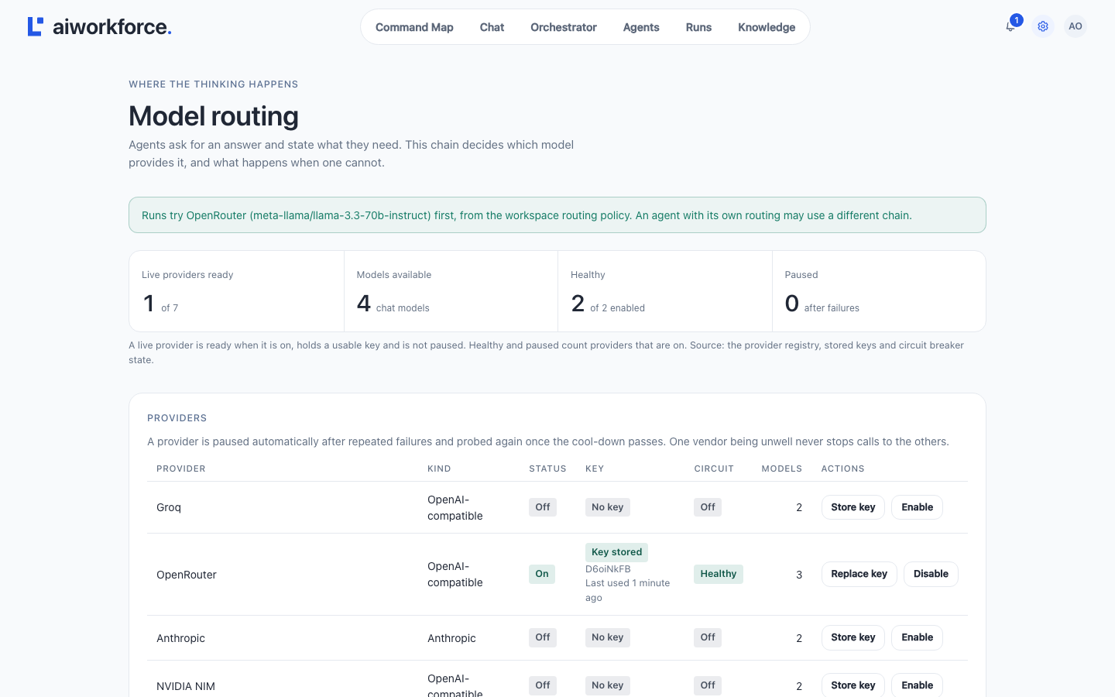
Figure 18. Model routing: providers, stored keys, circuit-breaker health and the fallback chain.

7. Requirement traceability
Each requirement from the BRD is mapped to its implementation. The status is honest: Implemented, Partial, or Not implemented. This is the single most useful part of an as-built document, because it states exactly what the code does and does not do.
Requirement | What it asks for | Status | Evidence in the build
FR-AUTH-01 | Login with email and password | Implemented | Argon2id, lockout after 8 failures, uniform errors
FR-AUTH-02 | JWT access + refresh | Implemented* | ES256, 15-min tokens, rotating refresh cookie; the signing key is in-memory (resets on restart)
FR-AUTH-03 | Role-based access control | Implemented* | 46 permission codes, 5 roles, re-checked in every service; 15 codes protect no endpoint yet
FR-AUTH-04 | Password reset | Not implemented | No endpoint; no outbound email configured
FR-AUTH-05 | Session list / remote sign-out | Not implemented | Only the current session can be signed out
FR-ORG-01 | Create a workspace | Implemented | POST /api/workspaces; creates the owner, rolls back on failure
FR-ORG-02 | Invite a member | Implemented* | Returns an invitation link; no email is sent
FR-ORG-03 | Role on invitation | Implemented | Role validated when the invitation is accepted
FR-ORG-04 | Update workspace settings | Not implemented | Workspace is create-and-read only
FR-ORG-05 | Member profile | Partial | GET /api/users/me is read-only
FR-ORG-06 | Deactivate a member | Partial | Soft “removed” status; no suspend
FR-ORG-07 | Reassign approvals | Not implemented | Approvals have no assignee field
FR-AGT-01 | Enable and configure agents | Implemented | Full CRUD except delete; versioned configuration
FR-AGT-02 | Persona, goals, model, policy | Partial | All editable except the per-class approval policy
FR-MCP-01 | Connect a tool via OAuth | Not implemented | Sandbox drivers only; OAuth exchange not built (the UI says so)
FR-MCP-02 | Scoped tool permissions | Partial | Scope checks enforced; grants come from the seeder, not the UI
FR-MCP-03 | Log every tool call | Partial | Tool calls appear as run steps; the tool_invocations table is not written
FR-MCP-04 | Disconnect / revoke | Not implemented | No endpoint
FR-MCP-05 | Tool health / rate-limit status | Not implemented | Not exposed
FR-KB-01 | Connect a knowledge source | Partial | Upload sources work; external connectors not built
FR-KB-02 | Ingest, chunk, embed | Implemented* | Full pipeline; embeddings use the offline sandbox vectors
FR-KB-03 | Grounded query | Implemented | Keyword + vector search, fused, with a grounded flag
FR-KB-04 | Citations | Implemented | Each passage carries document, page, heading and score
FR-KB-05 | Ingestion status | Partial | Per-source status shown; no external sync
FR-ORC-01 | Delegate a task | Implemented | From chat, a schedule, a direct run or a goal
FR-ORC-02 | Route to the right agent | Implemented | Mention → model planner → rules → fallback
FR-ORC-03 | Shared context / hand-off | Partial | Task hand-offs work; the memory service is not yet called
FR-ORC-04 | Multi-agent workflow | Implemented | Task graphs with dependencies; chat chains of up to 3 agents
FR-ORC-05 | Step retry / failure | Implemented | Router retries, task retries, retry a goal from the failed step
FR-ORC-06 | Failure isolation | Partial | Per-step transactions and per-provider circuit breakers
FR-ORC-07 | Live status | Implemented | The board; updated by polling, not a push channel
FR-GOV-01 | Approval gate for high-impact actions | Implemented | Outbound and destructive tools always gated
FR-GOV-02 | Approve / reject | Implemented | Permission re-checked when the decision is made
FR-GOV-03 | Audit-log entry | Partial | Nine orchestrator actions recorded in a hash chain; chain not yet verified
FR-GOV-04 | Search the audit log | Partial | Paged list; filtering is in the browser
FR-UI-01 | Chat interface | Implemented | The Chat screen
FR-UI-03 | KPI dashboard | Partial | Board stats and analytics; the daily roll-up table is unused
FR-UI-04 | Per-agent activity | Implemented | Running, waiting, asking and queued counts per agent
NFR-SEC-03 | Least-privilege tool scopes | Partial | Grant and scope filters enforced; grants come from the seeder
* “Implemented” with a caveat noted in the evidence column. A fuller gap list is in section 9.

8. Review and sign-off
Each module owner confirms that this document describes their part of the system as it is built.
Team member | Module | Confirms the design of
Aum Parmar | Project lead and architecture | Sections 1, 2 and 9
Param Patel | Gateway, auth, organisations | Gateway, identity and org services (2.2, 5)
Love Shah | Orchestration and shared memory | Orchestrator engine and chat (4.1, 4.2)
Panthil Shah | Agents and agent runtime | Agent runtime and model routing (4.1, 4.3)
Fahim Saiyad | Knowledge and RAG | Knowledge service and retrieval (4.2, 4.3)
Ismail Mansuri | MCP integration layer | Tool gateway and integrations (4.3, 5)
Yash Doshi | Frontend | The web client and all UI screens (section 6)
Afif Momin | DevOps, testing, docs | Deployment and CI (4.4), this document

9. Changes from the v1.0 design
The v1.0 design document was written before implementation. The build diverged from it in the following ways; this list is the record of those decisions.
- Stack. v1.0 specified FastAPI services, a Next.js client and a LangGraph agent runtime. The system was built on Java 21 with Spring Boot, a React + Vite client, and an agent runtime inside the orchestrator service. The service boundaries and responsibilities are unchanged.
- API base path. Endpoints are served under /api, not /v1. The operation set is broader than the 50 operations v1.0 specified: 99 gateway-reachable operations, because chat, schedules, voice, model routing and clarifying questions were added.
- Eight services, not seven. The memory service is a separate application as designed, but it is not yet called by any other service; its tables are reserved.
- Table names and count. The schema has 54 tables across 7 schemas. Names follow the implementation (for example agents, not ai_employees; goals and tasks, not a single tasks table). Twenty tables are reserved.
- Events. v1.0 put Kafka on the critical path between services. The build uses synchronous HTTP between services; Kafka is provisioned but has no producers or consumers.
- Retrieval. Hybrid keyword-plus-vector retrieval is built, but embeddings use the offline sandbox by default, so in practice retrieval is driven by keyword search until a real embedding provider is configured.
- Not yet built. Tool OAuth and disconnect, tool health status, password reset, SSO, a session list, workspace-settings updates, approval reassignment, and external knowledge connectors. These are recorded as Not implemented or Partial in section 7.
- Signing key. The identity service signs tokens with an ES256 key generated in memory at start-up; the persisted-key table is reserved. A restart invalidates existing tokens.
- Kubernetes. The manifests are designed and build in CI, but are not yet deployable without filling in the image tag and two configuration keys and providing the data stores (section 4.4).
Everything in sections 1 through 8 describes the system as built at commit d99740d, and was read from the source rather than assumed.

