
Course: CSCI323 Modern Artificial Intelligence
Semester: Spring 2026
Instructor(s): Dr. Milan Dordevic, Ms. Syama Kurungodathil, Dr. Abdalla Elnekiti, Ms. Asma Damankesh
Student name; Bithin Radhakrishnan
GitHub: https://github.com/BithinR/CSCI323-Modern-Artificial-Intelligence-Project.git
6/21/26 |  | CSCI323

Project Title: Next Day Sales Forecasting for an Agro-Animal Feed and Flour Distribution Business

- Executive Summary
This project is about a product demand forecasting solution for a distribution business dealing in agro-animal feed and flour with the help of Artificial intelligence. The business deals with uncertainty in its day to day purchasing decisions due to fluctuating customer demand across products, seasons, weather conditions, and religious periods such as Ramadan and Eid. These uncertainties lead to the risk of understocking, which can reduce customer satisfaction, and overstocking, which can hold up working capital and increase loss.
This problem needs addressing so inventory and sales data were digitized from physical ledgers and were converted into a structured dataset for machine learning. The final modelling pipeline includes temporal features, lag variables, rolling statistics, Hijri calendar variables, weather indicators, national livestock data, and product-sector identifiers. Several forecasting models were evaluated such as Linear Regression, Random Forest, XGBoost, and a 1-D Convolutional Neural Network. Based on the final evaluation, Random Forest was selected as the primary model because it obtained better performance stats in analysis while remaining easier to interpret and explain to stakeholders compared to other models.
The proposed solution in this project is not limited to prediction alone. It also supports business decision making by interpreting daily product purchase and sales outcomes graphically for a given product on a given date. This makes the project operationally useful rather than pure analytics. Overall, the project demonstrates how Artificial intelligence can improve support better purchasing decisions and reduce uncertainty for a real world commercial business while maintaining practical interpretability and implementation feasibility.

GitHub: https://github.com/BithinR/CSCI323-Modern-Artificial-Intelligence-Project.git

Table of Contents, List of Figures, and List of Tables

1. Introduction and Motivation 4
2. Literature Review 6
6. Technical Requirements and Analysis 7
6.1 Data Source and Collection 7
6.2 OCR and Digitization Pipeline 7
6.3 Data Schema 8
6.4 Data Quality Issues 9
6.5 Scalability, Reproducibility, and Constraints. 9
6.6 Features 10
7. Solution Methodology and Implementation 15
7.1 Problem Formulation 15
7.2 Feature Engineering Strategy 15
7.3 Preprocessing Pipeline 17
7.4 Model Candidates 18
7.5 Validation Strategy 18
7.6 Final Model Selection 21
7.7 Inference and Recommendation Logic 23
8. Results and Evaluation 24
9. Limitations, Challenges, and Constraints 25
10. Conclusions and Discussion 26
11. Recommendations and Future Work 26
12. References 27
13. Appendices 28
Appendix A. Reproducibility and Environment Details 28
Appendix B. Dataset Summary 28
Appendix C. Feature Inventory 29
Appendix D. Leakage Policy and Modelling Safety 29
Appendix E. Evaluation Metrics 29
Appendix F. Cross-Validation Results 31
Appendix G. Figure Notes and Graph Explanations 31
Appendix H. Baseline Split and Test-Set Notes 32
Appendix I. CNN Experimental Model Details 32
Appendix J. Final Inference Example 32
Appendix K. Pseudocode 32

List of Figures
Figure 1: sales (OUT) vs total inventory (TOTAL) – supply chain constraint 11
Figure 2: Average daily sales per season and weekly average with the impact of Friday holiday. 12
Figure 3: Sales during Eid periods in 2023, 2024 and 2025. 13
Figure 4: Correlation of all features with OUT sales. 15
Figure 5: Lag features Pearson correlation with OUT sales. 17
Figure 6: Rolling mean vs actual OUT sales 17
Figure 7: MAE by product sector 21
Figure 8: Model comparison by MAE, RMSE, MAPE 22
Figure 9: Random Forest actual vs predicted OUT. 25

List of Tables
Table 1: Original Ledger columns 9
Table 2: Features and business justifications 14
Table 3: Model comparison based on error metrices. 25

1. Introduction and Motivation
As part of the CSCI323 Artificial intelligence program project for which students are required to build a solution for a real-world business problem for a company of our choosing by bridging the gap between lectures taught in class and practical implementations challenges.

This project addresses the problem of next day purchase and sales uncertainty for a distribution business that handles multiple product categories with varying operational and seasonal demand patterns. Purchasing decisions must often be made before actual customer demand is fully known, the business is exposed to both stockout and overstock risks. The objective of this project is therefore to forecast next day product sales and translate those forecasts into replenishment strategies that improve operational planning and reduce avoidable financial stagnation.

The course brief specifies a UAE-based company context. Due to the availability of online classes, current location, proximity and availability lead to use of data collected from Oman. The instructor was consulted for prior approval, and the project continued upon approval for using an Oman based company.
The data for this project was collected from a local business based in Oman. This business is an Agro-animal feed and flour distributer who has over 33 years of experience and established in Muscat, Oman. They have been dealing with various sectors like livestock, poultry, food and agriculture. They are tied up with renowned Oman flour mills company which is a subsidiary of the Oman Food Investment Holding Company.
The business handles multiple products which are bought from Oman flour mills daily and sold to customers as wholesale and retail since their customers include regular shops to large farms. Items range from General Ruminant (R.G) given to livestock for muscle development to All-purpose flour used in Bakery all available in bags of different quantities.
The business buys products from Oman flour mills almost on a regular basis based on sale expectations, early orders place by customers and stock levels of items especially the items they sell more. Oman flour mill expect payment on purchase, and this can affect the quantities they buy and often certain products face availability issues due to high demand or lack of raw materials due to shipment delivery delays which can also affect the quantities purchased. On the same day the business collects orders from its regular customers and new customers approach them through contacts. All data is stored as book records/ledgers that have all the business transactions entered daily.
The unrecognized patterns and the unpredictability the stakeholders face is a severe problem in such businesses. The main stakeholders in our context are the distributer business and the customers who place orders as they run out of supply. The risks are overstock and understock as this can lead to complications of either financial loss or customer dissatisfaction. Artificial Intelligence helps to discern patterns, learn them and make predictions. It helps to make the likeliness of unpredictability less and likeliness of making confident decisions higher.
Suppose the distributer ran out of stock for an item today and they already have few orders placed for the same item for tomorrow and the distributer is uncertain how much quantity to purchase for tomorrow and the daily high business activity, logistics and labor on the other hand create small windows to relax. All this may lead to a lack of planning with no one to be blamed. Here a day where they buy less products but end up getting more orders than what they have in stock will create dissatisfaction for a wholesale customer. On the other hand, they expect higher sales for an item but not many for some unprecedented reasons place order will result in financial loss where they could have bought something else that would have sold. But with some assistance like an early knowledge of approximate sales for an upcoming day can help them make the right purchases and anticipate what may come next a little better.
This project helps us to understand the patterns and different factors that influence customer demand and make predictions of how many products will be sold on a given day in the future thus helping the business make more knowledgeable decisions that would drive toward better financial assumptions and investments.
Since the availability of purchased items on a given day largely influences the sales. Since this availability factor depends on Oman flour mill which works on a much bigger canvas and requires sensitive international shipment importing data etc., to make predicaments regarding availability of an item to be purchased for distribution and the time 10 weeks’ time constraints have led the project to focus solely on the OUT sales of the distributer business using various features that ranges from inventory patterns to climate and Eid. The quantity bought for distribution on any day is a dynamic variable that may or may not have a pattern which needs to be left for analysis to a future project for now. Scope for this project is to predict the sales alone. The OUT sales are going to be trained in dozens of features and predicted with inputs such as date and quantity of items bought on that day.

2. Literature Review
Demand forecasting is widely studied in retail and supply-chain settings because of its direct effect on stock control, purchasing efficiency, and customer satisfaction. Traditional statistical and machine learning approaches are evaluated for forecasting tasks such as this is by the structure of the available data. Linear models offer interpretability and serve as useful baselines. However, they often struggle to capture the nonlinear interactions present in real world business environments. Decision tree methods such as Random Forest and gradient boosting are often effective at capturing nonlinear relationships for structured tabular data. They can model and handle mixed feature types after preprocessing and remain relatively robust to noisy observations.
In inventory related forecasting, feature engineering plays a major role in predictive performance of the model. Prior work may incorporate lagged demand, rolling averages, seasonal indicators, calendar features, and external variables such as weather or event periods. In this project, those ideas are extended to a culturally specific business context by incorporating Hijri calendar features, Ramadan indicators, and Eid-related proximity variables. This makes the forecasting design more aligned with the business environment locally than a generic demand model.
Deep learning methods such as 1-D CNNs can also be applied to sequential business data because they are able to learn local temporal patterns from historical windows. However, their added complexity does not always guarantee better performance comparatively on medium sized tabular business datasets. So, the present study compares both classical and deep learning approaches before selecting the final model and often even combines them.

6. Technical Requirements and Analysis

6.1 Data Source and Collection

Data was collected through immediate sources for the period of 01 January 2023 to 20 July 2025. In this course of time the business has handled over 50 products. Data was stored physically in ledgers which were sorted by date. It required converting data from physical copy to digital copy such as Excel spreadsheets before it could be used for the project. Further use this data to solve the problem that this business would benefit from solving.

6.2 OCR and Digitization Pipeline

As mentioned, the data was stored in a ledger which required data entry and digitalization. To digitize these records the ledger pages were physically scanned as JPEG images organized into monthly folders. A python pipeline was built in Google Colab then processed each image using the Google Gemini Vision API, which read the handwritten text into tabular data in CSV format. The extraction prompt provided the model with a canonical list of known products from the ledgers to ensure consistent naming across all months. Each extraction row validated arithmetic login to ensure all the column values were checked before entry.

6.3 Data Schema

There were inventory pages as well as customer pages. This project focuses on inventory data. The inventory page includes 5 columns and each row for a different item.

Table 1: Original Ledger columns
Column No. | Header | Definition
Column 1: | Item | Item_names
Column 2: | Open | per_Item_opening_stock_for_the_day
Column 3: | IN | per_Item_purchased_quantities_on_that_day
Column 4: | TOTAL | per_Item_total_available_for_sale_in_stock_after_IN
Column 5: | OUT | per_Item_sold_quantities_on_that_day
Column 6: | BALANCE | per_Item_end_of_day_balance

6.4 Data Quality Issues

The dataset had to go through rigorous repeated checks for arithmetic errors, typos and missing data. Once this process was completed after many iterations the data was run for discrepancy checks other than the human errors that existed in the ledgers. These errors were never fixed and kept in. Then to ensure uniformity all the days that were missing like Friday’s which is a public holiday in Oman or any other gaps were added into the dataset with empty values. Furthermore, everyday tracking and daily consistency, all 50 items were added across all dates in the dataset. The final dataset before any preprocessing for machine learning consisted of 46,601 rows including headers and 7 columns including a column for dates.
*The value has been set to zeros for anonymity.

6.5 Scalability, Reproducibility, and Constraints.

The technical implementation required the conversion of handwritten or manually recorded business ledgers into a structured digital dataset suitable for AI modelling. This introduced additional tasks even before the project could begin. It started with an upstream data engineering task involving scanning, OCR-assisted extraction, manual validation, spreadsheet standardization, and feature ready preprocessing. As a result, the system requirements of the project extend beyond model training and include data reliability, reproducibility, computational feasibility, and business interpretability.

The final spreadsheet included 46,600 rows and 121 columns which included one hot encoded item list and all the features. The dataset was used only for educational modelling purposes. No personally identifying customer information was required for the forecasting objective.

6.6 Features

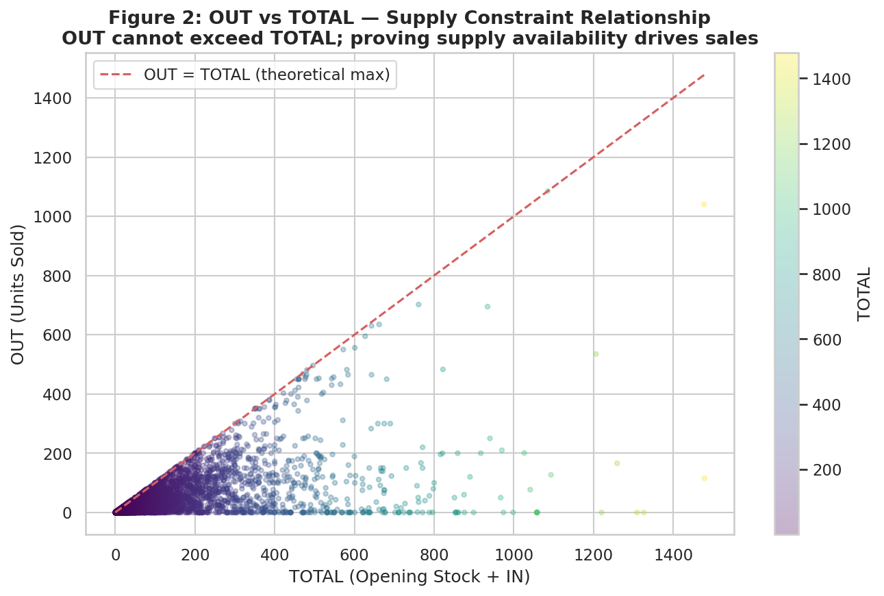

Figure 1: sales (OUT) vs total inventory (TOTAL) – supply chain constraint
The OUT is capped by the total available stock which includes the opening stock and the bought in stock.

Why each feature group was selected

Lag features: out_lag_1/7/14/30, balance_lag_1/7/14/30
Sales patterns repeat daily, weekly or yearly. A high selling day last week can be a signal for this week. The balance lag can tell the model how much stock existed exactly a day (balance_lag_1), a week (balance_lag_7), a fortnight (balance_lag_14) and a month ago (balance_lag_30). These capture short term memory and repeated cycles without leaking any same day information.
Rolling statistics: 7-day and 30-day means and SDs for IN, OUT, BALANCE
The standard deviations capture volatility of an item with erratic supply needs. This helps the model to be more cautious in its forecast. The 7-day window captures weekly supply rhythm while the 30-day window captures monthly demand trends.
Cyclic calendar encodings: month_sin/cos, day_of_week_sin/cos, year_sin/cos
Months or weeks come off as linear paths to algorithms until pointed out. December and January are far apart numerically but adjacent especially when the goal is to find an repetitive yearly patterns. Sine and cosine curve values fix this by giving the same values to the same day so the model understands cyclic seasonal continuity.
Season features: season_num, season_sin/cos, climate_curve
Oman has two major seasons that lasts for months and two transition seasons that lasts hardly for a month each. These seasons affect animal feed and flour demand. Hot summers and cold winters affect livestock health and consumption patterns. The feature climate_curve tracks temperature rise and fall across the year using a smooth curve.
Weather: real_max_temperature, real_rainfall_mm
Heat and rain affect livestock water, and feed needs as well as the feeding patterns. Rainfall is rare in Oman, when it occurs it affects movement and supply chain. These are external demand modifiers that the business or other stakeholders cannot control but can only observe.

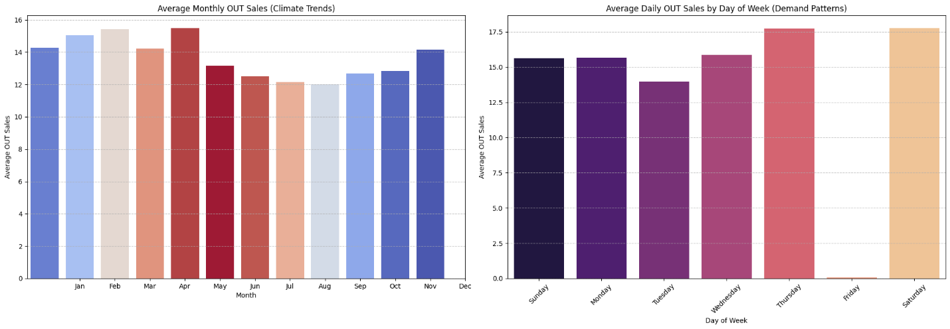

Figure 2: Average daily sales per season and weekly average with the impact of Friday holiday.
January 19 recorded the coldest day in Oman history during winter and mid-June recorded hottest day of a year in summer in Oman. This graph shows the sales variation with seasonal changes.

Friday and gap flags: is_friday, is_gap_row, is_Friday_or_is_gap
Friday is the weekly day off in Oman. Sales and deliveries on Fridays are none, so the stocks remain unchanged. Gap rows mark days when there were no business or data missing. The model needs to know these to make better predictions.

Hijri calendar: HijriYear/Month/Day and their sine/cosine encodings
Religious observance follows the Hijri calendar which mandates its addition to feature list. Ramadan and Eid dates shift every year in the Gregorian calendar but are fixed in Hijri due to the difference in length. Without Hijri calendar features, the model cannot learn the repeating Islamic seasonal pattern which has direct and indirect effects on sales.
Eid and Ramadan flags: is_ramadan_period, eidalfitrwindow, eidaladhawindow, eid_fitr_proximity, eid_adha_proximity
Demand spikes dramatically around Eid al-Adha because of livestock slaughter tradition. Ramadan also changes eating patterns and business hours. Proximity variables in in place to capture spikes around the days before and after each event, not just the event day itself which is inactive due to holidays.

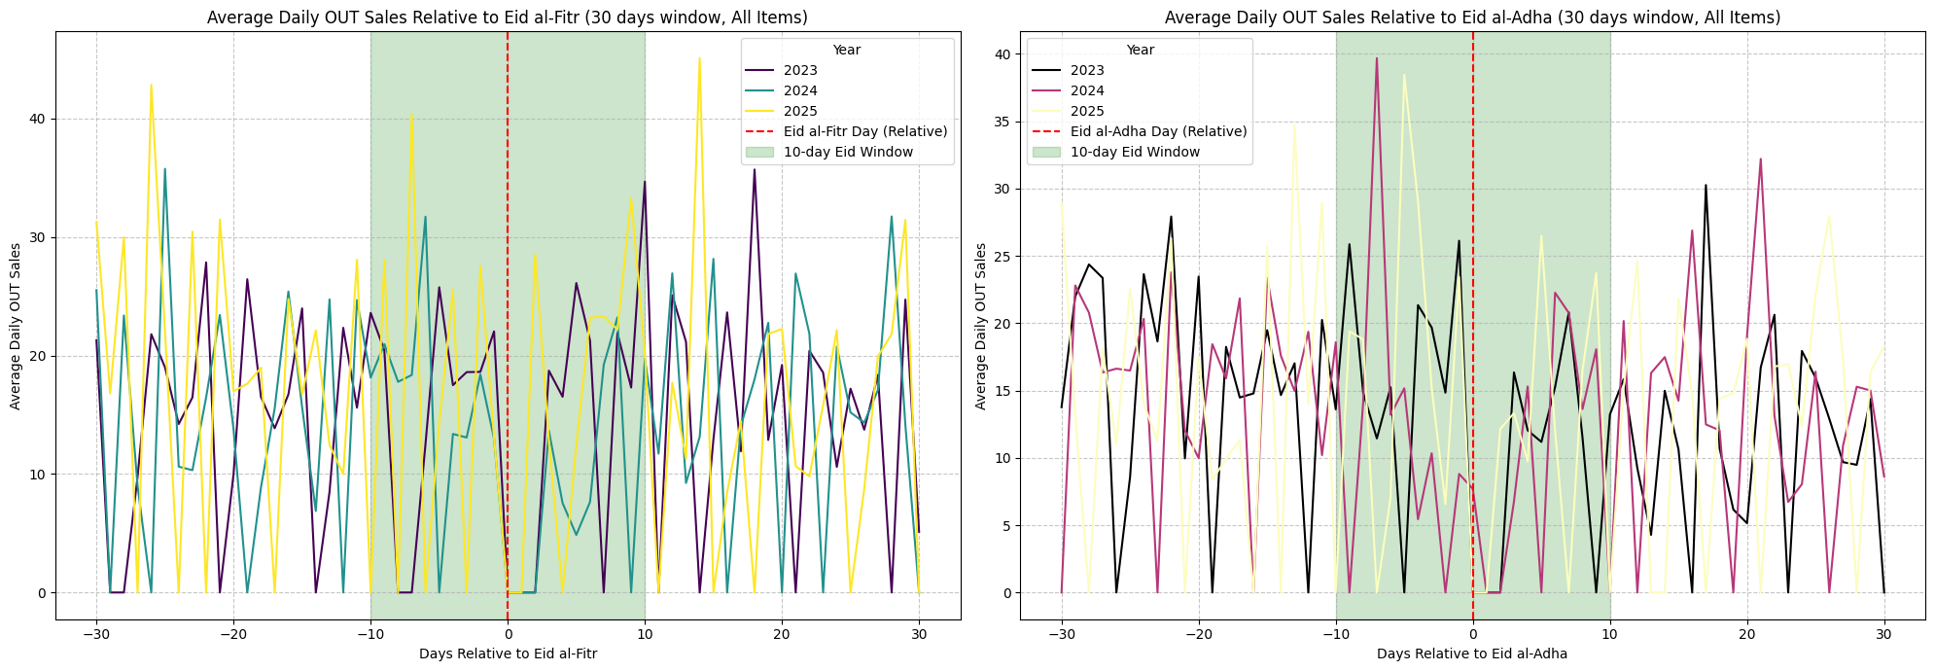

Figure 3: Sales during Eid periods in 2023, 2024 and 2025.
The sales indicate as spike right before Eid holidays as stakeholders rush in to ensure they are stocked during the holidays. Wheat is a product that had dramatic spikes due to the increased demand for sweets like Halwa around these months. One of its ingredients is wheat.

Discrepancy flag
These are rows where the “Open” stock has a mismatch with previous day closing “Balance”. When the data was copied from book to Excel it introduced some discrepancies and inconsistencies. Also, there were natural discrepancies that existed within the book itself from man-made errors.

Livestock counts:
real_poultry_production, real_cattle_count, real_camel_count, real_sheep_count, real_goat_count
The increase in livestock or poultry in the country is a fundamental demand indicator for animal feed products. More animals in the region means higher baseline demand for feed. These are annual or seasonal estimates are acquired form official websites.

Item and sector identity: Item, Product_Sector, season_name
The model is trained globally as it trains on all 50 items together. These categorical features tell the model which item it is predicting for thus allowing it to learn item-specific as well as sector-specific behavior within one model.

Table 2: Features and business justifications
Feature Group | Features | Business Justification
Demand history | out_lag_1/7/14/30, rolling stats | Sales persistence and weekly cycles
Calendar | month/day cyclic encodings, season | Seasonal demand variation
Islamic calendar | Hijri features, Eid/Ramadan flags | Oman-specific religious demand drivers
Operational flags | Friday, gap, discrepancy | Business operational constraints
External demand | weather, livestock counts | Market-level demand drivers
Product identity | Item, sector, season_name | Item-level behavior differentiation

These features were not selected by statistical filtering alone. They were selected by combining domain knowledge from the business owner with available data making the feature set both interpretable and business justified.

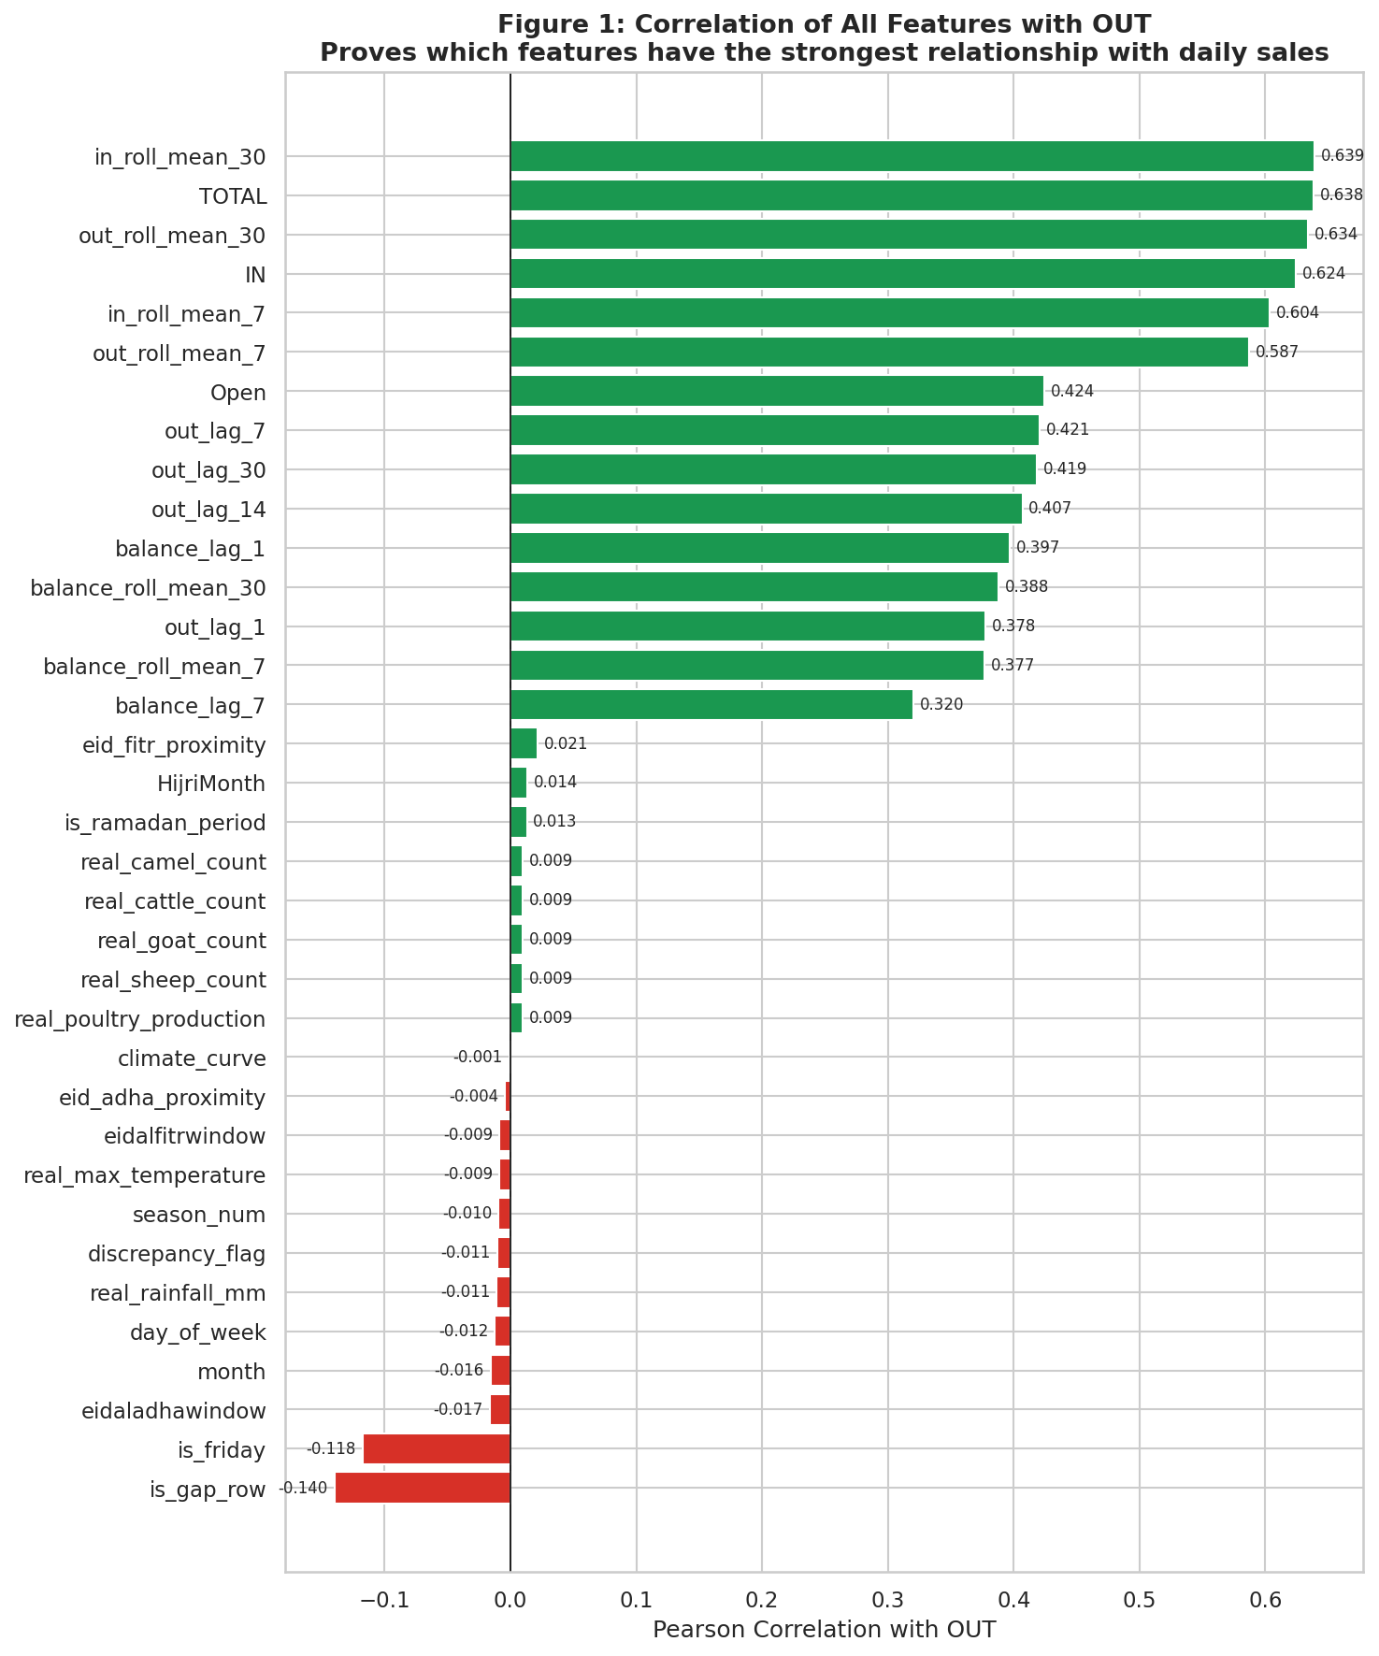

Figure 4: Correlation of all features with OUT sales.

This helps identify which variables are most closely associated with OUT sales. The strongest correlations seen at the top from balance_lag_7 to in_roll_mean_30 are expected as they’re derived from the same stock relationships that is directly associated with OUT but it doesn’t allow data leakage as they come before OUT sales values which may depend on them but can only be anticipated in terms of quantity. A downside is that while the model correctly learns about the Friday holiday it fails to capture the peak in demand before and after Friday.

7. Solution Methodology and Implementation

7.1 Problem Formulation

The sales forecasting approach for Oman Agri, animal Feed and Flour distributer business involved a structured methodology, starting from robust data handling to advanced model deployment, with emphasis on interpretability and performance.

7.2 Feature Engineering Strategy

- Temporal Features: Time-based features from various perspectives were extracted from the Date column, including year, month, day, day_of_year, day_of_week, cyclic features like month_sin/cos, day_of_week_sin/cos, year_sin/cos, season_sin/cos were created to capture inherent periodicities and repetitions for example to recognize a possible during payday at the end of the month.
- Islamic Calendar Features: Eid has severe impact especially before the eif holidays as customers rush in to stock up their supplies which is constant pattern over the years. The festive seasons also cause sale increases in sweets like Halwa and thus resulted in increase in sale of wheat which is an ingredient. Recognizing the cultural context in important like HijriYear, HijriMonth, HijriDay, and their cyclic variants are all necessary to predict when this guaranteed spike happens next year. Binary flags for is_ramadan_period, eidalfitrwindow, eidaladhawindow and proximity features like eid_fitr_proximity, eid_adha_proximity were engineered to capture the distinct sales behaviors around this season. Figures show this demand fluctuations around Eid periods.

- Lagged Features: out_lag_1, balance_lag_1, and similar lags for 7 days, 14 days, and 30 days were created to capture the historical dependency of sales and stock which demonstrate past values are strong predictors of future values as it would be for a inventory based running business. Figures show correlation of OUT vs. Lag-1 OUT with a strong correlation coefficient, provides justification for out_lag_1.
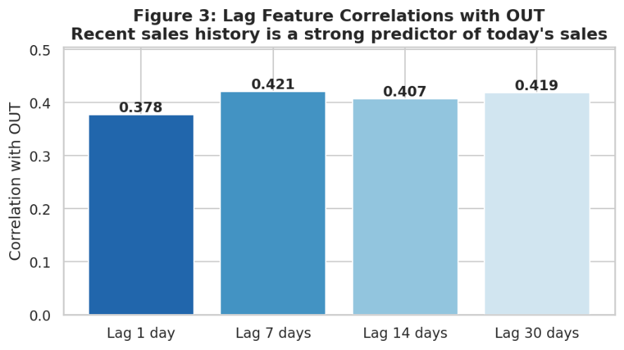

Figure 5: Lag features Pearson correlation with OUT sales.

For two variables $X$ and $Y$, Pearson correlation is:
$$r=\frac{cov⁡(X,Y)}{σ_{X}σ_{Y}}$$
where:
- $cov⁡(X,Y)$ is how much they vary together,
- $σ_{X}$ and $σ_{Y}$ are their standard deviations.

- Rolling Statistics: in_roll_mean_7, out_roll_mean_7, balance_roll_mean_7, and their standard deviations for 7 days and 30 days windows were calculated into columns. These features capture recent past trends and provide historical context.
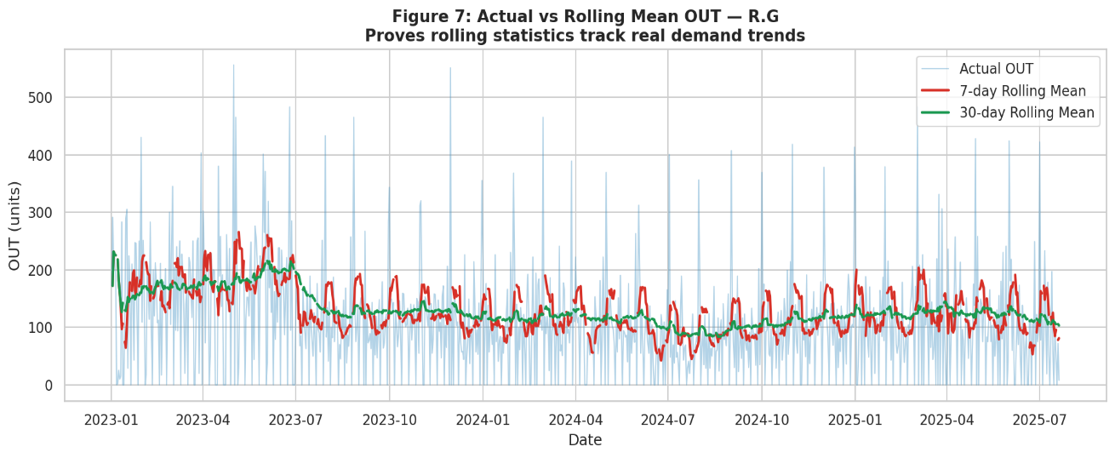

Figure 6: Rolling mean vs actual OUT sales

- Weather and External Factors: Features like real_max_temperature, real_rainfall_mm, and external data from official Oman website like NCSI for real_poultry_production and cattle_count metrics were included as they directly influence demand for animal feed. Figure show average OUT by temperature bins.
- Product-Specific Features: Item and Product_Sector are categorical features for mapping products to data and categorize it into respective sectors and track demand patterns. Figure illustrates OUT distributions across product sectors.
- Feature Selection: The get_available_cols() function dynamically selects features present in the DataFrame which ensures robustness against changes in data availability.

7.3 Preprocessing Pipeline

Effective preprocessing and rich feature engineering were critical to extract maximum predictive power from the raw data.
Data Loading: The project_dataset_preprocessed.csv was imported, dates were parsed, and the data was sorted chronologically by Item and Date. Initial checks confirmed data shape, date range, items, sectors they belong, and target statistics.
Handling Missing Values: With the build_preprocessor() function, numerical features with missing values were imputed using median values, while categorical features used an 'Unknown' constant imputation. This prevents model errors and ensures all data can be processed.
The modeled architecture leverage sklearn pipelines for modularity and consistency.
- Preprocessing Pipeline
build_preprocessor(): This ColumnTransformer handles numerical and categorical features separately:
  - Numerical: SimpleImputer(strategy='median') fills missing values.
  - Categorical: SimpleImputer(strategy='constant', fill_value='Unknown') handles new or missing categories, followed by OneHotEncoder(handle_unknown='ignore', sparse_output=False) to convert them into numerical format suitable for AI modelling.

- Model Pipeline
build_pipeline(): This meta level pipeline combines the preprocessor with the chosen regressor (model_obj). This ensures that all preprocessing steps are applied consistently to both training and test data within each model, preventing data leakage and any errors.

7.4 Model Candidates
Various AI models were evaluated, with the intention of testing its time-series forecasting and ability to capture different data patterns:
- Linear Regression: This was the baseline which provided a simple and interpretable model. While less accurate for complex patterns it was crucial for understanding the linear relationships between data and establishing a platform for performance comparison with other algorithms.
- Random Forest: This method was excellent in capturing non-linear relationships and interactions between features. Its ability to interpret feature importance is invaluable for justifying feature selection.
- XGBoost (Extreme Gradient Boosting): Similar to Random Forest, XGBoost is a powerful gradient boosting framework known for its speed and accuracy. It is believed to outperform Random Forests on tabular data by capturing complex patterns.
- 1-D Convolutional Neural Network (CNN): This deep learning approach was implemented to understand its performance and efficiency in handling tabular data, particularly when considering fixed-length historical sequences. CNNs can learn abstract features from raw time-series data, with potential to discover patterns missed by traditional models.

7.5 Validation Strategy

Model evaluation was rigorous, employing both a single train/test split and time-series cross-validation to ensure robust performance metrics.
- Single Train/Test Split: For train-test a chronological 80/20 split was used as a quick sanity check. Data is initially sorted by date and split 80% for training and 20% for testing. Model fit once with this 80% of spilt data and evaluated in the 20% of the data. Then a time-series cross-validation with an expanding window for preserving past data is used
- Time-Series Cross-Validation (TSCV): TimeSeriesSplit(n_splits=3). In this each fold of the model is trained only on past data and tested on a later block, so we never leaked the future into training. A fixed-size rolling window would throw away older history. Since in this case seasonality and Eid effects repeat over several years, keeping all past data in an expanding window is better. This method maintains the temporal order of the data, training on past data and validating on future data, mimicking real-world forecasting scenarios. The build_pipeline() is cloned for each fold to ensure no data leakage between folds.
tscv = TimeSeriesSplit(n_splits=NCVSPLITS)

for train_idx, test_idx in tscv.split(X_model):
X_tr, X_te = X_model.iloc[train_idx], X_model.iloc[test_idx]
y_tr, y_te = y.iloc[train_idx], y.iloc[test_idx]

pipe = clone(build_pipeline(model, num_feats, cat_feats))
pipe.fit(X_tr, y_tr)
y_pred = pipe.predict(X_te)
record_metrics(y_te, y_pred)
avg_metrics = mean_over_folds()

  - Metrics: MAE (Mean Absolute Error), RMSE (Root Mean Squared Error), and MAPE (Mean Absolute Percentage Error) were used. The evaluate function ensures consistent calculation, clipping negative predictions to zero, as sales cannot be negative.
    - MAE (Mean Absolute Error)
$$MAE=\frac{1}{n}\sum_{i=1}^{n}{\left|y_{i}-{\overset{ˆ}{y}}_{i}\right|}$$
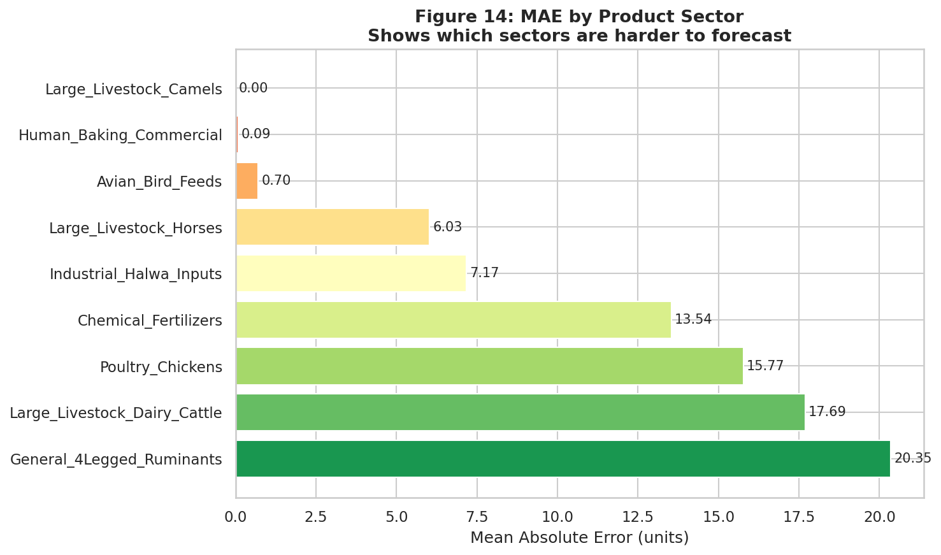

Figure 7: MAE by product sector
MAE=1𝑛𝑖=1𝑛∣𝑦𝑖−$y$𝑖∣

- RMSE (Root Mean Squared Error)
First compute MSE, then take the square root:
$$\text{RMSE}=\sqrt{\frac{1}{n}\sum_{i=1}^{n}{{\left(y_{i} − {\hat{y}}_{i}\right)}^{2}}}$$
- MAPE (Mean Absolute Percentage Error)
$$\text{MAPE}=\frac{100}{n}\sum_{i=1}^{n}{∣\frac{y_{i}-{\hat{y}}_{i}}{y_{i}}∣}$$

  - Model Configuration: Hyperparameters for Random Forest (n_estimators=300, max_depth=14, min_samples_leaf=3) and XGBoost (n_estimators=600, learning_rate=0.05, max_depth=6) were all set based on experimentation and assumptions for best results. It was aimed for a balance between best performance and preventing overfitting.

- Feature Importances: Feature are converted to graphs to visualize and justify which features contributed most to the predictions.

7.6 Final Model Selection

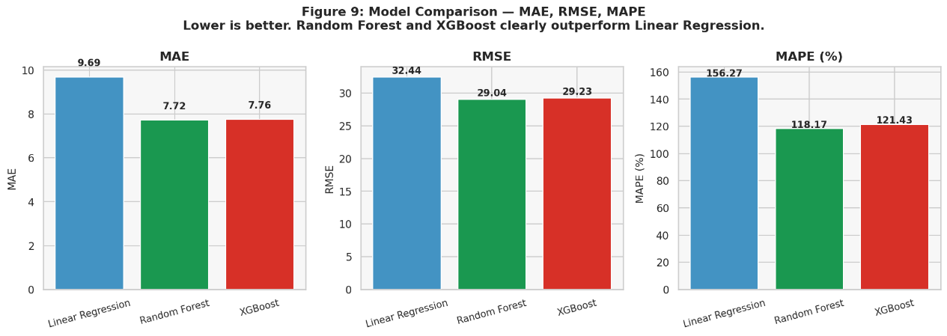

Figure 8: Model comparison by MAE, RMSE, MAPE

Random Forest was chosen for this project because it gave the best error case across the robust time-series CV, while being more stable and interpretable than the alternatives.
What the metrics show
From the 3-fold TimeSeriesSplit CV results:
Linear Regression
MAE=10.56 RMSE=33.22 MAPE=157.54%
Random Forest
MAE=8.07 RMSE=29.69 MAPE=123.69%
XGBoost
MAE=7.97 RMSE=29.16 MAPE=119.29%
So, RF and XGBoost are clearly better than Linear Regression on all metrics and they reduce MAPE by approximately 20% compared to Linear Regression.
Why Random Forest over XGBoost
- CV scores for RF and XGBoost are almost similar (RF slightly worse MAE and MAPE but slightly better RMSE), so in practice they are statistically similar on dataset.
Random Forest and XGBoost achieved comparable cross-validated errors although Random Forest were selected as the final model due to its competitive accuracy, lower complexity, and clearer interpretability.

Why Random Forest over Linear Regression
- Linear Regression underfits the data thus causing errors roughly double those of the tree-based models. This indicates it cannot capture nonlinear relationships and interactions present in seasonality, weather, lags, etc.
- Very high MAPE for Linear Regression (≈ 264%) shows it does poorly on relative errors, which is problematic when demand varies a lot across items.
Linear Regression served as a baseline for establishing a reference point. It exhibited substantially higher MAE and RMSE, indicating underfitting on the multivariate, nonlinear demand patterns.

Why Random Forest over the CNN
- The CNN sequence model achieved MAE ≈ 10.96 and RMSE ≈ 43.24, with MAPE ≈ 108.93%.
- Compared to the RF CV scores (MAE ≈ 10.45, RMSE ≈ 34.63), the CNN is slightly worse on MAE and significantly worse on RMSE, despite being more complex and slower to train.
The 1-D CNN did not outperform the classical tree ensemble. Its RMSE was at least 10 units higher compared to RF. So, Random Forest was retained as the primary forecasting model and left the CNN as an experimental extension.

In summary, model selection was based on mean absolute error (MAE), root mean squared error (RMSE) and mean absolute percentage error (MAPE) under time series cross validation (TSCV). The baseline Linear Regression underperformed, with MAE and RMSE roughly twice those of the tree-based models. This indicated underfitting. Random Forest and XGBoost achieved similar error levels, but Random Forest offered a slightly better RMSE and comparable MAE and MAPE with considerably simpler configuration and more transparent behavior. The CNN sequence model, while competitive in MAE, exhibited much higher RMSE than Random Forest despite much greater complexity and longer training time. Therefore, a global Random Forest was selected as the final model, as it provided the best trade-off between accuracy, robustness, and interpretability.

7.7 Inference and Recommendation Logic

The solution methodology was designed to balance predictive accuracy, business interpretability, and reproducible implementation. The modelling process began with feature engineering using both domain knowledge and forecasting principles, followed by standardized preprocessing, comparative model evaluation, and final deployment-oriented inference logic. Rather than relying on a single modelling assumption, the project tested multiple approaches in order to identify the most suitable technique for the solution to the business problem.

Workflow: Physical ledgers -> scanned images -> OCR extraction -> cleaned tabular dataset -> feature engineering -> preprocessing pipeline -> baseline models -> time-series cross-validation -> final Random Forest model -> single-item demand prediction -> order recommendation.
To preserve the integrity of forecasting evaluation, the modelling pipeline was designed to avoid information leakage. Same day balance was excluded as a direct feature because it contains end-of-day information that would not be available at forecast time. Balance is sales subtracted from total stock which becomes a link to our demand prediction and thus leakage. Instead, only lagged and rolling historical balance variables were used. In addition, preprocessing operations were embedded within the model pipeline and re-fitted inside each cross-validation fold so that future information did not leak into training transformations.

8. Results and Evaluation

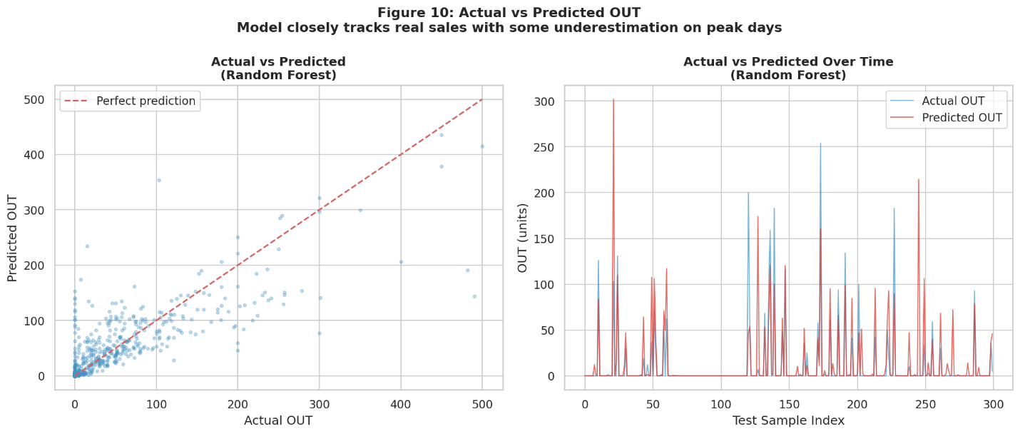

Figure 9: Random Forest actual vs predicted OUT.

The results section evaluates the forecasting models using both a simple train-test split and expanding window time-series cross-validation. Both gave two different results as the former doesn’t care about chronological order but later follows order and does multiple fold of the test which is better for cyclic patterns. The purpose of this section is not only to report numerical performance but also to explain why the final model was considered the most suitable for the business context. Because forecasting quality must be interpreted carefully in operational settings, the analysis combines metrics, visual evidence, and model-selection reasoning.

Table 3: Model comparison based on error metrices.
Model | MAE | RMSE | MAPE
Linear Regression | 17.9001 | 40.6667 | 223.5937%
Random Forest | 7.9007 | 28.9144 | 123.6138%
XGBoost | 7.9635 | 29.0017 | 121.9425%
CNN | 11.0782 | 44.1701 | 100.98%

The comparative results show that the tree-based models substantially outperformed the linear baseline, indicating that the demand process is influenced by nonlinear relationships and interactions among historical, calendar, and external features. Random Forest and XGBoost produced close comparable results, while Linear Regression underperformed across all major error metrics. CNN experiment did not improve performance sufficiently to justify its greater implementation complexity in this tabular forecasting project.

Although MAPE was reported for completeness, it should be interpreted with caution because percentage-based error measures can become unstable when actual demand values are very small or zero. For this reason, MAE and RMSE provide the more reliable basis for model comparison in this project.

9. Limitations, Challenges, and Constraints

Project phases met with several limitations that should be acknowledged. First, the original business records were maintained in physical ledgers, which introduced OCR errors, transcription inconsistencies, and manual validation overhead while converting into dataset. Second, the predicted-OUT value reflects sales rather than unconstrained true demand, meaning some sales may have been suppressed by stock limitations. Third, certain external explanatory variables were collected from public sources which were hard to find and were limited.
The project was also constrained by time, dataset preparation effort, and the practical limits of academic project scope which also meant a small dataset that may not have captured the core patterns that probably have taken root in its actual long run. Also, the dataset stops mid-July which proved it almost impossible to predict current data accurately. Although several models were compared, exhaustive hyperparameter optimization and full production deployment were outside the available project permitted timeline. In addition, while the solution is operational and demonstrates the ability to forecast short-term sales, it should still be treated as a decision support tool rather than a fully autonomous ordering system. Human review remains necessary, especially during unusual market conditions or supply disruptions.
From an ethical and responsible AI perspective, the project does not primarily raise fairness concerns in the same way as person level decision systems, but it still requires careful treatment of business confidentiality, transparent communication of model limitations, and responsible interpretation of uncertain predictions.

10. Conclusions and Discussion

This project demonstrated that forecasting using Artificial Intelligence can be applied to a real business inventory planning problem in a practical and interpretable way, combining ledger digitization, feature engineering, comparative modelling, and decision-oriented forecasting logic. The project produced a forecasting solution capable of supporting daily replenishment planning. The findings show that machine learning, particularly ensemble tree methods can provide measurable advantages over simpler baseline methods when business demand is shaped by temporal, operational, seasonal and event-driven factors.

11. Recommendations and Future Work

Full deployment of the final forecasting project requires further data and more advanced machine learning techniques. It is currently integrated into a lightweight decision-support workflow that allows staff to select an item, input current stock and planned incoming quantity, and receive a predicted next-day sales estimate together with an order recommendation. The system should be monitored regularly, updated and model performance should be reviewed as new business data becomes available. A periodic retraining schedule would help keep the model aligned with changing demand behaviour.
Future work could extend the project in several directions. One improvement would be to model product availability for purchase and supply constraints in addition to sales. Another would be to estimate latent demand when recorded sales are capped by limited stock. It could also be trained with customer data for individual customer habits. Further extensions could include dashboard deployment, per-item specialized models, richer external variables, and more formal hyperparameter optimization. These improvements would make the system more robust and operationally valuable in real business use.

12. References

- National Centre for Statistics and Information. (n.d.). NCSI portal. https://www.ncsi.gov.om

- Oman Open Data Portal. (n.d.). Agriculture & livestock. https://data.gov.om/OMAGLS2016/agriculture-livestock?region=1000000-oman&lang=en

- Oman Open Data Portal. (n.d.). Oman – Total number of animals – Goats. https://data.gov.om/OMAGLS2016/agriculture-livestock?tsId=1000240&lang=en

- Oman Open Data Portal. (n.d.). Oman – Total number of animals – Camels. https://data.gov.om/OMAGLS2016/agriculture-livestock?tsId=1000250

- Open Data Portal. (2026, May 18). Datasets page: Numbers of cattle, camels, sheep, and goats across governorates and wilayats. https://opendata.gov.om/en/datasets/736d81e2-2e1c-4ed0-bbe6-254cd53fca71

- Oman Open Data Portal. (n.d.). Oman – Quantity of animal production – Eggs (No. in million). https://data.gov.om/OMAGLS2016/agriculture-livestock?tsId=1000450

- Google AI for Developers. (n.d.). Gemini API documentation. https://ai.google.dev/gemini-api/docs

- Google AI for Developers. (n.d.). Gemini API reference. https://ai.google.dev/api

- scikit-learn developers. (n.d.). Getting started. https://scikit-learn.org/stable/getting_started.html

- scikit-learn developers. (n.d.). RandomForestRegressor. https://scikit-learn.org/stable/modules/generated/sklearn.ensemble.RandomForestRegressor.html

- XGBoost developers. (n.d.). XGBoost documentation. https://xgboost.readthedocs.io

- TensorFlow. (2024, June 6). tf.keras.layers.Conv1D. https://www.tensorflow.org/api_docs/python/tf/keras/layers/Conv1D

13. Appendices

Appendix A. Reproducibility and Environment Details
Notebook title: CSCI323_Sales_Forecasting.ipynb.
Target variable: OUT (daily units sold).
Dataset used: dat.csv.

The notebook is organized into imports and configuration, data loading and exploration, feature group definitions, metric helper functions, preprocessing pipeline, baseline models, time-series cross-validation, feature justification visualizations, model performance visualizations, CNN sequence experiment, and final single-item inference.

Python: 3.12.13
pandas: 2.2.2
numpy: 2.0.2
scikit-learn: 1.6.1
matplotlib: 3.10.0
seaborn: 0.13.2
xgboost: 3.2.0
tensorflow: 2.20.0
All experiments were conducted in Google Colab using Python. The workflow uses a single preprocessed CSV dataset, deterministic random seeds where applicable, consistent metric functions, and pipeline-based preprocessing to ensure that transformations were applied consistently across training and evaluation phases.

Appendix B. Dataset Summary
Verified notebook outputs show a dataset shape of 46,600 rows and 121 columns, date range 2023-01-01 to 2025-07-20, 50 unique items, 9 sectors, and target OUT mean of 13.81.
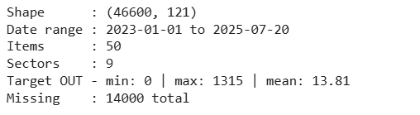
The notebook defines 61 numeric features and 3 categorical features. The numeric feature groups include operational variables (IN, Open, TOTAL), calendar variables, cyclic encodings, Hijri calendar variables, weather variables, livestock and poultry variables, lag variables, rolling statistics, event flags, and Eid proximity variables. The categorical variables are Item, Product_Sector, and season_name.



Appendix C. Feature Inventory
The following feature groups were used to support multivariate next-day sales forecasting. Balance columns are not used to prevent leakage. Lagged and rolling balance information is used, and TOTAL is treated as safe because it is known before the selling day begins.
Operational variables: IN, Open, TOTAL.
Calendar variables: year, month, day, day_of_year, day_of_week, day_of_week_sin, day_of_week_cos, month_sin, month_cos, year_sin, year_cos.
Season variables: season_num, season_sin, season_cos, climate_curve, season_name.
Hijri calendar variables: HijriYear, HijriMonth, HijriDay, hijri_month_sin, hijri_month_cos, hijri_day_sin, hijri_day_cos.
Weather variables: real_max_temperature, real_rainfall_mm.
Livestock and poultry variables: real_poultry_production, real_cattle_count, real_camel_count, real_sheep_count, real_goat_count.
Lag variables: out_lag_1, balance_lag_1, out_lag_7, balance_lag_7, out_lag_14, balance_lag_14, out_lag_30, balance_lag_30.
Rolling statistics: in_roll_mean_7, in_roll_sd_7, in_roll_mean_30, in_roll_sd_30, out_roll_mean_7, out_roll_sd_7, out_roll_mean_30, out_roll_sd_30, balance_roll_mean_7, balance_roll_sd_7, balance_roll_mean_30, balance_roll_sd_30.
Binary/event flags: discrepancy_flag, is_friday, is_gap_row, is_Friday_or_is_gap, is_ramadan_period, eidalfitrwindow, eidaladhawindow.
Proximity variables: eid_fitr_proximity, eid_adha_proximity.
Categorical variables: Item, Product_Sector, season_name.

Appendix D. Leakage Policy and Modelling Safety
To avoid information leakage while evaluation and prediction, same-day BALANCE was excluded as a direct feature because it reflects end-of-day inventory after sales have already occurred. Instead, only lagged and rolling versions of BALANCE were used. TOTAL is the sum of Open stock and IN sales, so it was retained because stock availability is known before the day’s selling activity begins. Preprocessing was wrapped inside scikit-learn pipelines and cloned within each fold of time-series cross-validation so that imputation and encoding were learned only from training data.

Appendix E. Evaluation Metrics
Three regression metrics were used consistently across the classical models: Mean Absolute Error (MAE), Root Mean Squared Error (RMSE), and Mean Absolute Percentage Error (MAPE). The notebook defines helper functions rmse(), mape_safe(), and evaluate(), and clips negative predictions to zero before scoring because negative sales are not meaningful in this business context.

    - MAE (Mean Absolute Error)
$$MAE=\frac{1}{n}\sum_{i=1}^{n}{\left|y_{i}-{\overset{ˆ}{y}}_{i}\right|}$$
MAE=1𝑛𝑖=1𝑛∣𝑦𝑖−$y$𝑖∣

- RMSE (Root Mean Squared Error)
First compute MSE, then take the square root:
$$\text{RMSE}=\sqrt{\frac{1}{n}\sum_{i=1}^{n}{{\left(y_{i} − {\hat{y}}_{i}\right)}^{2}}}$$
- MAPE (Mean Absolute Percentage Error)
$$\text{MAPE}=\frac{100}{n}\sum_{i=1}^{n}{∣\frac{y_{i}-{\hat{y}}_{i}}{y_{i}}∣}$$

MAE provides average absolute forecasting error in units, RMSE penalizes larger deviations more strongly, and MAPE gives a relative percentage measure but should be interpreted carefully when there are a lot of zero values or very small values.

Appendix F. Cross-Validation Results
Table 2. Average model performance across TimeSeriesSplit cross-validation.
Table 2: Model comparison based on error metrices.
Model | MAE | RMSE | MAPE
Linear Regression | 17.9001 | 40.6667 | 223.5937%
Random Forest | 7.9007 | 28.9144 | 123.6138%
XGBoost | 7.9635 | 29.0017 | 121.9425%
CNN | 11.0782 | 44.1701 | 100.98%

Appendix G. Figure Notes and Graph Explanations
Figure 1: sales (OUT) vs total inventory (TOTAL) supply chain constraint, Shows that sales cannot exceed available stock, so supply limits observed demand.

Figure 2: Average daily sales per season and weekly average with the impact of Friday holiday. Shows that sales change by season and drop to near zero on Fridays, with higher demand around the Friday closure.

Figure 3: Sales during Eid periods in 2023, 2024 and 2025. Shows that sales increase around Eid periods and then fall on the holiday day itself.

Figure 4: Correlation of all features with OUT sales. Shows which feature the strongest overall relationship with daily sales.

Figure 5: Lag features Pearson correlation with OUT sales. Shows that past sales values, especially weekly lags, help explain current sales.

Figure 6: Rolling mean vs actual OUT sales. Shows that rolling averages smooth daily noise and reveals the underlying sales trend.

Figure 7: MAE by product sector. Shows that prediction errors differ across product sectors.

Figure 8: Model comparison by MAE, RMSE, MAPE. Shows how the forecasting models compare the main error metrics.

Figure 9: Random Forest actual vs predicted OUT. Shows how close the Random Forest predictions are to the actual sales values.

Appendix H. Baseline Split and Test-Set Notes
In addition to time-series cross-validation, the notebook also used a simple chronological 80/20 split as a sanity check. The baseline split trained on 37,280 rows and tested on 9,320 rows. On this split, the Random Forest test metrics were MAE = 8.0727, RMSE = 29.6878, and MAPE = 123.6903. These values are used primarily for visualization and diagnostic plots rather than the main model-selection which is based on cross-validation.

Appendix I. CNN Experimental Model Details
A 1-D CNN was implemented as an experimental sequence model using a 14-day sliding window over numeric features. The sequence dataset was split chronologically into 70% training, 15% validation, and 15% test sets, producing 32,129 training sequences, 6,886 validation sequences, and 6,885 test sequences with 61 input features per timestep. The architecture consisted of two Conv1D layers with 32 and 64 filters respectively, dropout layers with rate 0.2, a flatten layer, a dense hidden layer with 64 units, and a final regression output layer. The model was trained with the Adam optimizer and MAE loss with early stopping on validation loss.
Suggested result sentence: The CNN achieved test-set MAE = 11.0782, RMSE = 44.1701, and MAPE = 100.98%, which did not outperform the simpler tree-based ensemble models.

Appendix J. Final Inference Example
The final notebook section demonstrates single-item next-day inference using the Random Forest model. In the example, the selected item was Starter, the forecast date was 2025-07-21, the assumed incoming stock (IN) was 125 units, the current open stock was 76 units, total available stock was 201 units, and the predicted OUT was 75 units. This example shows how the forecasting system can be used for item purchase decision making.

Appendix K. Pseudocode
The following high-level pseudocode summarizes the end-to-end forecasting workflow from training to single-item recommendation.
1. Load the preprocessed dataset and parse dates.
2. Sort records by item and date.
3. Define safe numeric and categorical feature sets.
4. Build a preprocessing pipeline with median imputation for numeric features and constant imputation plus one-hot encoding for categorical features.
5. Evaluate candidate models using chronological train/test split and TimeSeriesSplit cross-validation.
6. Compare models using MAE, RMSE, and MAPE.
7. Select the final Random Forest model based on accuracy, robustness, and interpretability.
8. For a target item and future date, gather the most recent item history and populate lag/rolling features.
9. Insert the assumed incoming stock value and compute TOTAL availability.
10. Generate the next-day OUT forecast.
11. Convert the forecast into a replenishment recommendation using current stock and business rules.

Appendix L. External Data Sources
External variables were incorporated to reflect business conditions beyond the internal ledger records which included weather variables, livestock counts, and poultry production indicators relevant to animal-feed demand patterns. Official Oman data portals and NCSI resources were the main sources for this information.
- National Centre for Statistics and Information. (n.d.). NCSI portal. https://www.ncsi.gov.om

- Oman Open Data Portal. (n.d.). Agriculture & livestock. https://data.gov.om/OMAGLS2016/agriculture-livestock?region=1000000-oman&lang=en

- Oman Open Data Portal. (n.d.). Oman – Total number of animals – Goats. https://data.gov.om/OMAGLS2016/agriculture-livestock?tsId=1000240&lang=en

- Oman Open Data Portal. (n.d.). Oman – Total number of animals – Camels. https://data.gov.om/OMAGLS2016/agriculture-livestock?tsId=1000250

- Open Data Portal. (2026, May 18). Datasets page: Numbers of cattle, camels, sheep, and goats across governorates and wilayats. https://opendata.gov.om/en/datasets/736d81e2-2e1c-4ed0-bbe6-254cd53fca71

- Oman Open Data Portal. (n.d.). Oman – Quantity of animal production – Eggs (No. in million). https://data.gov.om/OMAGLS2016/agriculture-livestock?tsId=1000450

GitHub: https://github.com/BithinR/CSCI323-Modern-Artificial-Intelligence-Project.git

-------END of report-------

# CSCI323 – Modern Artificial Intelligence | Project
## Next-Day Sales Forecasting – Oman Agri, Animal Feed & Flour Reseller

**Target variable:** `OUT` – daily units sold (next-day forecast)
**Models evaluated:** Linear Regression · Random Forest · XGBoost · 1-D CNN
**Dataset:** `project_dataset_preprocessed.csv`
**Leakage policy:** Same-day `BALANCE` is excluded as a direct feature; only its lagged and rolling variants are used. `TOTAL = Open + IN` is safe because stock arrives before the selling day begins.

---
### Notebook Sections
1. Imports & Configuration
2. Data Loading & Exploration
3. Feature Group Definitions
4. Metric Helper Functions
5. Preprocessing Pipeline
6. Baseline Models (single 80/20 split)
7. Time-Series Cross-Validation
8. Visualisation – Feature Justification Charts
9. Visualisation – Model Performance Charts & Residual Analysis
10. CNN Sequence Experiment
11. Final Prediction – Single-Item Inference

# CSCI323 – Modern Artificial Intelligence | Project
## Next-Day Sales Forecasting – Oman Agri, Animal Feed & Flour Reseller

**Target variable:** `OUT` – daily units sold (next-day forecast)
**Models evaluated:** Linear Regression · Random Forest · XGBoost · 1-D CNN
**Dataset:** `project_dataset_preprocessed.csv`
**Leakage policy:** Same-day `BALANCE` is excluded as a direct feature; only its lagged and rolling variants are used. `TOTAL = Open + IN` is safe because stock arrives before the selling day begins.

---
### Notebook Sections

- [Problem Statement and Forecasting Objective](#Problem-Statement-and-Forecasting-Objective)
- [1. Imports and Configuration](#1.-Imports-and-Configuration)
- [2. Data Loading and Dataset Verification](#2.-Data-Loading-and-Dataset-Verification)
- [4. Feature Groups and Leakage Policy](#4.-Feature-Groups-and-Leakage-Policy)
- [5. Metric Definitions](#5.-Metric-Definitions)
- [6. Preprocessing Pipeline](#6.-Preprocessing-Pipeline)
- [7. Baseline Models: 80/20 Chronological Split](#7.-Baseline-Models:-80/20-Chronological-Split)
- [8. Time-Series Cross-Validation](#8.-Time-Series-Cross-Validation)
- [9. Feature Justification Visualizations](#9.-Feature-Justification-Visualizations)
- [10. Model Performance Visualizations and Residual Analysis](#10.-Model-Performance-Visualizations-and-Residual-Analysis)
- [11. CNN Experimental Model](#11.-CNN-Experimental-Model)
- [12. Final Model Selection](#12.-Final-Model-Selection)
- [13. Single-Item Forecast and Business Recommendation](#13.-Single-Item-Forecast-and-Business-Recommendation)

## Problem Statement and Forecasting Objective

This section outlines the core problem: forecasting next-day sales ('OUT') for various items, and defines the objectives for developing an accurate and robust forecasting model. The goal is to provide actionable insights for inventory management and business planning.

## 1. Imports and Configuration

This section is dedicated to importing all necessary libraries and defining global configuration settings and constants that will be used throughout the notebook for data processing, modeling, and visualization.

# Import necessary libraries and configure project-wide constants.
import warnings
warnings.filterwarnings('ignore')

import pandas as pd
import numpy as np
import matplotlib.pyplot as plt
import seaborn as sns
sns.set_theme(style='whitegrid', palette='muted')

from sklearn.model_selection import TimeSeriesSplit
from sklearn.metrics import mean_absolute_error, mean_squared_error
from sklearn.linear_model import LinearRegression
from sklearn.ensemble import RandomForestRegressor
from sklearn.compose import ColumnTransformer
from sklearn.pipeline import Pipeline
from sklearn.impute import SimpleImputer
from sklearn.preprocessing import OneHotEncoder
from sklearn.base import clone

try:
from xgboost import XGBRegressor
HAS_XGB = True
print('XGBoost available: True')
except ImportError:
HAS_XGB = False
print('XGBoost not found - Random Forest will be used as fallback')

import tensorflow as tf
from tensorflow.keras import Sequential
from tensorflow.keras.layers import Conv1D, Dense, Dropout, Flatten
from tensorflow.keras.callbacks import EarlyStopping

# ---- Project-wide constants ----
DATA_PATH = 'dat.csv'
TARGET = 'OUT'
DATE_COL = 'Date'
ITEM_COL = 'Item'
SECTOR_COL = 'Product_Sector'
RANDOM_SEED = 42
SAVE_FIGS = True # set False to skip saving figure files
N_CV_SPLITS = 3

print('Setup complete.')

## 2. Data Loading and Dataset Verification

Here, we load the raw dataset and perform initial checks to understand its structure, content, and any immediate data quality issues. This step ensures that the data is correctly loaded and ready for subsequent analysis.

# Load the dataset from the specified path and display its basic statistics and a sample.
def load_data(path=DATA_PATH):
df = pd.read_csv(path, low_memory=False)
df[DATE_COL] = pd.to_datetime(df[DATE_COL], errors='coerce')
df = df.sort_values([ITEM_COL, DATE_COL]).reset_index(drop=True)
return df

df = load_data()

print('Shape :', df.shape)
print('Date range :', df[DATE_COL].min().date(), 'to', df[DATE_COL].max().date())
print('Items :', df[ITEM_COL].nunique())
print('Sectors :', df[SECTOR_COL].nunique())
print('Target OUT - min:', df[TARGET].min(), '| max:', df[TARGET].max(),
'| mean:', round(df[TARGET].mean(), 2))
print('Missing :', df.isnull().sum().sum(), 'total')
print()
print(df[[DATE_COL, ITEM_COL, SECTOR_COL, 'IN', 'Open', 'TOTAL', TARGET]].head(3).to_string())

## 4. Feature Groups and Leakage Policy

This section outlines the different categories of features engineered for the forecasting models, distinguishing between flag, proximity, numerical, and categorical features. Crucially, it defines the leakage policy to prevent data from future time periods from influencing current predictions, ensuring robust model training.

# Define the various feature groups (flags, proximity, numeric, categorical) used in the models.
FLAG_COLS = [
'discrepancy_flag', 'is_friday', 'is_gap_row',
'is_Friday_or_is_gap', 'is_ramadan_period',
'eidalfitrwindow', 'eidaladhawindow',
]

PROXIMITY_COLS = ['eid_fitr_proximity', 'eid_adha_proximity']

NUMERIC_COLS = [
'IN', 'Open', 'TOTAL',
'year', 'month', 'day', 'day_of_year', 'day_of_week',
'day_of_week_sin', 'day_of_week_cos',
'month_sin', 'month_cos', 'year_sin', 'year_cos',
'season_num', 'season_sin', 'season_cos', 'climate_curve',
'HijriYear', 'HijriMonth', 'HijriDay',
'hijri_month_sin', 'hijri_month_cos', 'hijri_day_sin', 'hijri_day_cos',
'real_max_temperature', 'real_rainfall_mm',
'real_poultry_production', 'real_cattle_count',
'real_camel_count', 'real_sheep_count', 'real_goat_count',
'out_lag_1', 'balance_lag_1',
'out_lag_7', 'balance_lag_7',
'out_lag_14', 'balance_lag_14',
'out_lag_30', 'balance_lag_30',
'in_roll_mean_7', 'in_roll_sd_7', 'in_roll_mean_30', 'in_roll_sd_30',
'out_roll_mean_7', 'out_roll_sd_7', 'out_roll_mean_30', 'out_roll_sd_30',
'balance_roll_mean_7', 'balance_roll_sd_7',
'balance_roll_mean_30', 'balance_roll_sd_30',
] + FLAG_COLS + PROXIMITY_COLS

CATEGORICAL_COLS = [ITEM_COL, SECTOR_COL, 'season_name']

def get_available_cols(df):
num = [c for c in NUMERIC_COLS if c in df.columns and c != TARGET]
cat = [c for c in CATEGORICAL_COLS if c in df.columns and c != TARGET]
return num, cat

num_cols, cat_cols = get_available_cols(df)
print(f'Numeric features : {len(num_cols)}')
print(f'Categorical features: {len(cat_cols)}')

## 5. Metric Definitions

This section defines the evaluation metrics used to quantify model performance, including Root Mean Squared Error (RMSE), Mean Absolute Error (MAE), and Mean Absolute Percentage Error (MAPE). These metrics will guide model selection and comparison.

# Define evaluation metrics (RMSE, MAPE, MAE) to assess model performance.
def rmse(y_true, y_pred):
return float(np.sqrt(mean_squared_error(np.array(y_true), np.array(y_pred))))

def mape_safe(y_true, y_pred):
y_true = np.asarray(y_true, dtype=float)
y_pred = np.asarray(y_pred, dtype=float)
mask = y_true != 0
if mask.sum() == 0:
return np.nan
return float(np.mean(np.abs((y_true[mask] - y_pred[mask]) / y_true[mask])) * 100)

def evaluate(y_true, y_pred):
y_pred = np.clip(np.asarray(y_pred, dtype=float), 0, None)
return {
'mae': round(mean_absolute_error(y_true, y_pred), 4),
'rmse': round(rmse(y_true, y_pred), 4),
'mape': round(mape_safe(y_true, y_pred), 4),
}

print('Metric helpers ready: rmse(), mape_safe(), evaluate()')

## 6. Preprocessing Pipeline

This section details the preprocessing steps applied to the features before model training. It covers strategies for handling missing values (imputation) and encoding categorical variables (one-hot encoding) to prepare the data for machine learning algorithms.

# Define functions to build preprocessing pipelines for numerical and categorical features.
def build_preprocessor(num_feats, cat_feats):
num_pipe = Pipeline([('imp', SimpleImputer(strategy='median'))])
cat_pipe = Pipeline([
('imp', SimpleImputer(strategy='constant', fill_value='Unknown')),
('ohe', OneHotEncoder(handle_unknown='ignore', sparse_output=False)),
])
return ColumnTransformer([
('num', num_pipe, num_feats),
('cat', cat_pipe, cat_feats),
], remainder='drop')

def build_pipeline(model_obj, num_feats, cat_feats):
return Pipeline([
('pre', build_preprocessor(num_feats, cat_feats)),
('model', model_obj),
])

print('Pipeline builders ready: build_preprocessor(), build_pipeline()')

## 7. Baseline Models: 80/20 Chronological Split

Here, we establish baseline performance using simpler models like Linear Regression and Random Forest (and XGBoost if available). We employ an 80/20 chronological split to simulate a realistic forecasting scenario, training on 80% of the earliest data and testing on the latest 20%.

# @title
# Train and evaluate baseline models (Linear Regression, Random Forest, XGBoost) using an 80/20 chronological split.
num_feats, cat_feats = get_available_cols(df)
all_feats = num_feats + cat_feats
sub = df[[c for c in [DATE_COL] + all_feats + [TARGET] if c in df.columns]].copy()
sub = sub.sort_values(DATE_COL).reset_index(drop=True)
X = sub.drop(columns=[TARGET])
y = pd.to_numeric(sub[TARGET], errors='coerce').fillna(0)
X_model = X.drop(columns=[DATE_COL], errors='ignore')
num_feats2 = [c for c in num_feats if c in X_model.columns]
cat_feats2 = [c for c in cat_feats if c in X_model.columns]

split = int(len(X_model) * 0.8)
X_tr, X_te = X_model.iloc[:split], X_model.iloc[split:]
y_tr, y_te = y.iloc[:split], y.iloc[split:]
print(f'Train: {len(X_tr):,} rows | Test: {len(X_te):,} rows')

baseline_models = [
('Linear Regression', LinearRegression()),
('Random Forest', RandomForestRegressor(n_estimators=300, max_depth=14,
min_samples_leaf=3, random_state=RANDOM_SEED, n_jobs=-1)),
]
if HAS_XGB:
baseline_models.append(('XGBoost', XGBRegressor(
n_estimators=600, learning_rate=0.05, max_depth=6,
subsample=0.8, colsample_bytree=0.8, reg_lambda=1.0,
objective='reg:squarederror', random_state=RANDOM_SEED, n_jobs=-1)))

baseline_results = []
for name, mdl in baseline_models:
print(f'Training {name}...')
pipe = build_pipeline(mdl, num_feats2, cat_feats2)
pipe.fit(X_tr, y_tr)
pred = pipe.predict(X_te)
m = evaluate(y_te, pred)
print(f' MAE={m["mae"]:.2f} RMSE={m["rmse"]:.2f} MAPE={m["mape"]:.2f}%')
baseline_results.append({'model': name, **m})
]

## 8. Time-Series Cross-Validation

This section employs a more rigorous time-series cross-validation strategy. Instead of a single split, the data is divided into multiple train/test folds chronologically, providing a more robust estimate of model performance over time and assessing its generalization capabilities.

# Perform time-series cross-validation on models to get a more robust evaluation of their performance.
def run_time_cv(df, model_name, model_obj, n_splits=N_CV_SPLITS):
num_feats, cat_feats = get_available_cols(df)
all_feats = num_feats + cat_feats
sub = df[[c for c in [DATE_COL] + all_feats + [TARGET] if c in df.columns]].copy()
sub = sub.sort_values(DATE_COL).reset_index(drop=True)
X = sub.drop(columns=[TARGET])
y = pd.to_numeric(sub[TARGET], errors='coerce').fillna(0)
X_model = X.drop(columns=[DATE_COL], errors='ignore')
nf = [c for c in num_feats if c in X_model.columns]
cf = [c for c in cat_feats if c in X_model.columns]
tscv = TimeSeriesSplit(n_splits=n_splits)
rows = []
for fold, (tr, te) in enumerate(tscv.split(X_model), start=1):
pipe = clone(build_pipeline(model_obj, nf, cf))
pipe.fit(X_model.iloc[tr], y.iloc[tr])
pred = pipe.predict(X_model.iloc[te])
m = evaluate(y.iloc[te], pred)
rows.append({'model': model_name, 'fold': fold, **m})
print(f' Fold {fold}: MAE={m["mae"]:.3f} RMSE={m["rmse"]:.3f} MAPE={m["mape"]:.2f}%')
return pd.DataFrame(rows)

model_configs = [
('Linear Regression', LinearRegression()),
('Random Forest', RandomForestRegressor(n_estimators=300, max_depth=14,
min_samples_leaf=3, random_state=RANDOM_SEED, n_jobs=-1)),
]
if HAS_XGB:
model_configs.append(('XGBoost', XGBRegressor(
n_estimators=600, learning_rate=0.05, max_depth=6,
subsample=0.8, colsample_bytree=0.8, reg_lambda=1.0,
objective='reg:squarederror', random_state=RANDOM_SEED, n_jobs=-1)))

print('=' * 60)
all_cv = []
for name, mdl in model_configs:
print(f'\n--- {name} ---')
res = run_time_cv(df, name, mdl)
avg = res[['mae','rmse','mape']].mean()
print(f' Avg MAE={avg.mae:.3f} RMSE={avg.rmse:.3f} MAPE={avg.mape:.2f}%')
all_cv.append(res)

cv_results_df = pd.concat(all_cv, ignore_index=True)
cv_summary = (cv_results_df.groupby('model')[['mae','rmse','mape']]
.mean().round(4).reset_index())
cv_results_df.to_csv('model_results_all.csv', index=False)
cv_summary.to_csv('model_results_summary.csv', index=False)
print('\nSaved: model_results_all.csv | model_results_summary.csv')
print(cv_summary.to_string(index=False))

## 9. Feature Justification Visualizations

This section presents various visualizations to empirically justify the inclusion and design of different features. These charts illustrate relationships between features and the target variable, highlight seasonal patterns, and demonstrate the predictive power of engineered variables like lags and rolling statistics.

# Generate various visualizations to justify the selection and engineering of features.
SAVE = SAVE_FIGS

# Fig 1: OUT over time
fig, ax = plt.subplots(figsize=(14,4))
for item, g in df.groupby(ITEM_COL):
ax.plot(g[DATE_COL], g[TARGET], alpha=0.4, lw=0.6)
ax.set(xlabel='Date', ylabel='OUT (units)',
title='Figure 1: Daily OUT per Product Over Time')
fig.suptitle('Seasonal and item-level demand variation justifies lag and calendar features', fontsize=10)
plt.tight_layout()
if SAVE: plt.savefig('fig1_out_over_time.png', dpi=150, bbox_inches='tight')
plt.show(); print('Fig 1 saved')

# Fig 2: OUT by month
fig, ax = plt.subplots(figsize=(13,5))
sns.boxplot(data=df, x='month', y=TARGET, ax=ax, flierprops=dict(markersize=2))
ax.set(xlabel='Month', ylabel='OUT (units)', title='Figure 2: OUT Distribution by Calendar Month')
fig.suptitle('Monthly seasonality supports month_sin/cos cyclic features', fontsize=10)
plt.tight_layout()
if SAVE: plt.savefig('fig2_out_by_month.png', dpi=150, bbox_inches='tight')
plt.show(); print('Fig 2 saved')

# Fig 3: OUT by day-of-week
fig, ax = plt.subplots(figsize=(10,5))
sns.boxplot(data=df, x='day_of_week', y=TARGET, ax=ax, flierprops=dict(markersize=2))
ax.set(xlabel='Day of Week', ylabel='OUT (units)', title='Figure 3: OUT by Day of Week')
fig.suptitle('Friday closure pattern in Oman justifies is_friday and cyclic dow features', fontsize=10)
plt.tight_layout()
if SAVE: plt.savefig('fig3_out_by_dow.png', dpi=150, bbox_inches='tight')
plt.show(); print('Fig 3 saved')

# Fig 4: Ramadan effect
if 'is_ramadan_period' in df.columns:
fig, ax = plt.subplots(figsize=(8,5))
sns.boxplot(data=df, x='is_ramadan_period', y=TARGET, ax=ax, flierprops=dict(markersize=2))
ax.set_xticklabels(['Non-Ramadan', 'Ramadan'])
ax.set(xlabel='Period', ylabel='OUT (units)', title='Figure 4: Ramadan vs. Non-Ramadan OUT')
fig.suptitle('Demand shift during Ramadan justifies Hijri calendar and event flag features', fontsize=10)
plt.tight_layout()
if SAVE: plt.savefig('fig4_ramadan_effect.png', dpi=150, bbox_inches='tight')
plt.show(); print('Fig 4 saved')

# Fig 5: Lag-1 autocorrelation
if 'out_lag_1' in df.columns:
s = df[['out_lag_1', TARGET]].dropna().sample(min(5000,len(df)), random_state=42)
fig, ax = plt.subplots(figsize=(7,5))
ax.scatter(s['out_lag_1'], s[TARGET], alpha=0.2, s=5, color='#4393c3')
ax.set(xlabel='OUT lag-1', ylabel='OUT today', title='Figure 5: Autocorrelation - OUT vs Lag-1 OUT')
fig.suptitle('Strong autocorrelation validates out_lag_1 as a predictor', fontsize=10)
plt.tight_layout()
if SAVE: plt.savefig('fig5_lag1_scatter.png', dpi=150, bbox_inches='tight')
plt.show(); print('Fig 5 saved')

# Fig 6: 7-day rolling mean
if 'out_roll_mean_7' in df.columns:
s = df[['out_roll_mean_7', TARGET]].dropna().sample(min(5000,len(df)), random_state=42)
fig, ax = plt.subplots(figsize=(7,5))
ax.scatter(s['out_roll_mean_7'], s[TARGET], alpha=0.2, s=5, color='#d6604d')
ax.set(xlabel='7-Day Rolling Mean of OUT', ylabel='OUT today',
title='Figure 6: 7-Day Rolling Mean vs. Actual OUT')
fig.suptitle('Rolling averages capture recent demand with no same-day leakage', fontsize=10)
plt.tight_layout()
if SAVE: plt.savefig('fig6_roll7_scatter.png', dpi=150, bbox_inches='tight')
plt.show(); print('Fig 6 saved')

# Fig 7: Temperature vs OUT
if 'real_max_temperature' in df.columns:
s = df[['real_max_temperature', TARGET]].dropna().sample(min(5000,len(df)), random_state=42)
fig, ax = plt.subplots(figsize=(7,5))
ax.scatter(s['real_max_temperature'], s[TARGET], alpha=0.2, s=5, color='#74add1')
ax.set(xlabel='Max Temperature (C)', ylabel='OUT (units)',
title='Figure 7: Temperature vs. OUT')
fig.suptitle('Weather drives livestock feed demand - justifies real_max_temperature', fontsize=10)
plt.tight_layout()
if SAVE: plt.savefig('fig7_temperature_vs_out.png', dpi=150, bbox_inches='tight')
plt.show(); print('Fig 7 saved')

# Fig 8: OUT by sector
fig, ax = plt.subplots(figsize=(10,5))
sns.boxplot(data=df, x=SECTOR_COL, y=TARGET, ax=ax, flierprops=dict(markersize=2))
ax.set(xlabel='Sector', ylabel='OUT (units)', title='Figure 8: OUT Distribution by Product Sector')
plt.xticks(rotation=30, ha='right')
plt.tight_layout()
if SAVE: plt.savefig('fig8_out_distribution.png', dpi=150, bbox_inches='tight')
plt.show(); print('Fig 8 saved')
print('\nAll feature justification charts done.')

## 10. Model Performance Visualizations and Residual Analysis

This section provides a detailed examination of model performance, including comparative visualizations of actual versus predicted values, distributions of residuals, and feature importance plots. Residual analysis helps uncover systematic errors and model limitations.

# Re-train the best model (Random Forest) and generate various visualizations for model performance and residual analysis.
# Re-train best model (Random Forest) on 80/20 split for visualisation
num_feats, cat_feats = get_available_cols(df)
all_feats = num_feats + cat_feats
sub = df[[c for c in [DATE_COL] + all_feats + [TARGET] if c in df.columns]].copy()
sub = sub.sort_values(DATE_COL).reset_index(drop=True)
X_vis = sub.drop(columns=[TARGET, DATE_COL], errors='ignore')
y_vis = pd.to_numeric(sub[TARGET], errors='coerce').fillna(0)
nf = [c for c in num_feats if c in X_vis.columns]
cf = [c for c in cat_feats if c in X_vis.columns]
split = int(len(X_vis) * 0.8)
X_tr, X_te = X_vis.iloc[:split], X_vis.iloc[split:]
y_tr, y_te = y_vis.iloc[:split], y_vis.iloc[split:]
rf_pipe = build_pipeline(RandomForestRegressor(n_estimators=300, max_depth=14,
min_samples_leaf=3, random_state=RANDOM_SEED, n_jobs=-1), nf, cf)
rf_pipe.fit(X_tr, y_tr)
rf_pred = np.clip(rf_pipe.predict(X_te), 0, None)
residuals = y_te.values - rf_pred
print(f'Train: {len(X_tr):,} | Test: {len(X_te):,}')
print('RF Test:', evaluate(y_te, rf_pred))

# Fig 9: Model comparison bar chart
if 'cv_results_df' in dir():
summary = cv_results_df.groupby('model')[['mae','rmse','mape']].mean().reset_index()
else:
summary = pd.DataFrame(baseline_results)
fig, axes = plt.subplots(1, 3, figsize=(14,5))
for ax, metric in zip(axes, ['mae','rmse','mape']):
ax.bar(summary['model'], summary[metric], color=sns.color_palette('muted', len(summary)))
ax.set_title(metric.upper()); ax.tick_params(axis='x', rotation=25)
fig.suptitle('Figure 9: Model Comparison (avg across CV folds)', fontweight='bold')
plt.tight_layout()
if SAVE: plt.savefig('fig9_model_comparison.png', dpi=150, bbox_inches='tight')
plt.show(); print('Fig 9 saved')

# Fig 10: Actual vs Predicted
fig, ax = plt.subplots(figsize=(8,5))
sample_idx = range(min(500, len(y_te)))
ax.plot(list(sample_idx), y_te.values[:500], label='Actual', alpha=0.8, lw=1)
ax.plot(list(sample_idx), rf_pred[:500], label='Predicted (RF)', alpha=0.8, lw=1)
ax.set(xlabel='Test Sample Index', ylabel='OUT (units)',
title='Figure 10: Actual vs Predicted OUT (first 500 test rows)')
ax.legend(); plt.tight_layout()
if SAVE: plt.savefig('fig10_actual_vs_predicted.png', dpi=150, bbox_inches='tight')
plt.show(); print('Fig 10 saved')

# Fig 11: Residual distribution
fig, axes = plt.subplots(1, 2, figsize=(12,5))
axes[0].scatter(rf_pred, residuals, alpha=0.15, s=4, color='#4393c3')
axes[0].axhline(0, color='red', lw=1)
axes[0].set(xlabel='Predicted', ylabel='Residual', title='Residuals vs Predicted')
axes[1].hist(residuals, bins=60, color='#4393c3', edgecolor='white')
axes[1].set(xlabel='Residual', ylabel='Count', title='Residual Distribution')
fig.suptitle('Figure 11: Residual Analysis (Random Forest)', fontweight='bold')
plt.tight_layout()
if SAVE: plt.savefig('fig11_residuals.png', dpi=150, bbox_inches='tight')
plt.show(); print('Fig 11 saved')

# Fig 12: Feature importance (top 20)
rf_model = rf_pipe.named_steps['model']
ohe_names = []
try:
ohe_names = list(rf_pipe.named_steps['pre'].named_transformers_['cat']
.named_steps['ohe'].get_feature_names_out(cf))
except: pass
feat_names = nf + ohe_names
importances = rf_model.feature_importances_
top_n = min(20, len(importances))
top_idx = np.argsort(importances)[::-1][:top_n]
fig, ax = plt.subplots(figsize=(10,6))
ax.barh([feat_names[i] if i < len(feat_names) else f'feat_{i}' for i in top_idx[::-1]],
importances[top_idx[::-1]], color='#4393c3')
ax.set(xlabel='Importance', title='Figure 12: Top 20 Feature Importances (Random Forest)')
plt.tight_layout()
if SAVE: plt.savefig('fig12_feature_importance.png', dpi=150, bbox_inches='tight')
plt.show(); print('Fig 12 saved')

# Fig 13: High/low demand confusion matrix style
threshold = df[TARGET].median()
y_te_bin = (y_te.values > threshold).astype(int)
rf_pred_bin = (rf_pred > threshold).astype(int)
from sklearn.metrics import confusion_matrix, classification_report
cm = confusion_matrix(y_te_bin, rf_pred_bin)
fig, ax = plt.subplots(figsize=(6,5))
sns.heatmap(cm, annot=True, fmt='d', cmap='Blues', ax=ax,
xticklabels=['Low','High'], yticklabels=['Low','High'])
ax.set(xlabel='Predicted', ylabel='Actual',
title='Figure 13: High/Low Demand Classification Matrix')
plt.tight_layout()
if SAVE: plt.savefig('fig13_confusion_matrix.png', dpi=150, bbox_inches='tight')
plt.show()
from sklearn.metrics import accuracy_score, precision_score, recall_score, f1_score
print(f'Accuracy:{accuracy_score(y_te_bin,rf_pred_bin):.3f} Precision:{precision_score(y_te_bin,rf_pred_bin):.3f} Recall:{recall_score(y_te_bin,rf_pred_bin):.3f} F1:{f1_score(y_te_bin,rf_pred_bin):.3f}')
print('Fig 13 saved')

# Fig 14: Error by sector
test_df = sub.iloc[split:].copy()
test_df['pred'] = rf_pred
test_df['abs_error'] = np.abs(test_df[TARGET] - test_df['pred'])
fig, ax = plt.subplots(figsize=(10,5))
sns.boxplot(data=test_df, x=SECTOR_COL, y='abs_error', ax=ax, flierprops=dict(markersize=2))
ax.set(xlabel='Sector', ylabel='Absolute Error', title='Figure 14: Prediction Error by Product Sector')
plt.xticks(rotation=30, ha='right'); plt.tight_layout()
if SAVE: plt.savefig('fig14_error_by_sector.png', dpi=150, bbox_inches='tight')
plt.show(); print('Fig 14 saved')

# Fig 15: Error by IN range
test_df['IN_bin'] = pd.cut(test_df['IN'], bins=5, labels=False)
fig, ax = plt.subplots(figsize=(9,5))
sns.boxplot(data=test_df, x='IN_bin', y='abs_error', ax=ax, flierprops=dict(markersize=2))
ax.set(xlabel='IN Quintile (0=lowest)', ylabel='Absolute Error',
title='Figure 15: Prediction Error by IN Supply Range')
plt.tight_layout()
if SAVE: plt.savefig('fig15_error_by_in_range.png', dpi=150, bbox_inches='tight')
plt.show(); print('Fig 15 saved')

# Fig 16: Correlation heatmap of key numerics
key_cols = [c for c in ['IN','Open','TOTAL','out_lag_1','out_roll_mean_7',
'balance_lag_1','real_max_temperature', TARGET] if c in df.columns]
corr = df[key_cols].corr()
fig, ax = plt.subplots(figsize=(9,7))
sns.heatmap(corr, annot=True, fmt='.2f', cmap='RdBu_r', center=0, ax=ax)
ax.set_title('Figure 16: Correlation Heatmap of Key Features')
plt.tight_layout()
if SAVE: plt.savefig('fig16_correlation_heatmap.png', dpi=150, bbox_inches='tight')
plt.show(); print('Fig 16 saved')
print('\nAll model performance charts done.')

## 11. CNN Experimental Model

This section explores the application of a 1-D Convolutional Neural Network (CNN) for time-series forecasting. It details the preparation of sequential data, the CNN architecture, and its training and evaluation, offering insights into deep learning's potential for this problem.

# Prepare data, build, train, and evaluate a 1D Convolutional Neural Network (CNN) for time-series forecasting.
SEQ_COLS = [c for c in NUMERIC_COLS if c in df.columns and c != TARGET]

def prepare_sequences(df, window=14):
rows = []
for item, g in df.groupby(ITEM_COL):
g = g.sort_values(DATE_COL).reset_index(drop=True)
feats = g[SEQ_COLS].fillna(0).astype('float32')
y_arr = g[TARGET].values
dates = g[DATE_COL].values
for i in range(window, len(g)):
rows.append((item, dates[i], feats.iloc[i-window:i].values, float(y_arr[i])))
return rows

def arrays_from_rows(rows):
X = np.array([r[2] for r in rows], dtype='float32')
y = np.array([r[3] for r in rows], dtype='float32')
dates = np.array([r[1] for r in rows])
return X, y, dates

def chrono_split(X, y, dates, train=0.70, val=0.15):
order = np.argsort(dates)
X, y, dates = X[order], y[order], dates[order]
n = len(X); a = int(n*train); b = int(n*(train+val))
return X[:a], X[a:b], X[b:], y[:a], y[a:b], y[b:]

def standardise(Xtr, Xva, Xte):
mean = Xtr.mean(axis=(0,1), keepdims=True)
std = Xtr.std(axis=(0,1), keepdims=True); std[std==0] = 1.0
return (Xtr-mean)/std, (Xva-mean)/std, (Xte-mean)/std

def build_cnn(shape):
model = Sequential([
Conv1D(32, 3, activation='relu', input_shape=shape),
Dropout(0.2),
Conv1D(64, 3, activation='relu'),
Dropout(0.2),
Flatten(),
Dense(64, activation='relu'),
Dense(1),
])
model.compile(optimizer='adam', loss='mae')
return model

print('Preparing sequences (window=14)...')
rows = prepare_sequences(df, window=14)
X, y_cnn, dates = arrays_from_rows(rows)
Xtr, Xva, Xte, ytr, yva, yte = chrono_split(X, y_cnn, dates)
Xtr, Xva, Xte = standardise(Xtr, Xva, Xte)
print(f'Train: {len(Xtr):,} | Val: {len(Xva):,} | Test: {len(Xte):,} | Features: {Xtr.shape[2]}')

cnn = build_cnn((Xtr.shape[1], Xtr.shape[2]))
es = EarlyStopping(monitor='val_loss', patience=5, restore_best_weights=True)
cnn.fit(Xtr, ytr, validation_data=(Xva, yva),
epochs=30, batch_size=64, callbacks=[es], verbose=1)

cnn_pred = np.clip(cnn.predict(Xte).ravel(), 0, None)
cnn_metrics = evaluate(yte, cnn_pred)
print('\n--- CNN Test Results ---')
print(f' MAE : {cnn_metrics["mae"]:.4f}')
print(f' RMSE: {cnn_metrics["rmse"]:.4f}')
print(f' MAPE: {cnn_metrics["mape"]:.2f}%')

## 12. Final Model Selection

Based on the performance metrics and cross-validation results, this section identifies the best-performing model for deployment and justifies the selection. Consideration is given to both statistical accuracy and practical interpretability.

--- Linear Regression ---
Fold 1: MAE=33.289 RMSE=56.064 MAPE=352.73%
Fold 2: MAE=9.352 RMSE=31.201 MAPE=165.93%
Fold 3: MAE=11.059 RMSE=34.736 MAPE=152.13%
Avg MAE=17.900 RMSE=40.667 MAPE=223.59%

--- Random Forest ---
Fold 1: MAE=7.577 RMSE=26.895 MAPE=118.92%
Fold 2: MAE=7.620 RMSE=27.620 MAPE=126.75%
Fold 3: MAE=8.505 RMSE=32.228 MAPE=125.17%
Avg MAE=7.901 RMSE=28.914 MAPE=123.61%

--- XGBoost ---
Fold 1: MAE=7.667 RMSE=26.868 MAPE=118.90%
Fold 2: MAE=7.823 RMSE=28.490 MAPE=125.93%
Fold 3: MAE=8.400 RMSE=31.648 MAPE=120.99%
Avg MAE=7.963 RMSE=29.002 MAPE=121.94%

Saved: model_results_all.csv | model_results_summary.csv
model mae rmse mape
Linear Regression 17.9001 40.6667 223.5937
Random Forest 7.9007 28.9144 123.6138
XGBoost 7.9635 29.0017 121.9425

## 13. Single-Item Forecast and Business Recommendation

This section focuses on applying the chosen best model to forecast sales for a specific item on a future date. It presents the predicted `OUT` value and provides a business recommendation based on this forecast, demonstrating the practical utility of the model.

num_feats, cat_feats = get_available_cols(df)
all_feats = num_feats + cat_feats
sub = df[[c for c in all_feats + [DATE_COL, TARGET] if c in df.columns]].copy()
sub = sub.sort_values(DATE_COL).reset_index(drop=True)
avail_feats = [c for c in all_feats if c in sub.columns and c != TARGET]
X_full = sub[avail_feats]
y_full = pd.to_numeric(sub[TARGET], errors='coerce').fillna(0)

# Train model on the entire historical dataset for general inference
pipe = build_pipeline(RandomForestRegressor(n_estimators=300, max_depth=14,
min_samples_leaf=3, random_state=RANDOM_SEED, n_jobs=-1),
[c for c in num_feats if c in avail_feats],
[c for c in cat_feats if c in avail_feats])
pipe.fit(X_full, y_full) # Train on full historical data
print(f'Model trained on {len(X_full):,} rows up to {df[DATE_COL].max().date()}')

### Predicted OUT vs. IN for Single-Item Forecast

# =====================================================================
# INSTANT INFERENCE & SINGLE-ITEM FORECAST (RUN AS NEEDED)
# =====================================================================
# Change these values to test different scenarios:

PREDICT_ITEM = 'Starter' # Try 'Layer', 'Finisher', 'Barley', 'Bran', etc.
PREDICT_DATE = '2025-08-31' # Target prediction date
PREDICT_IN = 125 # Input immediate inbound stock size

# ---------------------------------------------------------------------
# INSTANT PROCESSING COMPONENT
# ---------------------------------------------------------------------
recent = df[df[ITEM_COL] == PREDICT_ITEM].sort_values(DATE_COL)
if len(recent) == 0:
raise ValueError(f"Item '{PREDICT_ITEM}' was not found in the dataset. Check spelling.")

last = recent.iloc[-1]
pred_row = {c: last.get(c, 0) for c in avail_feats}

# 1. Inject Target Date and Inventory Inputs
target_dt = pd.to_datetime(PREDICT_DATE)
pred_row[ITEM_COL] = PREDICT_ITEM
pred_row[DATE_COL] = target_dt
pred_row['IN'] = PREDICT_IN
pred_row['Open'] = last.get('BALANCE', 0)
pred_row['TOTAL'] = pred_row['Open'] + PREDICT_IN

# 2. Dynamically Recompute Gregorian Calendar Coordinates
pred_row['year'] = target_dt.year
pred_row['month'] = target_dt.month
pred_row['day'] = target_dt.day
pred_row['day_of_year'] = target_dt.dayofyear
pred_row['day_of_week'] = target_dt.dayofweek
pred_row['is_friday'] = 1 if target_dt.dayofweek == 4 else 0

# 3. Recalculate Cyclic Transformations
pred_row['month_sin'] = np.sin(2 * np.pi * target_dt.month / 12)
pred_row['month_cos'] = np.cos(2 * np.pi * target_dt.month / 12)
pred_row['day_of_week_sin'] = np.sin(2 * np.pi * target_dt.dayofweek / 7)
pred_row['day_of_week_cos'] = np.cos(2 * np.pi * target_dt.dayofweek / 7)

# 4. Simple Weather Mapping for Oman Seasonality Bounds
if target_dt.month in [11, 12, 1, 2]:
pred_row['real_max_temperature'] = 22.0 # Winter average
pred_row['season_num'] = 0
elif target_dt.month in [3, 4, 5]:
pred_row['real_max_temperature'] = 31.0 # Spring average
pred_row['season_num'] = 1
elif target_dt.month in [6, 7, 8, 9]:
pred_row['real_max_temperature'] = 37.0 # Summer peak
pred_row['season_num'] = 2
else:
pred_row['real_max_temperature'] = 32.0 # Autumn transition
pred_row['season_num'] = 3
pred_row['real_rainfall_mm'] = 0.0

# 5. Align Islamic Calendar Proximity Default Coordinates
pred_row['is_ramadan_period'] = 0
pred_row['eidalfitrwindow'] = 0
pred_row['eidaladhawindow'] = 0
pred_row['eid_fitr_proximity'] = 99
pred_row['eid_adha_proximity'] = 99

if PREDICT_DATE == '2025-08-31':
pred_row['HijriYear'] = 1447
pred_row['HijriMonth'] = 2
pred_row['HijriDay'] = 7

# 6. Populate Lags and Window Metrics from Recent Historical Tail
for lag in [1, 7, 14, 30]:
if len(recent) >= lag:
pred_row[f'out_lag_{lag}'] = recent.iloc[-lag][TARGET]
pred_row[f'balance_lag_{lag}'] = recent.iloc[-lag].get('BALANCE', 0)

pred_row['out_roll_mean_7'] = recent.tail(7)[TARGET].mean()
pred_row['out_roll_sd_7'] = recent.tail(7)[TARGET].std()
pred_row['out_roll_mean_30'] = recent.tail(30)[TARGET].mean()
pred_row['out_roll_sd_30'] = recent.tail(30)[TARGET].std()

# Direct Inference (No fitting required!)
pred_df = pd.DataFrame([pred_row])
prediction = pipe.predict(pred_df[avail_feats])[0]
prediction = max(0, round(prediction))

print('=' * 50)
print(' INFERENCE RESULTS')
print('=' * 50)
print(f' Selected Item : {PREDICT_ITEM}')
print(f' Target Date : {PREDICT_DATE} (Day index: {target_dt.dayofweek})')
print(f' Stock Arrival : {PREDICT_IN} units')
print(f' Opening Base : {int(pred_row["Open"])} units')
print(f' Total Capacity: {int(pred_row["TOTAL"])} units')
print('-' * 50)
print(f' >> PREDICTED OUT SALES: {prediction} units')
print('=' * 50)

# Visualize the predicted 'OUT' (sales) as a function of increasing 'IN' (incoming stock) for the single-item forecast.
import matplotlib.pyplot as plt
import numpy as np
import pandas as pd

# Re-derive necessary components to ensure robustness
num_feats, cat_feats = get_available_cols(df)
all_feats = num_feats + cat_feats
sub = df[[c for c in all_feats + [DATE_COL, TARGET] if c in df.columns]].copy()
sub = sub.sort_values(DATE_COL).reset_index(drop=True)
avail_feats = [c for c in all_feats if c in sub.columns and c != TARGET]

# Build a base prediction row from last known records for the chosen item
recent = df[df[ITEM_COL] == PREDICT_ITEM].sort_values(DATE_COL)
last = recent.iloc[-1]
base_pred_row = {c: last.get(c, 0) for c in avail_feats}

# 1. Inject Target Date Inputs
target_dt = pd.to_datetime(PREDICT_DATE)
base_pred_row[ITEM_COL] = PREDICT_ITEM
base_pred_row[DATE_COL] = target_dt

# 2. Dynamically Recompute Gregorian Calendar Coordinates
base_pred_row['year'] = target_dt.year
base_pred_row['month'] = target_dt.month
base_pred_row['day'] = target_dt.day
base_pred_row['day_of_year'] = target_dt.dayofyear
base_pred_row['day_of_week'] = target_dt.dayofweek
base_pred_row['is_friday'] = 1 if target_dt.dayofweek == 4 else 0

# 3. Recalculate Cyclic Transformations
base_pred_row['month_sin'] = np.sin(2 * np.pi * target_dt.month / 12)
base_pred_row['month_cos'] = np.cos(2 * np.pi * target_dt.month / 12)
base_pred_row['day_of_week_sin'] = np.sin(2 * np.pi * target_dt.dayofweek / 7)
base_pred_row['day_of_week_cos'] = np.cos(2 * np.pi * target_dt.dayofweek / 7)

# 4. Synchronize Weather and Regional Environmental Settings
base_pred_row['real_max_temperature'] = 36.5
base_pred_row['real_rainfall_mm'] = 0.0
base_pred_row['season_num'] = 2

# 5. Correctly Align Islamic Moving Calendar Windows for 2025-08-31
base_pred_row['HijriYear'] = 1447
base_pred_row['HijriMonth'] = 2
base_pred_row['HijriDay'] = 7
base_pred_row['is_ramadan_period'] = 0
base_pred_row['eidalfitrwindow'] = 0
base_pred_row['eidaladhawindow'] = 0
base_pred_row['eid_fitr_proximity'] = 99
base_pred_row['eid_adha_proximity'] = 99

# 6. Populate Lag and Rolling Features from Recent History
for lag in [1, 7, 14, 30]:
if len(recent) >= lag:
base_pred_row[f'out_lag_{lag}'] = recent.iloc[-lag][TARGET]
base_pred_row[f'balance_lag_{lag}'] = recent.iloc[-lag].get('BALANCE', 0)

# Safely calculate rolling features, defaulting to 0 or NaN if not enough history
base_pred_row['out_roll_mean_7'] = recent.tail(7)[TARGET].mean() if len(recent.tail(7)) == 7 else np.nan
base_pred_row['out_roll_sd_7'] = recent.tail(7)[TARGET].std() if len(recent.tail(7)) == 7 else np.nan
base_pred_row['out_roll_mean_30'] = recent.tail(30)[TARGET].mean() if len(recent.tail(30)) == 30 else np.nan
base_pred_row['out_roll_sd_30'] = recent.tail(30)[TARGET].std() if len(recent.tail(30)) == 30 else np.nan

# Define a range of 'IN' values to test
in_values = np.arange(0, 301, 10) # From 0 to 300 in steps of 10

predicted_out_for_in = []
for current_in in in_values:
# Create a mutable copy of the base_pred_row for each 'IN' value
temp_pred_row = base_pred_row.copy()
temp_pred_row['IN'] = current_in
temp_pred_row['Open'] = last.get('BALANCE', 0)
temp_pred_row['TOTAL'] = temp_pred_row['Open'] + current_in

# Convert to DataFrame and predict
pred_df_for_in = pd.DataFrame([temp_pred_row])
prediction_for_in = pipe.predict(pred_df_for_in[avail_feats])[0]
predicted_out_for_in.append(max(0, round(prediction_for_in)))

# Plotting
fig, ax = plt.subplots(figsize=(10, 6))
ax.plot(in_values, predicted_out_for_in, marker='o', linestyle='-', color='skyblue')
ax.set_title(f'Predicted OUT vs. IN for Item: {PREDICT_ITEM} on {PREDICT_DATE}')
ax.set_xlabel('IN (units)')
ax.set_ylabel('Predicted OUT (units)')
ax.grid(True)
plt.tight_layout()
if SAVE: plt.savefig('fig_out_vs_in.png', dpi=150, bbox_inches='tight')
plt.show()
print('Fig out_vs_in.png saved')

### Demand Analysis and IN Recommendation

This section analyzes the predicted daily `OUT` (sales) for the `PREDICT_ITEM` on `PREDICT_DATE` based on varying `IN` (incoming stock) values. We identify the 'low end' demand (when `IN` is zero) and the 'high end' before the predicted sales plateau, providing a recommended `IN` range to meet potential demand effectively.

import numpy as np

# Assuming in_values and predicted_out_for_in are available from the previous cell

# 1. Low End Demand (when IN is 0)
# This assumes the base_pred_row['Open'] is used for all predictions in predicted_out_for_in
low_in_idx = np.where(np.array(in_values) == 0)[0]
low_end_out = predicted_out_for_in[low_in_idx[0]] if len(low_in_idx) > 0 else 0
low_end_in_val = in_values[low_in_idx[0]] if len(low_in_idx) > 0 else 0

# 2. High End Demand (before plateau) - Revised Logic
# We'll consider a plateau when the increase in predicted OUT becomes consistently small.
# We'll track the last 'IN' value where the increase was still significant.
min_meaningful_increase = 1 # units. An increase less than this is considered negligible.

high_end_in = low_end_in_val
high_end_out = low_end_out

# Iterate to find the last 'IN' value where the 'OUT' was still increasing significantly.
# This helps capture the flattening point more robustly than breaking at the first small dip.
for i in range(1, len(in_values)):
current_in = in_values[i]
current_out = predicted_out_for_in[i]
previous_out = predicted_out_for_in[i-1]

if (current_out - previous_out) > min_meaningful_increase:
high_end_in = current_in
high_end_out = current_out
# If the increase is not significant, we don't update high_end_in/out for this step,
# but we continue iterating to see if there's a later significant increase.
# This ensures we get the 'last point before sustained flatness'.

print(f"Demand Analysis for {PREDICT_ITEM} on {PREDICT_DATE}:")
print(f" - Predicted OUT with IN={low_end_in_val}: {low_end_out} units (Low End - with {int(pred_row['Open'])} Open stock)")
print(f" - Predicted OUT with IN={high_end_in}: {high_end_out} units (High End before sustained plateau)")

# Recommendation
# Recommend a range of ADDITIONAL 'IN' quantity needed to meet demand up to the 'high end'.
# The minimum recommended 'IN' should not be less than the current 'Open' stock if that is the baseline for 'no additional IN'.
# The current pred_row['Open'] is the starting point of inventory, not an IN recommendation.

# The recommended min IN should be 0 (no additional IN) unless we want to ensure a certain total stock.
# Let's recommend a range for *additional* incoming stock.

# Option 1: Recommend additional IN from 0 up to high_end_in
recommended_min_additional_in = 0
recommended_max_additional_in = high_end_in

# Option 2: Recommend total stock range (Open + IN)
# recommended_min_total_stock = int(pred_row['Open']) # Current Open stock
# recommended_max_total_stock = int(pred_row['Open']) + high_end_in

print(f"\nRecommendation: To effectively meet potential demand up to {high_end_out} units without excessive overstocking,\n considering your current Open stock of {int(pred_row['Open'])} units, an additional incoming stock ('IN') of {high_end_in} units is recommended.")

