GameMaker Server (Update 13)

English / Engels
Thank you for downloading GameMaker server. To get started you can look at the two examples. “platform_5.gmk” mostly contains D&D, and “maze_4.gmk” contains some of the basic GML functions.
In order to create a game with GameMaker Server, you’ll need to register your game. More info can be found on http://gamemakerserver.tk/help/register/.
To get an overview of the basic D&D functions, please go to http://gamemakerserver.tk/help/dandd/. A full list of GML functions can also be found on http://gamemakerserver.tk/help/functions/.

Installation
- Double click "Extension packages" in the bottom left of the GameMaker-window.
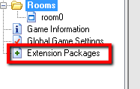
- Select "+install" in the window that appears. This opens a "Install extension packages"-window. Click "Install" and select the file you just downloaded. Click "open"
Close the "Install Extension Packages"-window.
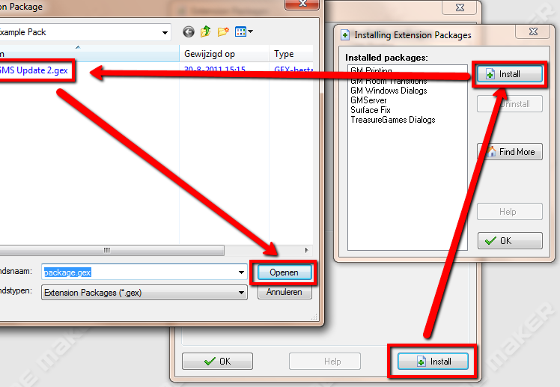
Now you have installed the extension package. If you want to add GameMaker Server package to your game, follow the following steps:
- Select "GameMaker Server" in the listbox "Available Packages" and then click the arrow right. Now, you've added GameMaker Server to your game. You can now close all the windows.
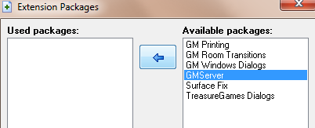

More info
More info can be found at http://gamemakerserver.tk/help/. If you have any problems or questions, feel free to PM me (Size43) or reply in the topic.
-Size43
http://gamemakerserver.tk/
gamemakerserver@hotmail.com
http://www.game-maker.nl/forums/topic,69556.0
http://gmc.yoyogames.com/index.php?showtopic=521378

