

Forensic Gait Analysis in Personal Identification: A Multidisciplinary Review of Methods, Challenges, and Future Directions
Shantanu Pathak^{1*}, Uma Kamboj²
Contact details: shantanupathak2018@gmail.com_{1*}, uma.21636@lpu.co.in₂
PhD Scholar, Department of Forensic Science, A School of Biosciences & Bioengineering Lovely Professional University, Punjab, India.

Submitted by:
Your Name: Shantanu Pathak
Course: PhD Forensic Science
Enrollment No: 12530767
Submitted to:
Name of Professor: Uma Kamboj
University Name: Lovely Professional University
Course: GEN745- Academic Writing and Presentation

Forensic Gait Analysis in Personal Identification: A Multidisciplinary Review of Methods, Challenges, and Future Directions
ABSTRACT
Forensic gait analysis, a branch of forensic podiatry, has gained recognition as a powerful tool for identifying individuals based on their unique walking patterns. This comprehensive review examines the intricate facets of forensic gait analysis, scrutinizing its scientific soundness and practical applicability in criminal identification. Gait, defined as an individual's manner of walking, is a significant biological characteristic in human identification, especially in relation to public safety and security concerns. Forensic gait analysis involves recognizing and comparing various aspects of an individual's gait to facilitate identification. Gait, observable from a distance, consists of repetitive, predominantly symmetrical movements, making it a valuable source of information even without the subject's knowledge. Forensic gait analysis primarily relies on gait features extracted from CCTV footage, which often suffers from limitations in resolution and quality. While gait features are class-level characteristics rather than unique to individuals, specific combinations can be highly distinctive, aiding in discrimination. However, concerns regarding the validity, reliability, and scientific foundation of gait analysis have been raised. This review critically evaluates the scientific foundations and practical implementation of forensic gait analysis. Efforts are underway to establish international standards, improve methodology accuracy, and reduce biases to enhance the acceptance and evidential value of gait evidence in court. Future research should focus on gait variabilities, discriminative strength, and comparative analyses between automated and observer-based methods.
Keywords: Forensic podiatry, criminal identification, public safety, validity, reliability, evidential value etc.

INTRODUCTION
Forensic gait analysis, which emerged as a subspecialty of forensic podiatry in year 2000, has progressively gained recognition as a potent tool for identifying individuals based on their distinctive patterns of ambulation. The objective of this review is to meticulously examine the intricate facets of forensic gait analysis, meticulously scrutinizing its scientific soundness and its practical applicability within the realm of criminal identification. Gait, defined as an individual's manner of walking, has long been acknowledged as a consequential biological characteristic in human identification, particularly considering mounting concerns pertaining to public safety and security. Forensic gait analysis entails the recognition and comparative analysis of diverse facets of an individual's gait, facilitating the process of identification. By virtue of its observability from a distance, gait—comprising repetitive, predominantly symmetrical movements—can be harnessed for gathering crucial information without
the cognizance or intent of the subject under scrutiny. Additionally, gait analysis presents a compelling pathway for the exploration and creation of alternative techniques for forensic identification.
This is owing to its capacity to play a role in every phase of an investigation, spanning from initial surveillance to intelligence collection. The locomotion process is a multifaceted phenomenon, necessitating the integration of sensory input and real-time modification of learned motor patterns. These modifications, engendered by nuanced variations in body segment positions and velocities, as well as environmental factors such as terrain, impose intricate adjustments upon the fundamental pattern of bipedal locomotion. Additionally, gross factors, including changes in velocity and direction, demand further adaptations to the locomotor pattern. Consequently, each step undertaken by an individual exhibits distinctive kinematic and kinetic characteristic, reflecting a myriad of compensatory responses to the subject's anatomy, physiology, pathology, and external influences.
To accurately characterize an individual's gait, it is indispensable to analyze multiple steps while considering the potential impact of influencing factors. Relying solely on a solitary step for gait characterization constitutes a fundamentally flawed strategy, as it fails to encapsulate the intricate interplay of mechanical, biological, and external factors. Forensic gait analysts play a pivotal role in meticulously sifting through the available information, collating data from a multitude of steps, and accounting for the prevalence of gait features within the wider population. At present, the field of forensic gait analysis predominantly revolves around the identification of gait attributes derived from closed-circuit television (CCTV) recordings. Unfortunately, such footage frequently suffers from constraints in resolution, lighting conditions, and frame rate, thereby undermining the quality of the discernible information. Moreover, as a two-dimensional representation of a three-dimensional activity, CCTV footage inherently fails to capture kinetic data, thus circumscribing its capacity to conclusively identify individuals.
The ascertained gait features accessible via prevailing forensic gait analysis practices typically pertain to class-level features, signifying compatibility with a proportion of the population rather than conferring uniqueness. Consequently, a profound acumen possessed by forensic gait analysts entails a deep-seated comprehension of the prevalence of the identified gait features within the wider population. This understanding is frequently nurtured through prior experiences, encompassing casework exposure, clinical practice, reference materials from textbooks, and a wealth of published case studies and research papers. Recent criticisms regarding the admissibility of gait analysis as evidence in Canadian courtrooms, as articulated by Edmond and Cunliffe, have prominently brought to the forefront concerns pertaining to the legitimacy, dependability, and scientific underpinning of forensic gait analysis.
Additionally, questions have arisen regarding the judiciary's ability to effectively evaluate the proficiency of expert witnesses and the evidential worth of their findings. Although Edmond and Cunliffe's concerns emanate from a limited number of cases, they underscore the exigency for a comprehensive appraisal of the scientific underpinnings and practical utilization of forensic gait analysis. Against this backdrop, the present review endeavors to meticulously scrutinize the scientific foundations and practical implementation of forensic gait analysis. By exhaustively surveying extant literature and conducting an inclusive survey, we aspire to address the raised concerns and shed illuminating insights into the current state of forensic gait analysis as a dependable and valid forensic identification tool. (Badiye et al., 2020; Birch et al., 2015, 2018, 2020a; Macoveciuc et al., 2019a; Seckiner et al., 2019; Van Mastrigt et al., 2018a)
GAIT RECOGNITION
According to Kelly, forensic gait analysis involves analyzing, comparing, and evaluating gait features to aid in criminal investigations. The focus is on identifying individuals based on their gait or specific gait features. However, the term "identification" can be problematic in this context. Currently, forensic gait analysis primarily relies on observational methods, where gait features are observed and documented. These features encompass various aspects of gait, including angular relationships, segmental orientations, and temporal and spatial displacements, which are observable in video footage.
While gait characteristics can provide valuable information and be highly discriminatory, it is important to note that they are not unique to an individual but rather represent class characteristics. Nevertheless, specific combinations of gait features can be highly distinctive, aiding in the discrimination of individuals in forensic investigations. (Kelly, 2020)
In the field of gait research, the conventional practice involves the collection of three-dimensional (3D) data. Nonetheless, in the context of forensic gait analysis, the emphasis is on extracting gait attributes from two-dimensional (2D) video footage, often acquired in uncontrolled environmental conditions. To facilitate a comparison between gait features derived from such 2D video footage and those acquired through the more comprehensive 3D motion analysis, a plausible approach entails the estimation of joint angles from video recordings. This estimation typically necessitates manual annotation of joint positions. This observer-based method is employed in forensic gait analysis to analyze gait patterns and extract relevant information from video recordings. (Lynnerup & Larsen, 2014)
The use of gait analysis in forensic investigations has gained attention due to surveillance cameras. This research explores factors affecting gait and addresses limitations of surveillance footage, including anatomical variations. Different techniques for gait assessment, such as biometric gait recognition and forensic gait analysis, are examined. The review identifies gaps in the literature on gait influences and proposes a "morphometric" approach for standardized procedures. These advancements provide insights for forensic investigations and intelligence-gathering. Surveillance cameras are crucial for investigations, and gait analysis discreetly analyzes footage, even with lower quality. Understanding intrinsic and extrinsic influences on gait is essential. Gait analysis integrates centuries of research and biometric applications. Advances in physical medicine, psychology, and biomechanics contribute to gait analysis in forensics. Given poor quality footage, gait analysis is necessary to identify patterns and traits. Intrinsic features and external influences impact gait. Detailed tables provide information on these influences. Biometric recognition considers physical and behavioral traits and aids forensic investigations by comparing traces to identify individuals with similar gait patterns.
Gait analysis enhances investigations across forensic applications. Automated comparison systems are crucial for generating candidate lists and establishing connections. Gait analysis from CCTV footage holds promise for investigation and intelligence gathering. Improved automated systems are needed for candidate generation and conclusive findings. (Seckiner et al., 2019)The utilization of video surveillance recordings as evidentiary material in criminal investigations has prompted the exploration of gait analysis for comparing the gait of disguised perpetrators and suspects. Through the application of functional anatomical and biomechanical expertise, the locomotion patterns exhibited by individuals, including potential wrongdoers, as recorded on surveillance videos, were subjected to rigorous analysis. Employing a structured checklist that addresses individual body segments during gait, the research team was able to provide assessments of gait patterns. Prominent parameters encompassed varus instability discerned in the knee during heel strike, along with a more pronounced lateral flexion of the spinal column on one side relative to the other. Based on these distinctive characteristics, the research team could reasonably determine whether a suspect could potentially be the perpetrator, although definitive identification of the perpetrator remains unattainable. Nonetheless, the team has been involved in several cases where the court acknowledged the value of this gait analysis as a valuable tool. (Larsen et al., 2008)
The primary objective of this study was to delve into the domain of forensic gait analysis. This encompassed a comprehensive examination and juxtaposition of gait patterns and attributes, with the ultimate goal of facilitating criminal and personal identification. Forensic gait analysis is considered a contributing factor to the identification process, although the individualization of gait has not yet been fully scientifically proven. The study focuses on the use of footprints and closed-circuit television (CCTV) footage as sources of evidence in forensic gait analysis. Footprints, whether bare prints, shoeprints, or imprints, are encountered at various crime scenes, such as burglary, robbery, sexual assaults, hit and run incidents, and homicides. This field is part of the emerging discipline of forensic podiatry, which applies podiatric knowledge and expertise to forensic investigations involving the foot and footwear. The principles and knowledge of forensic podiatry aid investigators and crime scene personnel in analyzing foot, footwear, and gait-related evidence, enabling the establishment of a suspect's physical or biological profile for identification purposes. The increasing prevalence of CCTV cameras and surveillance technology has sparked interest in the application of forensic gait analysis for personal identification. Historical cases, such as Thomas Jackson's identification based on his distinctive gait, demonstrate early examples of gait analysis in court proceedings. However, the reliability and accuracy of forensic gait analysis as a scientific method remain subjects of debate. The article explores different methods of forensic gait analysis, factors influencing
human gait, its applications in forensic contexts, and the considerations regarding its accuracy, reliability, and admissibility in legal proceedings. (Badiye et al., 2020)
The aim of this study was to establish a comprehensive and reliable database of gait features to enhance the practice of forensic gait analysis. This database is a pioneering effort, aiming to collect valuable data on prevalent gait characteristics within the population. The goal is to improve the interpretation of gait evidence in court proceedings. The development of this database aligns with the guidelines set forth by the Forensic Science Regulator's Codes of Practice and Conduct, ensuring adherence to best practices and ethical standards. Although the current size of the database may be relatively small, it still provides valuable support for gait analysts. By using the data cautiously and transparently, gait analysts can offer more objective and meaningful interpretations of gait evidence. As the database continues to expand and evolve, it holds the potential to further strengthen the field of forensic gait analysis, leading to more robust and scientifically valid findings in the courtroom. (Birch et al., 2018)
Clinical gait analysis and forensic gait analysis exhibit distinct differences in terms of data collection and conditions. Clinical gait analysis involves a planned process conducted under controlled settings, including ideal lighting and camera positioning. The subjects, typically patients, cooperate and may be partially undressed to eliminate the influence of clothing on gait assessment. They perform standardized tasks such as walking in a specified direction and pace within an open environment. Patients often present specific impairments that cause gait patterns significantly deviating from the expected range in the general population. It is important to note that a direct comparison between clinical and forensic gait analysis is not straightforward. Forensic gait analysts face additional challenges that are yet to be fully addressed and regulated. Therefore, it cannot be assumed that results obtained from clinical gait analysis can be directly applied or utilized for forensic purposes. The differences in data collection conditions and subject characteristics emphasize the need for tailored approaches in forensic gait analysis. (Mangone et al., 2023a)
ADMISSIBILITY OF GAIT EVIDENCE
The scientific foundation and practical implementation of forensic gait analysis in the Netherlands, United Kingdom, and Denmark, prompted by recent scrutiny of gait evidence admissibility in Canadian courts. A valuable forensic feature must be measurable, consistent within individuals, and differentiating between them. The comprehensive literature review unveils that forensic gait attributes can be either quantified through measurement or visually observed in surveillance video footage. However, further research is needed to ascertain accuracy, validity, and reliability. Gait exhibits variability within individuals under differing circumstances, with speed exerting a significant influence. Although clear variation exists between individuals, more research is required to determine discriminative strength. Notwithstanding its inherent constraints, forensic gait analysis has
made significant contributions to criminal proceedings in Europe. It's worth noting that the admissibility of gait evidence varies considerably across different courts. Observer-based methods prevail, with multiple analysts independently assessing gait features from perpetrator and suspect videos. Likelihood ratios derived from gait feature databases assess identity hypotheses. Partially automated gait recognition algorithms compare video clip differences to thresholds from gait recognition databases. Scientific basis of forensic gait analysis is limited. Gait feature databases allow supportive evidence with low evidential value. Recommendations include expanding knowledge on gait variabilities, discriminative strength, method accuracies, and likelihood ratios. Comparisons between automated and observer-based methods are needed. International standards for validity, reliability, proficiency tests, and gait feature data collection are warranted. (Inter)national guidelines on gait evidence admissibility and reducing cognitive and contextual bias are essential. These efforts aim to improve gait evidence acceptance and its evidential value. Ongoing research projects address these recommendations. (Van Mastrigt et al., 2018b)
The principles elucidated in this review by (Macoveciuc et al., 2019b) garnered considerable recognition within forensic science disciplines. The admissibility criteria for courtroom evidence, particularly when involving novel technologies and methods, necessitate rigorous testing methodologies devoid of unnecessary complexity. Collaboration between the legal and scientific spheres is indispensable to ensure transparency, robust evidence, and equitable trials. To effectively meet evidential criteria, forensic sciences must foster enhanced cooperation, establish meticulous quality assurance protocols, expand comprehensive training programs, and facilitate collaboration between scientific and legal communities. Gait analysis and recognition substantially benefit from the synergy between gait analysts and biometric specialists, thereby ensuring the incorporation of expertise and guidance in data collection procedures and algorithmic development. Concerns within forensic sciences primarily emanate from research practices and cognitive biases, warranting further attention. The provision of primers and codes of practice contributes to encouraging advancements in forensic gait analysis, accompanied by escalated research endeavors in gait recognition. However, courts should exercise prudence until the forensic gait analysis code of practice attains finalization and standardized methodologies gain recognition. A similar cautious approach should be applied to evidence obtained through untested methods lacking quantifiable error rates, regulatory codes, and demonstrated applicability within forensic contexts. (Macoveciuc et al., 2019b)
The utilization of precise and consistent terminology is of utmost importance in forensic gait analysis. The field draws upon a combination of language from clinical practice, podiatric biomechanics, and broader biomechanics. However, this amalgamation often leads to inconsistencies in language, definitions, and the clarity of communication. Illustrative instances encompass the interchangeable utilization of "gait" and "walking," the potential for confusion between "step" and "stride," the amalgamation of anatomical, positional, and pathological descriptors, and the insufficiency in describing pivotal movements of major body segments, such as the torso. This paper aimed to establish a shared understanding by disseminating well-established definitions of fundamental gait parameters applicable across professions and advocating for their implementation in forensic gait analysis. It provides guidance on selecting and employing appropriate terminology to describe gait within the
forensic context. The paper rigorously scrutinizes the established definitions of frequently employed terminology, pinpoints terms that hold the potential for perplexing readers, and puts forth a meticulously crafted framework of terminology to be employed exclusively within the domain of forensic gait analysis. Different gait patterns are characterized by differences in limb movement patterns. Thus, every individual has a unique gait pattern, while there are some features in a person’s gait that are common for everyone. (Birch et al., 2015)

DIFFERENT PARAMETERS UTILIZED IN FORENSIC GAIT ANALYSIS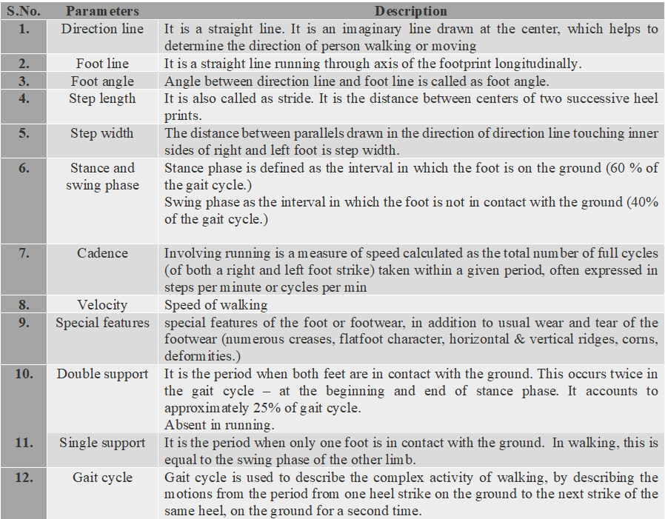
Table 1 Common parameters used in forensic gait analysis (Kirtley,2006)

APPLICATIONS OF GAIT ANALYSIS
Gait analysis is increasingly being utilized in scenarios where traditional identification methods prove to be ineffective. A prominent instance of this is the Hatton Gardens heist in the UK, where a suspect known as "Basil" deliberately concealed his face and other identifying characteristics. Nevertheless, he was ultimately convicted, partly due to the recognition of his gait. Gait analysis presents several benefits over other biometric measures. It can be conducted from a distance, even when other biometrics are obscured or the image quality is subpar. Furthermore, it does not necessitate the cooperation of the individual and can be executed in a non-invasive manner. Gait is relatively simple to observe and difficult to camouflage. As the deployment of surveillance cameras continues to rise, there has been an increasing interest among researchers in harnessing the potential of analyzing surveillance footage. Gait analysis offers unique advantages over other methods, rendering it a favorable option for analysis. One notable characteristic is its capacity to unobtrusively monitor individuals or situations from a distance, without their awareness, distinguishing it from other approaches. Additionally, specific
gait analysis features can be extracted even from recordings of lower quality. A crucial aspect of gait assessment involves identifying both internal and external factors that can influence an individual's gait. Through a precise focus on pinpointing, isolating, and comprehending these influences, researchers endeavor to distinguish and discern the precise modifications that exert the most profound influence on an individual's gait. This process is followed by the observation of normal gait patterns, enabling a better understanding of how various factors affect an individual's walking style. Gait analysis is a widely employed method in healthcare, rehabilitation, and sports science for purposes such as diagnosis, treatment planning, and intervention evaluation. It also holds significant relevance in forensic investigations, specifically in the analysis, comparison, and evaluation of gait features to aid criminal investigations. (Birch et al., 2020b) (Makihara et al., 2020; Mangone et al., 2023b) (Mangone et al., 2023a)
The Forensic Gait Analysis Working Group under The Chartered Society of Forensic Sciences is actively establishing a standardized framework for forensic gait analysis, specifically tailored for the scrutiny of the Forensic Science Regulator in the United Kingdom. This framework provides a clear and comprehensive overview of forensic gait analysis, encompassing its inherent limitations and challenges in practical application. The forthcoming publication of these standards is imminent. Meanwhile, in the United Kingdom, Professor Nixon and his research group are diligently engaged in the development of metric-based automated gait analysis methodologies. Simultaneously, they are conducting an extensive examination of the admissibility of biometric-based evidence in court proceedings. Notably, their collaborative efforts extend internationally to include cooperation with the Australian police. Within the UK context, Professor Birch's group is presently conducting a comprehensive evaluation of the efficiency of their observer-based gait analysis tool. This assessment specifically focuses on the tool's validity and reproducibility. Across the Netherlands, the Forensic Institute (NFI) and the research team led by Professors Otten are rigorously investigating the reliability, validity, and training efficacy of observers involved in gait analysis. Their efforts are dedicated to enhancing the overall quality and credibility of forensic gait analysis processes. They are also examining the detectability of specific gait features from different camera views using the avatar animations of gait in the Gait Observer Measurement Instrument (GOMI). (Van Mastrigt et al., 2018c) (Macoveciuc et al., 2019c). \
RECENT ADVANCEMENTS
The process of scrutinizing and assessing the distinctive gait patterns and attributes exhibited by an individual, particularly a suspect, and subsequently comparing these characteristics with the evidence collected at a crime scene for the purpose of criminal or personal identification is formally referred to as forensic gait analysis or forensic gait comparison. No completely automated gait recognition technologies have yet been employed in a criminal case, to our knowledge. In practice, however, a partially automated gait detection system based on manually specified joint locations has been utilized to calculate a distance score. A partially automated silhouette-based gait detection tool has been created for use in practice, although its application in casework has yet to be
documented. Presently, significant advancements are underway within the realm of forensic gait analysis. These advancements are driven by the prevalent challenges and constraints associated with its admissibility as evidence in court proceedings. In the United Kingdom. Recently, a “primer for courts” was written by scientists & judiciary because a need for standard was acknowledged, it will help the judges in handling evidences in court easily.
FUTURE PERSPECTIVE OF FORENSIC GAIT ANALYSIS
Advancements in technology and research are revolutionizing forensic gait analysis, with Artificial Intelligence (AI) playing a crucial role. Machine learning allows for precise recognition of gait patterns even from low-quality footage, expediting suspect identification. The continuous learning capability of AI ensures accuracy improvements over time, bolstering the reliability of forensic gait analysis for law enforcement and the judiciary(Kaur & Moza, 2023; Verma et al., 2023). Future research will concentrate on refining biometric recognition in gait analysis, potentially revealing additional traits like age, gender, weight, and medical conditions, thus enhancing investigative profiles, and reducing false identifications. State-of-the-art real-time gait analysis may emerge, utilizing wearable devices and AI algorithms for continuous monitoring. This technology aids law enforcement in swift suspect identification and serves as an early-warning system for medical conditions. The future of forensic gait analysis holds great promise, with AI algorithms, enhanced biometrics, and real-time analysis driving significant advancements in the field. However, addressing ethical challenges is crucial to uphold public trust and protect privacy rights.
CONCLUSION
Forensic gait analysis has emerged as a valuable tool within the realm of criminal identification, offering unique advantages over other biometric measures. By analyzing an individual's distinctive patterns of ambulation, gait analysis can aid in identifying individuals based on their gait or specific gait features. However, it is important to note that gait characteristics represent class-level features rather than conferring uniqueness to an individual. Nevertheless, specific combinations of gait features can be highly distinctive and aid in the discrimination of individuals in forensic investigation. Forensic gait analysis predominantly hinges on the examination of gait attributes extracted from closed-circuit television (CCTV) recordings. However, such footage often suffers from limitations in resolution, lighting conditions, and frame rate, which can undermine the quality of discernible information. Additionally, CCTV footage provides a two-dimensional representation of a three-dimensional activity, limiting its capacity to conclusively identify individuals. To accurately characterize an individual's gait, it is crucial to analyze multiple steps while considering the potential impact of influencing factors. Relying solely on a solitary step for gait characterization is flawed, as it fails to capture the intricate interplay of mechanical, biological, and external factors. Forensic gait analysts play a pivotal role in meticulously sifting through available information, collating data from multiple steps, and considering the prevalence of gait features within the wider population. Recent critiques of gait analysis as admissible evidence within legal proceedings have highlighted concerns surrounding its validity, reliability, and scientific foundation. While forensic gait analysis has made valuable contributions to criminal proceedings in diverse jurisdictions, there is a pressing need for more rigorous examination of its scientific foundations and practical application methods. Efforts are underway to establish international standards, improve methodology accuracy, and reduce cognitive and contextual biases to enhance the acceptance and evidential value of gait evidence in court. Advancements in the field include the development of comprehensive databases of gait features to enhance interpretation and provide more objective analyses. Collaboration between gait analysts and biometric specialists is crucial for incorporating expertise in data collection procedures and algorithmic development. Additionally, tailored approaches and standardized methodologies are necessary for forensic gait analysis due to the differences in data collection conditions and subject characteristics between clinical and forensic settings. Forensic gait analysis offers significant potential as a forensic identification tool, but its scientific foundations and practical implementation require ongoing research, standardization, and collaboration between scientific and legal communities. With further advancements, improvements in methodology, and the establishment of international standards, forensic gait analysis can become a more reliable and valid method for aiding criminal investigations and courtroom proceedings. (Seckiner et al., 2019)(Lynnerup & Larsen, 2014; Makihara et al., 2020; Mangone et al., 2023b) (Badiye et al., 2020; Larsen et al., 2008; Van Mastrigt et al., 2018b)
Acknowledgement:
I would like to extend my sincere gratitude to the individuals and institutions that have supported and contributed to the completion of this review article, " Forensic Gait Analysis in Personal Identification: A Multidisciplinary Review of Methods, Challenges, and Future Directions" Without their invaluable assistance, this work would not have been possible. I would like to sincerely extend my gratitude to Dr. Uma Kamboj, at Lovely professional University, is no conflict of interest in this work, ensuring academic integrity. Self-funding-maintained independence for an unbiased exploration of forensic gait analysis. Our heartfelt thanks to Dr. Umaj Kamboj.

REFERENCES
- Badiye, A., Kathane, P., & Krishan, K. (2020). Forensic gait analysis.
- Birch, I., Gwinnett, C., & Walker, J. (2018). Aiding the interpretation of forensic gait analysis: Development of a features of gait database. Science and Justice, 58(1), 78–82.
https://doi.org/10.1016/j.scijus.2016.06.009 (PubMed)
- Birch, I., Nirenberg, M., Vernon, W., & Birch, M. (2020a). Forensic gait analysis: Principles and practice.
- Birch, I., Nirenberg, M., Vernon, W., & Birch, M. (2020b). Forensic gait analysis: Principles and practice.
- Birch, I., Vernon, W., Walker, J., & Young, M. (2015). Terminology and forensic gait analysis. Science & Justice, 55(4), 279–284.
https://doi.org/10.1016/j.scijus.2015.03.002 (PubMed)
- Kaur, G., & Moza, B. (2023). Exploring railway forensics: Top approaches and future directions. Technology, 14(06), 12561–12567.
- Kelly, H. D. (2020). Forensic gait analysis.
- Kirtley, C. (2006). Clinical gait analysis: Theory and practice. Elsevier Health Sciences.
- Larsen, P. K., Simonsen, E. B., & Lynnerup, N. (2008). Gait analysis in forensic medicine. Journal of Forensic Sciences, 53(5), 1149–1153. DOI: 10.1111/j.1556-4029.2008.00807.x
- Lynnerup, N., & Larsen, P. K. (2014). Gait as evidence. IET Biometrics, 3(2), 47–54. DOI: 10.1049/iet-bmt.2013.0042
- Macoveciuc, I., Rando, C. J., & Borrion, H. (2019a). Forensic gait analysis and recognition: Standards of evidence admissibility. Journal of Forensic Sciences, 64(5), 1294–1303. DOI: 10.1111/1556-4029.14036
- Macoveciuc, I., Rando, C. J., & Borrion, H. (2019b). Same as above.
https://doi.org/10.1111/1556-4029.14036
- Macoveciuc, I., Rando, C. J., & Borrion, H. (2019c). Same as above.
https://doi.org/10.1111/1556-4029.14036
- Makihara, Y., Nixon, M. S., & Yagi, Y. (2020). Gait recognition: Databases, representations, and applications. In Computer Vision: A Reference Guide. DOI: 10.1007/978-0-387-31439-6_109
- Mangone, M., et al. (2023a). Gait analysis advancements: Rehabilitation value and new perspectives from forensic application. European Review for Medical and Pharmacological Sciences, 27(1). DOI: 10.26355/eurrev_202301_30740
- Mangone, M., et al. (2023b). Same as above.
https://doi.org/10.26355/eurrev_202301_30740
- Seckiner, D., Mallett, X., Maynard, P., Meuwly, D., & Roux, C. (2019). Forensic gait analysis—Morphometric assessment from surveillance footage. Forensic Science International, 296, 57–66.
https://doi.org/10.1016/j.forsciint.2019.01.007 (PubMed)
- Van Mastrigt, N. M., et al. (2018a). Critical review of the use and scientific basis of forensic gait analysis. Forensic Sciences Research, 3(3), 183–193. DOI: 10.1080/20961790.2018.1487462
- Van Mastrigt, N. M., et al. (2018b). Same as above.
https://doi.org/10.1080/20961790.2018.1487462
- Van Mastrigt, N. M., et al. (2018c). Same as above.
https://doi.org/10.1080/20961790.2018.1487462
- Verma, P., Mukherjee, D., & Moza, B. (2023). Decentralized money: A comprehensive review on cryptocurrencies. DOI: Not available
- https://grabstract.io/analysis/graphicalabstract

`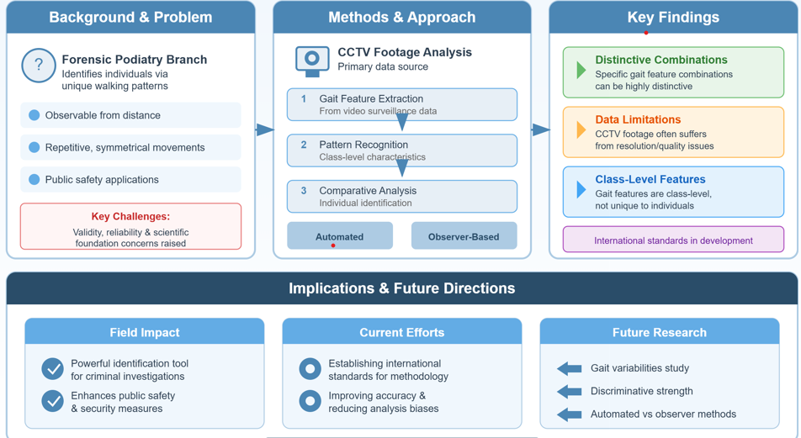
Figure 1 Graphical Abstract of Forensic Gait Analysis in Personal Identification: A Multidisciplinary Review of Methods, Challenges, And Future Directions

