BITLANCE GROUND OS
Development-Level Architecture & Implementation Plan
Prepared by
Uttamraj Singh
AI Developer — Bitlance Tech Hub
Presented to
Anurag Dhole — CEO, Bitlance Tech Hub
Rahul Saini — CTO, Bitlance Tech Hub
09 September 2026

01 — Engineering Executive Summary
This document translates the Ground OS product vision into a development-level architecture. The recommended first implementation is a modular monolith supported by asynchronous workers, Redis-based queues, PostgreSQL, object storage, real-time communication and provider adapters for WhatsApp, Voice AI, maps, transcription and creative generation.
The architecture deliberately avoids premature microservices. Business modules remain independently structured inside one deployable backend while expensive or asynchronous workloads run through workers. Components can later be extracted when real traffic justifies the operational complexity.

02 — Architecture Principles
- Modular first: clear domain boundaries without premature distributed systems.
- Event-driven automation: important business actions emit durable events.
- Asynchronous AI: recordings and calls are processed by workers, never inside synchronous user requests.
- Provider abstraction: WhatsApp, Voice AI, maps, AI and creative vendors sit behind adapters.
- Customer 360: one canonical customer identity connects every interaction.
- Multi-tenant by design: every business record is scoped to an organization.
- Security at the API layer: frontend visibility is never treated as authorization.
- Observable by default: logs, metrics, traces and audit events are part of the foundation.

03 — High-Level Architecture
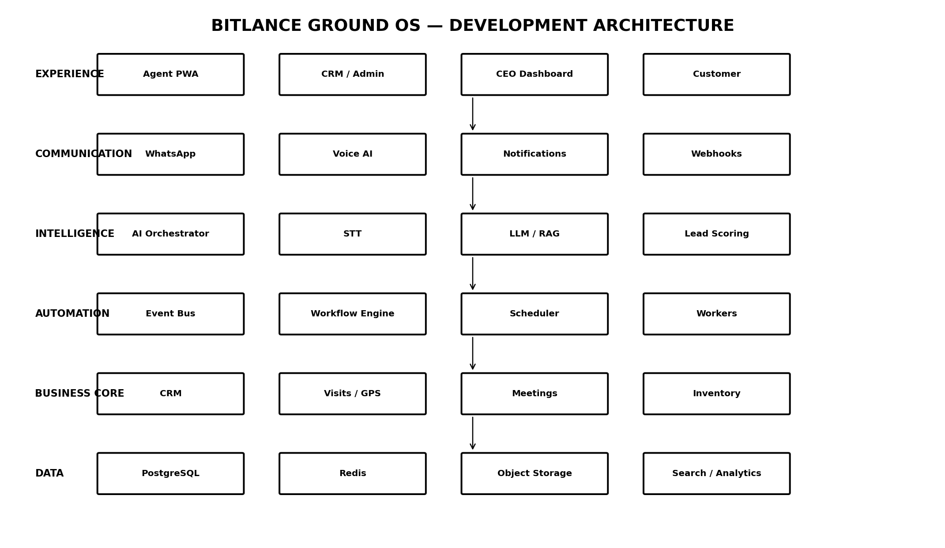
Six layers form the architecture: Experience, Communication, Intelligence, Automation, Business Core and Data.

04 — Recommended Application Strategy

Phase-1 deployment model
Frontend applications communicate with a single API/BFF. The backend contains domain modules for identity, agents, customers, leads, visits, meetings, WhatsApp, Voice AI, AI intelligence, workflows, creatives and analytics.
- API/BFF — request validation, authentication, authorization and orchestration.
- Domain modules — business logic and persistence boundaries.
- Worker process — asynchronous AI, media, notifications and workflow jobs.
- Realtime gateway — WebSockets/SSE for maps, processing status and notifications.
- Integration adapters — provider-specific implementations.

05 — Frontend Architecture
- Agent PWA: mobile-first field experience with GPS, visits, meetings, recording and offline-safe state.
- Management CRM: command center, agents, customers, meetings, AI intelligence and analytics.
- Customer-facing chatbot surfaces: Lifestyle Homes conversational experience.
- Shared design system: reusable components, states, forms, tables, timelines and command-center visual language.
The agent PWA should tolerate weak network conditions: cache assigned visits, queue safe local actions and synchronize when connectivity returns.

06 — Backend Domain Modules
- Identity & RBAC — users, organizations, roles, permissions and sessions.
- Agent Operations — agents, assignments, routes, visit lifecycle and activity.
- Customer/Lead — canonical customer profile, lead lifecycle and scoring.
- Meeting Intelligence — meeting session, recording, transcript and AI report.
- Conversation — channels, threads, messages and customer state.
- WhatsApp — inbound/outbound messaging and webhook processing.
- Voice — call lifecycle, provider adapter and call intelligence.
- Requirement Engine — normalized customer requirements and changes over time.
- Inventory — project/property/shop inventory and matching.
- Creative — creative briefs, generation, approval and delivery.
- Workflow — triggers, conditions, delays, actions and workflow runs.
- Analytics — operational events, aggregates and executive metrics.

07 — Core Data Architecture

PostgreSQL
Primary source of truth for transactional business data.
- organizations, users, roles, permissions
- agents, customers, leads
- projects, inventory
- visits, visit_events, locations
- meetings, recordings, transcripts, insights
- requirements, scores, objections, competitor_mentions
- conversations, messages
- voice_calls, voice_events
- creatives, creative_requests
- followups, workflows, workflow_runs
- notifications, audit_logs

Redis
- Caching
- rate limits
- locks
- live agent state
- short-lived workflow state
- queue backend

Object Storage
- meeting recordings
- call recordings
- transcripts/exports
- creative assets
- documents
- generated reports

Search / Analytics
Introduce a dedicated search engine when transcript/customer search or analytical volume justifies it. Keep transactional truth in PostgreSQL.

08 — Customer 360 Model
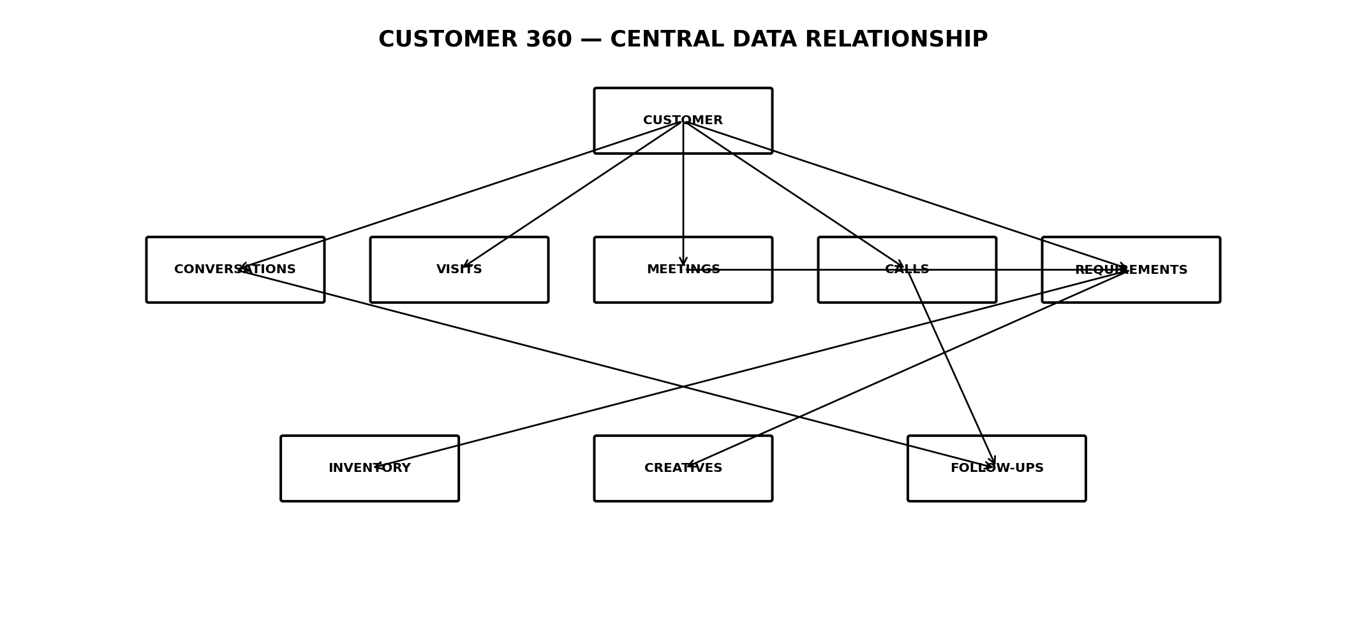
Customer should be the canonical identity around which conversations, visits, meetings, calls, requirements, inventory recommendations, creatives and follow-ups are connected.

09 — GPS & Field Operations
Location tracking should be event-oriented rather than a raw stream written continuously to the main database.
- Agent device requests location permission.
- Location service receives periodic coordinates.
- Relevant proximity and visit events are emitted.
- Visit service records arrival, verification, meeting and departure states.
- Live state can be held in Redis and streamed to authorized dashboards.
- Historical business events are persisted to PostgreSQL.
Production GPS frequency should be configurable to balance accuracy, battery consumption, privacy and operational requirements.

10 — Meeting Intelligence Pipeline
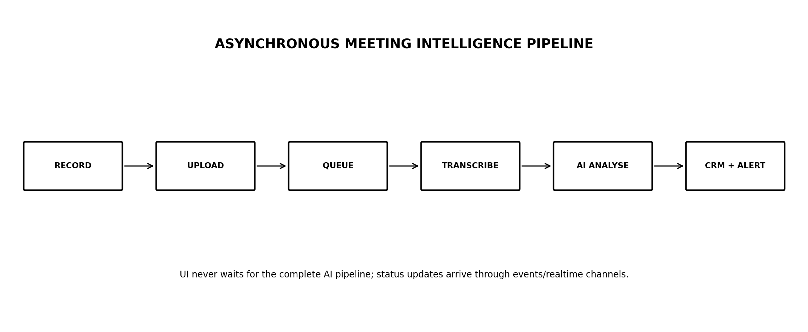
- Meeting starts and creates a session.
- Agent records locally or through the supported recording layer.
- Meeting ends and recording uploads to object storage.
- Backend emits RECORDING_UPLOADED.
- Worker sends audio to speech-to-text.
- Transcript is stored and analysed.
- AI extracts requirements, intent, objections, sentiment and recommended actions.
- Lead score and customer profile are updated.
- AI_REPORT_READY triggers dashboard updates and authorized notifications.

11 — AI Orchestrator
Create a single internal AI orchestration layer so AI logic is not scattered across CRM modules.
- transcribe()
- summarize()
- extractRequirements()
- classifyIntent()
- detectObjections()
- detectCompetitors()
- calculateLeadScore()
- generateFollowup()
- generateCreativeBrief()
- analyseVoiceCall()
AI outputs should use validated structured schemas wherever possible. Natural-language output should not be the only source of truth for automation.

12 — AI / RAG Knowledge Layer
Lifestyle Homes and future developer chatbots should use controlled knowledge retrieval.
- Project documents, FAQs, inventory and approved pricing enter the knowledge pipeline.
- Documents are processed, chunked and indexed.
- Relevant context is retrieved for each customer question.
- LLM generates an answer grounded in retrieved information.
- Sensitive or uncertain questions can trigger escalation.
Inventory and price information should be treated as structured source data where possible rather than relying solely on document retrieval.

13 — WhatsApp Architecture
WhatsApp webhooks should validate, persist and enqueue quickly. Long AI operations should never block webhook responses.
Webhook → Validate → Persist Message → Emit Event → Queue → AI/Workflow Processing → Response → WhatsApp API
- Conversation state stored centrally.
- Message idempotency prevents duplicate processing.
- Outbound messages tracked for status and delivery.
- Provider-specific API logic isolated inside the WhatsApp adapter.

14 — Voice AI Architecture
Voice AI is an automation consumer of conversation context.
CUSTOMER_INACTIVE → Workflow → Eligibility Check → Voice Provider Adapter → Call → Webhooks → Transcript → AI Analysis → CRM Update
- Configurable inactivity threshold.
- Calling-hour policy.
- Opt-out handling.
- Cooldown between attempts.
- Maximum call attempts.
- Lead/intent eligibility.
- Human-agent activity check.
The five-minute threshold is a demo workflow parameter, not a universal product rule.

15 — Event-Driven Architecture
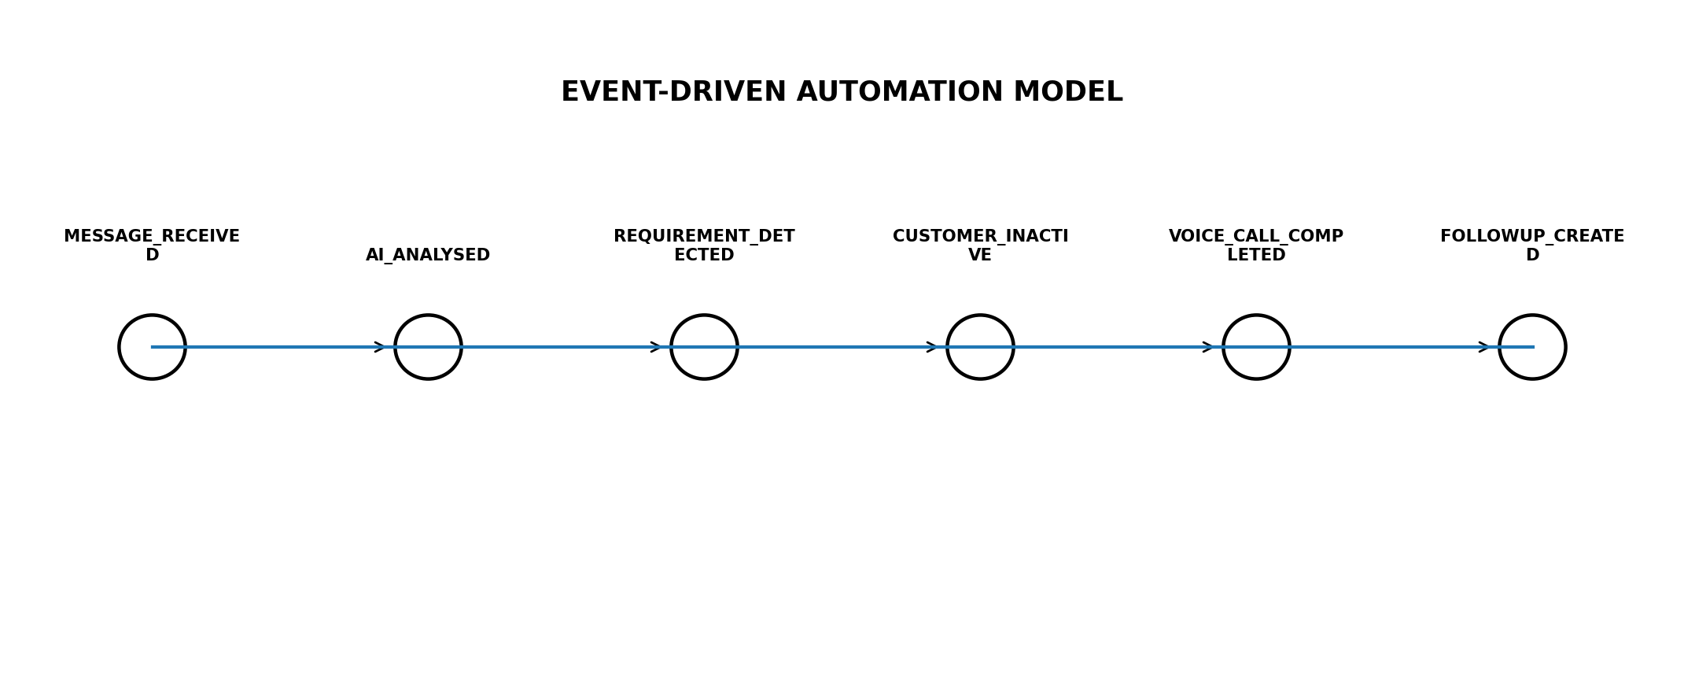
Recommended core events include:
- AGENT_ASSIGNED
- AGENT_ARRIVED
- LOCATION_VERIFIED
- MEETING_STARTED
- MEETING_ENDED
- RECORDING_UPLOADED
- TRANSCRIPT_READY
- AI_REPORT_READY
- REQUIREMENT_DETECTED
- LEAD_SCORE_UPDATED
- WHATSAPP_MESSAGE_RECEIVED
- CUSTOMER_INACTIVE
- VOICE_CALL_TRIGGERED
- VOICE_CALL_COMPLETED
- CREATIVE_REQUESTED
- CREATIVE_GENERATED
- FOLLOWUP_CREATED
Events should carry an event id, organization id, entity id, timestamp, producer and versioned payload.

16 — Queue & Worker Design
Initial recommendation: Redis + BullMQ or an equivalent reliable job system.
- ai-transcription
- ai-analysis
- whatsapp-outbound
- voice-calls
- creative-generation
- notifications
- workflow-jobs
- analytics
Jobs should be idempotent, retryable and observable. Poison/failing jobs should move to a dead-letter or failure queue for investigation.

17 — Workflow Engine
Workflow nodes should include Trigger, Condition, Delay, AI, Message, Voice, CRM Update, Creative, Human Approval, Webhook and Analytics.
A workflow run should persist its current state so restarts do not lose the customer journey.

Example
WhatsApp Message → Intent → Requirement → High Intent? → Notify CEO → Customer Inactive → Eligibility → Voice AI → Call Analysis → Creative → Follow-up

18 — API Design
Versioned API surface:
- /api/v1/auth
- /api/v1/users
- /api/v1/agents
- /api/v1/customers
- /api/v1/leads
- /api/v1/visits
- /api/v1/meetings
- /api/v1/requirements
- /api/v1/conversations
- /api/v1/whatsapp
- /api/v1/voice
- /api/v1/ai
- /api/v1/creatives
- /api/v1/workflows
- /api/v1/analytics
- /api/v1/inventory
Webhooks: /webhooks/whatsapp, /webhooks/voice and provider-specific external events.

19 — Repository Structure
bitlance-ground-os/
├── apps/
│ ├── web/
│ ├── agent-pwa/
│ └── admin/
├── services/
│ ├── api/
│ ├── worker/
│ ├── ai/
│ ├── workflow/
│ └── realtime/
├── packages/
│ ├── database/
│ ├── auth/
│ ├── events/
│ ├── types/
│ ├── ui/
│ └── integrations/
├── infrastructure/
└── docs/

20 — Integration Adapter Pattern
Every external provider should implement an internal interface.
- WhatsAppProvider
- VoiceProvider
- SpeechToTextProvider
- LLMProvider
- MapsProvider
- CreativeProvider
- StorageProvider
This keeps business logic independent from vendor-specific request formats, authentication and webhook semantics.

21 — Security & Multi-Tenancy
- organization_id on tenant-scoped records.
- Server-side authorization on every protected operation.
- Role-based access control with least privilege.
- Signed webhook verification.
- Secrets stored outside source code.
- Encrypted transport and secure object storage.
- Audit logs for sensitive operations.
- Controlled recording access.
- Configurable retention and deletion policies.
- Consent/opt-out and applicable communications requirements.

22 — Observability
- Structured application logs.
- Correlation IDs across API, events and workers.
- Metrics for API latency, queue depth and AI processing time.
- Webhook success/failure metrics.
- WhatsApp delivery metrics.
- Voice call outcomes.
- AI pipeline failures.
- Distributed tracing for critical customer workflows.
- Alerting for sustained operational failures.

23 — Deployment Architecture
A practical initial environment can use containerized services with separate web/API/worker processes.
- Reverse proxy / load balancer
- Frontend deployment
- API application
- Worker application
- Realtime gateway
- PostgreSQL
- Redis
- Object storage
- Monitoring/logging
- CI/CD pipeline
The first production deployment should favor managed database, managed object storage and managed infrastructure where practical, reducing operational burden on a small engineering team.

24 — Testing Strategy
- Unit tests for domain rules and scoring logic.
- Integration tests for database repositories and queues.
- Contract tests for provider adapters.
- Webhook idempotency tests.
- Workflow state/retry tests.
- AI schema validation tests.
- End-to-end tests for the demo journey.
- Permission and tenant-isolation tests.
- Load tests for message bursts and concurrent meetings.

25 — Development Roadmap

PHASE 0 — FOUNDATION
Repository, design system, auth, organizations, RBAC, database, CI/CD, logging.

PHASE 1 — FIELD
Agent PWA, leads, customers, visits, GPS, map, meeting state and recording.

PHASE 2 — AI
Transcription, AI summary, requirement extraction, objections, scoring and meeting quality.

PHASE 3 — WHATSAPP
Webhooks, conversation service, Lifestyle Homes chatbot and CRM synchronization.

PHASE 4 — AUTOMATION
Event bus, workflow engine, inactivity detection, follow-ups and executive notifications.

PHASE 5 — VOICE
Provider adapter, contextual calling, call analysis and CRM updates.

PHASE 6 — CREATIVE
Creative briefs, generation, approval and delivery.

PHASE 7 — INTELLIGENCE
Customer 360, AI search, territory intelligence, competitor intelligence and coaching.

26 — Demo-to-Production Strategy
The first demo should use the same interfaces as production while allowing mock providers.
- Mock GPS provider → real GPS implementation.
- Mock meeting processor → real transcription/AI workers.
- Mock WhatsApp provider → real Business API adapter.
- Mock Voice provider → real Voice AI adapter.
- Mock creative generator → real Bitlance Creative Engine.
The key is to mock at the adapter boundary, not inside business logic.

27 — Engineering Risks & Mitigations
Risk | Impact | Mitigation
AI hallucination | Wrong customer/property information | RAG + structured source data + confidence/escalation
Webhook duplication | Duplicate messages/actions | Idempotency keys + event deduplication
Voice over-triggering | Customer experience/compliance risk | Eligibility, cooldown, opt-out and calling-hour rules
Large recordings | Storage/cost growth | Object storage + retention policy + lifecycle rules
Weak network | Lost field activity | Offline-safe agent PWA + sync queue
Premature microservices | Slow development | Modular monolith first
Tenant leakage | Critical security issue | organization-scoped authorization + automated tests

28 — Engineering Definition of Done
- Every feature has API, authorization and audit behaviour defined.
- Background work is queued rather than blocking user requests.
- External integrations are adapter-based.
- AI outputs are schema-validated before automation.
- Important state changes emit events.
- Critical workflows are observable.
- Tenant isolation is tested.
- Failure/retry paths are implemented.
- Demo flow works end-to-end with mock providers.
- Production adapters can replace mocks without redesigning the domain.

29 — Final Architecture Decision
The recommended architecture for Bitlance Ground OS is a modular monolith + asynchronous workers + PostgreSQL + Redis + object storage + real-time gateway + event-driven workflow layer + provider adapters.
This approach gives Bitlance the fastest route to a polished working demo while preserving a credible path toward production scale. The system should only split modules into independent microservices when traffic, team ownership or operational requirements create a measurable reason to do so.

30 — Engineering North Star
BUILD THE PIPELINE, NOT THE FEATURE LIST.
A WhatsApp message should be able to become an event. A visit should become a verified activity. A meeting should become structured intelligence. Intelligence should become a recommendation. A recommendation should become an automated or human-approved action. Every action should return to the same Customer 360 timeline.
BITLANCE GROUND OS
Observe → Understand → Recommend → Automate → Convert

