BITLANCE TECH HUB
GROUND OS
AI-POWERED FIELD SALES & DEVELOPER INTELLIGENCE PLATFORM
PRODUCT VISION • UI/UX BLUEPRINT • DEMO SPECIFICATION
Prepared by
Uttamraj Singh
AI Developer — Bitlance Tech Hub
Presented to
Anurag Dhole
CEO — Bitlance Tech Hub
Rahul Saini
CTO — Bitlance Tech Hub
09 September 2026

Executive Summary
Bitlance Ground OS is proposed as a unified operating layer for field sales, customer conversations and AI-driven follow-up. It connects ground agents, GPS-based visit intelligence, meeting capture, AI transcription and analysis, lead scoring, requirement extraction, WhatsApp automation, Voice AI, creative generation, inventory matching and executive reporting.
The central idea is to convert every real-world interaction into structured intelligence and then convert that intelligence into an action. The system should not feel like a conventional CRM; it should feel like a live command center for the developer's sales operation.

Product Thesis
Every conversation should become data. Every useful data point should become an action. Every action should move the opportunity toward conversion.

Core Loop
DISCOVER → VISIT → MEET → RECORD → UNDERSTAND → ACT → FOLLOW UP → CONVERT

01 — Product Vision
The platform should bridge the gap between what happens on the ground and what management sees in the boardroom. An agent visits a shop owner, the system verifies the visit, captures the meeting, AI understands the conversation, the requirement engine structures the demand, management receives a concise intelligence summary, WhatsApp continues the customer journey, Voice AI can intervene after an appropriate inactivity window, and the creative engine produces the material required for follow-up.

Positioning
BITLANCE GROUND OS — Where every ground interaction becomes business intelligence.

02 — Experience Principles
- Command-center, not spreadsheet: prioritize live activity, timelines and decisions over dense tables.
- One customer, one timeline: WhatsApp, visits, meetings, calls, AI insights, creatives and follow-ups should converge into one history.
- AI should recommend action, not merely summarize data.
- Automation should be context-aware and consent-aware, never a blind trigger machine.
- Every important event should be traceable through an audit-friendly activity stream.
- Demo-first architecture: simulate external services initially, then replace adapters with production integrations.

03 — Information Architecture
BITLANCE // GROUND OS
- COMMAND — Overview, Live Operations, AI Intelligence
- FIELD — Agents, Live Locations, Visits, Meetings, Routes
- CUSTOMERS — Leads, Shop Owners, Developers, Conversations, Follow-ups
- AUTOMATION — WhatsApp, Voice AI, Campaigns, Workflow Builder
- INTELLIGENCE — Meeting Intelligence, Lead Scoring, Requirement Engine, Opportunity Radar
- CREATIVE — Creative Requests, AI Graphics, Campaign Assets, Content Library
- ANALYTICS — Sales Analytics, Agent Performance, Conversion Funnel, Territory Intelligence
- ADMIN — Team, Roles, Permissions, Integrations, Settings

04 — Command Center UI

Hero Screen: What is happening right now?
- Live agent map as the dominant visual surface.
- Active visits and meetings represented as dynamic states.
- Priority AI feed for high-intent leads, missed follow-ups and important market signals.
- Executive metrics: Active Agents, Live Visits, Meetings Today, High-Intent Leads, AI Follow-ups, Pipeline Value.
- Universal AI command bar: Ask Bitlance.

Visual Direction
Premium dark command-center aesthetic with restrained glass panels, high-contrast typography, geographic visualization, event pulses, contextual drawers and micro-animations. Avoid generic admin templates and excessive card grids.

05 — Agent Command

Agent Profile
- Current location and assignment
- Visit completion and route status
- Meeting quality score
- Requirement capture rate
- Follow-up discipline
- Conversion performance
- AI coaching insights

Example Insight
AI: This agent converts significantly better when budget and purchase timeline are qualified within the first five minutes.

06 — Smart Visit Lifecycle
ASSIGNED → EN ROUTE → ARRIVED → LOCATION VERIFIED → MEETING STARTED → MEETING ENDED → AI PROCESSING → REPORT READY → FOLLOW-UP
- Destination and shop-owner profile are loaded before arrival.
- GPS proximity can mark arrival; final policy should define acceptable accuracy and privacy handling.
- Start Meeting creates a visit/meeting session.
- Meeting end closes the session and sends the recording through the AI processing pipeline.
- Visit duration, status and location events become part of the customer and agent timeline.

07 — Meeting Workspace
- Customer name, shop, phone and project context
- Meeting timer
- Recording state
- GPS verification state
- Quick structured notes
- Voice-to-text notes
- Budget, property preference, business type, objections and follow-up fields
- End Meeting action

AI Processing Pipeline
Recording → Secure Storage → Transcription → Speaker Segmentation → Requirement Extraction → Sentiment/Intent → Objection Detection → Lead Score → Action Recommendation → Management Notification

08 — AI Meeting Intelligence

Meeting Report
- Executive summary
- Customer intent
- Requirement
- Budget
- Location preference
- Urgency
- Decision-maker status
- Objections
- Competitor mentions
- Recommended next action
- Recommended follow-up window

Meeting Quality Score
Score meetings on requirement discovery, customer engagement, objection handling, product knowledge, closing attempt and follow-up clarity.

09 — Requirement Engine
The requirement engine transforms unstructured conversation into a normalized customer requirement. It should continuously update as new messages, meetings and calls add evidence.
- Property type
- Configuration
- Budget
- Location
- Purpose: self-use / investment / business
- Timeline
- Amenities
- Parking
- Payment preference
- Objections
- Competitors
- Preferred communication channel

Inventory Matching
Requirement → Inventory Search → Match Score → Recommended Properties → Agent/Customer Presentation

10 — Dynamic Lead Intelligence
- Lead score from 0–100
- Intent level
- Purchase probability
- Response behaviour
- Budget fit
- Requirement completeness
- Recent engagement
- Follow-up risk
- Conversion trajectory
The score should be dynamic and explainable. Every score change should have a reason visible to authorized users.

11 — WhatsApp Command Center
The existing Bitlance WhatsApp automation and Lifestyle Homes chatbot should become a first-class surface inside Ground OS.
- Conversation list
- Live WhatsApp thread
- AI customer profile
- Lead score
- Detected requirement
- Recommended reply
- Inventory suggestions
- Creative suggestions
- Follow-up action
- Voice AI status

Lifestyle Homes Demo
Lifestyle Homes should serve as the showcase tenant/bot for the demonstration. The chatbot can answer project questions, qualify customers, collect requirements, share inventory, schedule site visits and escalate to human teams.

12 — Voice AI Continuation Engine
Voice AI should operate as an extension of the WhatsApp journey rather than as an independent caller.

Five-Minute Inactivity Workflow
Customer message → AI response → conversation monitoring → 5-minute inactivity → eligibility checks → Voice AI trigger → context injection → call → call analysis → CRM update → next action

Eligibility Guardrails
- Calling-hours policy
- Customer opt-out status
- Recent-call cooldown
- Lead eligibility
- Conversation state
- Existing human-agent activity
- Provider and regional compliance requirements
The five-minute interval is a demo configuration. Production timing should be configurable per workflow and lead segment.

13 — Voice AI Call Intelligence
- Call duration
- Intent
- Sentiment
- Requirement changes
- Objections
- Outcome
- Next action
- Follow-up date
- Transcript and summary
The voice agent should receive the relevant conversation context before calling so that it continues the customer's existing journey naturally.

14 — Creative Automation
AI Requirement → Creative Brief → Template/Brand Rules → Generate Asset → Approval → WhatsApp/Channel Delivery
- Property posters
- WhatsApp creatives
- Instagram assets
- Price cards
- Project comparison cards
- Follow-up creatives
- Festival creatives
- Brochures and campaign variants

Creative Intelligence
The creative engine should understand the customer's requirement before generating an asset. The system should not merely generate a generic property poster; it should generate the asset most relevant to the detected sales context.

15 — Automation Workflow Builder
Introduce a visual node-based workflow builder for non-developers.
Example: WhatsApp Message → Intent Detection → Requirement Extraction → Lead Score → Wait 5 Minutes → Eligibility Check → Voice AI → Call Analysis → CRM Update → CEO Notification → Follow-up
- Trigger nodes
- AI classification nodes
- Delay/wait nodes
- Condition nodes
- Communication nodes
- CRM update nodes
- Creative generation nodes
- Human approval nodes
- Analytics/event nodes

16 — CEO & Developer Intelligence
Management should receive decisions, not raw activity.
- High-intent lead alerts
- AI meeting summaries
- Missed follow-up alerts
- Demand trends
- Competitor mentions
- Agent performance anomalies
- Pipeline movement
- Daily intelligence brief

WhatsApp Executive Summary
New Ground Agent Meeting — Agent, customer, verified location, duration, requirement, budget, objections, lead score and recommended action. Include a deep-link into the authorized CRM report.

17 — AI Search / Ask Bitlance
A global command bar should allow natural-language questions such as:
- Which agents had the strongest meetings today?
- Show high-intent customers interested in 3 BHK under ₹1Cr.
- Which leads have pricing objections?
- Which follow-ups are overdue?
- What are customers asking for most this week?
- Generate today's field intelligence report.
The AI layer should respect permissions and return only information the current role is authorized to access.

18 — Territory & Market Intelligence
- Demand heatmap by location
- Property configuration demand
- Commercial vs residential demand
- Budget distribution
- High-intent clusters
- Visit density
- Conversion by territory
- Emerging demand patterns
Aggregated ground data can help developers decide where to focus inventory, marketing and agent coverage.

19 — Competitor Intelligence
AI can detect competitor names, price comparisons, payment-plan comparisons and recurring objections from authorized meeting and conversation data.
- Competitor mention frequency
- Common comparison points
- Pricing pressure
- Payment-plan pressure
- Customer sentiment
- Trend over time

20 — Agent Coaching AI
- Meeting quality score
- Discovery quality
- Objection handling
- Product knowledge
- Closing behaviour
- Follow-up clarity
- Personalized coaching recommendation
The goal is to turn Ground OS into both a sales operating system and a continuous field-training system.

21 — Smart Follow-Up Engine
- High intent → immediate human follow-up
- Price objection → payment-plan creative
- Comparison intent → comparison asset
- Site-visit intent → scheduling workflow
- Not ready → nurture sequence
- Unresponsive → controlled re-engagement
Every recommended action should explain why it was recommended.

22 — Customer 360 Timeline
The customer profile should have one chronological timeline containing WhatsApp messages, visits, GPS events, meetings, transcripts, AI insights, voice calls, generated creatives, follow-ups and inventory recommendations.
This timeline should be the signature UI of Ground OS.

23 — Executive Analytics
- Visits → Meetings → Qualified → Site Visits → Deals
- Agent productivity
- Meeting quality
- Lead velocity
- Pipeline value
- Requirement trends
- Follow-up compliance
- Creative demand
- Voice AI outcomes

24 — Roles & Permissions
- CEO — strategic intelligence and organization-wide visibility
- CTO — system health, integrations, audit and technical controls
- Sales Manager — agents, leads, visits, coaching and pipeline
- Agent — assigned customers, visits, meetings and follow-ups
- Developer — inventory, demand and customer intelligence
- Marketing — creative demand, campaigns and audience insights

25 — Event-Driven Architecture
The system should be designed around events so new automations can be added without rewriting the entire application.
- AGENT_ASSIGNED
- AGENT_ARRIVED
- LOCATION_VERIFIED
- MEETING_STARTED
- MEETING_ENDED
- RECORDING_UPLOADED
- TRANSCRIPT_READY
- REQUIREMENT_DETECTED
- LEAD_SCORE_UPDATED
- WHATSAPP_MESSAGE_RECEIVED
- CUSTOMER_INACTIVE
- VOICE_CALL_TRIGGERED
- VOICE_CALL_COMPLETED
- CREATIVE_REQUESTED
- CREATIVE_GENERATED
- FOLLOWUP_CREATED

26 — Integration Architecture
- Bitlance CRM — system of record
- WhatsApp Business — customer communication
- AI/LLM — reasoning, classification and extraction
- Speech-to-text — meeting and call transcription
- Voice AI — outbound conversational follow-up
- Maps/GPS — location and routing
- Bitlance Creative Engine — asset generation
- Storage — recordings, documents and media
- Analytics/Event layer — operational intelligence
External services should be wrapped behind adapters so providers can be replaced without changing business logic.

27 — Security, Privacy & Governance
- Role-based access control
- Least-privilege permissions
- Secure recording storage
- Encryption in transit and at rest
- Audit logs
- Configurable data-retention policies
- Recording consent and applicable local requirements
- WhatsApp and voice opt-out handling
- Provider credentials stored securely
- Access logging
- Synthetic data for demos where appropriate
Production deployment should complete a formal privacy, recording-consent, telecommunications and data-protection review before live autonomous calling or recording.

28 — Signature Demo Journey
The demo should be one continuous story rather than ten disconnected screens.
01 Agent receives a shop visit.
02 Agent travels to the location; map shows movement.
03 Arrival is verified.
04 Agent starts the meeting.
05 Meeting is recorded and ended.
06 AI processes the recording.
07 Requirements and objections are extracted.
08 Lead score updates.
09 CEO/developer receives a concise WhatsApp intelligence summary.
10 Customer continues with Lifestyle Homes chatbot.
11 Customer becomes inactive.
12 Eligibility workflow waits five minutes and checks calling policy.
13 Voice AI calls with conversation context.
14 Call is analysed.
15 Requirement triggers a creative brief.
16 Creative is generated and delivered.
17 Customer timeline and executive dashboard update.

29 — Signature UI: Customer Journey Timeline
The hero interaction should visualize the entire journey as a living event stream:
09:42 — WhatsApp enquiry
09:45 — AI qualification
10:41 — Agent arrived
10:43 — Meeting started
11:04 — Meeting completed
11:06 — AI analysis completed
11:07 — Lead score → 86
11:08 — CEO notified
11:13 — Creative generated
11:15 — Creative sent
11:20 — Conversation inactive
11:25 — Voice AI triggered
11:29 — Follow-up scheduled
This should feel like an operational timeline, with event states, AI markers and expandable evidence rather than a static activity log.

30 — MVP Scope

Must Have
- Agent dashboard
- Live GPS map
- Visit lifecycle
- Meeting start/end
- Meeting recording
- AI transcription
- AI summary
- Requirement extraction
- Lead scoring
- CEO WhatsApp summary
- Lifestyle Homes chatbot
- WhatsApp conversation panel
- Five-minute inactivity workflow
- Voice AI trigger
- Voice call summary
- Creative request/generation
- Executive dashboard

Should Have
- Agent performance
- Meeting quality score
- AI follow-up recommendations
- Inventory matching
- AI search
- Automation builder
- Customer timeline
- Competitor intelligence

Future
- Predictive conversion
- Route optimization
- Demand heatmaps
- Advanced forecasting
- Autonomous sales workflows

31 — Demo Data Model
Entity | Core Data | Key Relationships
Agent | Identity, role, location, performance | Assigned leads, visits, meetings
Lead / Customer | Contact, intent, score, preferences | Conversations, visits, meetings, calls
Visit | Destination, GPS, status, timestamps | Agent, customer, meeting
Meeting | Recording, transcript, summary, score | Visit, customer, requirements
Requirement | Budget, configuration, location, timeline | Customer, inventory, creatives
Conversation | Messages, channel, state | Customer, lead score, automation
Voice Call | Context, transcript, outcome | Conversation, customer, follow-up
Creative | Brief, template, asset, approval | Requirement, campaign, customer
Follow-up | Action, owner, due time, status | Customer, agent, automation

32 — Recommended Demo Screen Set

01 — Login
Bitlance Ground OS branded access screen.

02 — Command Center
Live map, operational metrics and AI priority feed.

03 — Agent Detail
Agent route, status, score and today's visits.

04 — Visit Detail
Shop owner, destination, arrival and visit controls.

05 — Meeting Mode
Recording, timer, customer context and quick notes.

06 — AI Meeting Report
Transcript, summary, requirements, objections and score.

07 — Customer 360
Complete chronological customer timeline.

08 — WhatsApp Intelligence
Conversation plus AI context and actions.

09 — Voice AI
Eligibility state, call status and post-call intelligence.

10 — Creative Studio
AI creative brief, generation and approval.

11 — Automation Builder
Visual workflow editor.

12 — Executive Intelligence
Demand, pipeline, agents, alerts and recommendations.

33 — Product Success Metrics
- Visit completion rate
- Verified visit rate
- Meeting completion rate
- Requirement extraction accuracy
- Lead-score calibration
- Follow-up SLA adherence
- WhatsApp response-to-conversion rate
- Voice AI connection and outcome rate
- Creative turnaround time
- Qualified-lead conversion rate
- Agent productivity
- Pipeline influenced by AI recommendations

34 — Implementation Strategy

Phase 1 — Working Demo
Build the complete journey with seeded Lifestyle Homes data and mocked external responses where needed. Prioritize visual polish and the end-to-end story.

Phase 2 — Real Integrations
Connect production WhatsApp, transcription, Voice AI, maps and creative services through modular adapters.

Phase 3 — Intelligence Layer
Introduce dynamic scoring, inventory matching, coaching, demand analytics and executive AI search.

Phase 4 — Scale
Add multi-developer tenancy, advanced permissions, configurable workflow templates, territory intelligence and predictive models.

35 — Final Product Definition
BITLANCE GROUND OS is not simply a CRM with GPS, a chatbot, or a voice bot. It is a connected intelligence system for developer sales operations.
An agent walks into a shop. Bitlance understands where the agent is, captures what happened, understands what the customer wants, turns the conversation into structured intelligence, informs management, continues the customer journey through WhatsApp and Voice AI, creates the required marketing material, and recommends the next best action.
That is the product.
Observe. Understand. Automate. Convert.
BITLANCE GROUND OS
Powered by Bitlance AI

VISUAL SYSTEM MAPS
A visual layer for understanding the product architecture, customer journey and automation logic at a glance.

A — Ground OS Mind Map
The platform connects Field, Conversation, Intelligence, Action and Management around a single operational core.
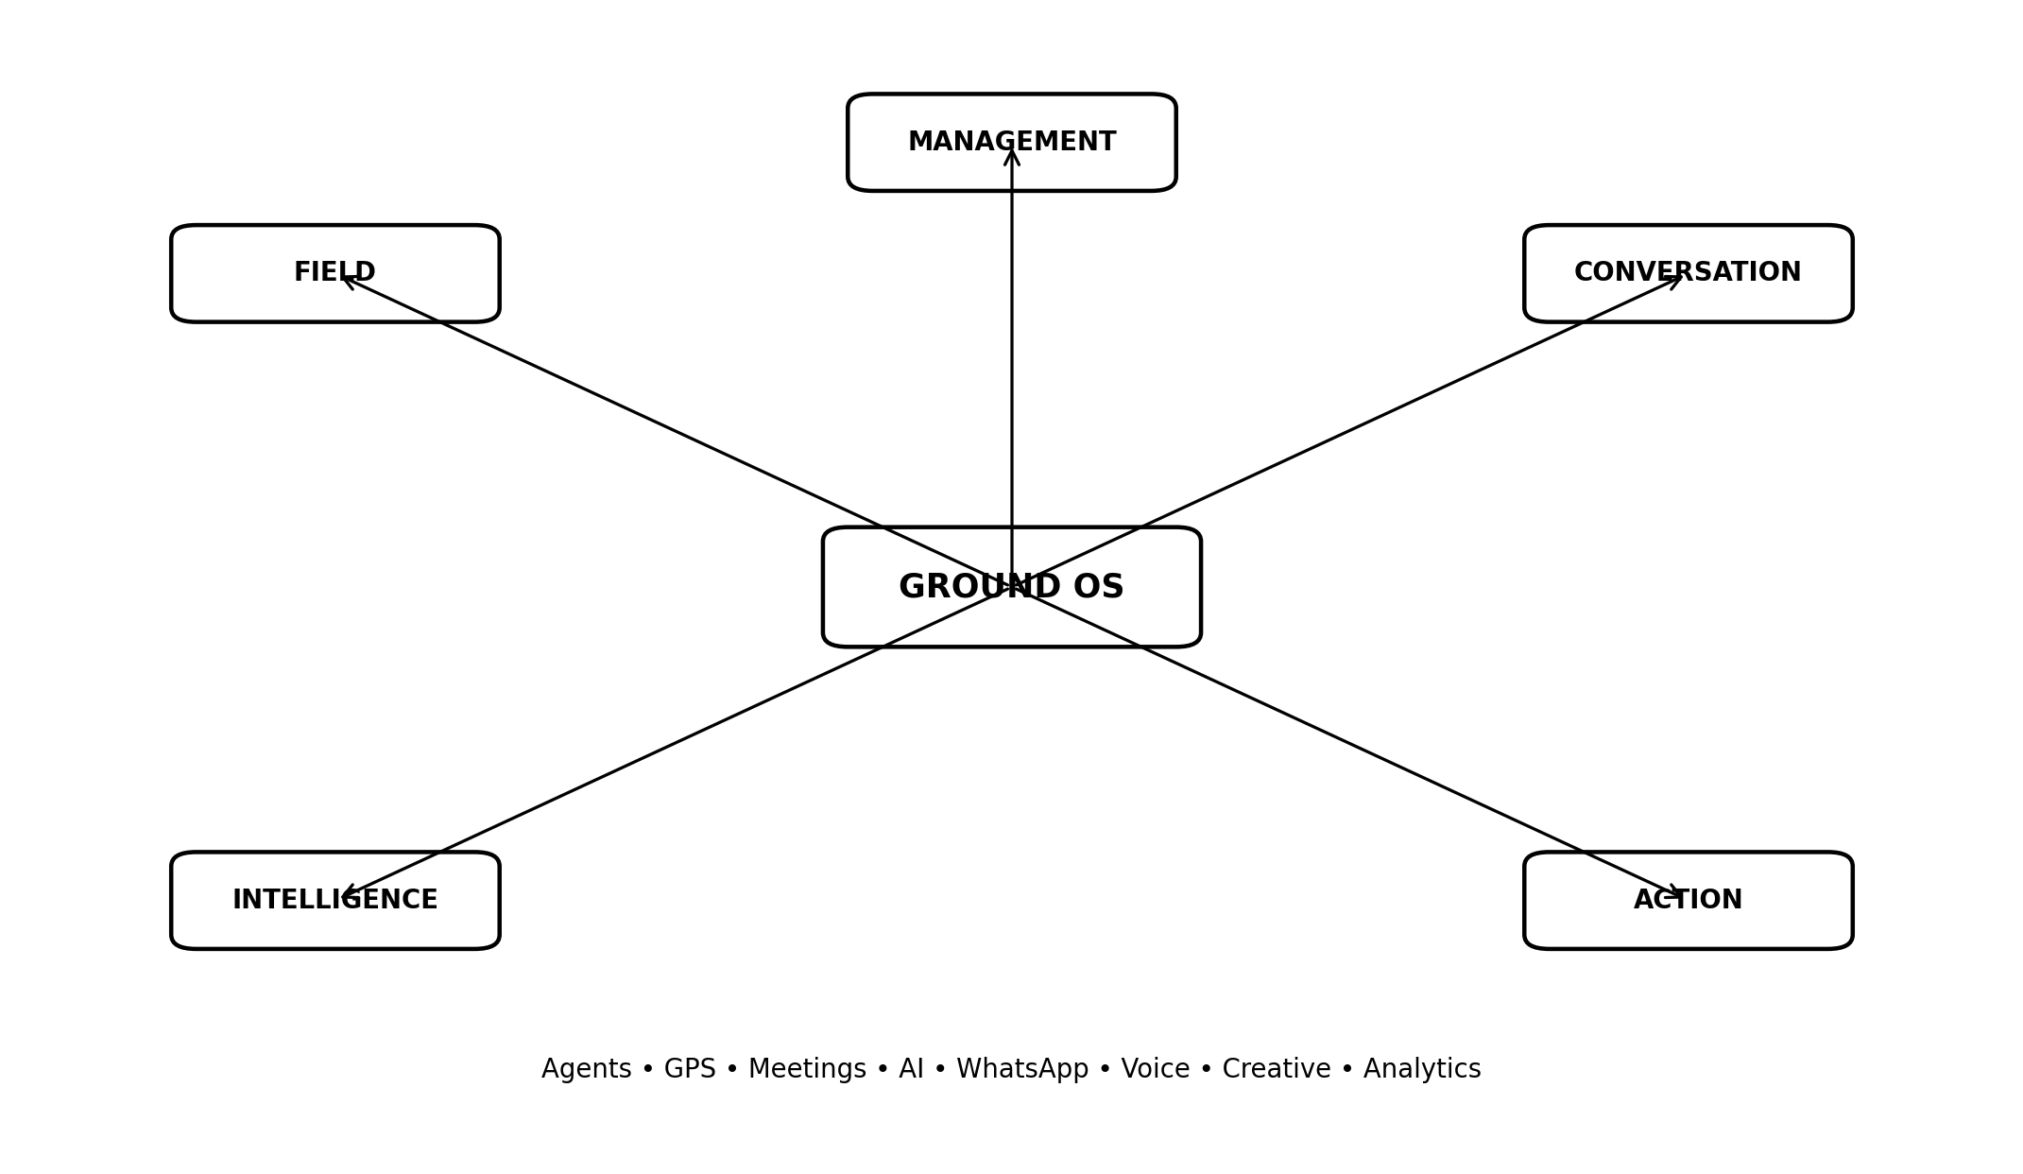

B — Customer Journey: One Continuous Timeline
Every customer interaction remains connected from first enquiry through field visit, AI analysis and follow-up.
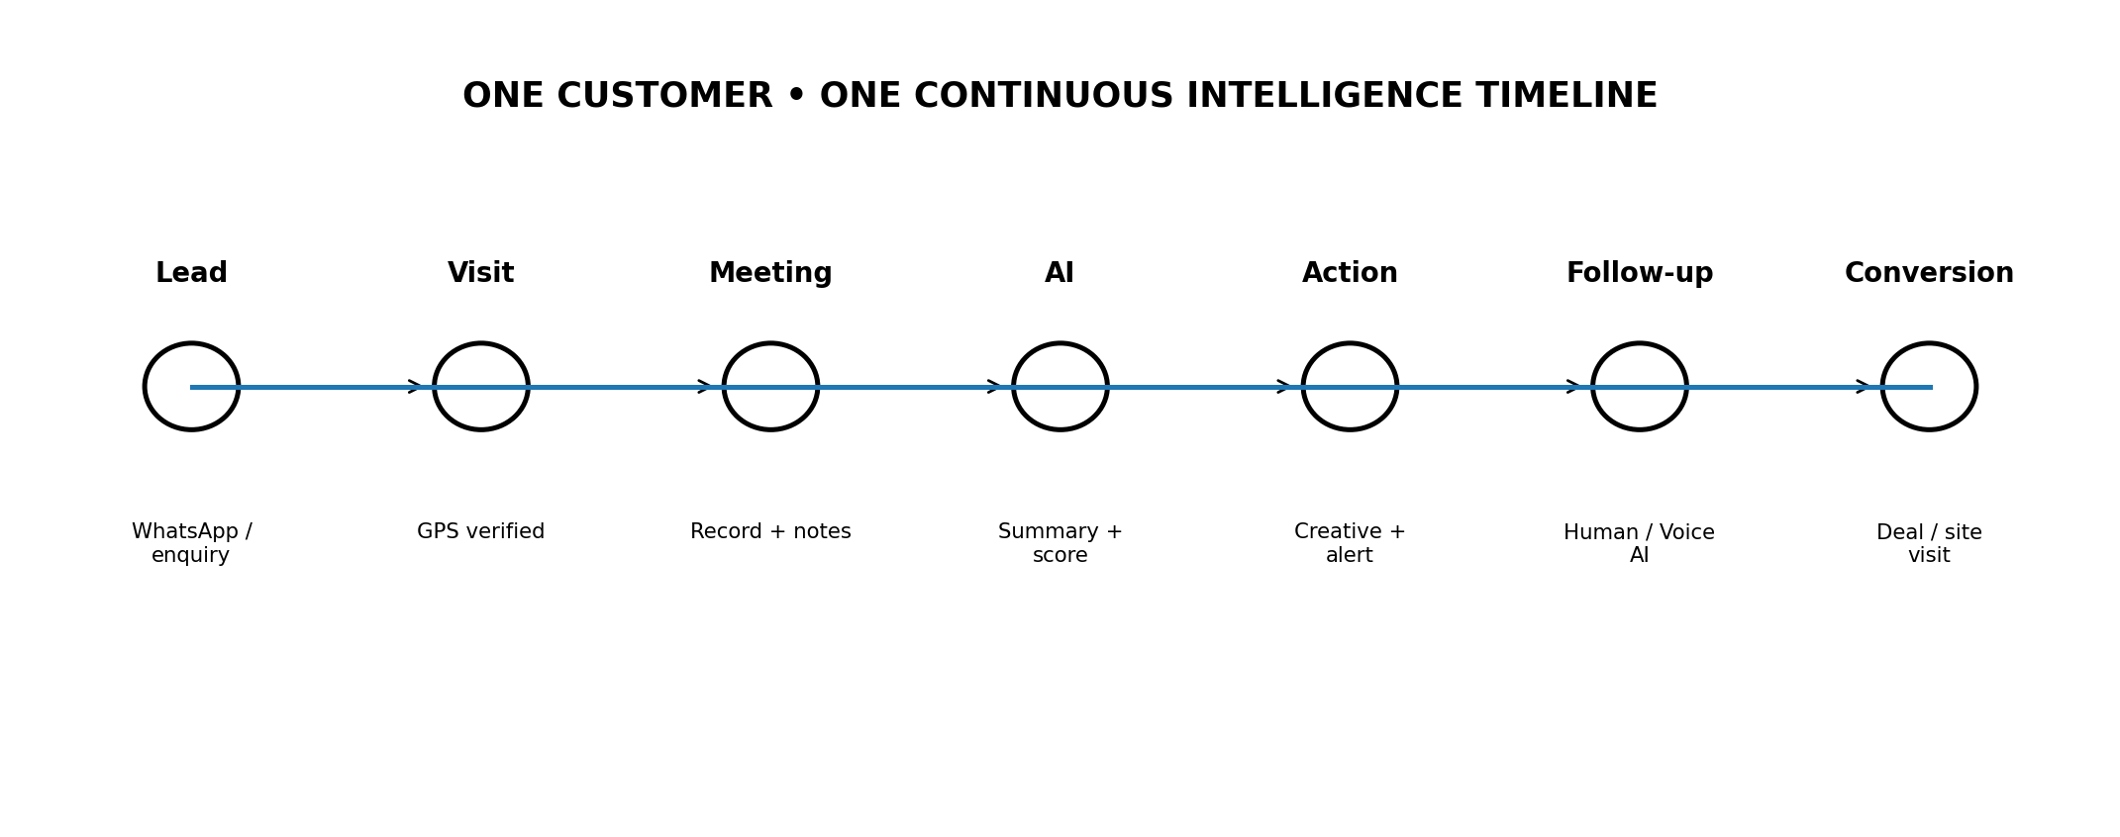

C — WhatsApp → Voice AI Automation
The Lifestyle Homes chatbot can transition into contextual Voice AI after inactivity, subject to eligibility and calling policies.
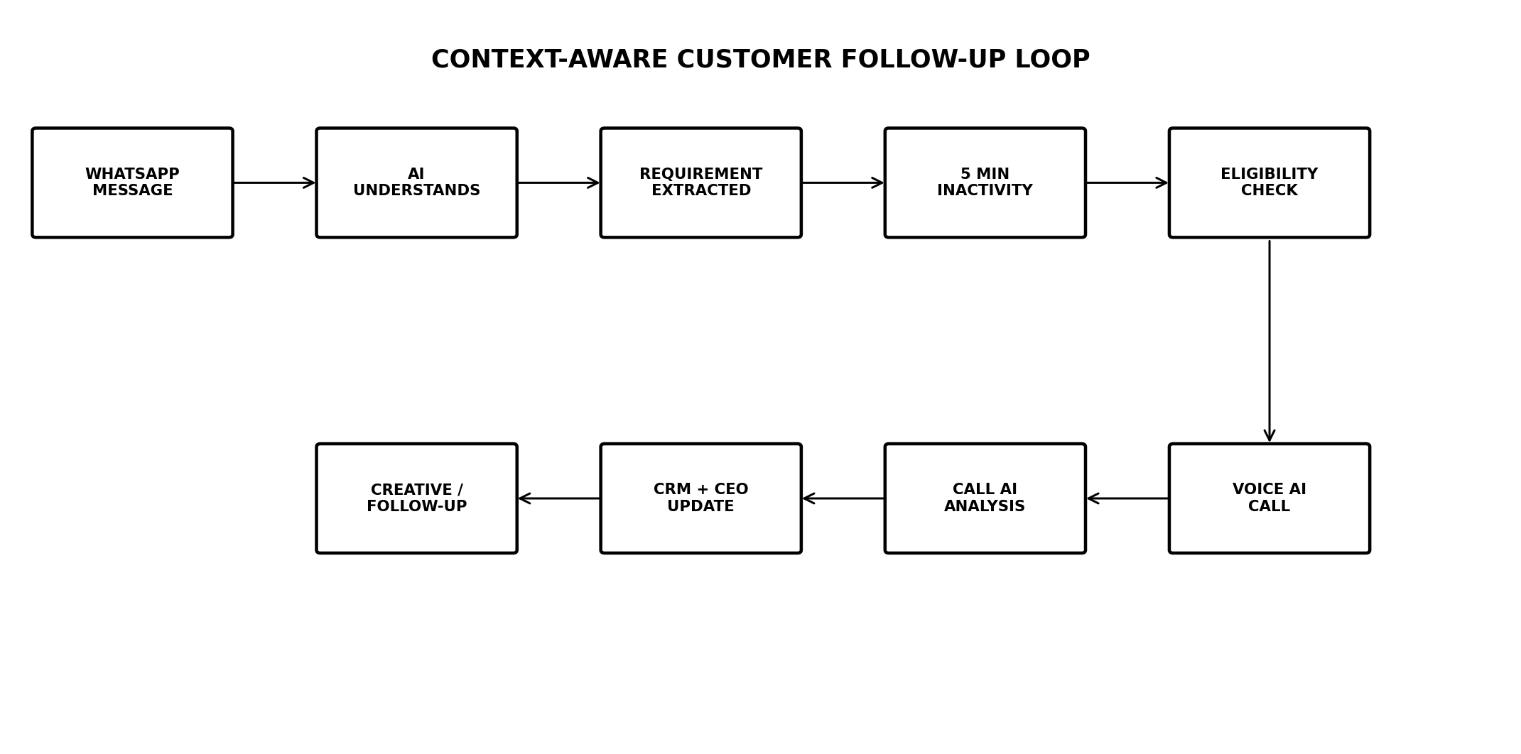

D — System Architecture
A modular event-driven architecture keeps channels, AI services, workflows and data loosely coupled.
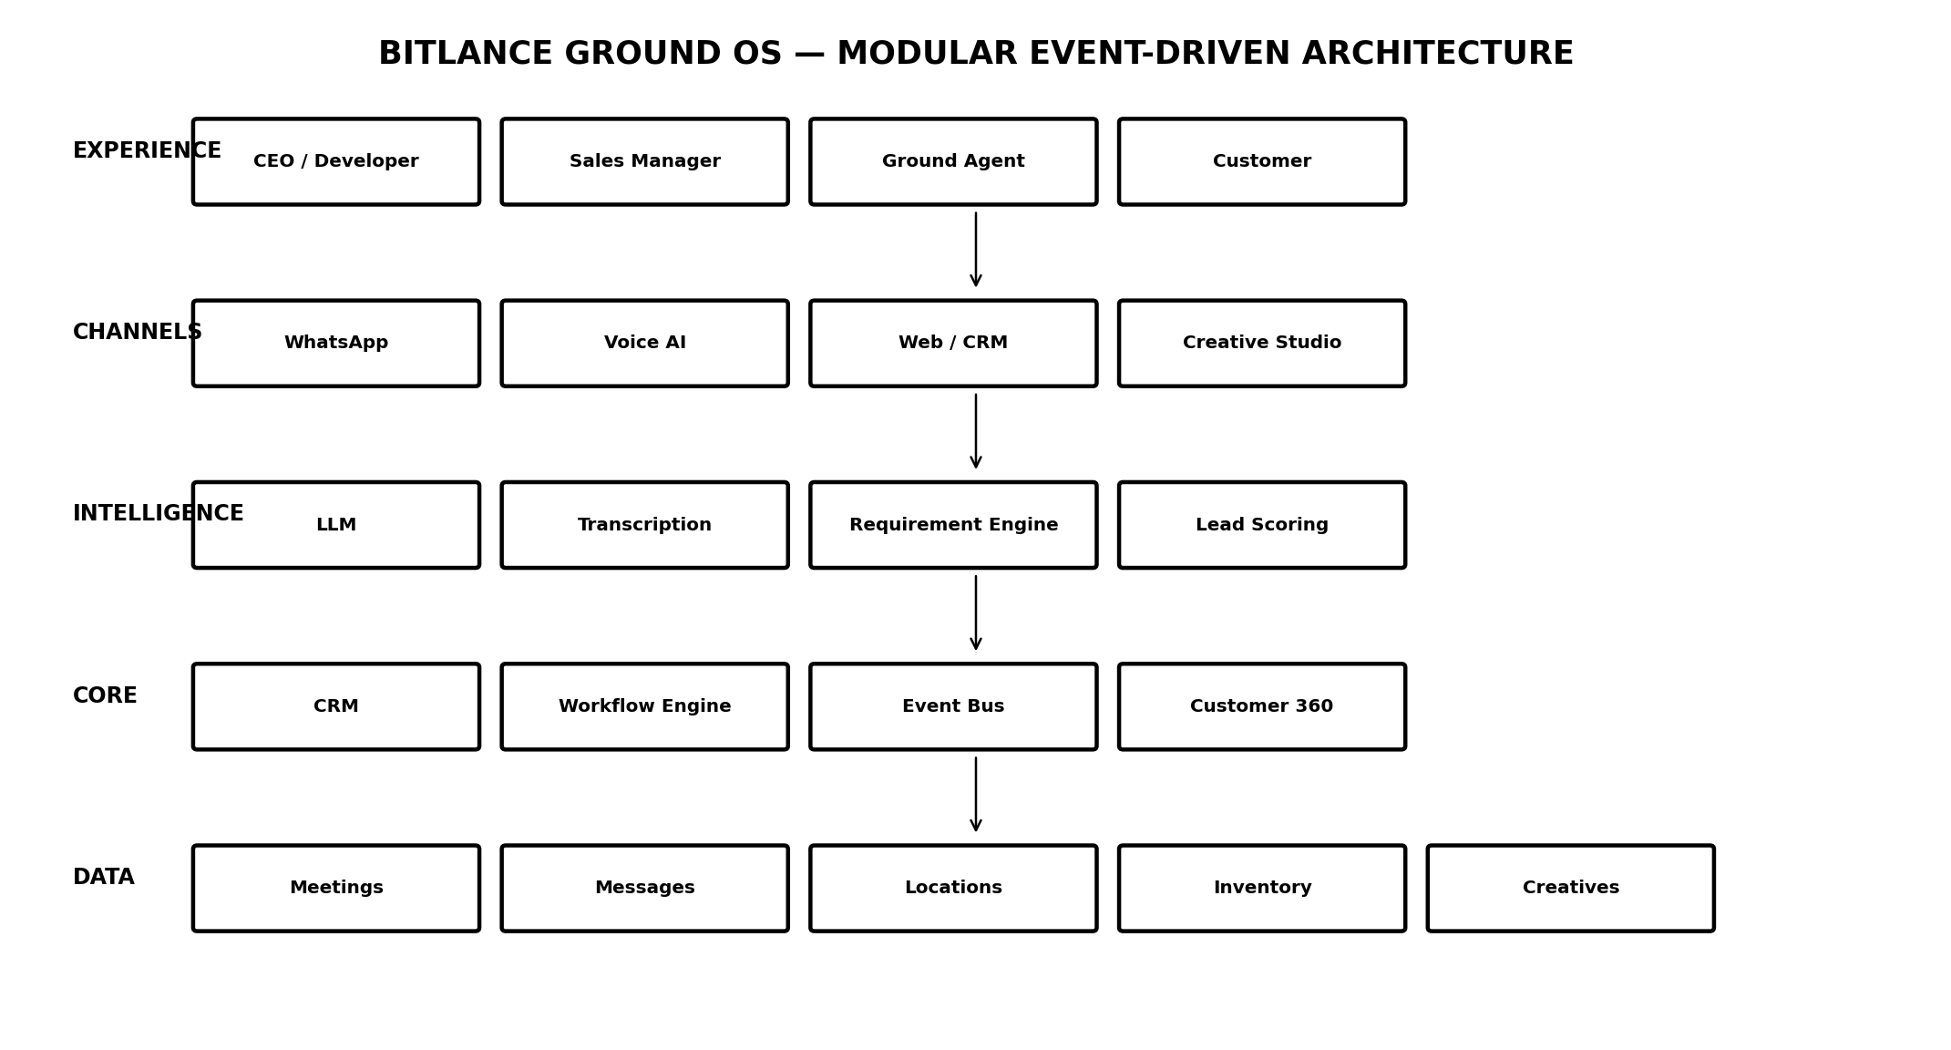

E — UI Screen Blueprint
Screen | Hero Interaction | Primary Decision
Command Center | Live map + AI priority feed | What needs attention now?
Agent Command | Route + visit queue + score | Who needs support?
Visit Mode | Arrival verification + meeting start | Is the visit active and valid?
Meeting Intelligence | Recording → AI report | What actually happened?
Customer 360 | Unified event timeline | What is the full customer story?
WhatsApp Intelligence | Conversation + AI context | What should we do next?
Voice AI | Eligibility + contextual call | Should the system call?
Creative Studio | Requirement → asset | What content will move the lead?
Automation Builder | Visual workflow | What should happen automatically?
Executive Intelligence | Signals + recommendations | What should leadership act on?

F — Signature UI: AI Priority Feed
The executive feed should rank events by business importance rather than behaving like a passive notification list.
HIGH INTENT Rajesh Kumar • 86/100 • 3 BHK • ₹80L–₹1Cr • pricing objection • recommend payment-plan creative + site visit
FOLLOW-UP RISK Customer has not received the recommended follow-up within the configured SLA.
MARKET SIGNAL Multiple customers in the same territory are asking for flexible payment plans.
AGENT COACHING Meeting discovery was strong, but budget qualification happened too late.

G — Design Language
- Premium dark command-center canvas rather than a generic admin template.
- Large map and timeline surfaces; small metric cards remain supporting elements.
- Selective glass-like panels for hierarchy, not decoration everywhere.
- Distinct AI states: processing, insight, warning, recommendation and completion.
- Motion communicates system state: agent movement, event pulses, processing and workflow transitions.
- Primary actions remain obvious: Start Visit, Start Meeting, End Meeting, Review AI Report, Call, Generate Creative, Follow Up.
- Every screen should answer one operational question before exposing secondary information.

H — The Demo Story
Aman receives a visit → travels to Rajesh Electronics → GPS verifies arrival → meeting starts → meeting ends → AI analyses the conversation → requirements and objections are extracted → lead score changes → CEO receives the intelligence → Lifestyle Homes chatbot continues the conversation → customer becomes inactive → workflow checks eligibility → Voice AI follows up → call is analysed → creative is generated → customer timeline updates.

I — Product North Star
OBSERVE → UNDERSTAND → RECOMMEND → AUTOMATE → CONVERT
Bitlance Ground OS should make the distance between a real-world customer conversation and a business decision as short as possible.

