### Highlights

* Results-oriented
* MS SQL
* Business development
* Power BI
* MS Excel, MS Word
* Ability to motivate staff and maintain good relations
* Resistance to stress
* Good manners

### Education

Bachelor of Technology: Electronics & communication Engineering - 2017

Meerut institute of Engineering &Technology , Meerut

### Certifications

1. Certification In **SQL** from chroma campus Noida

Certificate id: CCN 23844897

1. Certification in Power BI from chroma campus Noida certificate id: CCN 09298927

Looking to start my Career as a **US IT Recruiter** equipped with experience in **MS SQL** and **Power BI**. Employs excellent leadership skills and multi-tasking strengths. Demonstrated ability in my projects which was based on **Data Analytics.**

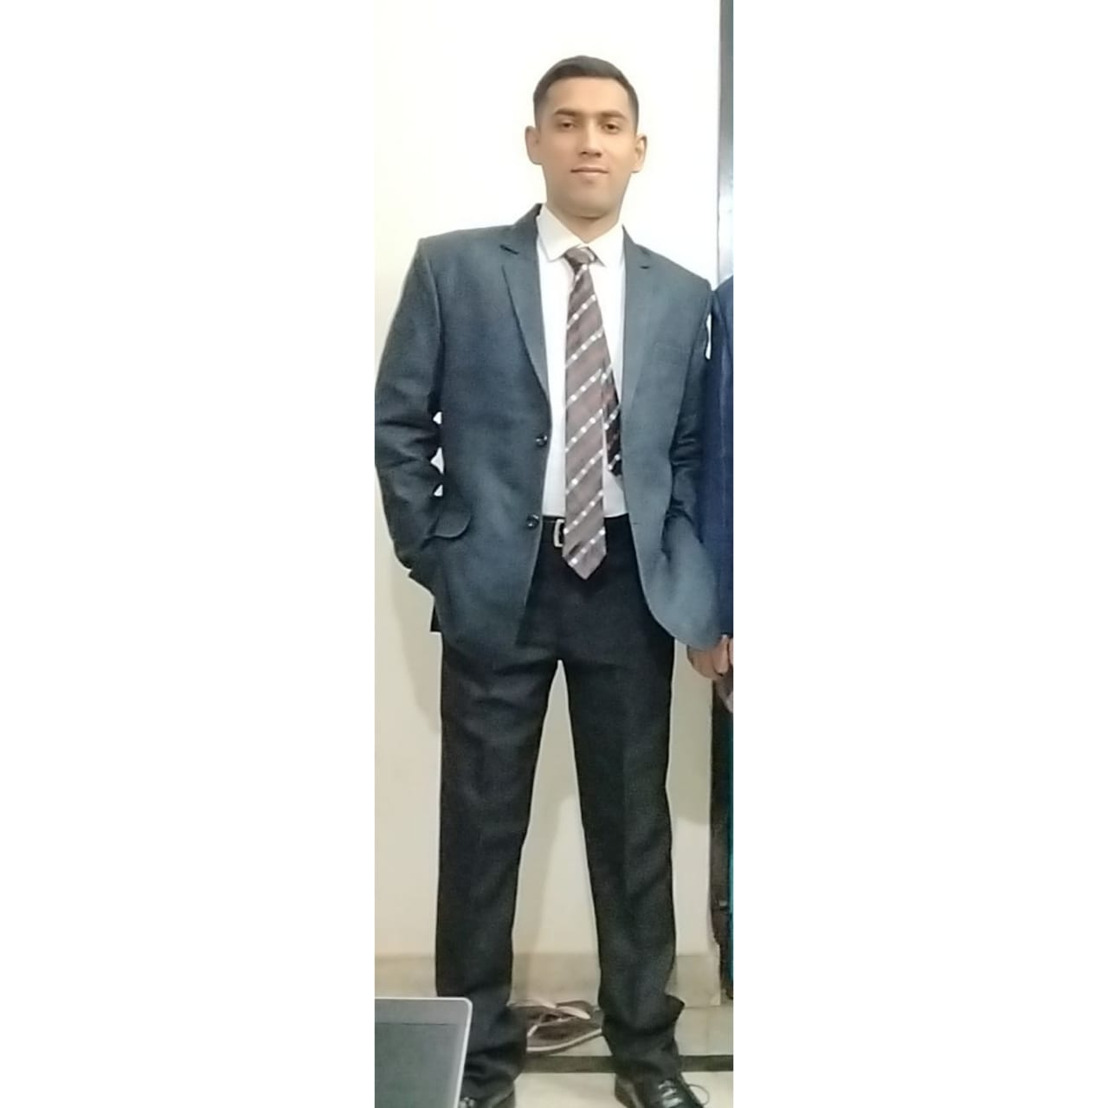

### Experience

05/2022 to 08/2022

**Associate Technical Support**

**Tech Mahindra Limited**, Noida

1. Conferred with users, and conducted computer diagnostics to investigate and resolve problems and to provide technical assistance and support.
2. Oversaw daily performance of computer systems.
3. worked in Net gear project USA
4. Maintained Data to Moniter the KPI regularly
5. Motivate and coach employees to meet service, sales, and repair goals

08/2021 to 03/2022

**Recruitment Associate**

**Nityo Infotech Services private limited,** Noida

1. sourcing of resumes to Hire people for our Implementation Partner Infosys. submissions and arranging interviews.  
2. Submissions of Candidates on Fulltime, C2C and W2

3.skilled in Technical Recruiting in the Information technology Industry  
4. Expertise in using job Portals Like Ceipal

5.Extensive working Knowledge of W2, C2C and 1099 Tax Model  
6. Extensive Worked With US citizens, Green card, EAD

10/2017 to 10 /2019

**MS Automated Operations Engineer**

**Ericsson India Global Services Private Limited,** Noida

1. Worked in Telnet project Belgium where Monitored Alarms for both Transmission and Ran Domain

Shubham Mishra

+91 -8800356169

Shubhammishra4338883@gmail.com