AI4SWEng
AI Engineering Suite to Support Agile, Efficient Software Engineering

KPI Interface for KIO Modules
Technical Documentation
Prepared by | Bitnet - Yasin Ünal
Affiliation | Bitnet
Project | AI4SWEng — Grant Agreement No. 101189908
Component | ai4sweng Python package, version 1.3.1
Date | 21 August 2026
Status | Technical reference

13  KIO modules | 16  KPIs mapped | 32  automated tests | 1  source of truth

This is an internal technical reference describing the design and usage of the ai4sweng software package. It complements, and does not replace, the official AI4SWEng D1.1 Project Management Handbook, which remains the authoritative source for the project's Key Performance Indicator definitions, baselines and targets.

Table of Contents

Table of Contents 2
1. Introduction 2
1.1 Purpose of This Document 3
1.2 Background 3
2. Problem Statement 3
3. Solution Overview 4
3.1 At a Glance 5
4. How ai4sweng Works 5
5. Installation 6
6. Usage Guide 6
6.1 Discovering KIOs and Their KPIs 6
6.2 Reading KPI Metadata 6
6.3 Inspecting the OTel Instrumentation Contract 7
6.4 Recording a Measurement 7
6.5 KPIs Realised as More Than One OTel Instrument 7
6.6 Fetching a KPI by ID 7
6.7 Error Handling Reference 7
7. Extending the KPI Catalog 8
8. Testing and Continuous Integration 8
9. Current Status and Future Work 9
9.1 Use Case (UC) Traceability — An Open Item 9
10. Conclusion 9
Appendix A — Full Worked Example 11
Appendix B — metrics.json Entry Schema 12
References 12

1. Introduction

1.1 Purpose of This Document
This document describes ai4sweng, a Python package developed to support the developers of Key Innovation Output (KIO) modules within the AI4SWEng project in correctly reporting the Key Performance Indicators (KPIs) their module is responsible for. It states the problem the package addresses, explains its design, and shows how a developer integrates it into a KIO module's codebase.

1.2 Background
The AI4SWEng Project Management Handbook (Deliverable D1.1) defines a KPI framework built around a traceability matrix linking Specific Objectives (SOs), Key Innovation Outputs (KIOs), Expected Outcomes, and KPIs. Thirteen KIOs (KIO1 through KIO13) are defined, each responsible for reporting one or more of the sixteen project-level KPIs — for example KPI 1.1 "Code generation speed" or KPI 9.2 "Technical debt reduction". Every KPI in the handbook carries a business definition (a baseline, a target, and a reporting unit) and, in the real telemetry pipeline that the AI4SWEng tools already emit data to, a specific OpenTelemetry instrumentation contract: a metric name, an instrument kind, a raw unit, and a set of required attributes.
D1.1 additionally records, for each KPI, which of the project's five pilot Use Cases (UC1 – SDLC, UC2 – Medical, UC3 – FPGA, UC4 – EV/TinyML, UC5 – GIS) will be used to validate it. A Use Case is not a metric-producing unit in its own right — it is the pilot context in which one or more KIOs are exercised together; the KPI itself is always produced by a KIO. This distinction is discussed further in Section 9.

2. Problem Statement
The KPI catalog lives in a static document. Before ai4sweng existed, a developer implementing a KIO module had to translate the relevant rows of the D1.1 KPI table into code by hand: decide on a metric name, decide whether it is a Counter, a Histogram or a Gauge, decide on a unit, and decide which attributes to attach to each data point. This translation step is repeated independently by every KIO team, and it is easy to get subtly wrong:
- A metric emitted under the wrong name never reaches the dashboard associated with its KPI.
- A metric emitted with the wrong instrument kind — for instance, a duration recorded as a Counter instead of a Histogram — silently produces a meaningless aggregate rather than an error.
- A missing or misspelled attribute (kio.id, source, llm, task_type) breaks per-KIO or per-source breakdowns on the dashboard without breaking the code that emitted it.
- Because none of these mistakes raise an exception at the point of failure, they are typically discovered only when someone notices that a dashboard panel is empty or misleading — long after the data was lost.
With thirteen KIO teams each performing this translation independently, the same KPI could easily end up represented under thirteen different metric names, instrument kinds, or attribute sets across the codebase, even though it is meant to be one consistent measurement across the whole project. Figure 1 illustrates this for a single KPI.
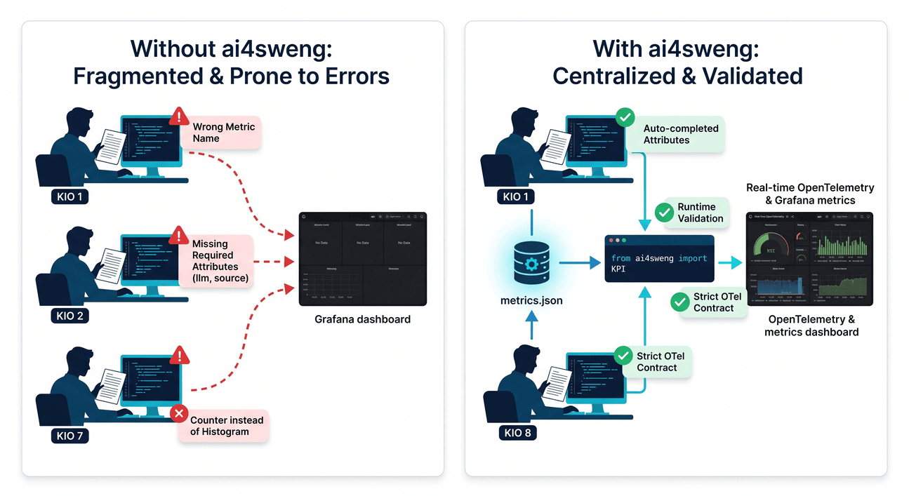
Figure 1 — One specification, breaks the dashboard it was meant to feed.

3. Solution Overview
ai4sweng centralises the KPI catalog in a single machine-readable file, ai4sweng/metrics.json, and exposes it through one Python interface: the KPI singleton, imported as "from ai4sweng import KPI". For every KIO, "KPI.KIOx" gives dotted attribute access to the KPIs that KIO is responsible for. Each attribute carries:
- the business metadata already defined in D1.1 — id, name, definition, unit, baseline and target;
- the exact OpenTelemetry instrumentation contract required to emit the metric correctly — metric name, instrument kind, raw unit and required attributes; and
- an optional ".record(value, **attributes)" helper that validates the caller-supplied attributes and emits a correctly labelled OpenTelemetry data point, automatically attaching which KIO the measurement came from.
Crucially, the package does not decide where a measured value comes from — that remains entirely up to the KIO developer, whether it is a CI pipeline duration, a manual review score, or an aggregation computed elsewhere. ai4sweng's responsibility ends at: here is what your module must report, and here is exactly how to report it so that it lands correctly on the dashboard. How the value itself is produced is deliberately outside its scope.
The net effect, KIO by KIO, is summarised below Table 1.

Table 1. Package contributions.
Without ai4sweng package | With ai4sweng package
✗ Each KIO invents its own metric name | ✓ One name per KPI, shared by every KIO
✗ Instrument kind (Counter / Histogram / Gauge) is a guess | ✓ Instrument kind is fixed by the catalog, not guessed
✗ A missing attribute fails silently on the dashboard | ✓ A missing attribute raises a ValueError immediately
✗ No IDE autocomplete for KPI.KIOx.<metric> | ✓ Full autocomplete via the generated type stub

4. How ai4sweng Package Works
ai4sweng is a tool, not a system: it has no server, no service to deploy, and no runtime of its own beyond the process that imports it. What it provides is a single, linear path from the catalog to the dashboard, identical for every KIO and every KPI, shown in Figure 2.
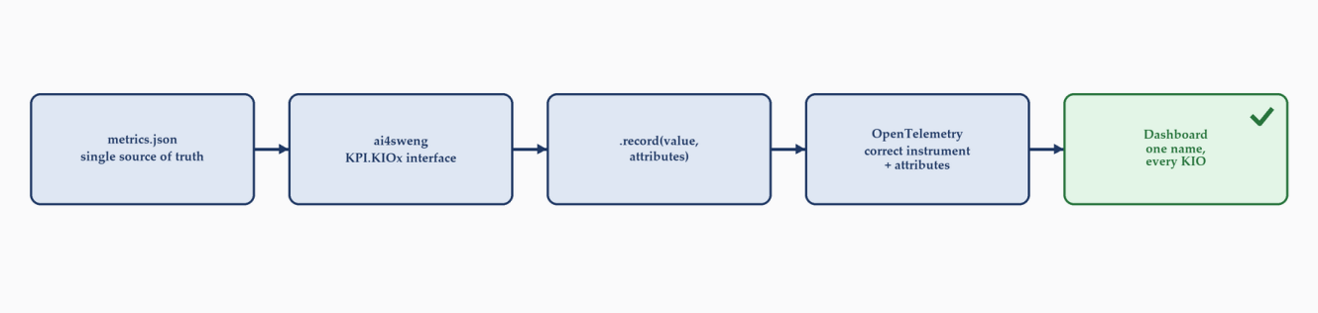
Figure 2 — The same five-step path, for every KIO and every KPI: no room for thirteen different interpretations.
Internally, the package is organised around a small set of files, each with a single, well-defined responsibility given in Table X.
Table 2. Builds included in the package (for developers)
File | Responsibility
ai4sweng/metrics.json | Single source of truth: the full KPI catalog (16 KPIs) and the list of declared KIOs. Hand-edited, English-only, consumed by dashboards and other services.
ai4sweng/kpi.py | Runtime model: KPIMetric, OTelSpec, _BoundKPIMetric, _KIONamespace and the _KPIInterface singleton exported as KPI.
ai4sweng/otel.py | Lazy OpenTelemetry recording backend. Only imported the first time .record() is actually called, so reading metadata never requires the otel extra to be installed.
ai4sweng/__init__.pyi + scripts/gen_stubs.py | A generated type stub so IDEs and type checkers (Pylance, mypy, PyCharm) can autocomplete KPI.KIO7.<Tab>, an attribute that is real only at runtime.
tests/ | 32 unit and integration tests, including one that fails the suite whenever the committed stub drifts out of sync with metrics.json.

A guiding design principle behind the OTel contract is to prefer real names over invented ones: the metric name, instrument kind, unit and required attributes recorded in metrics.json are taken from the real, already-running telemetry producer rather than invented ad hoc. A package name that does not match what production actually emits would simply recreate the mislabelling problem the package exists to prevent.

5. Installation
From within a clone of the repository:
pip install -e .

# To enable .record() (OpenTelemetry emission):
pip install -e ".[otel]"

Directly from git, for a teammate integrating the package into a KIO module:
pip install "ai4sweng[otel] @ git+https://<repo-url>"

6. Usage Guide

An illustration of its use is given in Figure 3 and 4.
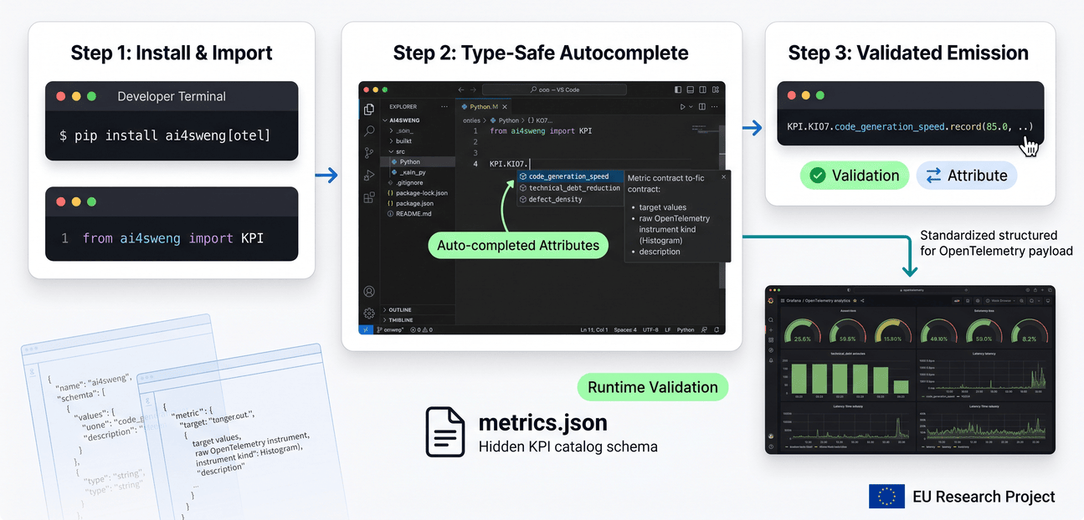
Figure 3. How to use the ai4sweng package
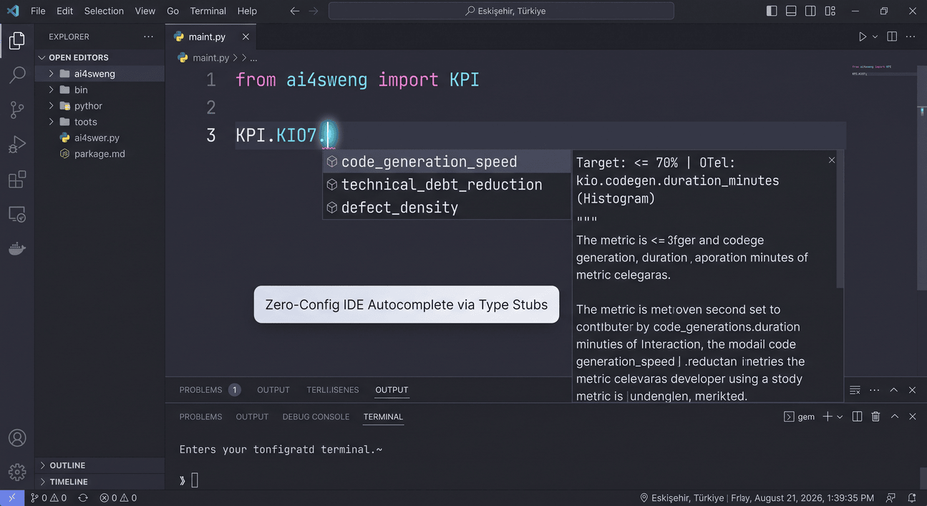
Figure 4. How to use the ai4sweng package in vscode

6.1 Discovering KIOs and Their KPIs
from ai4sweng import KPI

print(KPI.list_kios()) # ['KIO1', 'KIO2', ..., 'KIO13']
print(dir(KPI.KIO7)) # every KPI attribute KIO7 tracks

6.2 Reading KPI Metadata
metric = KPI.KIO7.code_generation_speed

metric.id # '1.1'
metric.name # 'Code generation speed'
metric.definition # what the metric measures
metric.unit # '% of baseline duration' (business/reporting unit)
metric.baseline # '100% (~100-120 min)'
metric.target # '≤ 70% (~30% reduction)'
metric.kios # ['KIO2', 'KIO3', 'KIO4', 'KIO7']

6.3 Inspecting the OTel Instrumentation Contract
metric.otel.name # 'kio.codegen.duration_minutes'
metric.otel.instrument # 'Histogram'
metric.otel.unit # 'min' (raw OTel measurement unit)
metric.otel.required_attributes # ['kio.id', 'source', 'llm', 'task_type']

6.4 Recording a Measurement
Requires the otel extra ("pip install ai4sweng[otel]"). "kio.id" is attached automatically because the metric was accessed through KIO7:
KPI.KIO7.code_generation_speed.record(
95.0, source="ci-pipeline", llm="qwen2.5:3b", task_type="generic"
)

# A missing required attribute raises a clear error instead of failing silently:
KPI.KIO7.code_generation_speed.record(95.0, source="ci-pipeline")
# ValueError: Missing required attribute(s) for 'kio.codegen.duration_minutes': llm, task_type. ...

6.5 KPIs Realised as More Than One OTel Instrument
A few KPIs map to more than one real OTel metric — for example KPI 8.2, "Active usage & satisfaction", is two separate histograms in production. For these, pass otel_key to say which one is meant:
KPI.KIO13.active_usage_satisfaction.record(
62.0, otel_key="usage_pct", source="svc", llm="qwen2.5:3b", task_type="adoption"
)
KPI.KIO13.active_usage_satisfaction.record(
4.1, otel_key="mos_score", source="svc", llm="qwen2.5:3b", task_type="adoption"
)

6.6 Fetching a KPI by ID
A KPI fetched directly by id is not bound to a specific KIO, so it must be bound with .for_kio(...) before it can be recorded:
kpi = KPI.get_kpi("1.1").for_kio("KIO3")
kpi.record(95.0, source="ci-pipeline", llm="qwen2.5:3b", task_type="generic")

6.7 Error Handling Reference
Table 3. Error and Exception table

Exception | Raised when
AttributeError | Accessing an undeclared KIO, e.g. a typo such as KPI.KI07.
KeyError | get_kpi(id) is called with an unknown KPI id, or get_kio_metrics(name) with an unknown KIO.
ValueError | A required attribute is missing from .record(); the KPI has no OTel spec in metrics.json; or otel_key is missing or invalid for a multi-instrument KPI.
ImportError | opentelemetry-api is not installed, or is too old for the requested instrument kind (e.g. synchronous Gauge needs >=1.23).

7. Extending the KPI Catalog
All KPI definitions live in ai4sweng/metrics.json. A new KPI is added by appending an object of this shape to the "kpis" list:
{
"id": "10.1",
"name": "Example metric name",
"attr": "example_metric_name",
"definition": "What this metric measures.",
"unit": "unit",
"baseline": "baseline value",
"target": "target value",
"kios": ["KIO3", "KIO7"],
"otel": [
{
"name": "kio.example_metric_name",
"instrument": "Histogram",
"unit": "s",
"required_attributes": ["source", "llm", "task_type"]
}
]
}
"attr" becomes the Python attribute name (auto-derived from "name" if omitted); "kios" lists every KIO the KPI is associated with, so its definition never needs to be duplicated per KIO; and "otel" is always a list, even for the common single-instrument case, with a second entry (each carrying its own "key") added only when a KPI genuinely maps to more than one real OTel metric. After editing metrics.json, run:
python scripts/gen_stubs.py
to regenerate the type stub, and call KPI.reload() at runtime (or simply restart the process) to pick up the change — no reinstall is required.

8. Testing and Continuous Integration
The package ships 32 automated tests covering metadata access, error paths, and — where opentelemetry-sdk is installed — end-to-end recording against a real InMemoryMetricReader, verifying that each KPI is emitted under the correct instrument kind and with the correct attributes. A dedicated test fails the suite if the committed type stub (ai4sweng/__init__.pyi) ever drifts out of sync with metrics.json, so a stale stub cannot silently ship.
A GitHub Actions workflow runs on every push and pull request across Python 3.9 through 3.12, first checking that the stub is up to date ("python scripts/gen_stubs.py --check") and then running the full test suite.

9. Current Status and Future Work
At version 1.3.1, all thirteen KIOs declared in D1.1 are represented, and all sixteen project-level KPIs from the D1.1 traceability matrix are present in metrics.json with a complete OpenTelemetry instrumentation contract. The package is MIT-licensed, covered by continuous integration, and installable either from a local clone or directly via git.

9.1 Use Case (UC) Traceability — An Open Item
As noted in Section 1.2, D1.1 records, for each KPI, which pilot Use Cases (UC1–UC5) are expected to validate it. This relationship is not currently represented in metrics.json. It is worth being precise about what would and would not be an appropriate way to add it:
- A KPI.UC1-style namespace mirroring KPI.KIOx would not fit the underlying model: a KPI is always produced by a KIO, whereas a Use Case is the pilot context in which one or more KIOs are exercised together. A Use Case does not produce a measurement independently of the KIO running inside it.
- A lightweight, purely informational field — for example a "ucs" list on each KPI entry, mirroring the existing "kios" list — would let a developer see which pilots a given KPI is expected to be validated in, without changing the recording API or the OTel contract in any way.
Whether this field is worth adding, and whether the real telemetry producer distinguishes data points by pilot (e.g. via a "uc.id"-style attribute), remains an open decision pending further discussion with the wider project team.

10. Conclusion
ai4sweng turns the KPI table in D1.1 from a document that every KIO team has to interpret by hand into a single, importable source of truth. A KIO developer no longer needs to invent a metric name, guess an instrument kind, or remember which attributes a dashboard expects — the package states it explicitly, validates it at the point of recording, and keeps IDE autocomplete and static type checking in sync with the catalog automatically. This narrows the gap between what D1.1 specifies and what the running system actually reports, which is precisely the gap in which KPI data has historically gone missing or been misreported.

Appendix A — Full Worked Example
The following self-contained script (examples/quickstart.py in the repository) exercises the interface end to end:
from ai4sweng import KPI

# 1) List every declared KIO
print("KIOs:", KPI.list_kios())

# 2) Which KPIs are available for a given KIO
print("Attribute names:", dir(KPI.KIO2))

# 3) Full details of each metric tracked by KIO2
for metric in KPI.KIO2:
print(f"\n--- {metric.attr} ---")
print(f" id : {metric.id}")
print(f" name : {metric.name}")
print(f" definition : {metric.definition}")
print(f" unit : {metric.unit}")
print(f" baseline : {metric.baseline}")
print(f" target : {metric.target}")
print(f" kios : {metric.kios}")

# 4) Inspect the OTel instrumentation contract
metric = KPI.KIO2.code_generation_speed
print("otel name :", metric.otel.name)
print("instrument :", metric.otel.instrument)
print("raw OTel unit :", metric.otel.unit)
print("required attributes:", metric.otel.required_attributes)

# 5) Record a measurement (requires: pip install ai4sweng[otel])
result = KPI.KIO2.code_generation_speed.record(
82.0, source="manual-test", llm="qwen2.5:3b", task_type="bugfix"
)
print("Recorded attributes:", result)
# {'kio.id': 'KIO2', 'source': 'manual-test', 'llm': 'qwen2.5:3b', 'task_type': 'bugfix'}

Appendix B — metrics.json Entry Schema
Every entry in the "kpis" array of ai4sweng/metrics.json follows this shape (shown here for KPI 1.1):
{
"id": "1.1",
"name": "Code generation speed",
"attr": "code_generation_speed",
"definition": "Average time from the start of the prompt/template to the
first successful build of a 300-500 LOC feature.",
"unit": "% of baseline duration",
"baseline": "100% (~100-120 min)",
"target": "≤ 70% (~30% reduction)",
"kios": ["KIO1", "KIO2", "KIO3", "KIO4", "KIO7"],
"otel": [
{
"name": "kio.codegen.duration_minutes",
"instrument": "Histogram",
"unit": "min",
"required_attributes": ["source", "llm", "task_type"]
}
]
}

References
[1] AI4SWEng D1.1 — Project Management Handbook, Grant Agreement No. 101189908.
[2] ai4sweng package source and README.md / README.tr.md, AI4SWEng repository.

