HuBaDrone Zwischenstand – 24.03.2017

Hauptbestandteil unseres ersten Zwischenstandes ist der Zusammenbau der Fernbedienung. Die Komponenten mussten Zusammengeschraubt und mit Kabeln verbunden werden. Ausserdem wurde die zu verwendende DIE, Arduino installiert, inklusive aller notwendigen Treiber und Packages.

Inhalt

Websiten HTML-Entwurf 2

Anhang 3

Website-Code 3

HTML 3

CSS 5

Javascript 5

# Websiten HTML-Entwurf

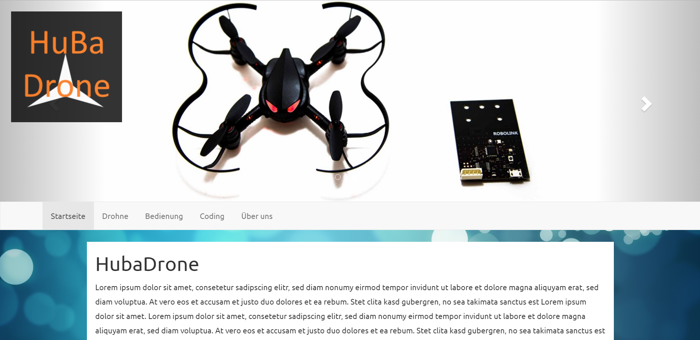

Abbildung - Übersicht der Website

Wir haben unser MockUp grösstenteils in HTML Umgesetzt. Wir werden in naher Zukunft eine Domain reservieren auf welche diese responsive Website hochgeladen wird. Wenn das HTML dann steht, werden wir mit der CMS Anbindung (Umbraco) beginnen. Umbraco ist ein OpenSource .NET Content Management System. Wir werde ein sauberes BackEnd programmieren, damit wir unsere Website einfach anpassen können.

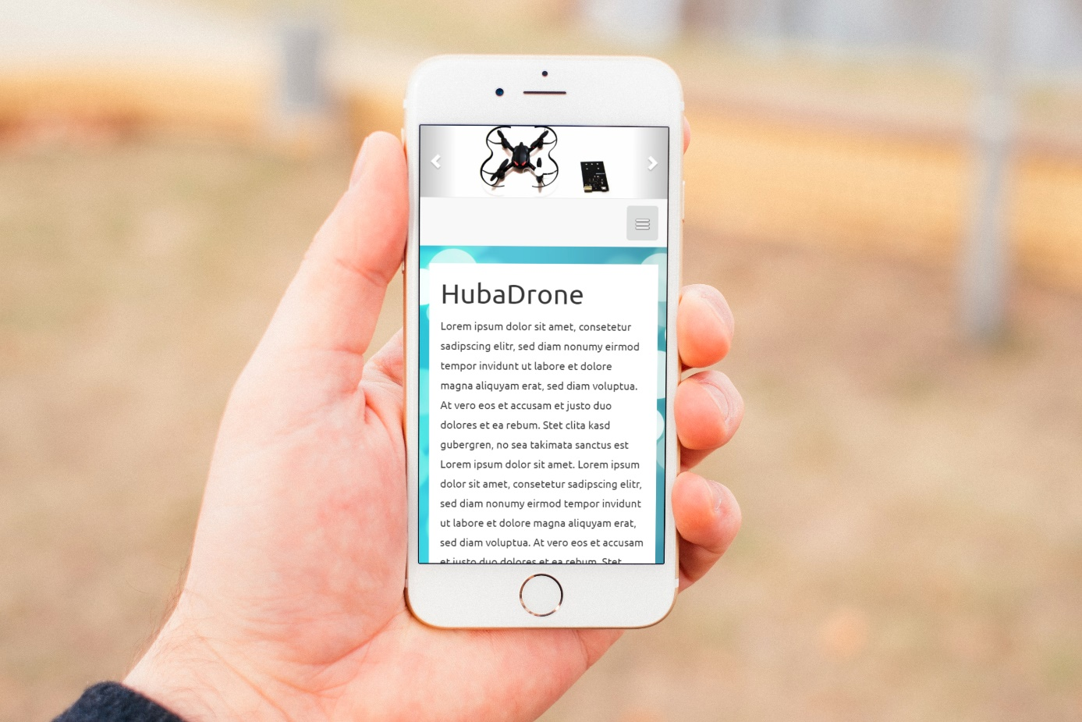

Abbildung - Mobile-Version der Website

# Anhang

## Website-Code

### HTML

<!DOCTYPE html>

<html lang="de">

<head>

<meta charset="UTF-8">

<meta http-equiv="X-UA-Compatible" content="IE=edge">

<meta name="viewport" content="width=device-width, initial-scale=1">

<title>HL Technik</title>

<!-- Bootstrap -->

<link href="css/bootstrap.min.css" rel="stylesheet">

<link href="css/style.css" rel="stylesheet">

<link href="css/nav.css" rel="stylesheet">

<script src="js/bootstrap.min.js"></script>

<script src="js/jquery-3.1.0.min.js"></script>

<script src="js/main.js"></script>

<link href="https://fonts.googleapis.com/css?family=Ubuntu" rel="stylesheet">

<script>

$(function(){

$('.carousel').carousel({

interval: 2000

});

$('.carousel-control.right').trigger('click');

});

</script>

</head>

<body>

<div id="logo">

<img src="images/logo.png" />

</div>

<div id="myCarousel" class="carousel slide" data-ride="carousel">

<!-- Indicators -->

<ol class="carousel-indicators">

<li data-target="#myCarousel" data-slide-to="0" class="active"></li>

<li data-target="#myCarousel" data-slide-to="1"></li>

<li data-target="#myCarousel" data-slide-to="2"></li>

<li data-target="#myCarousel" data-slide-to="3"></li>

</ol>

<!-- Wrapper for slides -->

<div class="carousel-inner" role="listbox">

<div class="item active">

<img src="images/slider1.jpg" alt="Chania">

</div>

<div class="item">

<img src="images/slider2.jpg" alt="Chania">

</div>

<div class="item">

<img src="images/slider3.jpg" alt="Flower">

</div>

<div class="item">

<img src="images/slider4.jpg" alt="Flower">

</div>

</div>

<!-- Left and right controls -->

<a class="left carousel-control" href="#myCarousel" role="button" data-slide="prev">

<span class="glyphicon glyphicon-chevron-left" aria-hidden="true"></span>

<span class="sr-only">Previous</span>

</a>

<a class="right carousel-control" href="#myCarousel" role="button" data-slide="next">

<span class="glyphicon glyphicon-chevron-right" aria-hidden="true"></span>

<span class="sr-only">Next</span>

</a>

</div>

<div class="row">

<div class="col-xs-12 header">

</div>

</div>

<nav class="navbar navbar-default navbar-center" id="custom-nav">

<div class="container">

<div class="navbar-header">

<button type="button" class="navbar-toggle" data-toggle="collapse" data-target="#myNavbar">

<img style="width: 20px;" src="images/menuicon.png" alt="menuicon" />

</button>

</div>

<div class="collapse navbar-collapse" id="myNavbar">

<ul class="nav navbar-nav">

<li class="active menupoint"><a href="#">Startseite</a></li>

<li class="menupoint"><a href="#">Drohne</a></li>

<li class="menupoint"><a href="#">Bedienung</a></li>

<li class="menupoint"><a href="#">Coding</a></li>

<li class="menupoint"><a href="#">Über uns</a></li>

</ul>

</div>

</div>

</nav>

<div class="row">

<div class="col-xs-0 col-md-1"></div>

<div class="col-xs-12 col-md-8 carouseldiv">

</div>

<div class="col-xs-0 col-md-1"></div>

</div>

<div class="withpadding">

<div class="container">

<div class="col-xs-0 col-md-1"></div>

<div class="col-xs-12 col-md-9 col-lg-10 col-xl-12 container content">

<h1>HubaDrone</h1>

<p>

<PLATZHALTER>

</p>

</div>

</div>

</div>

<script src="https://ajax.googleapis.com/ajax/libs/jquery/1.12.4/jquery.min.js"></script>

<script src="js/bootstrap.min.js"></script>

</body>

</html>

### CSS

body{

background: url(../images/background.jpg) no-repeat center center fixed;

-webkit-background-size: cover;

-moz-background-size: cover;

-o-background-size: cover;

background-size: cover;

font-family: 'Ubuntu', sans-serif;

overflow-x: hidden;

line-height: 26px;

}

.content{

background-color: white;

}

nav#custom-nav {

border-radius: 0;

margin-top: -1px;

}

#logo{

position: absolute;

top: 20px;

left: 20px;

z-index:20;

opacity: 0.8;

}

### Javascript

/// <reference path="jquery.min.js" />

$(document).ready(function () {

$(window).scroll(function () {

getScroll();

});

function getScroll(){

if (window.matchMedia("(min-width: 994px)").matches) {

setShadow(337);

} else if (window.matchMedia("(max-width: 768px)").matches) {

} else {

}

}

function setShadow(ScrollBreak) {

var scrolled = $(window).scrollTop();

if (scrolled >= ScrollBreak) {

$("#custom-nav").addClass("navbar-fixed-top");

$(".titlecontent").addClass("margintop");

} else {

$("#custom-nav").removeClass("navbar-fixed-top");

$(".titlecontent").removeClass("margintop");

}

}

}

)