Deal AI — Full Functional Documentation
Comprehensive documentation of the Deal AI platform: every feature, every flow, every endpoint. Read once, build twice.
Three repositories make up the system:
- `deal-ai` — Next.js 14 frontend (App Router, Lucia auth, Konva editor, Siri voice).
- `deal-ai-server` — Express.js backend (Prisma + MongoDB, OAuth, cron publisher).
- `TakamolAdvancedAI` — Flask Python AI service (gpt-4o-mini, dall-e-3, Ideogram, vision).
────────────────────────────────────────────────────────────

0. What is Deal AI?

In one paragraph
Deal AI is an AI-powered marketing co-pilot for real-estate developers. Drop in a project brochure (PDF, photos, basic info) and the platform turns it into a complete, weeks-long social-media campaign — automatically. It writes the marketing case study (target audience, ROI math, strategy), drafts hundreds of posts in Arabic and English tuned per network, generates a custom image for every post, schedules them across the calendar, and publishes them on autopilot to LinkedIn, Twitter/X, Facebook, and Instagram. The user can do all of this by clicking through forms — or just by *speaking* to the built-in voice assistant.

Core skills & services (what the user gets)
Service | What it does for the user
AI brochure ingestion | Upload a PDF brochure → AI reads every page, extracts project name, location, land area, every unit type with rooms / baths / spaces / finishing, and pre-fills the project form. Onboarding goes from 30 minutes of typing to 30 seconds.
AI case study generation | One click produces a complete marketing case study: who to target on each platform, recommended marketing strategy, performance metrics, ROI projections, posting frequency, pros/cons. All localized to Arabic.
AI content campaigns | Pick the platforms you want, the campaign goal (Branding / Engagement / Sales), the content length (Short / Medium / Long), and how many weeks. The platform generates an idea per post, writes the post copy in Arabic per network, and creates a custom AI image for each post.
AI image generation per post | Every generated post gets a unique on-brand image rendered by DALL-E 3 from a prompt the system writes for it. Images are stored in your cloud bucket and served from a CDN.
In-app image editor | Open any image in a Konva-based editor: apply branded frame templates, place Arabic / English text with proper RTL handling, add booking buttons / phone numbers / website URLs, crop, export.
Multi-platform connect & autopost | Connect your LinkedIn / Twitter / Facebook / Instagram accounts with a one-click OAuth popup. Confirmed posts publish on autopilot to the right account at the scheduled time. Tokens refresh themselves.
Voice assistant ("Siri") | Hold the mic and say *"create a project called Palm Hills in Riyadh with five villas and two apartment types"* — the assistant calls the right APIs and the project appears in your dashboard. Same for adding properties, creating case studies, drafting posts, deletions.
Calendar / scheduler view | A monthly calendar shows every post, color-coded by network, click any post to edit text, swap image, change time, mark confirmed, or move to trash.
Bilingual UX with RTL | Full Arabic and English support, RTL layouts where appropriate, locale-aware AI prompts (Arabic content for Arabic projects).
Soft-delete recycle bin | Deleted projects, properties, case studies, and posts go to a per-type bin and can be restored.
Project + property data model | Track real-estate projects, the units inside each (apartments / villas with rooms, baths, finishing, gardens, pools, view), the social platforms connected to each project, and every campaign run against it.

How it works — a typical user journey
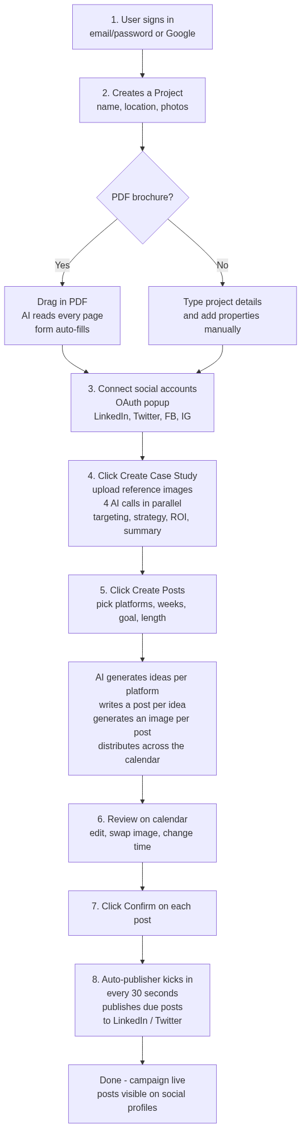

Under the hood (technical summary)
The platform is split across three services, each with one job:
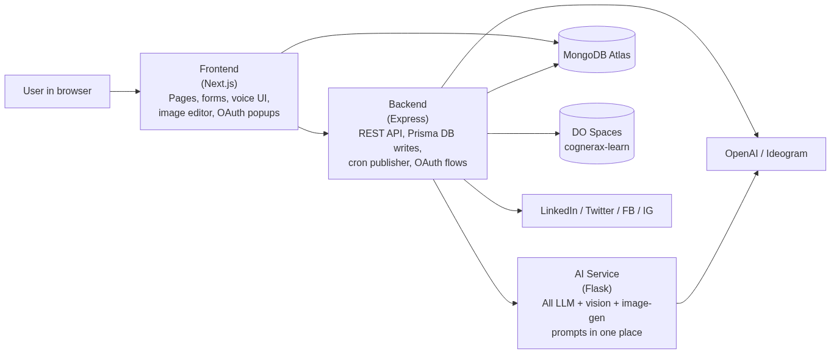
- Frontend handles all UI, form validation, voice capture, image editing, and OAuth popups. Authenticates users with Lucia + Google OAuth.
- Backend is the orchestrator: receives every request, fans out to the AI service for LLM work, writes results to MongoDB via Prisma, uploads media to DigitalOcean Spaces, and publishes confirmed posts to social networks every 30 seconds via a cron job.
- AI service is a stateless prompt library: every endpoint is a wrapper around an OpenAI or Ideogram call with a carefully tuned system prompt. Keeping prompts in one place means tone, tone-shifts, and dialect tuning happen in one repo.

What's special about it (vs. generic AI writers like Buffer, Hootsuite, Jasper)
- Real-estate verticalized: data model speaks "Project", "Apartment", "Villa", "ROI", "marketing strategy" — not generic "campaigns".
- PDF brochure ingestion: nobody else turns a developer's brochure into a structured project in one drop.
- Arabic-first: prompts, dictionaries, RTL layout, dialect-aware copy.
- Voice control: hands-free project + content management is a novelty in the AI-marketing space.
- End-to-end: from raw brochure → published content, all in one tool.
────────────────────────────────────────────────────────────

Table of Contents
- What is Deal AI? *(plain-language overview)*
- Executive Summary *(technical)*
- System Architecture
- Tech Stack
- Data Model
- State Machines
- Authentication
- Project Management
- PDF Brochure Auto-fill
- Case Study Generation
- Post Generation Pipeline
- Image Generation
- Social-Media OAuth & Posting
- Cron Scheduler
- Voice Assistant ("Siri")
- Image Editor (Konva)
- Localization
- Storage
- Frontend API Reference
- Backend API Reference
- Python AI Service Reference
- Configuration / Environment Variables
- Deployment
- Appendix A — Key Prompts
────────────────────────────────────────────────────────────

1. Executive Summary
Deal AI is an AI-driven social-media marketing platform for real-estate developers. It generates marketing case studies, plans content campaigns, drafts posts, generates images, and publishes them across multiple social networks. Arabic is the primary language; English is supported.

Headline capabilities
- Authentication: Email/password with Argon2 + Google OAuth via Lucia (frontend Next.js Server Actions).
- Project management: Real-estate projects, properties (apartments / villas), connected social platforms, soft-delete + restore.
- PDF brochure → structured data: Upload a PDF; gpt-4o-mini vision extracts title/location/units/floor-plans into form fields.
- AI case study: Four parallel calls to the Python AI service produce target-audience segmentation, marketing strategy, ROI projections, and project summary in one shot.
- Multi-platform post campaigns: AI-generated ideas + post content per platform across N weeks; dall-e-3 image per post; auto-distributed to days of the week.
- Image editor: Konva canvas with frame templates, RTL-aware text overlays, crop, export.
- Voice assistant ("Siri"): GPT-4o function-calling for hands-free project / property / case-study / post management. Web Speech API.
- Cron publisher: Every 30 s, publishes confirmed posts to LinkedIn (/v2/ugcPosts) and Twitter/X (/2/tweets) with token-refresh.
- Bilingual i18n: Arabic and English dictionaries; URL-prefixed routing.
- Cloud media: All uploads land in DigitalOcean Spaces (cognerax-learn bucket).

Design tenets
- Three-tier separation: UI (Next.js) ↔ orchestration (Express) ↔ inference (Flask).
- Python service is the single source of LLM/Image/Vision calls so prompts stay in one place.
- Backend is Prisma-only DB writer; frontend never touches the DB directly.
- Cron publisher in the Express backend is the single fan-out to social APIs.
────────────────────────────────────────────────────────────

2. System Architecture

High-level
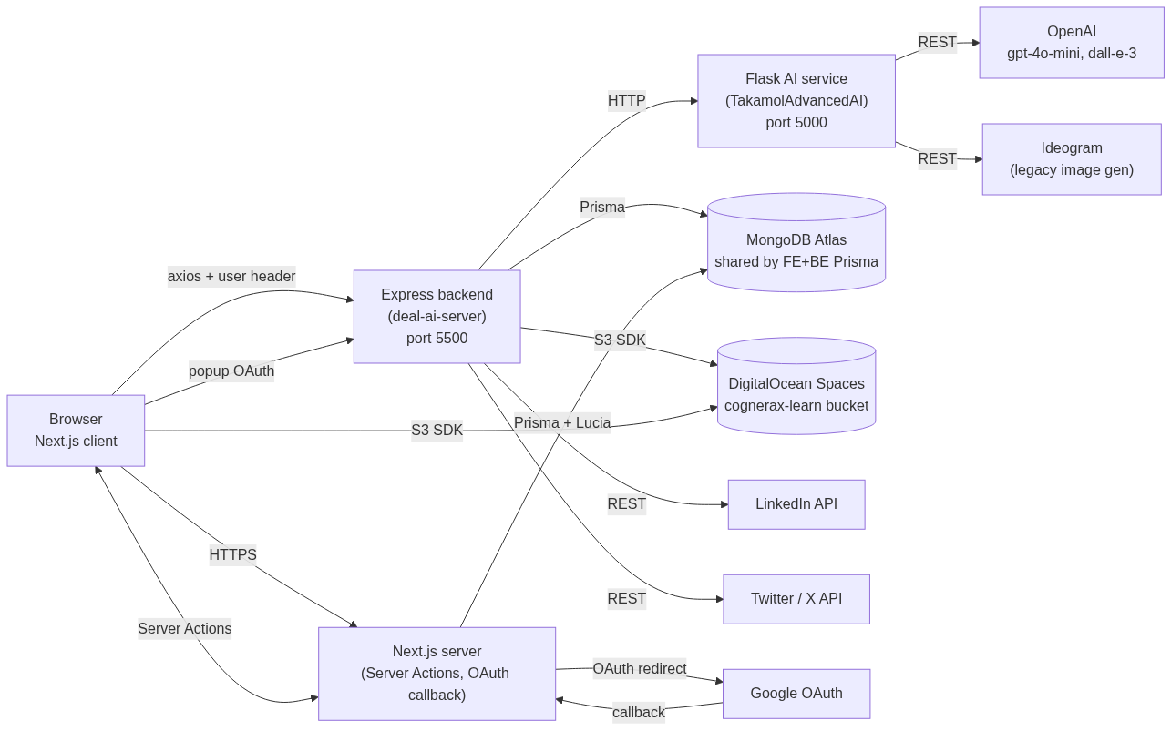

Inter-service dependencies
From | To | Protocol | Purpose
Browser | Next.js | HTTPS | Pages, server actions
Browser | Express | HTTPS + base64 user header | All app data CRUD
Browser | DigitalOcean Spaces | HTTPS (CDN) | Image rendering only
Browser | Express OAuth popup | HTTPS | LinkedIn/Twitter connect popup
Next.js | MongoDB | Prisma | Lucia sessions + User + Project
Express | MongoDB | Prisma | All data writes
Express | Python AI | HTTP (private) | LLM/vision/image calls
Express | OpenAI | HTTPS | Dall-e-3 image gen direct
Express | LinkedIn / Twitter | HTTPS | OAuth + publishing
Python | OpenAI | HTTPS | Chat + vision
Python | Ideogram | HTTPS | Legacy image (out of credit)
Service-port discovery (local dev):
Service | Port | Notes
Next.js | 3000 | yarn dev
Express | 5500 | yarn dev (nodemon)
Flask Python | 5000 | python app.py
Ollama (optional) | 11434 | Not used currently
────────────────────────────────────────────────────────────

3. Tech Stack

Frontend (`deal-ai`)
Layer | Library
Framework | Next.js 14.2.5 (App Router)
Language | TypeScript 5
Auth | Lucia 3.2 + Arctic 1.9 + @node-rs/argon2
ORM | Prisma 5.17 (MongoDB)
UI | Tailwind 3 + Radix UI + shadcn/ui
Forms | React Hook Form + Zod
Image canvas | Konva 9.3 + Sharp 0.33
Voice | voicegpt-assistant 1.0 + Web Speech API
LLM client | openai SDK
HTTP | axios + ky
Storage | aws-sdk v2 (DigitalOcean Spaces)
i18n | translate + custom dictionaries
State | React Context + Hook
Toasts | Sonner

Backend (`deal-ai-server`)
Layer | Library
Runtime | Node.js ≥ 16, ESM
Framework | Express 4.18
ORM | Prisma 5 (MongoDB, same schema as frontend)
Cron | node-cron 3.0
HTTP client | axios 1.7
Image | Sharp 0.33
Storage | aws-sdk 2 (DO Spaces)
Security | helmet + cors + morgan
Auth helpers | lucia + argon2 (used minimally)

Python AI service (`TakamolAdvancedAI`)
Layer | Library
Runtime | Python 3.12
Framework | Flask 3 + flask-cors + flask-socketio
LLM | openai 1.35 (gpt-4o-mini, gpt-4o, dall-e-3)
Vision | OpenAI gpt-4o-mini (image_url content blocks)
Image gen | OpenAI DALL-E + Ideogram V_2
Concurrency | threading + concurrent.futures (parallel AI calls)
Lang detect | langdetect
Server | gunicorn (-w 4) prod / Flask dev server local
────────────────────────────────────────────────────────────

4. Data Model

ER diagram
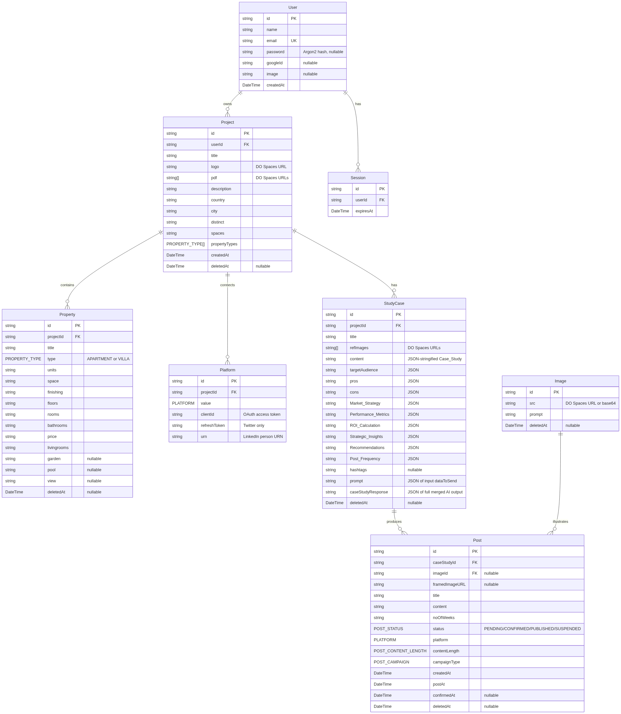

Enums
Enum | Values
PLATFORM | FACEBOOK, LINKEDIN, INSTAGRAM, TWITTER
PROPERTY_TYPE | APARTMENT, VILLA
POST_CAMPAIGN | BRANDING_AWARENESS, ENGAGEMENT, SALES_CONVERSION
POST_CONTENT_LENGTH | SHORT, MEDIUM, LONG
POST_STATUS | PENDING, CONFIRMED, PUBLISHED, SUSPENDED

Soft-delete
- Project, Property, StudyCase, Image, Post carry deletedAt: DateTime?.
- User, Session, Platform are hard-deleted only.

Schema source
Both deal-ai/prisma/schema.prisma and deal-ai-server/prisma/schema.prisma are byte-identical. Drift is a future hazard.
────────────────────────────────────────────────────────────

5. State Machines

Post lifecycle
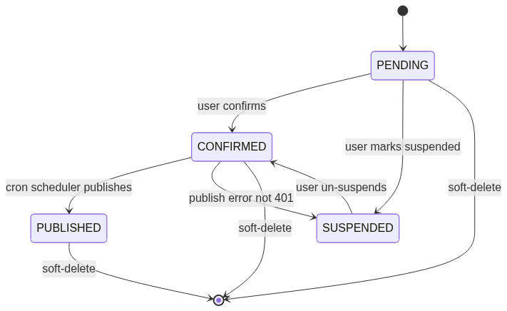

OAuth state lifecycle (LinkedIn / Twitter)
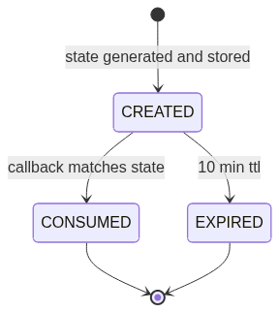
────────────────────────────────────────────────────────────

6. Authentication

6.1 Email/password sign-up
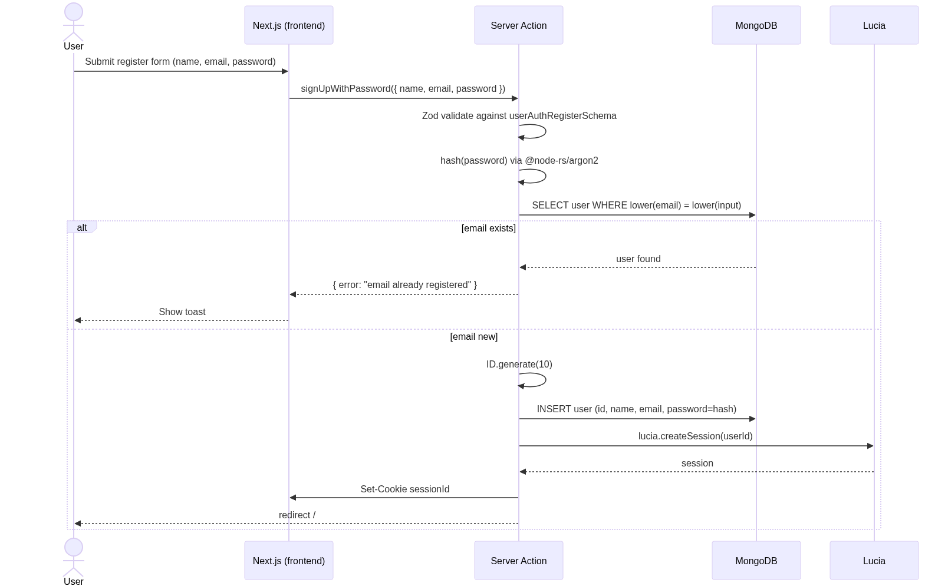
Code refs:
- deal-ai/src/actions/users.ts:21-65
- deal-ai/src/actions/helpers.ts:39-46 — hash()
- deal-ai/src/validations/users.ts:24-28 — schema

6.2 Google OAuth sign-in
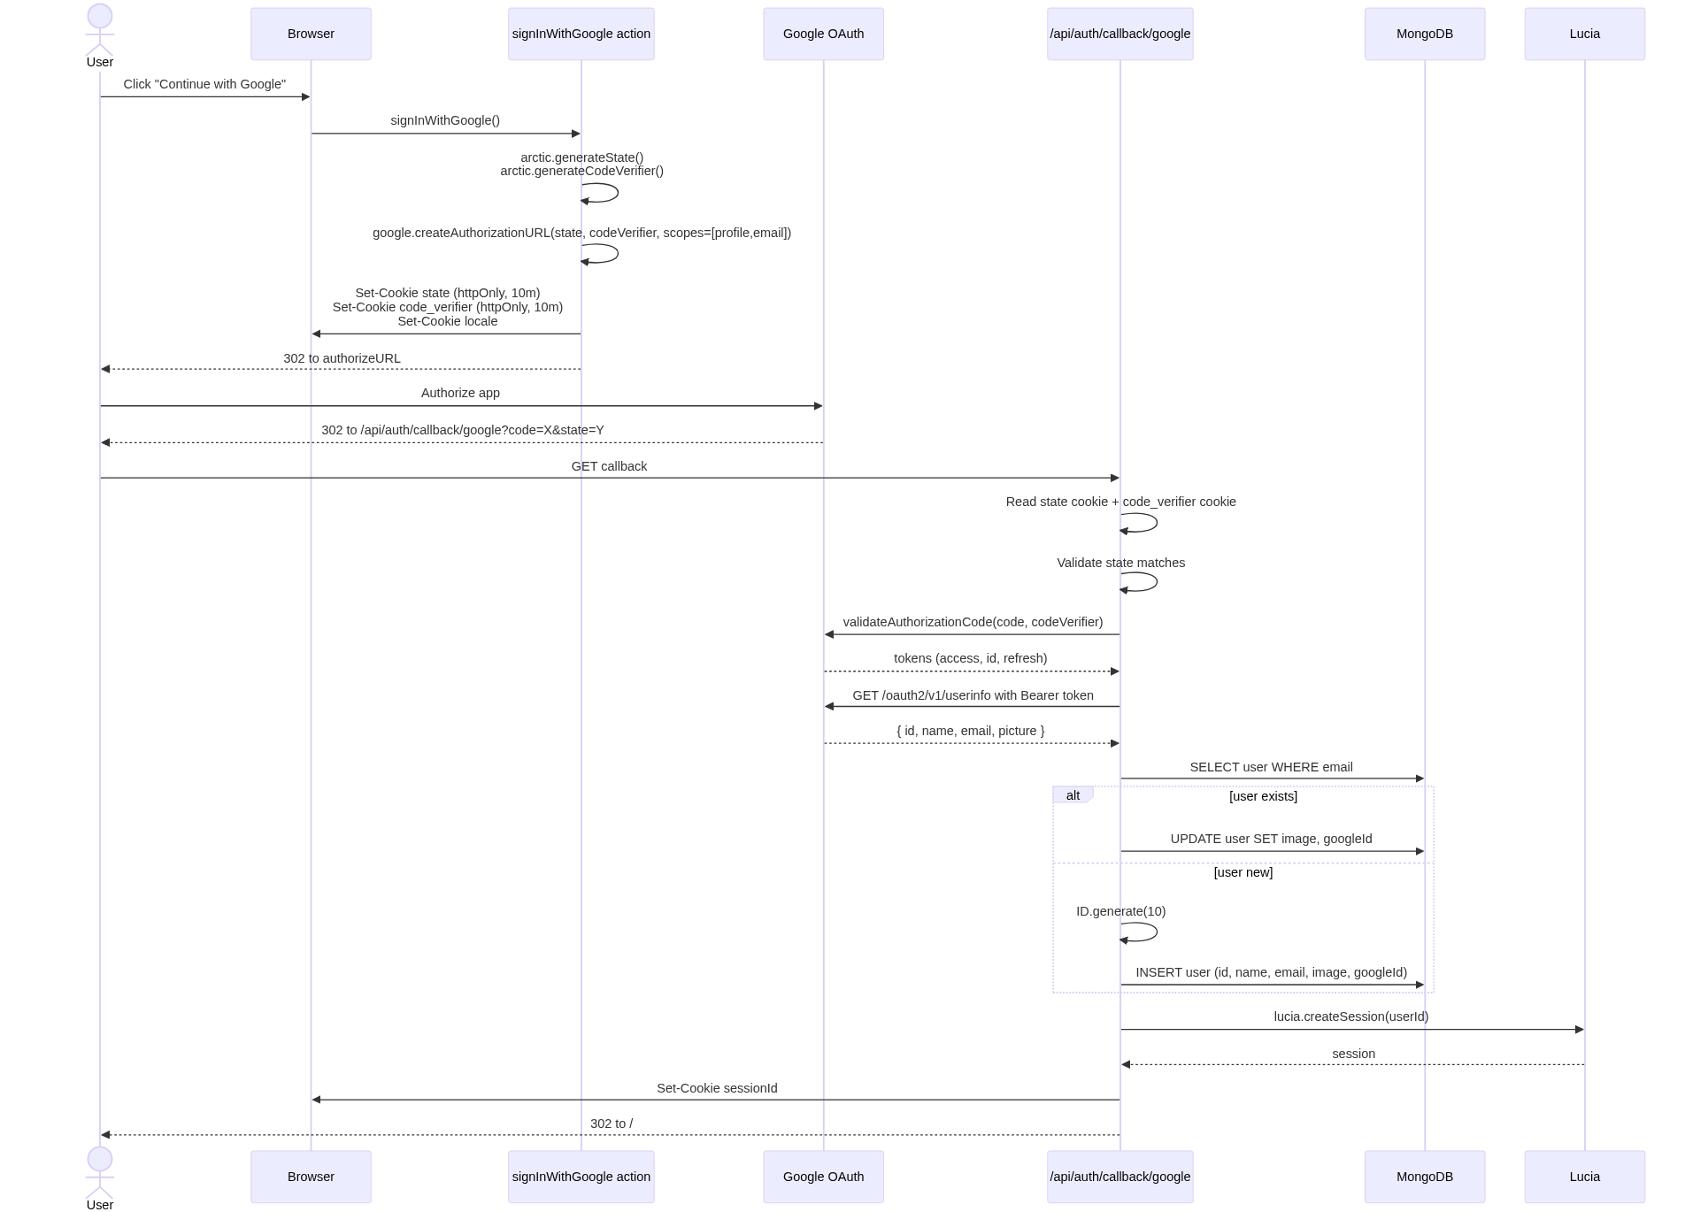
Code refs:
- deal-ai/src/actions/users.ts:107-148
- deal-ai/src/app/api/auth/callback/google/route.ts:1-100

6.3 Logout & profile updates
Action | File | Effect
Logout | actions/users.ts:150-168 | lucia.invalidateSession(), clear cookie, redirect to login
Update name/email | actions/users.ts:170-209 | Auth-checked DB update; revalidate layout cache
Update password | actions/users.ts:211-256 | Argon2 re-hash; new session created (forces re-login on other tabs)
────────────────────────────────────────────────────────────

7. Project Management
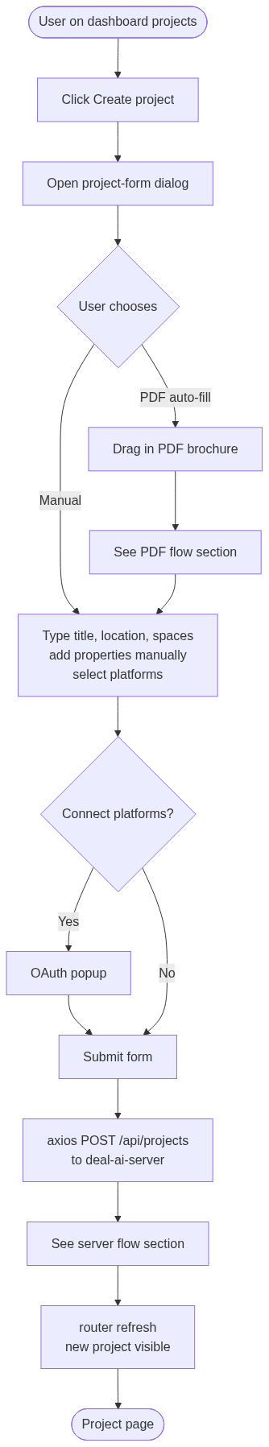

Server-side project creation
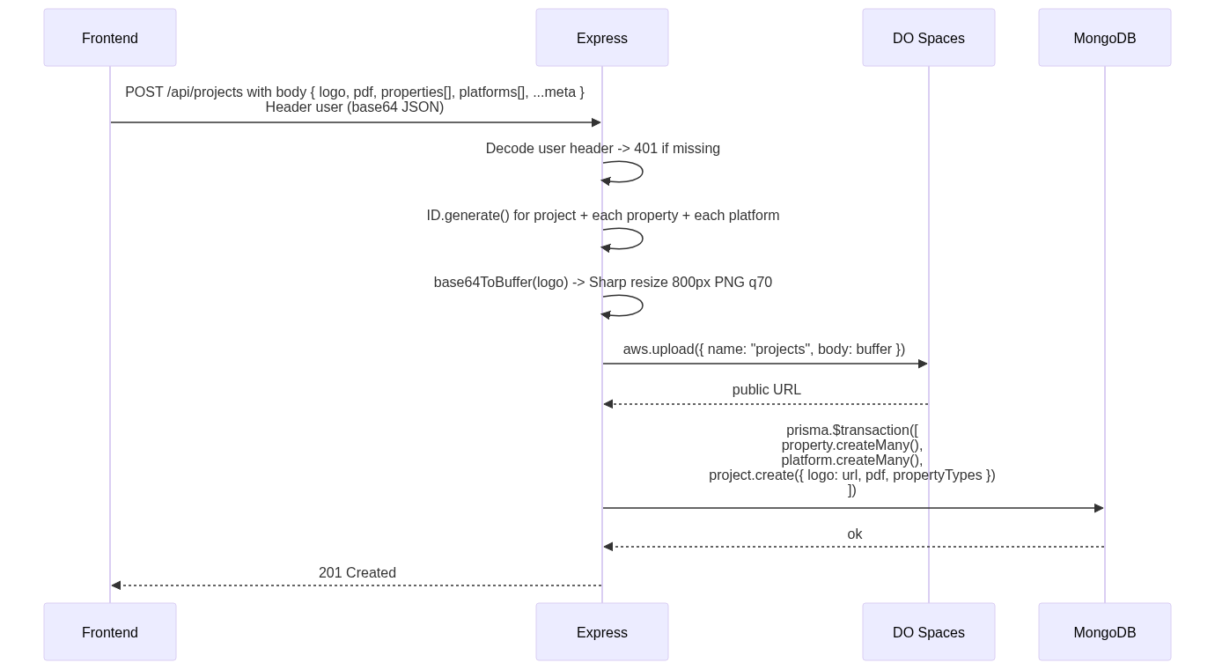
Refs: deal-ai-server/src/routes/projects.js:52-145, deal-ai/src/components/project-form.tsx.

Edit / soft-delete / restore
- Edit: PATCH /api/projects/:id with body fields.
- Soft-delete: PATCH deletedAt = now. Item moves to /dashboard/bin.
- Restore: PATCH deletedAt = null. Listed in /dashboard/projects again.
────────────────────────────────────────────────────────────

8. PDF Brochure Auto-fill
This is the killer onboarding feature: drag a PDF, get the form filled in.
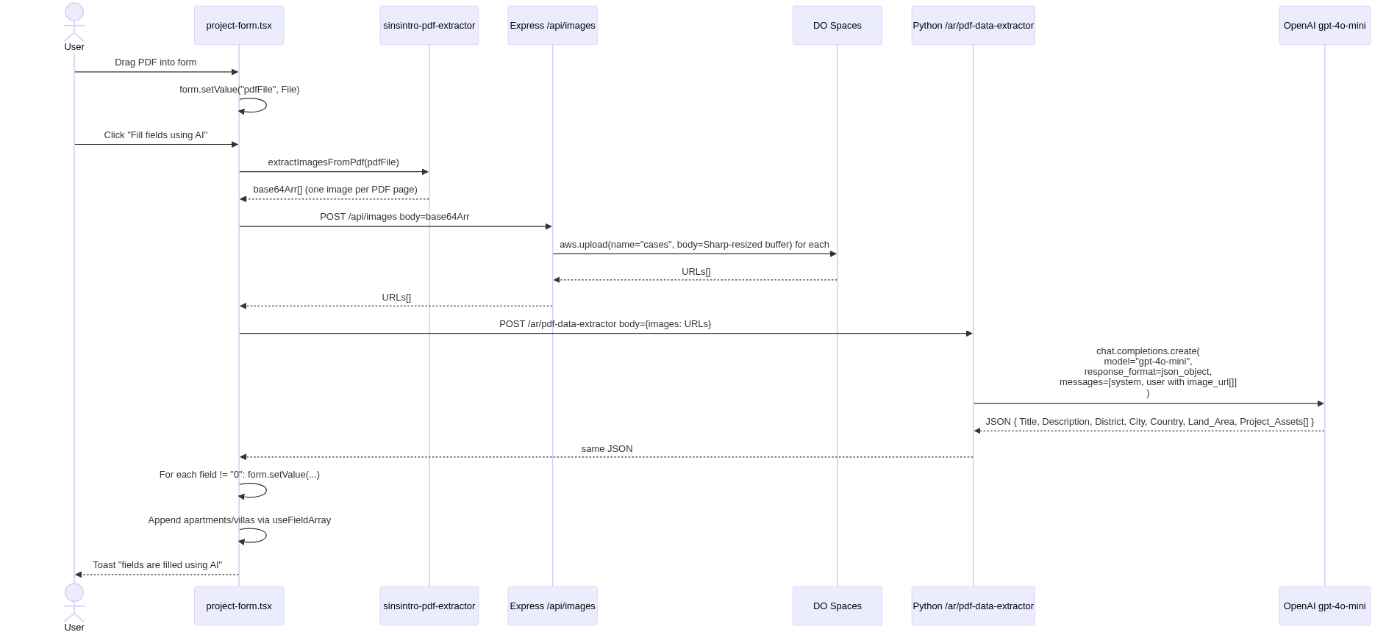
Refs: deal-ai/src/components/project-form.tsx:140-278; TakamolAdvancedAI/app.py:113-171.
System prompt is reproduced in Appendix A.
────────────────────────────────────────────────────────────

9. Case Study Generation
The most prompt-heavy flow. One client request fans out to four parallel AI calls.
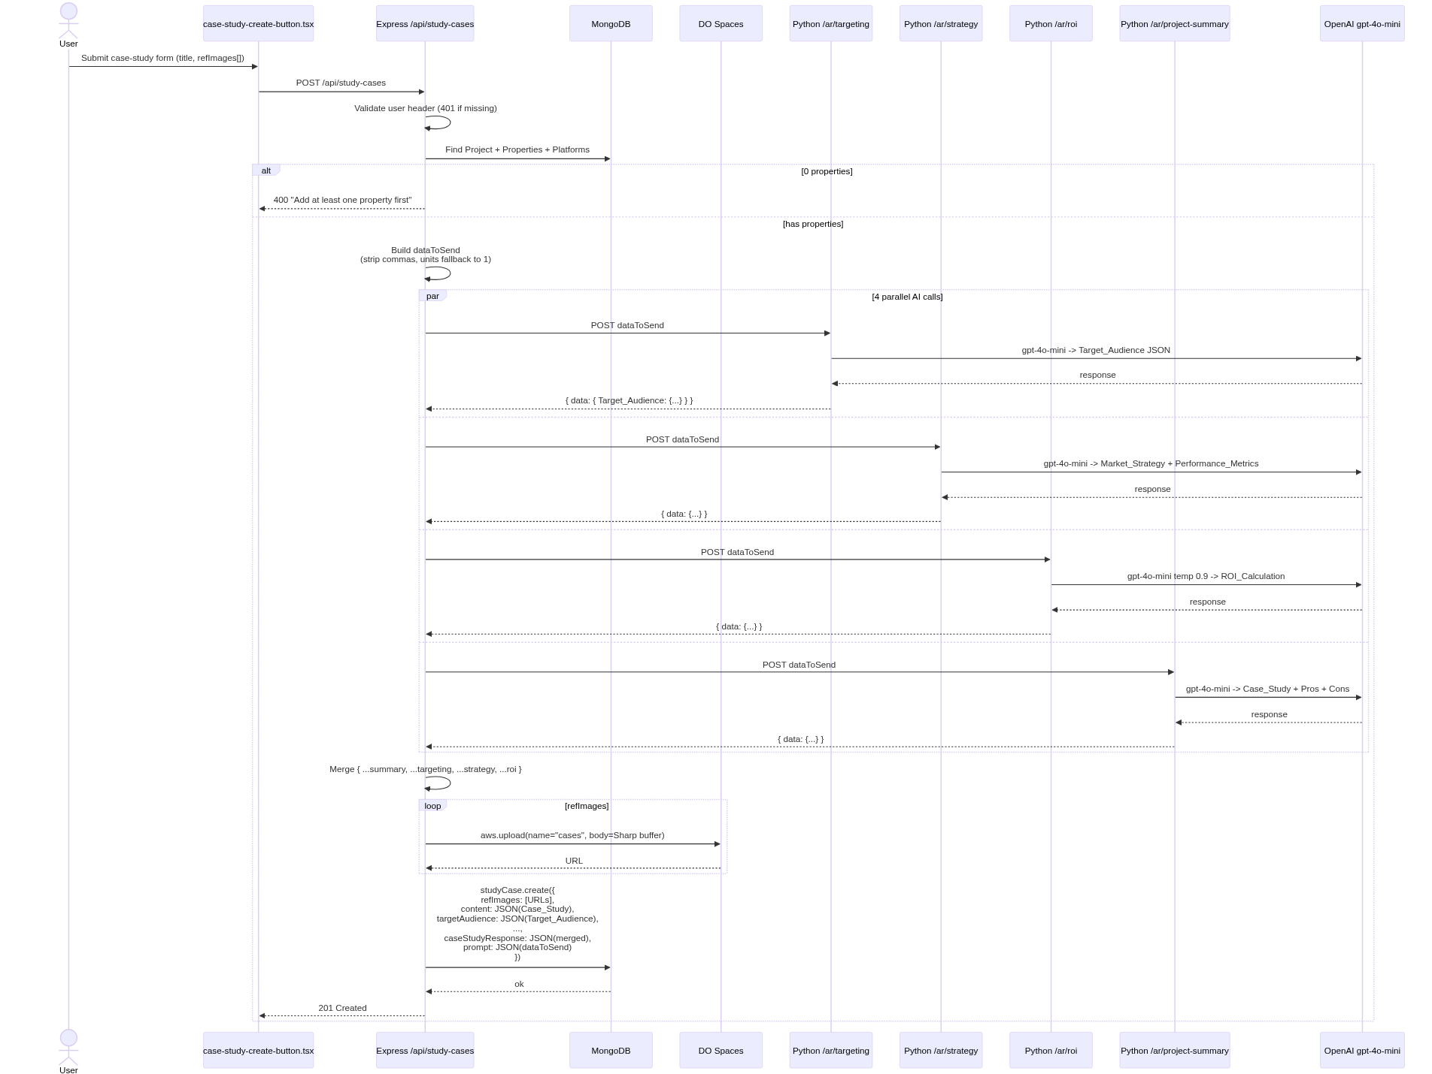

Asset normalization (the comma + units fix)
study-cases.js runs every property through:
[JS]
const stripCommas = v => typeof v === "string" ? v.replace(/,/g, "") : v;
const atLeastOne = v => {
const cleaned = stripCommas(v);
const n = parseFloat(cleaned);
return !isFinite(n) || n < 1 ? "1" : cleaned;
};
Reason: /ar/roi does float(price) * int(units); commas in "2,000,000" blow up float(), and units: "0" silently produces zero ROI. The frontend sometimes stores numeric fields as comma-formatted strings.
Refs: deal-ai-server/src/routes/study-cases.js:43-185; TakamolAdvancedAI/app.py:1486-1634.
────────────────────────────────────────────────────────────

10. Post Generation Pipeline
The biggest pipeline in the system. Two-stage: generate ideas, then generate posts (one per idea).

Stage 1: ideas
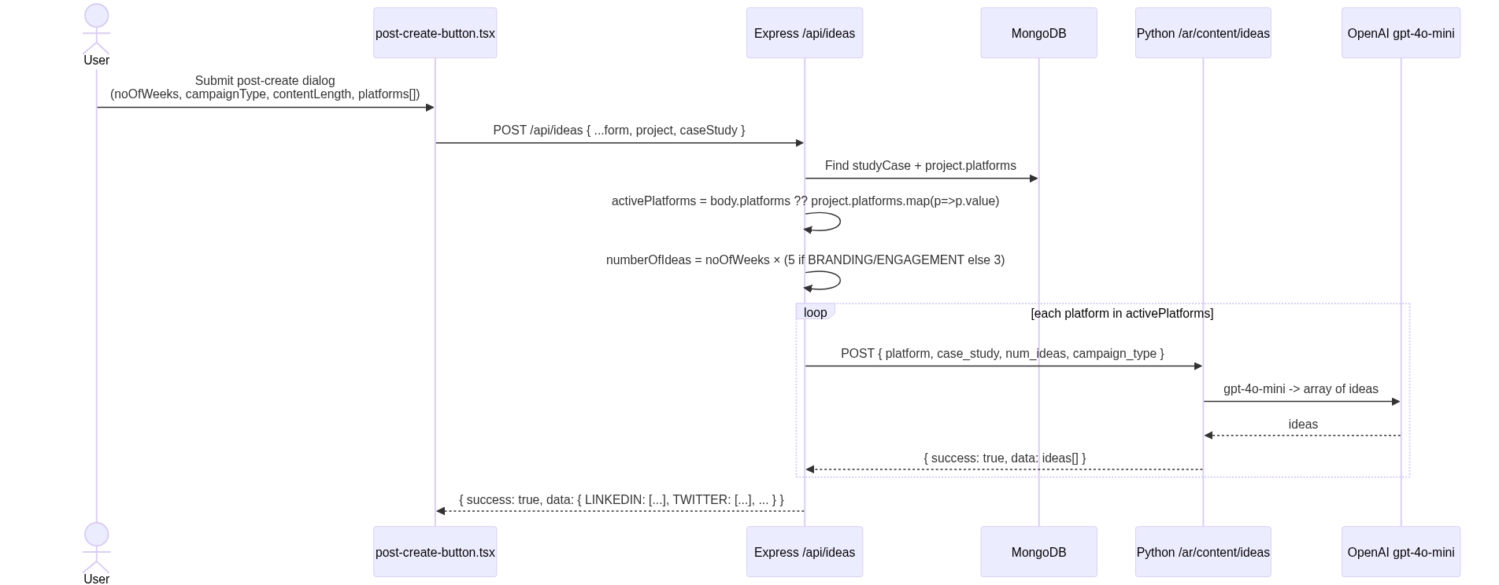

Stage 2: posts (per idea)
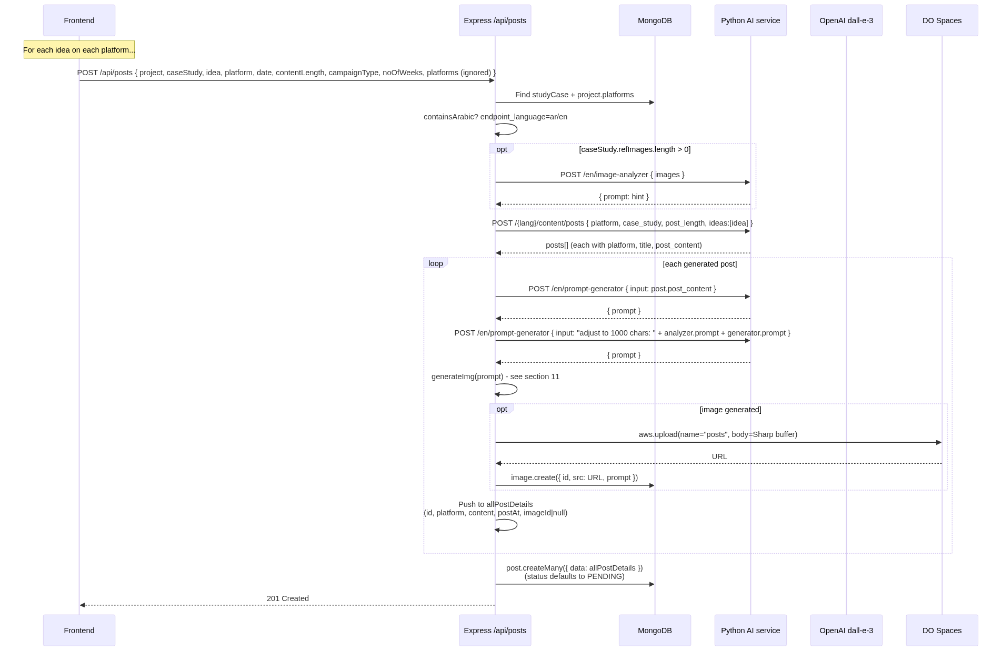

Day-of-week distribution (frontend logic)
[JS]
// post-create-button.tsx:104-150
const noOfPostsPerWeek =
data.campaignType === "BRANDING_AWARENESS" || data.campaignType === "ENGAGEMENT"
? 5 : 3;
const daysToPost = noOfPostsPerWeek === 3 ? [0, 2, 4] : [0, 1, 2, 3, 4];
// Each idea gets postAt incremented day by day, skipping non-daysToPost,
// random hour 11-20 local.
So a 5-week BRANDING_AWARENESS campaign with 4 platforms = 5 × 5 × 4 = 100 posts. Each calls /api/posts separately.
Refs:
- deal-ai/src/components/post-create-button.tsx:74-186
- deal-ai-server/src/routes/posts.js:71-400
- deal-ai-server/src/routes/ideas.js:71-205
────────────────────────────────────────────────────────────

11. Image Generation
The image-gen path went through three iterations:
- Original: Python /image-model-2 → Ideogram (out of credit).
- Local fallback: Skip image, post text-only.
- Current (this codebase): Express calls OpenAI dall-e-3 directly with retry-on-429.

Current flow
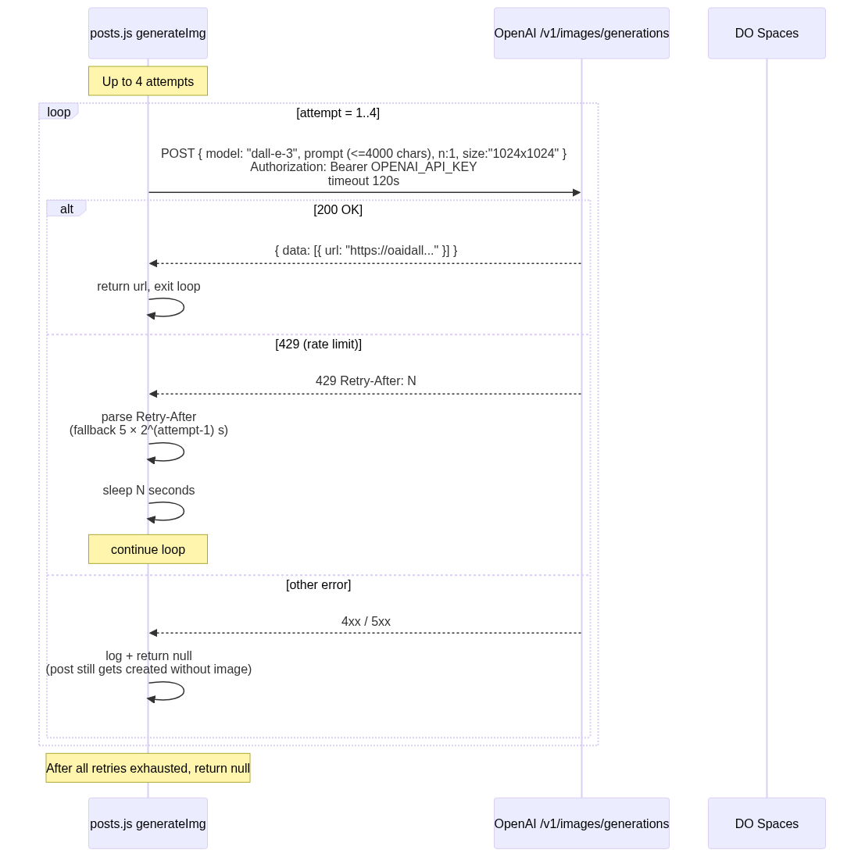
After generateImg returns a URL:
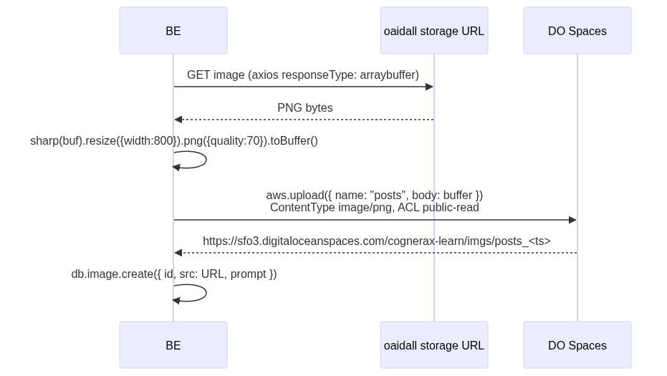

Why dall-e-3 directly (not Python)?
The Python service's /image-model-2 proxies to Ideogram, which ran out of API credits. Going direct from Express to OpenAI:
- Avoids the dead Python path.
- Lets us own the retry-on-429 logic in JS.
- Keeps the Sharp + S3 upload colocated with the Post insert.
Refs: deal-ai-server/src/routes/posts.js:56-108 (and identical copy in ideas.js).
────────────────────────────────────────────────────────────

12. Social-Media OAuth & Posting

LinkedIn — popup OAuth
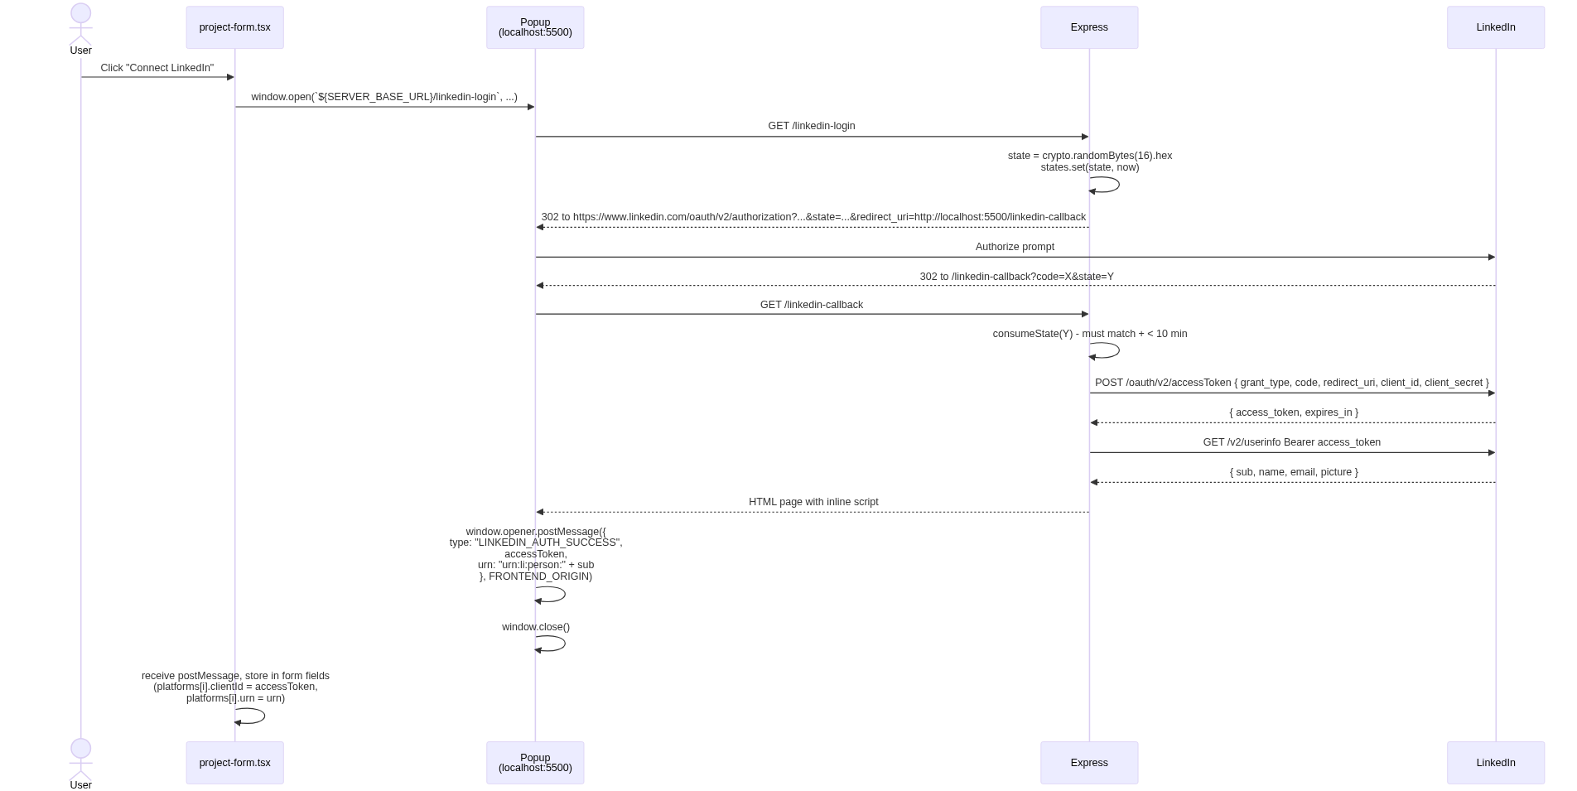

Twitter — OAuth 2.0 + PKCE
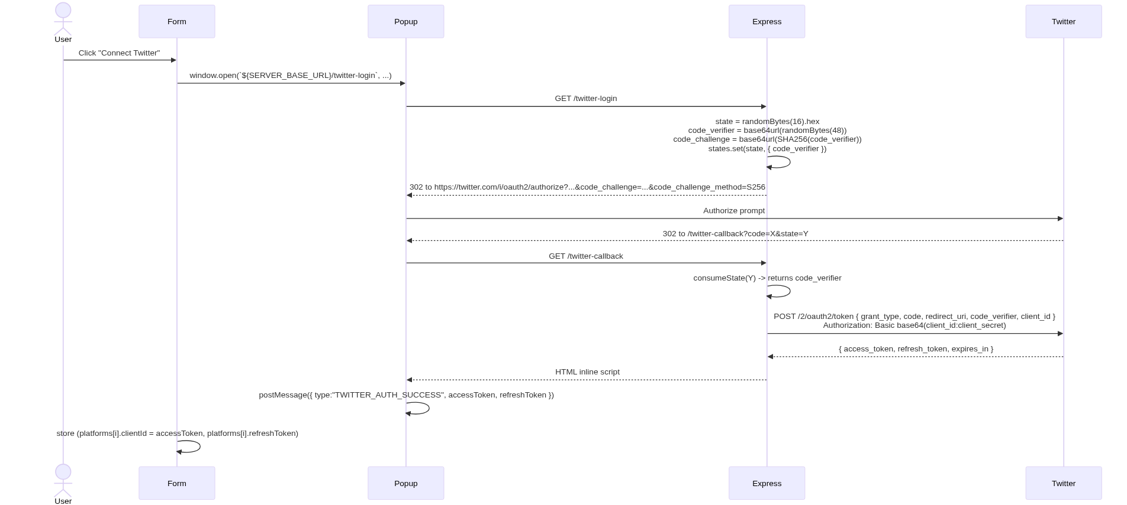

Posting (LinkedIn)
publishToLinkedIn({ text, accessToken, urn }) in deal-ai-server/src/lib/social.js:
[JS]
POST https://api.linkedin.com/v2/ugcPosts
Authorization: Bearer ${accessToken}
X-Restli-Protocol-Version: 2.0.0
Content-Type: application/json
{
"author": "<urn>",
"lifecycleState": "PUBLISHED",
"specificContent": {
"com.linkedin.ugc.ShareContent": {
"shareCommentary": { "text": "<post text>" },
"shareMediaCategory": "NONE"
}
},
"visibility": {
"com.linkedin.ugc.MemberNetworkVisibility": "PUBLIC"
}
}

Posting (Twitter)
publishToTwitter({ text, accessToken }):
[JS]
POST https://api.twitter.com/2/tweets
Authorization: Bearer ${accessToken}
{ "text": "<post text>" }

Token refresh (Twitter only)
When the cron publisher gets a 401 from /2/tweets, it auto-refreshes:
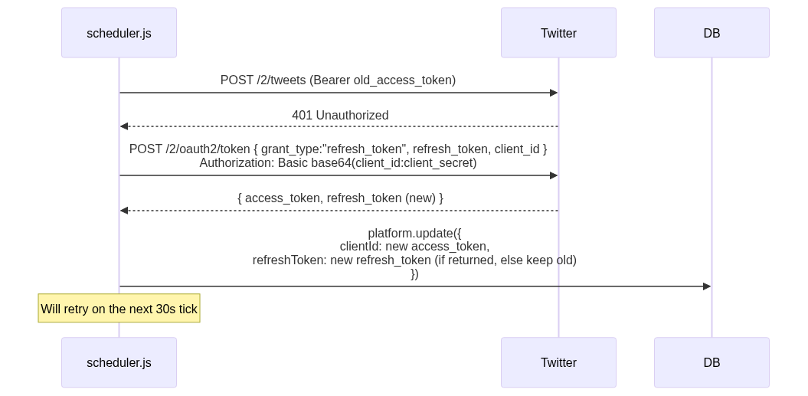
Refs: scheduler.js:150-205.
────────────────────────────────────────────────────────────

13. Cron Scheduler
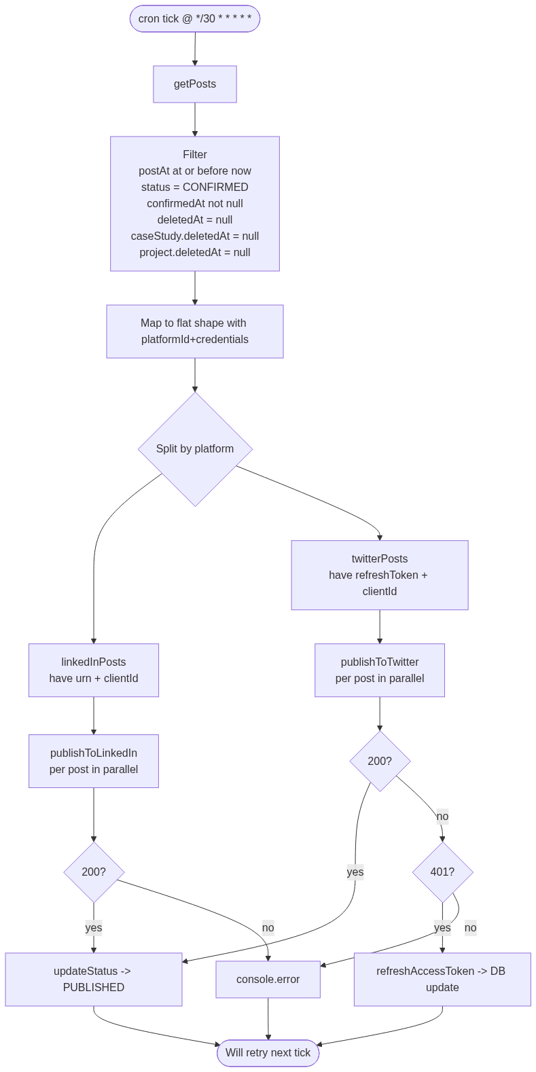
Refs: deal-ai-server/src/lib/scheduler.js:1-210; deal-ai-server/src/index.js:45.
────────────────────────────────────────────────────────────

14. Voice Assistant ("Siri")
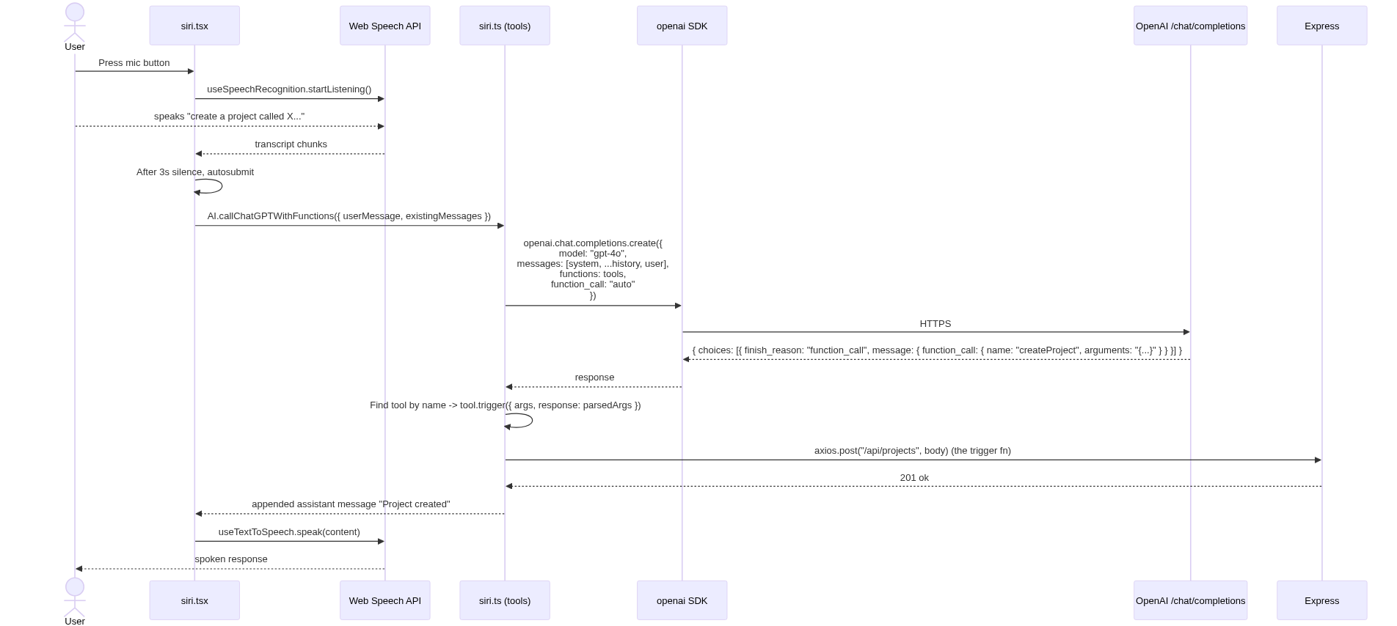

Tools defined in `src/lib/siri.ts`
Tool | Effect
createProject | POST /api/projects with structured fields
deleteProject | List user projects, find by title, DELETE
addPropertyTypes | POST /api/properties (bulk)
deleteProperty | Find + DELETE property
createStudyCase | POST /api/study-cases
deleteStudyCase | DELETE study case
createPost | POST /api/posts
deletePost | DELETE post
Each tool exposes a JSON-schema for its arguments and a trigger(data) async fn that performs the side effect.
Wake-word: "hello" (line 110-121 in siri.tsx) — listened for in continuous mode; once heard, subsequent transcripts populate the message.
Refs: deal-ai/src/lib/siri.ts, deal-ai/src/components/siri.tsx, deal-ai/src/lib/openai.ts.
────────────────────────────────────────────────────────────

15. Image Editor (Konva)
Entry: /[lang]/editors/images/:img-id opens ImageEditor which instantiates a PhotoEditor Konva wrapper.
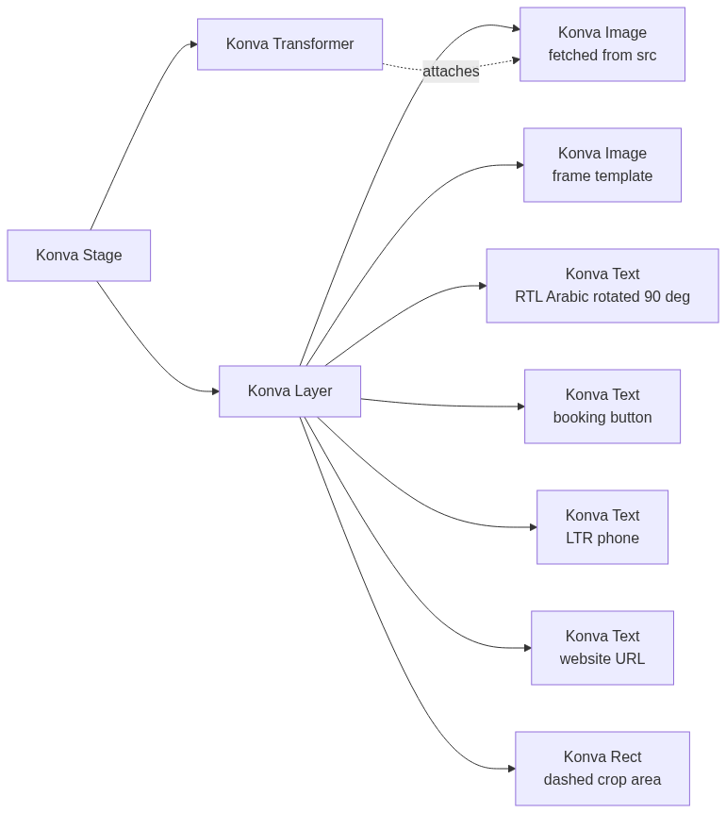
PhotoEditor public methods (src/lib/konva.ts):
Method | Purpose
addPhoto(src) | Load image from URL; scale-fit into crop area
addBase64(b64) | Same with base64 string
addFrame(frameId) | Load from public/frames/frame-XX.png (regular and filled variants)
addText(opts) | Add RTL/LTR text node with lang parameter
adjustCropRect(ratio) | Resize crop rectangle
setEditorSize(w, h) | Update stage dimensions
exportCanvas() | stage.toDataURL() for upload
Frame templates: public/frames/frame-01.png … frame-05.png (and filled/ variants). Each has its own applyFrame* constant in src/lib/constants.ts that places the title, CTA, phone, and URL at frame-specific coordinates.
────────────────────────────────────────────────────────────

16. Localization
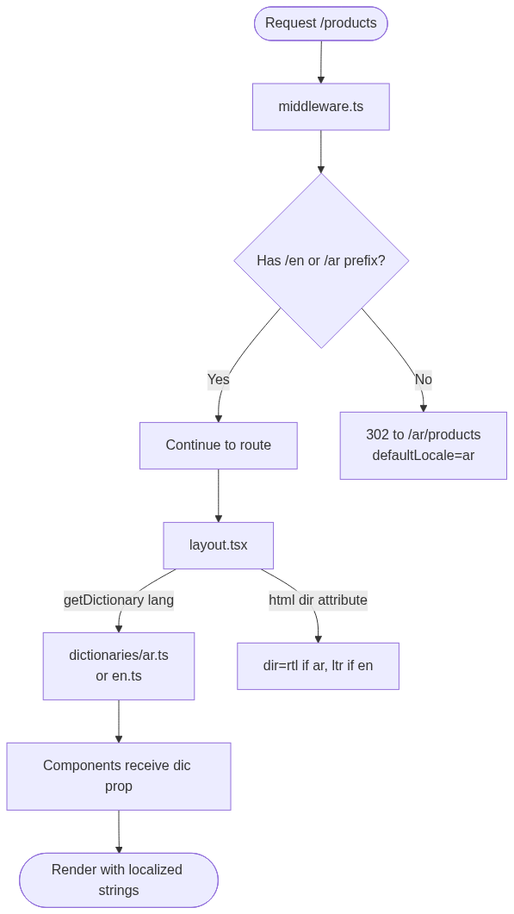

Files
- src/middleware.ts — locale routing
- src/lib/locale.ts — i18n config, getDictionary(), t(value, { from, to })
- src/dictionaries/en.ts, src/dictionaries/ar.ts — full UI strings (≈47 KB + 39 KB)
- src/app/[lang]/layout.tsx:62 — <html dir={lang === "ar" ? "rtl" : "ltr"}>

Dynamic translation
Anything outside the static dictionaries is run through the translate npm package (Google Translate under the hood) at request time via t(text, { from: "en", to: locale }). Used for backend error messages forwarded to user.

Backend i18n
Express has its own src/lib/locale.js mirror that reads the locale request header and provides c?.["error key"] lookups for translated error messages. Same dictionary files duplicated server-side.
────────────────────────────────────────────────────────────

17. Storage

DigitalOcean Spaces
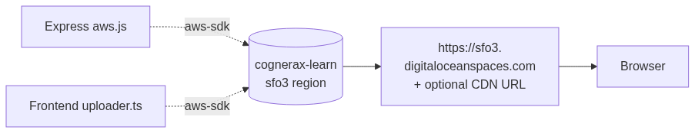

Upload prefixes
`name` arg | Final key | Used by
"projects" | imgs/projects_<timestamp> | Project logos
"cases" | imgs/cases_<timestamp> | Study-case ref images, PDF page images
"posts" | imgs/posts_<timestamp> | Post images (DALL-E generated)
ACL is always public-read; Content-Type defaults to image/png. The S3 client uses s3ForcePathStyle: true (DO Spaces requirement).

Allowed Next.js remote image hosts
next.config.mjs:12-52:
- cognerax-learn.sfo3.digitaloceanspaces.com
- sfo3.digitaloceanspaces.com
- cognerax-learn.sfo3.cdn.digitaloceanspaces.com
- takamolspace.lon1.digitaloceanspaces.com (legacy)
- lon1.digitaloceanspaces.com (legacy)
- oaidalleapiprodscus.blob.core.windows.net (DALL-E temp URLs)
- ideogram.ai (legacy)
- images.unsplash.com, plus.unsplash.com, source.boringavatars.com
────────────────────────────────────────────────────────────

18. Frontend API Reference

Pages (App Router)
Path | Purpose | Auth
/ | Landing → redirect to login if unauth
/[lang]/login | Email/password + Google OAuth | Public
/[lang]/register | Email/password sign-up | Public
/[lang]/dashboard | Overview | Required
/[lang]/dashboard/projects | Project list | Required
/[lang]/dashboard/projects/[project-id] | Project detail | Required
/[lang]/dashboard/projects/[project-id]/properties/[property-id] | Property edit | Required
/[lang]/dashboard/projects/[project-id]/cases/[case-study-id] | Case study + posts | Required
/[lang]/dashboard/projects/[project-id]/cases/[case-study-id]/posts/[post-id] | Post edit | Required
/[lang]/dashboard/calender | Calendar / scheduler view | Required
/[lang]/dashboard/bin | Trash overview | Required
/[lang]/dashboard/bin/{posts,cases,properties} | Per-type trash | Required
/[lang]/dashboard/settings | Settings hub | Required
/[lang]/dashboard/settings/appearance | Theme | Required
/[lang]/editors/images/[img-id] | Konva editor | Required
/api/auth/callback/google | Google OAuth callback | n/a

Server Actions (`src/actions/users.ts`)
Action | Purpose
signUpWithPassword({ name, email, password }) | Create user, hash, session
signInWithPassword({ email, password }) | Verify, session
signInWithGoogle() | Generate state/codeVerifier, set cookies, redirect to Google
logout() | Invalidate session, clear cookie, redirect
updateUser({ id, name, email }) | Edit profile
updatePassword({ id, password }) | Re-hash, new session

Frontend env vars (consumed in `src/`)
Variable | Used by | Purpose
NEXT_PUBLIC_BASE_URL | lib/auth.ts:40 | Google OAuth redirect URI base
NEXT_PUBLIC_SERVER_BASE_URL | lib/axios.ts:7, scheduler.tsx, project-form.tsx | Express backend base URL
NEXT_PUBLIC_AI_API | project-form.tsx:207 | Python AI service base (PDF extractor only on FE)
NEXT_PUBLIC_OPENAI_API_KEY | lib/openai.ts:14 | Voice assistant LLM
NEXT_PUBLIC_GOOGLE_MAPS_API_KEY | (maps component) | Map widgets
GOOGLE_CLIENT_ID / GOOGLE_CLIENT_SECRET | lib/auth.ts:38-39 | OAuth
DATABASE_URL | Prisma | MongoDB
DO_SPACE_* (URL/REGION/ID/SECRET/BUCKET) | lib/uploader.ts | DO Spaces
NODE_ENV | various | Cookie security toggle, error stack
────────────────────────────────────────────────────────────

19. Backend API Reference

Server config (`src/index.js`)
Setting | Value
Port | process.env.PORT ?? 8080 (production .env sets 5500)
Body limit | 100 MB JSON / 100 MB urlencoded
CORS origins | http://localhost:3000, https://urchin-app-6wl4t.ondigitalocean.app
CORS headers | Content-Type, locale, user
HTTP timeout | 300 000 ms (5 min)
Cron interval | */30 * * * * * (every 30 s)

Endpoints
Method | Path | Purpose | Auth | Externals called
GET | / | Health | — | —
GET | /api/projects | List projects | — | —
POST | /api/projects | Create project + properties + platforms | user header | DO Spaces
PATCH | /api/projects/:id | Update project | user header | —
DELETE | /api/projects/:id | Hard-delete project | user header | —
GET | /api/properties | List properties | — | —
POST | /api/properties | Bulk-create properties | user header | —
PATCH | /api/properties/:id | Update property | user header | —
DELETE | /api/properties/:id | Hard-delete property | user header | —
GET | /api/study-cases | List case studies | — | —
POST | /api/study-cases | Create case study (4 parallel AI calls) | user header | Python ×4, DO Spaces
PATCH | /api/study-cases/:id | Update case study | user header | —
DELETE | /api/study-cases/:id | Hard-delete case study | user header | —
GET | /api/ideas | List "ideas" (likely unused) | — | —
POST | /api/ideas | Generate per-platform content ideas | user header | Python (per platform)
GET | /api/posts | List posts | — | —
GET | /api/posts/caseStudyId | List posts for caseStudy | — | —
POST | /api/posts | Multi-step post-gen pipeline | user header | Python ×3-4, OpenAI dall-e-3, DO Spaces
PATCH | /api/posts/:id | Update post (status, content, etc.) | user header | —
DELETE | /api/posts/:id | Hard-delete post | user header | —
GET | /api/images | List images | — | —
POST | /api/images | Bulk upload base64 images to S3 | — | DO Spaces
POST | /api/images/regenerate | Regenerate single image from prompt | user header | Python
POST | /api/images/prompts/regenerate | Refine prompt text | user header | Python
PATCH | /api/images/:id | Update image src/metadata | user header | DO Spaces (if base64)
GET | /linkedin-login | OAuth init (popup) | — | LinkedIn
GET | /linkedin-callback | OAuth code exchange | — | LinkedIn ×2
POST | /linkedin-post | Publish to LinkedIn | — | LinkedIn
GET | /twitter-login | OAuth init with PKCE | — | Twitter
GET | /twitter-callback | OAuth code exchange | — | Twitter
POST | /post-tweet | Publish to Twitter | — | Twitter

Backend env vars
Variable | Required | Purpose
PORT | no | Server port (default 8080; set to 5500)
NODE_ENV | no | Stack-trace toggling
DATABASE_URL | yes | MongoDB connection string
NEXT_PUBLIC_AI_API | yes | Python AI service base URL
FRONTEND_ORIGIN | no | postMessage targetOrigin (default http://localhost:3000)
LINKEDIN_CLIENT_ID / LINKEDIN_CLIENT_SECRET / LINKEDIN_REDIRECT_URI | yes | LinkedIn OAuth
TWITTER_CLIENT_ID / TWITTER_CLIENT_SECRET / TWITTER_REDIRECT_URI | yes | Twitter OAuth
OPENAI_API_KEY (or NEXT_PUBLIC_OPENAI_API_KEY fallback) | yes | dall-e-3 image gen
DO_SPACE_* | yes | DO Spaces credentials
────────────────────────────────────────────────────────────

20. Python AI Service Reference
Bootstrap: app.py:53-78. Local-dev: python app.py → 127.0.0.1:5000. Prod: gunicorn -w 4 -b :$PORT app:app.

Endpoint catalog
Method / Path | Purpose | Helper / model
POST /ar/pdf-data-extractor | Vision-extract project metadata from PDF page images | pdf_extractor / gpt-4o-mini vision
POST /shortcontent | Short / Medium / Long copy variants | short_content_generator / gpt-4o-mini
POST /en/chat/casestudy | Case study EN | case_study_ai / gpt-4o-mini
POST /ar/chat/casestudy | Case study AR | same
POST /en/chat/socialmediaplan | Social plan EN | social_media_ai / gpt-4o-mini
POST /ar/chat/socialmediaplan | Social plan AR | same
POST /image | Direct image gen | image_creator / dall-e-2 1024² hd vivid
POST /image2 | Investment image | same
POST /image-model-2 | Architectural render via Ideogram V_2 RENDER_3D 16:9 | generate_image_from_ideogram
POST /image-model-2-remix | Ideogram remix from URL | generate_image_from_ideogram_remix
POST /en/prompt-generator | Build creative image prompt EN | prompt_creator / gpt-4o-mini
POST /ar/prompt-generator | Same AR | same
POST /en/prompt-enhancer | Refine user prompt EN | prompt_enhancer / gpt-4o-mini
POST /ar/prompt-enhancer | Same AR | same
POST /en/image-analyzer | Compare images, extract differences | image_analyzer / gpt-4o-mini vision
POST /ar/image-analyzer | Same AR | same
POST /investment/image-analyzer | Investment image analysis | same
POST /en/investment | Investment analysis EN | investment_generator / gpt-4o-mini temp 0.9
POST /ar/investment-selector | Detect property type from input | investment_selector / gpt-4o-mini
POST /ar/investment-editor | Edit investment proposal | investment_editor / gpt-4o-mini
POST /simple-investment | Simplified single-tower analysis | inline / gpt-4o-mini
POST /ar/investment-residential-building | Per-type investment | dynamic route
POST /ar/investment-residential-commercial-building | (multiplier 2.0) | dynamic
POST /ar/investment-commercial-building |  | dynamic
POST /ar/investment-shopping-mall |  | dynamic
POST /ar/investment-villas |  | dynamic
POST /ar/investment-villa |  | dynamic
POST /ar/investment-residential-compound |  | dynamic
POST /ar/investment-administrative-building |  | dynamic
POST /ar/investment-hotel |  | dynamic
POST /ar/investment-Commercial_residential_tower |  | dynamic
POST /ar/investment-Commercial_and_administrative_tower |  | dynamic
POST /ar/investment-administrative_tower |  | dynamic
POST /analyze-map | Analyze Google Maps URL via vision | inline / gpt-4o vision
POST /ar/analyze-location | 1-2 sentence Arabic explanation | generate_location_why_ar / gpt-4o-mini
POST /group-services | Group services by category | group_services / gpt-4o-mini temp 0
POST /unreal-engine-chat-v1 | Conversational chat | Unreal_Engine_Chat / gpt-4o-mini
POST /compare-two-projects | Compare two RE projects financially | start_comparison
POST /ar/recommend-property-type | Bilingual property-type recommendation | property_type_recommendation / gpt-4o-mini
POST /ar/land-best-use-conclusion | Best-use conclusion | land_best_use_conclusion / gpt-4o-mini
POST /ar/targeting | Audience targeting | create_platform_targeting / gpt-4o-mini temp 0.3
POST /ar/strategy | Marketing strategy | generate_market_strategy / gpt-4o-mini
POST /ar/roi | ROI projections | calculate_roi_projections / gpt-4o-mini temp 0.9
POST /ar/marketing-analysis | All four (parallel ThreadPoolExecutor) | composite
POST /ar/project-summary | Case study + pros/cons | calculate_project_summary / gpt-4o-mini
POST /ar/content/generate | Combined ideas + posts | ContentGenerator
POST /ar/content/ideas | Per-platform ideas | generate_content_ideas / gpt-4o-mini
POST /ar/content/posts | Per-platform posts from ideas | generate_posts_for_ideas / gpt-4o-mini
GET /twitter-login | (legacy) Twitter OAuth init | uses TWITTER_CLIENT_ID
GET /twitter-callback | (legacy) Twitter token exchange | session-stored
POST /post-tweet | (legacy) Tweet | session-token
GET /fetch-and-delete-first-tweet | (legacy) Cleanup tool
GET /linkedin-login | (legacy) LinkedIn OAuth init
GET /linkedin-callback | (legacy) Token exchange
POST /linkedin-post | (legacy) Post text
Note: The Python service's OAuth + posting endpoints are legacy and overlap with the Express backend's implementation. The Express versions (deal-ai-server/src/routes/{linkedin,twitter}.js) are now canonical; the Python ones can be considered deprecated.

Models in use (Python service)
Model | Where | Role
gpt-4o-mini | most text + vision endpoints | Default workhorse
gpt-4o | /analyze-map only | Higher-quality vision
dall-e-2 | /image, /image2 | Quick generation
dall-e-3 | investment_image_creator (semaphore=5) | High-quality investment images
Ideogram V_2 | /image-model-2, /image-model-2-remix | Architectural renders (16:9, RENDER_3D)

Concurrency primitives
- task_queue = Queue() (app.py:75) for async image-gen tasks.
- semaphore = threading.Semaphore(5) (app.py:77) caps concurrent image generation.
- concurrent.futures.ThreadPoolExecutor (app.py:1580) parallelizes the four marketing-analysis sub-calls.

Python env vars
Variable | Purpose
OPENAI_API_KEY | OpenAI auth (chat + image)
IDEOGRAM_API_KEY | Ideogram auth
TWITTER_CLIENT_ID / TWITTER_CLIENT_SECRET | (legacy) Twitter OAuth
LINKEDIN_CLIENT_ID / LINKEDIN_CLIENT_SECRET | (legacy) LinkedIn OAuth
DOMAIN_ORIGIN | Frontend origin for OAuth redirects
PORT | Server port (gunicorn)
────────────────────────────────────────────────────────────

21. Configuration / Environment Variables

Frontend `.env`
[BASH]
NEXT_PUBLIC_BASE_URL=http://localhost:3000
NEXT_PUBLIC_SERVER_BASE_URL=http://localhost:5500
NEXT_PUBLIC_AI_API=http://localhost:5000
DATABASE_URL=mongodb+srv://...
GOOGLE_CLIENT_ID=...
GOOGLE_CLIENT_SECRET=...
NEXT_PUBLIC_GOOGLE_MAPS_API_KEY=...
DO_SPACE_URL=https://sfo3.digitaloceanspaces.com
DO_SPACE_REGION=sfo3
DO_SPACE_ID=...
DO_SPACE_SECRET=...
DO_SPACE_BUCKET=cognerax-learn
NEXT_PUBLIC_OPENAI_API_KEY=sk-...

Backend `.env`
[BASH]
PORT=5500
NEXT_PUBLIC_AI_API=http://localhost:5000
FRONTEND_ORIGIN=http://localhost:3000
DATABASE_URL=mongodb+srv://...
LINKEDIN_CLIENT_ID=...
LINKEDIN_CLIENT_SECRET=...
LINKEDIN_REDIRECT_URI=http://localhost:5500/linkedin-callback
TWITTER_CLIENT_ID=...
TWITTER_CLIENT_SECRET=...
TWITTER_REDIRECT_URI=http://localhost:5500/twitter-callback
DO_SPACE_URL=https://sfo3.digitaloceanspaces.com
DO_SPACE_REGION=sfo3
DO_SPACE_ID=...
DO_SPACE_SECRET=...
DO_SPACE_BUCKET=cognerax-learn
OPENAI_API_KEY=sk-...
NEXT_PUBLIC_OPENAI_API_KEY=sk-... # fallback name

Python `.env`
[BASH]
OPENAI_API_KEY=sk-...
IDEOGRAM_API_KEY=...
TWITTER_CLIENT_ID=...
TWITTER_CLIENT_SECRET=...
LINKEDIN_CLIENT_ID=...
LINKEDIN_CLIENT_SECRET=...
DOMAIN_ORIGIN=http://localhost:3000
────────────────────────────────────────────────────────────

22. Deployment

Local dev
[BASH]
# Terminal 1: MongoDB Atlas — already remote, nothing to do
# Terminal 2: Python AI service
cd "TakamolAdvancedAI"
.venv\Scripts\python.exe app.py
# → http://127.0.0.1:5000
# Terminal 3: Express backend
cd "deal-ai-server"
yarn dev
# → http://localhost:5500
# Terminal 4: Next.js frontend
cd "deal-ai"
yarn dev
# → http://localhost:3000

Production targets (current)
Service | Platform | Build/run
Frontend (deal-ai) | Vercel | next build then static + serverless
Backend (deal-ai-server) | DigitalOcean App Platform | node src/index.js
Python AI (TakamolAdvancedAI) | Vercel (vercel.json) or Railway (railway.json) | gunicorn -w 4 -b :$PORT app:app
MongoDB | MongoDB Atlas | managed
Storage | DigitalOcean Spaces | managed
No Dockerfile in any repo; all platforms use buildpacks / runtime detection.
────────────────────────────────────────────────────────────

23. Appendix A — Key Prompts

A.1 PDF data extractor (`app.py:131-163`)
you will be provided some images and you have to understand it and reply with the data you understood from these images.
Your response must be in Arabic.
Guidance:
- If there are some floor plans then each one is a separate Asset.
- You have to focus on the number of rooms, number of bathrooms, number of living rooms, you have to get them as they are the highest priority.
- Asset_Type Must be in English only and select it from one of these: [Apartment, Villa]
Your response should only be in JSON format and look like this:
``json
{
"Title": "Project title here",
"Description": "make a full Description here",
"District": "the district of the project if provided, if not then type 0",
"City": "the city of the project if provided, if not then type 0",
"Country": "the country of the project if provided, if not then type 0",
"Land_Area": "Land Area here if provided, if not then type 0",
"Project_Assets": [
{
"Asset_Type": "Apartment | Villa",
"Title": "Asset class",
"No_Of_Units": "if not provided, write 0",
"Space": "numeric only without unit",
"Finishing": "or 0",
"Floors": "or 1",
"Rooms": "...",
"Bathrooms": "...",
"Livingrooms": "..."
}
]
}
``

A.2 Investment selector (`openai_api_requests.py:153-178`)
[CODE]
أنت أداة استكشاف نوع العقار الذي يريده العميل.
العميل سوف يرسل لك برومبت مثل هذه:
كومباوند عمارات سكنية في حي الياسمين في الرياض.
عليك أن تفهم نوع العقار الذي يريده العميل و ردك يجب أن يكون بصيغة JSON كالتالي:
{
"مبنى_سكني":"False",
"مبنى_تجاري":"False",
...
"كومباوند_سكني":"True",
...
}
إرشادات:
الفلل لا تعني فيلا.
النوع الصحيح للعقار يجب أن يحمل قيمة True و الباقي يجب أن يحمل قيمة False.
يجب أن يكون اختيار واحد فقط هو الذي يحمل قيمة True.

A.3 Land best-use conclusion (`openai_api_requests.py:762-785`)
[CODE]
أنت مستشار تطوير عقاري محترف. مهمتك تحليل بيانات الأرض وتقديم توصية نهائية واضحة ومباشرة للمطور العقاري...
صيغة الرد المطلوبة (JSON):
{
"best_use": {
"ar": "نص قصير يحدد أفضل استخدام",
"en": "A brief statement identifying the best use"
},
"conclusion": {
"ar": "ملخص نهائي احترافي يخاطب المطور العقاري...",
"en": "A professional final summary..."
}
}

A.4 Property-type recommendation (`openai_api_requests.py:597-657`)
System prompt frames the model as an "expert real estate analyst" and provides the available property types (13: residential, commercial, mixed, towers, villas, compounds, hotels, etc.). Instructs the model to weigh zoning, density, demographics, facilities, roads, market data; output bilingual JSON with recommendedType, confidence 0-100, reasoning, alternatives, marketInsights, zoningAnalysis.
────────────────────────────────────────────────────────────
*End of document.*
Generated: April 2026.
Source repos (now under Bits-Solutions-co):
- Bits-Solutions-co/deal-ai
- Bits-Solutions-co/deal-ai-server
- Bits-Solutions-co/TakamolAdvancedAI

