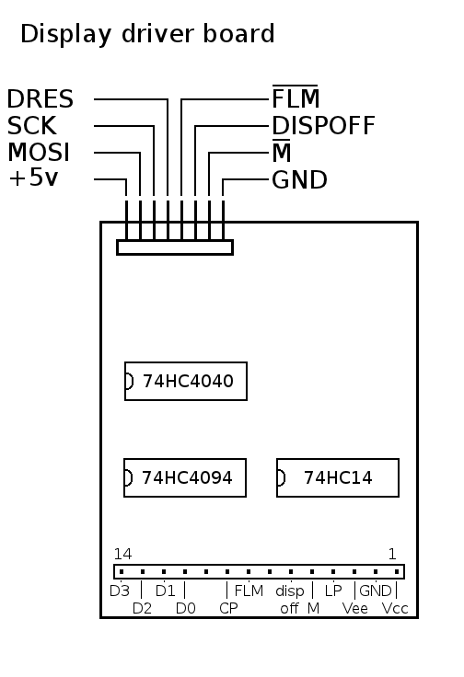
Fonera connections
- RED: +5V
- GREEN: GND
- WHITE: Boot (for stm32 flashing)
- YELLOW: Reset (for stm32 flashing)
- ORANGE: RXD (data into fonera)
- GREY: TXD (data out of fonera)
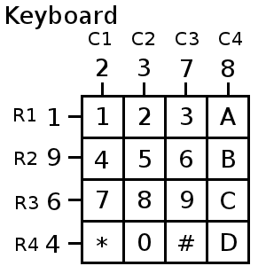

STM32F4discovery connections
- PB10: TXD (connect to fonera orange wire)
- PB11: RXD (connect to fonera grey wire)
- PB13: display SCK
- PB15: display MOSI
- PB7: display DRES
- PB12: display FLM
- PB14: display M
- PB8: display DISPOFF
- PD0: keyboard row 1
- PD1: keyboard row 2
- PD2: keyboard row 3
- PD3: keypbard row 4
- PC1: keyboard column 1
- PC2: keyboard column 2
- PC4: keyboard column 3
- PC5: keyboard column 4
- PB2: shorted to GND, to allow boot from system memory

