SUPERNOVA

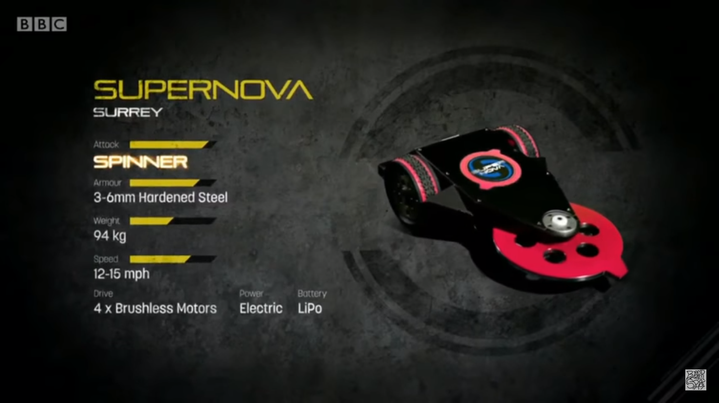

22 kg spinning wheel, at 2500 rpm

Chain drive for spinning disc

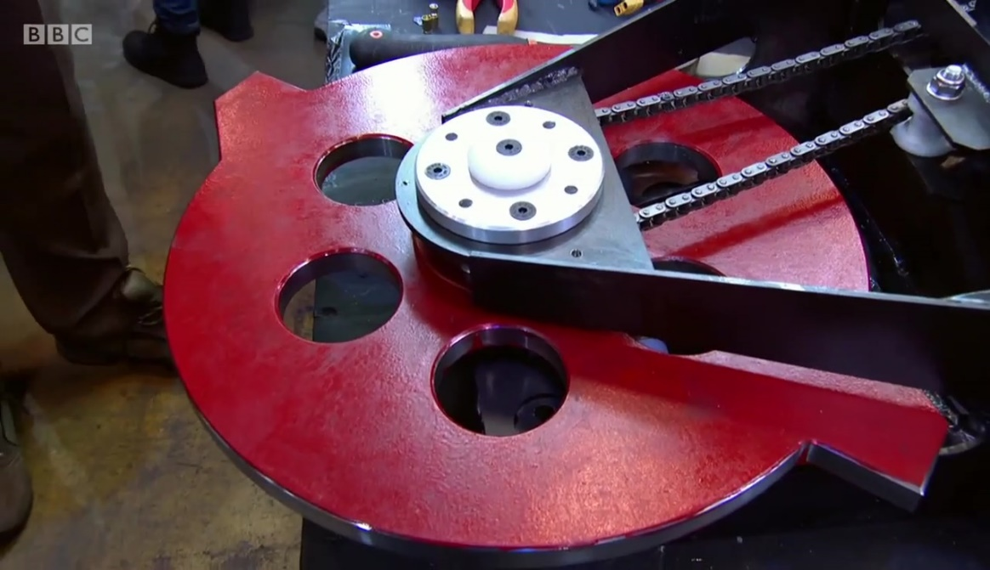

Utilized bicycle tyre treads

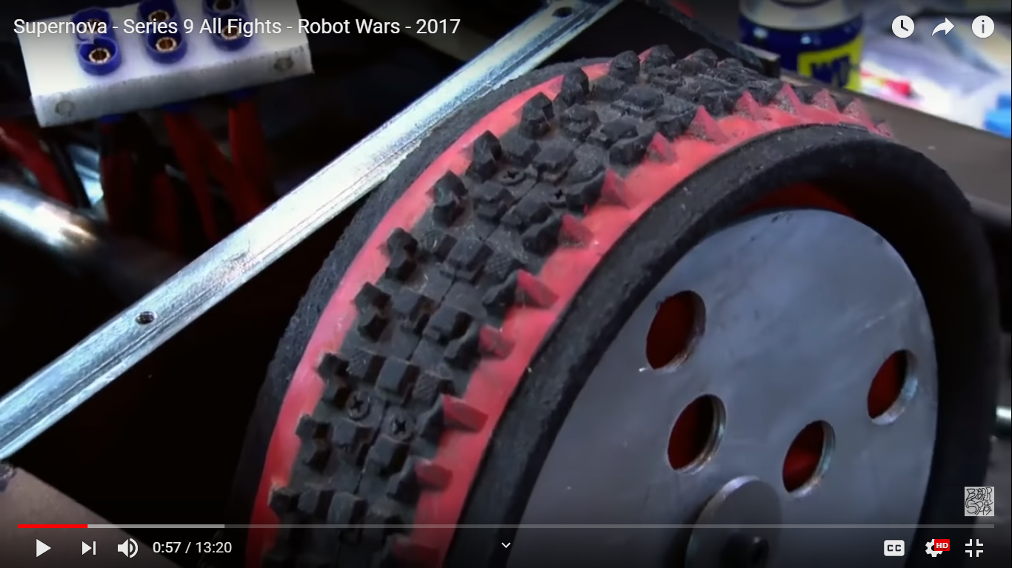

GIGABYTE

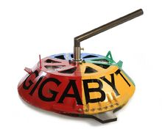

Gigabyte webpage

<https://battlebots.fandom.com/wiki/Gigabyte>

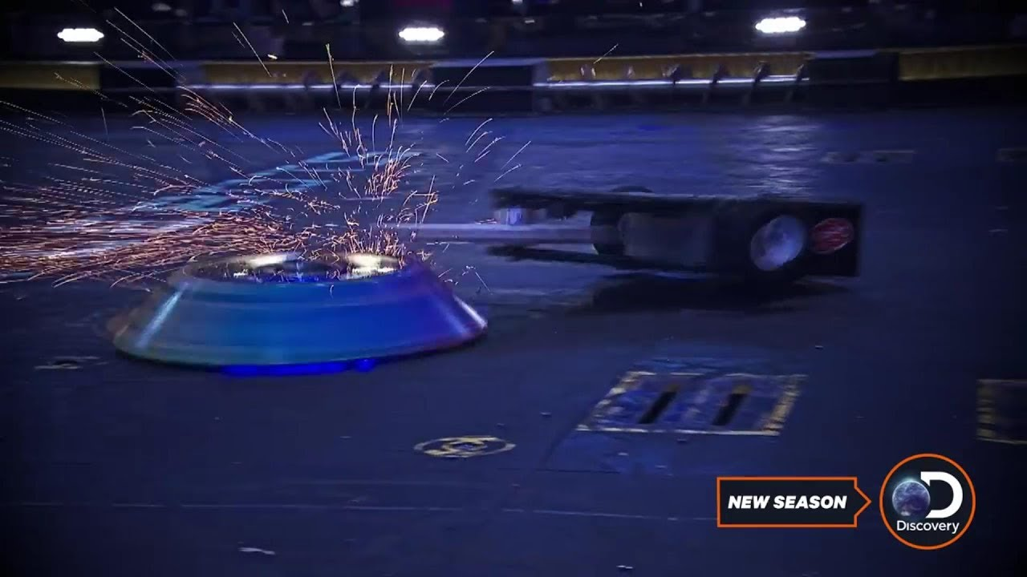

TOMBSTONE

HARDCORE ROBOTICS- TOMBSTONE BEST HITS OF ROBOGAMES

<https://www.youtube.com/watch?v=EzM1MpYC1js&ut=>

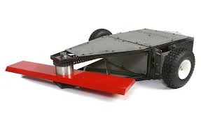

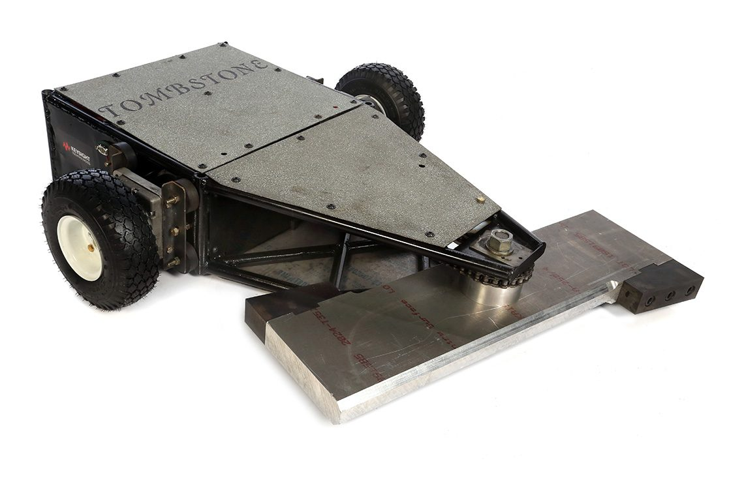

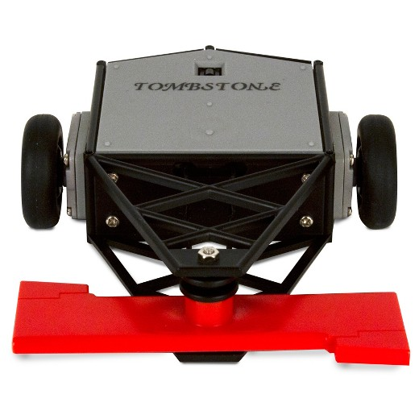

Megabyte inner view given below

