

Squares
Vs
Triangles

Version 1.4
Release Date: January 15, 2011

Developed and published by BitSits Games, Inc.
Shubhajit Saha, Bengal Engineering and Science University, Shibpur.
http://www.bitsits.blogspot.com/

Maya Agarwal, Bengal Institute of Technology, Techno India.
http://www.bitsitsgames.blogspot.com/

We hope you enjoy the game!

Table of Contents
SYSTEM REQUIREMENTS 3
HELP 3
PLAYING THE GAME 3
Goal 3
The Basics 3
Controls 3
Army 3
GAME MODES 4
Adventure 4
GAMEPLAY TIPS 4
Basic Tips 4
VERSION HISTORY 4
SCREEN SHOTS 5
CREDITS 6
LICENSE AGREEMENT WITH WARRANTY 6
REFERENCES 6

SYSTEM REQUIREMENTS

OS*: Windows 2000/XP/Vista/7
Additional Requirements: NET 2.0 Framework, XNA 3.0 support
Processor: 1.2+GHz
Memory (RAM): 512+MB
Free Hard Drive Space: 65+MB
DirectX Version: 8 or later
Sound: DirectX-compatible
Video: DirectX-compatible; 128+MB
Color Quality: 16-bit or 32-bit color mode (256 colors may not work)
Controls: Keyboard and mouse

*You must be an administrator to install and run this game.

HELP

If you require assistance with your game, please visit us here: http://www.bitsits.blogspot.com/
http://www.bitsitsgames.blogspot.com/

PLAYING THE GAME

Goal
This game is war between Squares and Triangles; you have to control Square army to make one of your squares reach the enemy’s (Triangles) castle. This game take place in a war field, there will be two castles one belongs to Squares and other to Triangles.

The Basics
Your main aim is to make one of the Squares reach the Triangles’ castle before the Triangles reach the Squares’ castle. Beside this you will avoid Squares from being killed and try to kill more and more Triangles.

Controls

Army
Army is of three types.
- Archery: Long range shooter.
- Shuriken: Short range heavy attack.
- Bazooka: Shoots in one direction.

GAME MODES

Adventure
Adventure mode is the primary mode of Squares Vs Triangles.

Triangles attacks come in five stages of 3 levels each:
- Stage 1: Easy Mode
- Stage 2: Medium Mode
- Stage 3: Hard Mode

GAMEPLAY TIPS

Basic Tips

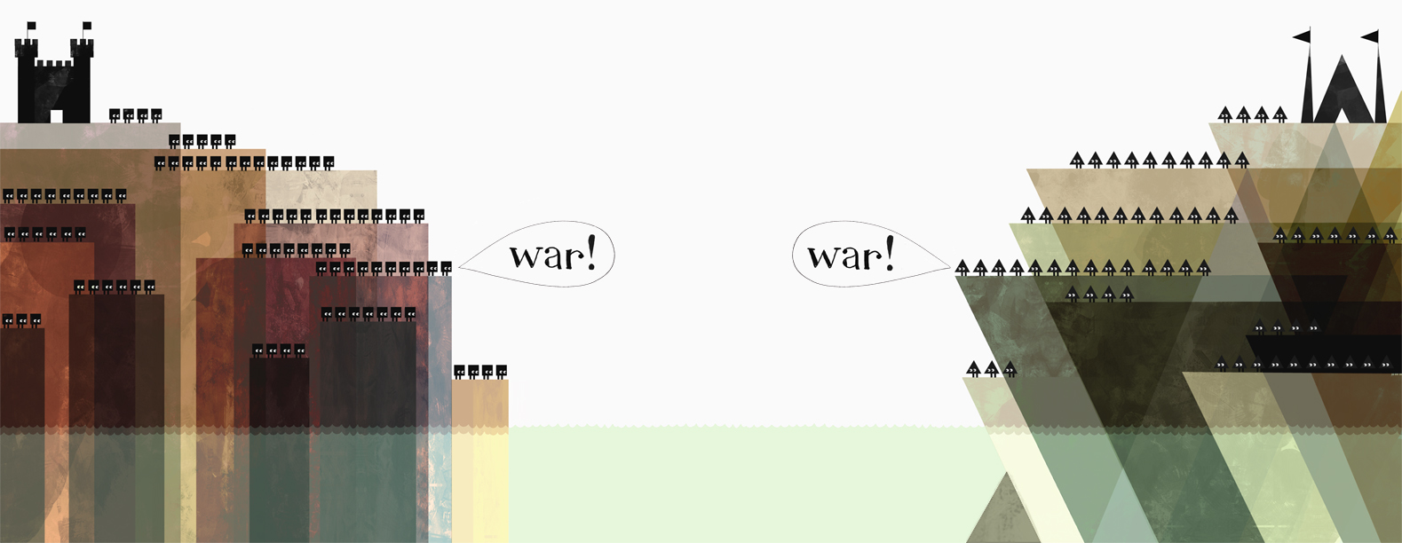
Jon Klassen’s art Shape Wars

SCREEN SHOTS
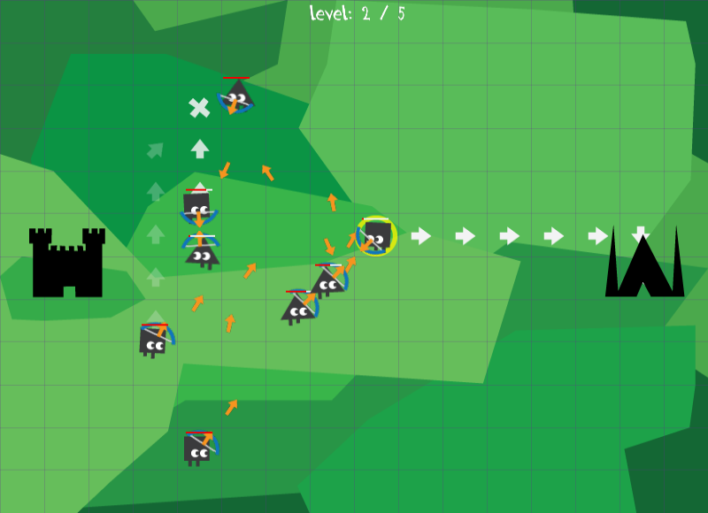

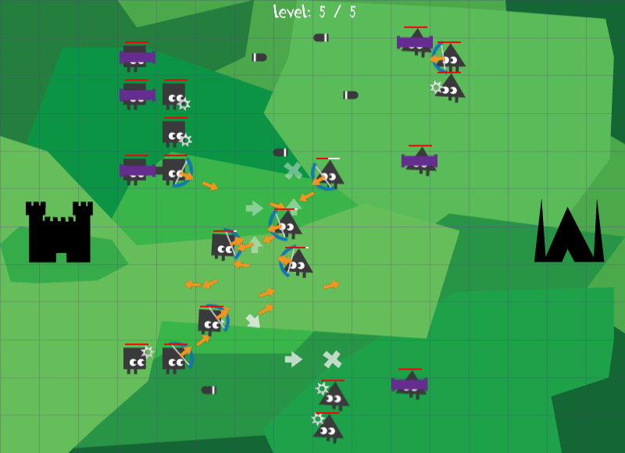

VERSION HISTORY

1.4 New levels added.
1.3 UI Bug fixes.
1.2 Better AI.
1.1 Bug fixes.
1.0 Basic Prototype.

CREDITS

This game was created by BitSits Games, Inc.
Game Design, Sound, Programming and Art: Shubhajit Saha
Game Concept, Level Designing and Writing: Maya Agarwal
Music: Track Marching from Album MU.S.GA [Music for Strategy Games] EP by PILL under Creative Commons Attribution-NonCommercial-ShareAlike 2.5 Brazil
Sound Effects: Snap-a-neck01.wav by CGEffex, canon.aif by man, bow_sound.wav by Anton, swosh-08.flac by qubodup. Sound effects are licensed under Creative Commons Sampling Plus 1.0 License.
Thanks to all our beta testers and players for their valuable feedback!

LICENSE AGREEMENT WITH WARRANTY

Copyright © 2010 BitSits Games. Squares Vs Triangles is licensed under a Creative Commons Attribution-NonCommercial-ShareAlike 3.0 Unported License.

REFERENCES

Wikipedia, the free encyclopedia that anyone can edit: http://en.wikipedia.org/

MSDN, Microsoft Development, Subscriptions, Resources, and More: http://msdn.microsoft.com/

App Hub: http://create.msdn.com/

XNAtutorial.com: http://www.xnatutorial.com/

XNA Development: Game Development for the masses http://www.xnadevelopment.com/

