**MOOCREC: LEARNING STYLES-ORIENTED MOOCS RECOMMENDER AND SEARCH ENGINE**

S.D Thoradeniya

IT 14 138232

Bachelor of Science Special (Honors) in Information Technology Specializing in Software Engineering

Department of Software Engineering

Sri Lanka Institute of Information Technology

Sri Lanka

September 2018

**MOOCREC: LEARNING STYLES-ORIENTED MOOCS RECOMMENDER AND SEARCH ENGINE**

S.D Thoradeniya

IT 14 138232

Dissertation submitted in partial fulfillment of the requirements for the degree Bachelor of Science Special (Honors) in Information Technology Specializing in Software Engineering

Department of Software Engineering

Sri Lanka Institute of Information Technology

September 2018

**DECLARATION**

I declare that this is my own work and this dissertation1 does not incorporate without acknowledgement any material previously submitted for a Degree or Diploma in any other University or institute of higher learning and to the best of my knowledge and belief it does not contain any material previously published or written by another person except where the acknowledgement is made in the text.

Also, I hereby grant to Sri Lanka Institute of Information Technology the nonexclusive right to reproduce and distribute my dissertation, in whole or in part in print, electronic or other medium. I retain the right to use this content in whole or part in future works (such as articles or books).

Signature:Date:2018-09-03

The above candidate has carried out research for the B.Sc Dissertation under my supervision.

Signature:Date:2018-09-03

**ABSTRACT**

Massive Open Online Courses (MOOCs) are the new revolution in the field of e-learning, providing a large number of courses in different domains to a wide range of learners. Because of the several MOOC platforms (like, edX, Coursera, Udacity, Futurlearn etc.) available today, it is a tedious manual task for a learner to browse through different courses in these platforms before he finds the best course that meets his learning style and current knowledge level in that subject matter. MoocRec is a unique learning styles-oriented system that aims to recommend the most appropriate courses for a learner from different MOOC platforms based on his learning styles and individual needs. The standard video styles used in MOOCs (such as talking head, tutorial/demonstration, slides, animation etc.) are considered as the key parameter when mapping a course with the learning styles. MoocRec also allows the learners to search for courses using, specific topics and English accent of the speaker to provide them with a better- personalized learning environment.

**ACKNOWLEDGEMENT**

The work described in this research paper was carried out as our 4th year research project for the subject Comprehensive Design Analysis Project. The completed final project is the result of combining all the hard work of the group members and the encouragement, support and guidance given by many others. Therefore, it is our duty to express our gratitude to all who gave us the support to complete this major task.

We are deeply indebted to our supervisor Mr. Nuwan Kodagoda and our co-supervisor Ms. Kushnara Suriyawansa, lecturers of Sri Lanka Institute of Information Technology whose suggestions, constant encouragement and support in the development of this research, particularly for the many stimulating and instructive discussions. We are also extremely grateful to Mr. Jayantha Amararachchi, Senior Lecturer/ Head-SLIIT Centre for Research who gave and confirmed the permission to carry out this research and for all the encouragement and guidance given.

We also wish to thank all our colleagues and friends for all their help, support, interest and valuable advices. Finally, we would like to thank all others whose names are not listed particularly but have given their support in many ways and encouraged us to make this a success.

Table of Contents

1 INTRODUCTION 8

1.1 Background Context 8

1.2 Research Gap 8

1.3 Research Questions 9

2 Methodology 10

2.1 User’s Learning Style 10

2.2 ILS Questionnaire 12

2.3 Mapping Moocs with learning style 13

2.4 Web application 14

2.5 Accent Recognition 14

2.6 Tools and Technologies 14

2.7 Research Findings 15

3 Results and Discussion 15

3.1 Evidence 15

3.2 Discussion 15

4 Conclusion 16

5 References 16

6 Appendices 17

**LIST OF FIGURES**

Figure 1: high level architecture diagram of MOOCRec 10

Figure 2: ILS questionnaire scoring sheet 14

Figure 3: Determine the Learning Styles 17

Figure 4: Recommend MOOCs to Learner 18

Figure 5: Searching for Specific Course 18

Figure 6: Filter MOOCs based on Topics 19

Figure 7: Class Diagram 21

Figure 8: Activity Diagram 22

Figure 9: Use-Case Diagram1 24

Figure 10: Use-Case Diagram2 25

**LIST OF TABLES**

Table 1: Felder and silverman learning style model 11

Table 2: Use Case Scenario 1 20

Table 3: Use Case Scenario 2 20

Table 4: Use Case Scenario 3 21

**LIST OF ABBREVIATIONS**

|  |  |
| --- | --- |
| MOOCs | Massive Open Online Courses |
| CNN | Convolutional Neural Network |
| RAM | Random Access Memory |
| CPU | Central Processing Unit |

# INTRODUCTION

## Background Context

MOOCs have emerged as big players in the field of online learning and its unique characteristics make it more effective in the modern era of education. Over the years, various platforms such as edX, Coursera, Udacity, Futurelearn etc. have emerged with the intent of providing massive educational resources to any learners. According to the survey from Class Central [1], until 2017, around 81 million students are registered worldwide, where 23 million were new learners that registered only in 2017. Similarly, the total number of MOOCs surpassed 9400 contributed from over 800 universities in 2017 [1]. Hence, we can see the exponential growth of MOOCs.

In the recent years, there has been increasing attention towards the characteristics of learners such as learning styles. Different learners have the ability to learn in different ways and hence poses their own style of learning. Because of this behavior, the learner mostly explores through different MOOCs platform to find the most suitable learning resources that best fit their needs, preferences and learning styles. It has been also stated from studies that providing learners with learning materials and resources that suit their preferences and learning style makes learning easier for them [2][3].

Several MOOC search engines are currently available, such as, Class Central [4], My Mooc [5], MoocLab [6] and Coursetalk [7] that serves as a unified platform for MOOC platforms. However, none of the existing systems takes the learner’s learning styles into consideration when searching for courses. Also, the learner can only search for courses based on basic filters, like provider, category, duration, language etc.

## Research Gap

Several studies have proposed to integrate the concept of learning styles into the open learning environment (MOOCs), to provide adaptive and personalized support for learning [3], [8], [9]. Other studies reveal the use of data mining and machine learning algorithms to automatically identify the learner’s learning styles. However, there has been no significant research to support the direct mapping of learning styles with MOOCs.

Researches regarding MOOCs search engine and recommenders are also being carried out at a rapid rate. A recommender system using Case Based Reasoning (CBR) approach is proposed in [10]. User’s query is described by five attributes where each attribute is assigned a weight value based on the user’s preference. “Courducate” is another system proposed for a personalized search engine with two functionalities: multi-site search and multi-filed search [11]. Besides using the BM25 ranking function, a noble ranking function is used to rank the sites upon query. A different approach is taken in [12] where the authors propose to associate MOOCs with learning outcomes. Hence, allowing learners to discover the most suitable MOOCs for their learning objectives. [13] proposes two contributions: Using attribute and attribute value weight of resources to get specific user preferences; A new algorithm to overcome the shortcomings of the Collaborative Filtering (CF) and provide more accurate personalized recommendations on MOOCs. In the similar context, Content-based and collaborative filtering recommendation approaches are used to accommodate several undergraduate characteristics when recommending MOOCs [14].

Finally, we can conclude that, until now, no system has been implemented that recommends courses to a learner from different MOOC platforms based on his learning styles and other personalized needs and requirements.

## Research Questions

The relationship between video styles used in MOOCs and learning styles of the learner needs to addressed. Questions regarding the affect of a specific video style to learner, browsing of MOOCs from different platforms etc. needs to answered. This research study attempts to answer the questions relating to these factors.

# Methodology

MoocRec: Learning Styles-Oriented MOOCs Recommender and Search Engine consists of 4 main procedures, first web crawling and scaping which involves extracting course contents from 3 main sites (futurelearners,edexcel and coursera) ,video style classifications which involves categorizing course content videos in to specific video styles, topic modeling which involves discovering of hidden semantic structures in a text body for discovering the abstract “topics” that occur in a collection of documents scraped from the Moocs and finally mapping MOOCs with Learning Styles which involves taking a questionnaire by the user and finding the users learning style and map it with the best fitted Mooc.

A screenshot of a social media post

Description generated with very high confidence

Figure 1: high level architecture diagram of MOOCRec

## User’s Learning Style

Learning style is the manner in which one learns best. It is based on individual characteristics and preferences. Individual learning styles are important to consider in effective teaching because different students learn in different ways. Various Learning Style models have been proposed over the years, however, we have adopted the widely used Felder and Silverman Learning Style Model (FSLSM) based on literature [25]. It has been proven from studies that FSLSM is the most appropriate model in personalized online learning environments. The FSLSM classifies learning styles into four different dimensions and identifies two types of learners for each dimension. The four dimensions are perception, input, processing, and understanding. A brief description of the characteristics of each learning styles is shown in the table above.

|  |  |  |
| --- | --- | --- |
| **Dimension** | **Learner Styles and their Characteristics** | |
| Perception | Sensory – Concrete or Practical Information | Intuitive – Conceptual or Theoretical Information |
| Input | Visual – Graphs/ Pictures / Diagrams | Verbal – Hear or Read Information |
| Processing | Active – Experiments / Participation | Reflective – Individual Learning or Thinking |
| Understanding | Sequential – Information in linear order | Global – Think about the big picture |

Table 1 Felder and silverman learning style model

## ILS Questionnaire

In order to identify the learning styles of the learner, Index of Learning Styles (ILS) questionnaire is embedded in the system. The Index of Learning Styles is a survey instrument used to assess preferences on four dimensions (active/reflective, sensing/intuitive, visual/verbal, and sequential/global) of a learning style model formulated by Richard M. Felder and Linda K. Silverman. The instrument was developed and validated by Richard M. Felder and Barbara A. Soloman. Users answer 44 a-b questions and submit the survey, and their four preferences are reported back to them immediately to be copied or printed out.

An algorithm is written according to the following learning style questionnaire score sheet to identify the user’s learning style .

• Place a “1” in the appropriate spaces in the table below (e.g. if you answered "a" to

Question 3, put a "1" in Column "a" by Question 3)

• Add up the columns and write the totals in the indicated spaces.

• For each of the four scales, subtract the smaller total from the larger one. Write the difference (1 to 11) and the letter (a or b) with the larger total.

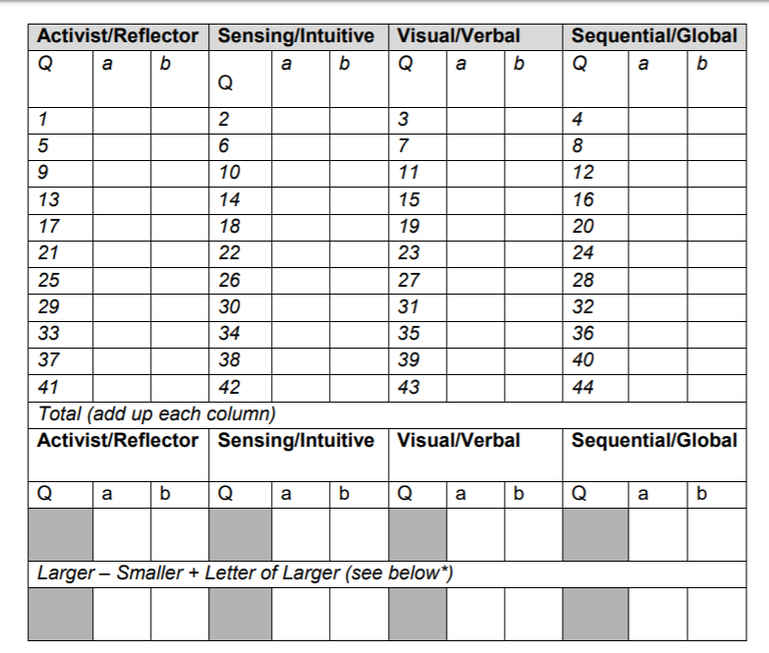

Figure 2: ILS questionnaire scoring sheet

## Mapping Moocs with learning style

Considering the properties of these learning styles and the characteristics of MOOC video styles and literature , a two-dimensional mapping was generated. The detail about the mapping is done based on the characteristics of video classifications of the content of the Moocs courses. A video is composed of different video styles. We only focus on talking head (labeled as Office Desk by Guo), slides, code, conversation and animation as they are most common in computer programming related courses. Based on video classification Equations , if the percentage of average talking head video style is more in a course, then based on the mapping algorithms it is more suitable to an intuitive, verbal and global learner. Similarly, if the coding video style dominates a video, it is more favorable to a sensory, verbal, active and global learner and so on.

## Web application

The frontend client application of MoocRec is a web application developed using Angular5, HTML5, CSS3, and JavaScript. Any learner who uses the system takes the ILS questionnaire to identify his learning styles. He can also take the standardized tests for programming languages, like Java, Python, PHP to determine their current knowledge level in that domain. Finally, the system recommends the most appropriate MOOCs from different platforms based on the mapping data. The learner can also further filter the courses. Following diagram describes the user interface for searching recommended MOOCs based on different parameters. An interactive dashboard is included in one’s profile to see history of the activities and also recommended courses for the user based on user’s learning style.

## Accent Recognition

So far no system has categorized courses according to the speaker’s accent, our system Moocrec focuses on identifying the dialect or accent of a speaker of a Mooc course and filter courses by the accent by understanding and modeling individual variation in spoken language. Individuals have their own speaking styles, depending on many factors, such as their dialect and accent as well as their socioeconomic background.

## Tools and Technologies

**Tools**

* Google Colaboratory

**Technologies**

* Python
* Html
* Css
* Javascript
* Mongodb
* Angular js
* Keras Library

## Research Findings

Following algorithm is used tomap video styles with learning styles after lot of research and testing the accuracy of the recommendations

|  |  |  |  |  |  |
| --- | --- | --- | --- | --- | --- |
|  | **Talki-ng Head** | **Code / Tutorial** | **Slide** | **Conver-sation** | **Animati-on** |
| Sensory |  | Yes | Yes |  |  |
| Intuitive | Yes |  |  | Yes | Yes |
| Visual |  |  |  |  | Yes |
| Verbal | Yes | Yes | Yes |  |  |
| Active |  | Yes |  | Yes |  |
| Reflective |  |  | Yes |  |  |
| Sequential |  | Yes | Yes |  |  |
| Global | Yes |  |  | Yes | Yes |

Table 2 Mapping of MOOCs with FSLSM Model

# Results and Discussion

## Evidence

After the learner takes the ILS questionnaire, he/she can identify their learning styles. MoocRec works perfectly to correctly identify the learning styles based on the questions answered as shown in Figure 3

A screenshot of a social media post

Description generated with very high confidence

Figure 3: Determine the Learning Styles

The system then recommends the most suitable courses to the learner based on his learning styles. At the same time, it also responds correctly when the learner searches for courses using specific keywords and topics as shown in Figure 4, 5 and 6.

A screenshot of a cell phone

Description generated with very high confidence

Figure 4: Recommend MOOCs to Learner

A screenshot of a cell phone

Description generated with very high confidence

Figure 5: Searching for Specific Course

A screenshot of a cell phone

Description generated with very high confidence

Figure 6: Filter MOOCs based on Topics

## Discussion

The video classification was carried out only for four different classes due to the computer programming domain. However, it can be expanded to cover other subject areas in other MOOC platforms. The findings of this research can provide valuable information regarding domain of MOOCs to various interested parties. Since, the dataset was not publicly available and was manually generated, the results and performance of the models were relatively considerate due to the usage of transfer learning and fine-tuning.

The time-taken for training the dataset was comparatively faster even on CPU. Using a GPU would give more faster results. Furthermore, if the hyperparameters of the networks are varied and tested with different values, it would give different result.

# Conclusion

In today’s world, MOOCs have grown as a popular platform for learning attracting learners of different learning styles. However, because of the different learning styles of the learners and the availability of similar courses in different MOOC platforms, it is overwhelming for a learner to explore through different resources before they finally find the course that is most suitable for them. This research paper proposes a practically usable solution called, MoocRec to overcome this widely faced problem. MoocRec is a first approach towards the objective of providing personalized MOOCs learning on the basis of the learner’s preferences and needs.

Although MoocRec is designed only for computer programming related courses in three MOOC platforms (edX, Coursera, and Futurelearn), it can be expanded to cover other domains of study and platforms as well.

# References

[1] C. Conati and X. Zhao, “Building and Evaluating an Intelligent Pedagogical Agentto

Improve the Effectiveness of an Educational Game”, In Proc. of IUI'04, pp. 13-16,

Madeira, Portugal, Jan. 2004.

[2] F. Esposito, O. Licchelli and G. Semeraro, “Discovering Student Models in elearning

Systems”, Journal of Universal Computer Science, Vol. 10, No. 1, pp. 47-57, 2004.

[3] D. Sampson, C. Karagiannidis and F. Cardinalli, “An Architecture for Web-based eLearning

Promoting Re-usable Adaptive Educational e-Content”, Educational

Technology & Society, Vol. 5, No. 4, pp. 27-37, ISSN 1436-4522, 2002.

[4] D. Heckerman, “A Tutorial on Learning With Bayesian Networks”, Technical Report

MSR-TR-95-06, Microsoft Research, Advanced Technology Division, Microsoft

Corporation, Nov. 1996.

[5] J. Pearl, “Bayesian Networks”, Technical Report R-216, Computer Science

Department, University of California, Los Angeles, 1995.

[6] Latent Semantic Analysis (LSA), Official Web Site, http://lsa.colorado.edu/

[7] P. Brusilovsky, S. A. Sosnovsky and O. Shcherbinina, “User Modeling in a

Distributed E-Learning Architecture”, In: L. Ardissono, P. Brna and A. Mitrovic

(eds.) User Modeling 2005. Lecture Notes in Artificial Intelligence, SpringerVerlag,

pp. 387-391, 2005.

[8] Amazon Comprehend -Semantic search developer guide

<https://docs.aws.amazon.com/comprehend/latest/dg/what-is.html>

[9] McAfee, Andrew, and Erik Brynjolfsson. "Big Data: The Management Revolution."

Harvard Business Review. Hank Boye, 01 Oct. 2012. Web. 08 Apr. 2016.

# Appendices

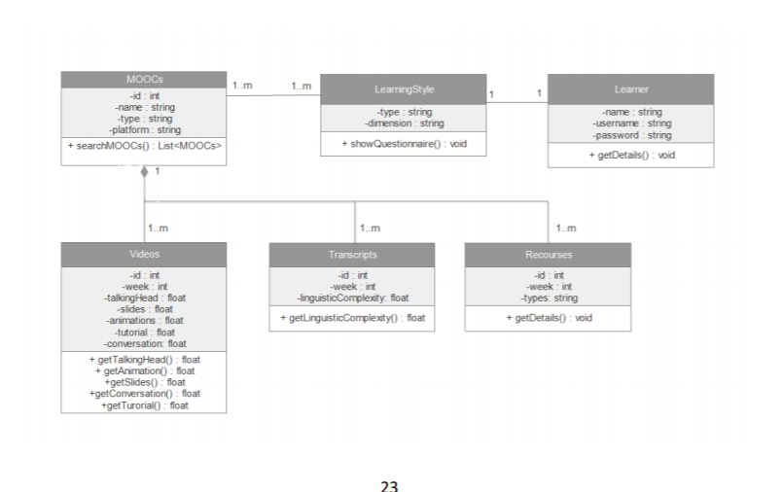

Figure 7: Class Diagram

Figure 8: Activity Diagram

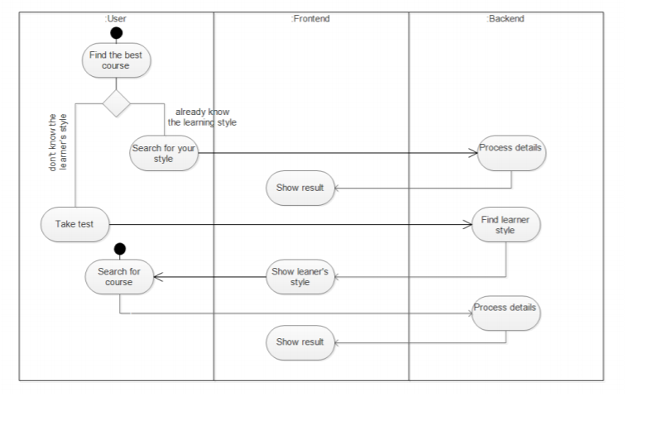

Figure 9 Use-Case Diagram1

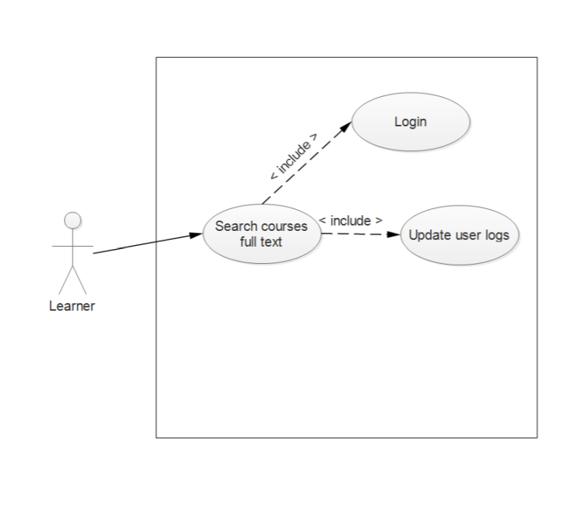

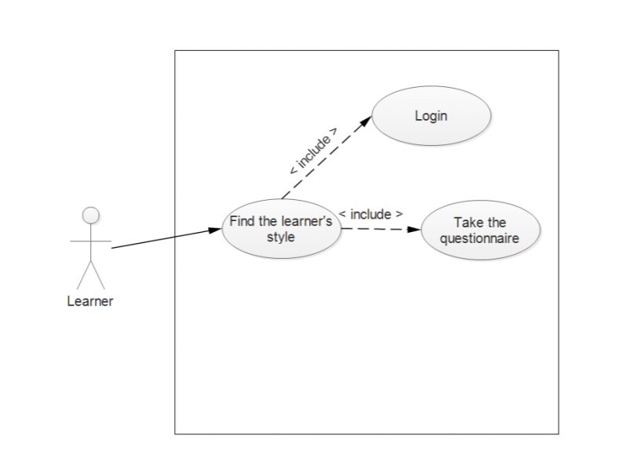

Figure 10. Use-Case Diagram2

|  |  |  |  |  |  |
| --- | --- | --- | --- | --- | --- |
|  |  |  |  | |  |
| Use case Name |  |  | Identify user’s learning style | |  |
| Pre –Condition |  |  | Provide ILS questionnaire of 40 questions and run the algorithm on answers provided | |  |
| Post-Condition |  |  | Identify user’s learning style analyzing the score | |  |
| Actor |  |  | Actor | |  |
|  |  |  | 1. | Take the questionnaire |  |
| Main Success Scenarios |  |  | 2. identify the learning style using standard ILS method and score  3. The use case ends with successfully identifying the user’s learning style and store it in to the database | |  |
| Extension |  |  | 1a. questionnaire is not completed  1b not start the process without questionnaire completed | |  |

Table 3: Use Case Scenario 1

|  |  |  |  |  |  |
| --- | --- | --- | --- | --- | --- |
|  |  |  | |  |  |
| Use case Name |  | Mapping learner’s style with video style | |  |  |
| Pre –Condition |  | Identify characteristics,attributes of the particular learning style of the learner | |  |  |
| Post-Condition |  | Map identified characteristics and variables with video style attributes using algorithms | |  |  |
| Actor |  | Backend System | |  |  |
|  |  | 1. | Select the learners learning style from database |  |  |
| Main Success Scenarios |  | 2. map the characteristics of learner’s style with video style  3. find the best fitting Mooc for the identified video style in a ranking way | |  |  |
|  |  |  | |  |  |
|  |  |  | |  |  |

Table 4: Use Case Scenario 2

|  |  |  |  |  |
| --- | --- | --- | --- | --- |
|  |  |  | |  |
| Use case Name |  | Filter course by accent | |  |
| Pre –Condition |  | Accent recognition of each speaker is stored in database. | |  |
| Post-Condition |  | A result of courses filtered by the selected accent | |  |
| Actor |  | Backend System | |  |
|  |  | 1. | Voice recognition and identify speaker’s learning style |  |
| Main Success Scenarios |  | 2. categorize courses by accent | |  |

Table 5: Use Case Scenario 3