

Tashishni

Mohammad Albittar

JAN/1/2020

Version 1.0.0

REVISION HISTORY
DATE | VERSION | DESCRIPTION | AUTHOR

Table of Contents

INTRODUCTION 3
PURPOSE 3
INTENDED AUDIENCE AND PERTINENT SECTIONS 3
PROJECT SCOPE 3
DOCUMENT CONVENTIONS 3
REFERENCES 3
DESCRIPTION 3
PRODUCT PERSPECTIVE 3
FEATURES 3
USER OVERVIEW 3
OPERATING ENVIRONMENT 3
CONTRAINTS: IMPLEMENTATION / DESIGN 3
DOCUMENTATION 3
ASSUMPTIONS / DEPENDENCIES 3
SYSTEM FEATURES 3
SYSTEM FEATURE 1 3
SYSTEM FEATURE 2 3
SYSTEM FEATURE 3 3
REQUIREMENTS OF EXTERNAL INTERFACE 3
USER INTERFACES 3
HARDWARE INTERFACES 3
SOFTWARE INTERFACES 3
COMMUNICATION INTERFACES 3
ADDITIONAL NONFUNCTIONAL REQUIREMENTS 3
PERFORMANCE 3
SAFETY 3
SECURITY 3
SOFTWARE QUALITY 3
APPENDICES 3
APPENDIX A: GLOSSARY OF TERMS 3
APPENDIX B: ANALYSIS DOCUMENTATION 3
APPENDIX C: ISSUES 3

INTRODUCTION

PURPOSE
This document introducing explain about Tashishni which make a user (Stakeholders) back to this document to gain details and explains to them what do they know about it.

The main goal of Tashishni Application gives a set of trips that you can make it inside Jordan based on your budget,and there another part of this project is a platform for businesses owners which make them manage their business.

INTENDED AUDIENCE AND PERTINENT SECTIONS
Users: Features
Developers: Operating enviroment

PROJECT SCOPE
The mobile app provides advantages to users:
1- knowing the approximate budget for a specific trip
2-facilitate marketing processes for owners businesses
3-reduce the scams for foreign tourists
the purpose of the Application is to help the users to find the best trip which based on their budget
Our business model is based on advertisements and premium accounts for users

DOCUMENT CONVENTIONS
- MERN Stack: I developed my platform by MongoDB, ExpressJS, Reactjs, and NodeJS.

- CRUD operations: Create(Add New Record To Database), Read (Read Data from database),Update(Edit Record on database),and delete(remove record from database).

- MD5: type of encryption by Hashing.

-HTTP:Hyper Text Transfer Protocol request response protocol between client and server sides

REFERENCES
- Mongoosejs.com. (2020). Mongoose v5.8.5: Deprecation Warnings. [online] Available at: https://mongoosejs.com/docs/deprecations.html [Accessed 10 Jan. 2020].

- Tutorialspoint.com. (2020). MongoDB Tutorial - Tutorialspoint. [online] Available at: https://www.tutorialspoint.com/mongodb/index.htm [Accessed 10 Jan. 2020].
- Tutorialspoint.com. (2020). ExpressJS Tutorial - Tutorialspoint. [online] Available at: https://www.tutorialspoint.com/expressjs/index.htm [Accessed 10 Jan. 2020].

- Reactjs.org. (2020). Getting Started – React. [online] Available at: https://reactjs.org/docs/getting-started.html [Accessed 10 Jan. 2020].

- Facebook.github.io. (2020). Getting Started · React Native. [online] Available at: https://facebook.github.io/react-native/docs/getting-started [Accessed 10 Jan. 2020].

-W3schools.com. (2020). W3Schools Online Web Tutorials. [online] Available at: https://www.w3schools.com/ [Accessed 10 Jan. 2020].

DESCRIPTION

PRODUCT PERSPECTIVE
My product is derived from trip advisor, trip advisor give to guests information about Hotels, the thing to do, restaurants,shopping...etc, but Tashishni product give to guests information like that but based on guest's budget

FEATURES
mobile app:
- get trip: give to guests trips paths based on their budget
- build your trip: guests can draw their trips and the App give them an expected salary

Web App:
the platform for owner business to manage their business ( businesses management system )

USER OVERVIEW
All kind of users who would like to make a trip based on a specific budget

OPERATING ENVIRONMENT
Mobile App: mobile phone with android or IOS operating system and internet connection.
web app: any device with a web browser and internet connection.

CONTRAINTS: IMPLEMENTATION / DESIGN
- Find API to supply us for business information
- upload images to the server
- using MongoDB queries
- using local storage by react-native
-Turn on GPS by App and get the current guest’s location

Design: Simple friendly user

DOCUMENTATION
Mobile and Web Applications

Mobile app: help the guests to gain on trips paths locally in Jordan based on their budget or build their trips then the app gives them approximate budget for this trip.

Web app: for owners businesses that make each owner manage his/her business like add, edit, and delete and the mobile app fully based on this platform to do its work.

Tashishni business model is based on advertisements and premium accounts

ASSUMPTIONS / DEPENDENCIES
- crash the server which hosted the project
- connection speed maybe effect on platform design and speed to get results from external API
- smartphones which no has a GPS
- any problems in external API maybe effect on the platform

Dependencies:
Finish to Start:
- finish register to start login
- search to your business to start to add businesses

Finish To Finish:
- finish selecting your trips to finish trips’ cart

Start To Finish:
-login by your account to start managing your business

SYSTEM FEATURES

SYSTEM FEATURE 1
Mobile App: get trip by budget

DESCRIPTION AND PRIORITY | -High priority  -guest can enter his/her budget and the app give him/her some trips can he/she visits based on budget
STIMULUS / RESPONSE SEQUENCES | - Open App  - Click on get trip button  - Enter your budget in a suitable place.  - Click on find the best trip button.  The App takes the guest’s budget and divided it into three parts based on percentages:  1- 40% Entertainment  2- 40% Eat  3- 20% Transportation  then go to the database and get the suitable offers based on this percentages
FUNCTIONAL REQUIREMENTS | - You can’t get any results if the budget’s text box was empty (required validation on user’s budget input)

SYSTEM FEATURE 2
Mobile App: Buiid Your Trip

DESCRIPTION AND PRIORITY | - Second priority  - guest can build his/her trip then the app gives the approximate budget
STIMULUS / RESPONSE SEQUENCES | - open App  - Click on build your trip  - select your places/restaurants//etc which you want to go to them
FUNCTIONAL REQUIREMENTS | - when clicking on build your trip button server will display all places which you can visit it

REQUIREMENTS OF EXTERNAL INTERFACE

USER INTERFACES
Mobile App
1- Get your trip screen
1.1Text input which guests can add his/her budget
1.2 checkboxes list to get the best results which suitable you
1.3 button when enter your budget click on it to display you suitable trips.

2- Build your trip screen
2.1 list of all places/shops which the guests can select the suitable for them
2.2 when clicking on a specific shop the app navigates them to another screen and list all shop items that the guest can select of them.

Web App
1- Dashboard page include:
1.1 Add business
1.1.1Textbox to search on business by external API.
1.1.2 File upload to upload a business’s image.
1.1.3 button to search it.

2- List all businesses
2.1 Business Name,Image,Edit,Delete
2.1.1 Delete: Direct remove business
2.1.2 Edit: Navigate to another page
2.1.2.1 Text input to search on your business by external API
2.1.2.2 File upload to edit your business image.

Use Case Diagram
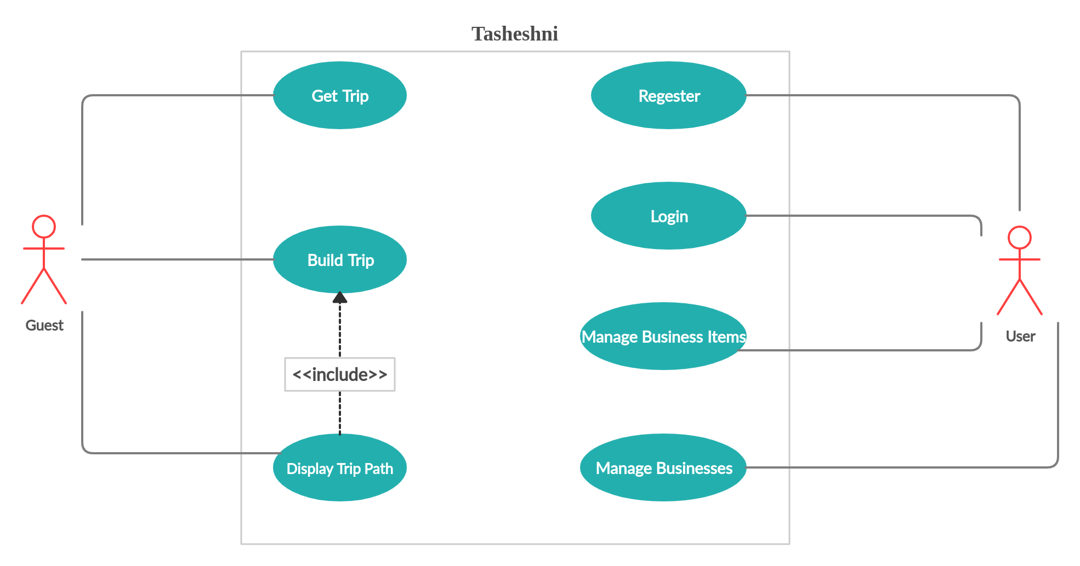

Database Design

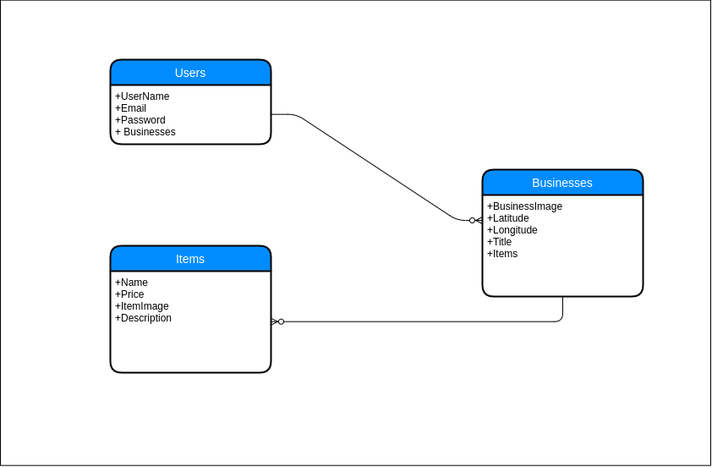

HARDWARE INTERFACES
- Smartphones.
- Any device which has a web browser

SOFTWARE INTERFACES
- Cross-platform
- MongoDB version 4.2.0
- Axios
- React-Native
- NodeJS
- ExpressJS
- Bootstrap

COMMUNICATION INTERFACES
Tashishni product use HTTP protocols to send and receive data to/from database.

ADDITIONAL NONFUNCTIONAL REQUIREMENTS

PERFORMANCE
Easy to use and friendly user.

SECURITY
Encrypt password by MD5.

