بسمه تعالی
دانشکده ی مهندسی برق و کامپیوتر
دانشگاه صنعتی اصفهان

شبکه‌های کامپیوتری۲ – نیمسال اول ۱۴۰۰-۱۳۹۹
تکلیف شماره یک – تحویل جمعه ۱۳۹۹/۷/۲۵

مریم سعیدمهر – ش.د. : ۹۶۲۹۳۷۳

4.P19. Consider the SDN OpenFlow network shown in Figure 4.30. Suppose that the desired forwarding behavior for datagrams arriving at s2 is as follows:
  - any datagrams arriving on input port 1 from hosts h5 or h6 that are destined to hosts h1 or h2 should be forwarded over output port 2.
  - any datagrams arriving on input port 2 from hosts h1 or h2 that are destined to hosts h5 or h6 should be forwarded over output port 1.
  - any arriving datagrams on input ports 1 or 2 and destined to hosts h3 or h4 should be delivered to the host specified.
  - hosts h3 and h4 should be able to send datagrams to each other.
Specify the flow table entries in s2 that implement this forwarding behavior.
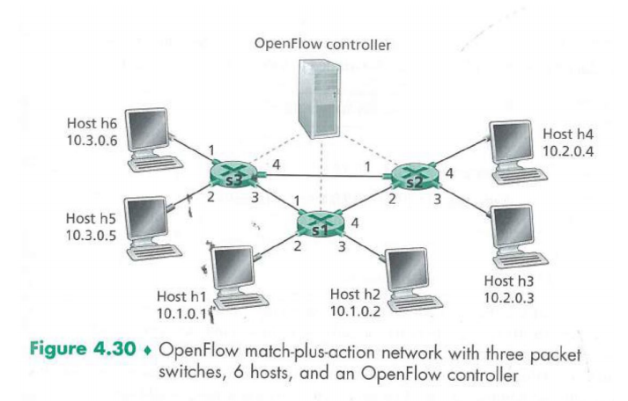

S2 Flow Table
Action | Match
Forward(2) | Ingress Port = 1 ; IP Src = 10.3.*.* ; IP Dst = 10.1.*.* ;
Forward(1) | Ingress Port = 2 ; IP Src = 10.1.*.* ; IP Dst = 10.3.*.* ;
Forward(3)  Forward(3)  Forward(4)  Forward(4) | Ingress Port = 1 ; IP Dst = 10.2.0.3 ;  Ingress Port = 2 ; IP Dst = 10.2.0.3 ;  Ingress Port = 1 ; IP Dst = 10.2.0.4 ;  Ingress Port = 2 ; IP Dst = 10.2.0.4 ;
Forward(3)  Forward(4) | Ingress Port = 4 ;  Ingress Port = 3 ;

4.P21. Consider again the scenario from P19 above. Give the flow tables entries at packet switches s1 and s3, such that any arriving datagrams with a source address of h3 or h4 are routed to the destination hosts specified in the destination address field in the IP datagram. (Hint: Your forwarding table rules should include the cases that an arriving datagram is destined for a directly attached host or should be forwarded to a neighboring router for eventual host delivery there.)

S1 Flow Table
Action | Match
Forward(2) | IP Src = 10.2.*.* ; IP Dst = 10.1.0.1 ;
Forward(3) | IP Src = 10.2.*.* ; IP Dst = 10.1.0.2 ;
Forward(1) | IP Src = 10.2.*.* ; IP Dst = 10.3.*.* ;

S3 Flow Table
Action | Match
Forward(1) | IP Src = 10.2.*.* ; IP Dst = 10.3.0.6 ;
Forward(2) | IP Src = 10.2.*.* ; IP Dst = 10.3.0.5 ;
Forward(3) | IP Src = 10.2.*.* ; IP Dst = 10.1.*.* ;

4.P22. Consider again the SDN OpenFlow network shown in Figure 4.30. Suppose we want switch s2 to function as a firewall. Specify the flow table in s2 that implements the following firewall behaviors (specify a different flow table for each of the four firewalling behaviors below) for delivery of datagrams destined to h3 and h4. You do not need to specify the forwarding behavior in s2 that forwards traffic to other routers.
  - Only traffic arriving from hosts h1 and h6 should be delivered to hosts h3 or h4 (i.e., that arriving traffic from hosts h2 and h5 is blocked).
  - Only TCP traffic is allowed to be delivered to hosts h3 or h4 (i.e., that UDP traffic is blocked).
  - Only traffic destined to h3 is to be delivered (i.e., all traffic to h4 is blocked).
  - Only UDP traffic from h1 and destined to h3 is to be delivered. All other traffic is blocked.

S2 Flow Table
Action | Match
Forward(3) | IP Src = 10.1.0.1 ; IP Dst = 10.2.0.3 ;
Forward(4) | IP Src = 10.1.0.1 ; IP Dst = 10.2.0.4 ;
Forward(3) | IP Src = 10.3.0.6 ; IP Dst = 10.2.0.3 ;
Forward(4) | IP Src = 10.3.0.6 ; IP Dst = 10.2.0.4 ;

S2 Flow Table
Action | Match
Forward(3) | IP Src = *.*.*.* ; IP Dst = 10.2.0.3 ; Port = TCP ;
Forward(4) | IP Src = *.*.*.* ; IP Dst = 10.2.0.4 ; Port = TCP ;

S2 Flow Table
Action | Match
Forward(3) | IP Src = *.*.*.* ; IP Dst = 10.2.0.3 ;

S2 Flow Table
Action | Match
Forward(3) | IP Src = 10.1.0.1 ; IP Dst = 10.2.0.3 ; Port = UDP ;

5.R15. Suppose you wanted to implement a new routing protocol in the SDN control plane. At which layer would you implement that protocol? Explain.

من یک پروتکل مسیریابی جدید را در لایه SDN’s network-control application پیاده سازی می کنم ، زیرا این لایه ای است که یک پروتکل مسیریابی مسیرهای end-to-end بین مبدا و مقصد را تعیین می کند.

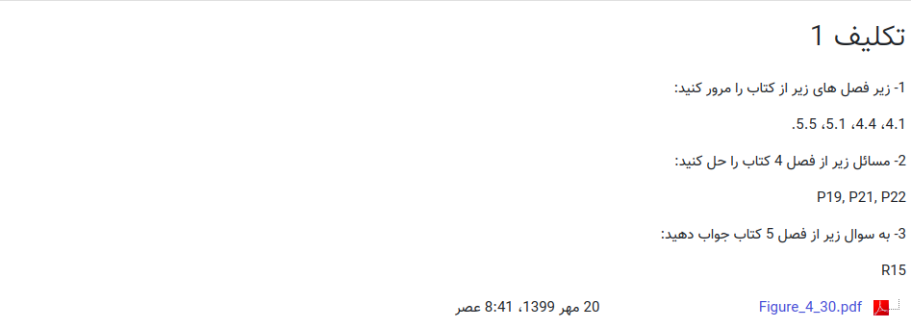
- زیربخش های 4.1 , 4.4 , 5.1 و 5.5 از کتاب مرور شدند.

