بسمه تعالی
دانشکده ی مهندسی برق و کامپیوتر
دانشگاه صنعتی اصفهان

شبکه‌های کامپیوتری۲ – نیمسال اول ۱۴۰۰-۱۳۹۹
تکلیف شماره سه – تحویل یکشنبه ۱۳۹۹/۸/۱۱

مریم سعیدمهر – ش.د. : ۹۶۲۹۳۷۳

5.P16. Consider the following network. ISP B provides national backbone service to regional ISP A. ISP C provides national backbone service to regional ISP D. Each ISP consists of one AS. B and C peer with each other in two places using BGP. Consider traffic going from A to D. B would prefer to hand that traffic over to C on the West Coast (so that C would have to absorb the cost of carrying the traffic cross-country), while C would prefer to get the traffic via its East Coast peering point with B (so that B would have carried the traffic across the country). What BGP mechanism might C use, so that B would hand over A-to-D traffic at its East Coast peering point? To answer this question, you will need to dig into the BGP specification.
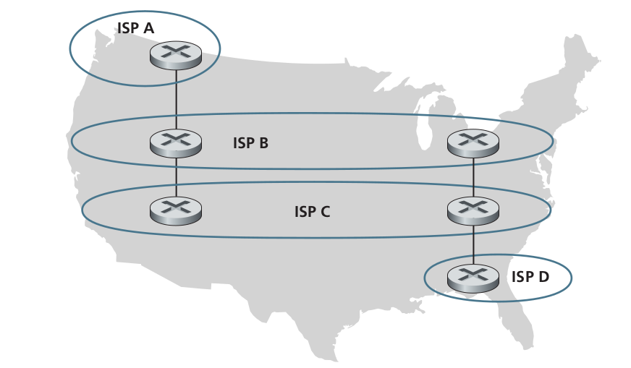
5.P17. In Figure 5.13, consider the path information that reaches stub networks W, X, and Y. Based on the information available at W and X, what are their respective views of the network topology? Justify your answer. The topology view at Y is shown below.
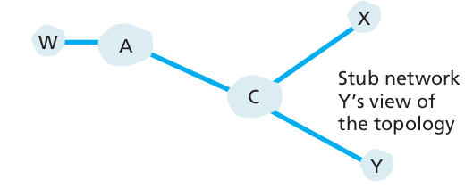
5.P18. Consider Figure 5.13. B would never forward traffic destined to Y via X based on BGP routing. But there are some very popular applications for which data packets go to X first and then flow to Y. Identify one such application, and describe how data packets follow a path not given by BGP routing.

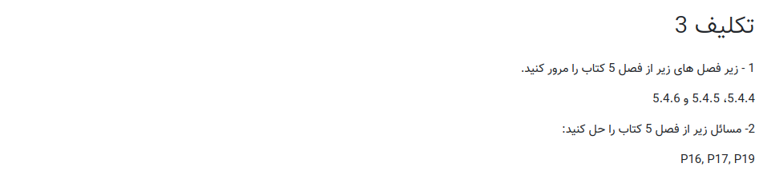
- زیربخش های 5.4.4 ، 5.4.5 و 5.4.6 از کتاب مرور شدند.

