**CLOUD BASED BUSS PASS SYSTEM**

*A Project Report submitted in partial fulfilment of the requirements for the award of the degree of*

**Bachelor of Technology**

**in**

Computer Science and Engineering

**by**

**Saksham Johri (171510046)**

**Aayushi Rai (171510003)**

**Pranjul Singhal (171510040)**

Under the Guidance of

Mr.Vivek Sharma

(Assistant Professor Dept. of CEA)

Department of Computer Engineering & Applications

**Institute of Engineering & Technology**



**GLA University**

**MATHURA-281406, INDIA**

**2019-2020**

**Department of computer Engineering and Applications**

**GLA University, 17 km. Stone NH#2, Mathura-Delhi Road,**

**Chaumuhan, Mathura – 281406 U.P (India)**



**Declaration**

I hereby declare that the work which is being presented in the Mini Project “**Cloud Based Buss Pass System”,** in partial fulfilment of the requirements for Mini Project viva voice, is an authentic record of our own work carried under the supervision of **Mr. Vivek Sharma, Assistant Professor, Department of CEA.**

Signature :__________________

Name of Candidates: Saksham Johri

University Roll No. : 171510046

Signature :__________________

Name of Candidates: Aayushi Rai

University Roll No. : 171510003

Signature :__________________

Name of Candidates: Pranjul Singhal

University Roll No. : 171510040

**ACKNOWLEDGEMENT**

The success and final outcome of this project required a lot of guidance and assistance from many people and we are extremely privileged to have got this all along the completion of my project. All that we have done is only due to such supervision and assistance and we would not forget to thank them.

We respect and thank **Mr. Vivek Sharma** for providing me an opportunity to do the project work and giving us all support and guidance which made us complete the project duly. We are extremely thankful to him for providing such a nice support and guidance, although he had busy schedule managing the corporate affairs. We owe our deep gratitude to our project guide **Mr. Vivek Sharma** who took keen interest on my project work and guided us all along, till the completion of our project work by providing all the necessary information for developing a good project. After doing this project we can confidently say that this experience has not only enriched me with technical knowledge but also has unparsed the maturity of thought and vision. The attributes required in being a successful professional.

Saksham Johri (171510046)

Aayushi Rai (171510003)

Pranjul Singhal (171510040)

**ABSTRACT**

Public transport especially buses are getting crowded day-by-day due to heavy demand of transport facility. Moreover the frequency of the buses are unregulated. Either the buses lines up at one time or buses get delayed for a long time. This kind of chaos is mainly due to irregular planning of bus intervals and not knowing the details of the amount of passengers expected at a time. Cloud is the best platform to implement this system as the storage is dynamic in cloud can be easily provided to people. The user’s renewal or registration can be done through credit card. In the manual system the user has to go on particular date and time. Initially users need to register with the application by submitting their details through online. The candidate can login with their username and password and renewal is performed. The renewal process is carried by paying the money using the credit card. The candidate can give their valuable feedback for further enhancement of this project.

CONTENTS

Declaration ii

Acknowledgement iii

Abstract iv

List of Figures vi

1. Introduction 1
   1. Overview
   2. Objective
   3. Organisation of the Project
2. Technology Review 2
   1. HTML 2
   2. CSS 2
   3. PHP 2
   4. JavaScript 3
   5. Amazon Web Services 3
3. Software Design 4
   1. Data Flow Diagram 4
   2. Use Case Diagram 5
   3. E-R Diagram 6

1. Implementation and User Interfaces 8
   1. User Interface
   2. Software Interfaces
   3. Hardware Interfaces

1. Software Testing 9
2. Conclusion
3. References

**List of Figures**

**__________________________________________________________**

3.1 Data Flow Diagram

3.2 Use Case Diagram

3.3 E-R Diagram

**CHAPTER-1**

**INTRODUCTION**

* 1. **Overview**

This system was intended to develop an application for U.S.R.T.C to perform functionalities like accessing the basic information of a student from educational institutions for authentication and provide Bus pass to a particular student without placing him/her in a queue for a long time.

Online Student Bus Pass Generation system is helpful to U.P.S.R.T.C by reducing the paper work, time consumption and makes a process of getting Bus pass as simple and fast.

* 1. **Objective**

Bus pass system is a web application for students to get bus passes through online. Before this application implementation the manual process is used to do the process of issuing the bus pass to the passenger. This manual process requires man power and is more time consuming. To avoid such difficulties we implemented this system.

The key components of bus pass system is

1. Bus pass generation
2. Bus pass renewal
   1. **Organisation of the Project**

* In the next chapter the technology review is defined which includes terms like HTML, CSS, PHP, JavaScript, AWS.
* In the next chapter we deal with the software design. It includes the various data flow diagrams, use case diagram etc.
* The following chapter implementation which includes all the output screens.
* The next chapter deals with the software testing.
* Final chapter has the conclusion part.

**CHAPTER-2**

**TECHNOLOGY REVIEW**

**2.1 HTML**

HTML stands for Hyper Text Markup Language, which is the most widely used language on web to develop web pages. HTML was created by Berners-Lee in late 1991.

HTML is a must for students and working professionals to become a great software engineer specially when they are working in Web Development Domain. Some advantages of learning HTML are:

* You can create a website or customize an existing web template if you know HTML well.
* If you want to start a career as a professional web designer, HTML and CSS designing is a must skill.
* If you want to optimise your website, to boost its speed and performance, it is good to know HTML to yield best results.

**2.2 CSS**

**Cascading Style Sheet (CSS) is a style sheet language. CSS is one of the core language of the open web and is standardised across Web browsers. CSS is used to style and lay out web pages, for example- to alter the font, colour, size and spacing of your content, split it into multiple columns, or add animations and other decorative features. The name cascading comes from the specified priority scheme to determine which style rule applies if more than one rule matches a particular element. This cascading priority scheme is predictable.**

**2.3 PHP**

The PHP Hypertext Preprocessor (PHP) is a programming language that allows web developers to create dynamic content that interacts with databases. PHP is basically used for developing web based software applications.

PHP is a must for students and working professionals to become a great Software Engineer especially when they are working in Web Development Domain. PHP is a server side

scripting language that is embedded in HTML. It is used to manage dynamic content, databases, session tracking, even build entire e-commerce sites.

It is integrated with a number of popular databases, including MySQL, PostgreSQL, Oracle, Sybase, Informix, and Microsoft SQL Server.

**2.4 JAVASCRIPT**

JavaScript is a programming language that adds interactivity to your website (for example games, responses when buttons are pressed or data is entered in forms, dynamic styling, and animation). JavaScript itself is fairly compact yet very flexible. Developers have written a large variety of tools on top of the core JavaScript language, unlocking a vast amount of extra functionality with minimum effort. These include:

* Browser Application Programming Interfaces (APIs) — APIs built into web browsers, providing functionality like dynamically creating HTML and setting CSS styles, collecting and manipulating a video stream from the user's webcam, or generating 3D graphics and audio samples.
* Third-party APIs — Allow developers to incorporate functionality in their sites from other content providers, such as Twitter or Facebook.
* Third-party frameworks and libraries — You can apply these to your HTML to allow you to rapidly build up sites and applications.

**2.5 AMAZON WEB SERVICES**

Amazon Web Services (AWS) is a subsidiary of Amazon that provides on-demand cloud computing platforms and APIs to individuals, companies, and governments, on a metered pay-as-you-go basis. In aggregate, these cloud computing web services provide a set of primitive abstract technical infrastructure and distributed computing building blocks and tools. One of these services is Amazon Elastic Compute Cloud, which allows users to have at their disposal a virtual cluster of computers, available all the time, through the Internet.

**CHAPTER-3**

**SOFTWARE DESIGN**

Software design is the process of implementing software solutions to one or more sets of problem. One of the main components of software design is the software requirements analysis (SRA).

**3.1 Data Flow Diagram:**

A DFD also known as ‘bubble chart’, has the purpose of clarifying system requirements and identifying those transformations. It shows the flow of data through a system. It is a graphical tool because it represents a picture. The DFD may be partitioned into levels that represents increasing information flow and functional details.

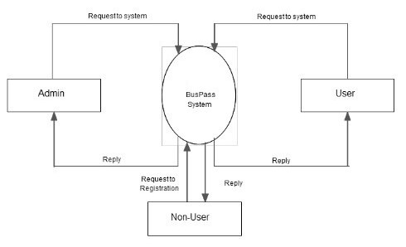

**Fig.3.1 0-level DFD**

ONLINE BUS PASS SYSTEM
12
4.1.2 1stLevel DFD
USER SIDE:
 

**Fig. 3.2 1-level DFD**

**3.2 Use Case Diagram:**

Use Case Diagram gives a graphic overview of the actors involves in the system, different functions needed by those actors and how these different functions are interacted.

The purpose of this is to capture the dynamic aspect of a system. However, this definition is too generic to describe the purpose. Use Case Diagrams are used to gather the requirements of a system including internal and external influences. These requirements are mostly design requirements.

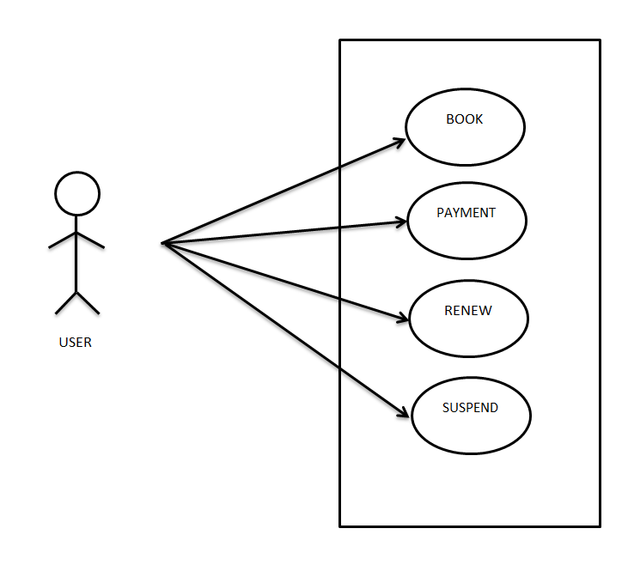

**Fig. 3.2 Use Case Diagram**

**3.3 E-R Diagram:**

Entity relationship diagrams are used in software engineering during the planning stages of the software project. They help to identify different system elements and their relationships with each other. In the diagram, the information inside the oval shapes are attributes of a particular entity.

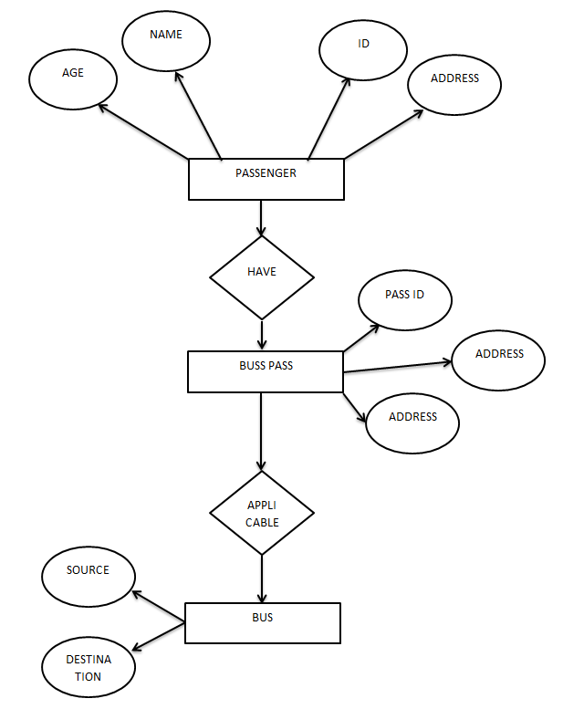

**CHAPTER-4**

**IMPLEMENTATION AND USER INTERFACES**

In this chapter we describe the various interfaces in the project like user interfaces, software interfaces and hardware interfaces. In the end output screens are shown depicting various screens in the system.

**4.1 User Interfaces:**

User interface is a part of software and is designed in such a way that it is expected to provide the user inside of the software. The UI provides fundamental platform for human-computer interaction. UI can be graphical, text based, audio-video based, depending upon the underlying hardware and software combination.

**4.2 Software Interfaces:**

3.1.a Front End: HTML, CSS, JavaScript

3.1.b Back End: PHP, Cloud Shell

3.1.c Operating System: Windows 10

**4.3 Hardware Interfaces:**

3.2.a Processor: Intel CORE i5

3.2.b Hard Disk: 64 bits

3.2.c RAM: 8 GB

**4.4 Output Screens:**

**Front Page-**

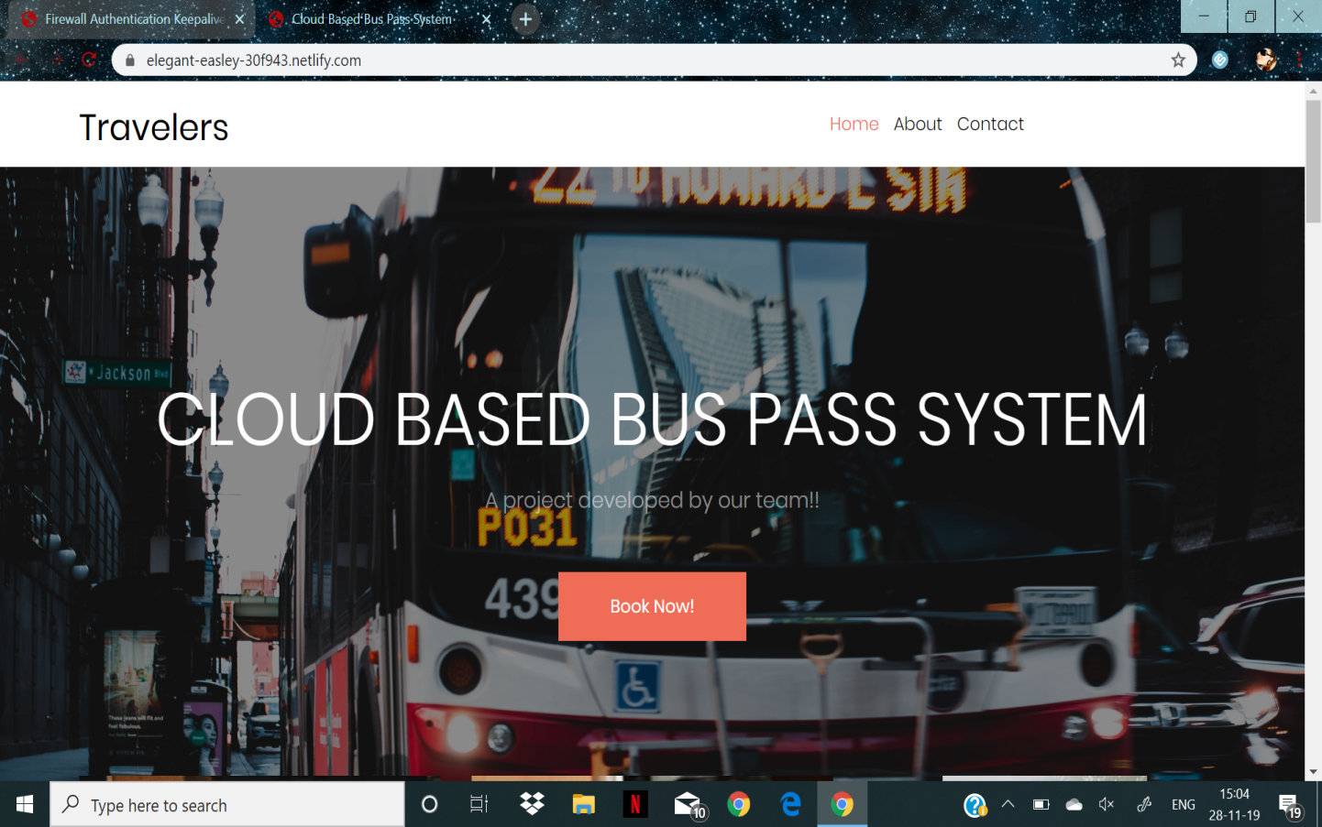

**CHAPTER-5**

**SOFTWARE TESTING**

Testing is one of the most import phases in the software development activity. In software development lifecycle (SDLC), the main aim of testing process is the quality: the developed software is tested against attaining the required functionality and performance.

During the testing process the software is worked with some particular test cases and the output of the test cases are analysed whether the software is working according to the expectations or not.

**5.1 Introduction**

The success of the testing process is determining the errors which mostly depends upon the test case criteria, for testing any software we need to have a description of the expected behaviour of the system and method of determining whether the observed behaviour confirmed to the expected behaviour.

**Level of Testing:**

Since the errors in the software can be injured at any stage. So, we have to carry out the testing process at different level during the development. The basic levels of testing are Unit Integration, System Testing and Acceptance Testing.

The Unit Testing is carried out on coding. Here different modules are tested against the specifications produces during design for the modules. In case of Integration Testing different tested modules are combined into sub systems and tested. In case of the system testing the full software is tested and in the next level of testing the system is tested with user requirement document prepared during SRS.

There are two basic approaches for testing. They are

**Functional Testing:**

In functional testing test cases are decided solely on the basis of requirements of the program or the module and the internals of the program or modules are not considered for selection of test cases. This is also called Black Box Testing.

**Structural Testing:**

In Structural Testing test cases are generated on actual code of the program or module to be tested. This is called White Testing.

**5.2 Testing Process**

A number of activities must be performed for testing software. Testing starts with test plan. Test plan identifies all testing related activities that need to be performed along with the schedule and guide lines for testing. The plan also specifies the levels of testing that need to be done, by identifying the different testing units. For each unit specified in the plan first the test cases and reports are produced. These reports are analyzed.

**Test plan:**

Test plan is a general document for entire project, which defines the scope, approach to be taken and the personal responsible for different activities of testing. The inputs for forming test plans are:

Project plan

Requirements documents

System design

**Test Case Specification:**

Although there is one test plan for entire project test cases have to be specified separately for each test case. Test case specification gives for each item to be tested. All test cases and outputs expected for those test cases.

**Test Case Execution and Analysis:**

The steps to be performed for executing the test cases are specified in separate document called test procedure specification. This document specify any specify requirements that exist for setting the test environment and describes the methods and formats for reporting the results of testing.

**Unit Testing:**

Unit testing mainly focused first in the smallest and low level modules, proceeding one at a time. Bottom-up testing was performed on each module. As developing a driver program, that tests modules by developed or used. But for the purpose of testing, modules themselves were used as stubs, to print verification of the actions performed. After the lower level modules were tested, the modules that in the next higher level those make use of the lower modules were tested.

Each module was tested against required functionally and test cases were developed to test the boundary values.

**Integration Testing:**

Integration testing is a systematic technique for constructing the program structure, while at the same time conducting tests to uncover errors associated with interfacing. As the system consists of the number of modules the interfaces to be tested were between the edges of the two modules. The software tested under this was incremental bottom-up approach.

Bottom-up approach integration strategy was implemented with the following steps.

* Low level modules were combined into clusters that perform specific software sub fractions.
* The clusters were then tested.

**System Testing:**

System testing is a series of different tests whose primary purpose is to fully exercise the computer based system. It also tests to find discrepancies between the system and its original objective, current specifications.

**CHAPTER-6**

**CONCLUSION**

Bus pass Registration and Renewal System Project is a real time project which is useful for the people who are facing problems with the current manual work of bus pass Registration and renewal. It also increases the validity period, frequently Warns to the student before completion of his validity period by website. His / Her Renewal or Registration can be done using a voucher or even by a credit card. This online bus pass registration application will help students save their time and renewal bus passes without standing in a line for hours near counters. Initially people need to register with the application by submitting details of photo, address proof, and required details and submit through online. They will verify your details and if they are satisfied they will approve bus pass. You can even renewal using credit card or other wire transfer methods.

**REFERENCES**

* [**www.w3schools.com**](http://www.w3schools.com)
* [**https://www.geeksforgeeks.org**](https://www.geeksforgeeks.org/)
* [**https://www.tutorialspoint.com**](https://www.tutorialspoint.com/)
* [**www.quora.com**](http://www.quora.com)