# 

# **ASSIGNMENT 4**

**MATLAB**

**PROJECT ON VOICE COMPARISON**

**SUBMITTED TO: SUBMITTED BY:**

**SIR VEDAVYASA KAMATH BRAJESH MAHAJAN**

**160911150**

**` INFORMATION TECH**

**INTRODUCTION**

I have made a software which is used to compare voice from the voice which are stored in project directory. Speech recognition is used in almost every security project where you need to speak and tell your password to computer and is also used for automation. For example, I want to turn my AC on or off using voice commands then I have to use Speech recognition. I have to make the system recognize that whether I am saying ON or OFF. In short, speech recognition plays a vital role in voice control projects. The technique I have used in this project is known as cross correlation.

Correlation is normally used in signal processing, where you need to compare two signals and need to find the similarity between them. It is also known as the dot product of those two signals. Correlation is also used for pattern recognition like you want to find some pattern in the signal then you can use Correlation. In m project, I am using correlation to find similarity between stored signal and testing signal.

**EXPLANATION OF PROCEDURE**

1. In the project directory, I have 5 recorded voice to compare with voice to be recorded.
2. I have uploaded the first five training audio files in the software.
3. Then, User records the audio file using software.
4. Using correlation I compare the recorded voice and listened voice.
5. In output, I have displayed graphs of listened voice and best matched voice.
6. Also, if none of the voices matches it replies with sound “Access denied”.

**IMAGE OF USER INTERFACE**

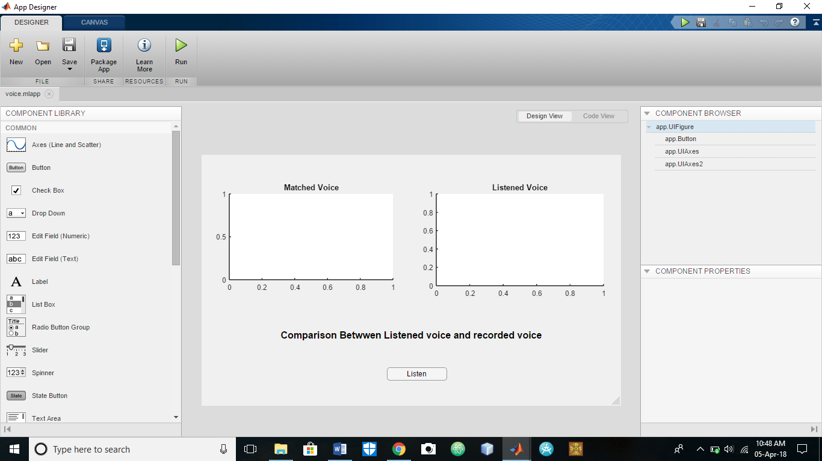

*First we press Listen button, then speak ‘hello’.*

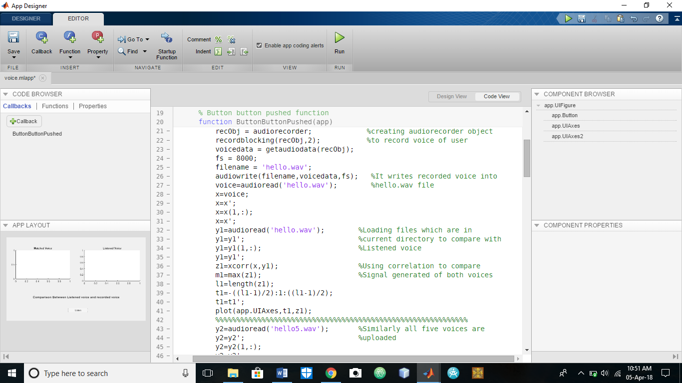**IMAGES OF CODE SNIPPET**

*In above picture, I am listening voice of user using audiorecorder object.*

**CODE SNIPPET FOR UPLOADING FIVE VOICE TO COMPARE**

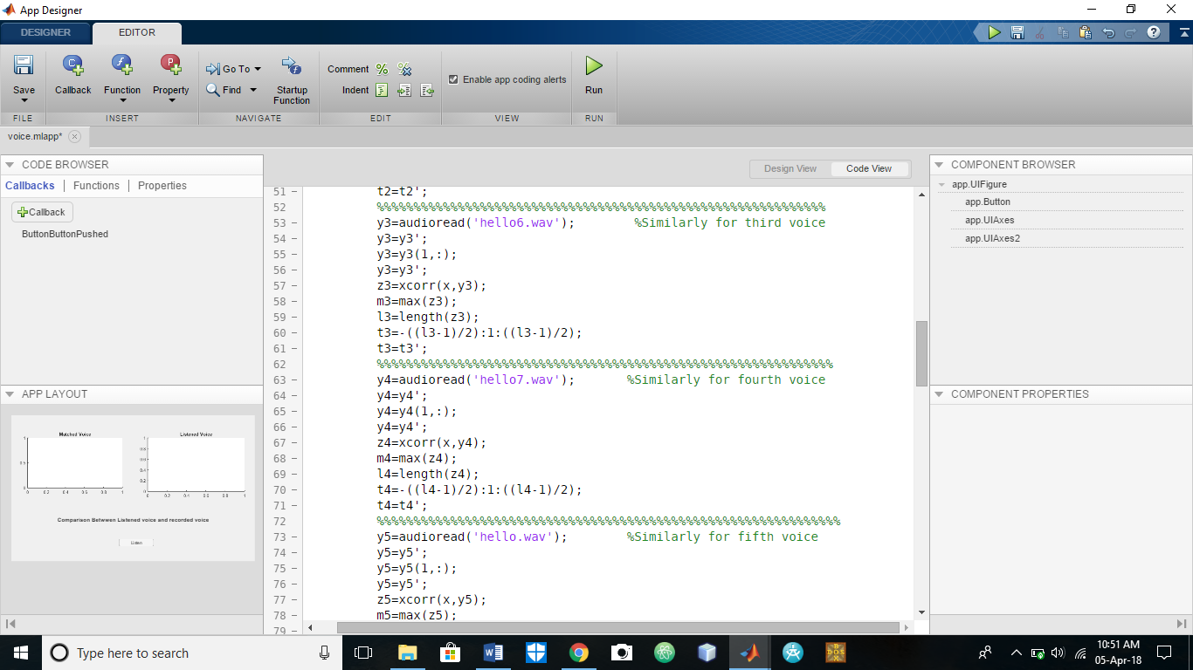

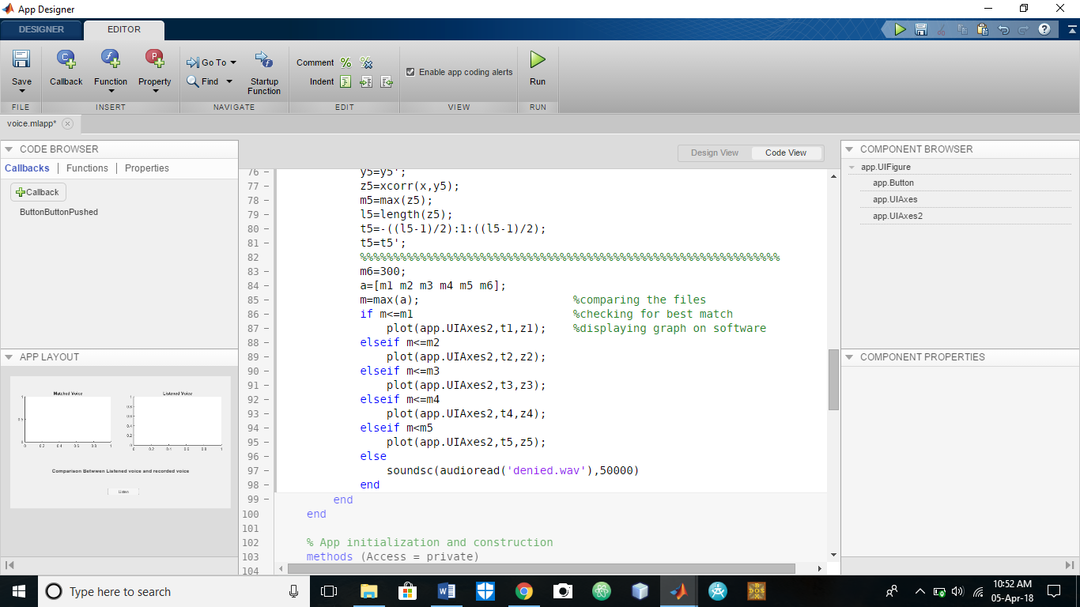*Here we have uploaded all five voice and now to compare voices code snippet is given below.*

**MY CODE**

recObj = audiorecorder; %creating audiorecorder object

recordblocking(recObj,2); %to record voice of user

voicedata = getaudiodata(recObj);

fs = 8000;

filename = 'hello.wav';

audiowrite(filename,voicedata,fs); %It writes recorded voice into

voice=audioread('hello.wav'); %hello.wav file

x=voice;

x=x';

x=x(1,:);

x=x';

y1=audioread('hello.wav'); %Loading files which are in

y1=y1'; %current directory to compare with

y1=y1(1,:); %Listened voice

y1=y1';

z1=xcorr(x,y1); %Using correlation to compare

m1=max(z1); %Signal generated of both voices

l1=length(z1);

t1=-((l1-1)/2):1:((l1-1)/2);

t1=t1';

plot(app.UIAxes,t1,z1);

%%%%%%%%%%%%%%%%%%%%%%%%%%%%%%%%%%%%%%%%%%%%%%%%%%%%%%%%%%%%

y2=audioread('hello5.wav'); %Similarly all five voices are

y2=y2'; %uploaded

y2=y2(1,:);

y2=y2';

z2=xcorr(x,y2);

m2=max(z2);

l2=length(z2);

t2=-((l2-1)/2):1:((l2-1)/2);

t2=t2';

%%%%%%%%%%%%%%%%%%%%%%%%%%%%%%%%%%%%%%%%%%%%%%%%%%%%%%%%%%%%%

y3=audioread('hello6.wav'); %Similarly for third voice

y3=y3';

y3=y3(1,:);

y3=y3';

z3=xcorr(x,y3);

m3=max(z3);

l3=length(z3);

t3=-((l3-1)/2):1:((l3-1)/2);

t3=t3';

%%%%%%%%%%%%%%%%%%%%%%%%%%%%%%%%%%%%%%%%%%%%%%%%%%%%%%%%%%%%%%

y4=audioread('hello7.wav'); %Similarly for fourth voice

y4=y4';

y4=y4(1,:);

y4=y4';

z4=xcorr(x,y4);

m4=max(z4);

l4=length(z4);

t4=-((l4-1)/2):1:((l4-1)/2);

t4=t4';

%%%%%%%%%%%%%%%%%%%%%%%%%%%%%%%%%%%%%%%%%%%%%%%%%%%%%%%%%%%%%%%

y5=audioread('hello.wav'); %Similarly for fifth voice

y5=y5';

y5=y5(1,:);

y5=y5';

z5=xcorr(x,y5);

m5=max(z5);

l5=length(z5);

t5=-((l5-1)/2):1:((l5-1)/2);

t5=t5';

%%%%%%%%%%%%%%%%%%%%%%%%%%%%%%%%%%%%%%%%%%%%%%%%%%%%%%%%%%%%%%%

m6=300;

a=[m1 m2 m3 m4 m5 m6];

m=max(a); %comparing the files

if m<=m1 %checking for best match

plot(app.UIAxes2,t1,z1); %displaying graph on software

elseif m<=m2

plot(app.UIAxes2,t2,z2);

elseif m<=m3

plot(app.UIAxes2,t3,z3);

elseif m<=m4

plot(app.UIAxes2,t4,z4);

elseif m<m5

plot(app.UIAxes2,t5,z5);

else

soundsc(audioread('denied.wav'),50000)

end

**README.TXT**

1. Open software and press Listen button.
2. Speak “hello” within 2 seconds.
3. Now, if you voice gets matched with any of five voices it will show you the graph of your voice and voice with which it is matched. It means you are recognized by software.
4. If your voice does not match with any of five voices it will reply with “Access denied”.

*********************