Olist Marketplace Analysis
Understanding Marketplace Performance & Customer Satisfaction
Prepared for: Olist Operations & Customer Experience Leadership
Data Period: September 2016 – October 2018
Analysis Report — Data Analyst Case Study

1. Problem Understanding
Olist connects small and medium Brazilian merchants to major online marketplaces through a single contract. When a customer places an order, the responsible seller ships it via Olist's logistics partners, and once the order is delivered (or the estimated delivery date passes) the customer receives a satisfaction survey.
Leadership has roughly two years of order history but no single consolidated view connecting delivery performance, seller and customer geography, product category, and payment behavior to customer satisfaction. This analysis works through that data — orders, items, payments, products, sellers, customers, reviews, and geolocation — to identify what is actually shaping the customer experience, and where the clearest opportunities are as Olist scales.

Scope of this report
This report addresses the six core questions defined in the brief: marketplace performance over time, delivery performance and satisfaction, seller and geographic patterns, product category performance, payment behavior, and a root-cause view of what drives low review scores. One optional deep dive — repeat customer behavior — is included as well.

2. Analytical Approach
All nine source tables were loaded and validated against the documented row counts and structure before any analysis began. Timestamps were parsed and delivery timing was calculated only for orders that were actually marked delivered and had a real delivery date — non-delivered orders were kept in the dataset but excluded from delivery-time metrics, since including them would misrepresent both groups.
Order items and payments were aggregated to one row per order (summing price and freight, and taking the highest-value payment record as the order's primary payment method) and joined onto the orders table to build a single master analytical dataset. Where an order had more than one review record, the most recently submitted review was used, so no order is double-counted.
Category performance used an item-level join to the product and category-translation tables. Seller and customer geography was compared at the state level, since zip-level geolocation data is not a clean one-to-one lookup (roughly 52 lat/lng readings per zip prefix on average) and state-level comparison is sufficient to answer the questions in scope. Findings are based on correlation and group comparison rather than causal modeling, consistent with the observational nature of this data.

3. Key Insights

3.1 Marketplace growth and satisfaction moved independently
Order volume and revenue both grew steadily and substantially across the ~2 year window, roughly tracking each other since average order value stayed fairly flat. Average review score, however, did not follow the same trend — it stayed in a fairly narrow 3.9–4.3 band for most of the period, without a clear relationship to how many orders were being placed that month.
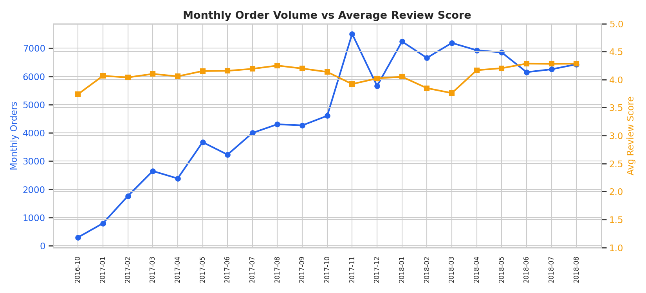
Figure 1 — Monthly order volume (left axis) vs average review score (right axis).

3.2 Delivery lateness is the single strongest driver of dissatisfaction
Orders delivered on or before the estimated delivery date average 4.29 out of 5 stars. Orders delivered late average just 2.27 — a gap of roughly two full stars on a five-point scale. This is by far the strongest relationship found anywhere in the dataset (correlation of -0.27 between days-late and review score, notably stronger than any other factor tested).
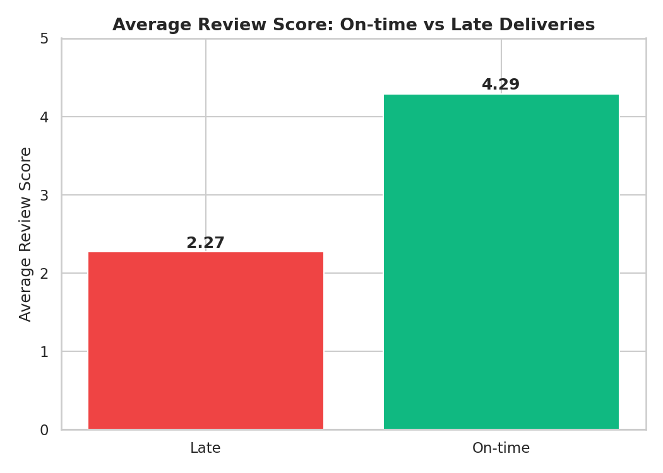
Figure 2 — Average review score, on-time vs. late deliveries.
This pattern holds consistently across states rather than being concentrated in one region — states with higher late-delivery rates (Rio de Janeiro at ~11.9%, Bahia at ~11.9%) also show lower average review scores (~3.93–3.97) compared to São Paulo, which has both the lowest late rate (~4.4%) and the highest average review score (~4.25) among high-volume states.

3.3 Sellers are heavily concentrated in São Paulo, and that concentration has a cost
71% of all order-item volume ships from sellers based in São Paulo state, with every other state contributing under 8%. Customers, by contrast, are distributed nationally — meaning most orders placed outside SP involve cross-state shipping by default.
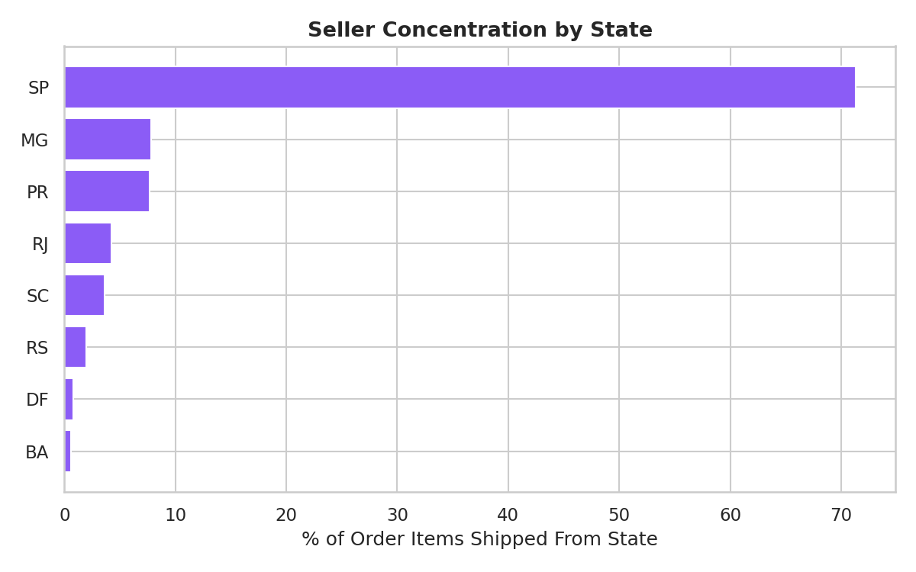
Figure 3 — Share of order items shipped, by seller state.
Cross-state orders carry meaningfully higher freight (R$23.63 average vs. R$13.45 for same-state orders — a 76% increase) and a lower average review score (4.02 vs. 4.20). Given how concentrated the seller base is, this cross-state pattern is the default experience for customers in most of the country, not an edge case.
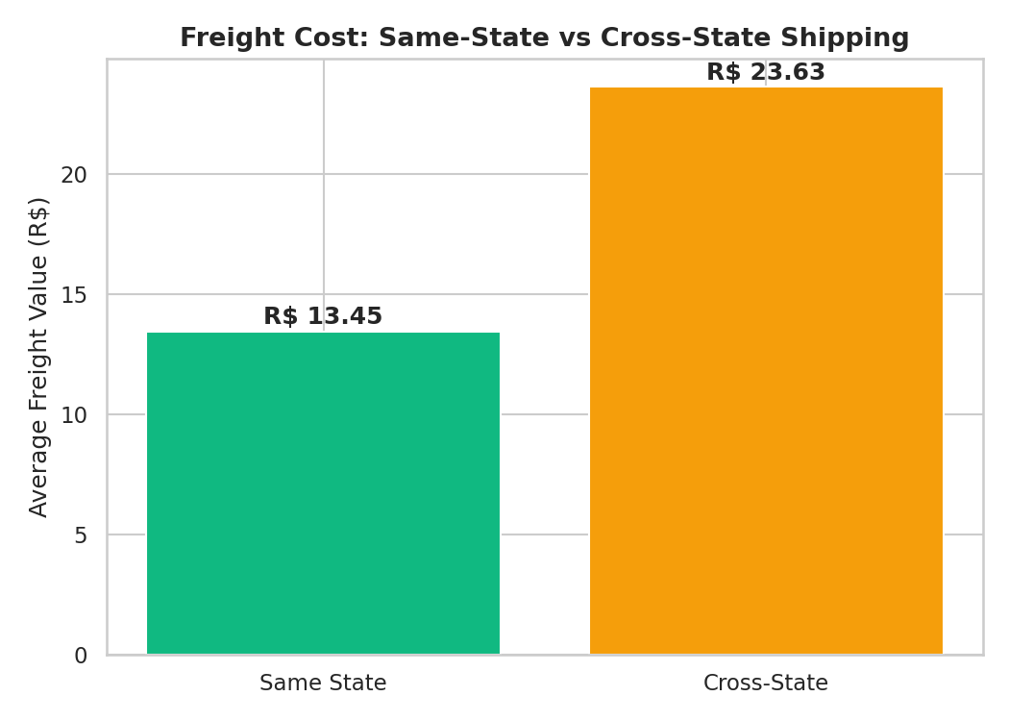
Figure 4 — Average freight cost, same-state vs. cross-state shipping.

3.4 A small number of categories underperform, but it is not a platform-wide problem
Most product categories track close to the platform-wide average review score. A handful of categories — notably office furniture (3.52 average, on 1,668 items — enough volume to matter), fixed telephony (3.76), and fashion menswear (3.76) — underperform meaningfully. The pattern fits more with bulky or fragile goods being harder to ship reliably than with a product-quality story.
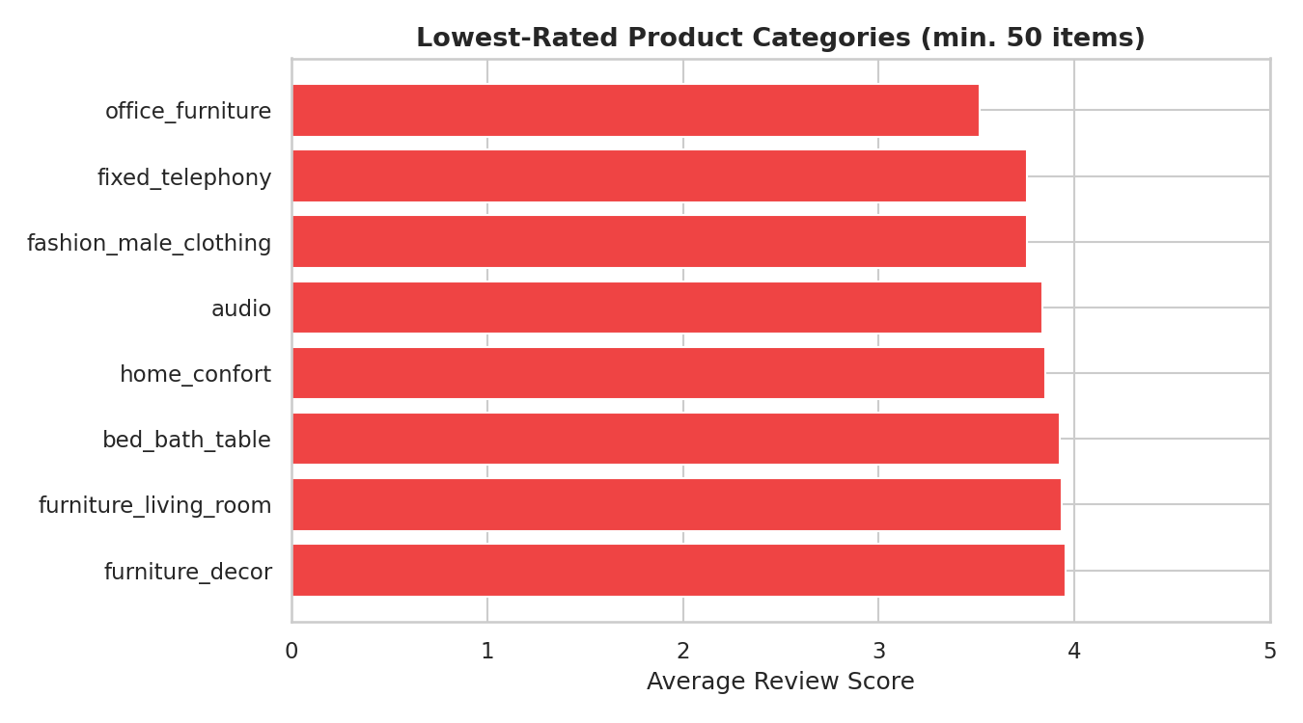
Figure 5 — Lowest-rated product categories (minimum 50 items sold).

3.5 Payment behavior has only a weak relationship with satisfaction
Credit card is the dominant payment method (75% of orders) and the only method used for meaningful installment plans (boleto and debit card are almost always paid in one installment). Higher installment counts correlate mildly with lower review scores (4.12 down to 3.87 as installment count rises past 10) but also with higher order value — this looks more like installments being used for bigger, more complex purchases than installments themselves causing dissatisfaction. Correlation with review score was under 0.04 for both order value and installment count.

3.6 Root cause ranking
- Primary driver — Delivery lateness: the strongest and most consistent factor found, holding across states and categories.
- Contributing/upstream driver — Seller geographic concentration: sits behind delivery lateness for much of the country, since most sellers are in one state.
- Secondary — Freight cost: entangled with cross-state shipping rather than acting as an independent driver.
- Secondary, localized — Product category: a few specific categories underperform, but this doesn't explain low scores platform-wide.
- Weak/minor — Payment type and installments: correlations too small to treat as a meaningful driver on their own.

3.7 Optional deep dive: repeat customers
Only about 3% of customers (using the person-level customer_unique_id, not the order-level customer_id) place more than one order in this two-year window — a low repeat rate for a marketplace of this size. A first-pass comparison of repeat rates between customers whose first order arrived late versus on time did not show a large difference (2.9% vs. 3.2%), so while delivery lateness clearly damages review scores, its direct link to repeat purchase is inconclusive from this cut alone and would benefit from a more rigorous cohort study.

4. Business Findings — Summary Table
Question | Headline Finding
Performance over time | Volume/revenue grew steadily; review scores stayed flat — they moved independently.
Delivery vs. satisfaction | On-time: 4.29★ avg. Late: 2.27★ avg. Strongest driver found in the data.
Seller/geography | 71% of sellers based in SP; cross-state orders cost 76% more in freight and score lower.
Category performance | Most categories near average; office furniture, fixed telephony, menswear underperform.
Payment behavior | Credit card dominant (75%); installments/value have only a weak link to satisfaction.
Root cause | Delivery lateness is the primary driver; seller concentration is a key upstream cause.

5. Actionable Recommendations
- 1. Treat delivery reliability, not just speed, as the top priority. The data shows it's specifically lateness relative to the promised date that damages satisfaction. Re-calibrating estimated delivery dates to be more accurate — even without changing actual logistics — should reduce the volume of orders classified as "late."
- 2. Actively recruit sellers outside São Paulo, prioritizing underserved high-population states. States like Rio de Janeiro and Bahia show both higher freight costs and higher late-delivery rates, consistent with their distance from the current seller base. Reducing average seller-to-customer distance should improve both metrics directly.
- 3. Give targeted operational attention to bulky/fragile categories. Office furniture in particular combines real sales volume with the weakest average review score of any sizeable category — worth investigating packaging, handling, and carrier practices specific to these goods.
- 4. Deprioritize payment-flow changes for now. The relationship between payment behavior and satisfaction is too weak in this data to justify significant investment there ahead of the delivery and seller-geography issues above.
- 5. Commission a proper cohort study on delivery experience and repeat purchase. The surface-level comparison here was inconclusive, but with a 3% repeat rate and a clear delivery-satisfaction link, this is a high-value question that deserves more rigorous, controlled analysis before ruling the connection in or out.

Full supporting analysis, code, and additional exploratory detail are available in the accompanying Colab notebook.

