E9 241 Digital Image Processing

Assignment 01

Name: Bitupan Arandhara Sr. No.: 25910

# Q1. Histogram Computation:

## Results:

1. Average intensity of the image using histogram: 103.31
2. Actual average intensity: 103.31
3. Verification: The two values are equal.
4. Histogram of the image is shown below:

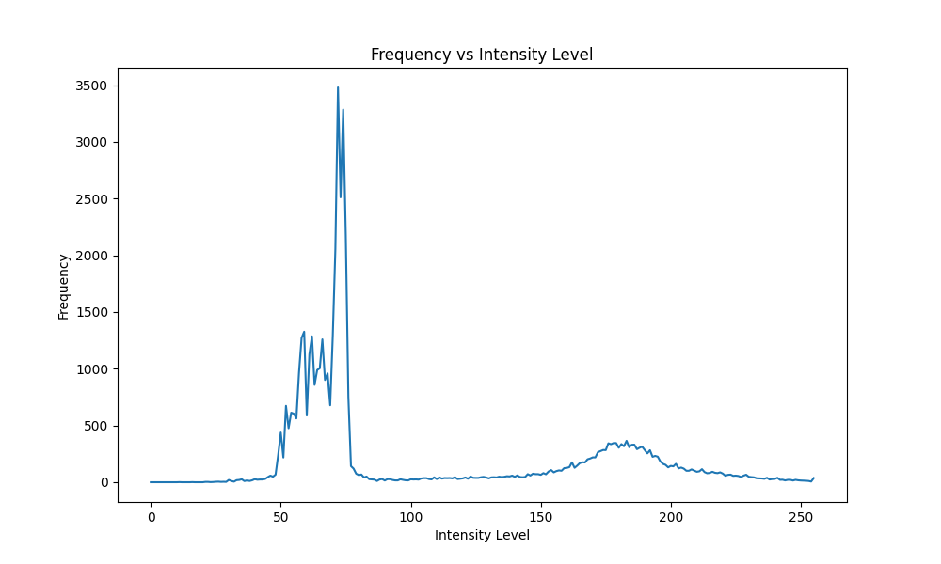

## Inferences:

1. **Bimodal Distribution:** The histogram plot of the image shows a bimodal distribution, i.e. it has two distinct peaks.

* The tall, sharp peak on the left corresponds to the dark background of the image. A large number of pixels fall into this small range of dark gray values.
* The shorter, broader peak on the right corresponds to the pixels of the coins. The broader nature of this peak suggests that the coins have more variation in brightness.

1. **Correctness of Average Intensity:** The average intensity calculated from the histogram is equal to the actual average intensity of the image pixels, which implies the correctness of the histogram computation.

# Q2. Otsu’s Binarization:

## Results:

1. **Binarization by Minimizing Within-Class Variance**:
   1. Optimal Threshold Found: 125
   2. Minimum Within-Class Variance: 265.102
   3. The image binarized using this threshold is shown below:



1. **Binarization by Maximizing Between-Class Variance** (with offset of 20 pixels):
   1. Optimal Threshold Found: 145
   2. Minimum Within-Class Variance: 2852.956
   3. The image binarized using this threshold is shown below:



* **Comparison of Original and Binarized Images:**

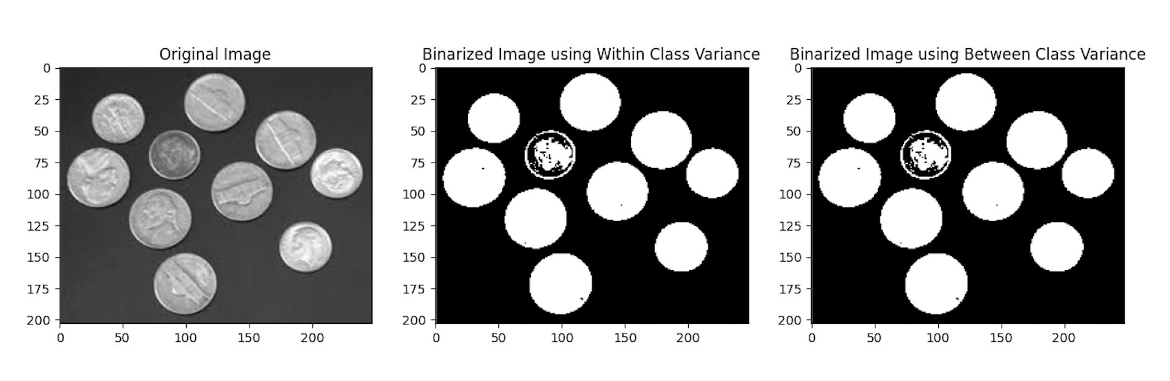

## Inferences:

1. **Difference in the thresholds**:

The optimal threshold for the original image was **125**. After adding a uniform offset of +20 to the image, the new optimal threshold was found to be **145**. The difference between the two computed thresholds is exactly the value of the offset.

1. **Explanation for the Difference:**

This is an expected result, and it demonstrates a key property of Otsu's method: Adding a constant offset k to every pixel shifts the entire image histogram horizontally by k units.And the shape of the histogram remains unchanged.

1. **Equivalence of Both Variance Methods**:

The thresholds that were computed using the within-class variance method and between-class variance method are equal. This is a result of the fact that total variance of the image is equal to the sum of the within-class variance and between-class variance. Hence, minimizing the within-class variance is equivalent to maximizing the between-class variance.

# Q3. Adaptive Binarization:

## Results:

1. **5 x 5 Block Size**:

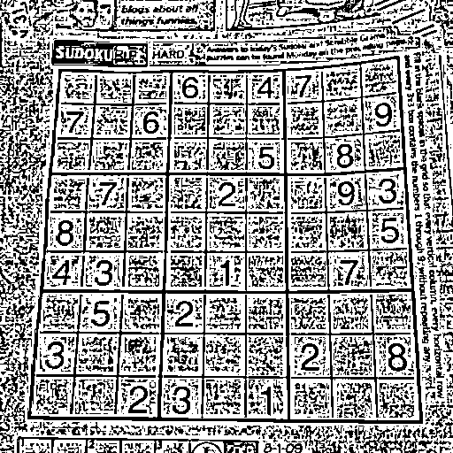

1. **10 x 10 Block Size**:

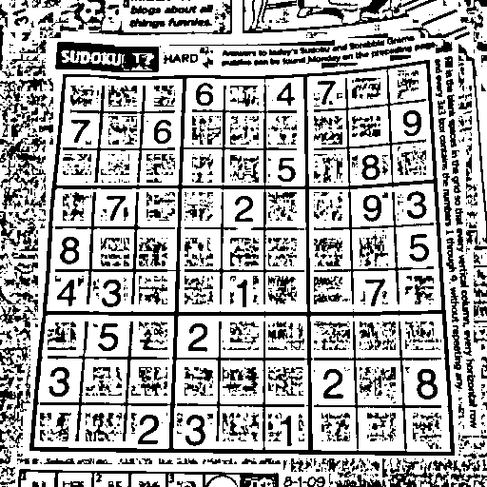

1. **25 x 25 Block Size**:

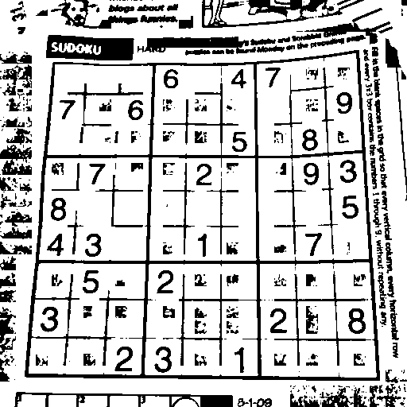

1. **50 x 50 Block Size**:

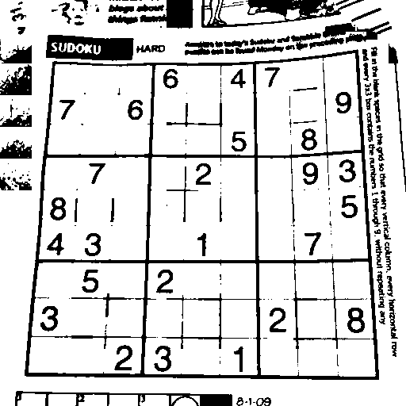

1. **Global Binarization (Full Image)**:

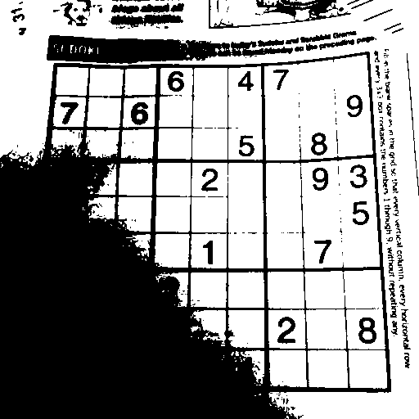

## Inferences:

1. **Failure of Global Binarization**:

The Global binarization result is very poor. The original image has a shadow in the bottom-left corner. The global threshold classifies this entire dark region as foreground (black). This result shows that global thresholding for images with uneven illumination does not provide accurate binarization of the image.

1. **Effect of Very Small Block Sizes** (5x5, 10x10):

The results for 5x5 and 10x10 block sizes are very noisy. These blocks are too small to contain a representative sample of both the foreground (dark) and background (bright). This results in a meaningless threshold for the image, hence binarization becomes noisy.

**Advantages**: They are better at capturing localized changes in illumination. If lighting conditions change over a very small area, a small block can capture this change.

**Disadvantages**: They can lead to a noisy binarization. As seen in the 5x5 and 10x10 block sizes, they may not contain enough pixels from both the foreground and background to calculate a meaningful threshold.

1. **Effect of Medium Block Sizes (25x25, 50x50):**

These block sizes provide much better results than small block sizes. They handle the shadow effectively.

**Advantages**: They can generate a more meaningful threshold as they are more likely to contain a good sample of the foreground and background pixels. This helps reduce the noise and handle gradual changes in lighting.

**Disadvantages**: If the block size is too large, it may not capture the local details properly. It may fail to adapt to lighting variations within the block.

# Q4. Connected Components:

## Results:

* The algorithm has found 67 connected components as there are 67 characters in the given quote.png image.
* The largest character is the **‘N’** in the world ‘**CULTIVATION’**. It consists of **545** pixels, and is identified, and highlighted in red:



## Inferences:

1. **Effective Binarization**:

The initial set up of binarizing the image successfully separated the foreground text from the background.

1. **Component Extraction**:

The algorithm correctly treated each character and punctuation marks as a separate component of the image. It successfully grouped the pixels of a single character under a single label and assigned different labels to different characters.

1. **Correct Largest Component Identification**:

The algorithm correctly identified the letter ‘N’ in the world ‘cultivation’. It consists of 545 pixels.