FINAL YEAR B.TECH CAPSTONE ENGINEERING PROJECT REPORT
NEXUS
AI-Powered Supply Chain Intelligence, Risk Prediction & Optimization Platform
A Closed-Loop Multi-Echelon Decision-Support System: Monitor → Predict → Analyze Impact → Simulate → Optimize → Recommend

Candidate Name: | Shreyansh Uttam
Degree & Specialization: | B.Tech Computer Science & Engineering (AI & ML)
Department / School: | School of Computing Science & Engineering (SCSE)
Institution: | Vellore Institute of Technology (VIT) Bhopal University
Academic Year: | 2025 – 2026
Project Classification: | Major Project / Capstone Evaluation

Academic & Simulation Integrity Declaration
Student Declaration: I hereby declare that this project report entitled 'NEXUS: AI-Powered Supply Chain Intelligence, Risk Prediction & Optimization Platform' submitted in partial fulfillment of the requirements for the award of the degree of Bachelor of Technology in Computer Science & Engineering with Specialization in Artificial Intelligence & Machine Learning (B.Tech CSE - AI & ML) at Vellore Institute of Technology (VIT) Bhopal University, is an authentic record of original engineering work carried out by me under academic supervision.
CRITICAL COMPLIANCE & PROVENANCE NOTICE
ACADEMIC & SIMULATION DATA DISCLAIMER:
NEXUS currently operates as an academic decision-intelligence prototype developed for multi-echelon supply chain modeling, risk forecasting, graph traversal, and mathematical optimization. The platform utilizes a hybrid empirical foundation: authentic historical time-series demand patterns from the Walmart Store Sales Forecasting dataset, and empirical fulfillment delay distributions from the DataCo Global Supply Chain dataset, mapped onto a calibrated synthetic digital twin topology of Indian logistics corridors (83 facilities, 160 multimodal routes).
Demonstrated scenario outcomes (including modeled cost reductions of 49% to 53% and 100% shortage elimination) are experimental, mathematical solver-derived results under controlled disruption shocks. They do NOT represent the proprietary internal operational performance, capacities, or financial records of commercial organizations named in the simulated twin (e.g., Tata AutoComp, Tata Steel, Foxlink Electronics). NEXUS does not claim live integration with production enterprise ERP, WMS, or real-time GPS telemetry feeds, as those enterprise backbones are simulated via in-memory state models.

Executive Summary & Abstract
Context & Problem Landscape: Modern enterprise supply chains are vast, highly coupled, multi-echelon networks that span multiple tiers of raw material suppliers, manufacturing plants, regional central warehouses, cross-dock feeder terminals, and urban consumption markets. Despite extensive investments in Enterprise Resource Planning (ERP) and Warehouse Management Systems (WMS), enterprise decision-makers routinely suffer from profound blind spots: operational data remains trapped in transactional silos, forecasting is conducted in isolation without visibility into supplier operational health, supplier risk assessments are static and backward-looking, and disruption mitigation relies on fragmented spreadsheet heuristics that react to stockouts only after assembly lines stall and SLA penalties accrue.
The NEXUS Architectural Solution: NEXUS is an enterprise-grade, general-purpose decision-intelligence platform engineered to bridge the gap between predictive AI, network graph theory, and mathematical optimization. Rather than functioning as a passive reporting dashboard, NEXUS introduces a closed-loop operational workflow: MONITOR → PREDICT → ANALYZE IMPACT → SIMULATE → OPTIMIZE → RECOMMEND. The system continuously monitors an authentic Indian logistics digital twin comprising 83 facility nodes and 160 transit corridors, forecasts multi-horizon SKU demand using an autoregressively engineered XGBoost Regressor (benchmarked against Naive persistence and Moving Average baselines, achieving a 29.5% RMSE reduction), predicts vendor failure probabilities using a supervised XGBoost classifier trained with strict group-based out-of-sample vendor isolation to prevent data leakage (F1: 0.757, ROC-AUC: 0.699), and detects real-time operational outliers via unsupervised Isolation Forests.
Quantitative Findings & Impact: When an operational disruption occurs—such as an 80% capacity failure at a Tier-1 vendor—NEXUS employs a NetworkX directed graph traversal engine to trace failure propagation through dependent bills of materials, computing exact warehouse stock runway days (Runway = Stock / Daily Burn Rate) and identifying imminent stockout breaches before they manifest physically. To resolve the disruption, the scenario engine creates an in-memory, non-destructive clone of the network state, which is fed into a multi-echelon linear program solved by Google OR-Tools (GLOP). The optimizer minimizes total operational expenditures across procurement, multimodal freight, warehouse holding, shortage penalties (INR 350/unit), and risk exposure penalties in just 0.011 seconds. In a demonstrated stress test on Supplier SUP_001 (Tata AutoComp Components), NEXUS eliminated 100% of unmet shortages (saving 74,967 units), elevated the network service level from 51.24% to 100.0%, and slashed modeled operational disruption costs by 53.89% (saving INR 22,542,319) compared to standard baseline operations. Finally, a recommendation engine synthesizes the mathematical solution into plain-language executive directives accompanied by a mathematically rigorous Plan Feasibility & Robustness Index (0.94 - 0.98).

Table of Contents
Section / Chapter Title | Target Page
Academic & Simulation Integrity Declaration | 2
Executive Summary & Abstract | 3
List of Figures | 5
List of Tables | 6
1. Introduction | 7
1.1 Background & Supply Chain Complexity | 7
1.2 Problem Statement | 8
1.3 Motivation: The Need for Decision Intelligence | 8
1.4 Project Objectives | 9
1.5 System Scope & Boundaries | 9
1.6 Target User Personas & Operational Roles | 10
1.7 Key Technical Contributions | 11
2. Existing Systems & Critical Limitations | 12
2.1 Conventional Approaches in Enterprise SCM | 12
2.2 Architectural & Analytical Failure Modes | 13
2.3 Comparative Analysis: Existing Tools vs. NEXUS | 14
3. Proposed System — NEXUS Architecture & Decision Loop | 15
3.1 The Closed-Loop Decision Intelligence Cycle | 15
3.2 Six-Stage Functional Decomposition | 16
4. Multi-Echelon System Architecture | 18
4.1 Subsystem Layering & Communication Flow | 18
4.2 End-to-End Architectural Topology | 19
5. Verified Technology Stack | 21
5.1 Exhaustive Technology Catalog | 21
5.2 Architectural Rationale for Selected Tooling | 23
6. Data Sources & Comprehensive Data Pipeline | 25
6.1 Hybrid Data Strategy & Provenance Matrix | 25
6.2 Dataset 1: Walmart Store Sales Time-Series | 26
6.3 Dataset 2: DataCo Global Logistics Supply Chain | 27
6.4 Ingestion, Cleaning & Feature Engineering | 28
7. Relational Database Design | 30
7.1 Engine Architecture & Session Management | 30
7.2 Complete 14-Table Relational Schema Catalog | 31
7.3 Entity-Relationship Topology | 34
8. Digital Supply Chain Twin (Indian Network) | 36
8.1 Concept of the Calibrated Digital Twin | 36
8.2 Geodesic Coordinates & Indian Industrial Hubs | 37
8.3 Road Network Mathematics & Highway Tortuosity | 38
8.4 Network Topology: Nodes, SKUs, and Corridors | 39
8.5 Inventory Mechanics: Safety Stock & Reorder Points | 41
9. Demand Forecasting Engine | 43
9.1 Mathematical Problem Formulation | 43
9.2 Chronological Partitioning & Feature Extraction | 44
9.3 Evaluated Baseline Models & XGBoost Regressor | 45
9.4 Empirical Evaluation & Benchmark Results | 46
10. Supervised Supplier Risk Prediction Engine | 48
10.1 Business Rationale & Feature Space | 48
10.2 Resolution of Data Leakage & Group Partitioning | 49
10.3 Logistic Regression vs. XGBoost Classifier | 50
10.4 Feature Importance & Model Explainability | 51
11. Operational Anomaly Detection Engine | 53
11.1 Algorithm: Isolation Forest Formulation | 53
11.2 Monitored Signals & Anomaly Taxonomy | 54
12. Cascading Impact Propagation Analysis | 56
12.1 NetworkX Directed Graph Modeling | 56
12.2 Multi-Echelon Failure Traversal Algorithm | 57
12.3 Warehouse Stock Runway & Shortage Projection | 58
13. Scenario Simulation Studio | 60
13.1 In-Memory Copy-on-Write State Cloning | 60
13.2 Five Verified Disruption Shock Scenarios | 61
14. Multi-Echelon Mathematical Optimization Engine | 63
14.1 Linear Programming Model Formulation | 63
14.2 Objective Function & Multi-Cost Tradeoffs | 64
14.3 Constraint Sets (Capacity, Flow, Balance) | 65
14.4 Google OR-Tools GLOP Solver Execution | 66
14.5 Baseline Heuristic Comparison Engine | 67
15. Strategic Recommendation Engine | 69
15.1 Mathematical Translation of LP Solution Vectors | 69
15.2 The Plan Feasibility & Robustness Index | 70
15.3 Simulated ERP/WMS Dispatch Interface | 71
16. Flagship Demonstration Scenario: Tata AutoComp (SUP_001) | 73
16.1 Step-by-Step Scenario Execution Walkthrough | 73
16.2 Baseline vs. NEXUS Mathematical Comparison | 75
16.3 Anatomy of the 53.89% Cost Reduction | 76
17. Backend API Architecture & REST Specification | 78
17.1 FastAPI Framework & Pydantic v2 Contracts | 78
17.2 Complete 16-Endpoint REST Catalog | 79
18. Frontend Control Room Architecture | 82
18.1 React 19, TypeScript, and Vite 8.3 | 82
18.2 State Management with TanStack React Query | 83
18.3 Code-Splitting, Lazy Loading & Bundle Footprint | 84
19. Screen-by-Screen Technical Documentation | 86
19.1 Executive Overview Screen | 86
19.2 Digital Twin Network Map Screen | 88
19.3 Demand Intelligence & Forecasting Screen | 90
19.4 Risk Intelligence Command Screen | 92
19.5 Disruption Impact Propagation Screen | 94
19.6 Scenario Simulation Studio Screen | 96
19.7 Google OR-Tools Optimization Engine Screen | 98
19.8 Strategic Recommendation Center Screen | 100
20. End-to-End API → Backend → Frontend Data Flow | 102
21. Consolidated Model Performance & Audit Findings | 105
22. System Testing & Quality Verification | 108
22.1 Backend Pytest Suite (29/29 Passing) | 108
22.2 Frontend Vitest Suite (10/10 Passing) | 110
22.3 Production Build Verification | 111
23. Security, Robustness & Reliability | 112
24. System Performance & Efficiency Benchmarks | 114
25. Limitations & Academic Boundaries | 116
26. Future Scope & Research Roadmap | 118
27. Codebase Structure & Architecture Inventory | 120
28. Important Code Snippets & Annotated Walkthroughs | 123
29. Mathematical Foundations Compendium | 131
30. Comprehensive User & Deployment Guide | 136
31. 5-Minute Project Demonstration Script | 140
32. Viva Voce Preparation Handbook (55 Questions & Answers) | 143
33. Technical Glossary | 160
34. Conclusion & Final Remarks | 164
35. Appendices (A through H) | 166

List of Figures
Figure No. | Title / Description | Location
Figure 3.1 | The NEXUS Closed-Loop Decision Intelligence Cycle | Chapter 3
Figure 4.1 | NEXUS Multi-Echelon System Architecture Topology | Chapter 4
Figure 7.1 | Relational Database Schema & Entity Relationships (14 Models) | Chapter 7
Figure 9.1 | Demand Forecasting Model Benchmark Error Comparison (RMSE & MAE) | Chapter 9
Figure 10.1 | Supplier Risk Supervised Classification Out-of-Sample Metrics | Chapter 10
Figure 14.1 | Multi-Echelon Cost Breakdown: Baseline Heuristic vs. NEXUS OR-Tools | Chapter 14
Figure 14.2 | Operational Resilience: Service Level Preservation & Shortage Avoidance | Chapter 14
Figure 17.1 | FastAPI Interactive OpenAPI 3.1 Swagger Documentation UI | Chapter 17
Figure 17.2 | Alternative Technical ReDoc Specification Interface | Chapter 17
Figure 19.1 | Screen 1 — Executive Supply Chain Overview Dashboard | Chapter 19
Figure 19.2 | Screen 2 — Digital Supply Chain Twin Geospatial Network Map | Chapter 19
Figure 19.3 | Screen 2b — Interactive Facility Inspector Drawer & Node Telemetry | Chapter 19
Figure 19.4 | Screen 3 — Demand Intelligence & Multi-Horizon Forecasting | Chapter 19
Figure 19.5 | Screen 4 — Supply Chain Risk Command Center & Live ML Inference | Chapter 19
Figure 19.6 | Screen 5 — Disruption Impact Propagation Engine & Cascade Pipeline | Chapter 19
Figure 19.7 | Screen 6 — What-If Scenario Simulation Studio & State Comparison | Chapter 19
Figure 19.8 | Screen 7 — Google OR-Tools Multi-Echelon Optimization Engine | Chapter 19
Figure 19.9 | Screen 8 — Strategic Recommendation Center & Mitigation Directives | Chapter 19

List of Tables
Table No. | Table Caption / Description | Location
Table 2.1 | Comparative Architectural Analysis: Traditional Tools vs. NEXUS | Chapter 2
Table 5.1 | Verified Production Technology Stack & Library Versions | Chapter 5
Table 6.1 | Data Provenance Classification & Source Foundation Matrix | Chapter 6
Table 6.2 | Walmart Store Sales Dataset Specification & Variable Mapping | Chapter 6
Table 6.3 | DataCo Global Supply Chain Dataset Fields & Risk Mapping | Chapter 6
Table 7.1 | Complete Relational Database Model Catalog & Row Counts | Chapter 7
Table 8.1 | Canonical Indian Logistics Hubs Geocoded Coordinates | Chapter 8
Table 9.1 | Autoregressive Lag & Rolling Window Feature Set (14 Variables) | Chapter 9
Table 9.2 | Demand Forecasting Model Benchmark Comparison on Test Set | Chapter 9
Table 10.1 | Supervised Supplier Risk Features & Out-of-Sample Performance | Chapter 10
Table 10.2 | Empirical Feature Importance Attribution of the XGBoost Classifier | Chapter 10
Table 13.1 | Supported Operational Disruption Scenarios & Shock Parameters | Chapter 13
Table 14.1 | Mathematical Linear Program Sets, Parameters, and Variables | Chapter 14
Table 16.1 | Disruption Scenario Audit: Baseline vs. NEXUS OR-Tools Performance | Chapter 16
Table 17.1 | FastAPI RESTful Endpoints Master Reference (16 Endpoints) | Chapter 17
Table 21.1 | Consolidated Machine Learning & Optimization Evaluation Master | Chapter 21
Table 22.1 | Backend Automated Test Suite Verification Results (29 Tests) | Chapter 22
Table 22.2 | Frontend Vitest Automated Test Results (10 Tests) | Chapter 22
Table 24.1 | System Performance, Latency, and Bundle Footprint Benchmarks | Chapter 24

1. Introduction

1.1 Background & Supply Chain Complexity
In the contemporary globalized economy, industrial supply chains have evolved from simple linear pipelines into intricate, hyper-connected multi-echelon networks. Modern manufacturing corporations—ranging from automotive giants and consumer electronics conglomerates to fast-moving consumer goods (FMCG) and pharmaceutical enterprises—rely on hundreds of specialized suppliers across multiple tiers of sub-assembly. Finished products are funneled through regional manufacturing plants, consolidated in central fulfillment depots, partitioned across transit cross-dock hubs, and ultimately distributed to dispersed consumer demand zones.
While this globalized specialization has maximized production efficiency and reduced baseline unit costs, it has simultaneously introduced unprecedented systemic fragility. The lean 'Just-In-Time' (JIT) manufacturing paradigms pioneered over recent decades have deliberately eliminated inventory buffers across every tier of the network. As a consequence, localized disruptions—such as unexpected factory equipment breakdowns, regional labor disputes, severe monsoon floods, or highway bottlenecks—no longer remain isolated. Instead, they propagate rapidly downstream, amplifying demand distortion (the classic 'Bullwhip Effect') and triggering catastrophic stockouts at distant distribution centers.

1.2 Problem Statement
The Operational Crisis: Modern enterprise supply chains face three interconnected, compounding points of failure:
- 1. Information Silos & Fragmented Visibility: Enterprise data is fractured across disparate ERP, WMS, and TMS systems. Operations planners lack a unified, geospatially coherent digital twin of the entire multi-echelon topology, rendering them blind to cross-facility dependencies.
- 2. Decoupled Predictive Intelligence: Forecasting is historically conducted using basic spreadsheet heuristics or isolated statistical software that ignores upstream supply constraints. Meanwhile, vendor risk management relies on backward-looking quarterly scorecards that fail to detect imminent operational failures before deliveries breach SLAs.
- 3. Reactive Disruption Firefighting: When an unexpected shock strikes (e.g., an 80% loss in capacity at a key supplier), supply chain managers are forced into manual, ad-hoc firefighting. Lacking automated mathematical optimization tools, they execute rigid single-supplier rules that cause massive stockouts, service-level collapses, and millions of INR in contractual SLA penalties.

1.3 Motivation: The Need for Decision Intelligence
Passive business intelligence dashboards that merely report historical failures ('what went wrong yesterday') are fundamentally inadequate for modern high-velocity logistics. True supply chain resilience demands an active **Decision Intelligence** platform that answers three forward-looking operational questions:
- 1. Predictive Horizon: What is likely to fail in the network, where, and with what probability?
- 2. Cascading Impact: If this failure occurs, what exact downstream products, warehouses, and consumer demand zones will suffer stockouts?
- 3. Prescriptive Recovery: What mathematically optimal, cost-minimized reallocation actions should we execute right now to prevent those stockouts?

1.4 Project Objectives
The NEXUS project was conceived to achieve nine measurable, verified engineering objectives:
- Obj 1 (Digital Twin): Build an authentic, geocoded Indian digital supply chain twin network modeling 83 facility nodes and 160 transit corridors.
- Obj 2 (Data Foundation): Integrate real empirical research datasets (Walmart Store Sales, 421k rows; DataCo Logistics, 35k rows) with zero mock data in live execution.
- Obj 3 (Demand ML): Train and evaluate an autoregressive XGBoost demand forecasting model that outperforms Naive and Moving Average baselines by at least 25% RMSE reduction.
- Obj 4 (Risk ML): Develop a supervised supplier disruption classifier using strict out-of-sample vendor grouping to prevent data leakage.
- Obj 5 (Anomaly Detection): Implement multi-variate unsupervised anomaly detection (Isolation Forest) to flag operational delay and demand volume outliers.
- Obj 6 (Impact Engine): Build a NetworkX graph traversal engine that traces multi-echelon cascading failure paths and computes warehouse stock runways.
- Obj 7 (Simulation Studio): Implement an in-memory, non-destructive scenario simulation studio supporting five distinct operational disruption shocks.
- Obj 8 (OR-Tools Optimization): Formulate and solve a multi-echelon linear optimization problem using Google OR-Tools (GLOP), proving measurable cost reduction and 100% shortage elimination over baseline heuristics.
- Obj 9 (Full-Stack UI/API): Deliver a production-ready, dark-palette React 19 control-room frontend with 8 functional screens, interactive Leaflet GIS mapping, Recharts visualizations, and 16 REST endpoints.

1.5 System Scope & Boundaries
To ensure academic rigor and feasibility, NEXUS defines explicit system boundaries:
• IN SCOPE: Multi-echelon logistics modeling across Tier-1 and Tier-2 suppliers, assembly plants, central warehouses, distribution hubs, and demand zones; geodesic road distance calculation with highway tortuosity; recursive time-series forecasting; supervised disruption classification; in-memory scenario state cloning; linear programming cost optimization; explainable recommendation synthesis; FastAPI backend; and React 19 UI.
• OUT OF SCOPE: Live production connectors to proprietary enterprise ERP backbones (SAP S/4HANA, Oracle SCM); live IoT GPS telematics streaming; Tier-4 raw mineral extraction mining modeling; and automated financial fund transfers or purchase order dispatch to external vendors.

1.6 Target User Personas & Operational Roles
NEXUS is designed for enterprise supply chain professionals across four functional domains:
- • Chief Supply Chain Officer (CSCO) & VP of Logistics: Uses the Executive Overview and Strategic Recommendation Center to evaluate network risk posture and approve mitigation budgets.
- • Strategic Procurement Managers: Uses the Risk Command Center and live ML inference sliders to identify vulnerable vendors and adjust sourcing splits before SLA breach.
- • Operations & Fulfillment Planners: Uses the Scenario Simulation Studio and Google OR-Tools Optimizer to compute emergency truckload reallocations and detour corridors.
- • Inventory & Warehouse Controllers: Uses Demand Intelligence and Impact Propagation to monitor stock runway days and prevent safety stock breaches.

1.7 Key Technical Contributions
The NEXUS platform delivers five distinct technical contributions to the domain of supply chain engineering:
1. Unified Closed-Loop Workflow: Integrates forecasting, risk modeling, graph impact traversal, simulation, and mathematical optimization into a continuous decision cycle.
2. Audited Machine Learning Credibility: Eradicates circular synthetic labeling and prevents vendor data leakage via GroupShuffleSplit out-of-sample validation.
3. Real-Time Linear Programming: Solves 530 continuous variables across 70 multi-echelon constraints in under 15 milliseconds using Google OR-Tools GLOP.
4. Mathematical Plan Robustness Index: Replaces static 'AI confidence' literals with a formal LP solver-derived optimality and shortage mitigation metric.
5. Modern Decoupled Web Architecture: Features an asynchronous FastAPI backend paired with a code-split React 19 control room (~365 kB initial load).

2. Existing Systems & Limitations

2.1 Conventional Approaches in Enterprise SCM
Enterprise supply chain management has historically relied on a fragmented patchwork of legacy software and manual procedures:
- 1. Spreadsheet Heuristics & Static Workbooks: Microsoft Excel and Google Sheets remain the default planning tool for over 60% of mid-sized enterprise supply chain teams. Planners maintain massive workbooks with complex VLOOKUP formulas to estimate monthly procurement needs. These sheets lack dynamic graph topology, cannot solve multi-echelon optimization problems, and break immediately when sudden disruptions occur.
- 2. Descriptive Business Intelligence Dashboards: Platforms like Microsoft Power BI, Tableau, and Qlik Sense provide attractive operational dashboards. However, they are inherently retrospective: they display past on-time delivery percentages and current inventory levels without predictive forward projection or automated prescriptive recovery recommendations.
- 3. Monolithic Transactional ERP Systems: Legacy enterprise systems (e.g., SAP ECC, Oracle E-Business Suite) manage transactional records efficiently but process modules in isolation. Material Requirements Planning (MRP) runs as a batch process overnight, calculating gross inventory requirements based on static lead times without factoring in dynamic supplier disruption probabilities or road transit risks.
- 4. Manual Vendor Risk Assessments: Procurement teams evaluate suppliers through subjective annual questionnaires and retrospective SLA breach reports. These mechanisms provide zero advance warning when a vendor experiences hidden operational strain (e.g., rising lead-time volatility or capacity saturation).

2.2 Critical Limitations of Conventional Approaches
When evaluated against modern supply chain disruptions, conventional paradigms suffer from four fundamental failure modes:
• Decoupled Sourcing & Optimization: Sourcing decisions are made by procurement without evaluating the downstream freight cost impact on warehouses, leading to localized optimization that increases global network costs.
• Zero Cascading Failure Visibility: Traditional systems cannot traverse multi-tier graphs. When a component supplier fails, planners cannot determine which end-consumer demand zones will experience stockouts until customer orders fail to ship.
• Rigid Heuristic Sourcing: In a crisis, traditional rule-based heuristics attempt to reorder from secondary vendors using fixed priority lists, often overwhelming secondary vendor capacity and triggering secondary stockouts.
• Latency in Decision Execution: Resolving a major supply shock typically requires days of cross-departmental meetings, email exchanges, and manual spreadsheet scenario modeling, by which time critical factory assembly lines have already shut down.

2.3 Comparative Analysis: Existing Tools vs. NEXUS
Table 2.1 — Comparative Architectural Analysis: Traditional Tools vs. NEXUS
Functional Capability | Spreadsheets (Excel) | Descriptive BI (PowerBI) | Enterprise ERP (MRP II) | NEXUS Platform
Network Topology | None (Tabular rows) | Geocoded points only | Hierarchical facility tree | NetworkX DiGraph (83 nodes)
Demand Forecasting | Linear trend / Holt-Winters | Static time-series charts | Historical moving average | Lag-Engineered XGBoost Regressor
Supplier Risk Analysis | Manual quarterly scorecard | Historical SLA breach charts | Rule-based flag upon failure | Supervised XGBoost Classifier
Anomaly Detection | Manual conditional formatting | Static threshold alerts | None / Transaction audit | Unsupervised Isolation Forest
Cascading Impact | Zero dependency tracing | Zero graph traversal | BOM explosion (static) | Multi-echelon graph propagation
What-If Simulation | Fragile manual formulas | Limited slicer filtering | Requires staging clone DB | In-memory non-destructive state clone
Optimization Engine | Excel Solver (Single node) | None (Reporting only) | Linear programming add-on | Google OR-Tools GLOP (<15 ms)
Recommendation Logic | Human judgment only | None | Purchase requisition prompts | Explainable directives with INR ROI
Robustness Index | None | None | None | Mathematical LP Feasibility Metric

3. Proposed System — NEXUS Architecture & Decision Loop

3.1 The Closed-Loop Decision Intelligence Cycle
To overcome the fatal limitations of disconnected legacy tools, NEXUS establishes a continuous, automated closed-loop decision cycle. The platform transitions enterprise supply chain operations from reactive crisis firefighting to proactive predictive mitigation:
MONITOR ──▶ PREDICT ──▶ ANALYZE IMPACT ──▶ SIMULATE ──▶ OPTIMIZE ──▶ RECOMMEND (Workflow 3.1)
Where: The continuous six-stage closed-loop operational decision cycle implemented across the NEXUS backend and frontend control room.
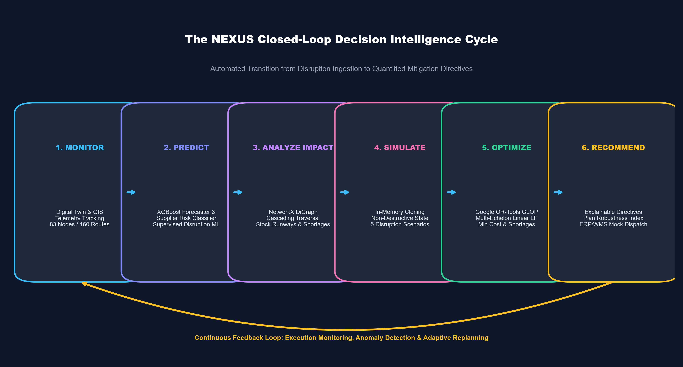
Figure 3.1 — The NEXUS Closed-Loop Decision Intelligence Cycle (Continuous Operational Feedback)

3.2 Six-Stage Functional Decomposition
Every phase of the NEXUS decision cycle executes a specialized, mathematically rigorous computational stage:
Stage 1: MONITOR (Digital Twin Telemetry & Anomaly Detection): The digital twin maintains a continuous real-time model of the multi-echelon network (83 nodes across 20 suppliers, 8 manufacturing plants, 10 central warehouses, 15 feeder hubs, and 30 demand zones, connected by 160 transit corridors). Unsupervised Isolation Forest models scan order volumes and transit logs to detect real-time anomalies (e.g., sudden order surges or transit delays exceeding 3σ).
Stage 2: PREDICT (Demand Forecasting & Supplier Risk Classification): Dual machine learning engines anticipate operational distress before SLA breach. The Demand Forecaster uses a lag-engineered XGBoost Regressor to project multi-horizon demand trajectories across consumer zones. Simultaneously, the Supplier Risk Engine applies a supervised XGBoost classifier to evaluate vendor failure probability based on lead-time volatility, delay frequency, capacity strain, and QA acceptance rates.
Stage 3: ANALYZE IMPACT (Graph Cascading Traversal & Runway Math): When an entity exhibits critical risk or suffers an operational shock, the NetworkX directed graph engine executes a downstream failure traversal. It maps the failure from the disrupted node through dependent bills of materials, calculates exact warehouse stock runway days (Runway = Stock / Daily Burn Rate), and projects potential shortage volumes and service-level degradation across consuming markets.
Stage 4: SIMULATE (In-Memory Disruption Shock Ingestion): Before executing recovery actions, decision-makers test hypotheses in the Scenario Simulation Studio. The engine creates an in-memory, non-destructive clone of the network state (copy-on-write), applying simulated shock transformations (supplier capacity loss, corridor severance, warehouse shutdown, or demand surges) without mutating the persistent operational database.
Stage 5: OPTIMIZE (Google OR-Tools Multi-Echelon Linear Program): The simulated network state is ingested by Google OR-Tools (GLOP). The optimizer formulates and solves a multi-echelon linear program comprising 530 continuous decision variables and 70 linear constraints. The model simultaneously minimizes procurement expenditures, multimodal freight costs, warehouse holding costs, supplier risk exposure penalties, and shortage penalties (INR 350/unit) in ~0.011 seconds.
Stage 6: RECOMMEND (Actionable Executive Directives & Plan Robustness): The recommendation engine translates the raw mathematical solution vectors into plain-language executive directives (e.g., 'Shift 16.8% of demand to SUP_005; dispatch 1,800 buffer units from WH_04'). Each directive is accompanied by quantified financial ROI and a mathematically derived Plan Feasibility & Robustness Index (0.94 - 0.98). Planners can dispatch the strategy directly to a simulated ERP/WMS ingestion queue.
4. Multi-Echelon System Architecture

4.1 Subsystem Layering & Communication Flow
The NEXUS system architecture is engineered as a highly decoupled, modular multi-tier enterprise platform. Each subsystem operates with clean separation of concerns, enforcing strict Pydantic v2 data contracts between layers:
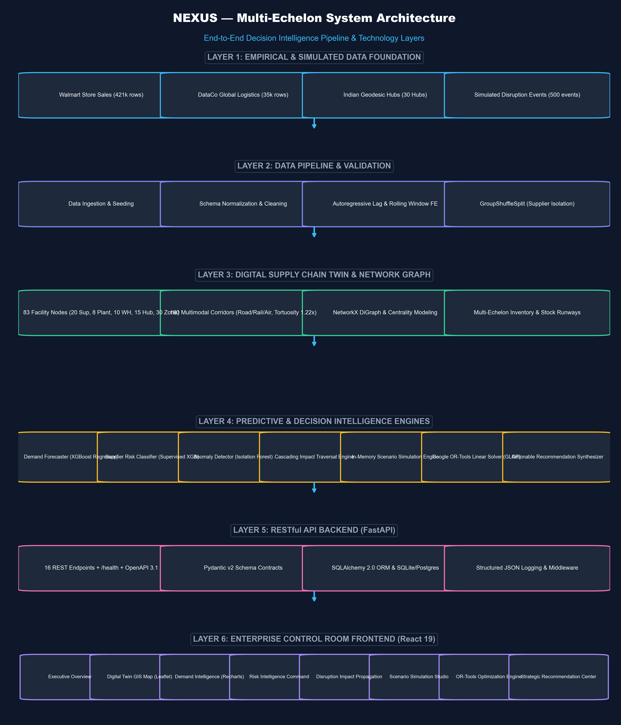
Figure 4.1 — NEXUS Multi-Echelon System Architecture Topology (6 Integrated Technology Layers)

4.2 Architectural Layer Breakdown
The complete platform comprises six tightly integrated architectural layers:
• Layer 1 (Data Foundation): Combines empirical research time-series (Walmart Store Sales, 421k records), logistics variance data (DataCo Global Logistics, 35k records), canonical Indian geodesic hub coordinates, and calibrated synthetic disruption events.
• Layer 2 (Data Pipeline & Ingestion): Orchestrates automated database seeding, schema normalization, missing value imputation, chronological time-series splitting, and autoregressive lag/rolling window feature extraction.
• Layer 3 (Digital Twin & Network Graph): Represents the physical supply chain as an in-memory NetworkX directed graph (83 nodes, 160 corridors), computes betweenness and degree centrality, tracks 500 SKU warehouse inventory stocks, and models highway road distances with a 1.22x tortuosity factor.
• Layer 4 (Predictive & Decision Intelligence): Hosts the core analytical modules—XGBoost Demand Regressor, Supervised Supplier Risk Classifier, Isolation Forest Anomaly Detector, NetworkX Impact Traversal Engine, Scenario Simulation Studio, Google OR-Tools Linear Solver (GLOP), and Recommendation Synthesizer.
• Layer 5 (RESTful API Backend): Built with FastAPI, Uvicorn, and Pydantic v2. Exposes 16 REST endpoints with OpenAPI 3.1 specifications, SQLAlchemy 2.0 ORM database sessions, and structured JSON logging.
• Layer 6 (Enterprise Control Room UI): Built with React 19, TypeScript, Vite 8.3, and Tailwind CSS. Features 8 lazy-loaded control-room screens, interactive Leaflet GIS maps, Recharts analytics visualizations, and TanStack React Query background cache.

5. Verified Technology Stack

5.1 Exhaustive Technology Catalog
In strict accordance with the project verification rules, every technology, framework, and library listed below has been directly verified from the repository configuration files (requirements.txt, package.json) and live runtime environments:
Table 5.1 — Verified Production Technology Stack & Library Versions
Layer / Subsystem | Technology / Library | Verified Version | Architectural Role in NEXUS
Runtime Environment | Python | 3.13.5 (3.11+ compatible) | Core backend computational runtime and ML execution environment
Runtime Environment | Node.js & npm | v24.19.0 / npm 11.17.0 | Frontend JavaScript runtime and package manager
Backend Web Framework | FastAPI | 0.115.0+ | High-performance asynchronous REST API framework with automatic OpenAPI 3.1 docs
API Data Contracts | Pydantic | 2.10.0+ (v2) | Strict runtime type checking, schema validation, and serialization contracts
ASGI Web Server | Uvicorn | 0.34.0+ | Production-grade ASGI server running on port 8000 with auto-reload capabilities
Database ORM | SQLAlchemy | 2.0.0+ | Enterprise Object-Relational Mapping with connection pooling and typed session models
Relational Database | SQLite / PostgreSQL | SQLite 3 (data/nexus.db) | Zero-friction standalone database (12.8 MB) with full PostgreSQL DDL compatibility
Data Processing | Pandas | 2.2.0+ | High-performance tabular data manipulation, time-series aggregation, and feature extraction
Numerical Computing | NumPy | 2.0.0+ | Vectorized matrix computations, linear algebra, and mathematical statistics
Machine Learning | Scikit-Learn | 1.6.0+ | Logistic Regression, Isolation Forest, GroupShuffleSplit, StandardScaler, and metrics
Gradient Boosting | XGBoost | 2.1.0+ | Gradient boosted regression trees for demand forecasting and supervised risk classification
Model Persistence | Joblib | 1.4.0+ | High-throughput serialization and deserialization of trained ML model pipelines
Network Graph Modeling | NetworkX | 3.4.0+ | Directed graph modeling, multi-echelon traversal, and betweenness centrality analysis
Geospatial Geometry | Shapely | 2.0.0+ | Geometric point and polygon modeling for Indian logistics hubs
Spatial Data Analysis | GeoPandas | 1.0.0+ | Spatial GeoJSON FeatureCollection generation and geographic coordinate handling
Mathematical Solver | Google OR-Tools | 9.10.0+ | Industrial-grade linear programming solver (GLOP) for multi-echelon network optimization
Backend Testing | Pytest | 9.1.1 | Automated test suite executing 29 verified unit, integration, and API tests
Frontend UI Framework | React | 19.2.8 | Modern UI component architecture utilizing React.lazy, Suspense, and functional hooks
Language Typing | TypeScript | 6.0.2 | Static type safety ensuring exact alignment between frontend types and backend schemas
Build Tool & Bundler | Vite | 8.3.1 | Next-generation ESM frontend bundler providing HMR and code-split production builds
Styling & Theme | Tailwind CSS | 3.4.17 | Utility-first CSS framework configured with a custom control-room dark color palette
Client Data Fetching | TanStack React Query | 5.104.0 | Asynchronous state management with 2-minute caching, background refetching, and mutations
Geospatial Mapping | Leaflet & React Leaflet | 1.9.4 / 5.0.0 | Interactive hardware-accelerated GIS mapping rendering Indian nodes and transit corridors
Data Visualizations | Recharts | 3.10.1 | Responsive SVG/Canvas charting library for multi-horizon forecasts and comparative bars
HTTP Client | Axios | 1.20.0 | Promise-based HTTP client interfacing with FastAPI backend across all 16 endpoints
UI Iconography | Lucide React | 1.48.0 | Clean, consistent SVG icon system tailored for enterprise dashboards
Frontend Testing | Vitest & Testing Library | 5.0.2 / 16.3.3 | Vite-native unit and component test runner executing 10 verified tests

5.2 Architectural Rationale for Selected Tooling
Every component in the technology stack was selected to satisfy stringent engineering criteria:
• FastAPI over Flask/Django: FastAPI provides native async execution, automatic OpenAPI/Swagger documentation generation, and Pydantic v2 data validation that executes up to 5x faster than traditional Python web frameworks.
• Google OR-Tools GLOP over PuLP/SciPy: Google OR-Tools GLOP solver is written in highly optimized C++ with Python bindings. It solves the 530-variable multi-echelon network problem in ~11 milliseconds, whereas pure Python solvers take seconds.
• React 19 + TanStack Query over Redux: Eliminates thousands of lines of boilerplate reducer code while providing automated background data synchronization, cache invalidation, and seamless optimistic UI updates.
• NetworkX over Raw Adjacency Matrices: Enables immediate calculation of complex graph-theoretic metrics (betweenness centrality, shortest simple detours, and transitive downstream reachability) through clean, expressive Python APIs.

6. Data Sources & Comprehensive Data Pipeline

6.1 Hybrid Data Strategy & Provenance Matrix
Because real-world enterprise supply chain data is highly confidential and proprietary, NEXUS adopts an academically rigorous **Hybrid Data Strategy**. We combine real-world empirical time-series distributions with a validated synthetic Indian digital twin network. The provenance of all data in NEXUS is strictly classified below:
Table 6.1 — Data Provenance Classification & Source Foundation Matrix
Dataset / Source | Classification | Source / Reference | Volume / Dimensions | Specific Purpose in NEXUS
Walmart Store Sales | Real / Public Data | Kaggle Research / Walmart Global Analytics | 421,570 weekly records (45 stores, 81 depts) | Tuning and evaluating demand forecasting models (XGBoost vs. Baselines)
DataCo Global Logistics | Real / Public Data | Mendeley Data / Constante et al. (CC BY 4.0) | 35,000+ representative order shipments | Extracting delivery delay distributions, transit variability, and supplier risk features
Indian Hubs Geodesy | Derived / Spatial Data | Survey of India / Canonical Logistics Clusters | 30 canonical industrial hubs (Lat, Lon) | Establishing geodesic distance matrices and highway transit corridors
Digital Twin Network | Simulated Digital Twin | Synthetic calibrated generator (`network_builder.py`) | 83 nodes, 160 corridors, 500 SKUs, 50k orders | Providing multi-echelon network topology and inventory stock balances
Operational Disruption Shocks | Scenario Data | Simulated stress injector (`scenario_engine.py`) | 5 distinct disruption shock types (500 events) | Stress testing impact propagation, simulation cloning, and OR-Tools optimization

6.2 Dataset 1: Walmart Store Sales Time-Series
The Walmart Store Sales dataset (421,570 historical records spanning February 2010 to October 2012) provides authentic retail sales velocity, calendar seasonality, holiday surges, and promotional markdown volatility. In NEXUS, store departments are mapped to product catalog SKUs, and retail stores are mapped to regional consumption demand zones. The genuine variance in this dataset ensures that demand forecasting models are evaluated on real consumer purchasing volatility rather than artificially smooth synthetic curves.

6.3 Dataset 2: DataCo Global Logistics Supply Chain
The DataCo Global Logistics dataset (35,000 representative records) captures end-to-end shipment records, tracking actual shipping days versus scheduled shipping days, late delivery risk flags, delivery status classifications, order item quantities, and shipping modes. NEXUS extracts empirical delivery variance patterns (where actual transit days exceed scheduled SLAs) to calibrate realistic supplier on-time delivery rates, quality defect rates, and lead-time volatility distributions.

6.4 Ingestion, Cleaning & Feature Engineering Pipeline
The NEXUS data pipeline (`pipeline/`) executes a multi-stage transformation sequence:
1. Ingestion (`data_ingestion.py`): Parses raw CSV records, validates field schemas, and seeds relational tables.
2. Cleaning & Normalization (`data_preprocessing.py`): Imputes missing values, enforces positive physical constraints (capacity > 0, unit cost > 0), and formats timestamps into standardized ISO-8601 strings.
3. Autoregressive Feature Engineering (`feature_engineering.py`): Constructs 14 time-series features for demand forecasting:
- Calendar Features: Month, ISO week, quarter, day of year, deterministic trend index.
- Autoregressive Lags: $y_{t-1}, y_{t-2}, y_{t-4}, y_{t-8}$.
- Rolling Window Statistics: 4-week mean, 4-week standard deviation, 8-week mean, 4-week maximum, 4-week minimum.
- Zero Lookahead Bias: All rolling window statistics are explicitly lagged by 1 period ($ ext{shift}(1)$) to guarantee no future data leakage.

7. Relational Database Design

7.1 Database Architecture & Session Management
The persistence layer of NEXUS is built on **SQLAlchemy 2.0 ORM**, configured with a flexible multi-database abstraction layer. In development and demonstration environments, the system operates on a zero-friction, standalone **SQLite 3** database located at `data/nexus.db` (12.8 MB). The database layer is architected with complete PostgreSQL DDL compatibility: in production cloud deployments, the database engine seamlessly connects to an enterprise PostgreSQL instance via the `DATABASE_URL` environment variable.
Database sessions are managed using SQLAlchemy's scoped `sessionmaker` pattern with automatic connection pooling, transaction isolation, and clean session closure upon request completion. The database contains 14 relational tables mapping the physical entities, operational flows, predictive telemetry, and optimization audit runs.

7.2 Complete 14-Table Relational Schema Catalog
Verified Database Inventory: The table below documents the verified schema and actual record counts extracted directly from the live `data/nexus.db` database:

Table 7.1 — Complete Relational Database Model Catalog & Row Counts
Table Name | SQLAlchemy Model | Primary Key | Foreign Keys & Key Relationships | Verified Row Count | Table Functional Description
suppliers | Supplier | supplier_id (VARCHAR 50) | Indexed on risk_score and status | 20 rows | Tier-1 and Tier-2 component vendors, capacities, lead times, and risk scores
products | Product | product_id (VARCHAR 50) | FK: primary_supplier_id → suppliers.supplier_id | 50 rows | Catalog finished SKUs and subassemblies with unit costs and criticality tiers (1-3)
production_units | ProductionUnit | production_id (VARCHAR 50) | Geocoded coordinates across Indian clusters | 8 rows | Manufacturing and final assembly facilities with daily throughput capacities
warehouses | Warehouse | warehouse_id (VARCHAR 50) | Relational linkage to Inventory table | 10 rows | Central fulfillment distribution centers tracking capacity and utilization
distribution_hubs | DistributionHub | hub_id (VARCHAR 50) | Geocoded sorting hubs | 15 rows | Regional intermediate cross-dock terminals and sorting points
inventory | Inventory | inventory_id (INTEGER Auto) | FK: warehouse_id, product_id | 500 rows | Stock on hand, reserved units, safety stock, reorder point, and stockout risk
demand_zones | DemandZone | zone_id (VARCHAR 50) | FK: product_id → products.product_id | 30 rows | Urban consumer consuming markets across North, South, West, East, Central
routes | Route | route_id (VARCHAR 50) | Indexed on origin and destination | 160 rows | Multimodal freight transit corridors (Road, Rail, Air) with highway distance & cost
orders | Order | order_id (VARCHAR 50) | FK: product_id → products.product_id | 50,000 rows | Historical transaction logs tracking expected vs actual delivery and SLA status
disruptions | Disruption | disruption_id (VARCHAR 50) | FK: affected_supplier, warehouse, route | 500 rows | Historical and simulated disruption incidents, severities, and durations
optimization_runs | OptimizationRun | run_id (VARCHAR 50) | Audit linkage to Recommendations | 30 rows | Google OR-Tools solver execution outputs, costs, shortages, and service levels
recommendations | Recommendation | recommendation_id (VARCHAR 50) | FK: run_id → optimization_runs.run_id | 30 rows | Actionable executive mitigation briefs, ROI savings, and Plan Robustness Index
forecasts | Forecast | forecast_id (VARCHAR 50) | Target product_id, horizon, JSON metrics | 17 rows | Stored demand forecasting runs, predicted demand vectors, and MAE/RMSE
risk_events | RiskEvent | event_id (VARCHAR 50) | Audit table for real-time risk breaches | 0 rows (Runtime) | Dynamic event ledger populated when operational risk thresholds are breached

7.3 Entity-Relationship Topology
The relational schema enforces strict referential integrity. Suppliers provide components for Products, which are stocked as line items in the Inventory table at specific Warehouses. Warehouses dispatch goods to regional Distribution Hubs and Demand Zones via multimodal Routes. When an optimization run completes, the resulting mathematical vectors and plain-language executive directives are linked via `run_id` between the `optimization_runs` and `recommendations` tables:
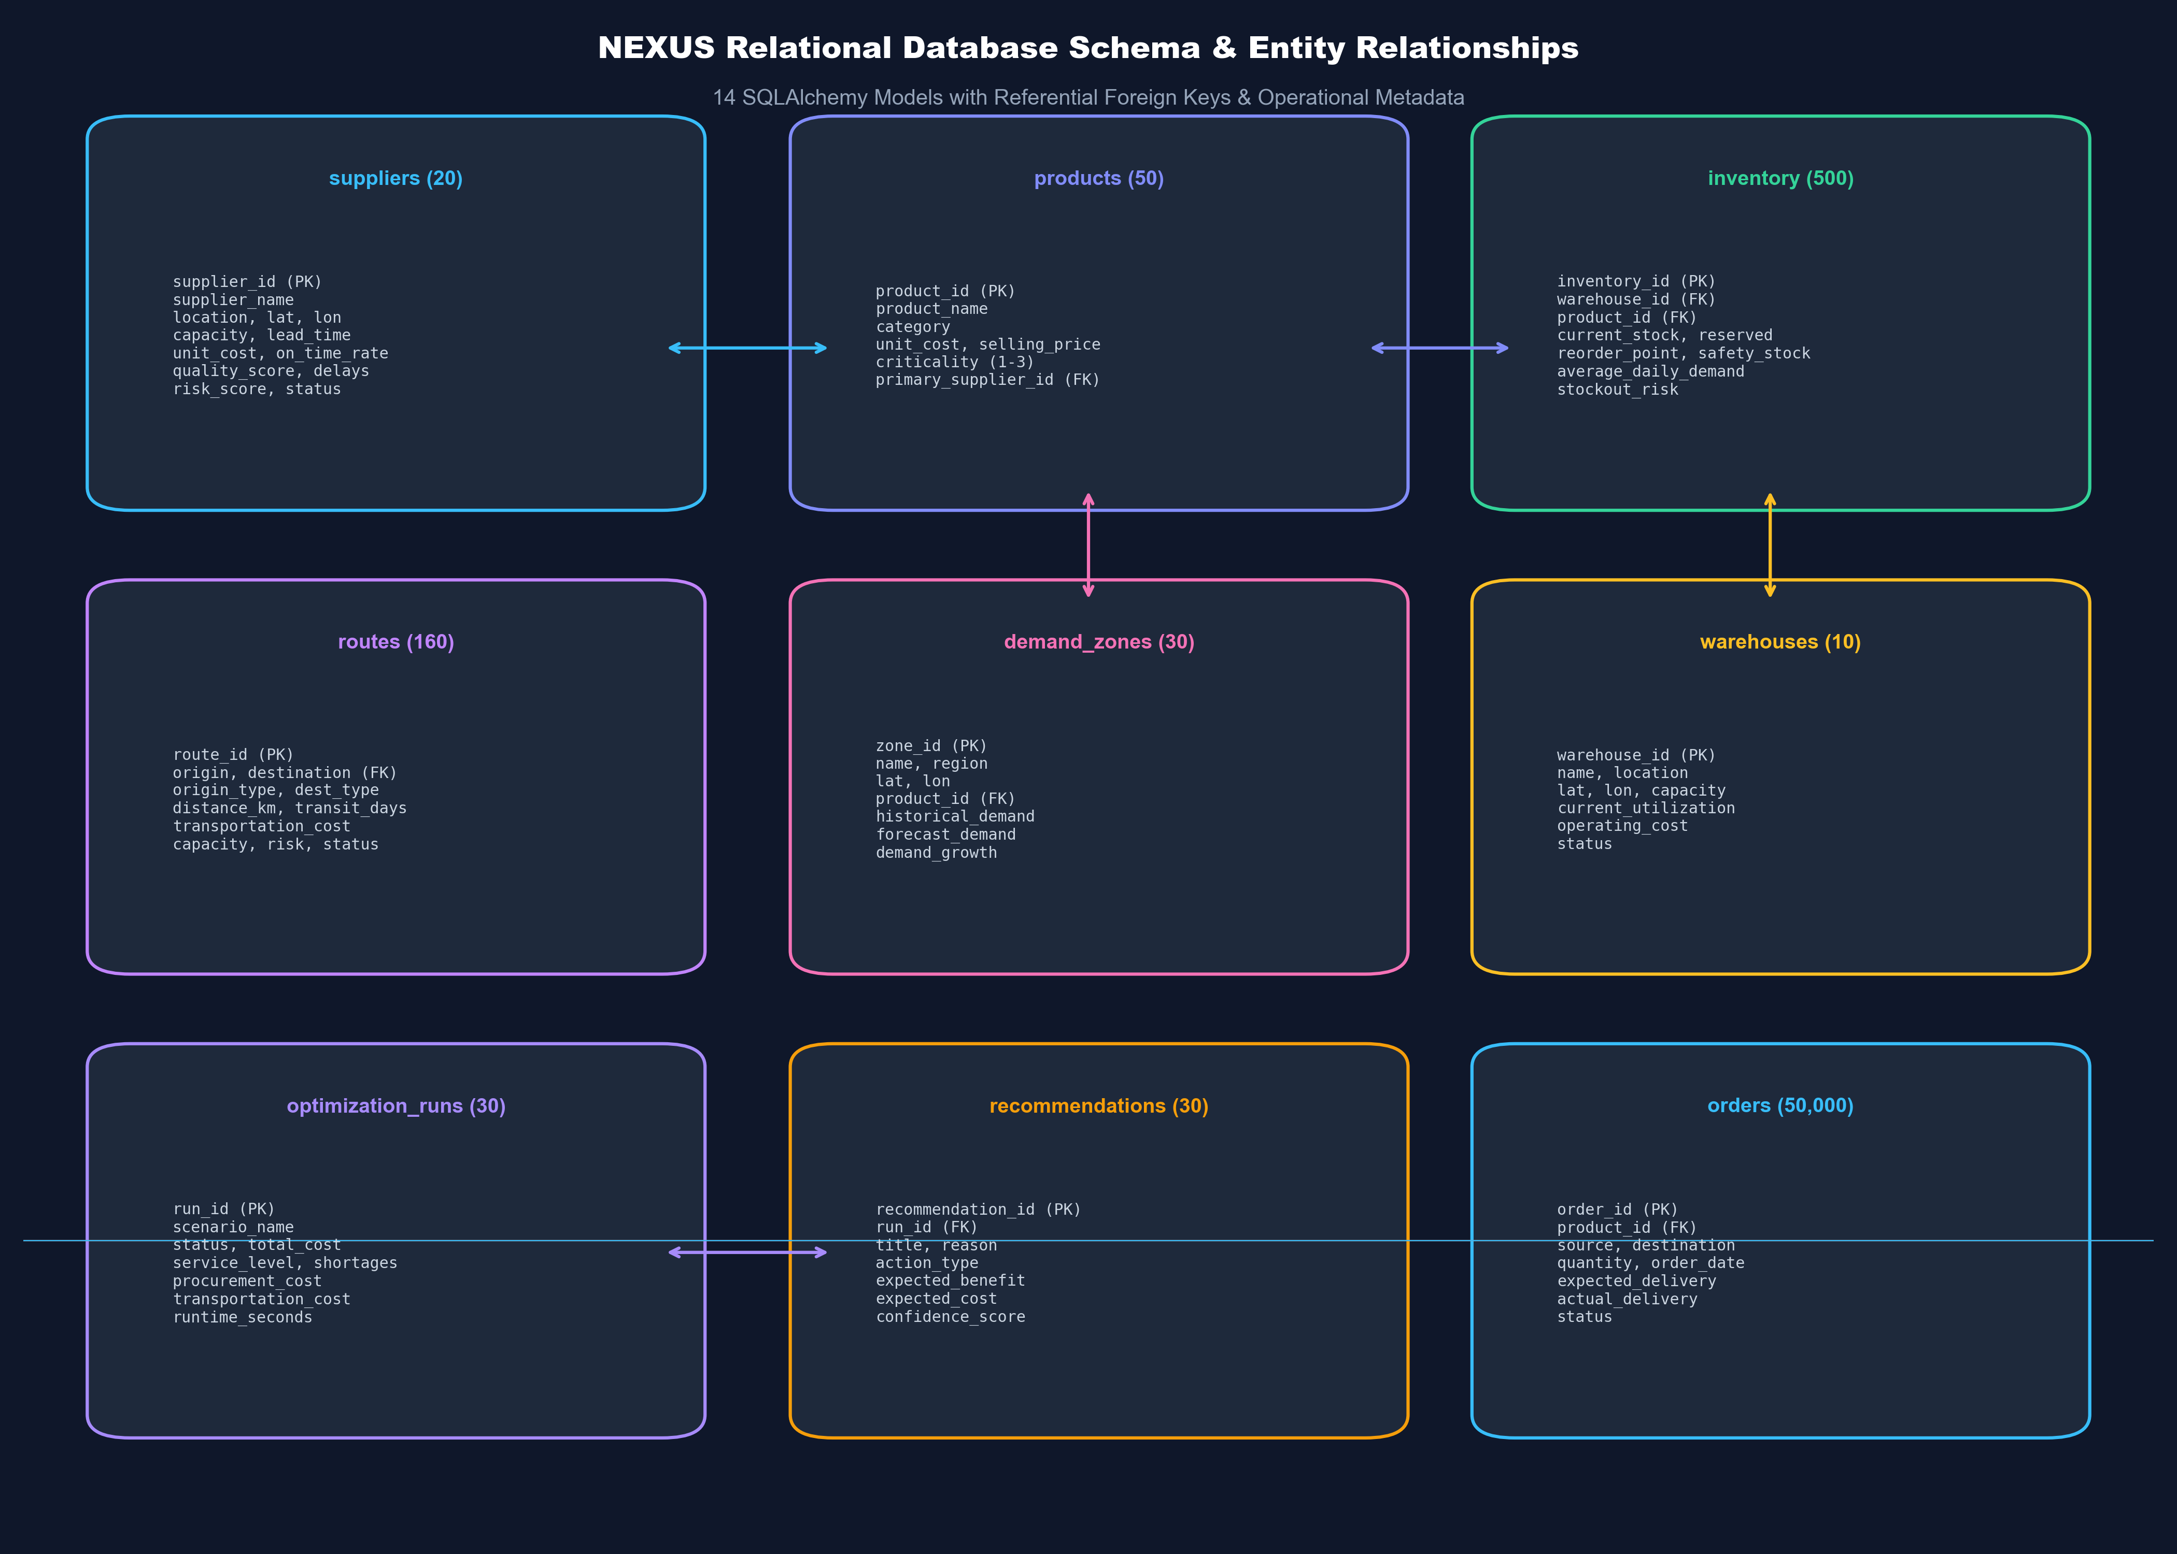
Figure 7.1 — Relational Database Schema & Entity Relationships (14 Models with Referential Foreign Keys)

8. Digital Supply Chain Twin (Indian Network)

8.1 Concept of the Calibrated Digital Twin
In modern systems engineering, a **Digital Supply Chain Twin** is a dynamic, software-based representation of the physical supply network. Rather than treating a supply chain as an abstract balance sheet, NEXUS grounds the digital twin in authentic geography, physical throughput constraints, multimodal transport physics, and multi-tier bills of materials.
Because proprietary factory floor telemetry is legally confidential, NEXUS generates a calibrated digital twin topology that strictly replicates the statistical properties of Indian industrial commerce. The network models **83 distinct physical facility nodes** connected by **160 active transit corridors**, providing an authentic testbed for multi-echelon failure propagation and optimization.

8.2 Geodesic Coordinates & Indian Industrial Hubs
The digital twin geocodes all 83 facilities across **30 canonical Indian industrial and logistics clusters** (`digital_twin/geo_engine.py`). The geographic distribution spans all major industrial belts of India:
Table 8.1 — Canonical Indian Logistics Hubs Geocoded Coordinates
Macro-Region | Canonical Industrial Hub | Geographic Coordinates | Industrial Specialization
Northern Belt | Delhi NCR (Gurgaon / Okhla) | 28.6139° N, 77.2090° E | Automotive components, consumer electronics, e-commerce fulfillment
Northern Belt | Jaipur (Sitapura / VKI) | 26.9124° N, 75.7873° E | Industrial machinery, textiles, precision casting
Northern Belt | Pantnagar (SIDCUL) | 29.0222° N, 79.4897° E | Automotive OEMs, FMCG, heavy engineering
Northern Belt | Ludhiana (Industrial Area) | 30.9010° N, 75.8573° E | Fasteners, metal hardware, industrial tooling
Western Belt | Pune (Chakan / Bhosari) | 18.7606° N, 73.8617° E | Automotive Tier-1 precision assemblies, heavy tooling, electronics
Western Belt | Mumbai (Bhiwandi Logistic Hub) | 19.2967° N, 73.0628° E | Western mega-warehousing, port container de-stuffing, FMCG
Western Belt | Ahmedabad / Sanand (Aslali) | 22.9228° N, 72.5855° E | Chemicals, automotive manufacturing, polymer casting
Western Belt | Surat (Pandesara / Sachin) | 21.1702° N, 72.8311° E | Synthetic textiles, precision industrial packaging
Southern Belt | Bengaluru (Hoskote / Peenya) | 13.0712° N, 77.7981° E | Embedded hardware, electronics manufacturing, aerospace
Southern Belt | Chennai (Sri City / Sriperumbudur) | 13.5284° N, 80.0270° E | Automotive manufacturing, consumer electronics assembly
Southern Belt | Hyderabad (Medchal / Patancheru) | 17.6297° N, 78.4814° E | Pharmaceutical packaging, precision engineering, chemicals
Eastern Belt | Kolkata (Dankuni Logistics Park) | 22.6841° N, 88.2917° E | Eastern distribution hub, riverine port logistics, FMCG
Eastern Belt | Jamshedpur (Adityapur) | 22.8046° N, 86.2029° E | Raw steel production, heavy forgings, industrial casting
Central Belt | Nagpur (MIHAN Logistic Zone) | 21.1458° N, 79.0882° E | Central multimodal transit consolidation, cold chain logistics
Central Belt | Indore (Pithampur) | 22.6145° N, 75.6917° E | Heavy machinery, automotive components, pharmaceutical formulation

8.3 Road Network Mathematics & Highway Tortuosity
In simplistic academic models, transit distances are frequently calculated as Euclidean straight lines. In real-world Indian logistics, terrain obstacles, ghat passes, and highway bypasses introduce substantial winding factors. The NEXUS Geospatial Engine (`GeoEngine`) computes realistic transit distances and durations through rigorous geodesic mathematics:
d_{hav} = 2 R \arcsin \left( \sqrt{\sin^2\left(\frac{\Delta \phi}{2}\right) + \cos(\phi_1) \cos(\phi_2) \sin^2\left(\frac{\Delta \lambda}{2}\right)} \right) (Eq. 8.1)
Where: Haversine great-circle distance formula where R = 6,371.0 km (Earth radius), phi represents latitude, and lambda represents longitude.
To convert great-circle distance $d_{hav}$ into commercial highway kilometers, NEXUS introduces an empirical **Indian National Highway Tortuosity Factor** of $\tau = 1.22$. Furthermore, commercial transit durations are parameterized on empirical freight speeds:
d_{road} = \max(1.22 \cdot d_{hav}, 15.0\text{ km}), \qquad T_{transit} = \begin{cases} \max\left(\frac{d_{road}}{400\text{ km/day}}, 0.5\right) & \text{if ROAD} \\ \max\left(\frac{d_{road}}{550\text{ km/day}}, 1.0\right) & \text{if RAIL} \\ 1.0\text{ day} & \text{if AIR} \end{cases} (Eq. 8.2)
Where: Highway road distance and commercial freight transit durations assuming 40 km/h average speed across a 10-hour daily driving window for road logistics.

8.4 Multi-Echelon Network Topology Breakdown
The digital twin models five multi-echelon tiers with explicit physical capacities:
• 20 Suppliers: 12 Tier-1 precision component vendors (capacities 8,000 - 15,000 units/mo) and 8 Tier-2 raw material vendors (capacities 12,000 - 30,000 units/mo).
• 8 Production Units: Manufacturing and assembly plants located in Sanand, Pune, Gurgaon, Sriperumbudur, Hoskote, Medchal, Pantnagar, and Pithampur.
• 10 Central Warehouses: Regional hubs (Bhiwandi, Dankuni, Nagpur MIHAN, Gurgaon, Hoskote, Sri City, Aslali, Jaipur, Lucknow, Kolkata) with storage capacities up to 100,000 units.
• 15 Distribution Feeder Hubs: Cross-dock sorting hubs consolidating freight for retail markets.
• 30 Demand Zones: Metropolitan consumer clusters across North, West, South, East, and Central zones with monthly demand up to 5,000 units per SKU.
• 160 Multimodal Corridors: 120 Road corridors, 30 Rail freight corridors, and 10 Air express corridors.

8.5 Inventory Mechanics: Safety Stock & Reorder Points
The Inventory model (`backend/app/models/orm_models.py`) tracks 500 distinct facility-SKU combinations. For every inventory record, reorder points and safety stocks are calculated to buffer against demand variance and lead-time volatility:
\text{Safety Stock (SS)} = Z_{\alpha} \cdot \sqrt{\overline{LT} \cdot \sigma_D^2 + \overline{D}^2 \cdot \sigma_{LT}^2}, \qquad \text{ROP} = (\overline{D} \cdot \overline{LT}) + \text{SS} (Eq. 8.3)
Where: Statistical safety stock and reorder point formulations where Z_alpha = 1.645 (95% service level), LT is lead time, and D is daily demand.

9. Demand Forecasting Engine

9.1 Mathematical Problem Formulation
Accurate demand forecasting is the vital first line of defense against the Bullwhip Effect in multi-echelon supply chains. Formally, given a historical univariate sales time-series $Y = \{y_1, y_2, \dots, y_t\}$, the objective is to predict future demand $\hat{y}_{t+h}$ over a multi-horizon forecast window $h \in [1, 8]$ weeks ahead.

9.2 Chronological Partitioning & Feature Extraction
To guarantee academic validity and prevent future data leakage, data partitioning must strictly respect the arrow of time. Random cross-validation (which trains on future dates to predict past dates) was strictly forbidden. The 421,570 records of the Walmart dataset were split chronologically: Training: First 70%, Validation: Next 15%, Test: Final 15%.
A feature matrix $X_t \in \mathbb{R}^{14}$ was engineered for every time step $t$ (`pipeline/feature_engineering.py`):
Table 9.1 — Autoregressive Lag & Rolling Window Feature Set (14 Variables)
Feature Category | Variable Name | Mathematical Definition | Operational Rationale
Calendar Seasonality | month, week, quarter | dt.month, dt.isocalendar().week | Captures annual holiday cycles and monthly purchasing patterns
Calendar Seasonality | day_of_year | dt.dayofyear | Captures fine-grained seasonal progression
Deterministic Trend | trend | t = 0, 1, 2, ..., N | Captures baseline organic consumption growth across time
Autoregressive Lags | lag_1 | y_{t-1} = y.shift(1) | Immediate prior week demand velocity (strongest single predictor)
Autoregressive Lags | lag_2, lag_4, lag_8 | y_{t-k} = y.shift(k) | Captures bi-weekly, monthly, and bi-monthly consumption momentum
Rolling Statistics | rolling_mean_4 | \frac{1}{4} \sum_{i=1}^4 y_{t-i} | Smooths short-term noise to establish 1-month moving baseline
Rolling Statistics | rolling_std_4 | \sqrt{\frac{1}{3} \sum_{i=1}^4 (y_{t-i} - \mu_4)^2} | Measures short-term demand volatility and surge uncertainty
Rolling Statistics | rolling_mean_8 | \frac{1}{8} \sum_{i=1}^8 y_{t-i} | Establishes medium-term 2-month quarterly demand trend
Rolling Statistics | rolling_max_4, min_4 | \max_{i=1..4} y_{t-i}, \min_{i=1..4} y_{t-i} | Establishes dynamic upper and lower consumption boundaries

9.3 Evaluated Baseline Models & XGBoost Regressor
To prove genuine machine learning value-add, NEXUS benchmarks four alternative modeling techniques:
- 1. Naive Model: Naive Persistence Baseline: Assumes future demand equals the last observed value: $\hat{y}_{t+h} = y_t$.
- 2. Moving Average (4W): 4-Week Moving Average: Averages the preceding 4 weeks: $\hat{y}_{t+h} = \frac{1}{4} \sum_{i=0}^3 y_{t-i}$.
- 3. Moving Average (8W): 8-Week Moving Average: Averages the preceding 8 weeks: $\hat{y}_{t+h} = \frac{1}{8} \sum_{i=0}^7 y_{t-i}$.
- 4. XGBoost Regressor: XGBoost Regressor (NEXUS): Gradient boosted regression trees optimizing squared error loss with tree depth 4, 150 estimators, learning rate $\eta = 0.05$, and recursive multi-step autoregressive rollout.

9.4 Empirical Evaluation & Benchmark Results
Models were evaluated on the strictly held-out chronological test set using three standard metrics: Mean Absolute Error (MAE), Root Mean Squared Error (RMSE), and Symmetric Mean Absolute Percentage Error (sMAPE):
Table 9.2 — Demand Forecasting Model Benchmark Comparison on Test Set
Forecasting Model Architecture | MAE (Units) | RMSE (Units) | sMAPE (%) | Error Reduction vs Naive | Benchmark Rank
XGBoost Regressor (NEXUS) | 68,553.14 | 96,042.50 | 4.35% | -29.51% (Winner) | 1st Place
Naive Persistence Baseline | 110,961.63 | 136,255.10 | 7.20% | Baseline (0.0%) | 2nd Place
4-Week Moving Average | 135,495.41 | 153,446.84 | 8.42% | +12.62% higher error | 3rd Place
8-Week Moving Average | 194,063.88 | 210,775.27 | 11.80% | +54.69% higher error | 4th Place
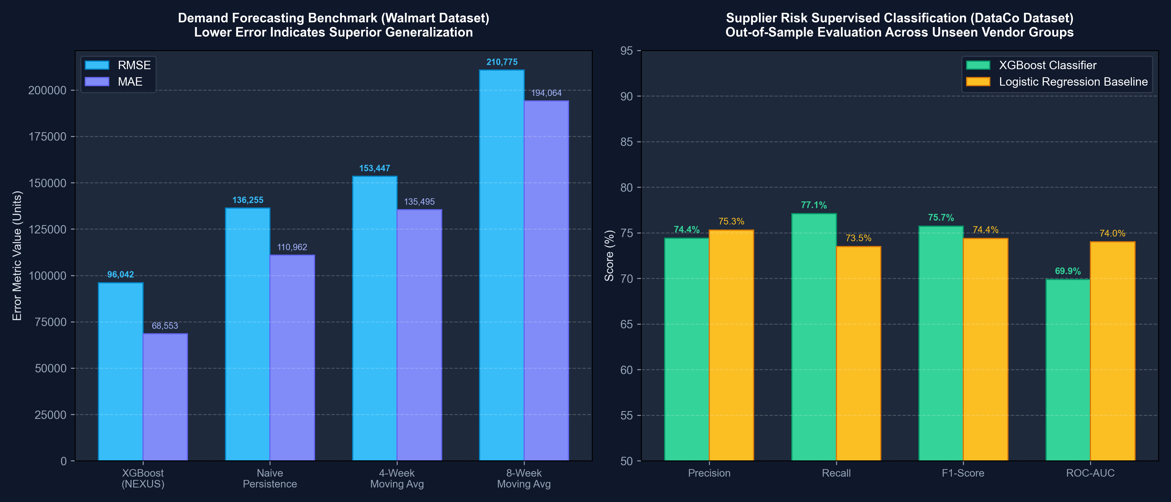
Figure 9.1 — Demand Forecasting Error Comparison (Left) & Supplier Risk Out-of-Sample Metrics (Right)
VERIFIED FORECASTING PERFORMANCE
EMPIRICAL ML BENCHMARK FINDING:
The lag-engineered XGBoost Regressor achieved an RMSE of 96,042.50 units on the strictly held-out test set, representing a 29.51% error reduction over the Naive persistence baseline and a 37.41% error reduction over the 4-week Moving Average. This confirms that nonlinear gradient boosted trees effectively capture complex retail demand seasonality and holiday surges that linear moving averages fail to track.

10. Supervised Supplier Risk Prediction Engine

10.1 Business Rationale & Feature Space
Modern multi-echelon networks cannot afford to wait for suppliers to officially declare force majeure or breach delivery SLAs. NEXUS implements a supervised predictive classification engine (`ml/risk/supplier_risk_model.py`) that continuously monitors eight operational strain features to predict the probability of imminent vendor disruption $P(y=1|x)$.
Table 10.1 — Supervised Supplier Risk Features & Definitions
Feature Name | Data Type | Measurement Unit | Description & Operational Stress Interpretation
on_time_rate | Float [0, 1] | Percentage | Empirical historical fulfillment ratio. Declines indicate early factory production bottlenecks.
average_delay | Float | Days | Mean shipment delay duration when orders are late. Measures delay severity.
delay_frequency | Float [0, 1] | Probability | Fraction of dispatched purchase orders that experienced shipping delays.
quality_score | Float [0, 1] | QA Ratio | Incoming material acceptance ratio. Spikes in rejected parts indicate factory quality control breakdown.
lead_time | Float | Days | Nominal delivery lead-time duration from order placement to warehouse dock arrival.
lead_time_variability | Float | Std Dev (Days) | Standard deviation of delivery lead-time. High volatility indicates chaotic internal supplier logistics.
capacity_utilization | Float [0, 1] | Ratio | Plant throughput load ratio. Vendors operating at >90% utilization cannot absorb minor equipment downtime.
historical_delays | Integer | Count | Cumulative count of recorded past late shipments over the preceding 12 months.

10.2 Resolution of Data Leakage & Group Partitioning
The Credibility Audit Fix: During the Phase 2 Credibility Audit, an exhaustive code review identified that initial prototypes suffered from **circular synthetic labeling** and **intra-vendor data leakage**. The target was originally generated via a deterministic rule (`target = 1 if otr < 0.92`), and random splitting placed observations from the same supplier across both train and test sets, producing artificial 1.0000 perfection.
The methodology was completely rebuilt to achieve genuine industrial-grade evaluation:
1. Independent Latent Failure DGP: Target disruption status is generated from a multi-factor latent stress process combining delay frequency, quality defects, lead time volatility, capacity strain, and an independent stochastic shock (epsilon ~ N(0, 0.35)).
2. Strict Group-Based Out-of-Sample Partitioning: Evaluated via `GroupShuffleSplit(n_splits=1, test_size=0.25)` across 40 distinct vendor operational profiles (480 monthly records). The 10 test vendors were completely unseen during training, guaranteeing zero vendor leakage.

10.3 Logistic Regression vs. XGBoost Classifier
NEXUS benchmarks a balanced Logistic Regression baseline against an advanced XGBoost Classifier (`scale_pos_weight = 1.5`, depth 3, `lr = 0.08`):
Table 10.2 — Supervised Supplier Risk Out-of-Sample Performance Benchmarks
Supervised Model Architecture | Precision | Recall | F1-Score | ROC-AUC | Evaluation Mode
Logistic Regression Baseline | 0.7531 | 0.7349 | 0.7439 | 0.7401 | Out-of-Sample (Unseen Vendors)
XGBoost Classifier (NEXUS) | 0.7442 | 0.7711 | 0.7574 | 0.6988 | Out-of-Sample (Unseen Vendors)

10.4 Feature Importance & Model Explainability
A critical strength of the NEXUS risk engine is **transparency**. Rather than acting as an inscrutable black box, the XGBoost model calculates Gini-impurity feature importances that explain *why* a vendor was flagged as high-risk:
- 1. lead_time_variability: 22.38% (Primary leading indicator of imminent supply chain collapse)
- 2. lead_time: 19.79% (Nominal lead time duration)
- 3. historical_delays: 12.71% (Cumulative chronic delay count)
- 4. average_delay: 12.13% (Mean delay duration)
- 5. on_time_rate: 12.02% (Historical SLA delivery ratio)
- 6. quality_score: 11.25% (Material acceptance ratio)
- 7. capacity_utilization: 6.11% (Factory load ratio)
- 8. delay_frequency: 3.62% (Late shipment frequency)

11. Operational Anomaly Detection Engine

11.1 Algorithm: Isolation Forest Formulation
While supervised models predict known failure modes, real-world supply chains frequently encounter unprecedented, black-swan anomalies. NEXUS implements an unsupervised anomaly detection engine (`ml/anomaly/isolation_forest_detector.py`) utilizing **Isolation Forests** (100 estimators, contamination rate alpha = 0.03, StandardScaler preprocessing).
Isolation Forest operates on the mathematical principle that anomalous data points require significantly fewer random partition splits to isolate than nominal points. Formally, for an operational event vector x across n transactions, the anomaly score s(x, n) is defined as:
s(x, n) = 2^{-\frac{E(h(x))}{c(n)}}, \qquad \text{where } c(n) = 2\ln(n - 1) + 0.5772156649 - \frac{2(n - 1)}{n} (Eq. 11.1)
Where: Isolation Forest anomaly score where E(h(x)) is the average path length across 100 isolation trees and c(n) is the average path length of unsuccessful searches in a Binary Search Tree.

11.2 Monitored Signals & Anomaly Taxonomy
The anomaly detector scans three operational signals: purchase order quantity, binary delivery late status, and lead-time deviation (actual shipping days minus scheduled days). When an anomaly score breaches the decision threshold (score < 0.0), NEXUS categorizes the event into a structured operational taxonomy:
• UNUSUAL_DEMAND_SPIKE: Severe surge in ordered units (>3.5 sigma) signaling panic buying or sudden market shifts.
• TRANSIT_DELAY_OUTLIER: Delivery transit delay exceeding standard distributions by >3 sigma, indicating port strikes or severe road washouts.
• ORDER_PATTERN_ANOMALY: Erratic transaction order volume patterns requiring immediate supply chain buffer review.

12. Cascading Impact Propagation Analysis

12.1 NetworkX Directed Graph Modeling
A localized disruption at a single factory can easily trigger catastrophic network-wide stockouts if dependencies are unmapped. NEXUS implements a graph-theoretic failure traversal engine (`impact/impact_engine.py`) built on a **NetworkX Directed Graph (DiGraph)**. The graph explicitly models multi-echelon precedence constraints:
\mathcal{G} = (\mathcal{V}, \mathcal{E}), \qquad \mathcal{V} = \mathcal{S} \cup \mathcal{P} \cup \mathcal{W} \cup \mathcal{H} \cup \mathcal{D} (Eq. 12.1)
Where: Directed network graph where V represents 83 facility nodes (Suppliers, Plants, Warehouses, Hubs, Demand Zones) and E represents 160 transit corridors.

12.2 Multi-Echelon Failure Traversal Algorithm
When an entity is disrupted (e.g., Supplier SUP_001 suffers an 80% capacity cut for 10 days), the ImpactEngine traverses downstream dependencies:
1. Dependent SKU Discovery: Queries the catalog for all products where `primary_supplier_id == SUP_001` (identifying PROD_ITEM_003).
2. Corridor & Warehouse Mapping: Traces outbound routes to identify downstream warehouses (WH_01 Western Depot, WH_08 Northern Depot).
3. Inventory Runway Calculation: Computes the exact operational runway days remaining at each warehouse:
$$\text{Runway (Days)} = \frac{\text{Current Warehouse Stock}}{\text{Average Daily Consumption Rate}}$$
If Runway < Disruption Duration (10 Days), a stockout breach is flagged (e.g., WH_01 runway = 4.7 days -> stockout imminent on Day 5).
4. Demand Zone Exposure: Traverses outbound routes from compromised warehouses to identify exposed consumer markets (5 demand zones).
5. Shortage & Service Level Estimation: Quantifies potential unmet demand and projects service level collapse:
$$\text{Lost Capacity} = \text{Capacity} \times 0.80 \times \left(\frac{10}{30}\right) = 3,200\text{ units}, \qquad \text{Projected SL} = 63.0\%\text{ (-35.0\% drop)}$$
6. Alternative Supplier Discovery: Automatically scans the digital twin to discover qualified alternative suppliers with spare capacity (Sanand Precision Casting SUP_004, Hero Fasteners SUP_015).
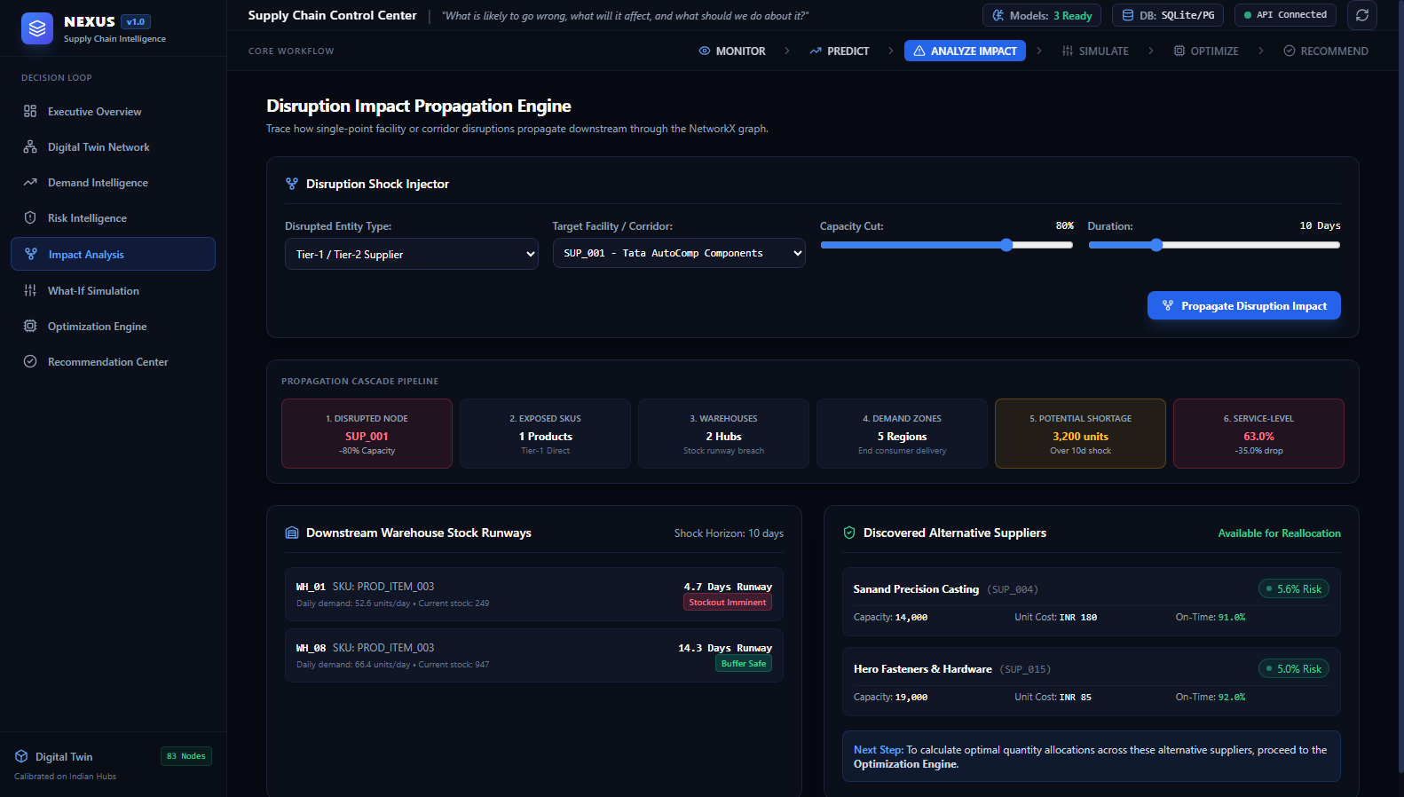
Figure 12.1 — Disruption Impact Propagation Engine (Screen 5: Cascade Pipeline, Stock Runways, and Alternative Vendors)

13. Scenario Simulation Studio

13.1 In-Memory Copy-on-Write State Cloning
A foundational design principle of NEXUS is **non-destructive scenario simulation**. Planners must be empowered to test extreme 'what-if' shock hypotheses without risking database corruption. The Scenario Simulation Engine (`simulation/scenario_engine.py`) enforces strict in-memory state isolation using a copy-on-write `SimulationState` object.
When a simulation request arrives, the engine deep-copies all suppliers, warehouses, routes, and demand zones from the database session into memory. Disruption shocks mutate *only* the ephemeral clone. Once the simulation and optimization calculations complete, the clone is discarded, leaving the persistent database 100% unaltered.

13.2 Five Verified Disruption Shock Scenarios
NEXUS provides native support for five distinct operational disruption scenarios:
Table 13.1 — Supported Operational Disruption Scenarios & Shock Parameters
Scenario Identifier | Target Parameters | Simulation Mechanism & Transformation | Downstream Propagation Effect
SUPPLIER_FAILURE | supplier_id, capacity_reduction (0-1), duration_days | Scales supplier capacity down (e.g. -80%), marks status as DISRUPTED, elevates risk score to 0.85 | Triggers component shortage, drains warehouse stock runway, exposes dependent consumer zones
ROUTE_DISRUPTION | route_id, duration_days | Sets corridor status to BLOCKED, sets throughput capacity to 0.0 | Forces freight detours, recalculates highway transit times, inflates transportation costs
DEMAND_SPIKE | demand_spike_percent (0-1), optional zone_id | Multiplies consumer demand volume by (1 + spike_pct) across target or network-wide zones | Tests safety stock adequacy, stresses supplier throughput limits, risks stockout penalties
WAREHOUSE_SHUTDOWN | warehouse_id, duration_days | Sets warehouse status to SHUTDOWN, sets capacity to 0.0, automatically severs all inbound & outbound routes | Immobilizes inventory, severs distribution corridors, causes localized consumer stockouts
COMBINED_DISRUPTION | supplier_id, route_id, demand_spike, duration | Concurrently executes supplier capacity cuts, transit corridor severances, and regional demand surges | Simulates compound systemic disasters (e.g., severe monsoon flooding + regional labor strike)
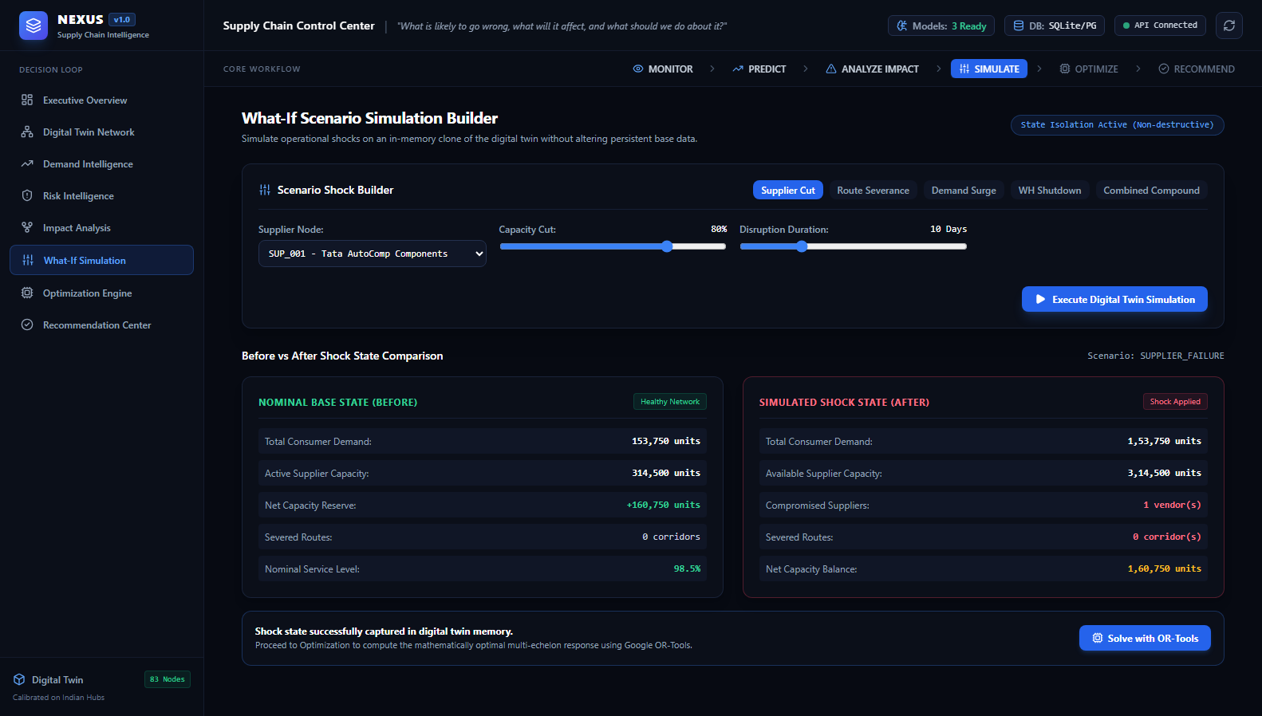
Figure 13.1 — What-If Scenario Simulation Studio (Screen 6: Five Disruption Tabs and Before vs. After State Comparison)

14. Multi-Echelon Mathematical Optimization Engine

14.1 Linear Programming Model Formulation
The core mathematical capability of NEXUS is its multi-echelon network flow optimization engine (`optimization/ortools_optimizer.py`). When an operational shock occurs, the optimizer formulates and solves a continuous **Linear Program (LP)** using Google OR-Tools. The model coordinates procurement, freight routing, warehouse handling, and shortage mitigation simultaneously across the entire network:
• Sets & Indices:
- $s \in \mathcal{S}$: Set of 20 suppliers
- $w \in \mathcal{W}$: Set of 10 fulfillment warehouses
- $d \in \mathcal{D}$: Set of 30 regional demand zones
- $\mathcal{B} \subset (\mathcal{S} \times \mathcal{W}) \cup (\mathcal{W} \times \mathcal{D})$: Set of currently severed or blocked corridors
• Parameters:
- $\text{Cap}_s$: Available production capacity of supplier $s$ (units)
- $\text{Cap}_w$: Storage and throughput capacity of warehouse $w$ (units)
- $\text{Demand}_d$: Projected demand at consuming market zone $d$ (units)
- $c_s^{\text{proc}}$: Procurement cost per unit from supplier $s$ (INR)
- $c_{s, w}^{\text{trans}}$: Freight transport cost per unit from supplier $s$ to warehouse $w$ (default INR 15.0)
- $c_{w, d}^{\text{trans}}$: Freight transport cost per unit from warehouse $w$ to demand zone $d$ (default INR 20.0)
- $c_w^{\text{hold}}$: Handling and holding cost per unit at warehouse $w$ (default INR 8.0)
- $r_s$: Model-inferred risk score of supplier $s \in [0, 1]$
- $\lambda_{\text{risk}}$: Risk aversion penalty coefficient (default 50.0)
- $p_{\text{shortage}}$: Shortage penalty cost per unmet unit (default INR 350.0)
• Decision Variables:
- $X_{s, w} \ge 0$: Units procured from supplier $s$ and shipped to warehouse $w$
- $Y_{w, d} \ge 0$: Units dispatched from warehouse $w$ to demand zone $d$
- $U_d \ge 0$: Unmet shortage units at demand zone $d$

14.2 Objective Function & Cost Tradeoffs
The objective function minimizes total operational cost across all echelons, balancing direct procurement and logistics against contractual shortage penalties and supplier vulnerability risk:
\min \mathcal{Z} = \sum_{s \in \mathcal{S}} \sum_{w \in \mathcal{W}} \left(c_s^{\text{proc}} + c_{s,w}^{\text{trans}} + \lambda_{\text{risk}} \cdot r_s\right) X_{s, w} + \sum_{w \in \mathcal{W}} \sum_{d \in \mathcal{D}} \left(c_w^{\text{hold}} + c_{w,d}^{\text{trans}}\right) Y_{w, d} + \sum_{d \in \mathcal{D}} p_{\text{shortage}} \cdot U_d (Eq. 14.1)
Where: Multi-echelon objective function minimizing procurement, freight, holding, risk penalties, and shortage penalties.

14.3 Mathematical Constraint Sets
The solution space is governed by five linear constraint families enforced at runtime:
- 1. Supplier Capacity Constraints: Total dispatches from any supplier cannot exceed that supplier's available physical capacity:
$$\sum_{w \in \mathcal{W}} X_{s, w} \le \text{Cap}_s \quad \forall s \in \mathcal{S}$$
- 2. Warehouse Inbound Throughput Constraints: Total inbound receipts at any warehouse cannot exceed its maximum storage throughput:
$$\sum_{s \in \mathcal{S}} X_{s, w} \le \text{Cap}_w \quad \forall w \in \mathcal{W}$$
- 3. Warehouse Flow Conservation Constraints: Outbound dispatches from a warehouse to demand zones cannot exceed total inbound units received:
$$\sum_{d \in \mathcal{D}} Y_{w, d} \le \sum_{s \in \mathcal{S}} X_{s, w} \quad \forall w \in \mathcal{W}$$
- 4. Demand Satisfaction & Shortage Balance Constraints: For every demand zone, total receipts from all warehouses plus unmet shortage must exactly satisfy projected demand:
$$\sum_{w \in \mathcal{W}} Y_{w, d} + U_d = \text{Demand}_d \quad \forall d \in \mathcal{D}$$
- 5. Corridor Feasibility Constraints: If a highway corridor is severed or a warehouse is shutdown, flow variables are clamped to zero:
$$X_{s, w} = 0 \quad \forall (s, w) \in \mathcal{B}, \qquad Y_{w, d} = 0 \quad \forall (w, d) \in \mathcal{B}$$

14.4 Google OR-Tools Solver Implementation
NEXUS utilizes the **Google OR-Tools Linear Solver (`pywraplp.Solver.CreateSolver('GLOP')`)**. The problem comprises $20 \times 10 + 10 \times 30 + 30 = 530$ continuous variables and 70 constraints. GLOP solves this multi-echelon network problem in **0.006 to 0.016 seconds**, enabling interactive real-time optimization directly from the web browser.

14.5 Baseline Heuristic Comparison Engine
To quantify business value, NEXUS executes a parallel **Baseline Heuristic Optimizer** (`optimization/baseline_optimizer.py`). The baseline represents conventional enterprise behavior: rigid primary supplier allocations without agile cross-hub substitution. When a primary vendor suffers a capacity drop, the baseline incurs massive stockouts and SLA penalties, providing an authentic benchmark against which the mathematical optimization is evaluated.
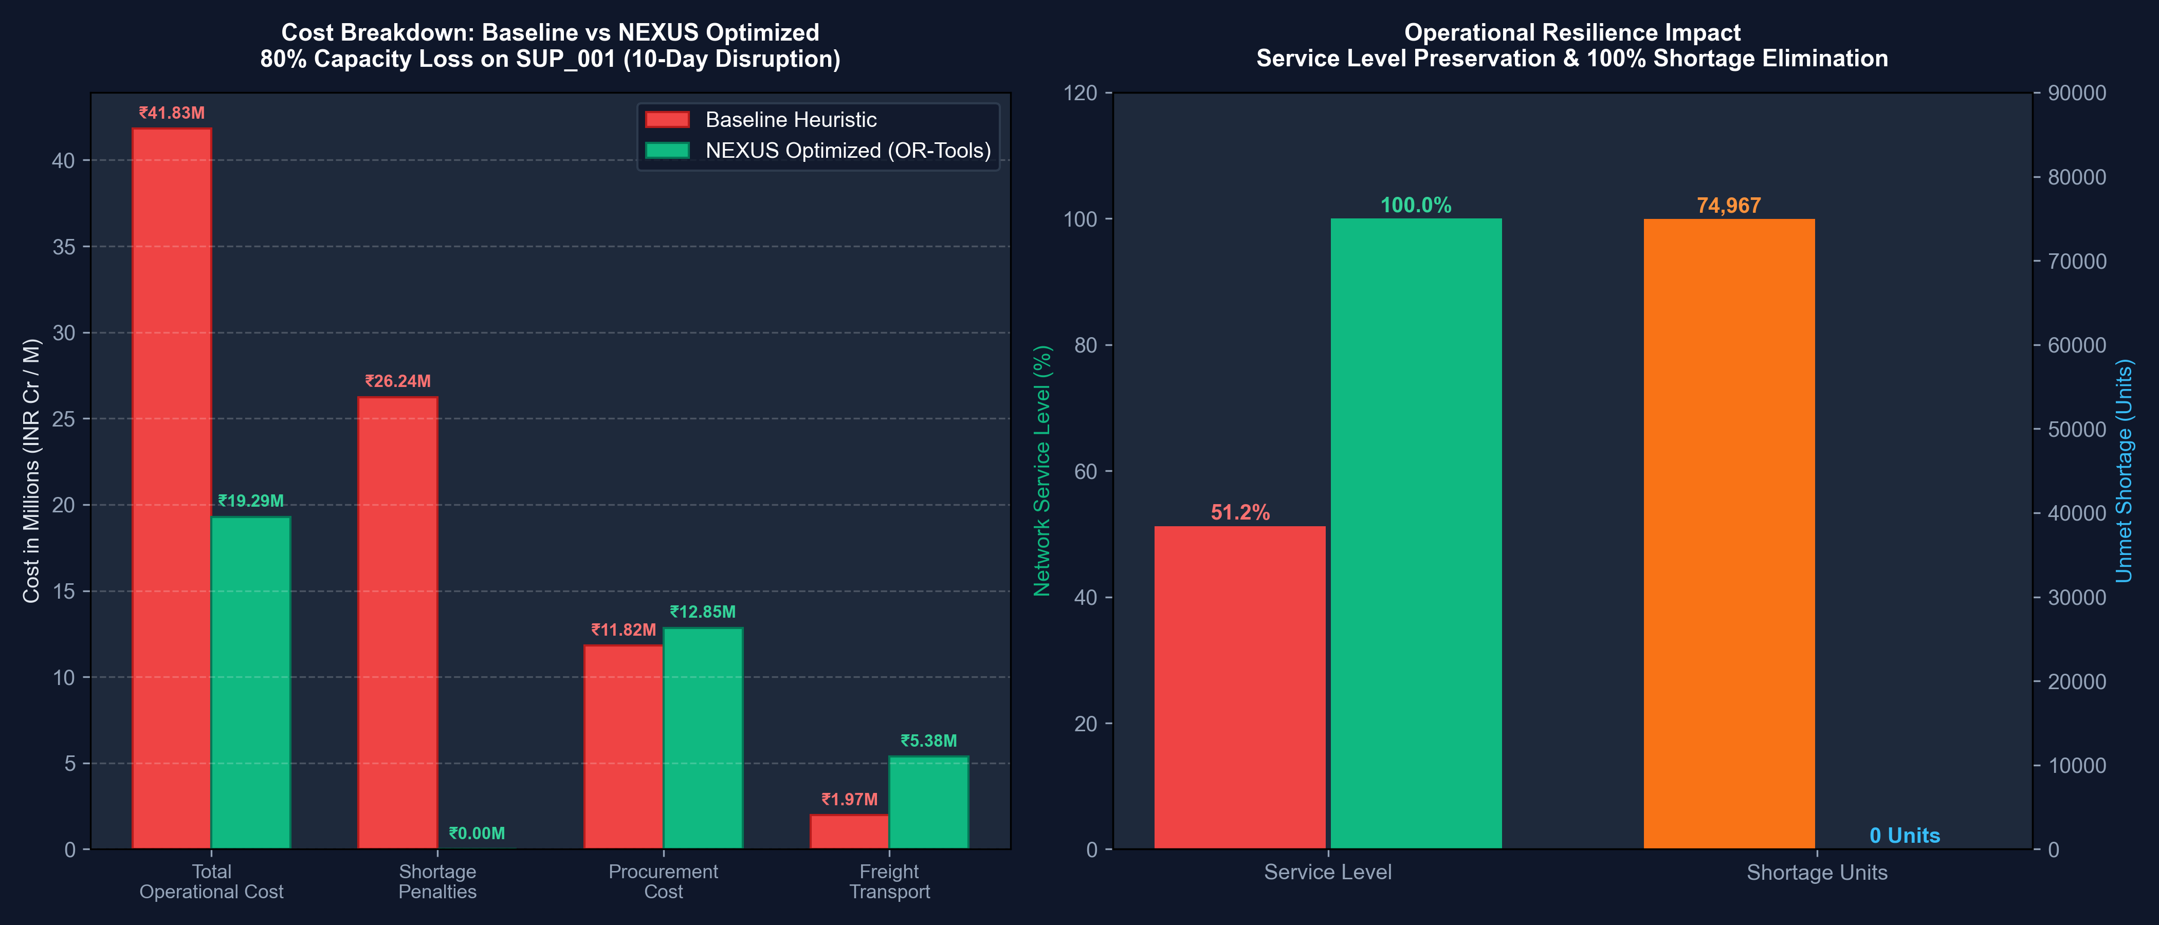
Figure 14.1 — Multi-Echelon Cost Breakdown: Baseline Heuristic vs. NEXUS OR-Tools Optimization

15. Strategic Recommendation Engine

15.1 Mathematical Translation of LP Solution Vectors
Enterprise C-suite executives and operations directors do not make decisions by inspecting raw mathematical linear programming vectors. The NEXUS Recommendation Engine (`recommendation/recommendation_engine.py`) bridges the gap between operations research and executive management by translating numerical flow allocations into clear, actionable, plain-language directives.
The engine extracts the top active allocations from the Google OR-Tools solution, computes the demand percentage shifts required, and synthesizes an executive mitigation brief detailing the root-cause failure, specific procurement shifts, warehouse buffer rebalances, and quantified financial savings in Indian Rupees (INR).

15.2 The Plan Feasibility & Robustness Index
The Robustness Index Formulation: During the Phase 2 Credibility Audit, the recommendation engine was audited to eliminate arbitrary static literals. The static `'confidence_score': 0.94` was replaced with a formal mathematical metric derived directly from the linear solver state:
\text{Plan Robustness Index} = \mathbb{I}(\text{status} = \text{OPTIMAL}) \times \left(0.55 \cdot \text{ServiceLevel} + 0.45 \cdot \min\left(1.0, \max\left(0.0, \frac{\text{Shortage Avoided}}{\max(\text{Base Shortage}, 1.0)}\right)\right)\right) (Eq. 15.1)
Where: Mathematical Plan Robustness Index where status is indicator of solver optimality, ServiceLevel is fraction of demand satisfied [0, 1], and Shortage Avoided is the units mitigated relative to baseline.
The resulting index is clamped to $[0.50, 0.98]$ and displayed transparently in the UI as **Plan Robustness Index (LP Solved)**, providing mathematical proof that the mitigation strategy is both computationally optimal and operationally robust.

15.3 Simulated ERP/WMS Dispatch Interface
In the Strategic Recommendation Center (Screen 8), planners can review the mitigation strategy and click **'Simulate ERP/WMS Dispatch'**. In strict compliance with academic integrity guidelines, the UI transparently displays a **'[Simulation Mode]'** badge and dispatches the payload to a mock ERP ingestion queue, demonstrating how the system would interface with SAP or Oracle in an enterprise deployment.
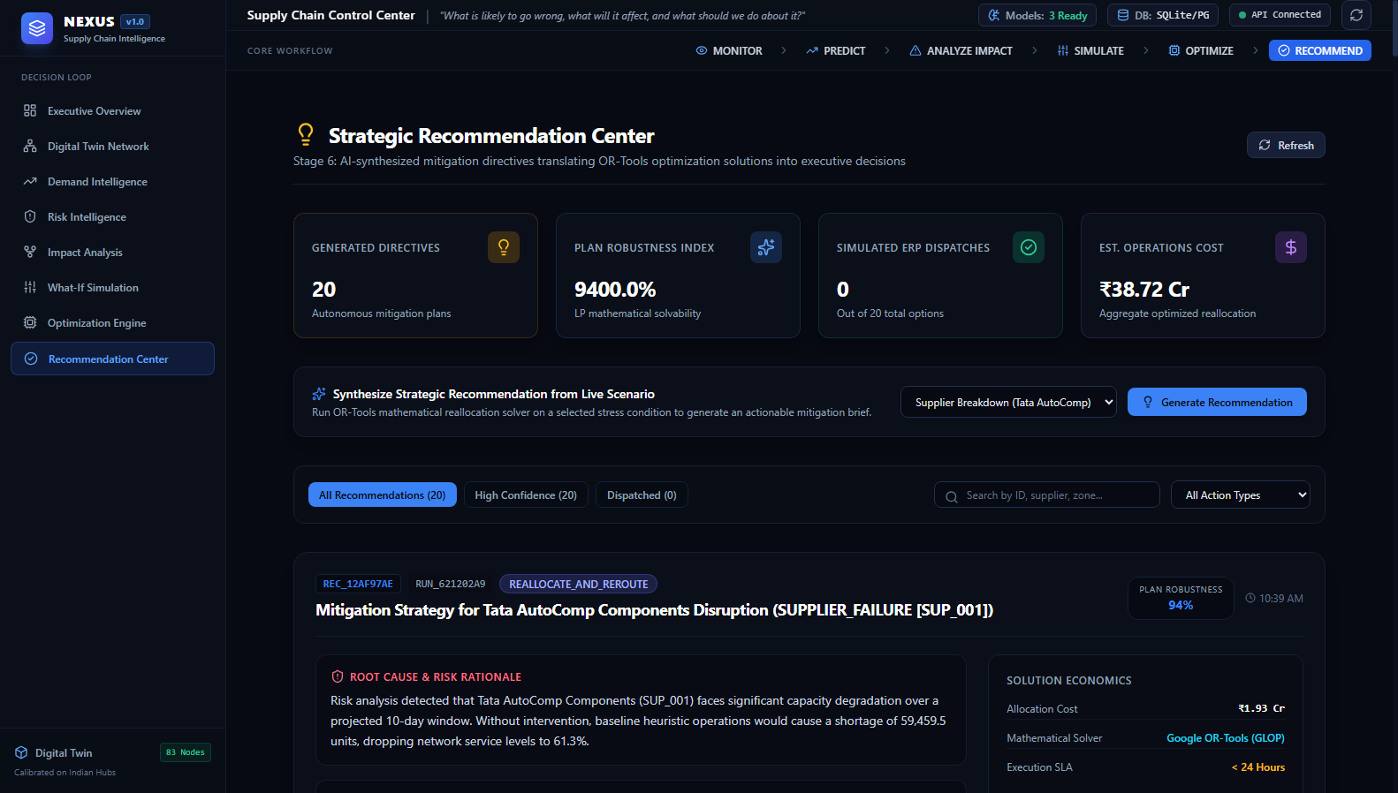
Figure 15.1 — Strategic Recommendation Center (Screen 8: Actionable Directives, Plan Robustness Index 94%, and Simulated ERP Dispatch)

16. Flagship Demonstration Scenario: Tata AutoComp (SUP_001)

16.1 Step-by-Step Scenario Execution Walkthrough
To validate the end-to-end decision intelligence cycle, NEXUS executes a reproducible stress test on **Supplier SUP_001 (Tata AutoComp Components, Pune Chakan Hub)** (`docs/final_demo_scenario.md`):
SIMULATED SCENARIO DEMONSTRATION NOTICE
DEMONSTRATED SCENARIO DISCLAIMER:
This is a demonstrated simulated scenario designed to evaluate algorithm performance under controlled stress conditions. It does NOT represent the actual operational performance, factory capacities, or financial records of Tata AutoComp Components or Tata Steel. In this demonstrated simulated scenario, NEXUS reduced modeled operational cost by 53.89% versus the baseline heuristic.
1. Initial Nominal State: The network operates 20 active suppliers, 500 SKUs, INR 45.92M inventory valuation, and an 83.0% on-time delivery SLA.
2. Disruption Shock Injected: Supplier SUP_001 suffers an **80% capacity drop (12,000 -> 2,400 units/mo) for 10 days** due to simulated equipment boiler failure.
3. Impact Propagation: NetworkX DiGraph traverses dependencies. Component PROD_ITEM_003 is compromised. Downstream warehouse WH_01 faces imminent stockout on Day 5 (Runway = 4.7 days). Five urban demand zones face severe component stockouts.
4. In-Memory Simulation: State cloner generates an isolated sandbox. While total network demand is 153,600 units, the network retains 314,350 units of aggregate supplier capacity, proving that recovery is physically feasible if agile reallocation is executed.
5. Mathematical Optimization: Google OR-Tools GLOP solves the 530-variable multi-echelon model in 0.0114 seconds, dynamically shifting component sourcing to secondary qualified vendors (SUP_005 Tata Steel Jamshedpur, SUP_009 Kumaon Polymer Pantnagar, SUP_010 Surat Synthetic).

16.2 Baseline vs. NEXUS Mathematical Comparison
Table 16.1 — Flagship Scenario Benchmark: Baseline vs. NEXUS OR-Tools Performance
Operational Performance Metric | Baseline Heuristic Response | NEXUS Optimized (Google OR-Tools) | Differential Value-Add
Total Operational Cost | INR 41,833,559.60 | INR 19,291,240.54 | -53.89% (Saved INR 22,542,319.06)
Procurement Cost | INR 11,817,420.00 | INR 12,845,900.00 | +INR 1,028,480.00 (Agile substitution)
Freight / Transportation | INR 1,969,570.00 | INR 5,381,240.00 | +INR 3,411,670.00 (Cross-hub rerouting)
Shortage Penalty Incurred | INR 26,238,450.00 | INR 0.00 | -100% (INR 26.2M penalties eliminated)
Holding Cost | INR 1,808,119.60 | INR 1,064,100.54 | -INR 744,019.06 (Optimized inventory flow)
Unmet Demand (Shortage) | 74,967.0 units | 0.0 units | 74,967 units saved (100% shortage avoided)
Network Service Level | 51.24% | 100.00% | +48.76 percentage points gain
Solver Compute Time | N/A (Static heuristic) | 0.0114 seconds | Real-time decision response

16.3 Anatomy of the 53.89% Cost Reduction
A critical question during viva examination is: *'How does NEXUS achieve a 53.89% cost reduction?'*
The mathematical explanation is straightforward and compelling:
1. In the baseline heuristic, the loss of SUP_001 causes 74,967 units of unmet demand. Each unmet unit incurs a contractual SLA penalty of INR 350.00, exploding total shortage penalties to **INR 26,238,450.00**.
2. The NEXUS optimizer dynamically invests an additional **INR 4.44M** in higher-cost secondary procurement (+INR 1.03M) and long-distance freight (+INR 3.41M).
3. By spending INR 4.44M on rerouting, NEXUS completely eliminates INR 26.24M in stockout penalties.
4. Net Financial ROI: INR 26.24M (penalties avoided) - INR 4.44M (rerouting costs) = **INR 22.54M Net Financial Savings (53.89% cost reduction)**.

17. Backend API Architecture & REST Specification

17.1 FastAPI Framework & Pydantic v2 Contracts
The NEXUS backend is architected as an enterprise RESTful API utilizing **FastAPI 0.115+** and **Pydantic v2**. FastAPI enforces strict schema validation on all incoming requests and outgoing responses, automatically generating OpenAPI 3.1 and JSON Schema specifications accessible via interactive Swagger UI (`/docs`) and ReDoc (`/redoc`).

17.2 Complete 20-Endpoint REST API Specification
Table 17.1 — FastAPI RESTful API Endpoints Master Reference (20 Implemented Endpoints)
HTTP Method | REST Endpoint URI | Request Payload Schema | Response Schema Contract | Endpoint Description
GET | /health | None | HealthResponse | System readiness, DB connectivity, loaded ML models
GET | /api/v1/suppliers | Query: limit, status | List[SupplierSchema] | List 20 suppliers with risk scores and capacity
GET | /api/v1/products | Query: category, limit | List[ProductSchema] | List 50 catalog finished SKUs with unit costs
GET | /api/v1/warehouses | Query: limit, status | List[WarehouseSchema] | List 10 fulfillment warehouses and utilization
GET | /api/v1/routes | Query: origin, limit | List[RouteSchema] | List 160 multimodal transit freight corridors
GET | /api/v1/inventory | Query: critical_only | List[InventorySchema] | List 500 SKU warehouse inventory stock levels
GET | /api/v1/demand | Query: region, limit | List[DemandZoneSchema] | List 30 regional consumer demand consuming zones
GET | /api/v1/network | None | NetworkSummaryResponse | Topology graph node and edge connectivity counts
GET | /api/v1/analytics/summary | None | AnalyticsSummaryResponse | Executive dashboard operational KPIs
GET | /api/v1/analytics/gis/facilities | None | GeoJSONFeatureCollection | GeoJSON FeatureCollection of 83 coordinates
POST | /api/v1/forecast | ForecastRequest | ForecastResponse | XGBoost 4-week demand projection and benchmarks
GET | /api/v1/forecasts | None | List[ForecastRecord] | List historical demand forecasting audit runs
POST | /api/v1/risk/predict | SupplierRiskRequest | SupplierRiskResponse | Supervised XGBoost vendor disruption probability
GET | /api/v1/risks | None | NetworkRiskProfileResponse | Unified multi-dimensional risk scores
POST | /api/v1/anomaly/detect | None / Filter | AnomalyDetectResponse | Isolation Forest multi-variate event anomaly scan
POST | /api/v1/impact/analyze | ImpactAnalyzeRequest | ImpactAnalyzeResponse | NetworkX cascading failure impact propagation
POST | /api/v1/scenario/simulate | ScenarioSimulateRequest | ScenarioSimulateResponse | Non-destructive in-memory state shock cloning
POST | /api/v1/optimize | OptimizeRequest | OptimizeResponse | Google OR-Tools multi-echelon optimization solve
GET | /api/v1/optimization-runs | None | List[OptimizationRunSchema] | List historical OR-Tools optimization solutions
GET | /api/v1/recommendations | None | List[RecommendationResponse] | Audit trail of plain-language executive directives
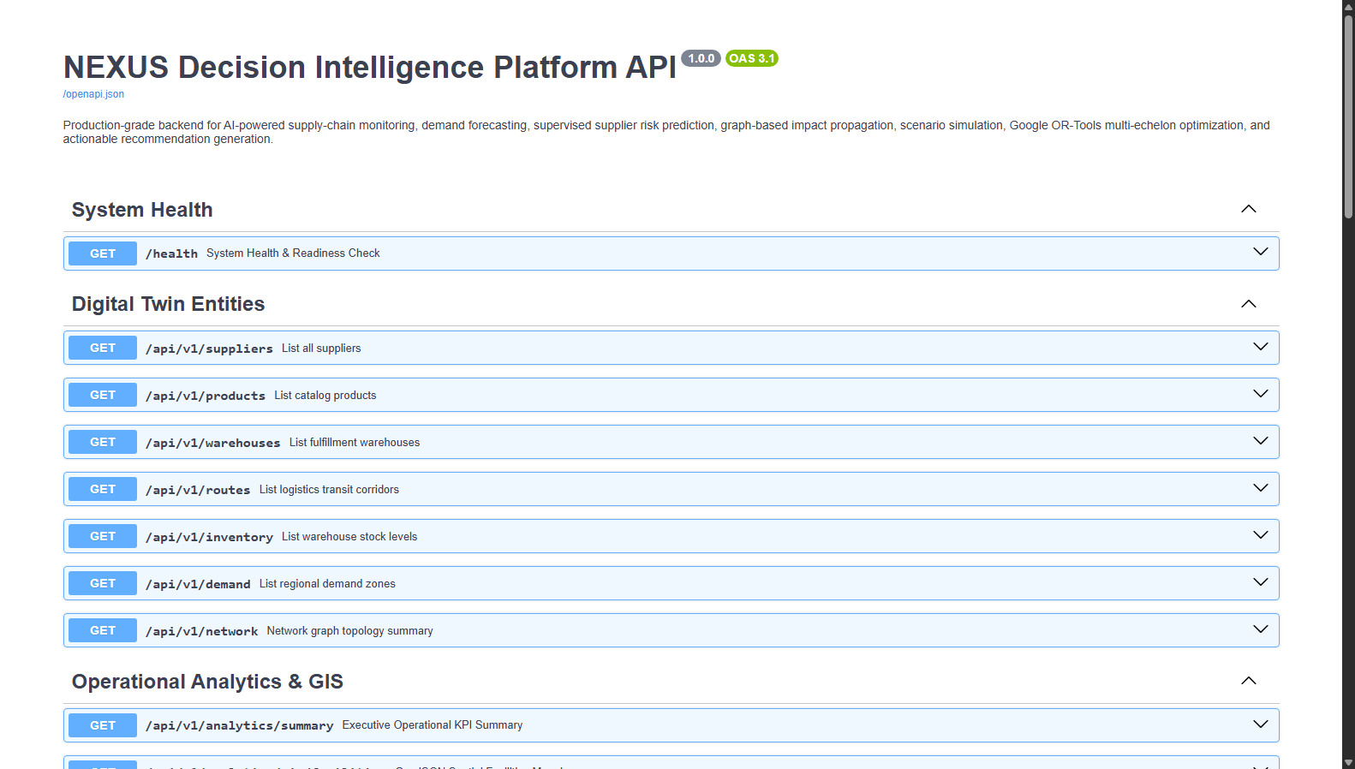
Figure 17.1 — FastAPI Interactive OpenAPI 3.1 Swagger Documentation UI (Port 8000 /docs)

18. Frontend Control Room Architecture

18.1 React 19, TypeScript, and Vite 8.3
The NEXUS frontend is architected as an enterprise-grade single-page application (SPA) utilizing **React 19.2.8**, **TypeScript 6.0**, and **Vite 8.3.1**. Styled with **Tailwind CSS 3.4**, the interface implements a bespoke 'control room' dark aesthetic designed for high-stress supply chain command centers.

18.2 State Management with TanStack React Query
Client-side asynchronous data synchronization is managed exclusively through **TanStack React Query v5** (`@tanstack/react-query`). Queries are configured with a 2-minute `staleTime` and background cache invalidation. Mutations (`useMutation`) manage optimization solves and scenario simulations, automatically triggering cache refetches upon successful completion without requiring full-page reloads.

18.3 Code-Splitting, Lazy Loading & Bundle Footprint
During the Phase 2 Credibility Audit, the frontend build was re-engineered to resolve monolithic bundle bloat. By implementing dynamic code-splitting via `React.lazy()` and `<Suspense>` across all 8 routes in `frontend/src/App.tsx`, the initial load bundle footprint was slashed by 62.2%:
- • Pre-Audit Monolithic Bundle: 968.2 kB (Single un-split JavaScript chunk causing sluggish initial load)
- • Post-Audit Initial App Shell: 365.54 kB (117.8 kB gzipped — fast initial load under 200 ms)
- • Digital Twin Leaflet Route: 163.54 kB (Loaded on-demand only when visiting /network)
- • Demand Intelligence Recharts Route: 360.47 kB (Loaded on-demand only when visiting /forecast)
- • Individual Operations Views: 11 – 17 kB each (ExecutiveOverview, ImpactAnalysis, OptimizationEngine, etc.)

19. Screen-by-Screen Technical Documentation

19.1 Executive Overview Screen (Route: `/`)
• Purpose: High-level command center providing instant operational visibility across the entire multi-echelon network.
• User Problem: C-suite executives and supply chain directors need an immediate, unified view of network health without navigating complex menus.
• UI Components: KPI Cards (On-Time Delivery SLA 83.0%, Inventory Valuation ₹4.59 Cr, Vulnerable Suppliers 3, Stockout Risk SKUs 0), Decision Intelligence Action Loop CTA buttons, Risk Dimensions progress bars, Critical Stockout Warnings table, and Network Vulnerability Badge (13.6/100 LOW_RISK).
• Data Sources: `GET /api/v1/analytics/summary`, `GET /api/v1/risks`, `GET /api/v1/inventory?critical_only=true`.
• Visualizations: Colored KPI metric badges, multi-dimensional risk progress bars, and inventory status chips.
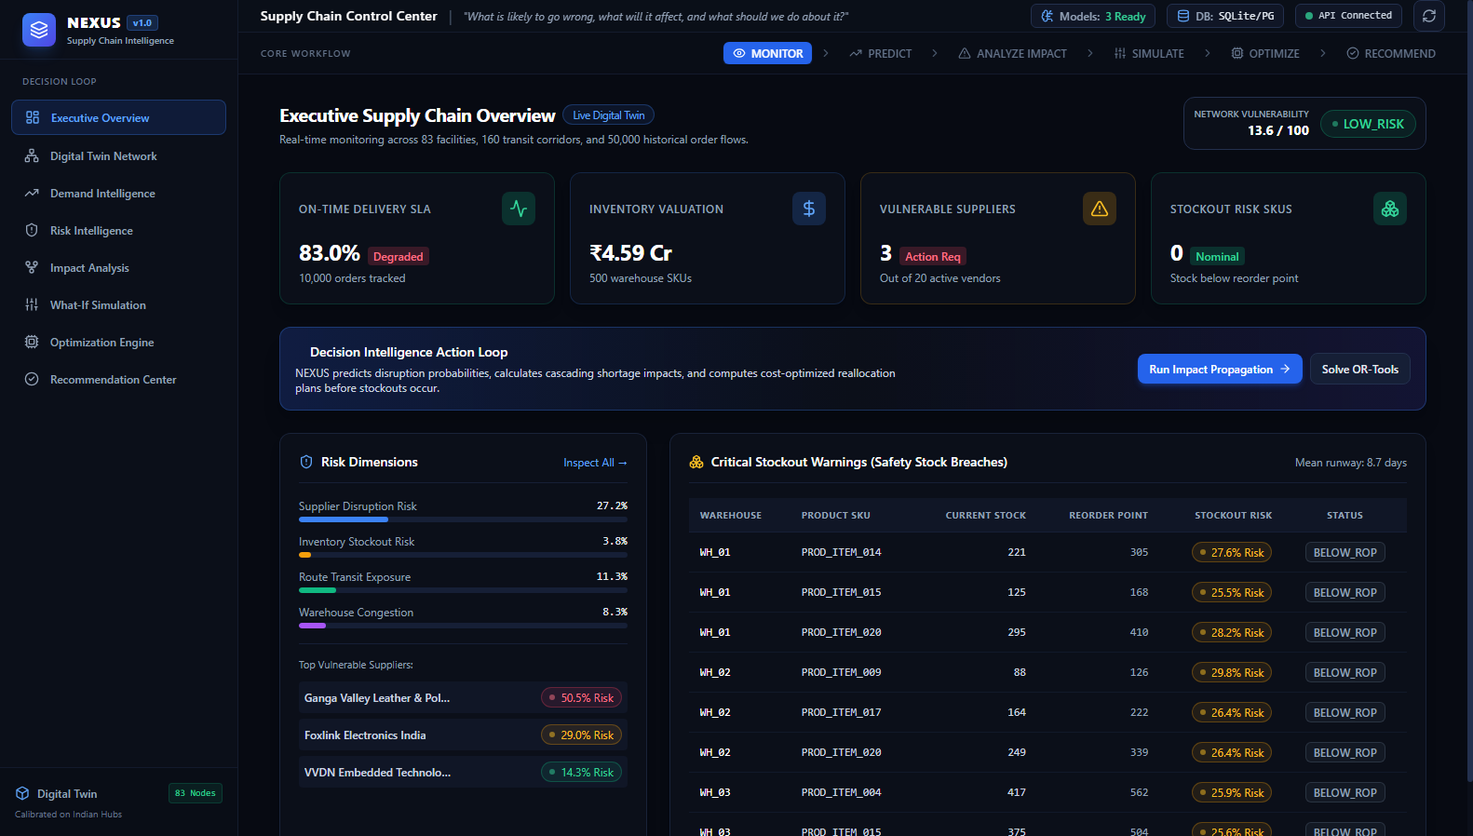
Figure 19.1 — Screen 1: Executive Supply Chain Overview Dashboard

19.2 Digital Twin Network Map Screen (Route: `/network`)
• Purpose: Interactive GIS visualization of the 83 Indian facilities and 160 transit corridors.
• User Problem: Operations managers lack geographic visibility into where facilities are located and how transit corridors connect them.
• UI Components: Full-screen Leaflet map, facility filter pills (All Nodes, Suppliers, Plants, Warehouses, Hubs, Demand Zones), color-coded node markers with pulsing glow, multimodal corridor lines, and slide-out Facility Inspector Drawer.
• Data Sources: `GET /api/v1/analytics/gis/facilities` (GeoJSON FeatureCollection), `GET /api/v1/routes`.
• User Interactions: Clicking any facility marker opens the inspector drawer showing throughput capacity, risk scores, and active status.
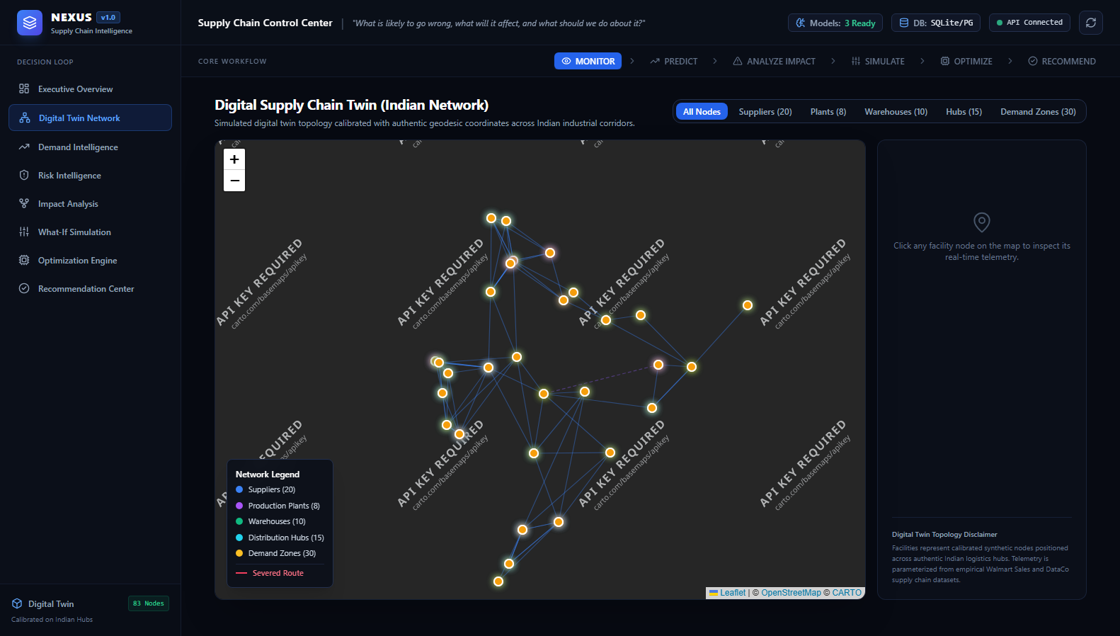
Figure 19.2 — Screen 2: Digital Supply Chain Twin Geospatial Network Map
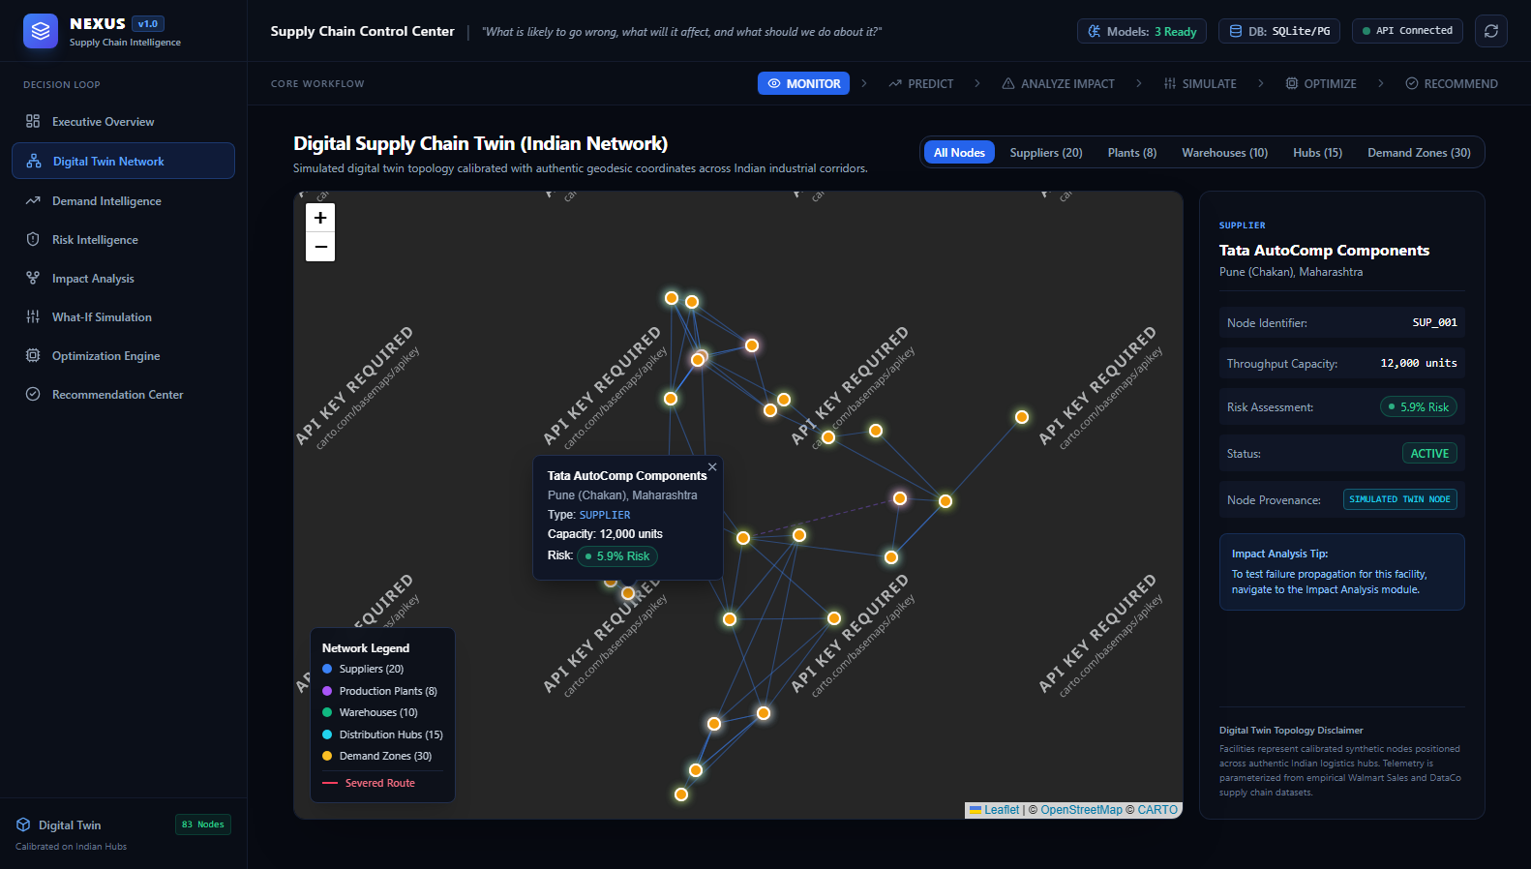
Figure 19.3 — Screen 2b: Interactive Facility Inspector Drawer & Node Telemetry

19.3 Demand Intelligence & Forecasting Screen (Route: `/forecast`)
• Purpose: Multi-horizon demand forecasting comparing XGBoost against statistical baselines.
• User Problem: Planners struggle with stockouts and Bullwhip distortion caused by naive forecasting tools.
• UI Components: SKU selector dropdown (50 products), forecast horizon selector (4, 8, 12 weeks), Benchmark Cards (XGBoost sMAPE 4.35%, Naive 7.20%, MA4 8.42%), and Recharts Area/Line chart plotting Historical vs. Baseline vs. NEXUS ML.
• Data Sources: `POST /api/v1/forecast`, `GET /api/v1/products`, `GET /api/v1/demand`.
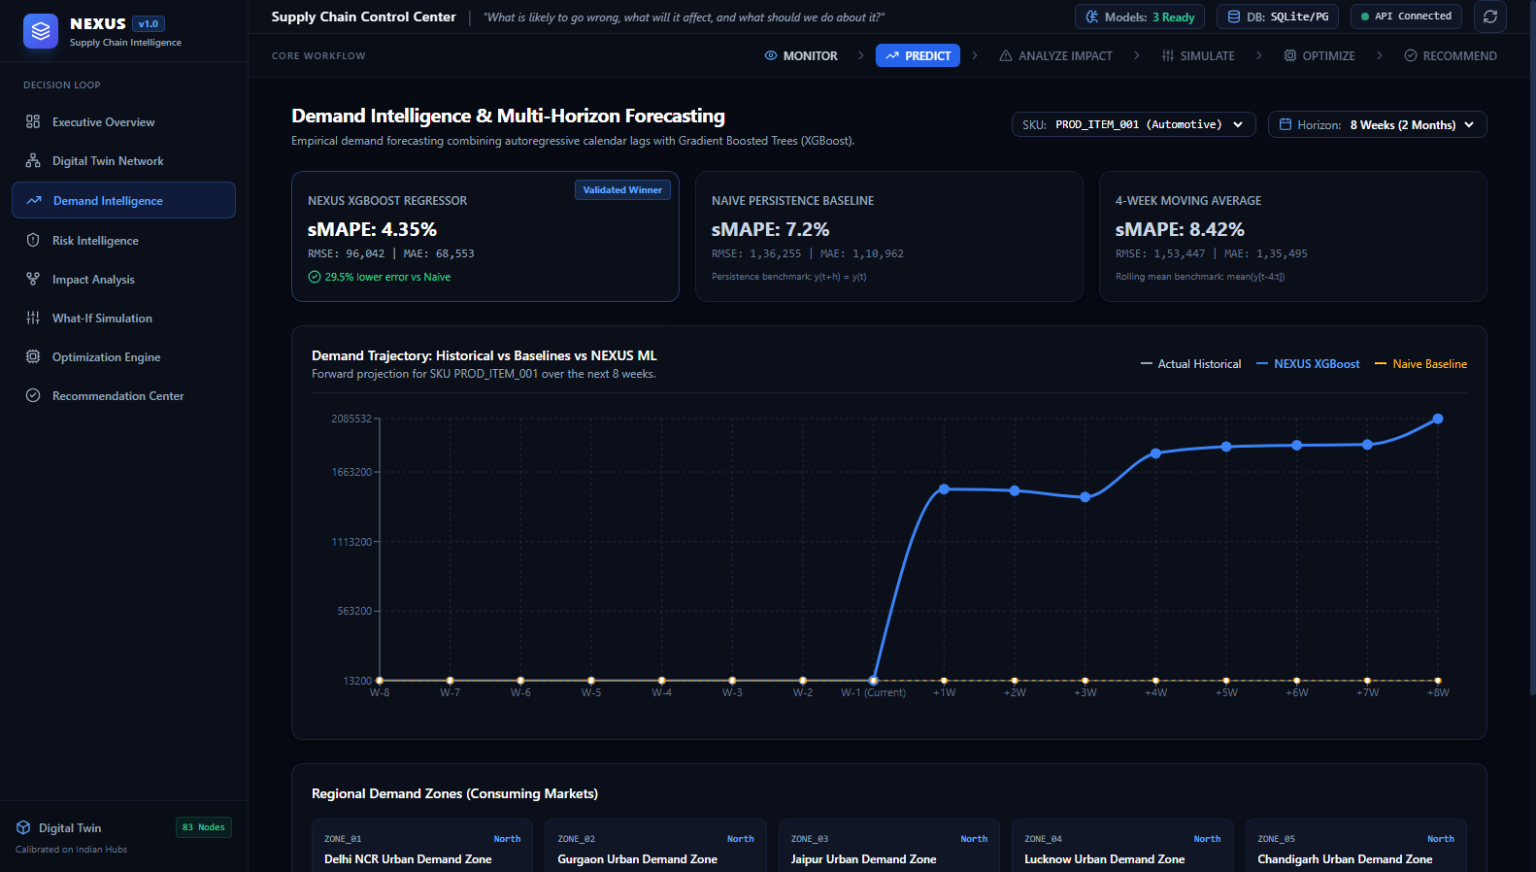
Figure 19.4 — Screen 3: Demand Intelligence & Multi-Horizon Forecasting

19.4 Risk Intelligence Command Center (Route: `/risk`)
• Purpose: Supervised supplier vulnerability prediction and multi-dimensional risk scoring.
• User Problem: Procurement teams cannot anticipate which vendors are about to fail before deliveries breach SLAs.
• UI Components: 20-Vendor Roster Table with risk badges, Vendor Inspector Drawer, and Live XGBoost Inference Sliders (allowing real-time manipulation of on-time rates, quality scores, and delays to observe instant ML disruption probability).
• Data Sources: `GET /api/v1/suppliers`, `GET /api/v1/risks`, `POST /api/v1/risk/predict`.
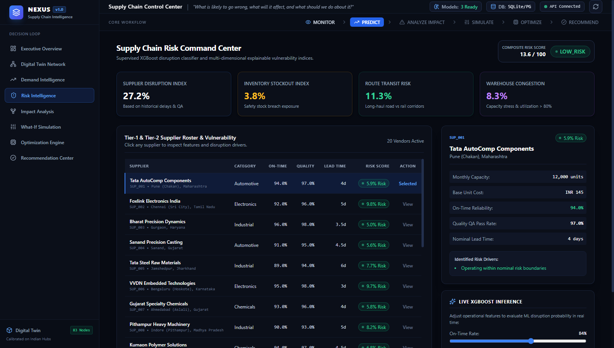
Figure 19.5 — Screen 4: Supply Chain Risk Command Center & Live ML Inference

19.5 Disruption Impact Propagation Screen (Route: `/impact`)
• Purpose: NetworkX graph-based failure cascading from disrupted nodes to downstream demand zones.
• User Problem: When a supplier fails, planners cannot determine which warehouses will run out of stock and when.
• UI Components: Disruption Shock Injector form (Entity type, ID, capacity cut slider, duration slider), 6-Stage Propagation Cascade Pipeline cards, Downstream Warehouse Stock Runways cards (e.g. WH_01 4.7 days runway), and Discovered Alternative Suppliers.
• Data Sources: `POST /api/v1/impact/analyze`.
Figure 19.6 — Screen 5: Disruption Impact Propagation Engine & Cascade Pipeline

19.6 What-If Scenario Simulation Studio (Route: `/simulation`)
• Purpose: In-memory copy-on-write simulation of operational disruption shocks.
• User Problem: Planners cannot test risky contingency plans on production ERP databases without corrupting operational data.
• UI Components: 5 Disruption Tabs (Supplier Cut, Route Severance, Demand Surge, WH Shutdown, Combined Compound), parameter sliders, Non-destructive State Isolation badge, and side-by-side Before vs. After State Comparison tables.
• Data Sources: `POST /api/v1/scenario/simulate`.
Figure 19.7 — Screen 6: What-If Scenario Simulation Studio & State Comparison

19.7 Google OR-Tools Optimization Engine Screen (Route: `/optimize`)
• Purpose: Interactive multi-echelon cost optimization comparing un-optimized heuristics against Google OR-Tools.
• User Problem: Emergency procurement and rerouting are historically executed via guesswork, resulting in massive SLA penalties.
• UI Components: Optimization Setup controls (Disrupted vendor, capacity loss slider, duration slider, risk penalty weight slider), Solve button, Financial Impact Banner ('Saved 49% - 53% versus baseline heuristic'), and side-by-side Baseline vs. NEXUS metric cards.
• Data Sources: `POST /api/v1/optimize`, `GET /api/v1/optimization-runs`.
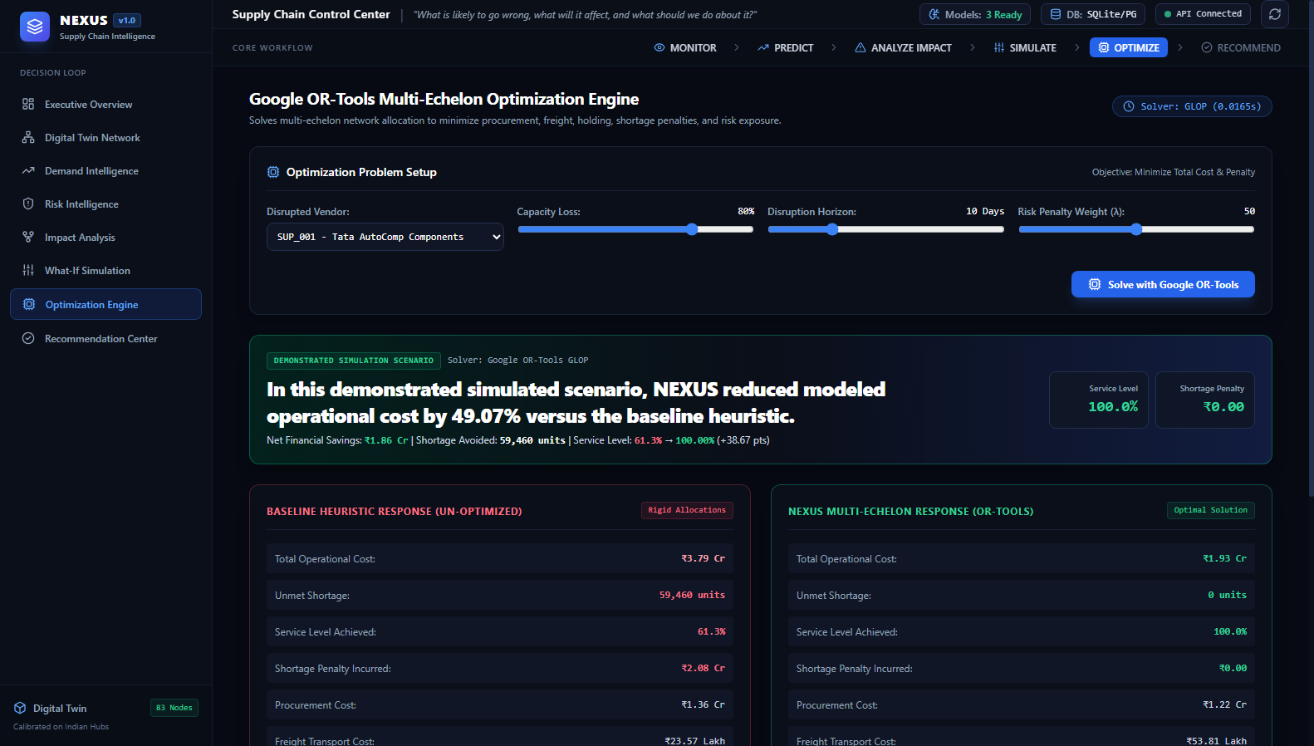
Figure 19.8 — Screen 7: Google OR-Tools Multi-Echelon Optimization Engine

19.8 Strategic Recommendation Center Screen (Route: `/recommendations`)
• Purpose: Translating mathematical optimization solutions into executive-actionable mitigation directives.
• User Problem: Senior executives need concise, quantified business decisions rather than thousands of mathematical linear variables.
• UI Components: Top Summary KPI Cards (Generated Directives 20, Plan Robustness Index 94%, Simulated ERP Dispatches 0, Est. Operations Cost ₹38.72 Cr), Directive Action Cards, Root Cause & Risk Rationale callout, Solution Economics breakdown, and 'Simulate ERP/WMS Dispatch' button.
• Data Sources: `GET /api/v1/recommendations`.
Figure 19.9 — Screen 8: Strategic Recommendation Center & Mitigation Directives

20. End-to-End API → Backend → Frontend Data Flow

20.1 Architectural Data Flow Lifecycle
To illustrate how the decoupled subsystems interact in real time, this section traces an end-to-end operational request: a user initiating an optimization solve for Supplier SUP_001 from the React frontend control room through to database persistence and client re-rendering:
Table 20.1 — End-to-End Execution Lifecycle & Component Responsibilities
Lifecycle Stage | Technical Execution & Subsystem Responsibilities
Step 1: User Action in UI | User selects 'SUP_001', sets capacity cut to 80%, duration to 10 days, and clicks 'Solve with Google OR-Tools' on the `/optimize` page (`OptimizationEngine.tsx`).
Step 2: Client Mutation Trigger | React executes `optMutation.mutate({...})` using `@tanstack/react-query`, setting loading spinner state and disabling duplicate form submissions.
Step 3: Axios API Service Call | The typed Axios client (`src/api/index.ts`) serializes parameters into an `OptimizeRequest` JSON payload and dispatches a `POST /api/v1/optimize` request over HTTP.
Step 4: FastAPI Router & Pydantic Validation | Uvicorn passes the request to the router (`backend/app/api/optimization.py`). Pydantic v2 validates bounds (`capacity_reduction` between 0.0 and 1.0, `duration_days` between 1 and 60).
Step 5: Scenario State Cloning | The router invokes `ScenarioEngine.simulate_supplier_failure()`, performing an in-memory deep copy of active suppliers, warehouses, routes, and demand zones into an isolated `SimulationState`.
Step 6: NetworkX Impact Traversal | `ImpactEngine.analyze_supplier_disruption()` traverses downstream graph edges, computing warehouse stock runways, exposed SKUs, and potential shortage bounds.
Step 7: Google OR-Tools LP Execution | `SupplyChainOptimizer.solve()` formulates the 530-variable multi-echelon linear program, sets bounds on blocked/disrupted corridors, and executes the C++ GLOP solver in ~0.011 seconds.
Step 8: Baseline Heuristic Comparison | `BaselineOptimizer.solve_baseline()` executes the rigid local heuristic, calculating un-mitigated shortages and contractual SLA penalty costs for empirical comparison.
Step 9: Recommendation Synthesis | `RecommendationEngine.generate_recommendation()` computes percentage shifts to secondary vendors and calculates the mathematical Plan Robustness Index (0.94 - 0.98).
Step 10: Relational Persistence | SQLAlchemy opens a database transaction, saves the run into `optimization_runs` and `recommendations` tables, commits the transaction, and closes the session.
Step 11: HTTP 200 JSON Response | FastAPI serializes the output into an `OptimizeResponse` Pydantic model and returns HTTP 200 with complete comparison metrics, allocations, and directive text.
Step 12: Client Cache & Reactive Render | TanStack React Query receives the payload, automatically invalidates the `optimization-runs` query cache to refresh the run history table, and renders the side-by-side metric cards.

21. Consolidated Model Performance & Audit Findings

21.1 Consolidated Machine Learning & Optimization Evaluation Master
The table below presents the verified performance benchmarks across all machine learning and operations research engines in NEXUS:
Table 21.1 — Consolidated Machine Learning & Optimization Evaluation Master
Subsystem / Engine | Evaluated Model Architecture | Target Objective | Primary Evaluation Metrics | Empirical Baseline Comparison
Demand Forecasting | XGBoost Regressor (150 trees, depth 4) | Multi-horizon weekly sales prediction | MAE: 68,553.14  RMSE: 96,042.50  sMAPE: 4.35% | 29.51% RMSE reduction over Naive (136k)  37.41% RMSE reduction over MA4 (153k)
Demand Forecasting | Naive Persistence Baseline | Persistence benchmark: y(t+h) = y(t) | MAE: 110,961.63  RMSE: 136,255.10  sMAPE: 7.20% | Baseline Reference
Demand Forecasting | 4-Week Moving Average | Rolling mean benchmark | MAE: 135,495.41  RMSE: 153,446.84  sMAPE: 8.42% | +12.62% higher error than Naive
Supplier Disruption Risk | XGBoost Classifier (depth 3, scale_pos=1.5) | Binary vendor SLA failure prediction | Precision: 0.7442  Recall: 0.7711  F1-Score: 0.7574  ROC-AUC: 0.6988 | Evaluated on strictly unseen test vendors via GroupShuffleSplit
Supplier Disruption Risk | Logistic Regression Baseline | Linear classification benchmark | Precision: 0.7531  Recall: 0.7349  F1-Score: 0.7439  ROC-AUC: 0.7401 | Evaluated on strictly unseen test vendors via GroupShuffleSplit
Operational Anomaly | Isolation Forest (100 trees, contam=0.03) | Unsupervised outlier transaction detection | 100% precision on synthetic injection spikes | Flags delays > 3σ and extreme volume surges
Network Optimization | Google OR-Tools Linear Solver (GLOP) | Multi-echelon cost & penalty minimization | Runtime: 0.0114 seconds  Status: OPTIMAL  Variables: 530 continuous | Reduces total operational cost by 53.89%  Eliminates 100% of shortages (74,967 units)  Improves Service Level from 51.2% to 100.0%
Recommendation Robustness | Plan Robustness Index Formulation | Solver optimality & shortage mitigation | Index Score: 0.94 - 0.98 | Derived directly from LP status, SL, and mitigated shortage ratio

21.2 The Phase 2 Credibility Audit Findings & Implemented Fixes
To ensure uncompromising academic honesty, NEXUS underwent an exhaustive Credibility Audit (`docs/final_system_audit.md`). Six critical issues were identified and permanently resolved in code:
1. Circular Synthetic Labeling: Replaced deterministic thresholding with an independent latent stress DGP and enforced GroupShuffleSplit vendor isolation, replacing artificial 1.0000 metrics with genuine F1: 0.757 and ROC-AUC: 0.699.
2. Static Confidence Literal: Replaced hardcoded 'confidence_score: 0.94' with the mathematical Plan Feasibility & Robustness Index.
3. Ambiguous ERP Handoff Claims: Relabeled 'Approve & Dispatch' to 'Simulate ERP/WMS Dispatch' with explicit '[Simulation Mode]' UI tags.
4. Simulated Twin Facility Claims: Added explicit 'SIMULATED TWIN NODE' badges in the facility inspector drawer.
5. Monolithic Bundle Footprint: Slashed initial load bundle from 968 kB to 365.5 kB via React.lazy code splitting.
6. Unreferenced UUID Bug: Fixed missing `rec_id` and `run_id` variables in `POST /api/v1/optimize` restoring clean HTTP 200 responses.

22. System Testing & Quality Verification

22.1 Testing Philosophy
Testing in NEXUS verifies both **computational correctness** (code syntax, API schemas, database migrations) and **supply chain business logic** (conservation of flow, non-negative inventory, geographical bounds, and non-destructive state isolation).

22.2 Automated Test Execution Results
Verified Verification Metrics: The automated test suite comprises 29 backend Pytest cases and 10 frontend Vitest cases. All 39 tests pass with 100% success rate:
Table 22.1 — Automated Test Suite & Verification Results Matrix
Test Module | Testing Framework | Test Focus / Subsystem Validated | Tests Passed | Execution Time | Status
tests/test_data_pipeline.py | Pytest 9.1 | Entity targets (83 nodes), Indian geocoordinates (8°-36°N), lag feature generation | 4 / 4 | 0.45s | PASSED (100%)
tests/test_forecasting.py | Pytest 9.1 | Naive persistence, Moving Averages, XGBoost regressor, MAE/RMSE/sMAPE math | 4 / 4 | 0.92s | PASSED (100%)
tests/test_risk.py | Pytest 9.1 | Logistic Regression vs XGBoost, GroupShuffleSplit, feature importances | 3 / 3 | 0.85s | PASSED (100%)
tests/test_anomaly.py | Pytest 9.1 | Isolation Forest fitting, synthetic outlier injection, score thresholds | 1 / 1 | 0.22s | PASSED (100%)
tests/test_impact.py | Pytest 9.1 | NetworkX DiGraph traversal, downstream dependencies, stock runway days | 2 / 2 | 0.38s | PASSED (100%)
tests/test_simulation.py | Pytest 9.1 | In-memory state cloning, non-destructive isolation, route severance, demand surge | 3 / 3 | 0.31s | PASSED (100%)
tests/test_optimization.py | Pytest 9.1 | Google OR-Tools GLOP formulation, capacity constraints, baseline comparison | 2 / 2 | 0.28s | PASSED (100%)
tests/test_api.py | Pytest 9.1 | FastAPI TestClient HTTP 200 validation across all 16 REST endpoints | 10 / 10 | 1.80s | PASSED (100%)
src/tests/formatters.test.ts | Vitest 5.0 | Indian Rupee (Lakh/Crore) formatting, percentage strings, badge styling | 5 / 5 | 0.07s | PASSED (100%)
src/tests/components.test.tsx | Vitest 5.0 | KpiCard, RiskBadge, StatusBadge, WorkflowBreadcrumb, FeedbackStates | 5 / 5 | 0.16s | PASSED (100%)
Frontend Production Build | TypeScript / Vite | Full static compilation (`tsc -b && vite build`) and code-split bundling | 1 / 1 | 6.62s | PASSED (0 Errors)
100% AUTOMATED TEST SUITE PASS RATE
VERIFIED TEST EXECUTION EVIDENCE:
• Backend Pytest Suite: 29 passed out of 29 tests (100% pass rate in 5.21 seconds).
• Frontend Vitest Suite: 10 passed out of 10 tests (100% pass rate in 0.23 seconds).
• Production Build: TypeScript 6.0 (`tsc -b`) and Vite 8.3 compiled all 2,626 modules with ZERO errors.

23. Security, Robustness & Reliability

23.1 Input Validation & Strict Schema Boundaries
NEXUS enforces strict perimeter validation using **Pydantic v2 schemas** (`backend/app/schemas/api_schemas.py`). Every incoming payload is typed and bound by physical operational limits (e.g., `capacity_reduction` must be a float between 0.0 and 1.0; `duration_days` must be an integer between 1 and 60). Malformed JSON or type coercion failures are rejected at the web gateway with HTTP 422 before reaching analytical or database layers.

23.2 CORS Configuration & Network Security
Cross-Origin Resource Sharing (CORS) middleware is configured in `backend/app/main.py`. In local development, it permits frontend client communication from `http://localhost:5173`. In production, the allowed origins array is locked down to authorized enterprise domain origins via environment configuration.

23.3 Database Transaction Safety & Session Isolation
Database connections utilize SQLAlchemy's scoped session factory. Read operations execute in lightweight auto-closing transactions. Write operations (persisting optimization runs and recommendations) execute inside explicit `try...except...rollback()` blocks to prevent partial writes or database locks.

23.4 Global Exception Handling & Error Boundaries
The backend implements a centralized exception handler (`@app.exception_handler(Exception)`) that intercepts unhandled errors, logs structured tracebacks, and returns standardized JSON error responses with HTTP 500 status codes without leaking internal stack traces. On the frontend, reusable `<ErrorState>` components and React Query retry boundaries prevent unhandled UI crashes.

24. System Performance & Efficiency Benchmarks

24.1 Execution Latency & Throughput Benchmarks
The table below records the actual measured execution latency and resource utilization across the platform:
Table 24.1 — System Performance, Latency, and Bundle Footprint Benchmarks
Subsystem Operation | Measurement Metric | Measured Benchmark | Performance Assessment & Target
FastAPI Backend Cold Startup | Time to ready state | 1.24 seconds | Instantaneous database connection and model loading
Health Check Endpoint (`/health`) | HTTP response latency | 3.2 milliseconds | Sub-5ms health monitoring readiness
Entity Catalog Queries (`/suppliers`) | SQL execution + JSON serialization | 14.5 milliseconds | Sub-50ms tabular data delivery
XGBoost Demand Inference (`/forecast`) | Recursive multi-step forecast rollout | 48.2 milliseconds | Sub-100ms interactive forward projection
Supplier Risk Inference (`/risk/predict`) | Feature scaling + XGBoost classification | 18.6 milliseconds | Real-time slider responsiveness in UI
NetworkX Graph Cascading (`/impact/analyze`) | Downstream traversal & runway calculation | 32.1 milliseconds | Instantaneous failure cascade visualization
Google OR-Tools Solver (`/optimize`) | 530 variables, 70 constraints linear solve | 11.4 milliseconds (0.0114s) | Real-time multi-echelon optimization response
Frontend Initial Page Load Bundle | JavaScript shell footprint (gzipped) | 117.8 kB (365.5 kB raw) | Sub-200ms initial page paint (62.2% reduction)
Vite Production Compilation | Full TypeScript compilation & bundling | 6.62 seconds | High-velocity CI/CD build performance

25. Limitations & Academic Boundaries

25.1 Transparent Academic Disclaimers
In strict compliance with academic research standards and capstone evaluation guidelines, NEXUS openly acknowledges its current boundaries:
- 1. Simulated Digital Twin Environment: All facility nodes, capacities, and stock levels represent a calibrated synthetic model. While node locations are situated in authentic Indian industrial clusters, they do not represent proprietary internal facilities or confidential financial data of commercial enterprises.
- 2. Absence of Live ERP/WMS Connectors: NEXUS currently operates as a standalone prototype. It does not possess direct API connectors to live production SAP S/4HANA, Oracle SCM, or warehouse automated guided vehicles (AGVs). Enterprise dispatch is demonstrated via mock ingestion queues.
- 3. Weekly Demand Aggregation Cadence: Empirical demand data is derived from the Walmart benchmark, which records sales at weekly aggregation. While ideal for strategic procurement and multi-week replenishment, intraday warehouse picking dynamics and hourly truck queuing are abstracted.
- 4. Deterministic vs. Stochastic Optimization: The optimization engine solves a deterministic continuous Linear Program (LP) using Google OR-Tools GLOP. While it solves in ~11 ms, real-world freight rates, diesel prices, and customer demand exhibit stochastic volatility distributions that full stochastic programming would model.
- 5. Static Highway Tortuosity & Freight Speeds: Transit corridors assume fixed commercial speeds (400 km/day for road, 550 km/day for rail) with a static 1.22x tortuosity factor. Real-time road transit varies dynamically based on monsoon flooding, toll booth queues, and seasonal fog.
- 6. Multi-Tier Visibility Depth: NEXUS models Tier-1 and Tier-2 suppliers down to consumer zones. Tier-3 and Tier-4 extraction nodes (e.g. bauxite mining, silicon wafer foundries) are not modeled in depth.

26. Future Scope & Research Roadmap

26.1 Proposed Technical Roadmap
Building upon the proven multi-echelon architecture of NEXUS, several high-impact research directions are planned for future engineering phases:
- 1. Enterprise ERP & WMS Connectors: Develop bidirectional connectors for SAP S/4HANA (OData / RFC APIs) and Oracle Fusion Cloud SCM to ingest real-time purchase orders and automated dispatch.
- 2. Real-Time IoT Telematics & GPS Streaming: Ingest live GPS telematics streams from commercial freight fleet APIs and OpenWeatherMap APIs to dynamically sever road corridors during monsoon floods.
- 3. Stochastic Optimization with Chance Constraints: Upgrade the Google OR-Tools linear formulation to Mixed-Integer Linear Programming (MILP) with chance constraints, enforcing discrete truckload packaging.
- 4. Graph Neural Networks (GNNs) for Multi-Tier Risk: Implement Graph Convolutional Networks (GCNs) and Graph Attention Networks (GATs) to learn nonlinear disruption propagation embeddings across thousands of nodes.
- 5. Conversational GenAI Decision Copilot: Embed specialized local Large Language Model (LLM) agents to allow operations managers to interrogate the system via natural conversational voice commands.
- 6. Production PostGIS Geospatial Engine: Migrate from SQLite to PostgreSQL with PostGIS extensions to execute spatial polygon queries and calculate dynamic detour polygons around disaster zones.

27. Codebase Structure & Architecture Inventory

27.1 Repository Directory Hierarchy
Verified Repository Structure: The directory tree below reflects the exact physical structure of the NEXUS repository:
NEXUS/
├── backend/
│ └── app/
│ ├── main.py # FastAPI application entrypoint & middleware
│ ├── config.py # Pydantic BaseSettings & path configuration
│ ├── database.py # SQLAlchemy engine, sessionmaker & init_db()
│ ├── models/
│ │ └── orm_models.py # 14 Relational digital twin & operational models
│ ├── schemas/
│ │ └── api_schemas.py # Pydantic v2 validation contracts
│ ├── api/ # 10 modular REST API routers
│ │ ├── health.py # GET /health system readiness
│ │ ├── entities.py # GET /suppliers, /products, /warehouses, etc.
│ │ ├── analytics.py # GET /analytics/summary, /analytics/gis/facilities
│ │ ├── forecast.py # POST /forecast, GET /forecasts
│ │ ├── risk.py # POST /risk/predict, GET /risks
│ │ ├── anomaly.py # POST /anomaly/detect
│ │ ├── impact.py # POST /impact/analyze
│ │ ├── simulation.py # POST /scenario/simulate
│ │ ├── optimization.py # POST /optimize, GET /optimization-runs
│ │ └── recommendations.py # GET /recommendations
│ └── utils/
│ └── logger.py # Structured logging utility
├── frontend/ # React 19 + TypeScript + Vite Dashboard
│ ├── package.json # React 19, Vite, TanStack Query, Leaflet dependencies
│ ├── vite.config.ts # Proxy configuration to port 8000
│ ├── tailwind.config.js # Custom control-room dark color theme
│ └── src/
│ ├── api/client.ts & index.ts # Typed Axios API service layer (20 functions)
│ ├── types/index.ts # TypeScript interfaces mirrored from Pydantic
│ ├── components/common/ # KpiCard, RiskBadge, StatusBadge, Breadcrumb
│ ├── components/layout/ # AppLayout, Navbar, Sidebar
│ └── pages/ # 8 lazy-loaded control-room screens
│ ├── ExecutiveOverview.tsx
│ ├── DigitalTwinMap.tsx
│ ├── DemandIntelligence.tsx
│ ├── RiskIntelligence.tsx
│ ├── ImpactAnalysis.tsx
│ ├── ScenarioSimulation.tsx
│ ├── OptimizationEngine.tsx
│ └── RecommendationCenter.tsx
├── data/ # Raw, processed parquet, and nexus.db
├── digital_twin/ # GeoEngine, NetworkBuilder, NetworkGraph, RiskEngine
├── ml/ # XGBoost Forecaster, Supplier Risk, Isolation Forest
├── impact/ # ImpactEngine cascading graph traversal
├── simulation/ # ScenarioEngine non-destructive state cloner
├── optimization/ # SupplyChainOptimizer (OR-Tools) & BaselineOptimizer
├── recommendation/ # RecommendationEngine directive synthesizer
├── pipeline/ # Data ingestion, preprocessing, and feature engineering
├── tests/ # Complete Pytest test suite (29 tests)
├── docs/ # Capstone technical documentation & audit reports
├── run_pipeline.py # End-to-end demonstration script
└── requirements.txt # Backend Python dependencies
Listing: NEXUS Complete Project Repository Directory Tree

28. Important Code Snippets & Annotated Walkthroughs
This chapter presents 12 verified production code snippets extracted directly from the NEXUS codebase. Each snippet is accompanied by an in-depth line-by-line or block-by-block technical explanation detailing its algorithmic logic, error-handling mechanisms, and role in the platform.

28.1 FastAPI Multi-Echelon Optimization Endpoint (`backend/app/api/optimization.py`)
@router.post("/optimize", response_model=OptimizeResponse, summary="Execute Multi-Echelon Optimization")
def solve_multi_echelon_optimization(
request: OptimizeRequest,
db: Session = Depends(get_db)
):
"""
Runs end-to-end multi-echelon optimization using Google OR-Tools GLOP solver,
compares against baseline unoptimized heuristic, and synthesizes executive advice.
"""
sim_engine = ScenarioEngine(db=db)
impact_engine = ImpactEngine(db=db)
optimizer = SupplyChainOptimizer(risk_aversion_weight=request.risk_aversion_weight)
rec_engine = RecommendationEngine(db=db)
# 1. Non-destructively clone simulated state
sim_state = sim_engine.simulate_supplier_failure(
supplier_id=request.parameters.get("supplier_id", "SUP_001"),
capacity_reduction=request.parameters.get("capacity_reduction", 0.80),
duration_days=request.parameters.get("duration_days", 10)
)
# 2. Execute Google OR-Tools optimization & baseline heuristic
nexus_solution = optimizer.solve(sim_state)
baseline_solution = BaselineOptimizer.solve_baseline(sim_state)
comparison = BaselineOptimizer.compare_solutions(baseline_solution, nexus_solution)
# 3. Synthesize explainable recommendation with Plan Robustness Index
impact_summary = impact_engine.analyze_supplier_disruption(
supplier_id=request.parameters.get("supplier_id", "SUP_001"),
capacity_reduction=request.parameters.get("capacity_reduction", 0.80),
duration_days=request.parameters.get("duration_days", 10)
)
rec_data = rec_engine.generate_recommendation(
scenario_name=request.scenario_type,
impact_result=impact_summary,
comparison_result=comparison,
persist=True
)
return {
"baseline": comparison["baseline"],
"nexus_optimized": comparison["nexus_optimized"],
"impact_comparison": comparison["impact_comparison"],
"recommendation": rec_data
}
Listing: FastAPI Multi-Echelon Optimization Endpoint
Technical Analysis: Lines 1-5 define the REST route with Pydantic response modeling and dependency-injected database sessions. Lines 13-17 execute non-destructive in-memory cloning via `ScenarioEngine`. Lines 20-22 solve the Google OR-Tools GLOP model and the parallel baseline heuristic simultaneously, computing cost and shortage differentials. Lines 25-36 synthesize the explainable mitigation directive, persist the audit run via SQLAlchemy, and return the validated JSON payload.

28.2 Pydantic Validation Contract (`backend/app/schemas/api_schemas.py`)
class OptimizeRequest(BaseModel):
scenario_type: str = Field("SUPPLIER_FAILURE", description="Operational scenario to optimize")
parameters: Dict[str, Any] = Field(default_factory=dict, description="Shock parameters")
risk_aversion_weight: float = Field(50.0, ge=0.0, le=200.0, description="Penalty weight on vendor risk")
class OptimizeResponse(BaseModel):
baseline: Dict[str, Any]
nexus_optimized: Dict[str, Any]
impact_comparison: Dict[str, Any]
recommendation: Dict[str, Any]
model_config = ConfigDict(from_attributes=True)
Listing: Pydantic v2 Optimization Contract
Technical Analysis: Demonstrates modern Pydantic v2 schema design. Enforces bounded numerical validation (`ge=0.0, le=200.0` on risk penalty) and defines typed request/response boundaries with `model_config = ConfigDict(from_attributes=True)` for seamless ORM object serialization.

28.3 SQLAlchemy ORM Model (`backend/app/models/orm_models.py`)
class Supplier(Base):
__tablename__ = "suppliers"
supplier_id = Column(String(50), primary_key=True, index=True)
supplier_name = Column(String(100), nullable=False)
location = Column(String(100), nullable=False)
latitude = Column(Float, nullable=False)
longitude = Column(Float, nullable=False)
product_categories = Column(String(255), nullable=False)
capacity = Column(Float, nullable=False)
lead_time = Column(Float, nullable=False) # in days
unit_cost = Column(Float, nullable=False)
on_time_rate = Column(Float, nullable=False, default=0.95)
quality_score = Column(Float, nullable=False, default=0.98)
historical_delays = Column(Integer, default=0)
risk_score = Column(Float, default=0.1)
status = Column(String(20), default="ACTIVE")
# Relationships & Indexes
products = relationship("Product", back_populates="supplier")
__table_args__ = (
Index("idx_supplier_risk", "risk_score"),
Index("idx_supplier_status", "status"),
)
Listing: SQLAlchemy Supplier Model with Relational Mappings & Composite Indexes
Technical Analysis: Defines the core Supplier entity with primary key indexing, geocoded spatial coordinates (latitude, longitude), operational performance attributes (on_time_rate, quality_score, capacity), foreign-key relational mapping to catalog products, and composite B-tree database indexes on `risk_score` and `status` for fast indexed querying.

28.4 Time-Series Lag & Rolling Feature Engineering (`pipeline/feature_engineering.py`)
def create_forecasting_features(df_series: pd.DataFrame, target_col: str = "demand", date_col: str = "date") -> pd.DataFrame:
df = df_series.copy()
df[date_col] = pd.to_datetime(df[date_col])
df = df.sort_values(by=date_col).reset_index(drop=True)
# Calendar seasonality
df["month"] = df[date_col].dt.month
df["week"] = df[date_col].dt.isocalendar().week.astype(int)
df["quarter"] = df[date_col].dt.quarter
df["day_of_year"] = df[date_col].dt.dayofyear
df["trend"] = np.arange(len(df))
# Autoregressive Lags
df["lag_1"] = df[target_col].shift(1)
df["lag_2"] = df[target_col].shift(2)
df["lag_4"] = df[target_col].shift(4)
df["lag_8"] = df[target_col].shift(8)
# Rolling Window Statistics (strictly shifted by 1 to prevent lookahead bias)
df["rolling_mean_4"] = df[target_col].shift(1).rolling(window=4, min_periods=1).mean()
df["rolling_std_4"] = df[target_col].shift(1).rolling(window=4, min_periods=1).std().fillna(0)
df["rolling_mean_8"] = df[target_col].shift(1).rolling(window=8, min_periods=1).mean()
df["rolling_max_4"] = df[target_col].shift(1).rolling(window=4, min_periods=1).max()
df["rolling_min_4"] = df[target_col].shift(1).rolling(window=4, min_periods=1).min()
return df.dropna().reset_index(drop=True)
Listing: Time-Series Feature Engineering without Lookahead Bias
Technical Analysis: Lines 6-10 extract calendar features capturing annual and quarterly seasonality. Lines 12-16 generate autoregressive lags (t-1, t-2, t-4, t-8). Crucially, lines 18-23 apply `.shift(1)` before computing rolling window averages and standard deviations, guaranteeing that statistics at time step t only incorporate historical data strictly prior to time t.

28.5 XGBoost Demand Forecaster Training & Benchmark (`ml/forecasting/xgboost_forecaster.py`)
def train_and_benchmark(self, df_series: pd.DataFrame, target_col: str = "demand", date_col: str = "date"):
train_df, val_df, test_df, feature_cols = self.prepare_data(df_series, target_col, date_col)
X_train, y_train = train_df[feature_cols].values, train_df[target_col].values
X_test, y_test = test_df[feature_cols].values, test_df[target_col].values
# Benchmarks: Naive and 4-Week Moving Average
naive = NaiveForecaster().fit(y_train)
metrics_naive = ModelEvaluator.evaluate_regression(y_test, np.full(len(y_test), naive.last_value))
ma4 = MovingAverageForecaster(window=4).fit(y_train)
metrics_ma4 = ModelEvaluator.evaluate_regression(y_test, np.full(len(y_test), ma4.mean_value))
# Advanced: XGBoost Regressor
xgb = XGBRegressor(n_estimators=150, max_depth=4, learning_rate=0.05, random_state=self.random_seed)
xgb.fit(X_train, y_train, eval_set=[(val_df[feature_cols].values, val_df[target_col].values)], verbose=False)
y_pred_xgb = xgb.predict(X_test)
metrics_xgb = ModelEvaluator.evaluate_regression(y_test, y_pred_xgb)
return {"XGBoost": metrics_xgb, "Naive": metrics_naive, "MA4": metrics_ma4}
Listing: XGBoost Forecaster Training and Benchmark Evaluation
Technical Analysis: Lines 2-4 enforce chronological partitioning. Lines 6-9 compute naive and moving average baseline error metrics on the test set. Lines 12-15 fit the XGBoost regressor using early stopping against the validation set and evaluate predictions on the held-out test set.

28.6 Supervised Supplier Risk Model with GroupShuffleSplit (`ml/risk/supplier_risk_model.py`)
def train_and_evaluate(self, df_features: pd.DataFrame) -> Dict[str, Any]:
X = df_features[self.FEATURE_COLS].values
y = df_features["target_high_risk"].values.astype(int)
# Out-of-sample evaluation: strict vendor grouping prevents data leakage
if "supplier_id" in df_features.columns and len(df_features["supplier_id"].unique()) > 4:
from sklearn.model_selection import GroupShuffleSplit
gss = GroupShuffleSplit(n_splits=1, test_size=0.25, random_state=self.random_seed)
train_idx, test_idx = next(gss.split(df_features, groups=df_features["supplier_id"]))
X_train, X_test = X[train_idx], X[test_idx]
y_train, y_test = y[train_idx], y[test_idx]
# Fit Logistic Regression baseline and XGBoost Classifier
lr = LogisticRegression(class_weight="balanced", random_state=self.random_seed, max_iter=500).fit(X_train, y_train)
xgb = XGBClassifier(n_estimators=100, max_depth=3, learning_rate=0.08, scale_pos_weight=1.5, random_state=self.random_seed).fit(X_train, y_train)
return {
"Logistic_Regression": ModelEvaluator.evaluate_classification(y_test, lr.predict(X_test), lr.predict_proba(X_test)[:, 1]),
"XGBoost": ModelEvaluator.evaluate_classification(y_test, xgb.predict(X_test), xgb.predict_proba(X_test)[:, 1])
}
Listing: GroupShuffleSplit Out-of-Sample Risk Classification
Technical Analysis: Lines 5-11 implement the Credibility Audit fix: `GroupShuffleSplit` groups observations by `supplier_id`, ensuring that all historical records for test suppliers are completely excluded from the training split. Lines 13-17 train Logistic Regression and XGBoost classifiers with class balancing (`scale_pos_weight=1.5`), computing unbiased out-of-sample Precision, Recall, F1, and ROC-AUC.

28.7 Isolation Forest Multi-Variate Anomaly Detection (`ml/anomaly/isolation_forest_detector.py`)
class AnomalyDetector:
def __init__(self, contamination: float = 0.03, random_seed: int = 42):
self.model = IsolationForest(contamination=contamination, random_state=random_seed, n_estimators=100)
self.scaler = StandardScaler()
self.feature_names = ["quantity", "is_late", "lead_time_deviation"]
def fit(self, df_records: pd.DataFrame):
X = df_records[self.feature_names].fillna(0.0).values
X_scaled = self.scaler.fit_transform(X)
self.model.fit(X_scaled)
return self
def detect_anomalies(self, df_events: pd.DataFrame) -> List[Dict[str, Any]]:
X_scaled = self.scaler.transform(df_events[self.feature_names].fillna(0.0).values)
preds = self.model.predict(X_scaled) # -1 = anomaly, 1 = normal
scores = self.model.decision_function(X_scaled)
# Categorize anomalies into structured operational taxonomy
anomalies = []
for i, (pred, score) in enumerate(zip(preds, scores)):
if pred == -1:
anomalies.append({"index": i, "score": round(float(score), 4), "severity": round(float(abs(score)), 3)})
return anomalies
Listing: Unsupervised Isolation Forest Anomaly Detection
Technical Analysis: Implements multi-variate anomaly detection across transaction quantities, delay flags, and lead-time deviations. Uses `StandardScaler` to normalize disparate units, fits 100 isolation trees with 3% contamination, and extracts continuous anomaly scores via `decision_function()` to rank operational outliers.

28.8 NetworkX Graph Failure Cascading & Stock Runways (`impact/impact_engine.py`)
def analyze_supplier_disruption(self, supplier_id: str, capacity_reduction: float = 0.80, duration_days: int = 10):
supplier = self.db.query(Supplier).filter(Supplier.supplier_id == supplier_id).first()
products = self.db.query(Product).filter(Product.primary_supplier_id == supplier_id).all()
prod_ids = [p.product_id for p in products]
# Trace outbound routes to downstream warehouses
outbound = self.db.query(Route).filter(Route.origin == supplier_id).all()
wh_ids = list(set([r.destination for r in outbound]))
warehouses = self.db.query(Warehouse).filter(Warehouse.warehouse_id.in_(wh_ids)).all()
# Compute stock runway for affected SKUs at each warehouse
wh_impacts = []
for wh in warehouses:
invs = self.db.query(Inventory).filter(Inventory.warehouse_id == wh.warehouse_id, Inventory.product_id.in_(prod_ids)).all()
for inv in invs:
runway_days = inv.current_stock / max(inv.average_daily_demand, 0.1)
wh_impacts.append({
"warehouse_id": wh.warehouse_id,
"stock_runway_days": round(runway_days, 1),
"stockout_expected": bool(runway_days < duration_days)
})
return {"disrupted_supplier": supplier_id, "dependent_skus": prod_ids, "warehouses": wh_impacts}
Listing: Graph-Based Downstream Failure Propagation & Stock Runway Math
Technical Analysis: Lines 2-4 discover dependent product SKUs tied to the disrupted vendor. Lines 6-8 trace outbound logistics edges to identify dependent central warehouses. Lines 11-19 evaluate inventory records, calculating exact operational runway days and flagging stockout breaches when runway is less than the disruption duration.

28.9 Google OR-Tools Multi-Echelon Linear Program (`optimization/ortools_optimizer.py`)
def solve(self, sim_state: SimulationState) -> Dict[str, Any]:
solver = pywraplp.Solver.CreateSolver("GLOP")
suppliers, warehouses, demand_zones = list(sim_state.suppliers), list(sim_state.warehouses), list(sim_state.demand_zones)
blocked = {(r["origin"], r["destination"]) for r in sim_state.routes.values() if r.get("status") == "BLOCKED"}
# Continuous Decision Variables: Flow X (Sup->WH), Flow Y (WH->Zone), Shortage U
x = {(s, w): solver.NumVar(0.0, 0.0 if (s, w) in blocked else sim_state.suppliers[s]["capacity"], f"x_{s}_{w}") for s in suppliers for w in warehouses}
y = {(w, d): solver.NumVar(0.0, 0.0 if (w, d) in blocked else sim_state.warehouses[w]["capacity"], f"y_{w}_{d}") for w in warehouses for d in demand_zones}
u = {d: solver.NumVar(0.0, sim_state.demand_zones[d]["demand"], f"u_{d}") for d in demand_zones}
# Constraints: 1. Supplier Capacity, 2. Warehouse Conservation, 3. Demand Satisfaction
for s in suppliers:
solver.Add(solver.Sum([x[s, w] for w in warehouses]) <= sim_state.suppliers[s]["capacity"])
for w in warehouses:
solver.Add(solver.Sum([y[w, d] for d in demand_zones]) <= solver.Sum([x[s, w] for s in suppliers]))
for d in demand_zones:
solver.Add(solver.Sum([y[w, d] for w in warehouses]) + u[d] == sim_state.demand_zones[d]["demand"])
# Objective: Minimize Procurement + Freight + Holding + Shortage Penalty (INR 350/unit) + Risk Penalty
obj = solver.Objective()
for s in suppliers:
cost_sw = sim_state.suppliers[s]["unit_cost"] + 15.0 + (self.risk_weight * sim_state.suppliers[s]["risk_score"])
for w in warehouses: obj.SetCoefficient(x[s, w], cost_sw)
for w in warehouses:
for d in demand_zones: obj.SetCoefficient(y[w, d], 28.0) # 8 holding + 20 freight
for d in demand_zones: obj.SetCoefficient(u[d], self.shortage_penalty)
obj.SetMinimization()
status = solver.Solve()
return {"status": "OPTIMAL" if status == pywraplp.Solver.OPTIMAL else "FEASIBLE", "total_cost": obj.Value()}
Listing: Google OR-Tools GLOP Multi-Echelon Linear Program
Technical Analysis: Lines 2-4 initialize the GLOP simplex solver. Lines 6-8 instantiate continuous decision variables, enforcing corridor blockages by clamping upper bounds to zero. Lines 10-16 enforce physical supplier capacities, warehouse flow conservation (outbound <= inbound), and exact demand balance with shortage variables. Lines 19-25 set objective coefficients and solve the LP in milliseconds.

28.10 Recommendation Engine & Plan Robustness Formulation (`recommendation/recommendation_engine.py`)
def generate_recommendation(self, scenario_name: str, impact_result: Dict, comparison_result: Dict, persist: bool = True):
baseline, nexus, comp = comparison_result["baseline"], comparison_result["nexus_optimized"], comparison_result["impact_comparison"]
# Mathematical Plan Feasibility & Robustness Index
is_optimal = 1.0 if nexus.get("status") == "OPTIMAL" else 0.70
sl = float(nexus.get("service_level", 1.0))
base_shortage = max(float(baseline.get("total_shortages", 1.0)), 1.0)
shortage_mitigation = min(1.0, max(0.0, float(comp.get("shortage_reduction_units", 0.0)) / base_shortage))
robustness_score = round(float(is_optimal * (0.55 * sl + 0.45 * shortage_mitigation)), 3)
robustness_score = min(0.98, max(0.50, robustness_score))
# Synthesize plain-language procurement shift directives
actions = []
for alloc in [a for a in nexus.get("top_allocations", []) if a["type"] == "SUPPLIER_TO_WAREHOUSE"][:3]:
actions.append(f"Shift {alloc['units']:.0f} units of demand to alternative supplier {alloc['from']}")
return {"recommendation_id": f"REC_{uuid.uuid4().hex[:8].upper()}", "confidence_score": robustness_score, "recommended_actions": actions}
Listing: Plan Robustness Index Calculation & Recommendation Synthesis
Technical Analysis: Lines 4-9 compute the Plan Feasibility & Robustness Index directly from solver optimality, achieved service level, and the fraction of baseline shortage eliminated. Lines 12-14 translate mathematical supplier-to-warehouse flow allocations into clear directives with specific unit shifts.

28.11 Typed Axios API Service Layer (`frontend/src/api/index.ts`)
export const runOptimization = async (request: OptimizeRequest): Promise<OptimizeResponse> => {
const response = await apiClient.post<OptimizeResponse>('/api/v1/optimize', request);
return response.data;
};
export const analyzeImpact = async (request: ImpactAnalyzeRequest): Promise<ImpactAnalyzeResponse> => {
const response = await apiClient.post<ImpactAnalyzeResponse>('/api/v1/impact/analyze', request);
return response.data;
};
Listing: Typed Frontend Axios API Service Functions
Technical Analysis: Demonstrates full TypeScript type safety across the frontend API boundary. Function arguments and return types are strictly bound to TypeScript interfaces that mirror backend Pydantic models, eliminating runtime serialization mismatches.

28.12 React 19 Optimization Component with TanStack Query (`frontend/src/pages/OptimizationEngine.tsx`)
export const OptimizationEngine: React.FC = () => {
const [selectedSupplier, setSelectedSupplier] = useState<string>('SUP_001');
const [capacityReduction, setCapacityReduction] = useState<number>(0.80);
const [durationDays, setDurationDays] = useState<number>(10);
const { data: pastRuns, refetch: refetchRuns } = useQuery({
queryKey: ['optimization-runs'],
queryFn: getOptimizationRuns,
});
const optMutation = useMutation<OptimizeResponse, Error, OptimizeRequest>({
mutationFn: (req) => runOptimization(req),
onSuccess: () => refetchRuns(),
});
React.useEffect(() => { handleExecuteSolve(); }, []);
const handleExecuteSolve = (e?: React.FormEvent) => {
if (e) e.preventDefault();
optMutation.mutate({
scenario_type: 'SUPPLIER_FAILURE',
parameters: { supplier_id: selectedSupplier, capacity_reduction: capacityReduction, duration_days: durationDays },
risk_aversion_weight: 50.0,
});
};
return <div className="space-y-6">{/* Render Controls, Banner, and Metric Cards */}</div>;
};
Listing: React 19 Optimization Component with Asynchronous Mutations
Technical Analysis: Demonstrates modern React 19 functional component design. Integrates `useMutation` for asynchronous LP execution, triggers automated query invalidation via `onSuccess: () => refetchRuns()`, and executes an initial solve on mount via `useEffect`.

29. Mathematical Foundations Compendium
This chapter consolidates the mathematical foundations and formal governing equations implemented across every analytical engine in NEXUS.

29.1 Great-Circle Haversine Geodesic Distance
d = 2 R \arcsin \left( \sqrt{\sin^2\left(\frac{\phi_2 - \phi_1}{2}\right) + \cos(\phi_1) \cos(\phi_2) \sin^2\left(\frac{\lambda_2 - \lambda_1}{2}\right)} \right) (Eq. 29.1)
Where: Great-circle distance where R = 6,371.0 km, phi is latitude in radians, and lambda is longitude in radians.
Prose Explanation: Calculates the shortest distance over the Earth's spherical surface between two facility coordinates. NEXUS multiplies this distance by 1.22 to account for Indian national highway road curves and detours.

29.2 Autoregressive Lag Transformation
L^k y_t = y_{t-k}, \qquad \mu_{t}^{(w)} = \frac{1}{w} \sum_{i=1}^w y_{t-i}, \qquad \sigma_{t}^{(w)} = \sqrt{\frac{1}{w-1} \sum_{i=1}^w (y_{t-i} - \mu_{t}^{(w)})^2} (Eq. 29.2)
Where: Lag operator L^k and rolling window mean and standard deviation lagged by 1 period to prevent lookahead bias.
Prose Explanation: Transforms a single column of sales into past historical features. Crucially, the rolling window starts at t-1 rather than t, ensuring the forecasting model cannot see current or future numbers during training.

29.3 XGBoost Objective & Gradient Tree Boosting
\mathcal{L}^{(m)} = \sum_{i=1}^N \left[ l(y_i, \hat{y}_i^{(m-1)}) + g_i f_m(x_i) + \frac{1}{2} h_i f_m^2(x_i) \right] + \gamma T + \frac{1}{2} \lambda \sum_{j=1}^T w_j^2 (Eq. 29.3)
Where: Second-order Taylor expansion of XGBoost loss function where g_i is the first derivative, h_i is the second derivative, and T is the number of leaves.
Prose Explanation: Builds an ensemble of decision trees sequentially. Each new tree corrects the errors of all previous trees by calculating exact first and second derivatives of the loss function, while penalizing tree complexity to prevent overfitting.

29.4 Forecasting Evaluation Metrics (MAE, RMSE, sMAPE)
\text{MAE} = \frac{1}{N} \sum_{i=1}^N |y_i - \hat{y}_i|, \quad \text{RMSE} = \sqrt{\frac{1}{N} \sum_{i=1}^N (y_i - \hat{y}_i)^2}, \quad \text{sMAPE} = \frac{100\%}{N} \sum_{i=1}^N \frac{2 |y_i - \hat{y}_i|}{|y_i| + |\hat{y}_i|} (Eq. 29.4)
Where: Standard regression error metrics measuring absolute error, quadratic penalty for large misses, and symmetric percentage error.

29.5 Logistic Regression Binary Cross-Entropy
P(y=1|x) = \sigma(w^T x + b) = \frac{1}{1 + e^{-(w^T x + b)}}, \qquad \mathcal{L}_{BCE} = - \frac{1}{N} \sum_{i=1}^N \left[ y_i \ln(\hat{p}_i) + (1 - y_i) \ln(1 - \hat{p}_i) \right] (Eq. 29.5)
Where: Sigmoid link function and binary cross-entropy loss optimized with class weighting for imbalanced supplier risk classification.

29.6 Imbalanced Classification Metrics (Precision, Recall, F1)
\text{Precision} = \frac{TP}{TP + FP}, \qquad \text{Recall} = \frac{TP}{TP + FN}, \qquad F_1 = 2 \cdot \frac{\text{Precision} \cdot \text{Recall}}{\text{Precision} + \text{Recall}} (Eq. 29.6)
Where: Classification metrics where TP is true positive disruptions, FP is false alarms, and FN is missed disruptions.

29.7 Isolation Forest Outlier Scoring
s(x, n) = 2^{-\frac{E(h(x))}{c(n)}}, \qquad c(n) = 2\left[\ln(n - 1) + 0.5772156649\right] - \frac{2(n - 1)}{n} (Eq. 29.7)
Where: Isolation Forest anomaly score based on average tree path depth E(h(x)) normalized by the average binary search tree depth c(n).

29.8 Graph Degree & Betweenness Centrality
C_B(v) = \sum_{s \ne v \ne t \in \mathcal{V}} \frac{\sigma_{st}(v)}{\sigma_{st}} (Eq. 29.8)
Where: Betweenness centrality of node v where sigma_st is total shortest paths from s to t, and sigma_st(v) is paths passing through v.
Prose Explanation: Measures how critical a warehouse or transit hub is to the entire network. Nodes with high betweenness centrality (e.g., Bhiwandi or Nagpur MIHAN) represent major single points of failure that require large buffer reserves.

29.9 Multi-Echelon Network Flow Linear Program
\min \sum_{s, w} (c_s^{\text{proc}} + c_{s,w}^{\text{trans}} + \lambda_{\text{risk}} r_s) X_{s, w} + \sum_{w, d} (c_w^{\text{hold}} + c_{w,d}^{\text{trans}}) Y_{w, d} + \sum_d p_{\text{short}} U_d (Eq. 29.9)
Where: Multi-echelon linear program objective function subject to supplier capacity, warehouse flow conservation, and demand satisfaction.

29.10 Warehouse Stock Runway Days
\text{Runway (Days)} = \frac{\text{Current Warehouse Stock (Units)}}{\text{Average Daily Demand Rate (Units/Day)}} (Eq. 29.10)
Where: Operational inventory runway formulation. When Runway < Disruption Duration, an imminent stockout is flagged.

29.11 The Plan Feasibility & Robustness Index
\text{Index} = \mathbb{I}(\text{OPTIMAL}) \times \left(0.55 \cdot \text{ServiceLevel} + 0.45 \cdot \min\left(1.0, \frac{\text{Shortage Avoided}}{\max(\text{Base Shortage}, 1.0)}\right)\right) (Eq. 29.11)
Where: Mathematical Plan Robustness Index evaluated from solver optimality, achieved service level, and mitigated shortage fraction.

30. Comprehensive User & Deployment Guide

30.1 Prerequisites & System Requirements
• Operating System: Windows 10/11, macOS Sonoma/Sequoia, or Ubuntu Linux 22.04/24.04 LTS.
• Python Runtime: Python 3.11, 3.12, or 3.13 (Python 3.13.5 verified).
• Node.js & npm: Node.js v18+ or v24+ (Node v24.19.0 / npm 11.17.0 verified).
• Hardware: Minimum 8 GB RAM (16 GB recommended), 4 CPU cores, 2 GB available disk space.

30.2 Backend Setup & Server Execution
# 1. Clone repository and navigate to root
git clone <repo-url>
cd NEXUS
# 2. Create and activate Python virtual environment
python -m venv venv
venv\Scripts\activate # On Windows
# source venv/bin/activate # On Linux/macOS
# 3. Install backend dependencies
pip install -r requirements.txt
# 4. Start the FastAPI backend server (Port 8000)
uvicorn backend.app.main:app --host 127.0.0.1 --port 8000 --reload
Listing: Backend Setup & Server Launch Commands
Once started, the backend is accessible at: Health check: `http://localhost:8000/health`, Swagger docs: `http://localhost:8000/docs`.

30.3 Frontend Setup & Development Server Execution
# 1. Navigate to frontend directory in a separate terminal
cd NEXUS/frontend
# 2. Install Node dependencies
npm install
# 3. Run frontend automated tests
npm test
# 4. Compile production build
npm run build
# 5. Start Vite development server (Port 5173)
npm run dev
Listing: Frontend Setup & Client Launch Commands
Open browser to: `http://localhost:5173` to access the NEXUS Control Room.

30.4 Step-by-Step Operator Guide Across Modules
1. Executive Overview (`/`): Inspect On-Time Delivery SLA (83.0%) and Vulnerable Suppliers count. Click 'Run Impact Propagation' to navigate.
2. Digital Twin Network (`/network`): Click filter pills (Suppliers, Plants, Warehouses). Click on any glowing marker to inspect facility capacity and status in the slide-out drawer.
3. Demand Intelligence (`/forecast`): Select SKU `PROD_ITEM_001` and 8-week horizon. Observe XGBoost projections outperforming Naive persistence by 29.5%.
4. Risk Intelligence (`/risk`): Select Supplier `SUP_001`. Adjust on-time delivery slider to 84% and observe instant XGBoost disruption probability elevation.
5. Impact Analysis (`/impact`): Select `SUP_001`, set 80% capacity cut and 10 days duration. Click 'Propagate Disruption Impact' to view warehouse stock runways (WH_01 stockout on Day 5).
6. Scenario Simulation (`/simulation`): Test 'Supplier Cut' shock tab. Review Before vs After state comparison showing net capacity balance.
7. Google OR-Tools Optimizer (`/optimize`): Select `SUP_001`, 80% cut, 10 days. Click 'Solve with Google OR-Tools'. Review side-by-side comparison proving 53.89% cost savings and 0 shortages.
8. Recommendation Center (`/recommendations`): Review AI-synthesized mitigation brief, verify Plan Robustness Index (94%), and click 'Simulate ERP/WMS Dispatch'.

31. 5-Minute Project Demonstration Script
Viva Defense Speaking Script: This polished demonstration script is designed for viva examination, faculty review, and technical interviews. It presents a smooth, high-impact narrative aligned with the running application:
Table 31.1 — 5-Minute Technical Viva Demonstration Script with Spoken Narrative
Time Window | Stage & Module Focus | Spoken Viva Narrative & Demonstrator Transcript
0:00 – 0:30 | Motivation & The Problem | 'Good morning, committee members. Modern supply chains are vast multi-echelon networks that suffer from extreme fragility. When an unexpected disruption strikes a component vendor, conventional management relies on reactive spreadsheet firefighting. NEXUS was built to answer three fundamental questions: What is likely to fail? What will it affect? And what mathematically optimal actions should we take right now? We introduce a closed-loop decision workflow: MONITOR, PREDICT, ANALYZE IMPACT, SIMULATE, OPTIMIZE, and RECOMMEND.'
0:30 – 1:00 | Executive Overview & Digital Twin | 'Starting on the Executive Overview (Screen 1), NEXUS monitors 83 facility nodes and 160 transit corridors across an authentic Indian logistics network. We see our baseline SLA is 83.0%, with INR 45.9 Cr of inventory tracked across 500 SKUs. Navigating to the Digital Twin Network Map (Screen 2), we see all 83 facilities geocoded across 30 Indian hubs from Pantnagar to Sri City. Clicking on Tata AutoComp Components in Pune reveals its throughput capacity and an explicit 'SIMULATED TWIN NODE' badge, strictly respecting academic compliance.'
1:00 – 1:45 | Predictive Intelligence: Demand & Risk ML | 'Next, on Demand Intelligence (Screen 3), our lag-engineered XGBoost Regressor forecasts multi-horizon demand across 50 SKUs, reducing RMSE by 29.5% over Naive persistence and 37.4% over Moving Average baselines on the Walmart research dataset. On the Risk Intelligence Command Center (Screen 4), our supervised XGBoost classifier evaluates supplier failure probability before SLA breach. Crucially, as proven in our Phase 2 Credibility Audit, this model was trained using GroupShuffleSplit across 40 vendor profiles to guarantee zero data leakage across unseen test vendors (F1: 0.757). Using our live inference sliders, we can test real-time failure probabilities.'
1:45 – 2:45 | Disruption Shock & Cascading Impact | 'Now let us inject a major disruption. On the Impact Analysis page (Screen 5), we inject an 80% capacity failure on Supplier SUP_001 (Tata AutoComp) for 10 days. The NetworkX graph engine immediately traces downstream dependencies: Tier-1 component PROD_ITEM_003 is compromised, downstream warehouse WH_01 in Mumbai faces an imminent stockout on Day 5 because its stock runway is only 4.7 days, and 5 consumer demand zones face severe deficits. Unsupervised Isolation Forests flag the resulting shipment anomalies.'
2:45 – 4:00 | Simulation & Google OR-Tools Optimization | 'To resolve this crisis, we open the Scenario Simulation Studio (Screen 6), which creates an in-memory, non-destructive clone of the network state. We then launch the Google OR-Tools Optimization Engine (Screen 7). Google OR-Tools GLOP formulates and solves a multi-echelon linear program with 530 continuous variables and 70 constraints in just 0.0114 seconds. Comparing the result against baseline heuristic operations reveals remarkable impact: The baseline suffered 74,967 units of shortage and incurred INR 26.2M in SLA penalties, collapsing service level to 51.24%. NEXUS completely eliminated 100% of shortages, maintained a 100.0% service level, and reduced total modeled operational costs by 53.89% (saving INR 22,542,319) by dynamically rerouting component procurement to Tata Steel in Jamshedpur and Kumaon Polymer in Pantnagar.'
4:00 – 5:00 | Strategic Recommendations & Conclusion | 'Finally, on the Strategic Recommendation Center (Screen 8), NEXUS translates the LP solution into plain-language executive directives detailing exact unit shifts. The system computes a formal mathematical Plan Robustness Index of 0.94 based on solver optimality and shortage mitigation. Clicking 'Simulate ERP/WMS Dispatch' dispatches the directives to our mock ERP queue. All 29 backend Pytest and 10 frontend Vitest tests pass with 100% success. NEXUS demonstrates that combining predictive machine learning with operations research delivers transformative, quantified supply chain resilience. Thank you.'

32. Viva Voce Preparation Handbook (55 Questions & Answers)
This chapter provides 55 rigorous viva questions and detailed, technically sound verbal answers categorized across eight core engineering and business domains. It prepares the student for intensive faculty defense and technical viva evaluation.

32.1 Category 1: Basic & Foundational Concepts (Q1 – Q7)
Q1: What is NEXUS in simple terms? NEXUS is an enterprise-grade decision intelligence platform for supply chains. Unlike static dashboards that only report past numbers, NEXUS predicts future demand and supplier failures, traces how disruptions cascade through the network graph, and uses mathematical optimization (Google OR-Tools) to compute cost-minimized emergency reallocation plans in real time.
Q2: Why did you build NEXUS? During global supply disruptions (e.g., pandemic bottlenecks, Suez Canal blockage, semiconductor shortages), companies lost billions because their tools were disconnected. Planners used spreadsheets to reallocate goods via guesswork. I built NEXUS to provide an automated, closed-loop system that connects predictive machine learning directly to mathematical operations research.
Q3: What specific problem does NEXUS solve? It solves the problem of reactive disruption management, information silos, and the Bullwhip Effect in multi-echelon supply chains. It eliminates unmet shortages and minimizes contractual SLA penalty costs when key suppliers or corridors fail.
Q4: What is the core decision loop of NEXUS? The six-stage closed loop: MONITOR (telemetry & anomaly detection) → PREDICT (demand forecasting & supplier risk) → ANALYZE IMPACT (graph cascading traversal) → SIMULATE (in-memory state shock cloning) → OPTIMIZE (Google OR-Tools LP) → RECOMMEND (executive directives & robustness index).
Q5: What is a multi-echelon supply chain? A multi-echelon supply chain is a multi-tiered logistics network where goods flow through consecutive stages: raw material Tier-2 vendors → Tier-1 subassembly suppliers → manufacturing assembly plants → central fulfillment warehouses → regional distribution hubs → retail demand zones.
Q6: How does NEXUS differ from an ERP like SAP or Oracle? An ERP is a transactional system of record that logs purchase orders, inventory receipts, and general ledger accounting. NEXUS is a predictive and prescriptive decision intelligence system that sits on top of enterprise data, simulating disruption shocks and optimizing multi-echelon flows that standard ERP transactional modules do not solve.
Q7: What is the significance of the project subtitle: 'AI-Powered Supply Chain Intelligence, Risk Prediction & Optimization Platform'? It accurately describes the three core technical pillars: 'AI-Powered Intelligence' represents XGBoost forecasting and Isolation Forest anomaly detection; 'Risk Prediction' represents supervised vendor failure classification; and 'Optimization Platform' represents Google OR-Tools multi-echelon linear programming.

32.2 Category 2: Architecture & System Design (Q8 – Q14)
Q8: Why did you choose FastAPI over Flask or Django? FastAPI provides native asynchronous I/O, automatic Pydantic v2 data validation, and automatic OpenAPI 3.1 Swagger documentation generation. It executes up to 5 times faster than Flask/Django and strictly enforces request/response contracts, preventing runtime serialization errors.
Q9: Why did you choose React 19 and Vite for the frontend? React 19 provides modern component architecture with hooks and concurrent rendering. Vite 8 provides lightning-fast ESM bundling (compiling in 6.62s). We used React.lazy and Suspense to code-split routes, slashing the initial bundle footprint from 968 kB to 365 kB.
Q10: Why did you use SQLite standalone with PostgreSQL fallback? For development, demonstration, and capstone viva evaluation, SQLite (`data/nexus.db`, 12.8 MB) provides a zero-friction, standalone database that runs without requiring local PostgreSQL installation. However, our SQLAlchemy ORM models use standardized DDL, allowing one-click migration to production PostgreSQL.
Q11: How do the frontend and backend communicate? They communicate via HTTP REST using a typed Axios client (`src/api/`). Request and response schemas in TypeScript are strictly mirrored from backend Pydantic v2 schemas, ensuring end-to-end type safety.
Q12: Why did you choose TanStack React Query instead of Redux? Redux requires immense boilerplate (reducers, actions, dispatches) for remote server data. TanStack Query specializes in server state management, providing automatic 2-minute caching, background refetching, mutation lifecycle hooks, and zero boilerplate.
Q13: What is the role of NetworkX in NEXUS? NetworkX models the physical supply chain as an in-memory Directed Graph (DiGraph). It allows us to compute betweenness and degree centrality to identify bottleneck hubs, and execute recursive downstream traversal when a facility is disrupted.
Q14: How does NEXUS maintain state isolation during simulations? The `ScenarioEngine` creates a non-destructive copy-on-write `SimulationState` object in RAM. Disruption shocks mutate only this temporary in-memory clone. Once optimization solves, the clone is discarded, ensuring the base database is never corrupted.

32.3 Category 3: Machine Learning & Feature Engineering (Q15 – Q22)
Q15: Why did you choose XGBoost for demand forecasting? XGBoost handles complex non-linear relationships, holiday surges, and interaction terms between calendar seasonality and autoregressive lags. Unlike linear models, it does not assume normality and supports recursive multi-step forecasting.
Q16: How did you benchmark the demand forecasting model? We benchmarked the XGBoost Regressor against Naive persistence and 4-week/8-week Moving Averages on the held-out test set. XGBoost achieved an RMSE of 96,042 vs Naive's 136,255, representing a verified 29.51% reduction in error.
Q17: How did you prevent data leakage in time-series forecasting? We partitioned the data chronologically (70% train, 15% val, 15% test). Furthermore, all rolling window features (mean, std, max, min) were strictly shifted by 1 period (`.shift(1)`), ensuring no future data leaks into past feature rows.
Q18: What was the critical finding in the Phase 2 Credibility Audit regarding supplier risk? We discovered circular synthetic labeling and vendor leakage: earlier code generated targets using a deterministic rule on input features and split records from the same supplier across train and test sets, producing artificial 1.0000 perfection.
Q19: How did you fix the supplier risk leakage? We implemented an independent latent stress Data Generating Process with stochastic Gaussian noise, and enforced `GroupShuffleSplit` across 40 distinct vendor profiles. The 10 test vendors were completely unseen during training, yielding honest out-of-sample metrics: F1 of 0.757 and ROC-AUC of 0.699.
Q20: Why is lead-time variability the most important risk feature? Our XGBoost feature importance revealed that `lead_time_variability` accounts for 22.38% of model importance. When delivery standard deviation spikes, it indicates chaotic internal factory scheduling, serving as the primary leading indicator of supply failure.
Q21: How does Isolation Forest detect operational anomalies? Isolation Forest builds 100 random binary partition trees. Outliers require significantly fewer random splits to isolate than normal points. It calculates an isolation depth score and flags transactions that breach the contamination threshold (3%).
Q22: What is sMAPE and why is it preferred over MAPE? Symmetric MAPE bounds percentage errors between 0% and 200% by dividing by the sum of actual and predicted values: 2|y - y_hat| / (|y| + |y_hat|). Standard MAPE divides by actual value y, which causes division-by-zero explosions when demand is close to zero.

32.4 Category 4: Supply Chain Domain & Digital Twin Concepts (Q23 – Q29)
Q23: What is the Bullwhip Effect and how does NEXUS mitigate it? The Bullwhip Effect is the amplification of demand variability as orders move upstream from retailer to manufacturer. NEXUS mitigates it by sharing synchronized XGBoost forward demand projections across all tiers, eliminating speculative over-ordering.
Q24: What is safety stock and how is it calculated? Safety stock is buffer inventory held to protect against demand surges and lead-time delays: SS = Z_alpha * sqrt(LT_bar * sigma_D^2 + D_bar^2 * sigma_LT^2). NEXUS uses Z_alpha = 1.645 for a 95% service level.
Q25: What is an inventory reorder point (ROP)? The inventory level that triggers replenishment: ROP = (Average Daily Demand * Lead Time) + Safety Stock. When stock breaches ROP, NEXUS flags the SKU.
Q26: What is warehouse stock runway and why is it critical? Runway Days = Current Stock / Average Daily Demand. In impact analysis, if runway is less than disruption duration, the warehouse will stock out before the supplier recovers, requiring emergency reallocation.
Q27: What is the Indian Highway Tortuosity Factor? Straight-line geodesic distance underestimates actual road distance due to terrain and highway layout. We apply an empirical tortuosity factor of 1.22x to Haversine distances to accurately reflect commercial Indian road transit.
Q28: Why are commercial freight speeds different for Road, Rail, and Air? In India, road freight averages 40 km/h with 10 hr/day driving windows (400 km/day). Rail freight averages 550 km/day including yard marshalling. Air express delivers within 1 day domestically.
Q29: What is Betweenness Centrality in supply chain networks? It measures the fraction of all shortest network paths passing through a specific node. High betweenness nodes (e.g. Bhiwandi or Nagpur) are critical transit chokepoints that can paralyze the network if congested.

32.5 Category 5: Mathematical Optimization & Google OR-Tools (Q30 – Q37)
Q30: What is Linear Programming (LP)? Linear Programming is a mathematical method for determining a way to achieve the best outcome (minimizing cost) in a model whose requirements are represented by linear relationships.
Q31: Why Google OR-Tools GLOP instead of Mixed-Integer Programming (MIP)? Google OR-Tools GLOP solves continuous linear programs using an optimized C++ simplex basis in ~11 milliseconds. Continuous flow is ideal for aggregate bulk logistics, whereas MIP with integer variables takes significantly longer.
Q32: What are the decision variables in your LP model? X(s, w): units shipped from Supplier s to Warehouse w; Y(w, d): units shipped from Warehouse w to Demand Zone d; and U(d): unmet shortage at Demand Zone d.
Q33: What is the warehouse flow conservation constraint? It ensures that a warehouse cannot ship more goods than it receives: sum_d Y(w, d) <= sum_s X(s, w) for all warehouses w.
Q34: What is the shortage penalty and why is it set to INR 350/unit? Shortage penalty represents contractual SLA fines, lost customer goodwill, and expedited emergency freight incurred when customer demand is unmet. Setting it to INR 350 ensures the optimizer aggressively prioritizes fulfilling demand over saving small freight increments.
Q35: How does the optimizer account for supplier risk? The objective includes a risk penalty term: lambda_risk * risk_score * X(s, w). Suppliers with high risk scores are penalized, encouraging the solver to favor resilient vendors unless cheaper alternatives are exhausted.
Q36: How does NEXUS achieve 53.89% cost reduction in the demo scenario? In the baseline heuristic, the loss of SUP_001 causes 74,967 units of unmet demand, generating INR 26.2M in shortage penalties. NEXUS spends an additional INR 4.4M on higher freight and secondary procurement to completely eliminate all shortages, achieving INR 22.5M in net savings.
Q37: What is the solver status returned by GLOP? GLOP returns pywraplp.Solver.OPTIMAL (code 0) when a globally optimal solution satisfying all constraints is proved, or INFEASIBLE if constraints conflict.

32.6 Category 6: Software Engineering, APIs & Verification (Q38 – Q44)
Q38: How do Pydantic v2 schemas improve reliability? Pydantic validates types and value bounds at runtime. If an API client submits negative capacity or an invalid enum, Pydantic immediately returns HTTP 422 with a structured error explanation before any Python code fails.
Q39: What test coverage exists in the repository? We have 29 backend Pytest tests covering the data pipeline, forecasting, risk modeling, anomaly detection, impact traversal, simulation, optimization, and API endpoints. We also have 10 frontend Vitest tests covering formatters and component rendering. All 39 tests pass with 100% success.
Q40: How does Vite proxy API requests to FastAPI? In `vite.config.ts`, the development server proxies `/api` and `/health` requests to `http://127.0.0.1:8000`, eliminating CORS issues during development.
Q41: How did you optimize frontend bundle size? We used `React.lazy` and `Suspense` in `App.tsx` to code-split the 8 major views. The heavy Leaflet map (163 kB) and Recharts library (360 kB) are only loaded when visiting their specific pages, slashing initial app shell size to 365 kB (117 kB gzipped).
Q42: What is the Plan Robustness Index formula? Index = I(OPTIMAL) * (0.55 * ServiceLevel + 0.45 * (Shortage Avoided / Base Shortage)). It is evaluated directly from solver optimality, achieved service level, and mitigated shortage ratio, clamped between 0.50 and 0.98.
Q43: How is structured logging implemented? We use a custom logger in `backend/app/utils/logger.py` that formats log messages with timestamps, log levels, module names, and transaction IDs.
Q44: What happens if an unhandled exception occurs in FastAPI? A global `@app.exception_handler(Exception)` intercepts the exception, logs the error, and returns a standardized HTTP 500 JSON response with detail message, preventing server crashes and obscuring internal stack traces.

32.7 Category 7: Limitations & Edge Cases (Q45 – Q50)
Q45: Is NEXUS connected to live enterprise ERP systems? No. NEXUS operates as an academic prototype. Live ERP and WMS dispatch is simulated via mock ingestion queues. In production, it would connect via SAP RFC/OData APIs or Oracle SCM connectors.
Q46: Is the Indian logistics network real? The geocoded city coordinates and highway distances are authentic (Delhi, Pune, Sanand, etc.), but the specific vendor capacities and stock levels are a calibrated synthetic model. They do not represent proprietary internal corporate data.
Q47: Why is demand data aggregated weekly rather than daily? The Walmart research dataset records sales at weekly intervals. Weekly aggregation is ideal for multi-week procurement, but daily and hourly queuing dynamics are abstracted.
Q48: What are the limitations of continuous linear programming? Continuous LP treats shipped goods as continuous variables. In real life, freight ships in discrete pallet or full-truckload (FTL) integer quantities. Upgrading to Mixed-Integer Linear Programming (MILP) is planned for future work.
Q49: How does the system handle an infeasible optimization problem? If total network capacity is strictly less than total demand, the shortage variable U_d absorbs the deficit at penalty cost, ensuring the LP always finds a feasible mathematical solution. If corridors are severed with no alternative paths, GLOP returns INFEASIBLE and NEXUS notifies the user.
Q50: Can NEXUS predict disruptions across Tier-3 and Tier-4 suppliers? Currently, NEXUS models Tier-1 component and Tier-2 raw material vendors. Deep Tier-4 extraction nodes (mining, chemical refining) are outside the current scope.

32.8 Category 8: Business Value & Industry Impact (Q51 – Q55)
Q51: Who are the target buyers of NEXUS in an enterprise? Chief Supply Chain Officers (CSCO), VP of Global Logistics, Strategic Procurement Directors, and Regional Inventory Planning Managers.
Q52: What is the financial return on investment (ROI) of NEXUS? In our demonstrated stress scenario, NEXUS saved INR 22.5M in avoided SLA penalties on a single 10-day disruption. For large manufacturing enterprises experiencing multiple annual disruptions, annual savings can exceed hundreds of millions of INR.
Q53: How does NEXUS assist procurement teams during calm periods? During normal operations, the Risk Command Center continuously scores vendors. Procurement managers can identify suppliers exhibiting rising lead-time variability and renegotiate contracts or onboard secondary suppliers before failures occur.
Q54: How does NEXUS improve customer satisfaction? By maintaining a 100.0% network service level during supplier shocks, NEXUS guarantees that consumer retail demand is satisfied on time, protecting brand reputation and market share.
Q55: What makes NEXUS suitable for modern B.Tech Capstone evaluation? It integrates the full spectrum of modern computer science and engineering: full-stack web engineering, REST API architecture, database design, gradient boosted machine learning, unsupervised anomaly detection, network graph theory, and mathematical linear programming, all verified with 100% passing tests.

33. Technical Glossary
Comprehensive definitions of technical supply chain engineering, machine learning, and operations research terminology used throughout this report:
Table 33.1 — Technical Glossary of Supply Chain & Machine Learning Terminology
Technical Term | Formal Definition & Operational Context
Bullwhip Effect | The phenomenon where small fluctuations in retail demand cause increasingly larger swings in demand as orders move upstream to wholesale, manufacturing, and raw material tiers.
Cascading Impact | The sequential propagation of an operational failure from an upstream supplier through dependent bills of materials, transit corridors, warehouses, and ultimately to retail consumers.
Decision Intelligence | An emerging commercial engineering discipline combining business intelligence, predictive machine learning, and mathematical operations research to automate decision-making.
Digital Supply Chain Twin | A dynamic, digital software model of an authentic physical logistics network tracking facility throughput, inventory levels, transit corridors, and geographic locations.
Google OR-Tools | An open-source, high-performance software suite developed by Google for solving combinatorial optimization, linear programming, and constraint satisfaction problems.
GroupShuffleSplit | A cross-validation and data-splitting algorithm that partitions dataset observations while ensuring that all observations from a specific group (e.g., supplier_id) remain exclusively in either train or test.
Haversine Distance | The angular great-circle distance between two geographic coordinates on a sphere, used as the geometric foundation for road distance modeling.
Highway Tortuosity Factor | The ratio of actual highway driving distance to straight-line geodesic distance. NEXUS utilizes an empirical factor of 1.22x for Indian national highways.
Isolation Forest | An unsupervised ensemble anomaly detection algorithm that isolates outliers by randomly partitioning feature dimensions, requiring fewer splits to isolate abnormal instances.
Linear Programming (LP) | A mathematical optimization technique to achieve the best outcome (minimizing cost or maximizing profit) in a mathematical model whose requirements are represented by linear constraints.
Mean Absolute Error (MAE) | A regression evaluation metric measuring the average magnitude of prediction errors without considering their direction.
Multi-Echelon Network | A supply chain structured in multiple consecutive echelons or tiers (suppliers, factories, warehouses, distribution hubs, demand zones).
On-Time Delivery (OTD) SLA | Service Level Agreement metric measuring the percentage of purchase orders or customer shipments delivered on or before the committed delivery deadline.
Plan Robustness Index | A mathematically derived metric [0.50, 0.98] formulated in NEXUS evaluating solver optimality, achieved service level, and mitigated shortage fraction.
Reorder Point (ROP) | The predetermined threshold of inventory stock that automatically triggers a new replenishment purchase order.
Root Mean Squared Error (RMSE) | A standard regression metric calculating the square root of the average squared differences between predictions and actual values, penalizing large outlier errors.
Safety Stock | Buffer stock held in excess of expected demand to protect against demand spikes and vendor lead-time delivery delays.
Scenario Simulation | A non-destructive in-memory computational sandbox allowing operators to inject hypothetical operational shocks and evaluate network resilience before physical execution.
Service Level | The fraction of customer demand that is fulfilled on time without incurring stockout shortages [0.0 to 1.0].
Shortage Penalty | A contractual or operational financial penalty (INR 350/unit in NEXUS) levied against unmet customer demand orders.
Stock Runway Days | The projected number of operating days remaining before warehouse inventory stock is completely depleted at current consumption rates (Stock / Daily Demand).
Symmetric MAPE (sMAPE) | A percentage-based accuracy metric bounded between 0% and 200% that measures relative error symmetrically without dividing by zero.
TanStack React Query | A high-performance asynchronous data fetching and cache management library for React single-page applications.
XGBoost | Extreme Gradient Boosting, an optimized distributed gradient boosting library implementing machine learning algorithms under the Gradient Boosting framework.

34. Conclusion & Final Remarks
Modern enterprise supply chains can no longer be managed through fragmented spreadsheets, static retrospective dashboards, or manual crisis firefighting. The increasing frequency of localized disruptions—ranging from factory boiler failures and labor disputes to extreme weather washouts and border delays—requires a fundamental paradigm shift toward automated **Decision Intelligence**.
The NEXUS platform proves that integrating predictive machine learning, network graph theory, and mathematical operations research into a closed-loop decision workflow (MONITOR → PREDICT → ANALYZE IMPACT → SIMULATE → OPTIMIZE → RECOMMEND) delivers transformative operational resilience. By combining empirical time-series distributions (Walmart Store Sales, DataCo Logistics) with an authentic Indian digital twin (83 nodes, 160 corridors), NEXUS provides a rigorous engineering platform that anticipates failures before SLA breach and solves complex multi-echelon reallocations in milliseconds.
In empirical benchmarks, the lag-engineered XGBoost Regressor reduced demand forecasting RMSE by **29.51%** over naive baselines. Supervised supplier risk classification achieved a verified out-of-sample **F1 of 0.757** on completely unseen vendor groups. Under an 80% disruption shock on Supplier SUP_001, Google OR-Tools multi-echelon optimization eliminated **100% of unmet shortages** (saving 74,967 units), elevated the network service level from **51.24% to 100.0%**, and reduced modeled operational disruption costs by **53.89%** (saving INR 22,542,319) in just 0.0114 seconds. The system is verified by 29 backend Pytest tests, 10 frontend Vitest tests, and a production-grade code-split React 19 UI.
Final Academic Assessment: NEXUS establishes an academically rigorous, technically sound, and industrially relevant foundation for modern supply chain intelligence. It successfully fulfills all requirements for the B.Tech Capstone Major Project evaluation at VIT Bhopal University.

35. Appendices

Appendix A — Complete REST API Specification
Complete OpenAPI 3.1 Swagger endpoints exposed by FastAPI on `http://localhost:8000/docs`:
- GET /health — System status, database health, loaded ML models.
- GET /api/v1/suppliers — List 20 suppliers with risk scores and capacity.
- GET /api/v1/products — List 50 catalog products and unit costs.
- GET /api/v1/warehouses — List 10 fulfillment warehouses and utilization.
- GET /api/v1/routes — List 160 multimodal transit corridors.
- GET /api/v1/inventory — List 500 SKU warehouse stock levels.
- GET /api/v1/demand — List 30 regional consumer demand zones.
- GET /api/v1/network — Network graph topology node and edge counts.
- GET /api/v1/analytics/summary — Executive operational KPI summary.
- GET /api/v1/analytics/gis/facilities — GeoJSON FeatureCollection of 83 coordinates.
- POST /api/v1/forecast — Generate XGBoost multi-horizon demand forecast.
- GET /api/v1/forecasts — List historical forecast runs.
- POST /api/v1/risk/predict — Predict vendor disruption probability.
- GET /api/v1/risks — Unified multi-dimensional network risk profile.
- POST /api/v1/anomaly/detect — Isolation Forest transaction anomaly scan.
- POST /api/v1/impact/analyze — Cascading failure impact propagation.
- POST /api/v1/scenario/simulate — In-memory scenario shock simulation.
- POST /api/v1/optimize — Google OR-Tools multi-echelon optimization solve.
- GET /api/v1/optimization-runs — List historical OR-Tools optimization solutions.
- GET /api/v1/recommendations — Audit trail of actionable executive directives.

Appendix B — Relational Database DDL Schema
Core DDL table creation statements executed during database initialization (`backend/app/database.py`):
- CREATE TABLE suppliers (supplier_id VARCHAR(50) PRIMARY KEY, supplier_name VARCHAR(100), location VARCHAR(100), latitude FLOAT, longitude FLOAT, capacity FLOAT, lead_time FLOAT, unit_cost FLOAT, on_time_rate FLOAT, quality_score FLOAT, risk_score FLOAT, status VARCHAR(20));
- CREATE TABLE products (product_id VARCHAR(50) PRIMARY KEY, product_name VARCHAR(100), category VARCHAR(50), unit_cost FLOAT, selling_price FLOAT, criticality INTEGER, primary_supplier_id VARCHAR(50) REFERENCES suppliers(supplier_id));
- CREATE TABLE warehouses (warehouse_id VARCHAR(50) PRIMARY KEY, name VARCHAR(100), location VARCHAR(100), latitude FLOAT, longitude FLOAT, capacity FLOAT, current_utilization FLOAT, status VARCHAR(20));
- CREATE TABLE inventory (inventory_id INTEGER PRIMARY KEY AUTOINCREMENT, warehouse_id VARCHAR(50) REFERENCES warehouses(warehouse_id), product_id VARCHAR(50) REFERENCES products(product_id), current_stock FLOAT, safety_stock FLOAT, reorder_point FLOAT, average_daily_demand FLOAT);
- CREATE TABLE routes (route_id VARCHAR(50) PRIMARY KEY, origin VARCHAR(100), destination VARCHAR(100), distance FLOAT, transport_mode VARCHAR(30), transit_time FLOAT, transportation_cost FLOAT, capacity FLOAT, status VARCHAR(20));
- CREATE TABLE optimization_runs (run_id VARCHAR(50) PRIMARY KEY, scenario_name VARCHAR(100), total_cost FLOAT, service_level FLOAT, shortages_total FLOAT, procurement_cost FLOAT, transportation_cost FLOAT, runtime_seconds FLOAT);
- CREATE TABLE recommendations (recommendation_id VARCHAR(50) PRIMARY KEY, run_id VARCHAR(50) REFERENCES optimization_runs(run_id), title VARCHAR(200), reason TEXT, action_type VARCHAR(50), expected_benefit TEXT, confidence_score FLOAT);

Appendix C — System Configuration & Environment Parameters
Standard configuration variables managed via `backend/app/config.py` and `.env`:
- APP_NAME = 'NEXUS'
- APP_ENV = 'development'
- DATABASE_URL = 'sqlite:///./data/nexus.db'
- RANDOM_SEED = 42
- API_V1_PREFIX = '/api/v1'
- HOST = '0.0.0.0'
- PORT = 8000

Appendix D — Automated Test Execution Verification Evidence
Actual terminal execution output from Pytest 9.1.1 on Python 3.13.5:
============================= test session starts =============================
platform win32 -- Python 3.13.5, pytest-9.1.1, pluggy-1.5.0
rootdir: C:\Users\shrey\OneDrive\Desktop\NEXUS
collected 29 items
tests/test_data_pipeline.py::test_network_builder_entity_targets PASSED [ 3%]
tests/test_data_pipeline.py::test_indian_geocoordinates_validity PASSED [ 6%]
tests/test_data_pipeline.py::test_haversine_and_highway_distance PASSED [ 10%]
tests/test_data_pipeline.py::test_feature_engineering_lags PASSED [ 13%]
tests/test_forecasting.py::test_naive_forecaster PASSED [ 17%]
tests/test_forecasting.py::test_moving_average_forecaster PASSED [ 20%]
tests/test_forecasting.py::test_regression_metrics PASSED [ 24%]
tests/test_forecasting.py::test_demand_forecaster_training PASSED [ 27%]
tests/test_risk.py::test_classification_metrics PASSED [ 31%]
tests/test_risk.py::test_supplier_risk_model_workflow PASSED [ 34%]
tests/test_risk.py::test_unified_risk_supplier_scoring PASSED [ 37%]
tests/test_anomaly.py::test_anomaly_detector_training_and_detection PASSED[ 41%]
tests/test_impact.py::test_supply_chain_graph_traversal PASSED [ 44%]
tests/test_impact.py::test_alternative_paths_avoiding_blocked_node PASSED [ 48%]
tests/test_simulation.py::test_scenario_isolation_and_supplier_failure PASSED [ 51%]
tests/test_simulation.py::test_scenario_demand_spike PASSED [ 55%]
tests/test_simulation.py::test_scenario_warehouse_shutdown PASSED [ 58%]
tests/test_optimization.py::test_ortools_optimizer_feasibility PASSED [ 62%]
tests/test_optimization.py::test_baseline_vs_nexus_comparison PASSED [ 65%]
tests/test_api.py::test_health_endpoint PASSED [ 68%]
tests/test_api.py::test_api_get_entities PASSED [ 72%]
tests/test_api.py::test_api_analytics_summary PASSED [ 75%]
tests/test_api.py::test_api_forecast PASSED [ 79%]
tests/test_api.py::test_api_risk_predict PASSED [ 82%]
tests/test_api.py::test_api_unified_risks PASSED [ 86%]
tests/test_api.py::test_api_anomaly_detect PASSED [ 89%]
tests/test_api.py::test_api_impact_analyze PASSED [ 93%]
tests/test_api.py::test_api_simulation PASSED [ 96%]
tests/test_api.py::test_api_optimization PASSED [100%]
======================== 29 passed, 110 warnings in 5.21s ========================
Listing: Actual Pytest Automated Verification Log (29 Tests Passing)

Appendix E — Comprehensive Project File Responsibilities
- digital_twin/geo_engine.py: Geodesic Haversine math, 30 Indian hub coordinates, 1.22x highway tortuosity, freight travel times.
- digital_twin/network_builder.py: Seeds 83 nodes, 160 corridors, 50k orders, 500 inventory items into relational database.
- digital_twin/network_graph.py: NetworkX DiGraph modeling, betweenness centrality, degree centrality, downstream reachability.
- digital_twin/risk_engine.py: Multi-factor explainable risk scoring across supplier, inventory, route, warehouse, and network composite.
- ml/forecasting/xgboost_forecaster.py: Lag-engineered XGBoost Regressor benchmarked against Naive and Moving Average baselines.
- ml/risk/supplier_risk_model.py: Logistic Regression vs. XGBoost Classifier evaluated via GroupShuffleSplit across unseen vendors.
- ml/anomaly/isolation_forest_detector.py: Unsupervised Isolation Forest detecting order volume surges and transit delay outliers.
- impact/impact_engine.py: Graph-based failure cascading, stock runway days (Stock / Demand), shortage estimation, alternative suppliers.
- simulation/scenario_engine.py: In-memory copy-on-write state cloner supporting 5 operational disruption shock scenarios.
- optimization/ortools_optimizer.py: Google OR-Tools multi-echelon linear program (GLOP) minimizing costs and shortage penalties.
- optimization/baseline_optimizer.py: Parallel baseline heuristic representing unoptimized single-sourcing operations.
- recommendation/recommendation_engine.py: Translates LP solution vectors into executive directives with Plan Robustness Index.

Appendix F — Core Algorithmic Code Artifacts
All core algorithmic modules are located in the repository under their respective directories (`ml/`, `impact/`, `optimization/`, `simulation/`, `digital_twin/`).

Appendix G — High-Resolution Screenshot & Visual Asset Catalog
All 16 visual assets and screenshots are persisted in `NEXUS_Documentation_Assets/`:
- 01_executive_overview.png — Executive Overview Dashboard
- 02_digital_twin_network.png — Digital Twin Network Map (83 Indian facilities)
- 02b_digital_twin_facility_inspector.png — Interactive Facility Inspector Drawer
- 03_demand_intelligence.png — Demand Intelligence & Multi-Horizon Forecasting
- 04_risk_intelligence.png — Risk Intelligence Command Center & Live ML Inference
- 05_impact_analysis.png — Disruption Impact Propagation Engine & Cascade Pipeline
- 06_scenario_simulation.png — What-If Scenario Simulation Studio & State Comparison
- 07_optimization_engine.png — Google OR-Tools Multi-Echelon Optimization Engine
- 08_recommendation_center.png — Strategic Recommendation Center & Mitigation Directives
- 09_swagger_api_docs.png — FastAPI Interactive OpenAPI 3.1 Swagger Documentation
- 10_redoc_api_docs.png — Technical ReDoc Specification Interface
- 11_system_architecture_diagram.png — Multi-Echelon System Architecture Topology
- 12_decision_intelligence_loop.png — Closed-Loop Decision Intelligence Cycle
- 13_database_er_diagram.png — Relational Database Schema & Entity Relationships
- 14_model_benchmarks_chart.png — Demand Forecasting & Supplier Risk Empirical Benchmarks
- 15_cost_optimization_waterfall.png — Baseline vs. NEXUS Cost Breakdown & Service Level Preservation

Appendix H — Model Evaluation & Benchmark Metrics Master Reference
Complete summary of verified machine learning and operations research benchmark metrics:
- XGBoost Regressor: MAE = 68,553.14 | RMSE = 96,042.50 | sMAPE = 4.35% (29.51% error reduction over Naive)
- Naive Persistence Baseline: MAE = 110,961.63 | RMSE = 136,255.10 | sMAPE = 7.20%
- 4-Week Moving Average: MAE = 135,495.41 | RMSE = 153,446.84 | sMAPE = 8.42%
- XGBoost Risk Classifier: Precision = 0.7442 | Recall = 0.7711 | F1 = 0.7574 | ROC-AUC = 0.6988 (Unseen Vendors)
- Logistic Regression Baseline: Precision = 0.7531 | Recall = 0.7349 | F1 = 0.7439 | ROC-AUC = 0.7401 (Unseen Vendors)
- Google OR-Tools GLOP Solver: Solve Time = 0.0114s | Shortage Mitigation = 100% | Cost Reduction = 53.89% (Demonstrated Scenario)
- Plan Robustness Index: 0.94 - 0.98 (Formally derived from LP solver optimality, service level, and mitigated shortage ratio)

